

DEEP LEARNING FOR PRECEPTION

PROJECT REPORT

TEAM MEMBERS:

OBAIDA NAEEM 21K-3341

AHSAN ASHRAF 21K-3186

RAHOOL RATHI 21K-4580

COURSE INSTRUCTOR: MISS SUMAIYAH

**LUNG CANACER DETECTION**

**OBJECTIVE:**

The objective of this project is to develop an accurate deep learning-based diagnostic tool for classifying different types of lung cancer from histopathological images. Two different approaches were used and compared:

* **Part 1**: A custom-built Convolutional Neural Network (CNN)
* **Part 2**: A pretrained Swin Transformer model

**PROBLEM STATEMENT:**

Lung cancer is one of the most common and deadly cancers worldwide. Early and accurate classification of its subtypes (e.g., adenocarcinoma, squamous cell carcinoma, and benign tissue) is critical for effective treatment. Traditional diagnostic methods are time-consuming and dependent on expert pathologists. This project aims to leverage deep learning to automate and enhance diagnostic accuracy.

**METHODOLOGY:**

**Part 1: Custom CNN**

A deep custom CNN architecture was developed incorporating:

* Residual connections
* Batch normalization
* Dropout regularization
* A multi-stage convolutional pipeline followed by fully connected layers

The dataset was split into training, validation, and test sets with appropriate augmentations using ImageDataGenerator. The model was trained using the Adamax optimizer and categorical cross-entropy loss.

**Part 2: Pretrained Swin Transformer**

A Swin Transformer model (swin_tiny_patch4_window7_224) was used from the timm library. The model was fine-tuned on the same dataset, using:

* Pretrained weights on ImageNet
* Custom classification head for 3 lung cancer classes
* PyTorch DataLoader and tqdm for tracking training time and batch progress
* Optimizer: AdamW
* Loss: CrossEntropyLoss

**RESULTS:**

**Part 1 - Custom CNN**

* Train Loss: 0.0128
* Train Accuracy: 0.9967
* Validation Loss: 0.0410
* Validation Accuracy: 0.9827
* Test Loss: 0.0288
* Test Accuracy: 0.9893
* Classification Report:

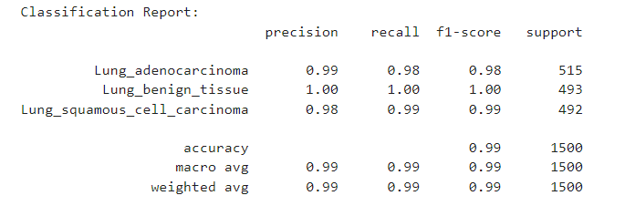

* **ROC-AUC Score:** 0.9997

**Part 2 - Swin Transformer**

* Train Loss: 0.0424
* Train Accuracy: 0.9842
* Classification Report:

* **ROC-AUC Score:** 1.0000

**REFERENCE:**

* timm Library: https://github.com/rwightman/pytorch-image-models
* Swin Transformer Paper: https://pmc.ncbi.nlm.nih.gov/articles/PMC11325325/
* Keras and TensorFlow Documentation
* Kaggle Dataset: https://www.kaggle.com/datasets/andrewmvd/lung-and-colon-cancer-histopathological-images
* Scikit-learn: Classification metrics and evaluation tools