**Acknowledgement**

We are extremely grateful to our teacher, **Prof. Kumar Devadutta** for his valuable guidance in helping us learn concepts of Android Application Development. We are also thankful to him for his consistent support and encouragement.

We would also like to extend our gratitude to our fellow classmates for their support.

Tools and Techniques Lab has helped us improve our technical skills in this domain which will also help us in industrial work in the future.

**Declaration**

We hereby declare that the Android Application **“Brain Trainer”** developed is original and authentic to the best of our knowledge.

The idea behind this project is completely original and genuine.

This project is submitted for examination purpose only.

If any kind of redundancy is found, this submission can be expelled out from the evaluation.

**Abstract**

We have developed an Android Application **“Brain Trainer”** to allow individuals to check their intellect , speed and accuracy with regard to basic mathematical calculations.

This application is a quizzing app which tests an individual’s basic mathematical knowledge within a particular interval of time.

Improving on basic mathematics is essential as it forms the foundation for advanced concepts - which has its applications in various fields, while also making a person quick-witted.

This application has future implementations as a basic gaming app that one can indulge in during his leisure while also sharpening his skills.

Making this application has helped us improve our technical skills in this domain and will also help us in industrial work in future.

**Introduction**

**OVERVIEW:**

A general trend among the students being observed these days is their increasing indulgence in mobile games of all sorts. Also, a general dislike for mathematics as a subject is on the rise. Thus, our aim is to combine the two in such a way that the children can use it to their advantage while enjoying it.

**OBJECTIVE:**

The idea behind this application is to develop an educational game which children can enjoy and at the same time work on their basic mathematical skills. These basic skills will be beneficial to them further in life.

**SCOPE:**

This app can be used by children and adults alike. Children can use it for study purposes. Adults for a break from their work.

**LIMITATIONS:**

The app covers only basic level mathematics, suitable for children. It barely touches upon the difficult and tedious calculations for secondary level.

**Hardware and Software Requirements**

**HARDWARE:**

This application is intended to be a stand-alone, single-user system. The app will run on an android mobile device or an android emulator. No further android devices or interfaces will be required.

**SOFTWARE:**

The software will run on an android operating system specifically version 2.3(Gingerbread) and above.

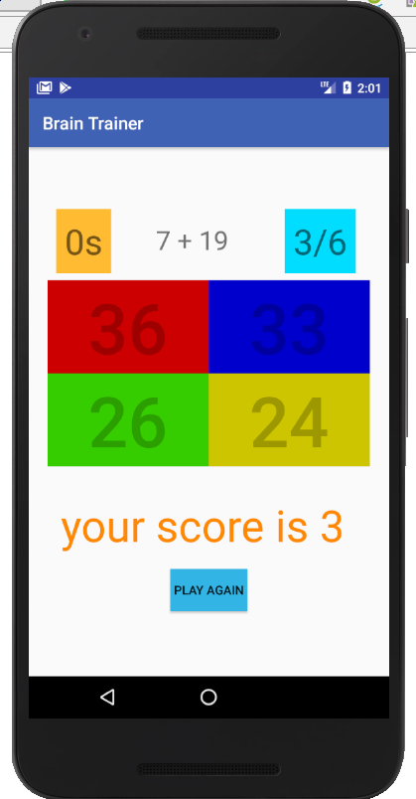

Project report on **“BRAIN TRAINER”**

application

1705714 - Pragya Chaudhary

1705734 - Shantanu Raj

1705735 - Shaurya Mishra

1705736 - Shreenkhala Verma

1705760 - Vishal Kumar Singh

Under the guidance of **Prof.Devdatta Pattnaik**