SOC Phishing Email Investigation Report
Portfolio Lab | Simulated Evidence | Analyst: Abdul Rahman Sesay

1. Executive Summary
The SOC investigated a simulated email impersonating Microsoft Account Support. The message used urgency, a look-alike sender domain, a credential-verification lure and an unexpected ZIP attachment. Simulated SPF, DKIM and DMARC results failed. Based on the combined evidence, the lab verdict is Malicious with High severity.

2. Scope and Safety
This project is designed for portfolio and training use. Publishable indicators use reserved documentation values. No live malicious attachment is included, and no real organisation or user was targeted.

3. Initial Triage
Observed red flags included brand impersonation, urgency, a verification request, a look-alike sender domain and an unexpected archive attachment.

4. Header Analysis
The From, Reply-To, Return-Path, Received and Message-ID fields were reviewed. Authentication-Results in the simulated header show SPF=fail, DKIM=fail and DMARC=fail. These results increase suspicion when combined with the impersonation indicators.

5. URL and Attachment Analysis
The URL was extracted without visiting it directly. The domain uses a simulated look-alike spelling. The ZIP attachment is treated as suspicious and would be hashed and analysed only in an isolated environment. This package intentionally contains no malware.

6. Verdict and Severity
Verdict: MALICIOUS (SIMULATED). Severity: HIGH. Threat type: credential phishing with potential malware delivery. The verdict is supported by impersonation, authentication failures, a credential lure and an unexpected attachment.

7. Response Recommendations
Quarantine the email; hunt for matching messages and IOCs; block confirmed malicious indicators; identify user interaction; reset credentials/revoke sessions if compromise is confirmed; investigate endpoints if execution occurred; and document/tune detections.

8. Indicators of Compromise
Type | Indicator | Assessment
Sender | support@micr0soft-security.example | Simulated look-alike sender
Reply-To | verification@micr0soft-security.example | Simulated suspicious reply address
Domain | micr0soft-security.example | Simulated typosquatting pattern
URL | https://micr0soft-security.example/verify | Simulated credential-phishing URL
IP | 192.0.2.76 | TEST-NET-1 documentation IP
Attachment | Account_Update.zip | Simulated unexpected archive
SHA-256 | LAB-SIMULATED-HASH-NOT-A-REAL-FILE | Placeholder only; no malware supplied

9. MITRE ATT&CK Mapping
- T1566 - Phishing: social-engineering delivery via email.
- T1566.002 - Spearphishing Link: simulated verification link.
- T1566.001 - Spearphishing Attachment: unexpected ZIP attachment.

10. Visual Walkthrough
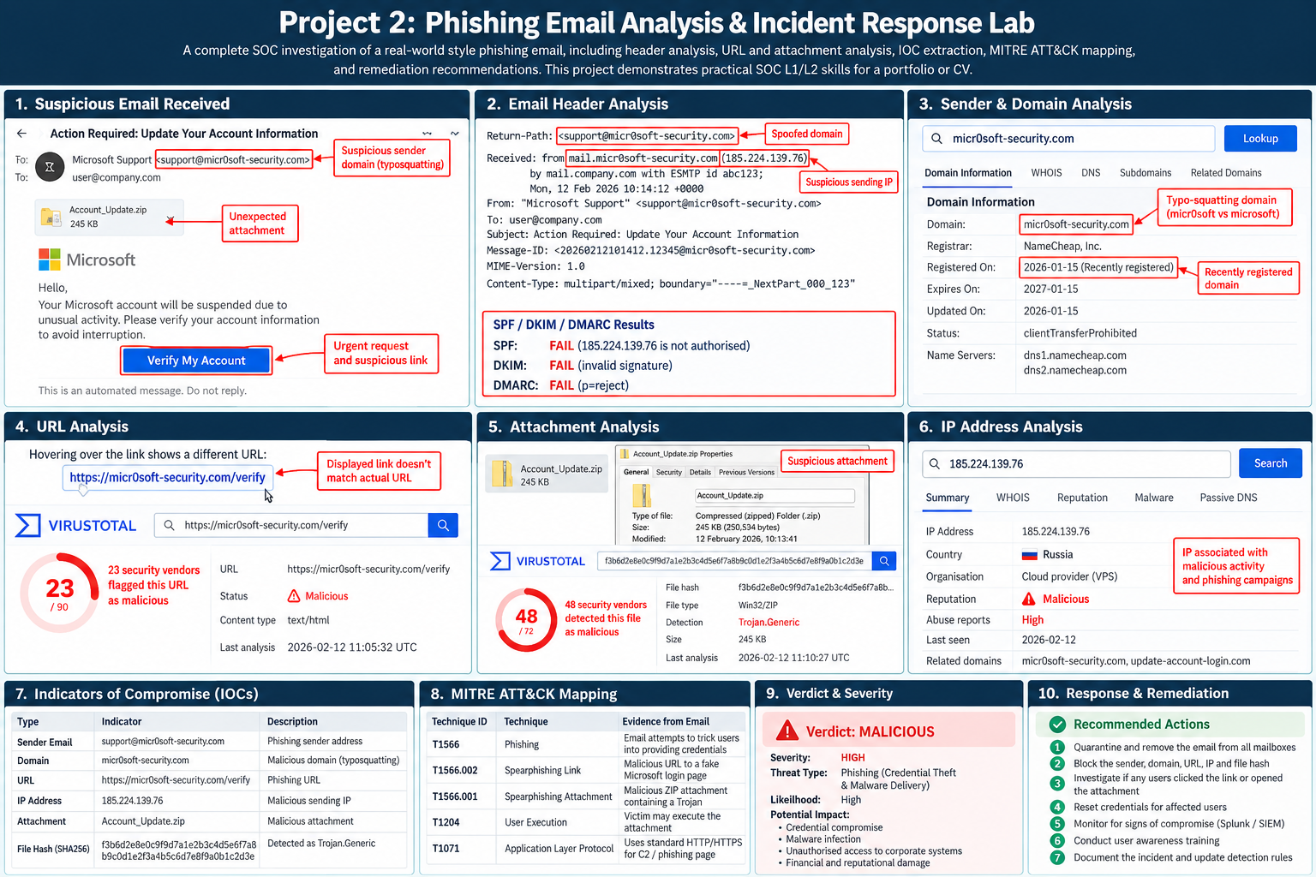
Figure 1. Illustrative investigation workflow. Reputation counts and threat-intelligence details shown in the artwork are examples, not live findings.

