**Results**

**Climate Data**

Summary of temperature and precipitation patterns over time period of study





|  |  |  |  |  |  |  |  |  |
| --- | --- | --- | --- | --- | --- | --- | --- | --- |
| Variable | Intercept | SE | T value | P | Year | SE | T value | P |
| Avg_Hi | 4.6063 | 10.5046 | 0.439 | 0.663 | 0.0017 | 0.0053 | 0.325 | 0.746 |
| Avg_Lo | -67.7237 | 9.2136 | -7.35 | 6.31e-10 | 0.0310 | 0.0047 | 6.66 | 9.49e09 |
| Precip | -2537.7346 | 1508.9971 | -1.682 | 0.0978 | 1.6812 | 0.7619 | 2.207 | 0.0312 |

**Phenology summary**

A total of 290 alpine plant species found at greater than 3200 m altitude were studied using the earliest reported bloom date from herbarium vouchers (statistically significant –> p<0.05) (see Appendix A for results of individual species).

Summary of how bloom date varied with respect to year (1950-2011)

* Number that didn’t change: 234
* Number that had earlier date: 56, average slope=-.5244, average adjusted R2=0.2218;
* Number that had later date: 0
* Any additional notes or anomalies

Summary of how bloom date varied with respect to average high temperature

* Number that didn’t show relationship: 208
* Number that had earlier date with higher temps: 82, average slope = -9.7737, average adjusted R2 = 0.2269
* Number that had later date with higher temps: 0
* Any additional notes or anomalies

Summary of how bloom date varied with respect to average low temperature

* Number that didn’t show relationship: 203
* Number that had earlier date with higher temps: 86, average slope = -10.3772, average adjusted R2 =0.2230
* Number that had later date with higher temps: 1, slope = 14.3997, adjusted R2=0.2558
* Any additional notes or anomalies

Summary of how bloom date varied with respect to precipitation

* Number that didn’t show relationship: 274
* Number that had earlier date with more precip: 2, average slope: -0.0006, average adjusted R2 = 0.1433
* Number that had later date with more precip: 12, average slope: 0.0008, average adjusted R2 =0.2493

When look at all species at the same time:

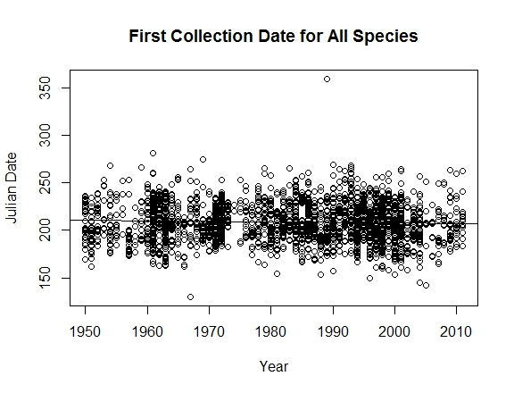

Both intercept and slope significant. If include all data, the date of first collection is statistically earlier by 0.062563/year, or 3.75 days earlier over the course of the study period. However, very little of the variation in bloom date is explained by year (adjusted R2=0.0025).

|  |  |  |  |  |  |  |  |  |
| --- | --- | --- | --- | --- | --- | --- | --- | --- |
| Variable | Intercept | SE | T value | P | Year | SE | T value | P |
| Bloom date | 332.3755 | 16.5953 | 20.028 | <2e-16 | -.0626 | 0.0083 | -7.509 | 6.19e=14 |
|  |  |  |  |  |  |  |  |  |
|  |  |  |  |  |  |  |  |  |

If we only look at the species that show a significant relationship with year:

**Discussion**

* Compare to Gallagher et al 2009 results
* Compare to Munson & Sher 2015 results
* Discuss selection criteria for indicator species and list potential species that would make good indicator species based on those criteria
* Provide methods so other groups/regions could easily determine indicator species
* Caution against using these rates of change at face value; lots of factors to consider, including a change in collection effort (e.g., are roads more accessible earlier? So perhaps plants not earlier but just able to get to them earlier).
* Consider doing graph of number of collections per year to show whether or not effort of collection has changed over study period and then discuss how that impacts phenology results.