**Results**

**Climate Data**

Summary of temperature and precipitation patterns over time period of study





|  |  |  |  |  |  |  |  |  |
| --- | --- | --- | --- | --- | --- | --- | --- | --- |
| Variable | Intercept | SE | T value | P | Year | SE | T value | P |
| Avg_Hi | 4.6063 | 10.5046 | 0.439 | 0.663 | 0.0017 | 0.0053 | 0.325 | 0.746 |
| Avg_Lo | -67.7237 | 9.2136 | -7.35 | 6.31e-10 | 0.0310 | 0.0047 | 6.66 | 9.49e09 |
| Precip | -2537.7346 | 1508.9971 | -1.682 | 0.0978 | 1.6812 | 0.7619 | 2.207 | 0.0312 |

**Phenology summary**

A total of 290 alpine plant species found at greater than 3200 m altitude were studied using the earliest reported bloom date from herbarium vouchers (statistically significant –> p<0.05)

Summary of how bloom date varied with respect to year (1950-2011)

* Number that didn’t change: 237
* Number that had earlier date: 53
* Number that had later date: 0
* Any additional notes or anomalies: 18 had adjusted r^2>0.25

Summary of how bloom date varied with respect to average high temperature

* Number that didn’t show relationship: 208
* Number that had earlier date with higher temps: 82, average slope = -9.7737, average adjusted R2 = 0.2269
* Number that had later date with higher temps: 0
* Any additional notes or anomalies

Summary of how bloom date varied with respect to average low temperature

* Number that didn’t show relationship: 203
* Number that had earlier date with higher temps: 86, average slope = -10.3772, average adjusted R2 =0.2230
* Number that had later date with higher temps: 1, slope = 14.3997, adjusted R2=0.2558
* Any additional notes or anomalies

Summary of how bloom date varied with respect to precipitation

* Number that didn’t show relationship: 274
* Number that had earlier date with more precip: 2, average slope: -0.0006, average adjusted R2 = 0.1433
* Number that had later date with more precip: 12, average slope: 0.0008, average adjusted R2 =0.2493

When look at all species at the same time:

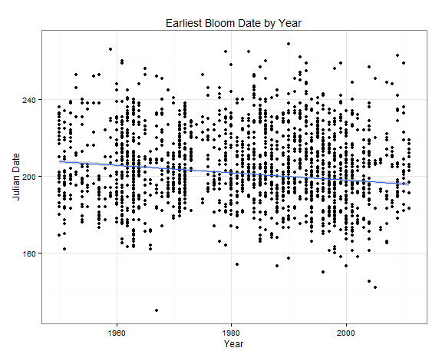

Both intercept and slope significant. If include all data, the date of first collection is statistically earlier by 0.1935/year, or 11.8 days earlier over the course of the study period. However, very little of the variation in bloom date is explained by year (adjusted R2=0.0298).

If we only look at the species that show a significant relationship with year:

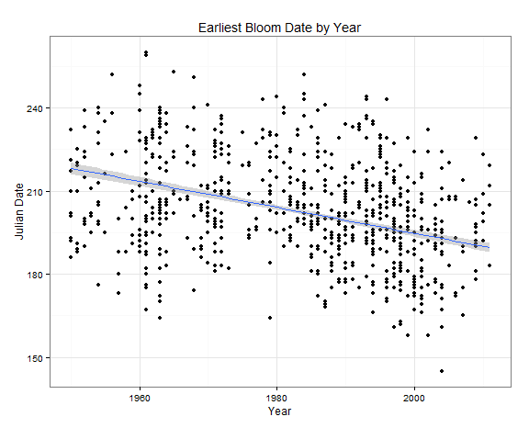

When we only look at the relationship between first collection date and year for species that show a significant relationship with year, it is an even more dramatic result. The date of first collection is 0.47 days earlier each year, or 28.67 days earlier over the course of the study. More of the variation in bloom date is related to year than in the analysis with all of the species (adjusted r^2=0.1656).

|  |  |  |  |  |  |  |  |  |
| --- | --- | --- | --- | --- | --- | --- | --- | --- |
| Variable | Intercept | SE | T value | P | Year | SE | T value | P |
| Bloom date(all species) | 584.98 | 26.51 | 22.06 | <2e-16 | -0.1935 | 0.0134 | -14.48 | <2e-16 |
| Bloom date (sig. spp.) | 1133.9245 | 55.39 | 20.47 | <2e-16 | -0.4696 | 0.0279 | -16.83 | <2e-16 |
|  |  |  |  |  |  |  |  |  |

**Discussion**

* Compare to Gallagher et al 2009 results
* Compare to Munson & Sher 2015 results
* Discuss selection criteria for indicator species and list potential species that would make good indicator species based on those criteria