**Final Group Project: Library Management**

**MIS 6326 DATABASE MANAGEMENT**

**Presented to Professor Vivek Mishra**

**LIBRARY MANAGEMENT:**

**RELATIONAL DATABASE MANAGEMENT SYSTEM**



**BY GROUP MEMBERS:**

**Bhavan Mehta**

**Elizabeth Worley**

**Jatan Rathod**

**Rahul Bhatt**

**Vaibhavi Pandit**

|  |  |
| --- | --- |
|  |  |

**Final Group Project: Library Management**

**TABLE OF CONTENTS**

**PROBLEM DESCRIPTION** **4**

**PROBLEM STATEMENT** **4**

**ORGANIZATION DESCRIPTION** **4**

**Company Overview** **4**

**SCOPE OF DATABASE** **6**

**Address Table** **6**

**Author Table** **6**

**Book Table** **6**

**Borrow Table** **6**

**Member Table** **6**

**Return Table** **7**

**Reviews Table** **7**

**ENTITY RELATIONSHIP DIAGRAM** **9**

**RELATIONAL DATABASE SCHEMA** **10**

**Address Table** **10**

**Author Table** **10**

**Book Table** **10**

**Borrow Table** **10**

**Member Table** **11**

**Return Table** **11**

**Reviews Table** **11**

**MENU AND DATA INPUT SCREEN FORMS** **14**

**SAMPLE REPORTS** **28**

**Future Improvements**

**Final Group Project: Library Management**

**Problem Description**

**Problem Statement**

Being one of the famous libraries in town, it wants to expand its customers and be the best among all. Hence the management system aim is to develop a new programmed system that will provide ever lasting solution to manual base operations and make available a channel through which staff can maintain records and customer have information about library material. The database keeps track of information about the books in the library, their cost, status, total books available in the library. The user can find immediately with an automated system rather than manual writing system. Moreover, the database will provide more security

**Organization Description**

**Company Overview**

A library is a collection of organized information and resources which is made accessible to well defined community for borrowing or reference sake. The information is provided in digital or physical format. The collection can include newspaper, books, films, prints, maps, CDs. Library Management system allows the user to store book details and customer details. The System is strong enough to withstand regressive yearly operations. This system will reduce data entry, time and also provide readily calculated reports.

**Employees**

Library employs thirty people: six desk customer service representatives, one administrative/payroll secretary, one day shift manager, one night manager, two custodians, two maintenance personnel, two guards, five clerks, two caretakers, four personnel attendees, three information guides, and one newly created position a database administrator.

**Final Group Project: Library Management**

**Scope of Database**

**Address Table**

The Address Table provides the address of the customers and other additional information. It has a direct relationship with Member Table. The primary key is AddressId. The forgein key is MemberId.

**Author Table**

The Author table captures the name of the author and the frequency of the books borrowed by the author.

**Book Table**

The Book table contains primary key as BookId. It contains other attributes also such as BookTitle, BookSubject, BookPublisher, BookStatus**.**

**Borrow Table**

The Borrow Table is the most important table. The BorrowId is the primary key it also has other attributes BorrowDate, ReturnDate, Status. The BookId and MemberId is the foreign key.

**Member Table**

The Member Table is a lookup table used to check and maintain the members. The table has a MemberId that is generated to uniquely identify each member and hence the primary key. It contains MemberLastName, MemberFirstName and MemberStatus.

**Return Table**

The Return Table contains the ReturnId primary key, BorrowId and BookId forgein key. Other attributes like ActDateReturn, ReturnDate and Fine.

**Review Table**

The Review Table contains the reviews regarding the books issued by various members. The ReviewId being the primary key. Other attributes like ReviewContent, PublishDate and forgein keys MemberId and BookId.

**Final Group Project: Library Management**

**Entity Relationship Diagram**

|  |  |  |  |  |  |  |  |  |
| --- | --- | --- | --- | --- | --- | --- | --- | --- |
| **Final Group Project: Library Management** | | | | | |  |  |  |
| **Book Table** |  | | | |  |  |  |  |
| **CREATE TABLE Room** | | | | | **INTEGER** | **Not Null** | **IDENTITY(1,1),** |  |
| **BookID** | | | | |  |
| **BookTitle** | | | | | **VARCHAR** | **Not Null ,** |  |  |
| **BookSubject** | | | | | **VARCHAR** | **Null,** | **DEFAULT 1,** |  |
| **BookPublisher** | | | | | **VARCHAR** | **Null** |  |
| **BookStatus VARCHAR NULL**  **Author VARCHAR NULL**  **CONSTRAINT PKBOOKID PRIMARY KEY (BookID),** | | | | | | |  |  |
| **CONSTRAINT FKBORROWID FOREIGN KEY BORROWID REFERENCES** | | | | | | | |  |
| **(RoomType))** | | | | |  |  |  |  |
| **Borrow Table** | | | | |  |  |  |  |
|  | |  |  |  |  |  |  |  |
| **CREATE TABLE Borrow** | | | **INTEGER** | **Not Null,** |  |  |
| **(BorrowID** | | | | |  |  |
| **BorrowDate** | | | | | **INTEGER** | **Not Null,** |  |  |
| **ReturnDate INTEGER**  **BookID INTEGER**  **MemberID INTEGER**  **Status VARCHAR**  **CONSTRAINT PRIMARY KEY (BORROWID),** | | | | | |  |  |  |
| **CONSTRAINT FKBOOKID FOREIGN KEY BookID REFERENCES (BOOK),** | | | | | | | |  |
| **CONSTRAINT MEMBERID FOREIGN KEY MemberID REFERENCES (Member))** | | | | | | | |  |
| **Member Table** | | | | |  |  |  |  |
|  | |  | |  | |  |  |  |
| **CREATE TABLEMember** | | | | **Not Null** | **IDENTITY(1,1),** |  |
| **(MemberID** | | | | | **INTEGER** |  |
| **MemberName** | | | | | **VARCHAR (50)** | **Not Null,** |  |  |
| **MemberLastName** | | | | | **VARCHAR (255)** | **NOT Null,** |  |  |
| **Member Status** | | | | | **VARCHAR** | **NOTNull,** |  |  |
|  | | | | |  |  |  |  |
|  | | | | |  |  |  |  |
|  | | | | |  |  |  |  |
|  | | | | |  |  |  |  |
|  | | | | |  |  |  |
|  | | | | | | |  |  |
| **Return Table** | | | | |  |  |  |  |
|  | |  | | |  |  |  |  |
| **CREATE TABLE Return** | | | | | **INTEGER** | **Not Null** | **IDENTITY(1,1),** |  |
| **(ReturnID** | | | | |  |
| **BorrowID** | | | | | **VARCHAR (50)** | **Not Null,** |  |  |
| **BookID** | | | | | **INTEGER** | **Not Null,** |  |  |
| **ActDateReturned** | | | | | **INTEGER** | **Not Null,** |  |  |
| **LateDay** | | | | | **INTEGER** | **Not Null,** |  |  |
| **Fine** | | | | | **INTEGER** | **Not Null,** |  |  |
| **CONSTRAINT PRIMARY KEY(ReturnID)**  **CONSTRAINT FK BOOKID FOREIGN KEY BookID REFERENCES (BOOK),** | | | | | | | |  |
| **CONSTRAINT FK BORROWID FOREIGN KEY BorrowID REFERENCES (Borrow))**  **Reviews Table**  **CREATE TABLE Reviews**  **(ReviewID INTEGER NOT NULL,**  **MemberID INTEGER NOT NULL,**  **BookID INTEGER NOT NULL,**  **ReviewContent INTEGER NOT NULL,**  **PublishDate INTEGER NOT NULL,**  **CONSTRAINT PRIMARY KEY(ReviewID)**  **CONSTRAINT FK BOOKID FOREIGN KEY BookID REFERENCES(BOOK),**  **CONSTRAINT FK MEMBERID FOREIGN KEY MemberID REFERENCES(Member))**  **AUTHOR TABLE**  **CREATE TABLE Author**  **(AuthorID INTEGER NOT NULL,**  **BookName VARCHAR NOT NULL,**  **BookSubject VARCHAR NOT NULL,**  **BookPublished VARCHAR NOT NULL,**  **CONSTRAINT PRIMARY KEY(AuthorID))**  **ADDRESS TABLE**  **CREATE TABLE Address**  **(AddID INTEGER NOT NULL,**  **MemberID INTEGER NOT NULL**  **Street INTEGER NOT NULL**  **City INTEGER NOT NULL**  **State INTEGER MOT NULL**  **CONSTRAINT PRIMARY KEY(AddID)**  **Final Group Project: Library**  **CONSTRAINT FK MEMBERID FOREIGN KEY MemberID REFERENCES(Member))** | | | | | | | |  |
|  | | | | |  |  |  |  |
|  | | | | | | |  |  |

**Final Group Project: Library Management**

**Menu and Data Input Screen Forms**

**The following section includes descriptions and illustrations of the database Data Input Screens. Descriptions follow the print screen or illustration.**

**Borrow List :** The Borrow List form shows details about current borrowed books and it also shows Menu button which will trigger another forms to Add book, Member Registration, Return book and New Borrow.

Borrow List form also shows a button to generate a Book Borrow Report which shows all the transaction in the database system with their status.

The layout of the Borrow-List form is shown in the below screenshot:

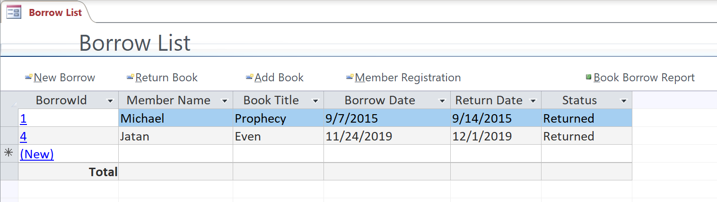

**Member Details:** The member detail form allows to enter new customer details such as Member ID, First Name, Last Name and Member Status in the respective Database Table. This information can be used later in other forms**.**

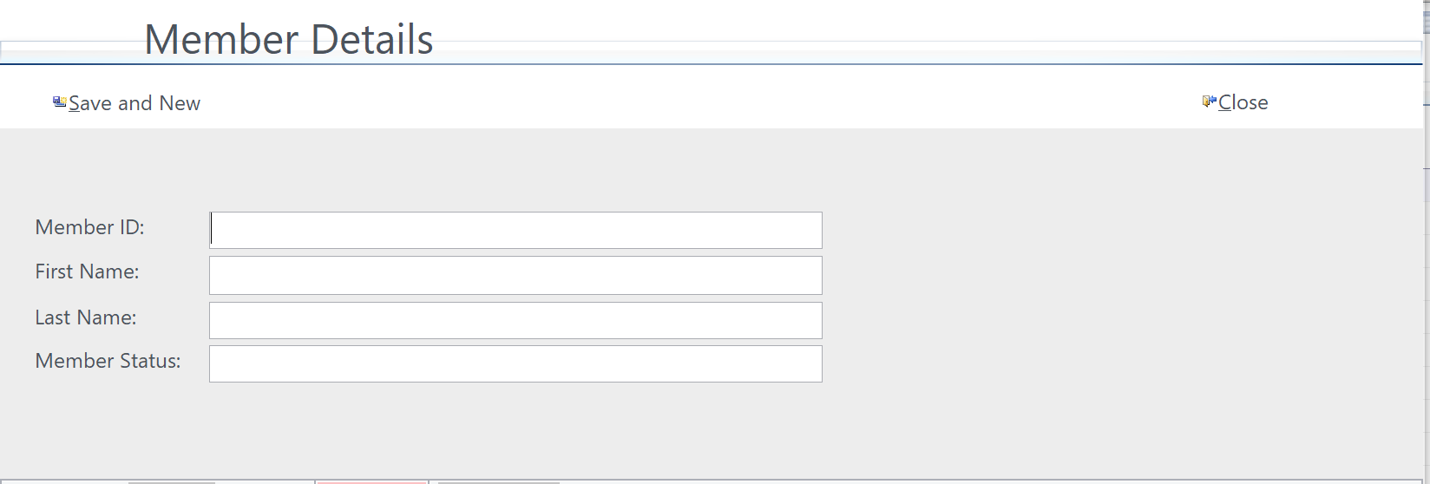

**Final Group Project: Library Management**

**Entering a new member:** Below screenshot shows the Member entry and clicking Save and New button creates a record in the Member table.

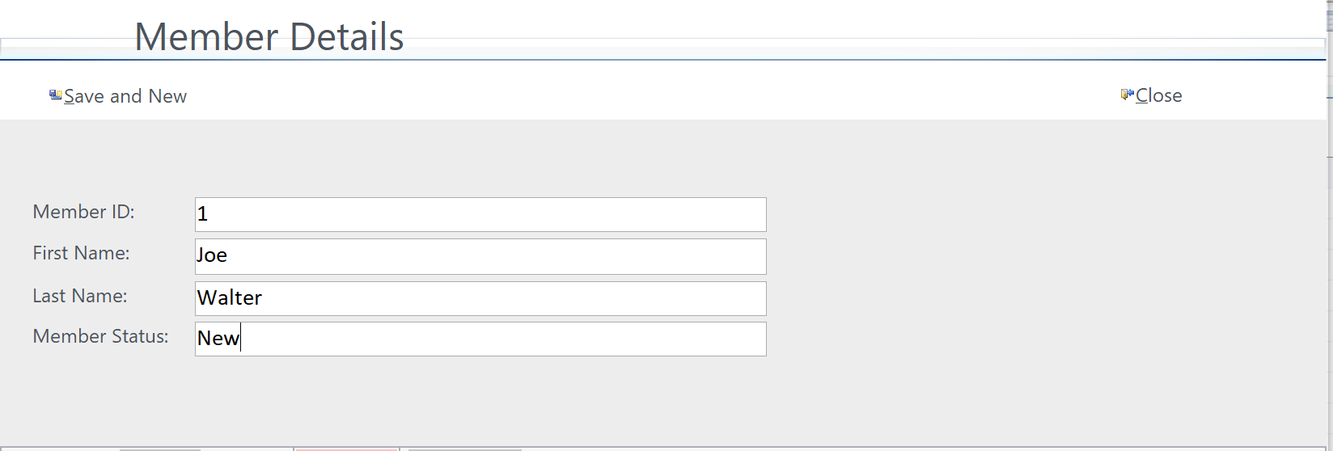

**Book Details:** Book details form allows to add a new book and relevant details like Title, Subject, Publisher, Status and Author in the Book Table. This information can be used directly when customer is trying to borrow a book by automatically filling up the details related to Book.

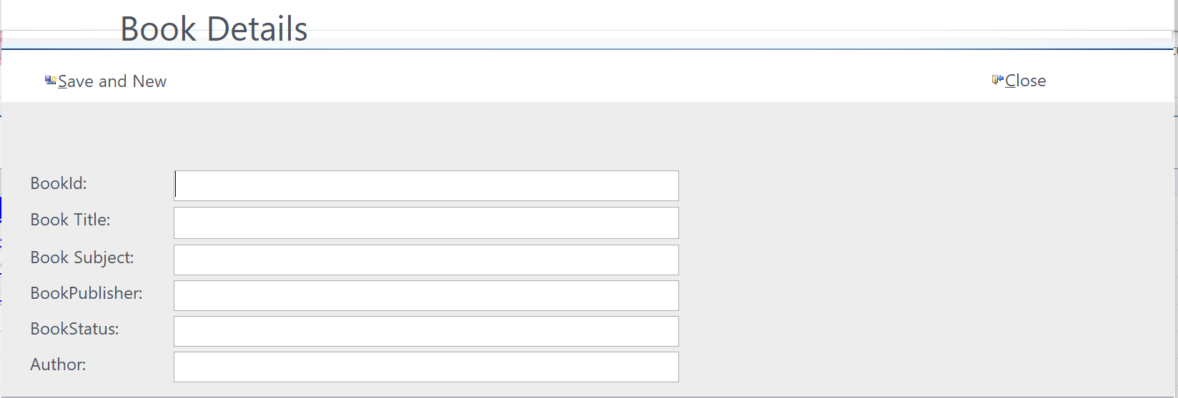

**Final Group Project: Library Management**

**Entry:** As seen in the screenshot shown below, a new Book is added into the Library database with all related information. Clicking on save button creates an entry into the Book table.

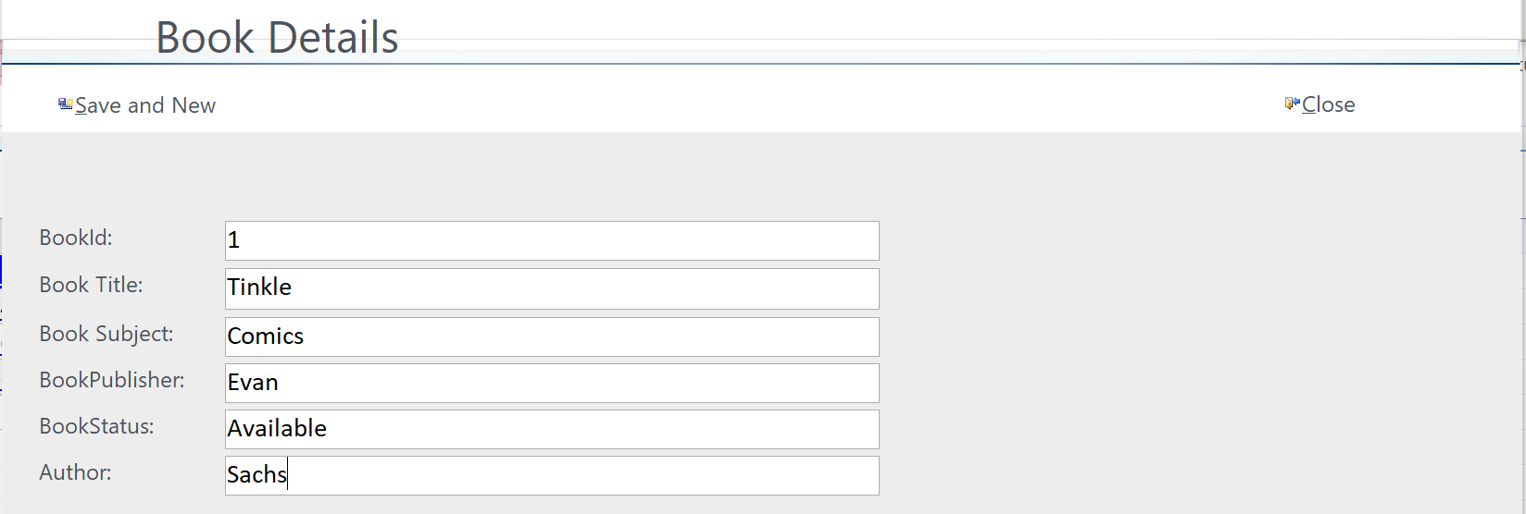

**Final Group Project: Library Management**

**Borrow Details:** This form allows customer to borrow a book that is currently available as seen in the below screenshot:

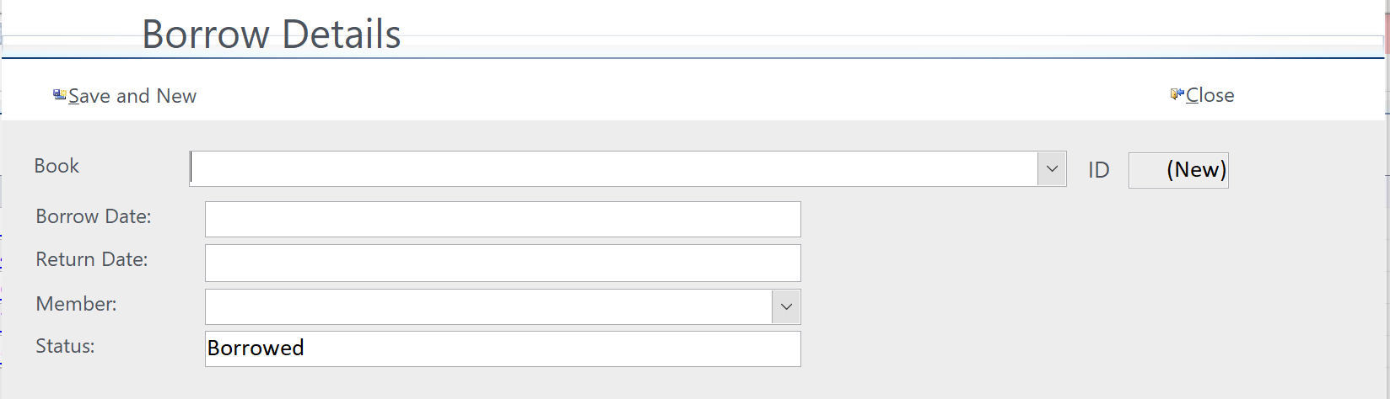

**Entry:**

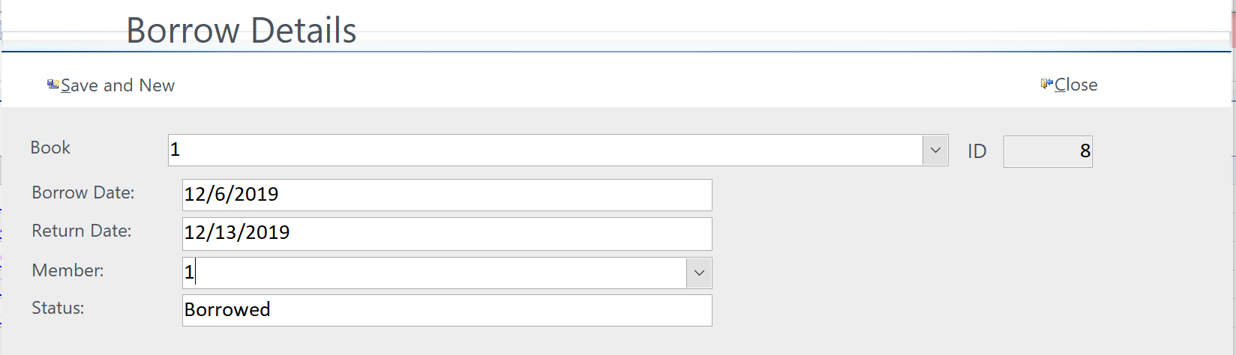

**Return Details:** The form shows the details of the books which have to be returned and fine for late application is also applied.

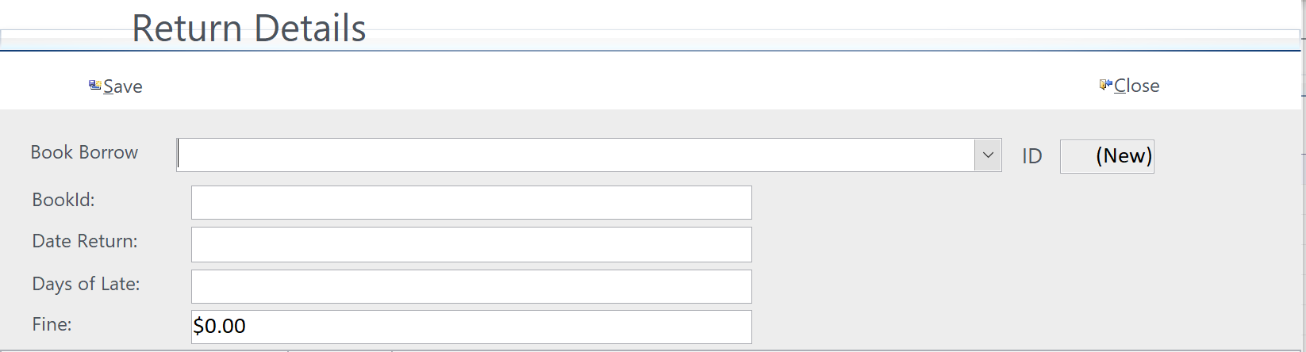

**Final Group Project: Library Management**

**Drop Down List for books:**

The list shows the current borrowed books that can be returned.

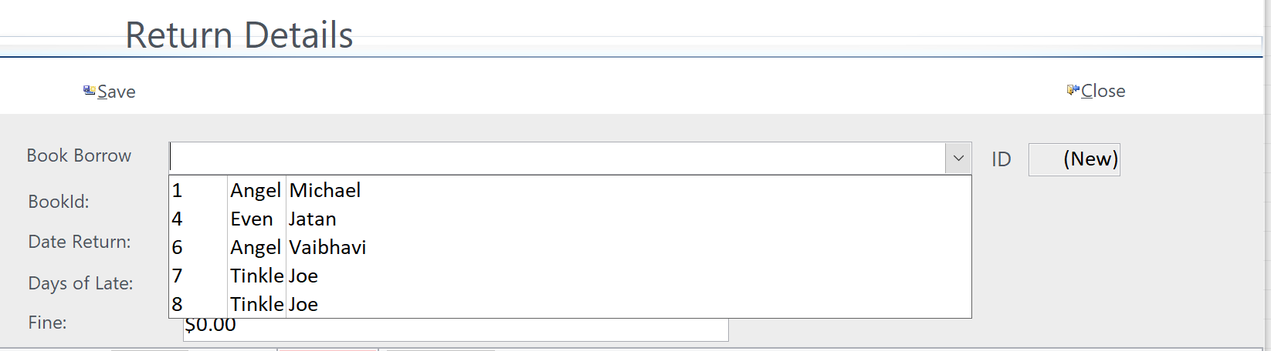

**Fine applied for late return:**

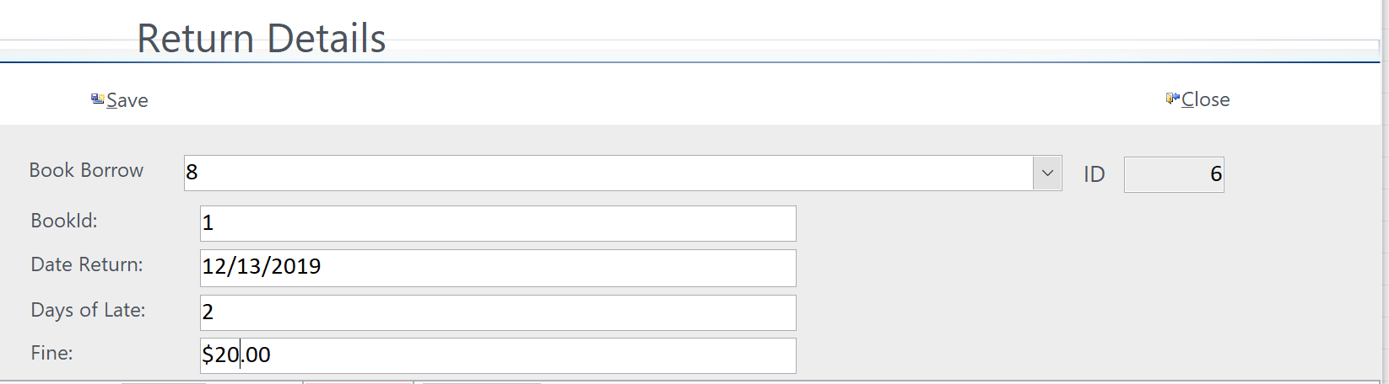

**Final Group Project: Library Management**

**Report Generation:**

The employee is also able to generate a whole report of the transactions which has taken place in the database**.** Below are a few generated reports.

**Book Report:** The following report generates the names of all the books available in the library. It gives the publisher, Status and Author too. The BookId is the primary key for this report. The members can see the availability of books.

**BorrowRpt:** The report gives details about books borrowed by members of the library. It also gives the borrow date and return date of books. Moreover also the status of the book such as returned or borrowed. This helps the members to know which book will be available untill when.

**Member Report :** The report shows the members of have access to borrow books from the library. This also shows the status of each member such as admin, new, block, active. This additionally helps the library employees to make sure the status of each student and keep a record.

**Return Report:** This is the most important report which is generated by the database system. It gives the employees details about the book which was borrowed and the return date along with the BookId. If any member is late in returning a book fine is applied. This report keeps a track about the members and their punctuality about the return dates of the books.

**Final Group Project: Library Management**

**Future Improvements**

We plan to make some improvements to this database in the future. Some of these improvements are:

* A notification showing the user when a book becomes available. If a user needs a certain book and it is currently in “Borrowed” status, they can fill out a form requesting to be notified when the book becomes available again. They can also request in this form to place a 1-day hold as soon as the book becomes available so it is not lent out again before they can go in person to check out the book. Once the book becomes available again, there will be a notification sent to that user letting them know once the book is available, and when their hold expires (if applicable).
* A form requesting information on a certain book. This will be a search form for the user to search for a specific book. This result will show all copies of that specific book and the status. The status will be specific, such as “Borrowed by Charles Smith until 12/10/2019”. If there are any copies available, those will be listed first in the result. This will allow the users to find more specific information on a book they are looking for.
* A form requesting information on a certain member. This will be the start of a social aspect of this library: allowing users to search for other users. The Member Detail form will be more specific and include “Preferred Genre to Read”, “Favorite Book”, “Favorite Quotation” etc. It will also include a history of the books that the user has borrowed with the dates the books were borrowed and then returned. The user will have the option to exclude any book from this public list, as well as their last name or other personal information. This will help foster relationships between the users and to this specific library.