## Practical 1 : Data Consolidation

Objective: Combine data from two sheets into one summary sheet by items.

Step 1: Prepare the data

1. Jan sheet
2. Go to sheet tab at the bottom
3. click on + icon
4. right click to rename it to Jan

1. Enter the details like items, Quantity, Amount

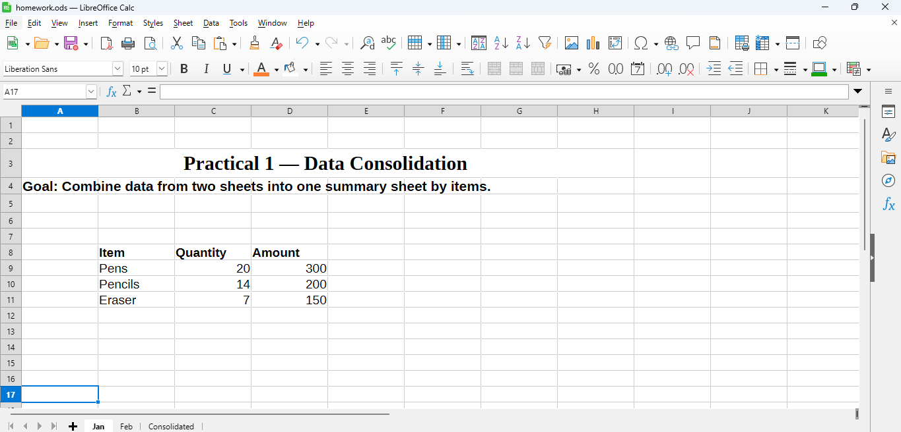

1. Make another sheet for feb sales same like above

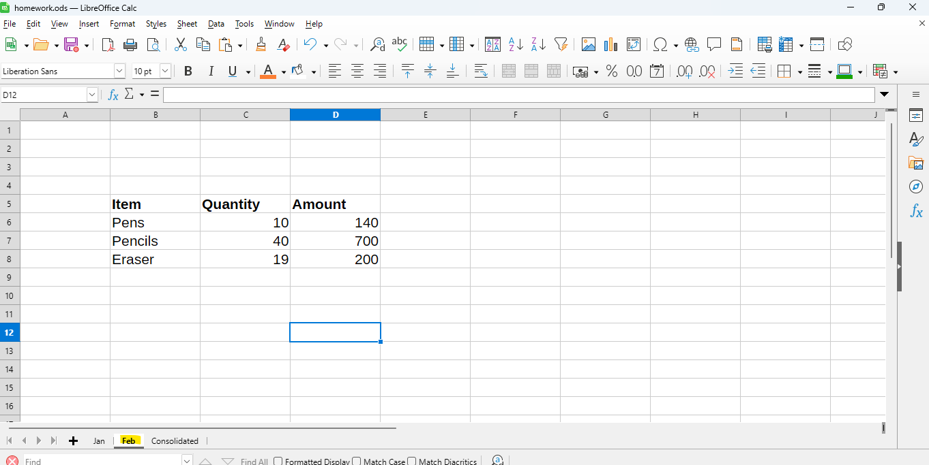

Step 2 : Create a new sheet

1. Insert a new sheet and rename it Consolidated.
2. Click in cell A1 — this is where the combined data will appear.

Step 3: Open the Consolidate dialog

1. Go to the top menu:  
   **Data → Consolidate…**
2. The *Consolidate* dialog box will open.

Step 4: Add source ranges

1. Click inside the **Source data range** box.

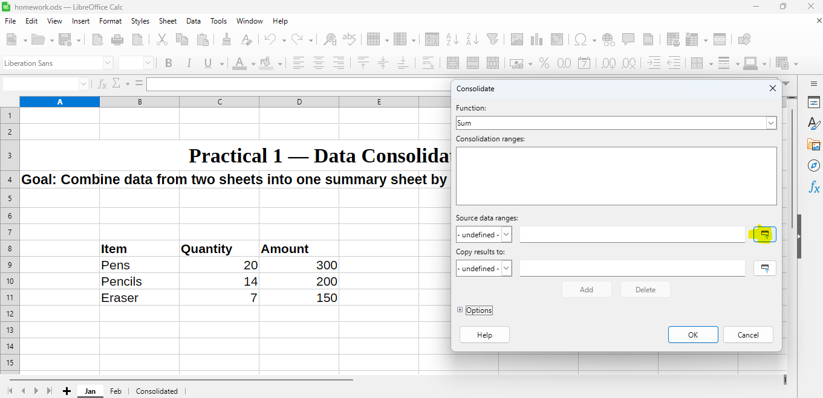

1. Go to the **Jan** sheet → select the range B8:D11.

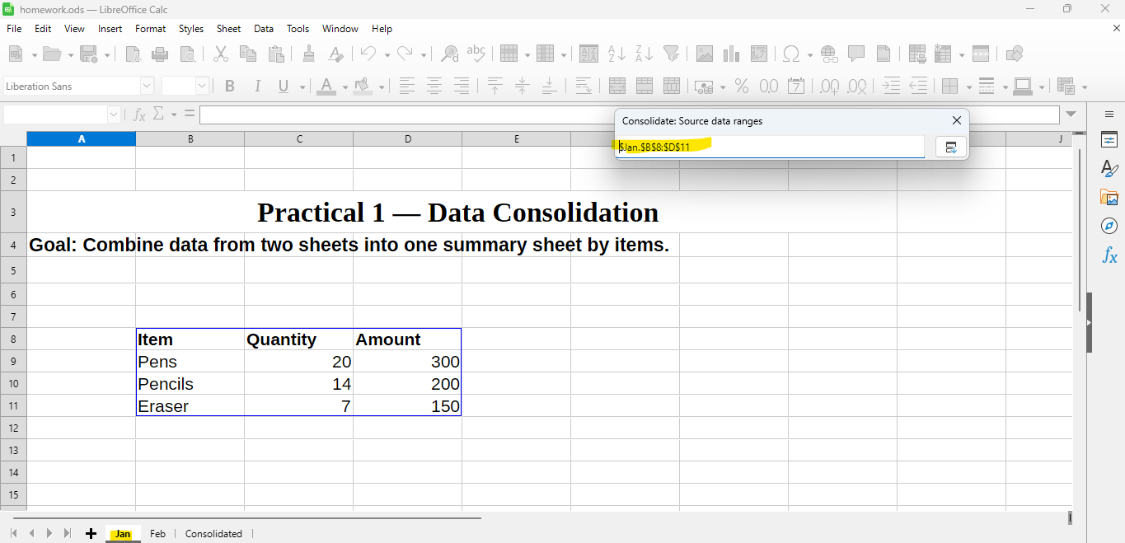

1. Click the **Add** button in the Consolidate dialog.

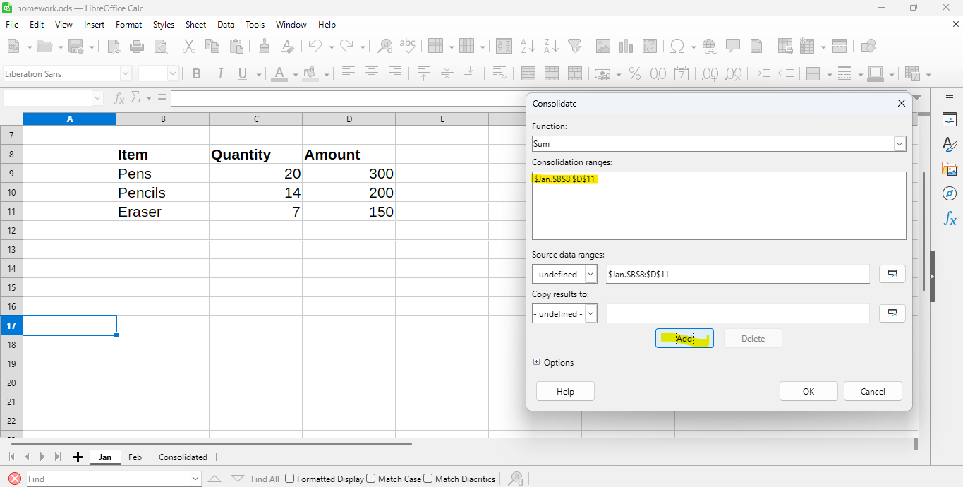

1. Now go to the **Feb** sheet → select B5:D8 → click **Add** again.

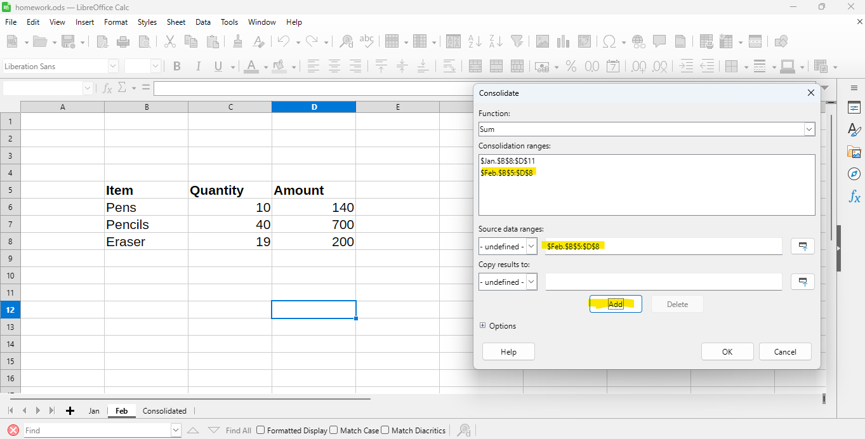

**Step 5: Choose the Function**

In the dialog:

* Under **Function**, select **Sum** (default).

**Step 6: Output location**

“Copy results to” points to the correct cell in **Consolidated** sheet (for example $Consolidated.$A$1).

Step 8: Click Ok

Calc will automatically:

* Combine the data from both sheets.
* Match items by name.
* Add up the quantities and amounts.

## Practical 2: Macro Function

Objective:To record and run a simple **macro** in LibreOffice Calc that performs formatting automatically, and to create a **basic user-defined macro function** using LibreOffice Basic.

**Step 1: Open a new spreadsheet**

1. Open LibreOffice Calc.

1. Save it as **Macro_Function.ods**

1. In the sheet, type this data:

**Step 2: Enable Macro Recording (important!)**

Before recording, make sure macro recording is turned **ON**.

1. Go to  
   **Tools → Options → LibreOffice → Advanced and** Check **“Enable macro recording (limited)”**

1. Click **OK** and restart LibreOffice Calc.

**Step 3: Start Recording the Macro**

1. Select **Tools → Macros → Record Macro**
2. A screenshot of a computer

   AI-generated content may be incorrect.

(You’ll see a small floating window appear.)

1. Now perform some formatting actions, for example:
   * Select cells A1:B1
   * Make them **Bold**
   * Apply a **background color** (Format → Cells → Background)
   * **Center align** the text (Format → Align → Center)
2. When done, click **Stop Recording** in the small recorder window.

**Step 4: Save the Recorded Macro**

1. After clicking stop, a dialog box appears.
2. Choose:
   * **Save macro in:** *This Document (Macros.odf)*
   * Create a **new module** named Module1
   * Save macro name as: **FormatHeader**
3. Click **Save**.

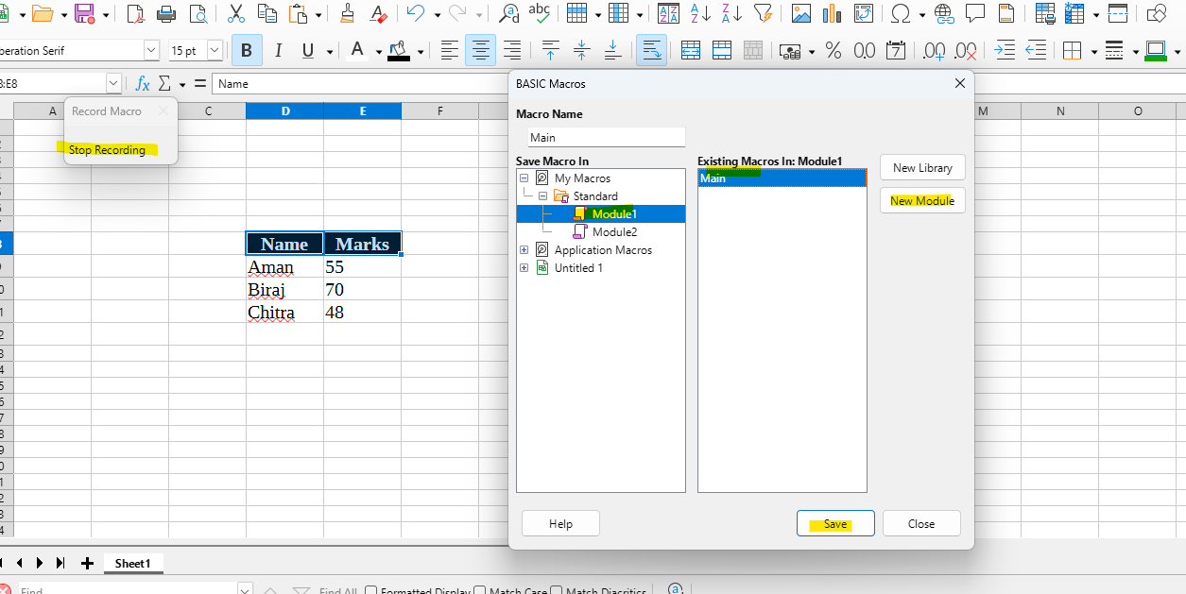

**Step 5: Run the Macro**

1. Now go to: **Tools → Macros → Run Macro**
2. Navigate to:
3. Macros.odf → Standard → Module1 → main
4. Click **Run**  
   → Your header row formatting is applied automatically!

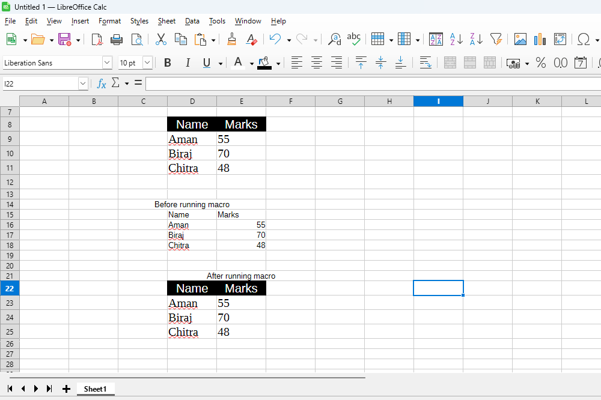

## Practical 3: Multiple Operations

Objective: You are given marks of 10 students in 5 subjects (Math, Science, English, Social Science, Hindi). Create a workbook to:

1. Calculate Total Marks and Percentage (out of 500) for each student.
2. Assign a Grade using the scale: **>=75 → A1, 60–74.99 → A2, 45–59.99 → B1, 33–44.99 → B2, <33 → Fail**.
3. Compute Class Average (%) and Class Highest Total.
4. Determine each student’s Rank by total marks (1 = highest).
5. Highlight students who scored < 33 in any subject (use conditional formatting).

**Step-by-step instructions and formulas**

1. **Total (column G)**
   * In cell **G2** enter:  
     =SUM(B2:F2)

* + Drag (fill) down G2 through G11.

**Percentage (column H)**

* In **H2** enter (rounded to 2 decimals):  
  =ROUND(G2/500*100,2)
* Fill down H2:H11.

**Grade (column I)** using nested IF:

* In **I2** enter:  
  =IF(H2>=75,"A1",IF(H2>=60,"A2",IF(H2>=45,"B1",IF(H2>=33,"B2","Fail"))))
* Fill down I2:I11.

**Rank (column J)** (1 = highest total):

* In **J2** enter:  
  =RANK.EQ(G2,$G$2:$G$11,0)  
  *(Excel)* — For LibreOffice use =RANK(G2;$G$2:$G$11;0)
* Fill down J2:J11.

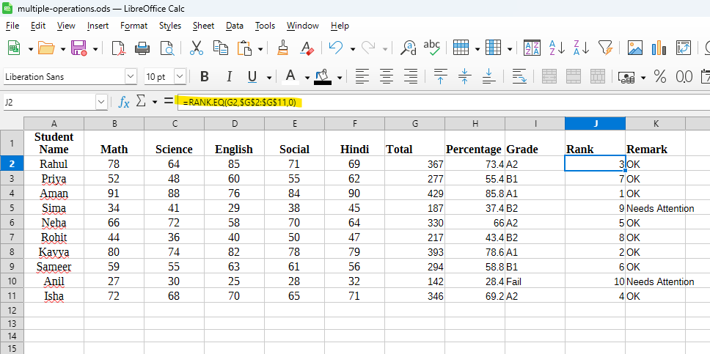

**Remark (column K)** — to flag if any subject < 33:

* In **K2** enter:  
  =IF(OR(B2<33,C2<33,D2<33,E2<33,F2<33),"Needs Attention","OK")
* Fill down K2:K11.

## Practical 4: Create subtotals in Calc

### Objective:

Create a worksheet in LibreOffice Calc showing the sales of different products.  
Sort the data according to the *Category* column and use the **Subtotal** feature to find the total sales for each category and a grand total for all products.

**Step 1: Enter the data**

Type the following data in a new Calc sheet.

**Step 2: Sort the data**

Before using Subtotals, you must sort the data by **Category**.

1. Select the range E4:G12.
2. A screenshot of a computer

   AI-generated content may be incorrect.
3. Go to **Data → Sort**.

1. In the dialog box:
   * Choose **Category** as the Sort Key .
   * Click ok

Now your data will be arranged as per the Category (Stationery, Fruit, Grocery).

**Step 3: Apply Subtotals**

1. Again, select the same range of data (E4:G12).

1. Go to **Data → Subtotals**.

1. In the dialog box:
   * Under **Group by**, select **Category**.

* + Under **Calculate subtotals for**, tick **Sales**.
  + Under **Use function**, select **Sum**.

1. Click **OK**.

**Step 4: View the result**

Calc will insert subtotal rows automatically for each category and a **Grand Total** at the end.

## Practical 5: Scenario

### Objective:

Use LibreOffice Calc’s **Scenarios** to compare Total Profit under different Cost Price / Selling Price assumptions.

### Problem Statement

A company sells three products — **Pen**, **Notebook**, and **Eraser**. Using the given data, calculate profit per product and total profit. Then create three scenarios (Normal, Best, Worst) that change Cost Price (CP) and Selling Price (SP) and compare the **Total Profit** using Scenario Manager.

### Solution:

Step 1: open new calc spreadsheet sheet

* Enter the details

Step 2 – Calculate Profit for each product

In **E2**, enter the formula:

=(C2-B2)*D2

Fill down to **E4**.

In **E5**, calculate total profit:

=SUM(E2:E4)

=SUM(E2:E4)

**Step 2 — Plan scenarios**

Create three scenarios:

* **Normal Case** — keep current CP and SP (baseline).
* **Best Case** — SP increases by **10%**, CP decreases by **5%**. (SP × 1.10, CP × 0.95)
* **Worst Case** — SP decreases by **10%**, CP increases by **5%**. (SP × 0.90, CP × 1.05)

We will change values in columns **B (CP)** and **C (SP)** under each scenario and read result cell **E5** (Total Profit).

**Step 3 — Create scenarios in LibreOffice Calc**

1. **Select** the range **B2:C4** (these are the cells that will change between scenarios).

1. Menu: **Tools → Scenarios...** → click **Add**.
   * Name: Normal Case

* + Description: Base data
  + Click **OK** (this saves current values as the Normal Case).

1. Click **Add** again → Name: Best Case.
   * Now you must supply the new values for the selected cells. Instead of typing formulas here, change the actual values in B2:C4 temporarily (do it on the sheet) to the Best Case numbers, then click **Add** with those values visible.
   * With B2:C4 showing these Best Case values, press **Add** in the Scenarios dialog and name it Best Case.

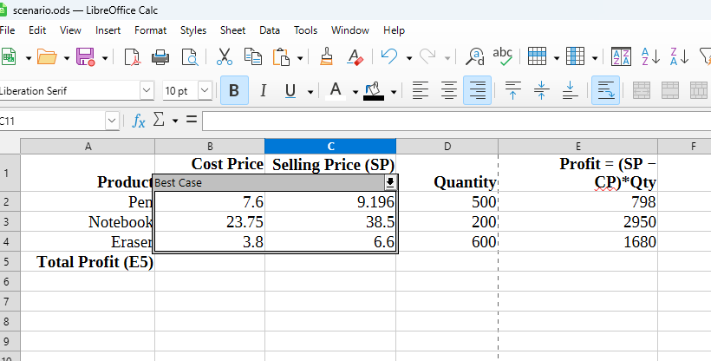

1. Restore the sheet to base values (or use Undo) so you still have Normal Case active.

1. Repeat to create **Worst Case**:

