

Title
Hydraulic Jump: Modeling Traffic Shockwaves

Supervisor
Dr. Manoj Kumar Gupta

Prepared by:
Rahul - 23BME7086

Content
Catalog
Abstract 3
2. Introduction 4
2.1 Background 4
2.2 Problem statement 4
2.3 Objective 5
3. Literature Review 5
3.1 LWR Model: 5
3.2 LWR Model Equation 8
3.3 General Dynamics of LWR Model 9
4. THEORETICAL BACKGROUND 10
4.1 Hydraulic Jump Theory 10
4.2 Traffic Flow Theory 13
4.2.1 Fundamental Traffic Variables: 13
4.2.2 Key relationships 15
5. Methodology 15
5.1 Matlab Model 15
5.2 SUMO Simulation 20
5.2.1 Single Lane Road Model 20
5.2.2 Speed Drop Disturbance 20
5.2.3 Why was SUMO used? 21
5.2.4 Shockwave Observation 21
5.2.5 Visualization of Sumo Results 22
5.2.6 Traffic Simulation Output 23
6. Result and Analysis 24
7. Validation 25
8. Applications 26
8.1 Smart Traffic Control [reference] 26
8.2 Signal Timing Optimization [reference] 26
8.3 Highway Congestion Prediction [reference] 27
8.4 Autonomous Vehicle Systems [reference] 27
9. Conclusion 28
10. Future Scope 29
10.1 AI-Based Traffic Prediction [reference] 29
10.2 Real-Time Data Integration [reference] 29
11. References 31

Appendix - MATLAB Codes 32

Abstract
Traffic congestion is a condition where the number of vehicles on a road exceeds its capacity, causing traffic jams. It often occurs as backward-propagating waves, even when there are no visible blockages. This issue reduces road efficiency and increases travel time. This study addresses the need for a simpler understanding of how traffic shock waves form. The project aims to model traffic shock waves by comparing them to the Hydraulic Jump phenomenon in fluid mechanics. The goal is to create a framework based on conservation laws to predict changes in shock wave speed and density. An one-dimensional traffic model using the Lighthill-Whitham-Richards approach is implemented in MATLAB with finite difference methods. Microscopic traffic simulations were run in SUMO. A dynamic system model is developed in Simulink for validation. Results show a strong match between theoretical predictions and simulation outputs regarding shock wave speed. The model has useful applications in predicting congestion, optimizing traffic signals, and developing intelligent transportation systems.

- Introduction
  - Background
Traffic congestion is a condition marked by slower speeds, longer trip times, and increased vehicle waiting times. It often happens when the number of vehicles exceeds the capacity of a road or intersection. External factors that cause traffic congestion include accidents, road construction, and weather conditions. These sudden changes in traffic conditions are similar to the disruptions seen in fluid flow systems. This has become one of the major challenges in transportation systems.
In fluid mechanics, a hydraulic jump is a sudden, turbulent rise in water level. This phenomenon happens when high-velocity, shallow flow, known as supercritical flow, changes quickly into slow, deeper flow, called subcritical flow. It is commonly seen in open channel flows, such as rivers and spillways. This transition features a sharp change in flow properties and significant energy loss. It follows the principles of mass and momentum conservation.
In transportation engineering, [reference number] a traffic shockwave is a disturbance in vehicle flow that moves backward. It happens when cars suddenly slow down or change lanes. When this disturbance occurs due to sudden braking, the vehicles behind react one after another. This reaction creates a density wave.
The co-relation between hydraulic jumps and traffic shockwaves offers a strong way to understand congestion dynamics using physical modeling principles.

  - Problem statement
Traffic jams often occur without any clear obstacles, raising important questions about their causes. How do these waves of congestion appear suddenly, and why do they move backward against the flow of cars?

While driver behavior is complex, traffic flow shows collective patterns that can be described by large-scale physical models. This brings us to an important research question: Can sudden traffic congestion be described mathematically using principles similar to hydraulic jumps in fluid mechanics?
To solve this, we need a conservation-law framework to predict how shockwaves form and how fast they travel across different traffic densities.
Traffic densities provide insights into the level of congestion on a roadway. High densities indicate that vehicles are close together, which leads to increased travel times and potential accidents.

  - Objective
The main goal of this project is to draw a parallel between hydraulic jump effects in fluid mechanics and shockwave formation in traffic flow systems.

The specific goals are: -
- To connect hydraulic jump principles with changes in traffic density.
- To Calculate shockwave speed using Rankine-Hugoniot condition, with traffic parameters like density and velocity
- To create a one-dimensional numerical simulation model for traffic flow analysis.
- To confirm theoretical predictions using software tools like MATLAB, SUMO, and Simulink.

- Literature Review
The most significant contributions to macroscopic traffic flow theory were made independently by Lighthill and Whitham in 1955, followed by Richards in 1956. Their combined work resulted in the Lighthill-Whitham-Richards (LWR) model [reference], which is still one of the key models in traffic flow theory.

The Light hill-Whitham-Richards Model views traffic as a continuous, compressible medium instead of a separate group of vehicles. It helps us study vehicle flow on a large scale and is explained using a partial differential equation [reference]. This model is grounded in the principle of vehicle conservation.

  - LWR Model:
This describes traffic behavior through the continuity equation: We have three main macroscopic quantities: density ρ, flow Q, and local speed V. These relationships are represented by a diagram called fundamentals diagram. [reference]
Fig : Fundamental diagram

The hydrodynamic relationship between these quantities is
Q = ρV.
The vehicle conservation implies the dynamic continuity equation, e.g., for a homogeneous road:
$\frac{∂ρ}{∂t}+ \frac{∂Q}{∂x}= \frac{∂ρ}{∂t}+ \frac{∂(ρV)}{∂t}$ = 0
….(i)

where:
ρ represents traffic density (vehicles per unit length).
q represents traffic flow (vehicles per unit time).
x denotes position.
t denotes time.
V local speed.

YouTube Reference : Link

The LWR model predicts that shockwaves will form when traffic density changes suddenly. These shockwaves occur because of the nonlinear nature of the flow-density relationship, and they move according to conservation principles. We can find the shockwave speed using the Rankine-Hugoniot condition, which is often applied in fluid dynamics to describe discontinuities.
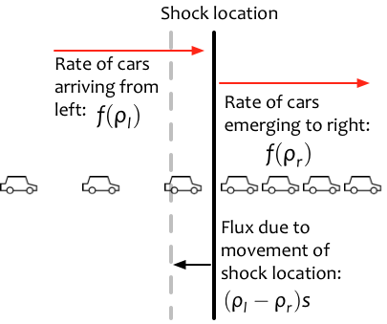
[reference]

The Rankine-Hugoniot condition [reference] helps find the speed at which a discontinuity, or shockwave, moves in systems governed by conservation laws. It says that the speed of the shockwave is the difference in flow divided by the difference in density across the discontinuity. In traffic flow modeling, this condition is used to calculate the speed of a Traffic Shockwave by looking at the traffic states before and after the shockwave.

The Rankine–Hugoniot conditions can be expressed as:
From eq(i), we get
$${ρ_{1U_{x,1}}=ρ}_{2U_{x,2}}$$
This is the first Rankie-Hugoniot relation. Derived using conservation of mass.
$${ρ_{1U_{x,1}}+P_{1}=P_{2}+ρ}_{2U_{x,2}}$$

This is the second RH relation. Derived using conservation of momentum.
$\frac{1}{2}u_{x,1}^{2}+\frac{c_{s,1}^{2}}{γ−1} = \frac{1}{2}u_{x,2}^{2}+\frac{c_{s,2}^{2}}{γ−1}$

This is the third RH relation. Derived using conservation of energy.
Where, m is the mass flow rate per unit area.
ρ1 and ρ2 are the mass densities of the fluid before and after the wave.
u1 and u2 are the fluid velocities before and after the wave.
p1 and p2 are the pressures in the two areas.
h1 and h2 are the specific enthalpies in the two regions.
If traffic density changes abruptly between two states, the shockwave speed is calculated using the Rankine–Hugoniot condition [reference]:

$$W_{s}=\frac{Q_{2}−Q_{1}}{ρ_{2}−ρ_{1}}$$
Conservation Laws:
Conservation of Mass: Mass cannot be created or destroyed. The total mass within a system stays the same over time.
Conservation of Momentum: The total momentum of a system stays constant unless an external force acts on it.
Conservation of Energy: Energy cannot be created or destroyed. It can only change from one form to another.

  - LWR Model Equation
As, we discussed earlier about hydrodynamic relation and continuity equation. There is another equation used to understand the traffic flow in the macroscopic level.
$$\frac{∂ρ}{∂t}+\frac{∂}{∂x}(Q_{e}(ρ)) =\frac{∂ρ}{∂t}+Q_{e}^{'}(ρ)\frac{∂ρ}{∂x}=0$$

It is even written as:
$$\frac{∂ρ}{∂t}+(V_{e}+ρV_{e}^{'}(ρ))\frac{∂ρ}{∂x}= 0$$

LWR Wave Velocity:
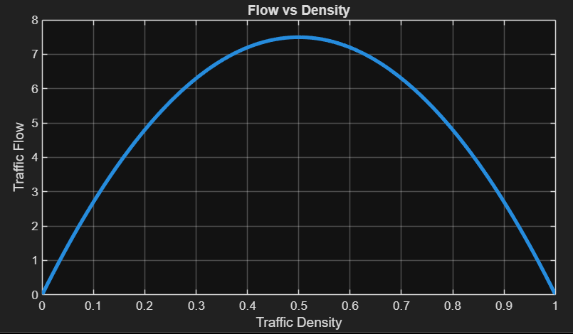
Fig: Fundamental Diagram
In the top plot shows the relationship between traffic flow and density, known as the fundamental diagram. The slope of the curve indicates the wave speed, c. Mathematically, the wave speed is given by c = Q′(ρ).
This can also be expressed as c = V + ρV′(ρ).

The bottom graph compares vehicle speed and wave speed. The blue dashed curve indicates the equilibrium vehicle speed, Ve, while the red curve shows the wave speed, c. An important point is that wave speed is never greater than vehicle speed. Drivers only react to the vehicles in front of them, which means information travels backward through braking interactions. As a result, congestion waves usually move slower than vehicles and often go upstream.

When there is a small disturbance in traffic density, it propagates with speed c. If c is greater than zero, the disturbance moves forward. If c is less than zero, it moves backward. This behavior relates to the formation and upstream movement of traffic jams.

  - General Dynamics of LWR Model
The colored surface shows how density changes along the road over time. Each color represents a different density level. The wave speed c = Q′(ρ) depends on density, so each density layer moves at its own speed, much like layers sliding over each other. Lower-density and higher-density regions travel at different speeds, which causes the surface to tilt and change shape over time. As faster characteristics catch up to slower ones, the smooth density profile steepens and creates a sharp discontinuity. This represents a traffic shockwave. At this moment, the smooth solution fails, and a shock forms, indicating the sudden start of congestion moving along the road.
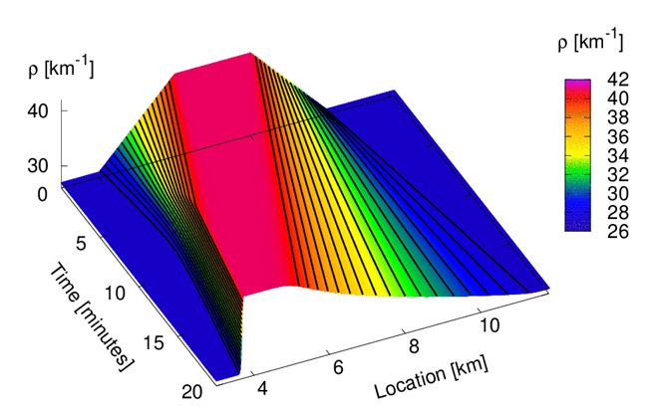
Figure 3: Density Evolution Surface [reference]
The 3D density surface clearly shows nonlinear wave propagation in traffic flow. The tilt of the surface along the spatial axis indicates the direction and strength of characteristic speeds. Areas with different density values move at different speeds, causing distortion of the originally smooth density distribution. As time goes on, the gradient of the surface becomes steeper. This shows compression of characteristics. This graphical representation clearly demonstrates how smooth solutions of the conservation law change into discontinuous shock solutions.

The LWR model is nonlinear because the flow function Q(ρ) depends on density in a nonlinear way. Because of this nonlinearity, small changes in initial density can grow over time. In contrast to linear wave equations, where waves just add together, nonlinear waves interact and change each other’s speed. This interaction causes waves to steepen and shocks to form. This non-linearity is the main reason why traffic jams can form spontaneously, even without external obstacles.

- THEORETICAL BACKGROUND
  - Hydraulic Jump Theory
Consider the flow of water over a dam, as shown in Fig. 16.27. The water depth at section 1-1 is small. As we move downstream, the depth of water increases rapidly over a short length of the channel. This is because at section 1-1, the flow is a shooting flow, as the depth of water is less than the critical depth. Shooting flow is an unstable type of flow and does not continue downstream. It then converts to a streaming or tranquil flow, and the depth of water increases. This sudden increase in depth of water is called a hydraulic jump or a standing wave. Thus, a hydraulic jump is defined as:
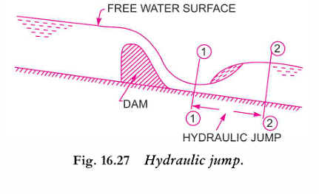
"The rise of the water level, which takes place due to the transformation of the unstable shooting flow to the stable streaming flow."
That unstable shooting flow is known as a supercritical flow, and the stable streaming flow is known as a subcritical flow.
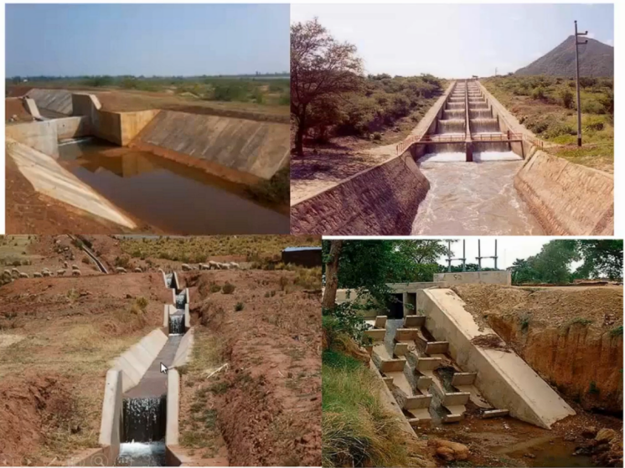
Fig 5 : showing real world hydraulic jumps

When a hydraulic jump takes place, a loss of energy due to eddy formation and turbulence occurs. Eddy formation refers to the swirling motion of fluid that occurs when the flow becomes turbulent, creating currents that deviate from the main flow direction. A hydraulic jump commonly occurs downstream of spillways and dam outlets, and is widely used in hydraulic engineering for energy dissipation and erosion control. A hydraulic jump converts high-speed, low-depth water flow into low-speed, high-depth flow through sudden turbulence, reducing excess kinetic energy.
The behavior of open channel flow follows the conservation of mass and momentum. The flow regime depends on the flow velocity and depth. We classify it using the dimensionless Froude number. [reference]

Froude Number: ${(F_{e})}_{1} = \frac{V_{1}}{\sqrt{gd_{1}}}$
where:
V = mean flow velocity
g = gravitational acceleration
h = hydraulic depth
This Froude number determines the flow regimes. If Fe > 1, then it is known as a supercritical flow, which has high velocity and shallow depth. In this flow, is dominated by inertial forces

Based on this upstream Froude number, the hydraulic jumps are further classified as :
* Undular jumps: This has Fe = 1- 1.7, and gentle standing waves are observed.
*Oscillating jumps: This has Fe = 2.5-4.5, and Unstable waves are observed.
* Steady jumps: This has Fe = 4.5-9, and stable hydraulic jumps are observed with high energy loss.
* Strong jumps: This has Fe > 9, we can see the maximum dissipation in these jumps.

Expression for the depth of the hydraulic jump:
To derive the expression, the following assumptions are made:
- The flow is uniform, and the pressure distribution is due to hydrostatic before and after the jump.
- Losses due to friction on the surface of the bed of the channel are small and hence neglected.
- The slope of the bed of the channel is small, so that the component of the weight of the fluid in the direction of flow is negligibly small.
$$d_{2}−d_{1} = \frac{V_{1}^{2}−V_{2}^{2}}{2g}$$
[reference]

The expression of depth of hydraulic jump in terms of Froude Number:
$$\frac{d_{2}}{d_{1}} = \frac{1}{2}(\sqrt{1+8Fr_{1}^{2}}−1)$$
Expression for Loss of Energy Due to Hydraulic Jump:
As mentioned before, when a hydraulic jump takes place, a loss of energy due to eddies formation and turbulence occurs. This loss of energy is equal to the difference of specific energies at sections 1-1 and 2-2
Or loss of energy due to hydraulic jump,
hL = E1 - E2
$$h_{L} = \frac{{[d_{2}−d_{1}]}^{3}}{4d_{1d_{2}}}$$

  - Traffic Flow Theory
Traffic flow theory models how groups of vehicles move by using macroscopic variables and conservation laws. Instead of following individual vehicles, traffic is viewed as a continuous medium, like fluid flow.

The basis of macroscopic traffic modeling comes from the Lighthill–Whitham–Richards model. This model describes how vehicle density evolves along a roadway using a conservation law. It was developed in the year 1955-1956 by James Lighthill and Gerald Whitham, and by Peyton Richards.

The model introduced the idea of kinematic waves in traffic flow. These are disturbances that move at speeds determined by the slope of the flow-density curve. It provides a way to predict queue formation, bottleneck dissipation, and the effects of speed limits or ramp metering. The LWR model supports many commonly used numerical methods, including the Cell Transmission Model.

    - Fundamental Traffic Variables:
Three key parameters form the basis of this analysis: traffic volume, density, and capacity. In addition, evaluating travel times and distinguishing between instantaneous and average speeds provides further insight into roadway performance. [reference]

Traffic Flow, it is denoted by q is the number of vehicles passing a fixed point on a roadway within a specified period, typically expressed in vehicles per hour. This measure provides a direct insight into the usage of the road.
Units: vehicles/hour
q = N/T

Traffic density (k), represents the number of vehicles occupying a unit length of roadway, usually measured in vehicles per kilometer or vehicles per mile. Density captures the “crowdedness” of a road; a high density means that vehicles are closely spaced, which may increase the risk of delays or accidents. The relationship between volume and density is not linear, but they are intimately connected through the vehicle's speed.
Units: vehicles/km
k = N/L

The capacity of a roadway is the maximum volume it can handle under ideal conditions this is the peak flow rate at which vehicles can traverse the road without causing congestion.
Capacity is influenced by factors such as lane width, roadway geometry, signal timing, and driver behavior.

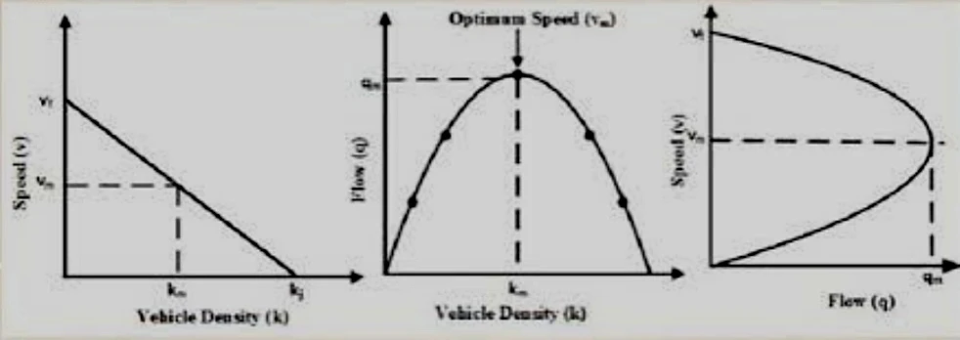
Fig 6: Traffic volume, Density & Capacity Relationship Curve

The fundamental relationship in traffic flow theory is given by:
q = k × vₛ

Vs is the Average vehicle speed.
Fundamental Diagram of traffic flow is a core concept in traffic engineering that graphically represents the relationship between three key traffic variables: traffic density, flow, and speed. It is used to analyse and predict traffic behaviour under various conditions, in traffic management, road design, and congestion control.
The Curve diagram mentioned in the above fig 6, tell about the relationship between q,k,v. And those graphs are called Fundamental Diagram of traffic flow.

    - Key relationships
Flow-Density(q-k) curve is typically parabolic or triangular.
It shows at zero density, flow is zero which say that no vehicle is there. As the density increases, flow increases until it reaches a maximum capacity at critical density. Beyond critical density the flow decreases due to congestion. The position where vehicles are stopped is known as jam density. It is denoted as kj. At this point flow drops to zero.

Speed-Density(v-k) curve is a linear with a negative slope.
In this graph when density is zero, speed is at its free-flow speed(vf). Speed decreases as density increases, reaching zero at jam density.

Speed-Flow (v-q) Curve: This curve is a non-functional which means two speeds can correspond to the same flow, reflecting that the same traffic volume can occur in both free flow where low density and high speed is observed and congested flow which has high density and low speed.

- Methodology
In this section, we described the modeling and simulation approach used to study the traffic shockwave formation. This methodology combines both the theoretical model with computational simulations to analyse traffic parameters and congestion wave propogation.

Three different tools were used in this study: MATLAB for numerical modeling, SUMO for microscopic traffic simulation, and Simulink for system representation. Each tool plays a major role in analyzing the traffic shockwaves.

  - Matlab Model
For this study, numerical modeling of traffic flow was performed using MATLAB because it provides tools for numerical computation and visualization, making it suitable for solving differential equations and analyzing traffic flow behaviour.

    - Road Representation as a One-Dimensional Domain
The road was modeled as a one-dimensional spatial domain representing the longitudinal movement of vehicles. This assumption simplified the traffic system by ignoring lateral vehicle movements, such as lane changes, and focuses mainly on the variation of traffic density along the road length.

The road length L is defined as a continuous path :
x ∈ [0, L]
where
x = spatial position along the road
L = total road length

    - Traffic Flow Governing Equation
The traffic flow model was used based on the conservation of vehicles principle. The governing equation of traffic density is given by
$$\frac{∂t}{∂k} + \frac{∂x}{∂q} = 0$$
Where,
k = traffic density
q = traffic flow

The relationship between flow and density is represented by the basic fundamental traffic equation:
q=k×v
Where,
v = average vehicle speed.

    - Introduction of Traffic Disturbance
To show a real traffic behaviour, a disturbance was created. The disturbance in traffic is caused by a sudden reduction in vehicle speed due to factors such as braking, obstacles, or speed limit changes.

When a disturbance occurs, vehicles behind the disturbance begin to slow down, which increases the traffic density. This change propagates through the traffic stream and slowly forms a congestion wave called a traffic shockwave. This disturbance increases the traffic density.
    - Why did I choose MATLAB?
The main reasons why I chose MATLAB are:
- MATLAB provides efficient numerical computation capability.
- It has flexible data processing and visualization tools, and is easy to code.
- MATLAB can process simulation output from external tools such as SUMO, VISSIM, MATSIM, etc.

These features all make MATLAB a suitable platform for this study of traffic flow models and help to visualize shockwave dynamics.

    - Visualization of Simulation Results
MATLAB was also used to visualize the simulation results through graphical plots, along with numerical calculations. The outputs generated from the MATLAB model include:
      - Traffic Density vs Flow Relation
The traffic density vs flow relation was obtained from the basic fundamental traffic equation:
q=k×v.
Where, q = Traffic flow(vehicles/sec)
k = density(vehicles/km)
v = velocity(km/h)
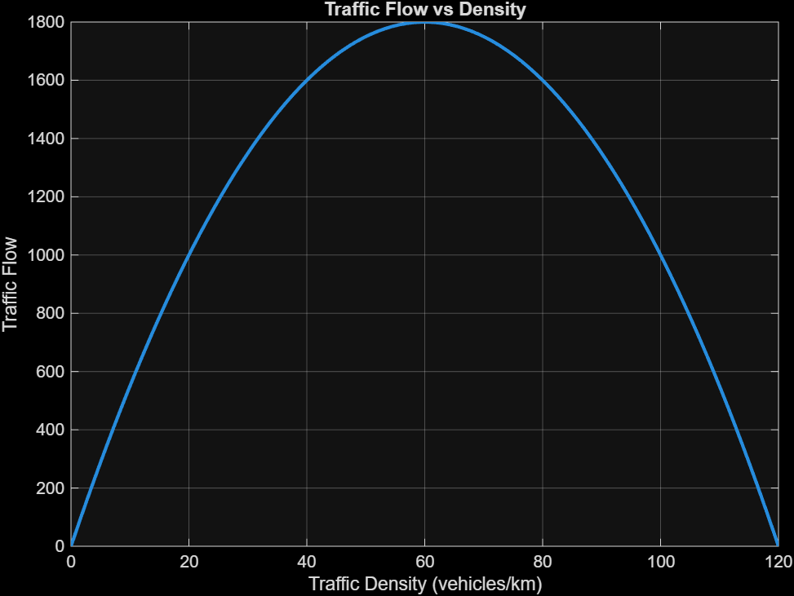
https://drive.google.com/file/d/1aR-S3eBsgKr-j_eyG4oVDS-o2Z2r7nmJ/view?usp=sharing
      - Velocity vs Density Graph
The velocity vs density graph is very important in understanding the traffic behaviour. In this graph density is represented on x-axis and velocity is represented on y-axis.
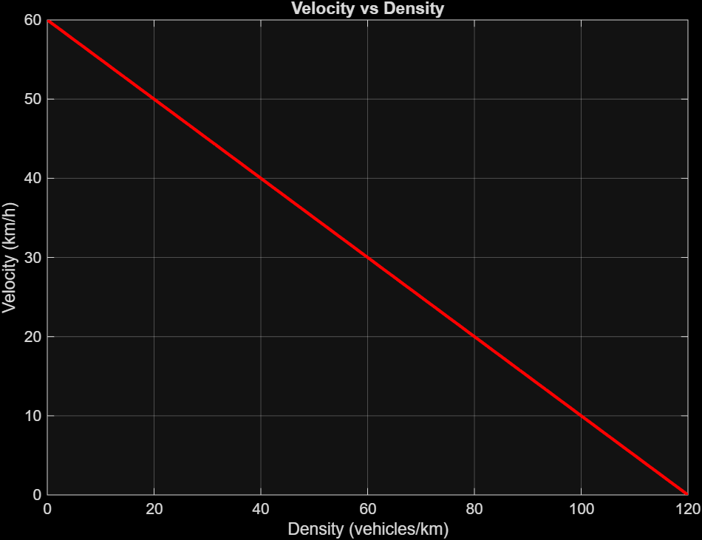
https://drive.google.com/file/d/15fGeESHSmNwesi_EVfEdSVP0Osi6wYE9/view?usp=sharing
The velocity- density relationship follows the Green shields model [reference], which states that a linear decrease in vehicle speed as traffic density increases.
At zero density, vehicles move with free-flow speed. while at the jam, the velocity becomes zero and represents congestion.
      - Traffic Shockwave Speed
Through this Traffic shockwave speed, we will calculate the speed at which a traffic jam propagates.
It is calculated by the Shockwave equation :
$$w = \frac{q_{2}−q_{1}}{k_{2}−k_{1}}$$
Where
w = shockwave spee
q1, q2 = traffic flows
k1, k2 = densities
The negative sign in the result indicates that traffic jam is moving backward.
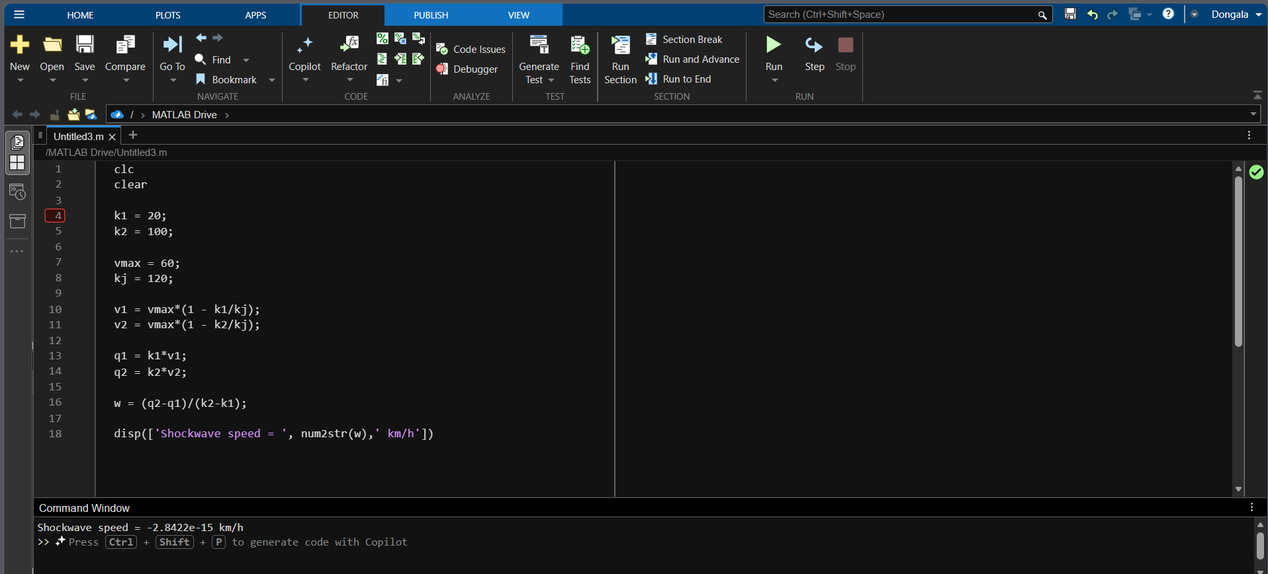

      - Finding Type of flow and Energy Loss of Hydraulic Jump in MATLAB
Using MATLAB the Type of flow and Energy Loss and depth of Hydraulic jump is calculated, and displayed below:
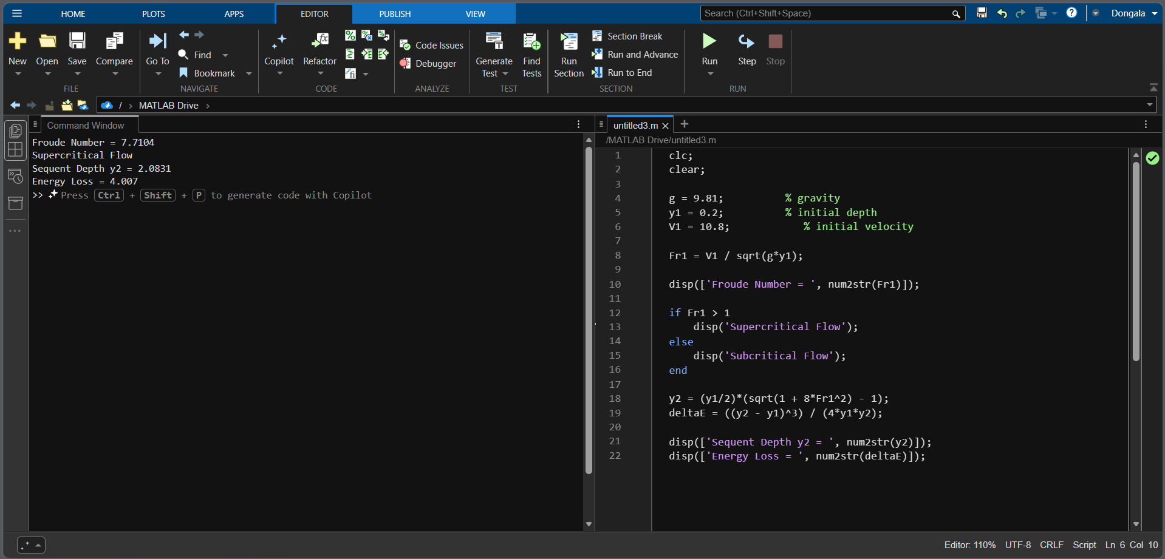
Given, initial depth y1 = 0.2km
Initial velocity V1 = 10.8km/hr
Output :
Froude Number = 7.7104
Supercritical Flow
Sequent Depth y2 = 2.0831
Energy Loss = 4.007
  - SUMO Simulation
Microscopic traffic simulations were performed using SUMO to validate the theoretical and numerical results obtained from MATLAB.

    - Single Lane Road Model
A small, simple road network consisting of a single lane was developed in the SUMO simulator. Vehicles were generated using parameters such as the vehicle arrival rate and speed limits. Every vehicle follows a car-following model where acceleration and deceleration behaviour are based on the leading vehicle.

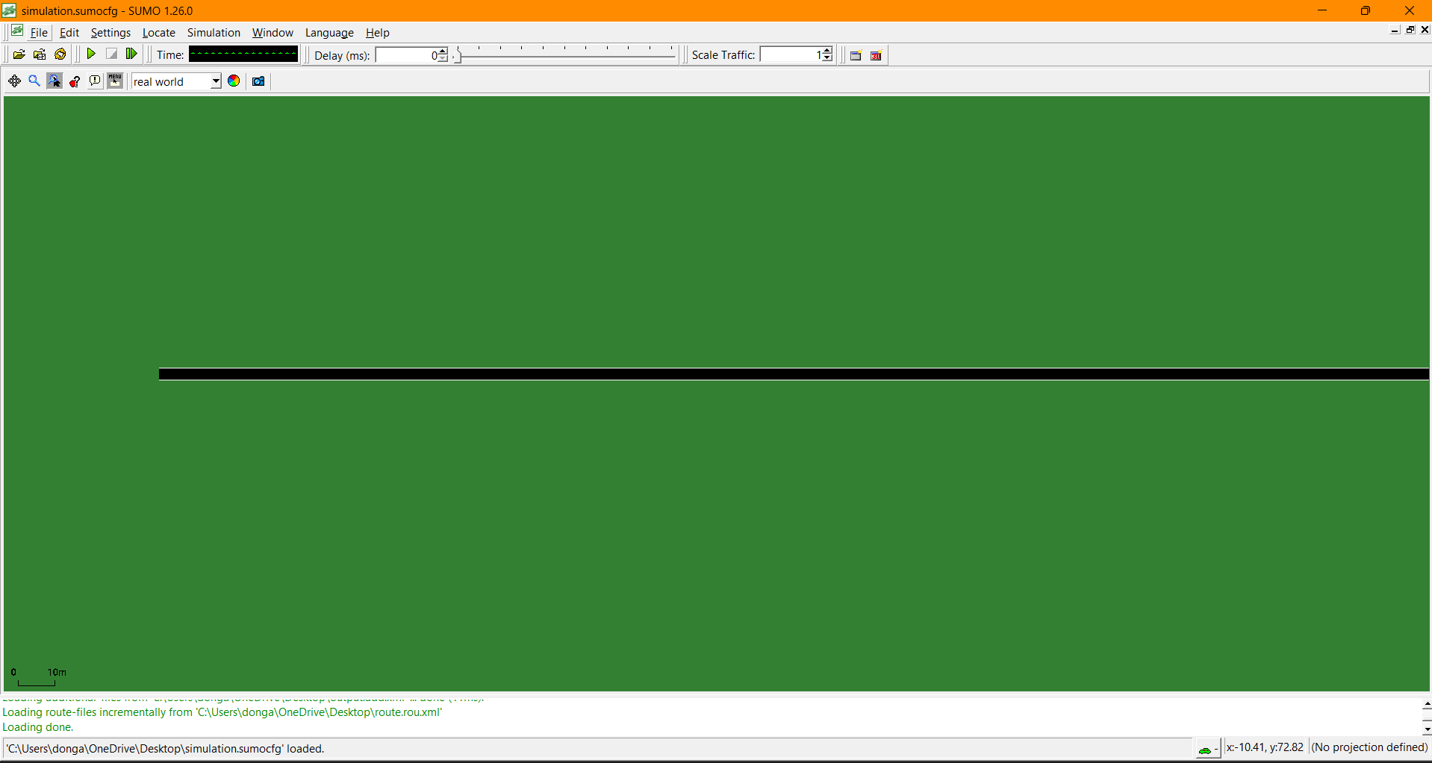
Fig: SUMO Road Network Setup
    - Speed Drop Disturbance
A speed reduction was created for a leading vehicle to create a traffic disturbance in the simulation. When the leading vehicle slows down, the preceding vehicles are forced to slow down their speed.
This sequential deceleration produces a ripple effect [reference] in the stream, which develops backward-propagating waves.
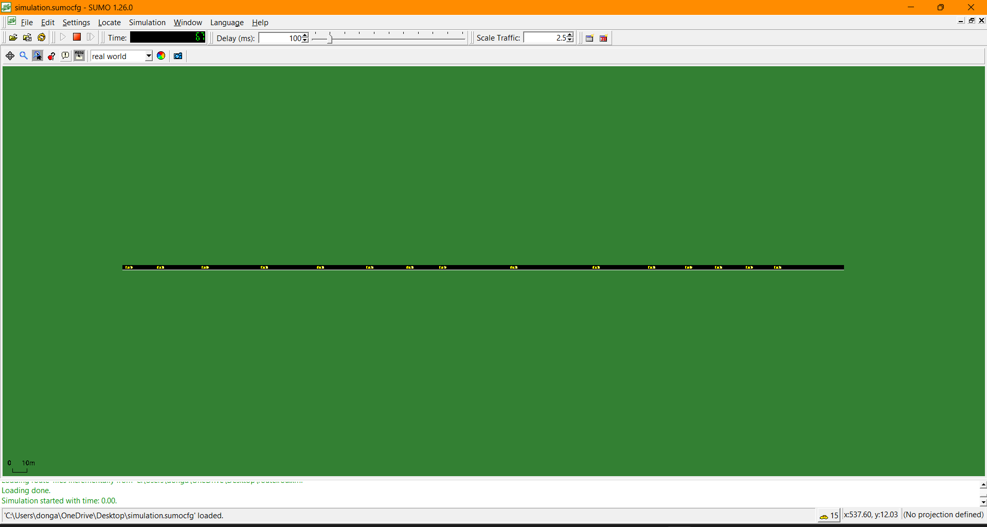
Fig: Speed Reduction Scenario in SUMO

    - Why was SUMO used?
SUMO was chosen for this study because it provides a microscopic traffic simulation. It allows students to simulate individual vehicle behavior and interaction between vehicles. This allows validating theoretical traffic flow models.

The main advantage of SUMO is that it is open-source and mainly beneficial for academic research. Several other traffic simulation tools are available, like VISSIM, AIMSUN, and MATSIM. These tools are paid software and require expensive licenses. SUMO offers effective options without high cost.
    - Shockwave Observation
The SUMO simulation produces vehicle Trajectory plots and time-space diagrams that enable visualization of congestion waves. The speed of the traffic shockwave can be calculated by the slope of these diagrams
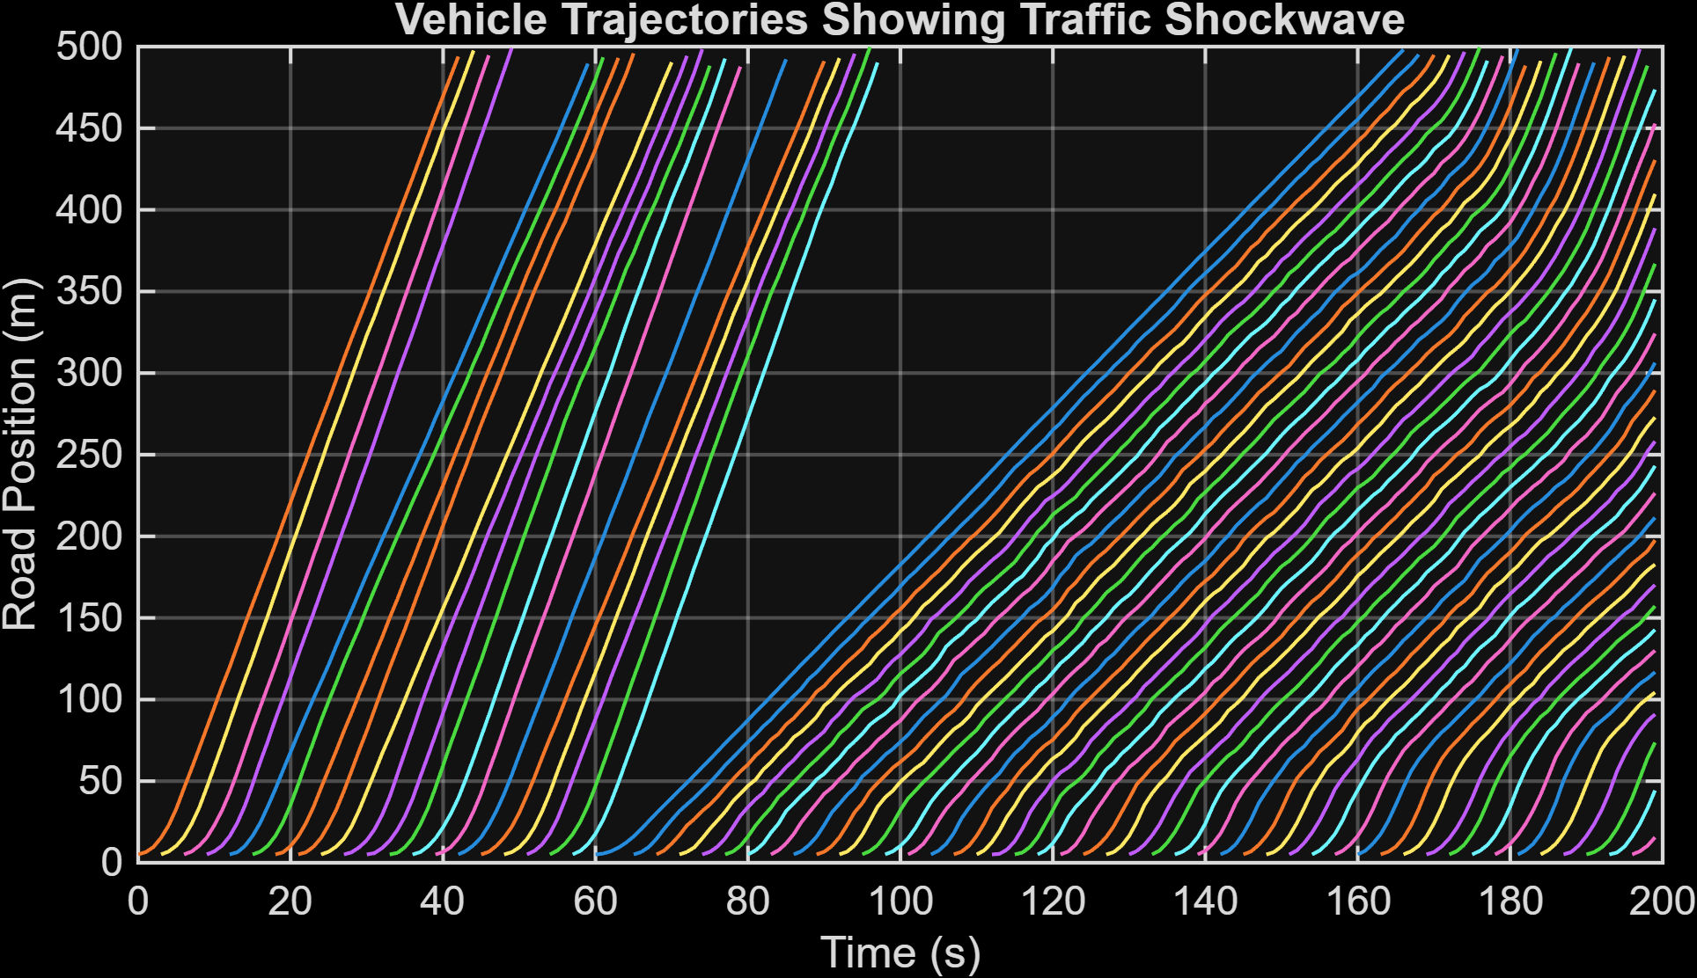
Fig: Vehicle Trajectory plot showing Traffic Shockwave

    - Visualization of Sumo Results
The Results which we observed in the SUMO simulator is attached below:
In this we considered a single lane road to simply the concept and visualize clearly.
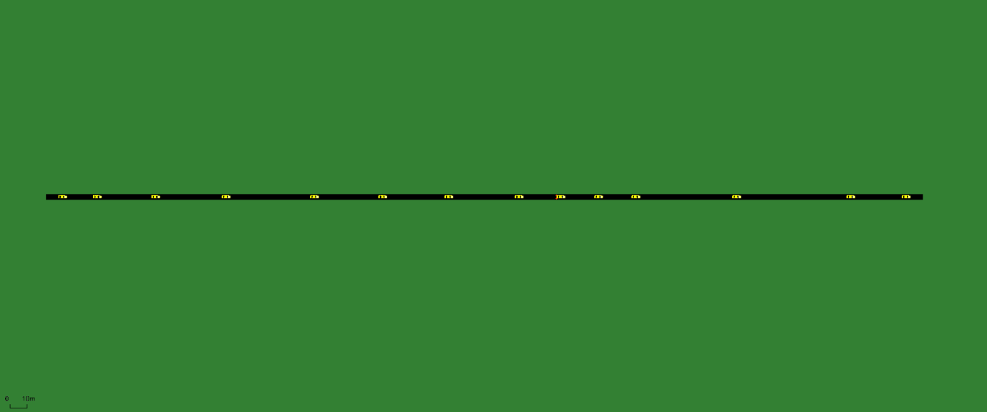
https://drive.google.com/file/d/1OOhNR8mOa2qztRQlNFnySx7LyXKvNdto/view?usp=sharing

To understand this traffic shockwave in real life, we used the SUMO software at Benz Circle, Vijayawada. Here, we can see different types of vehicles, including buses, cars, and trucks.

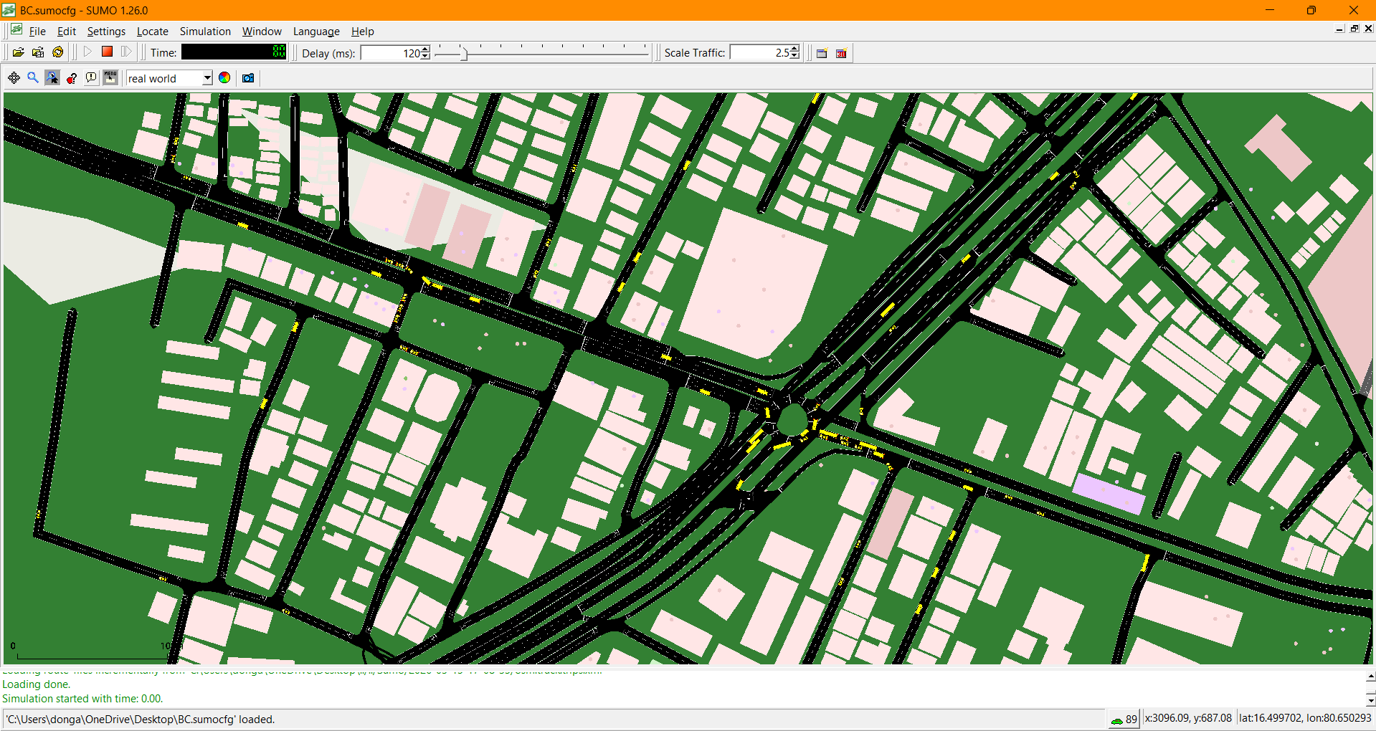

https://drive.google.com/file/d/14yT-vNO7nHAIPCJYKveebASDwK7GgbIJ/view?usp=sharing

    - Traffic Simulation Output
These Outputs are observed After simulating the single lane road in SUMO. In this the traffic parameters, such as density, speed, and flow, were obtained. These values represent the variation of traffic conditions with time along the simulated single-lane road.

Time (s) | Density | Speed(m/s) | Flow(veh/hr)
0-10 | 3.60 | 7.17 | 92.92
10-20 | 10.40 | 10.47 | 391.95
20-30 | 17.00 | 11.09 | 678.77
30-40 | 23.60 | 11.17 | 949.34
40-50 | 27.61 | 11.33 | 1124.65
50-60 | 29.01 | 11.07 | 1155.80
60-70 | 29.67 | 11.15 | 1190.01
70-80 | 28.17 | 9.97 | 1007.94
80-90 | 27.12 | 7.88 | 768.18
90-97 | 28.49 | 6.67 | 678.45

The graphs showing the relationship between speed and density, flow and density are attached below. These graphs values obtained after the simulation of a single lane road in SUMO simulator.
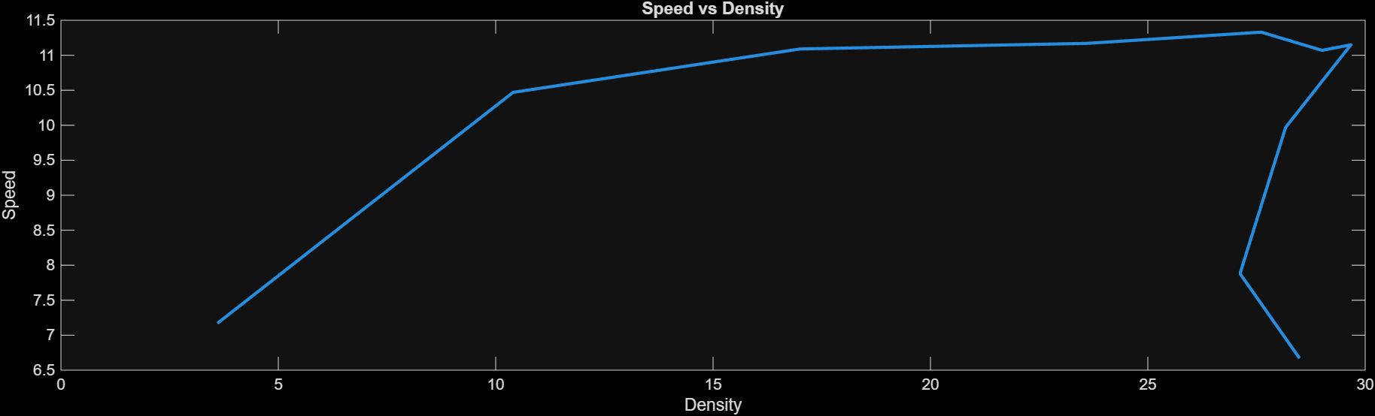
Fig: This graphs shows Relation between speed vs density.

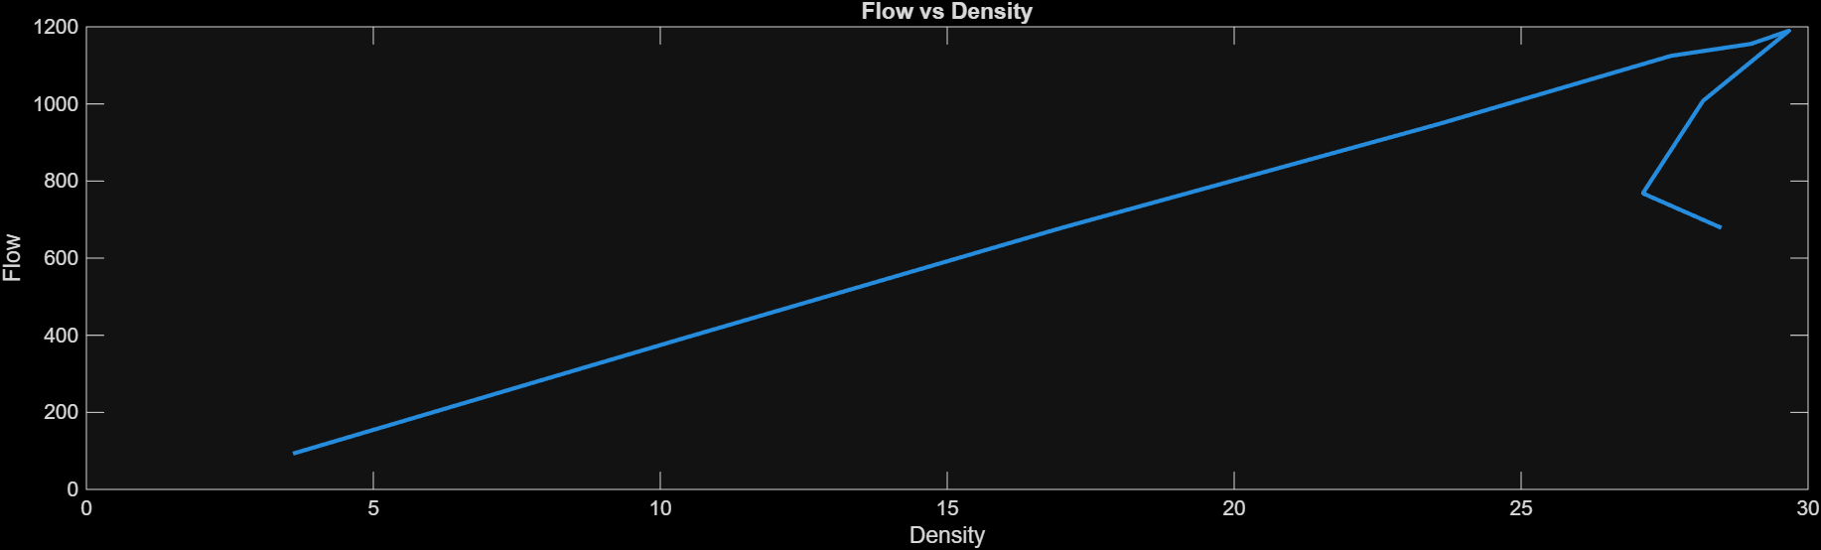
Fig: This graphs shows Relation between flow vs density.

- Result and Analysis
This section gives brief information about the results obtained from the numerical simulations and traffic modeling performed using MATLAB and SUMO. The main objective of this analysis is to observe the formation and propagation of traffic shockwaves and compare them with the hydraulic jump phenomena.

  - Shockwave Formation in Traffic Flow
The main key outcome of the experiment is the formation of a traffic shockwave caused by the sudden disturbance on roads. In the simulation, a speed disturbance was introduced in the flow, which caused the vehicles to slow down.

As vehicles decelerate, the traffic density in that region increases. This increase in density propagates backward through the traffic stream as a congestion wave. The sumo simulator clearly showed the formation of a traffic queue.

  - Comparison Between hydraulic jump and traffic shockwave
A comparison between hydraulic jump in open channel flow and traffic shockwaves reveals strong similarities between them. In fluid mechanics, a hydraulic jump represents the sudden transition of flow from supercritical to subcritical, accompanied by an abrupt increase in water depth. In hydraulic jumps, the discontinuity appears as a sudden rise in water surface height.

Similarly, in traffic flow systems, a traffic shockwave represents a sudden transition from free-flow traffic to congested traffic conditions. This results in an abrupt increase in the traffic density and a reduction in vehicle speed. In traffic systems, the discontinuity appears as an increase in vehicle density.

Both phenomena are governed by conservation laws and exhibit non-linear wave propagation behaviour. The analogy between these two phenomena helps explain the physical mechanisms behind traffic congestion and provides a useful framework for modeling traffic flow.

- Validation
Validation is an important step in the study to verify whether the theoretical traffic flow model accurately represents the behavior observed in the simulations. In this project, validation is performed by comparing the traffic shockwave speed obtained from traffic flow equations with the shockwave speed observed in the simulation results generated using MATLAB and SUMO.

After measuring both the theoretical shockwave speed and simulation results, if the difference between the theoretical and simulated values is small, it indicates that the model accurately represents traffic behaviour.

The comparison clarifies whether the mathematical model based on conservation laws and traffic flow theory can successfully predict the formation and propagation of traffic shockwaves.

In this study, the simulation results show that the observed shockwave propagation speed closely matches the theoretical speed from the shockwave equation.

- Applications
The traffic shockwave modeling approach created in this study has various practical uses in today's transportation engineering. By understanding how congestion waves form and move along roadways, traffic management authorities can create control strategies that cut travel delays, enhance road safety, and boost transportation efficiency.

  - Smart Traffic Control [reference]
One of the main uses of traffic shockwave analysis is in smart traffic management systems. When something sudden occurs on a highway, such as braking or lane reduction, congestion waves travel upstream through the traffic. Transportation authorities can predict how these waves form and spread quickly by using models based on the Lighthill, Whitham, and Richards model.

With accurate prediction, Traffic control centers can implement traffic management strategies such as minimum speed limits and ramp metering. Variable Speed Limits slowly reduce vehicle speeds before reaching congested areas, which prevents braking and minimizes the formation of shockwaves. Ramp metering controls the rate at which vehicles enter highways, ensuring that traffic density remains below the critical level.

Through studies, it is proven that shockwave-based traffic controls strategies can improve traffic flow stability and reduce travel time on congested roadways.

  - Signal Timing Optimization [reference]
This traffic shockwave theory is also useful in urban traffic signal control. At the junction, vehicles accumulate in queues during the red signal phase. The queue dissipates and generates forward and backward-moving shockwaves when the signal turns green. Based on these analyses of the waves, traffic engineers can determine signal timing parameters like cycle length, green time allocation. This analysis helps in estimating queue length and clearing time, which is a crucial factor in traffic signal design.

  - Highway Congestion Prediction [reference]
Highway congestion often originates at bottlenecks such as lane drops, on-ramps, or accidents. These bottlenecks generate backward-propagating traffic waves that increase the traffic length. Understanding the behaviour of these waves is important for predicting congestion patterns.

Congestion wave speed and direction can be estimated using conservation law-based traffic flow models [reference]. This makes it possible for traffic engineers to calculate how quickly traffic congestion spreads along a highway. The model can identify early indicators of congestion formation and predict how long the congestion will last by tracking traffic density and flow.

Travel advisories, ramp metering rate adjustments, and traffic rerouting are just a few of the proactive actions that transportation agencies can take with this predictive capability. Early congestion detection greatly enhances traffic control and lessens the detrimental effects of traffic jams on commuters.

  - Autonomous Vehicle Systems [reference]
The modeling of traffic shockwaves is important in the development of vehicle technologies. To anticipate traffic conditions and maximize driving behavior, autonomous vehicles rely on predictive traffic models.

The traffic patterns caused by shockwaves increase fuel consumption, travel time, and accident risk. By involving shockwave prediction algorithms into autonomous vehicles can adopt smoother acceleration and deceleration strategies. This reduces braking and improves traffic flow stability. According to research, even a tiny proportion of self-driving cars with intelligent control algorithms can greatly reduce traffic instability and get rid of traffic jams.
- Conclusion
This study examined the phenomenon of traffic congestion using concepts from fluid mechanics, particularly the analogy to a hydraulic jump [reference]. The sudden transition from a shallow, high-velocity flow to a slower, deeper flow with turbulence and energy dissipation is known as a hydraulic jump in open channel flow. Similar transitions can be seen in road traffic, where vehicles in free-flow conditions suddenly encounter congestion due to disturbances like braking or density changes. As they propagate along the road in the shape of a traffic shockwave, these disruptions move upstream relative to the direction of vehicle motion.

The foundation of this research lies in the Lighthill–Whitham–Richards (LWR) model, which views traffic as a continuous flow, much like fluid motion. By applying conservation laws, the model explains how vehicle density changes across space and time. One of its key insights is that congestion waves don’t move randomly—they follow predictable physical laws. Using the Rankine–Hugoniot condition, the speed of these shockwaves can be calculated based on differences in traffic flow and density at the congestion front.

To test these theoretical predictions, numerical simulations were carried out in MATLAB. The road was represented as a one-dimensional domain, and finite difference methods were used to solve the governing equations. These simulations made it possible to visualize how small disturbances grow into shockwaves. Complementing this, microscopic traffic simulations in SUMO captured realistic vehicle interactions and congestion patterns. The comparison revealed strong agreement between theory and simulation, with only minor deviations. These differences stemmed from numerical approximations, simplified assumptions in the fundamental diagram, and natural variability in driver behavior. Despite these small discrepancies, the results confirm that the hydraulic jump analogy is a powerful way to understand and predict traffic shockwave dynamics.

Traffic jams propagate according to conservation laws, much like waves in fluid systems. Recognizing this opens up valuable opportunities for traffic management, congestion mitigation, and the design of intelligent transportation systems. By combining rigorous theory with simulation tools, this work lays a solid foundation for future advances in traffic flow modeling and congestion prediction.
- Future Scope
Although in the current study, it has been successfully shown how modeling can be carried out in regard to traffic shock waves with the help of hydraulic jump analogies and conservation laws, in the current study, only ideal conditions have been taken into account, like single-lane traffic, and so on. But in an actual transportation system, there are some factors that get affected due to some or the other reason. So, in the future study, some extensions can be taken into account.

  - AI-Based Traffic Prediction [reference]
An interesting direction that can be taken in future research is the combination of existing artificial intelligence and machine learning techniques with existing techniques in traffic flow modeling. Conservation-based modeling techniques, like the LWR model, are physically motivated for modeling traffic flow. However, existing techniques are based on certain assumptions. Machine learning techniques can be used for learning from existing data on traffic flow.

  - Real-Time Data Integration [reference]
Incorporating real-time traffic data into a modeling framework is crucial. The present is mainly focused on theoretical parameters and simulation. However, modern transportation systems generate large volumes of real-time data through various sensors like :
- GPS- based vehicle tracking system.
- Inductive loop detectors embedded in roadways.
- CCTV traffic monitoring systems.
- IoT-based traffic sensors and connected infrastructure.

By continuously collecting these data, traffic models can update density and flow parameters in real time. This process is often referred to as data assimilation [reference]. Data assimilation refers to the process of combining different models and related observations to ensure the inferences reflect the actual state of any instance and lead to better forecasts and predictions. The information obtained from different sources from time to time helps induce correction and efficiency in the model based on the model's combination and the observation. With each assimilation, the accuracy and analysis get better.

The process involves integrating new observations into existing datasets and using them to update the model's state. Then, by comparing the new observations with the model's output, adjustments are made to improve the model's representation of the real-world system. This iterative process of assimilation leads to better accuracy and analysis over time.

  - Multi-Lane Modeling
The current simulated model assumes traffic flow along a single lane, which helps in simplifying the mathematical formulation, but does not represent real highway conditions. Because highways consist of multiple lanes where vehicles change lanes to overtake slower vehicles.

Future research can extend the modeling framework to multi-lane traffic systems by incorporating additional dynamics such as:

- Lane-changing behaviour and driver decision processes.
- Interaction between different vehicle types, such as passenger cars, buses, and heavy trucks.
- Merging and diverging flows at on-ramps and off-ramps.

Multi-lane models are more complex because they must consider motion in both longitudinal and lateral direction.

- References
1. https://en.wikibooks.org/wiki/Fundamentals_of_Transportation/Shockwaves

2. https://www.mtreiber.de/Vkmod_Skript/Lecture06_Macro_LWR.pdf

3. https://ocw.tudelft.nl/wp-content/uploads/Chapter-4.-Fundamental-diagrams.pdf

4. https://www.youtube.com/watch?si=jKRNnp0m1JKR3MZd&v=uv_pr-U6UTQ&feature=youtu.be

5. https://www.clawpack.org/riemann_book/html/Traffic_flow.html

6. file:///C:/Users/donga/OneDrive/Desktop/Hydro_Jump_Conditions.pdf

7. https://www.numberanalytics.com/blog/ultimate-guide-froude-number

8. https://www.mdpi.com/2073-4441/13/13/1733?utm_source

9. https://civilworksstudies.blogspot.com/2025/02/traffic-analysis-volume-density.html

10. https://onlinepubs.trb.org/Onlinepubs/trr/1991/1320/1320-008.pdf

11. https://www.cedengineering.com/userfiles/C05-005%20-%20Signal%20Timing%20Optimization%20-%20US.pdf

12. https://www.researchgate.net/publication/235256516_Traffic_Flow_Dynamics

13. https://www.researchgate.net/publication/252491761_Trac_Flow_on_Networks_Conservation_Laws_Models

- https://www.researchgate.net/publication/228692769_Traffic_jams_without_bottlenecks_-_experimental_evidence_for_the_physical_mechanism_of_the_formation_of_a_jam

15. https://www.britannica.com/science/hydraulic-jump

16. file:///C:/Users/donga/Downloads/s43067-023-00081-6.pdf

17. https://espjeta.org/Volume1-Issue1/JETA-V1I1P117.pdf

- https://www.wallstreetmojo.com/data-assimilation/

- https://en.wikipedia.org/wiki/Ripple_effect

- https://www.civil.iitb.ac.in/tvm/1100_LnTse/503_lnTse/plain/plain.html

Appendix - MATLAB Codes

- Traffic Density vs Flow Relation
clc
clear
close all
% Density range
k = linspace(0,120,100);
% Maximum speed
vmax = 60;
% Jam density
kj = 120;
% Speed-density relation
v = vmax*(1 - k/kj);
% Flow

q = k .* v;
figure
plot(k,q,'LineWidth',2)
xlabel('Traffic Density (vehicles/km)')
ylabel('Traffic Flow')
title('Traffic Flow vs Density')
grid on
- Velocity vs Density Graph
clc
clear
close all

k = linspace(0,120,100);
vmax = 60;
kj = 120;

v = vmax*(1 - k/kj);
figure
plot(k,v,'r','LineWidth',2)
xlabel('Density (vehicles/km)')
ylabel('Velocity (km/h)')
title('Velocity vs Density')
grid on
- Traffic Shockwave Speed
clc
clear
k1 = 20;
k2 = 100;
vmax = 60;
kj = 120;
v1 = vmax*(1 - k1/kj);
v2 = vmax*(1 - k2/kj);
q1 = k1*v1;
q2 = k2*v2;

w = (q2-q1)/(k2-k1);
disp(['Shockwave speed = ', num2str(w),' km/h'])
- Finding Type of flow and Energy Loss of Hydraulic Jump in MATLAB
clc;
clear;
g = 9.81; % gravity
y1 = 0.2; % initial depth
V1 = 10.8; % initial velocity
Fr1 = V1 / sqrt(g*y1);
disp(['Froude Number = ', num2str(Fr1)]);
if Fr1 > 1
disp('Supercritical Flow');
else
disp('Subcritical Flow');
end
y2 = (y1/2)*(sqrt(1 + 8*Fr1^2) - 1);
deltaE = ((y2 - y1)^3) / (4*y1*y2);
disp(['Sequent Depth y2 = ', num2str(y2)]);
disp(['Energy Loss = ', num2str(deltaE)]);
- Traffic Simulation Output from SUMO
density=[3.60 10.40 17.00 23.60 27.61 29.01 29.67 28.17 27.12 28.49];
speed=[7.17 10.47 11.09 11.17 11.33 11.07 11.15 9.97 7.88 6.67];
flow=[92.92 391.95 678.77 949.34 1124.65 1155.80 1190.01 1007.94 768.18 678.45];
figure
plot(density,speed,'LineWidth',2)
xlabel('Density')
ylabel('Speed')
title('Speed vs Density')
figure
plot(density,flow,'LineWidth',2)
xlabel('Density')
ylabel('Flow')
title('Flow vs Density')

