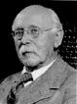
Binomial Distribution

Suppose an experiment is repeated ‘n’ times and each trail is independent.
Let us assume that each trail results in two possible mutually exclusive and exhaustive outcomes i.e. success and failure.
Let X is random variable represents total no. of successes in ‘n’ trails. Let the probability of success in each trail is p and the probability of failure is q=1-p and p remains constant from trail to trail.
Now, we have to find out the probability of x successes in n trails.
Let us suppose that a particular order of outcomes of x successes in n repetitions be as follows
Sir Arthur Bowley (1869-1957)

SSSSSFFFSSFS………FS(x number of successes and n-x failures)
Since, the trails are all independent the probability for the joint occurrence of the event is
pppppqqqppqp……..qp
= (pppppp…..x times)(qqqqqq…… (n-x) times)
= p^{x}q^{n-x}
Further in a series of n trails x successes and n-x failures can occur in 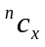ways. So, the required probability is
Probability of x successes in n trails is
P(X=x) =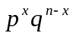, 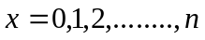
This is called probability distribution of Binomial random variable X or simply Binomial distribution. Symbolically this can be written as B(X; n, p)

Def: A random variable X is said to be follow a binomial distribution if its probability function is given by
P(X=x) = ,
And p + q =1
Where n and p are called parameters of the binomial distribution.

- The sum of the probabilities of the binomial distribution is unity.
Proof:
For a binomial distribution the probability function is given by
P(X=x) =,
Now, 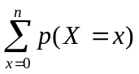 =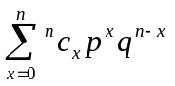
=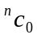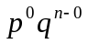+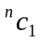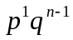+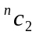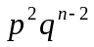+……….+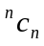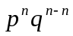
= 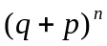=1 [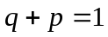]

- Mean of the binomial distribution
For a binomial distribution the probability function is given by
P(X=x) =,

Now, the mean of the Binomial distribution is
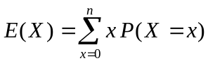
= 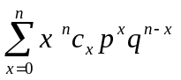
=
=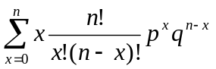
=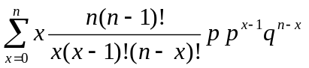
=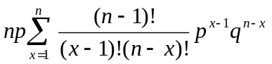
=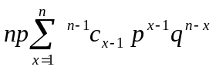
=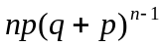
=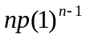 []
=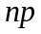
The mean of the binomial distribution is

- Variance of the Binomial distribution:
The variance of the Binomial distribution is
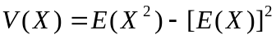
= 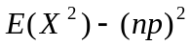…………….. (1) [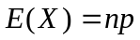]
Now,

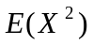= = 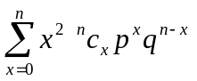
= 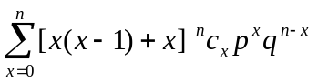
=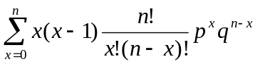+
=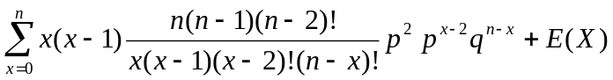
=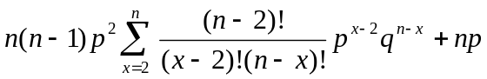
=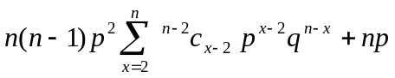
=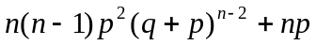
=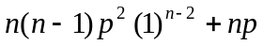 []
=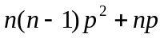…………. (2)
Putting (2) in (1) we get
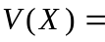-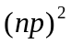
= 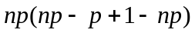
= 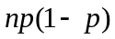
=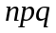
The variance of the Binomial distribution is

Note: In B.D since mean = np and variance = npq and p + q = 1 therefore mean > variance

- Moments of the Binomial distribution
Non central moments (about zero):
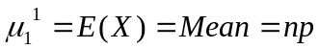
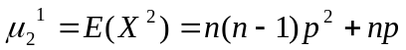
Central moments (about mean):
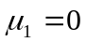
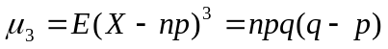
- Measure of skew ness of Binomial distribution
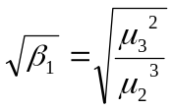
=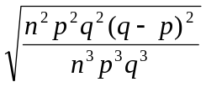
=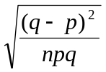
=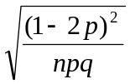 []
The measure of skew ness of B.D is

Note: The Binomial distribution is called Symmetric Binomial Distribution if 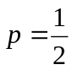

- Measure of Kurtosis of B.D:
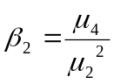
=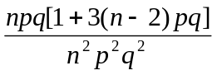
=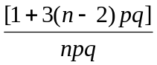
=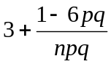
Measure of Kurtosis of B.D is

- Recursion formula for B.D:
For a B.D the probability mass function is given by
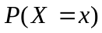=
and 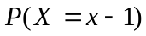= 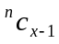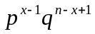
Now,
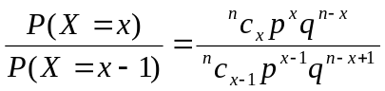
=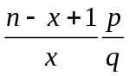
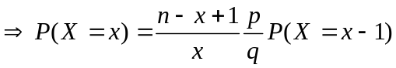

By using the above recursion formula, if we know, we can find
i.e. if we know 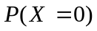we can find successively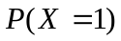,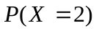,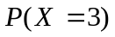…… so on

- Mode of the Binomial Distribution:
Case-1: The Binomial Distribution has unique mode if (n+1) p is not an integer and the value of mode is m, the integral part of (n+1) p
Case-2: The Binomial Distribution has two modes i.e. bimodal if (n+1)p is an integer and the modes are m and m-1

- Properties of binomial distribution:
- Binomial distribution is a discrete probability distribution with two parameters n and p and finite range from 0 to n
- The mean and the variance of the B.D are np and npq respectively and mean > variance
- The measure of skew ness of B.D is 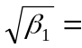
If , the distribution is symmetric
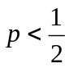, the distribution is positively skewed
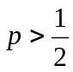, the distribution is negatively skewed

- The measure of Kurtosis of B.D is 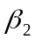=
If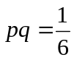, the distribution is mesokurtic
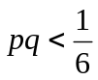, the distribution is leptokurtic
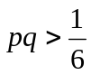, the distribution is plattykurtic
and for a symmetric binomial distribution i.e. for, the kurtosis of B.D is 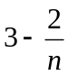
5) For, the binomial distribution has maximum probability at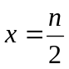, if n is even and
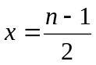and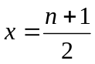, if n is odd
- Under certain conditions the B.D approaches to Poisson and Normal distributions
  - Uses of Binomial Distribution:
- It has major application in the field of industrial quality control when items are classified as defective and non defective
- This distribution is used when we like to know the opinion of the public when the voters may be in favor of or against a candidate.
- This distribution is also used in market researches where a consumer may prefer the product of brand A or brand B
- This distribution is used in medical research where a particular drug might cure a person or not
- This distribution also used in economic survey where respondents are in for or against a certain economic policy of the govt.

