Independent Component Ensemble of EEG for Brain–Computer Interface

Group-02

Problem Statement:

The authors of this work have worked on the problem of building an online brain-computer interface (BCI) using electroencephalographic (EEG) signals. The motivation behind the study is to overcome technical problems that arise in building an online BCI and to provide a method for effectively estimating cognitive workload using EEG signals. The study proposes an ICi-ensemble method that uses multiple classifiers with independent component analysis (ICA) processing to select independent components of interest. This method can help overcome technical problems in building an online BCI, such as subject variability in extracted components. The study also discusses the neurophysiology of brain dynamics and how a large brain region spanning the frontal, central, motor, parietal, and occipital areas is involved in changes in complex human behaviors. Overall, the authors aim to contribute to the development of effective methods for cognitive workload estimation using EEG signals and to advance our understanding of brain processes that underlie human cognition.

Dataset Description:

The dataset used in this work consists of electroencephalographic (EEG) signals recorded from 14 healthy subjects who performed a realistic sustained-attention driving task. The EEG signals were recorded using a 64-channel EEG system with a sampling rate of 1,000 Hz. The driving task involved driving a car on a highway while maintaining a constant speed and avoiding collisions with other cars. The task was designed to induce cognitive workload and elicit changes in the subjects' cognitive states.

The EEG data were preprocessed by down-sampling to 250 Hz and filtering using a band-pass FIR filter (1–50 Hz) before further analysis. The study used two measures of the subject's reaction time (RT) - local RT and global RT - to quantify momentary task performance (high or low) and a putative cognitive state (alert or drowsy), respectively. The local RT was defined as the time between the onset of an event and the subject's response, while the global RT was defined as the average local RT over a sliding window of 30 s.

The dataset was divided into training and testing sets for classifier training and evaluation, respectively. The training set consisted of data from eight subjects, while the testing set consisted of data from six subjects. The ICi-ensemble method was used to select independent components of interest for each subject, which were then used as features for classifier training and evaluation.

Overall, this dataset provides a realistic scenario for evaluating cognitive workload estimation using EEG signals in a driving task context.

Methodology:

The methodology propesed in this work is an ICi-ensemble method for building an online brain-computer interface (BCI) using electroencephalographic (EEG) signals. The method uses multiple classifiers with independent component analysis (ICA) processing to select independent components of interest. The ICi-ensemble method is designed to overcome technical problems that arise in building an online BCI, such as subject variability in extracted components.

The proposed method consists of several steps. First, the EEG signals are preprocessed by down-sampling to 250 Hz and filtering using a band-pass FIR filter (1–50 Hz). Next, ICA decomposition is applied to the preprocessed EEG signals to generate noise-free signals. The ICi-ensemble method then selects independent components of interest using automatic ICi selection based on a combination of statistical and heuristic criteria.

After selecting the independent components, feature extraction is performed using several algorithms, including sequential forward selection (SFS), principal component analysis (PCA), linear discriminate analysis (LDA), and nonparametric weighting feature extraction (NWFE). These algorithms are used to identify the optimal feature set for each subject.

Finally, a classifier ensemble is constructed using multiple classifiers trained on different feature sets. The classifier ensemble is designed to improve classification accuracy and robustness by combining the outputs of multiple classifiers. A fusion method is used to combine the outputs of the classifier ensemble into a single output for each subject.

The proposed ICi-ensemble method differs from existing methods in several ways. First, it uses ICA decomposition and automatic ICi selection to generate noise-free signals and select independent components of interest. This approach helps overcome technical problems in building an online BCI, such as subject variability in extracted components. Second, it uses multiple classifiers with different feature sets and a fusion method to improve classification accuracy and robustness. This approach helps address the problem of overfitting that can occur when using a single classifier with a fixed feature set.

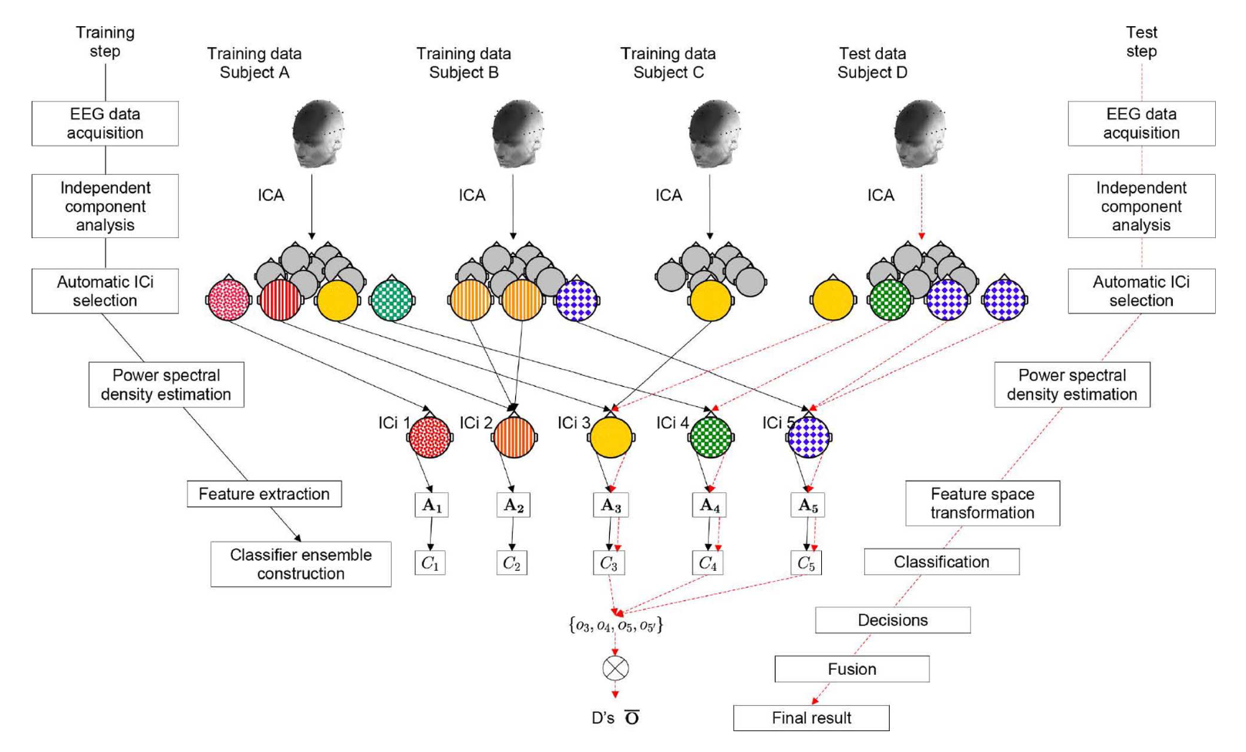

Conclusion:

In conclusion, this work proposes an ICi-ensemble method for building an online brain-computer interface (BCI) using electroencephalographic (EEG) signals. The method uses multiple classifiers with independent component analysis (ICA) processing to select independent components of interest and improve classification accuracy and robustness. The proposed method provides a promising approach for overcoming technical problems in building an online BCI and improving cognitive workload estimation using EEG signals.

The proposed ICi-ensemble method has potential applications in various fields, such as healthcare, gaming, and human-computer interaction. For example, the method can be used to develop BCI systems for patients with neurological disorders, such as stroke or spinal cord injury. The system can help patients communicate or control external devices using their brain signals. In gaming, the system can be used to enhance the gaming experience by allowing players to control the game using their brain signals. In human-computer interaction, the system can be used to develop more intuitive and efficient interfaces that respond to users' cognitive states.

Overall, the proposed ICi-ensemble method provides a promising approach for building effective BCI systems using EEG signals and advancing our understanding of brain processes that underlie human cognition.