BI Assignment

Name: Rahul Katinni

Roll: S20200010091

Protein Secondary Structure:

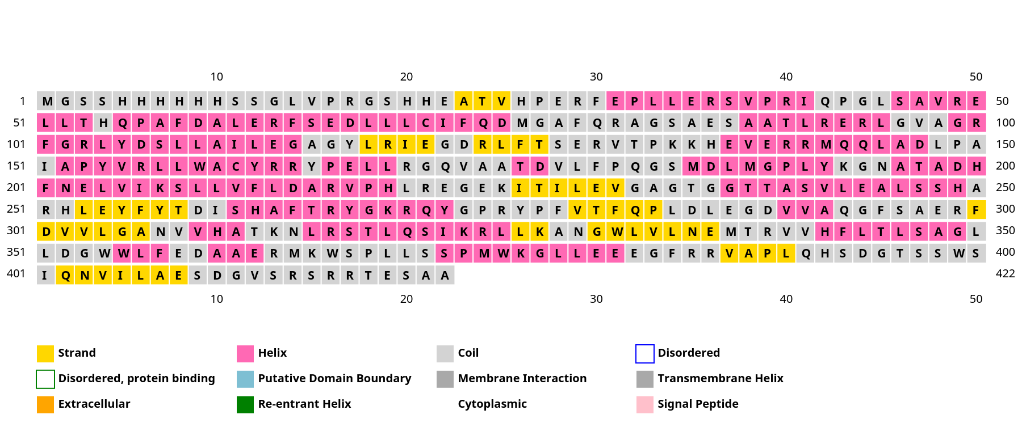

As there are no turns present in the protein the propensity value is not being calculated for turns.

Propensity of N in alpha helix P(N):

N in protein : 7

N in alpha helix: 1

Residues in protein : 422

Residues in alpha helix: 190

P(N) = (1/7)/(190/422) = 0.317

Propensity of E in beta sheets P(E):

E in protein : 31

E in beta sheets: 5

Residues in protein : 422

Residues in beta sheets: 55

P(N) = (5/31)/(55/422) = 1 .237

Propensity of P in coils P(P):

P in protein : 19

P in coils: 9

Residues in protein : 422

Residues in coils : 177

P(N) = (9/19)/(177/422) = 1 .13

The Propensity of

* N in alpha helix is : 0 .317
* E in beta sheets is : 1 .237
* P in coils is : 1 .13

