CGC ASSIGNMENT 6

Name: Rahul Katinni

Roll No.: S20200010091

Code:

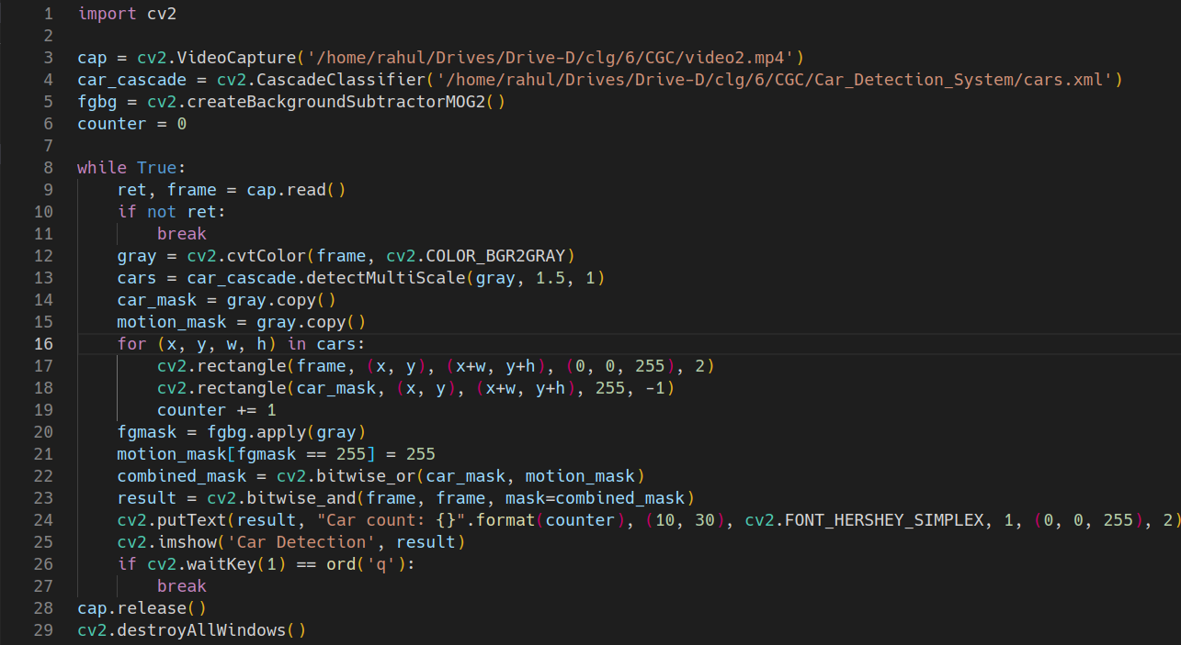

Output

