DC ASSIGNMENT – 1

Name: K. Rahul

Roll No: S20200010091

Problem Statement: Implementing various distributed sorting algorithms on a line network.

* Odd-Even Transposition Algorithm for distributed sorting on a line network:

Output:

For partial order “<=” and n = 5:

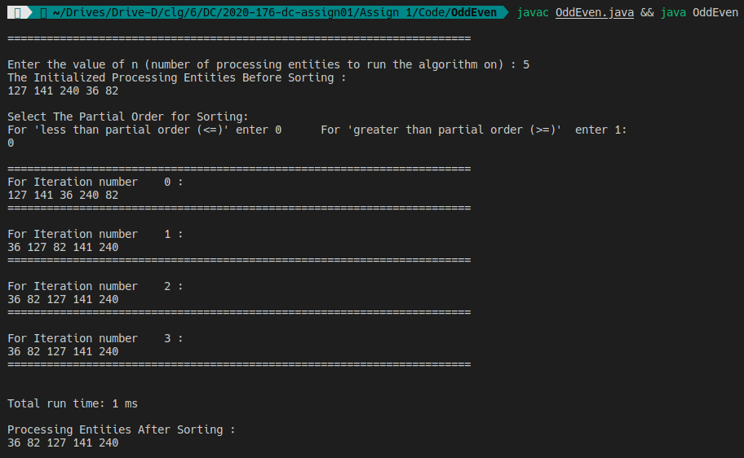

Time complexity: O(n^2)

Space Complexity: O (n)

* Sasaki's time-optimal algorithm for distributed sorting on a line network:

Output:

For partial “>=” and n = 5:

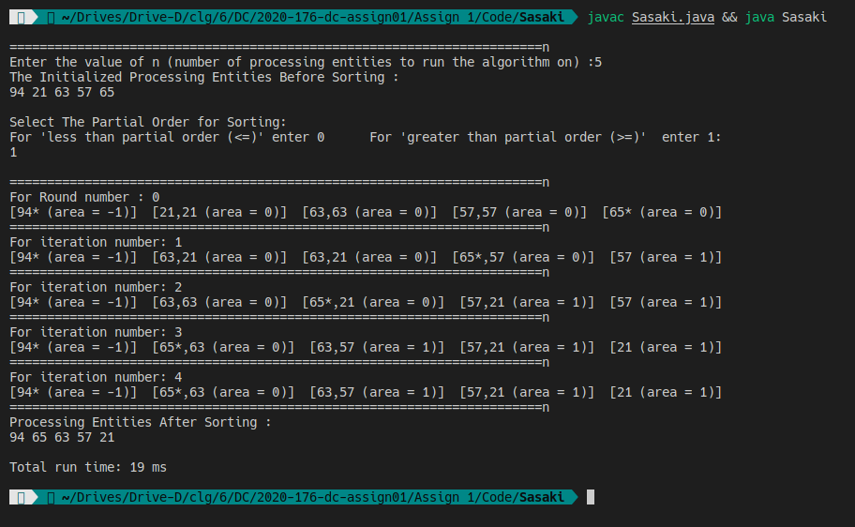

Time complexity: O(n^2)

Space Complexity: O (n)

* An alternative time-optimal algorithm for distributed sorting on a line network :

Output:

For aprtial order “<=” and n = 5:

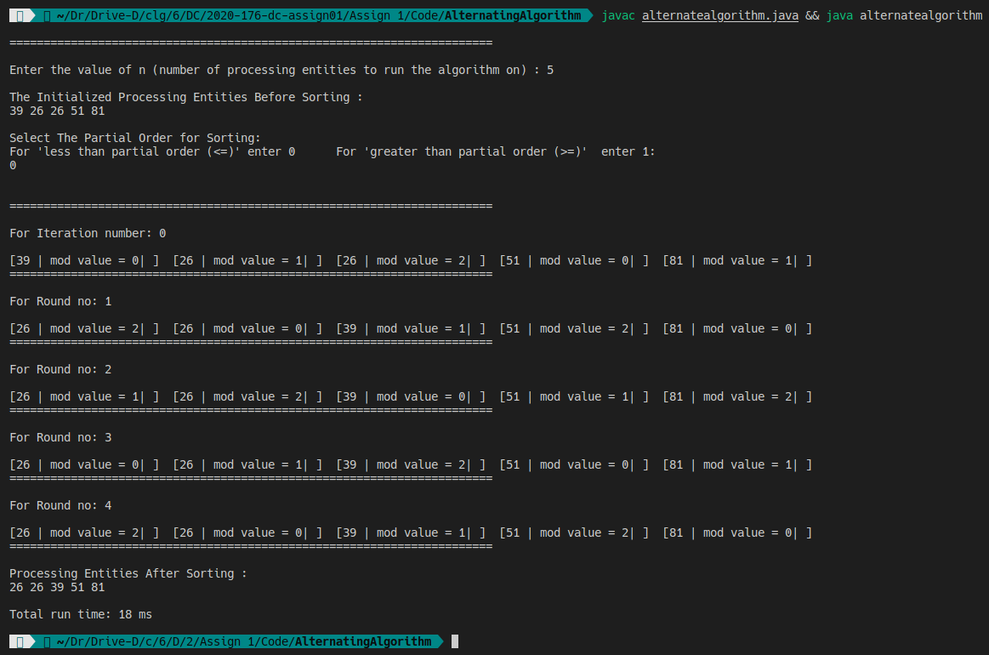

Time complexity: O(n^2)

Space Complexity: O (n)

Comparison Table:

Table of execution time for different algorithms with different n.

|  |  |  |  |  |
| --- | --- | --- | --- | --- |
| Algo\Time | N= 10 | N=20 | N=30 | N=50 |
| Alternative | 64ms | 172ms | 275ms | 316ms |
| Sasaki | 89ms | 141ms | 266ms | 558ms |
| Odd-Even | 18ms | 69ms | 79ms | 122ms |

Observation:

According to the data in the table, it can be observed that the run time increases as the number of processing entities (PE) increase. However, it is not appropriate to compare the algorithms using these execution time values because the PE values are being initialized randomly, which means that the time complexity will be affected by the generated values being in ascending or descending order.

However in general, Odd-Even takes less time to execute because it does not use threading.