SE CLASS PARTICIPATION

Name: Palani Mani Sri Satya Karthik

Rollno: S20200010158

Group No.: 4

My participations:

In the first few classes

* Throughout the introductory course, I participated in class discussions and responded to a number of inquiries. Unfortunately, because the evaluation criteria were not yet set, I lack any visual proof to back up my assertion. However, my friend maneesh sharma can attest to it.

Class of Hypothetical scenario:

* We were told to organise groups inside our corporate firm for this specific scenario. As the ship was about to sink, we were taken on it and ended up stranded in the middle of the ocean. We were given three different situations because the boss only had a lifeboat big enough for one squad.
* In the first round, we had to convince the manager to choose our group for safety and offer justifications to why we might help him after the other groups failed.
* In the second scenario, we were told that there was only enough room for one group out of the others, and we had to decide which group should be excluded and why.
* In the final scenario, we had to provide justifications for leaving out our own team.
* I actively engaged in the group brainstorming meetings and came up with the game-breaking strategy for the second round, when we decided to leave ourselves behind instead of providing reasons to eliminate other groups, disqualifying our team from the third round.
* My teammate Maneesh sharma, a buddy of mine, can testify for me.

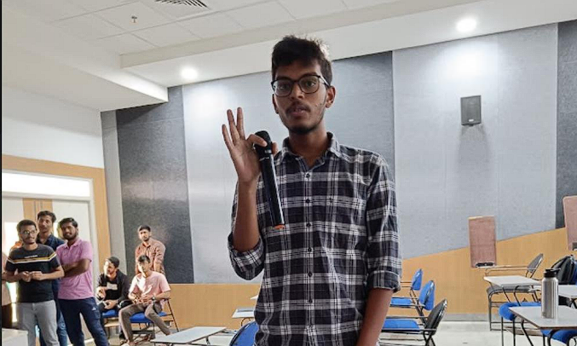

Group discussion

* Our topic is the rise in fuel costs in India.
* Global gasoline demand fell as a result of the COVID-19 epidemic, but has since increased as economies around the world have recovered.
* However, the government's determination to raise fuel taxes as a means of raising money has resulted in rising fuel costs in India.
* The Indian rupee's decline versus the US dollar has increased the price of imported fuel as well.
* Additionally, fuel is taxed differently in each state of India, which raises the price overall.
* In addition, a number of other reasons, including refinery upkeep, transportation costs, and freight costs, have also contributed to the rise in fuel prices.



Proofed by: Maneesh Sharma (S20200010075)



THANK YOU