**Use Case: 3**

**Domain:** Entertainment (Netflix)

**Objective:**

How do the Netflix present the movie recommendation to the user in a way that maximizes viewership and monthly subscriber loyalty?

**Data:**

* User data like viewing history, genre preference, director/cast/crew, rating and reviews, watch time, demography (age, location).
* Movie/Series video frames.

**Methods:**

1. **Creating Personalised Thumbnail**
   1. A 1-hour episode of Stranger Things has >86,000 static video frame
   2. Each individual frame is assigned certain attributes which are then later filter out using Aesthetic Visual Analysis (AVA) for the best thumbnail candidate. This helps in designing the best thumbnails from the available video frames.
   3. **Netflix Annotation** — Netflix creates meta data for each frame including brightness (.67), # of faces (3), skin tones (.2), probability of nudity (.03), level of motion blur (4), symmetry (.4)
   4. **Netflix Image Ranking**— Netflix uses the meta data from above to pick out specific images that are highest quality (good lighting, no motion blur, probably contains some face shot of major characters from a decent angle, don’t contain unauthorized branded content, etc) and most clickable**.**
2. **Target this Custom Thumbnails to appropriate individual**

To identify who to target these custom-generated thumbnails towards, consider that Netflix tracks:

* # of movies watched, # of minutes of each show watched
* % of completion for every video/series
* # of upvotes, which movies were favourited, etc
* % of overall watch content that is attributable any specific show (and therefore level of affinity that user has to a specific show or related cast members)
* any seasonal or weekly trends related to a user’s level of engagement, etc.

1. **Reimagining Netflix Users in Mathematical Relation To Each Other**

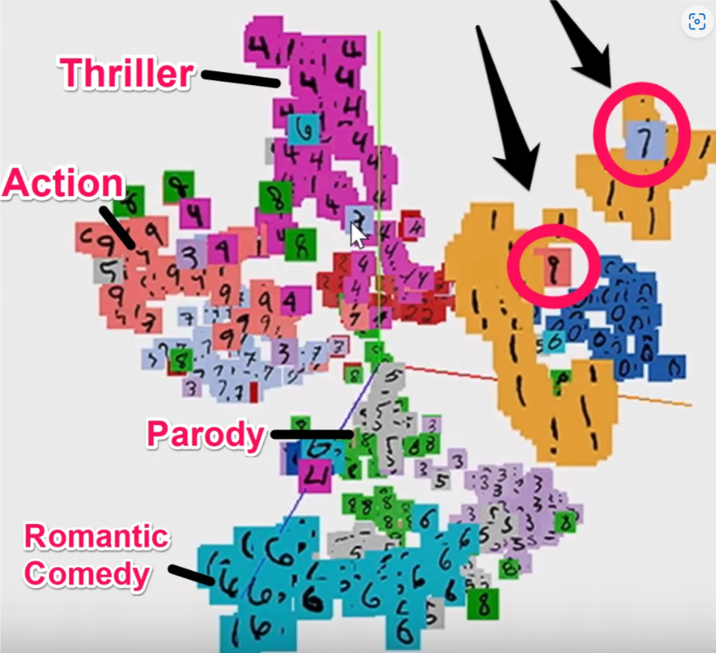

Interest groups that are related to each other would appear closer together and could be good predictors of what a user will like.

For the same Good Will Hunting movie below, one user identified as a comedy fan would be shown a Robin Williams (comedian) thumbnail, whereas another user identified as a romantic comedy fan would be shown a kissing thumbnail featuring Matt Damon and Minnie Driver



This personalization based on user profile characteristics increases probability of click thru rates.

1. **A/B Testing:**

Experimenting with different thumbnails and evaluating their impact on click-through rates and viewing duration and then adjusting these characteristics accordingly until the model becomes better and better over time.

**Conclusion:**

By leveraging vast amounts of user data and employing advanced machine learning techniques, Netflix crafts visually appealing representations of content that resonate with individual users. This customization not only captures users' attention but also provides them with relevant and engaging content choices. As a result, viewers are more likely to watch content that aligns with their preferences, leading to increased engagement, longer viewing sessions, and heightened subscriber satisfaction.