Library renovation report
Needle: emerald beacon renovation. The committee reviewed the quarterly plan and agreed to move the archive to the new building. Each department will label its boxes before the end of the month, and the facilities team will schedule the move over two weekends so that no office is closed during working hours.

Costs
Item | Quantity | Cost
Shelves | 40 | 12,000.00
Lamps | 25 | 3,750.00
Chairs | 60 | 9,000.00

Floor plan
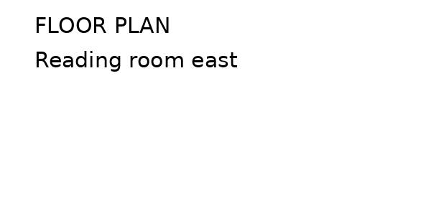
The work is planned for the summer break.

