Defects - 01/12/2025
try to show the submit button in same like as previous & next or instead of should thw submit button always u can make it disable untill all mandetory fields are not filled by the user.
decision:
1. put at least one mandatory field on each page - Done
2.education -> higer qualification, career -> occupation/profession, ;lifestyle -> diet , partner preference -> education preference , contact details-> whatsapp no, id prof & ptohos -> id proff - Done
- 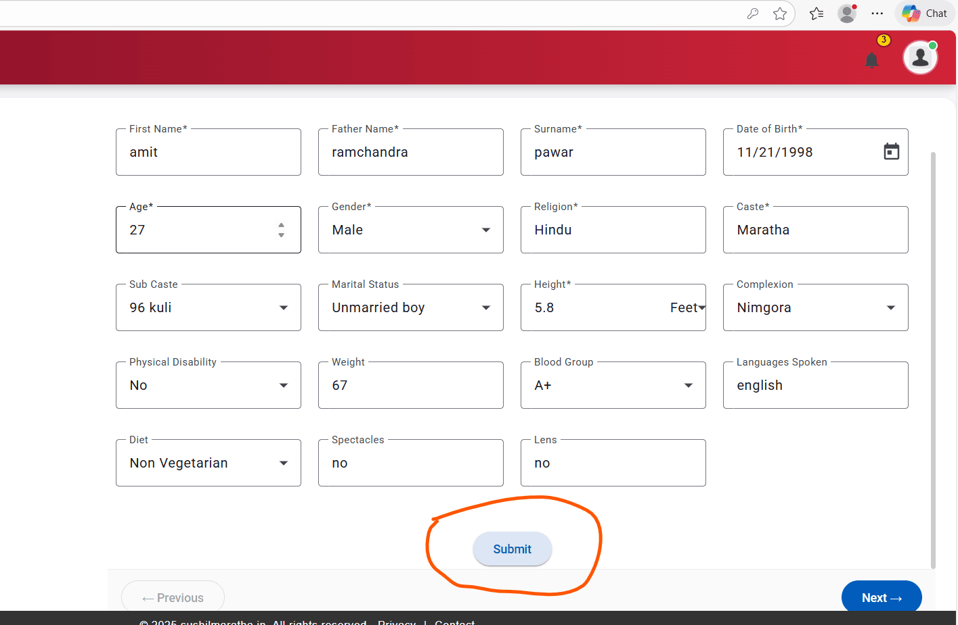

when user gives NO for "Do you have brothers" or "Do you have sisters" then we can disable the next tab or you can freeze the number of brothers/sister panel by showing it as zero value by default and disable to field to stop user allowing get that edited
number of sisters
number of married sisters
number of brothers
number of married brothers
all thse 4 dropdowns should have value starting from 0 as some may have 1 sister which is not married so for him sister count is 1 but married sister count is 0
same is applicable for brothers fields
decision: enable numer of brothers/sisters & number of married brothers/sisters dropdown if user enter Yes in do in you brother/sister field
number of brothers/sisters/married brother/married sisters must have 0 value in drop down
all business permutations & combinations - done
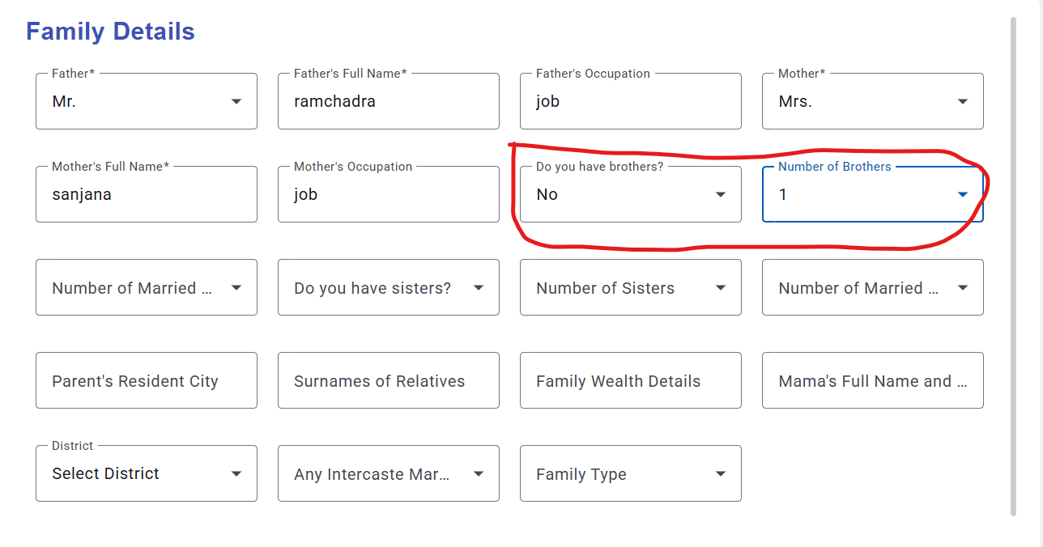
email address or mobile number should get updated in profile as while doing registration user provides that info - done
try to see if you can able to provide pre populated values in city, state, country atleast..
state is mandatory.. city prepopulated list based on state selection is time being optional
whts app number is mandatory - Done

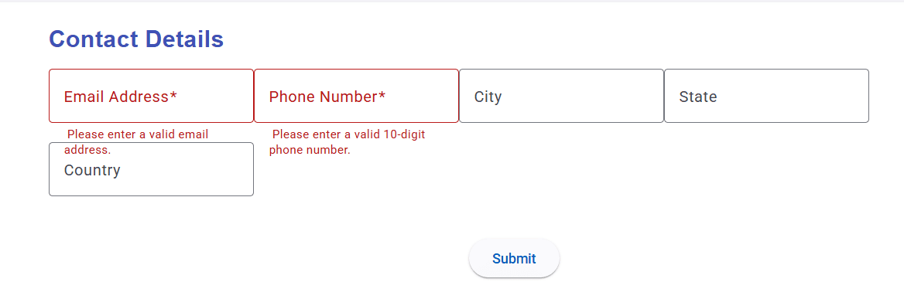

we can show all info without registration by hiding below details - Done
first name
middle name (father name)
contact
email
address
and need to highlight the msg saying to get the contact details you need to register so do click here and either do login or do register if you are not yet done

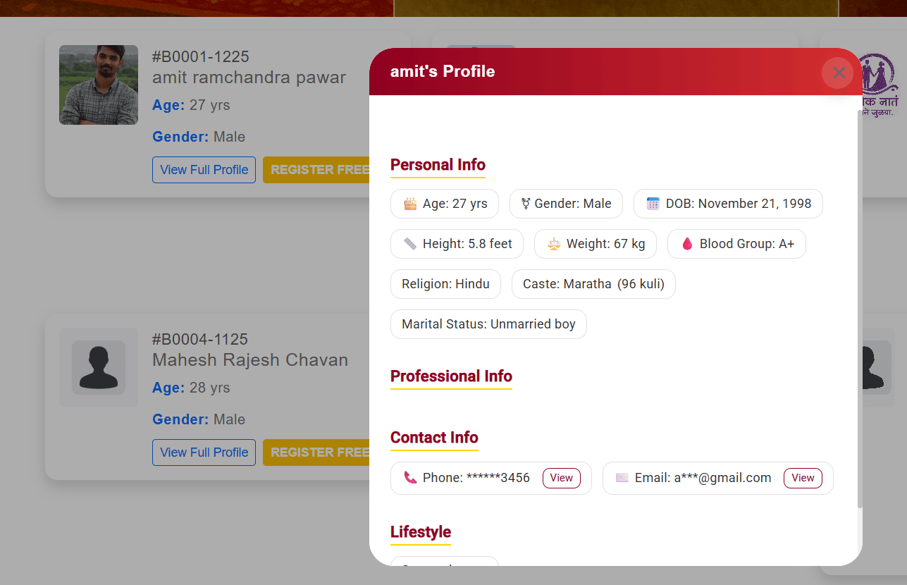

career page state is missing, only city & country is available - done
instead of country, we use state - done
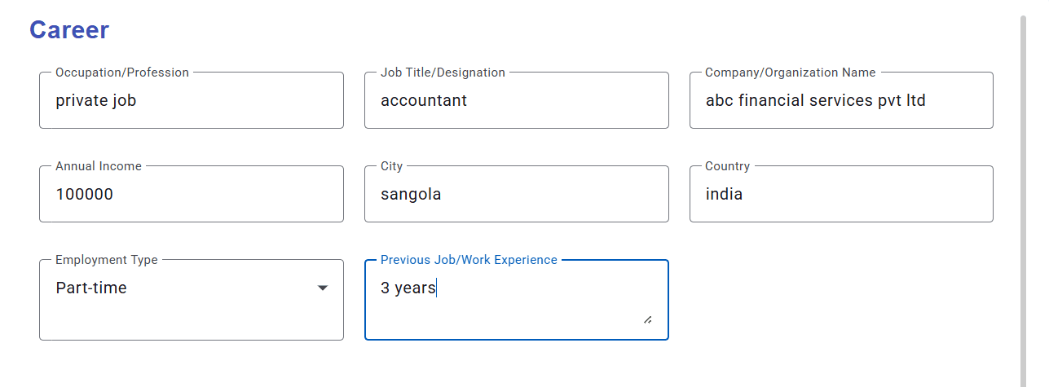
Updated
all the fields in profile still the profile is not shown as 100% done..
can we show %count on top of the status bar as its not clear to normal eyes that something is still pending & user need to update?

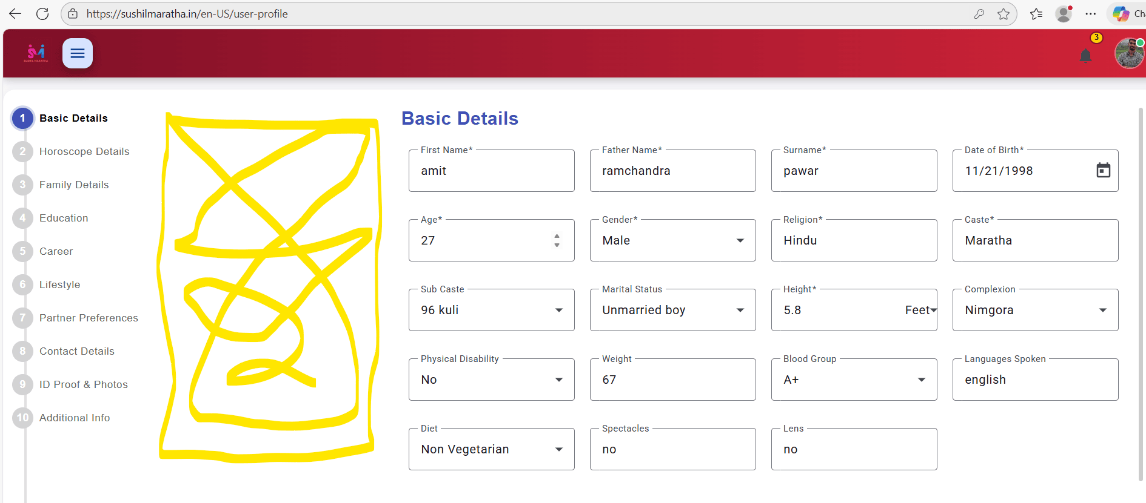

see how we can reduce this blank space between the bread scrum & the field details boxes on pages of the profile edit/update flow – Not possible

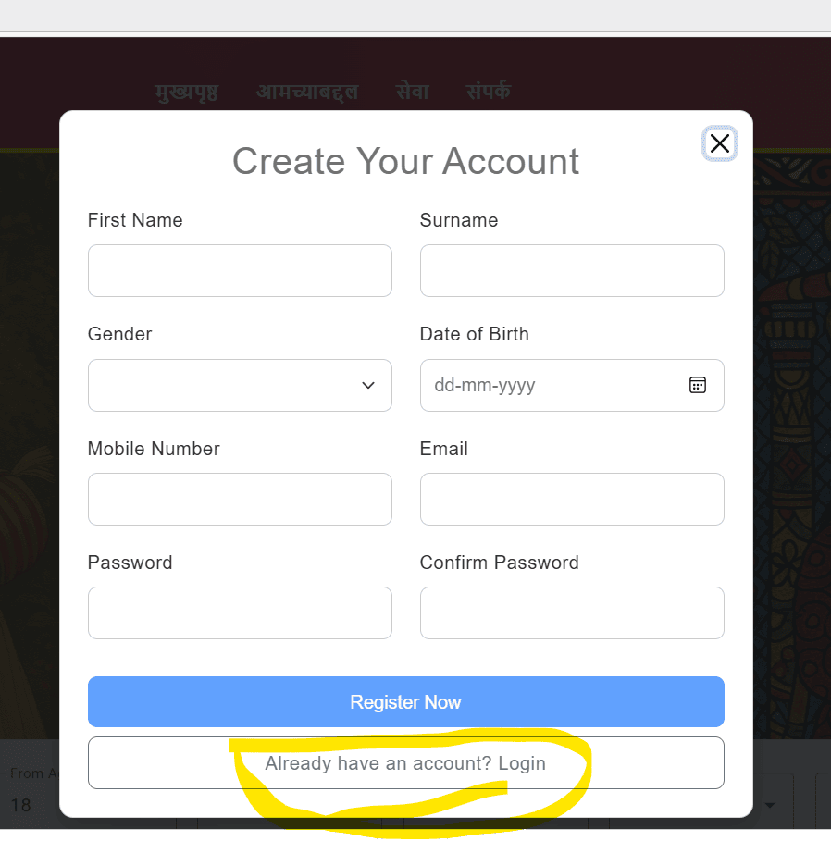
on register screen if user clicks on "already have an account? login button, then control is not opening the login screen which is not correct
expected: when user click on "Already have an account" Login" button , user should get redirect to login screen

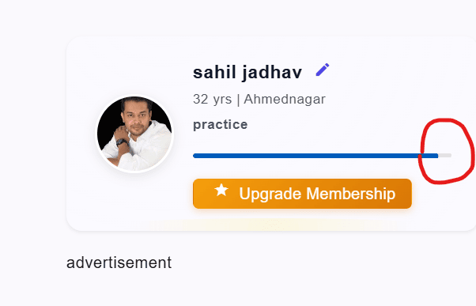
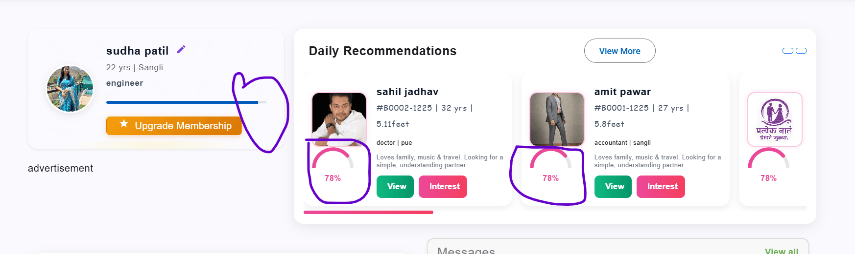
even user update complete profile with all field values , life graph not shown as 100%done (refer first image)
even user profile is fully updated in the daily recommendations section it shows 78% profile completion status for all profiles displayed as recommended. – not developed yet
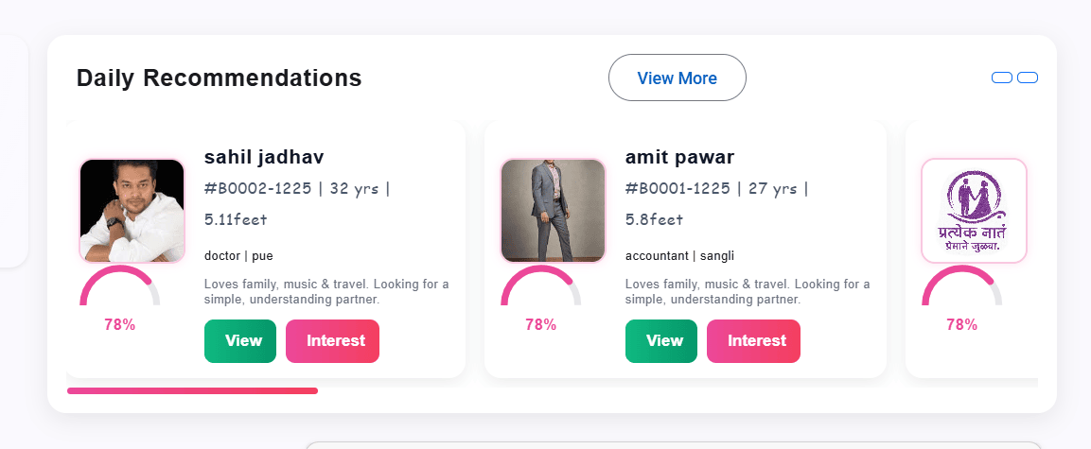
can we make daily recommendations profiles bar as auto scrolling bar which continuously moved towards left to right? – scrollbar is there

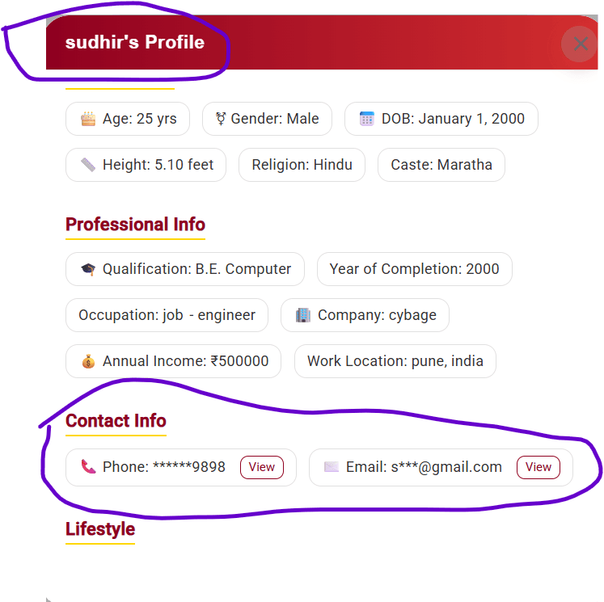
we need to mention only surname & registration id instead of user first name in the header - done
In contact info , hide phone number & email completely when user is not logged in - Done
when user is logged in we can show those details completely
daily recommendations -> view -> should show all the profile details
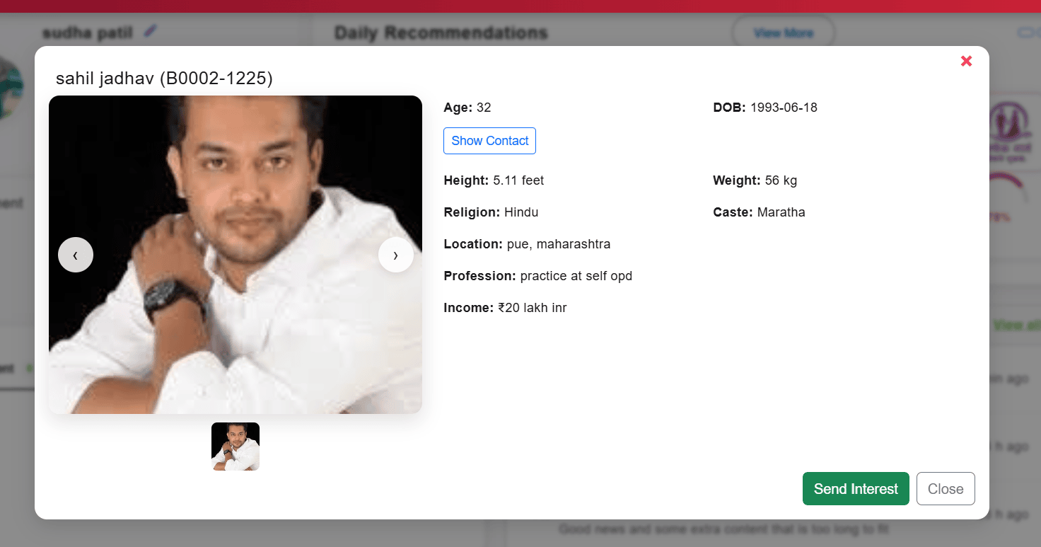

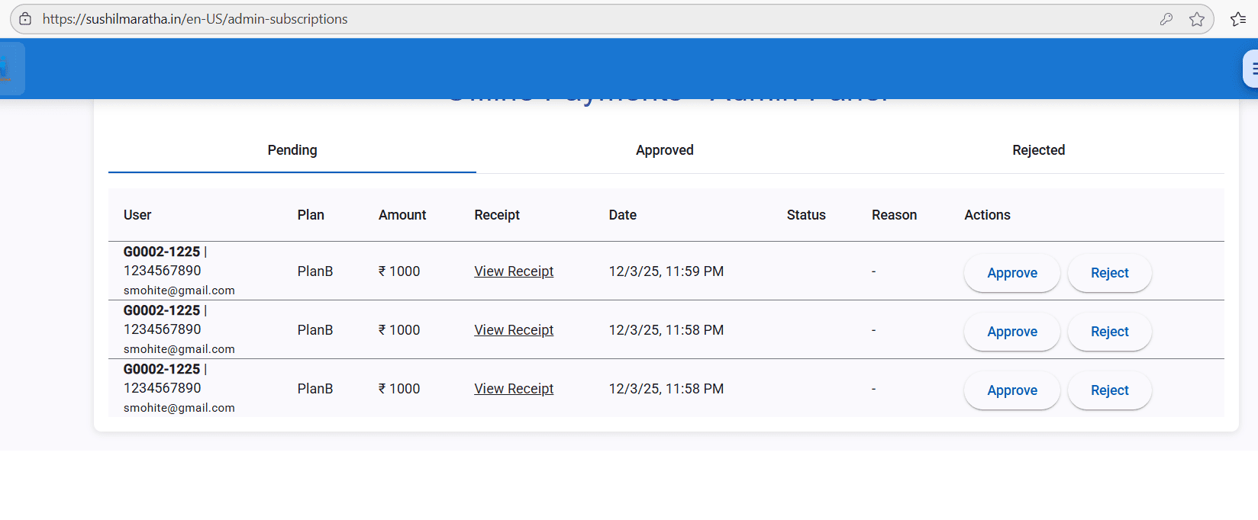
user is able to do payment for same plan multiple times & admin subscription approval/rejection sheet shows all entries based on time stamp
expected : user should able to do placement for the given plan only once , and post payment control should go to dashboard with msg saying "admin will review your details & your profile user will be gets activated soon" - Done

