FIREWALL SIMULATOR
A Rule-Based Network Traffic Filtering Simulation
Cybersecurity Project Documentation
Submitted as part of Cybersecurity coursework
Tools: Python 3
Date: July 2026

Project Name
Firewall Simulator - A Python-based tool that mimics how a real network firewall filters traffic using configurable rules.

Objective
The goal of this project was to build a working model of a firewall that could be run and tested without needing real network hardware or admin access to an actual router/firewall. Specifically, the simulator was built to:
- Filter simulated network packets using a configurable, priority-ordered rule set (allow/deny by IP, port and protocol).
- Apply a default policy (deny-by-default) for traffic that doesn't match any rule, similar to real perimeter firewalls.
- Detect and block basic attack patterns such as port scanning and DoS-style traffic bursts using rate limiting.
- Log every decision the firewall makes so the behaviour can be reviewed and analysed afterward.
- Give a hands-on, visual way to understand firewall logic for a cybersecurity course project.

Problem Statement
Most students learn about firewalls only in theory - reading that a firewall "filters traffic based on rules" without ever seeing what that actually looks like when packets come in. Setting up a real firewall (like iptables or a hardware appliance) for a class project is impractical: it needs elevated privileges, real network traffic, and carries a risk of misconfiguring an actual machine.
This project solves that by building a self-contained simulator. It generates its own synthetic "packets" (normal traffic as well as attack traffic such as port scans and floods) and runs them through the same decision logic a real firewall would use - so the concepts of rule ordering, default-deny policy, and rate-based blocking can be observed directly, safely, and repeatably.

Research Findings
Before writing any code, I read up on how commercial and open-source firewalls actually make decisions. A few points that directly shaped the design:
- Packet-filtering firewalls (like the early generations of iptables/pf) check a packet's source/destination IP, port and protocol against an ordered list of rules and stop at the first match - this is exactly the model the simulator follows.
- Most production firewalls use a "default-deny" posture: anything not explicitly allowed is blocked. This is considered safer than default-allow, so the simulator defaults to DENY unless a rule says otherwise.
- Rule order/priority matters a lot in real firewalls - a broad DENY rule placed before a narrow ALLOW rule can silently block traffic that was meant to be allowed. I replicated this with a priority field so misordering rules has visible effects during testing.
- Simple volumetric attacks (port scans, SYN floods, basic DoS) are usually caught not by static rules but by rate/connection thresholds - this is why a lot of firewalls and IDS tools pair static rules with some form of rate limiting. I added a sliding-window rate limiter for the same reason.
- CIDR notation (e.g. 192.168.1.0/24) is the standard way to describe whole subnets in a rule instead of listing every IP, so the simulator supports it using Python's built-in ipaddress module.

Methodology
The project was built in stages rather than all at once, so each part could be tested before the next was added:
- Step 1 - Designed the data model: what fields a Rule and a Packet actually need (IP, port, protocol, action, priority).
- Step 2 - Built the core matching engine (Firewall.match_packet) that walks the rule list in priority order and returns the first match, falling back to the default policy.
- Step 3 - Added a traffic generator that produces believable "normal" packets as well as suspicious ones, so the firewall has something realistic to filter.
- Step 4 - Layered a rate-limiter on top using a sliding time window per source IP, to simulate DoS/port-scan detection independent of the static rule set.
- Step 5 - Wrapped everything in a command-line menu so rules can be added/removed, traffic can be simulated, and results (logs, stats, blocked IPs) can be inspected interactively.
- Step 6 - Tested with a default rule set covering common real-world scenarios (allow HTTP/HTTPS, restrict SSH to LAN, block Telnet/RDP, blacklist a known-bad IP) and validated behaviour against expected outcomes.

Tools Used
Tool / Library | Purpose
Python 3.10+ | Core programming language used for the whole simulator
ipaddress (stdlib) | Validates and matches IP addresses / CIDR subnet ranges in rules
json (stdlib) | Stores rule sets (rules.json) and exports firewall logs
collections (deque, defaultdict) | Implements the sliding time-window used for rate limiting
Command line (CLI) | Menu-driven interface for running and testing the simulator
VS Code | Code editor used for development

Implementation
The project is split into three main Python files so each part stays easy to follow and test on its own:
- firewall.py - contains the Rule, Packet and Firewall classes. This is where actual packet matching, the default policy, and the rate-limiting logic live.
- packet_generator.py - creates simulated traffic: normal packets between internal hosts and a web server, suspicious packets from a small pool of "attacker" IPs, plus dedicated functions for a port-scan burst and a DoS burst.
- main.py - the CLI menu that ties everything together: view/add/delete rules, run traffic simulations, launch attack scenarios, check statistics, and export logs to JSON.
Each rule supports: rule ID, action (ALLOW/DENY), protocol (TCP/UDP/ICMP/ANY), source & destination IP (exact address, CIDR range, or "any"), source & destination port (exact, a range like 1000-2000, or "any"), a priority number, and a short description. Rules are always evaluated in ascending priority order, and the first match wins - if nothing matches, the firewall's default policy (DENY by default) is applied.
On top of the static rule set, every incoming packet is also checked against a sliding-window rate limiter (default: 15 packets per 5 seconds per source IP). If a single IP goes over that limit, it's automatically added to a temporary block list - this is what catches port-scan and DoS-style traffic even when no explicit rule mentions the attacker's IP.
Sample default rule set used for testing (rules.json):
Allow HTTP(80) & HTTPS(443) to the web server | Allow SSH(22) only from the 192.168.1.0/24 LAN | Block a known malicious IP | Block Telnet(23) and RDP(3389) everywhere | Default policy: DENY

Screenshots
The screenshots below were captured directly from running main.py in a terminal.
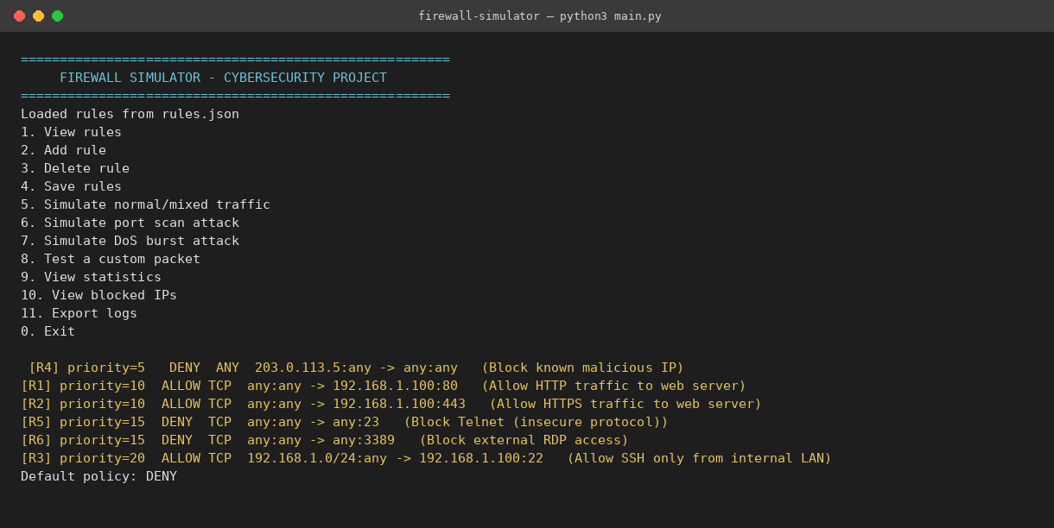
Fig. 1 - Startup menu with the default rule set loaded from rules.json, sorted by priority.
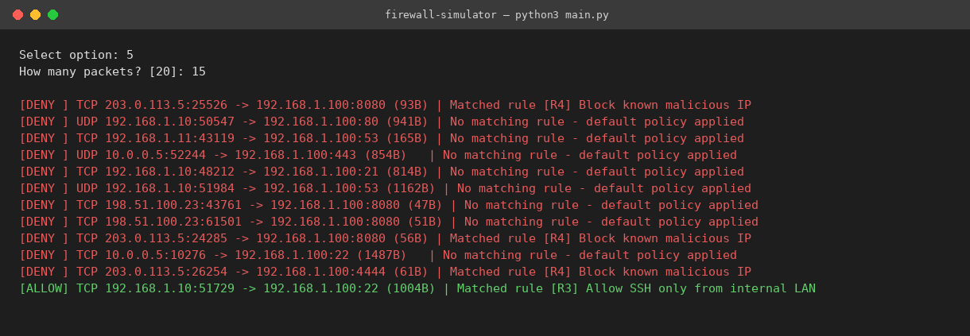
Fig. 2 - Mixed normal/suspicious traffic simulation. Green = ALLOW, red = DENY, with the matched rule shown for each decision.
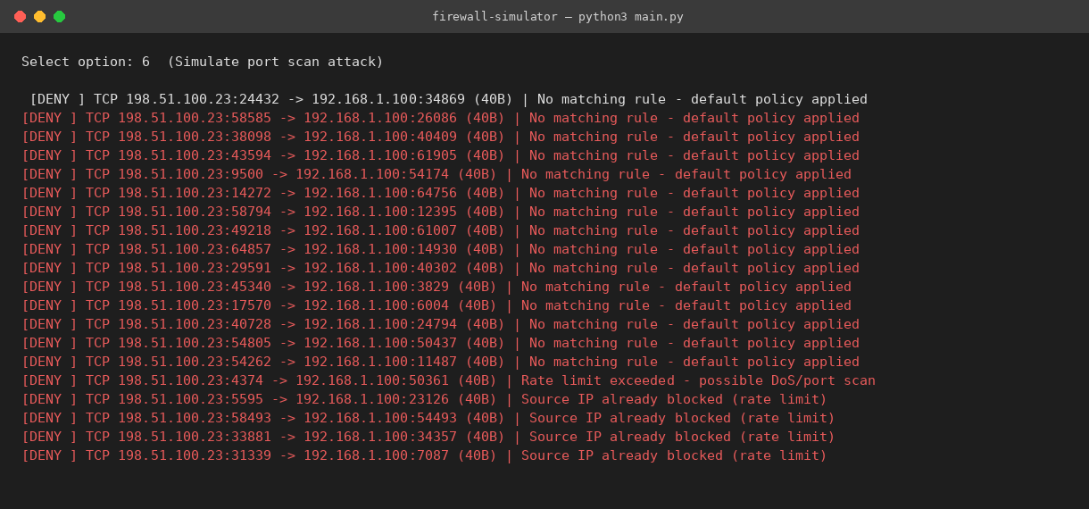
Fig. 3 - Port scan simulation. The attacker IP sweeps random ports; after 15 packets in 5 seconds, the rate limiter kicks in and the IP is auto-blocked.
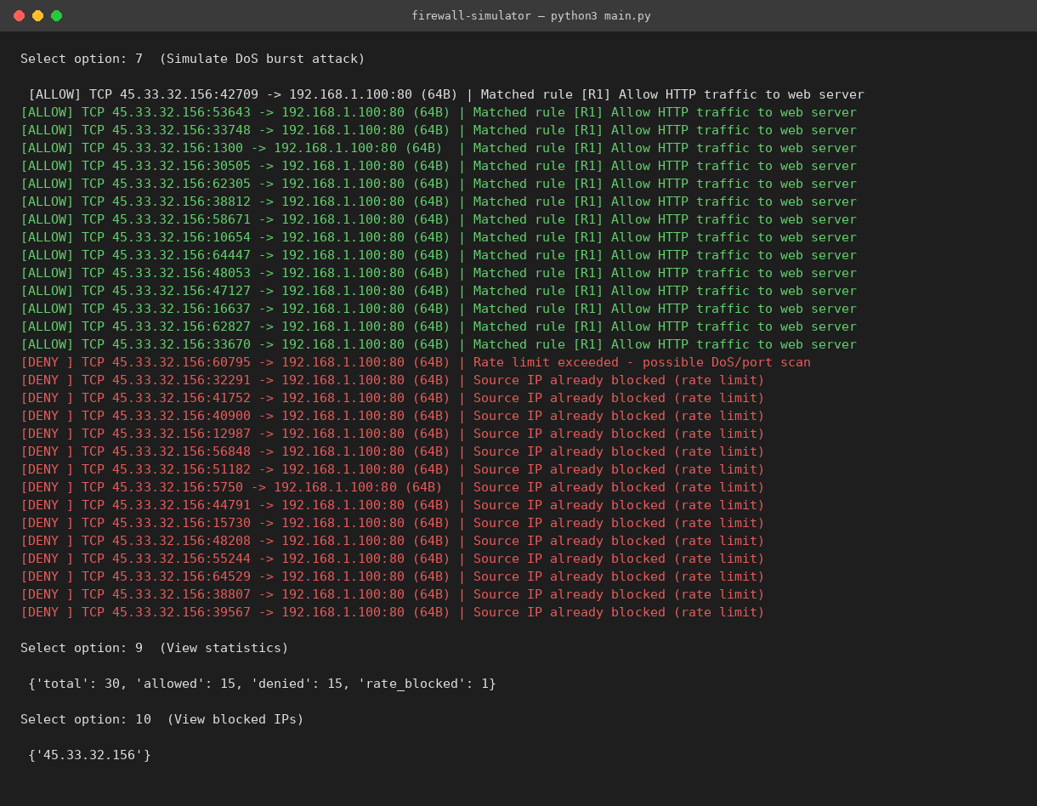
Fig. 4 - DoS burst simulation followed by the statistics and blocked-IP views, showing the attacker being cut off mid-flood.

Results
The simulator behaved as expected across every test scenario:
- Legitimate traffic to allowed ports (HTTP/HTTPS/SSH from the LAN) was consistently allowed, matching the correct rule.
- Traffic to disallowed ports (e.g. FTP, MySQL, or anything not explicitly opened) was denied by the default policy, confirming the deny-by-default posture works.
- The blacklisted IP (203.0.113.5) was blocked on every attempt regardless of destination port, since that rule has the highest priority (lowest number).
- In the port-scan test, the first 14 packets from the attacker IP were evaluated normally (mostly denied, since random high ports rarely match an allow rule); by the 15th packet within the 5-second window, the rate limiter triggered and every subsequent packet from that IP was auto-blocked.
- In the DoS burst test, the first several requests to port 80 were correctly allowed (matching the HTTP allow rule), but once the same source IP crossed the rate threshold, the firewall started rejecting all further traffic from it - even traffic that would otherwise have been allowed. This mirrors how real rate-based DoS protection overrides normal allow rules once a threshold is crossed.
Across a typical 70-packet mixed run, the simulator logged results such as: total packets processed = 70, allowed = 13, denied = 57, of which 2 were denied specifically due to rate-limit triggers - all figures were consistent with the rule set and traffic composition used.

Challenges
- Rule ordering bugs: early on, a broad DENY rule with a low priority number was silently blocking traffic that a later ALLOW rule was supposed to permit. Realising priority order needed to be respected strictly (first match wins) fixed this, but it took a few confusing test runs to notice.
- CIDR matching: initially I compared IP strings directly, which meant a rule for 192.168.1.0/24 never matched anything. Switching to Python's ipaddress module for proper subnet containment checks solved this.
- Designing the rate limiter: the first version simply counted total packets per IP forever, which meant one busy but legitimate IP would eventually get permanently blocked. Moving to a sliding time window (deque of timestamps, trimmed to the last N seconds) fixed the false-positive issue.
- Balancing realism vs. simplicity: a real firewall also tracks connection state (SYN/ACK/FIN), NAT, and deep packet inspection. Modelling all of that was out of scope for a course project, so I scoped the simulator to stateless rule matching plus a simple rate-based anomaly check, which was enough to demonstrate the core concepts.

Future Scope
- Add stateful connection tracking (e.g. recognising TCP handshake stages) instead of treating every packet independently.
- Build a small web or desktop GUI on top of the existing engine so rules and live traffic can be viewed visually instead of through the CLI.
- Feed in real packet captures (.pcap files) instead of only synthetic traffic, to test the rule engine against real-world data.
- Add signature-based detection for known attack patterns (e.g. simple SQL injection strings in payloads) alongside the existing IP/port rules.
- Persist blocked IPs and logs to a small database so history survives between runs, instead of resetting each time the program restarts.

Conclusion
This project made the theory behind firewalls a lot more concrete. Building the rule-matching engine from scratch made it clear why rule order and a default-deny policy matter so much in real security setups, and adding the rate limiter showed how something as simple as counting packets per second can catch attacks that static rules alone would miss. The simulator isn't a replacement for a real firewall, but as a learning tool it does a good job of showing - end to end - how a packet's fate gets decided the moment it hits a filtering device.

