XNOR gate using 6 MOS Transistors

P R Rahul Hebbar, Defence Institute of Advanced Technology

*Abstract*—*XNOR is a Hybrid gate which has OR, AND and NOT operation done to the inputs. XNOR gate is also called as equivalance gate because of the operation gives logic high when inputs are same and logic low when inputs are opposite. This is also the reason why XNOR is used as one bit equality comparator. XNOR is used for various applications like Pseudo-Random number generator, Equality comparator, Correlation and sequence detection etc. Here we have implemented XNOR using only 6 MOS transistors with 32nm technology for simulation.*

# Reference circuit details

In the circuit below, we have achieved XNOR operation only by using 3 NMOS and 3 PMOS transistors. The circuit consists of 2 CMOS inverters and 2 MOS pass gate configuration. By clever logic hack we have achieved XNOR logic using less number of transistors. Here both NMOS and PMOS belong to the 32 nm family and the circuit shows promising results for an operating voltage of 3.3V. Here the input to both gates are pulse signals with 10ms and 20ms time periods and 50% of duty cycle. This way we get all the four cases necessary to check the validity of our XNOR logic.

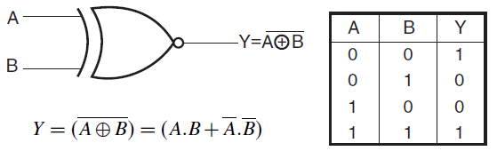

Fig. 1. XNOR Truth Table

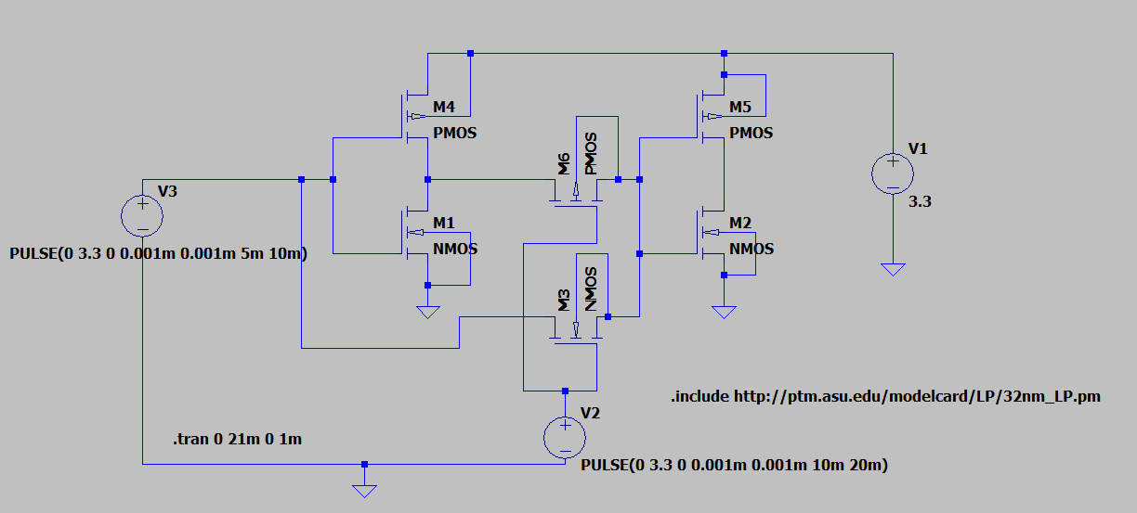 Fig. 2. XNOR Schematic

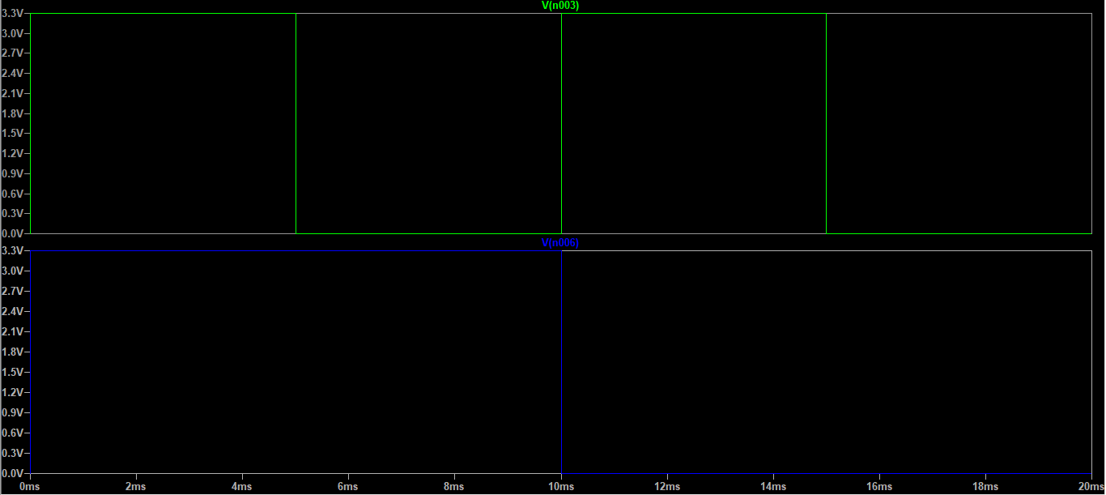

Fig. 3. XNOR Input To Schematic

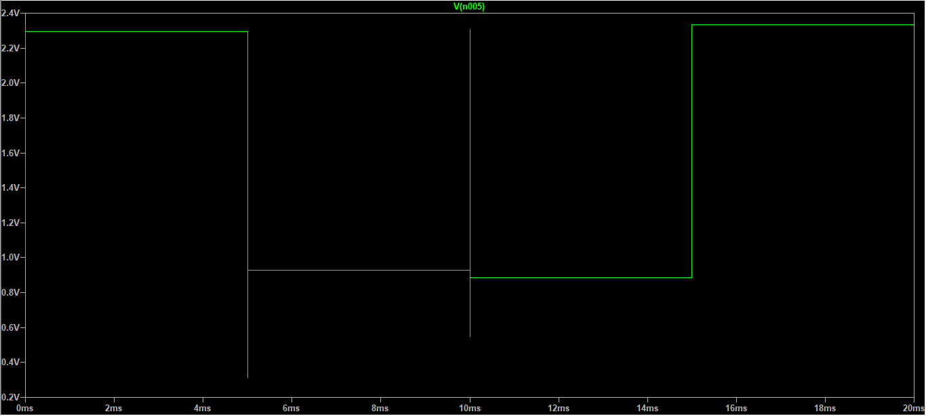

Fig. 3. XNOR Output Waveform

##### References

1. Cristiano Calligaro,(2008) Design of a rad-hard library of digital cells for space applications.
2. Fig 1. Courtesy of electronics-tutorial.net, https://www.electronics-tutorial.net/digital-logic-gates/xnor-gate/