
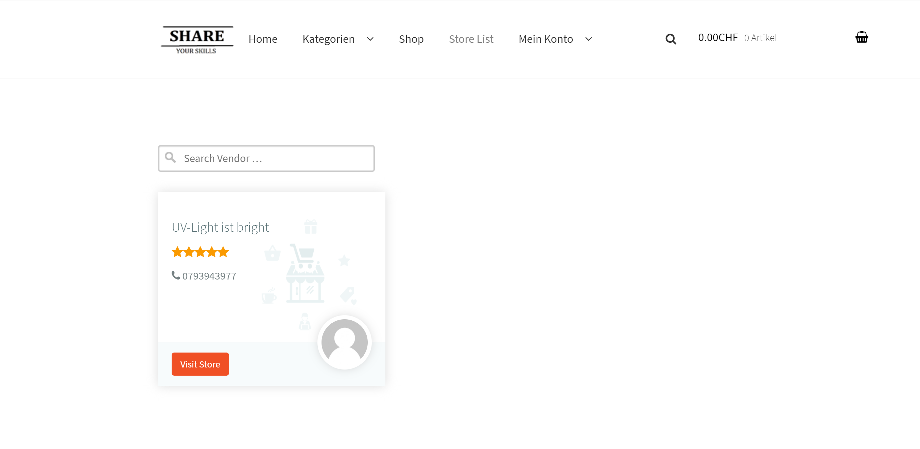
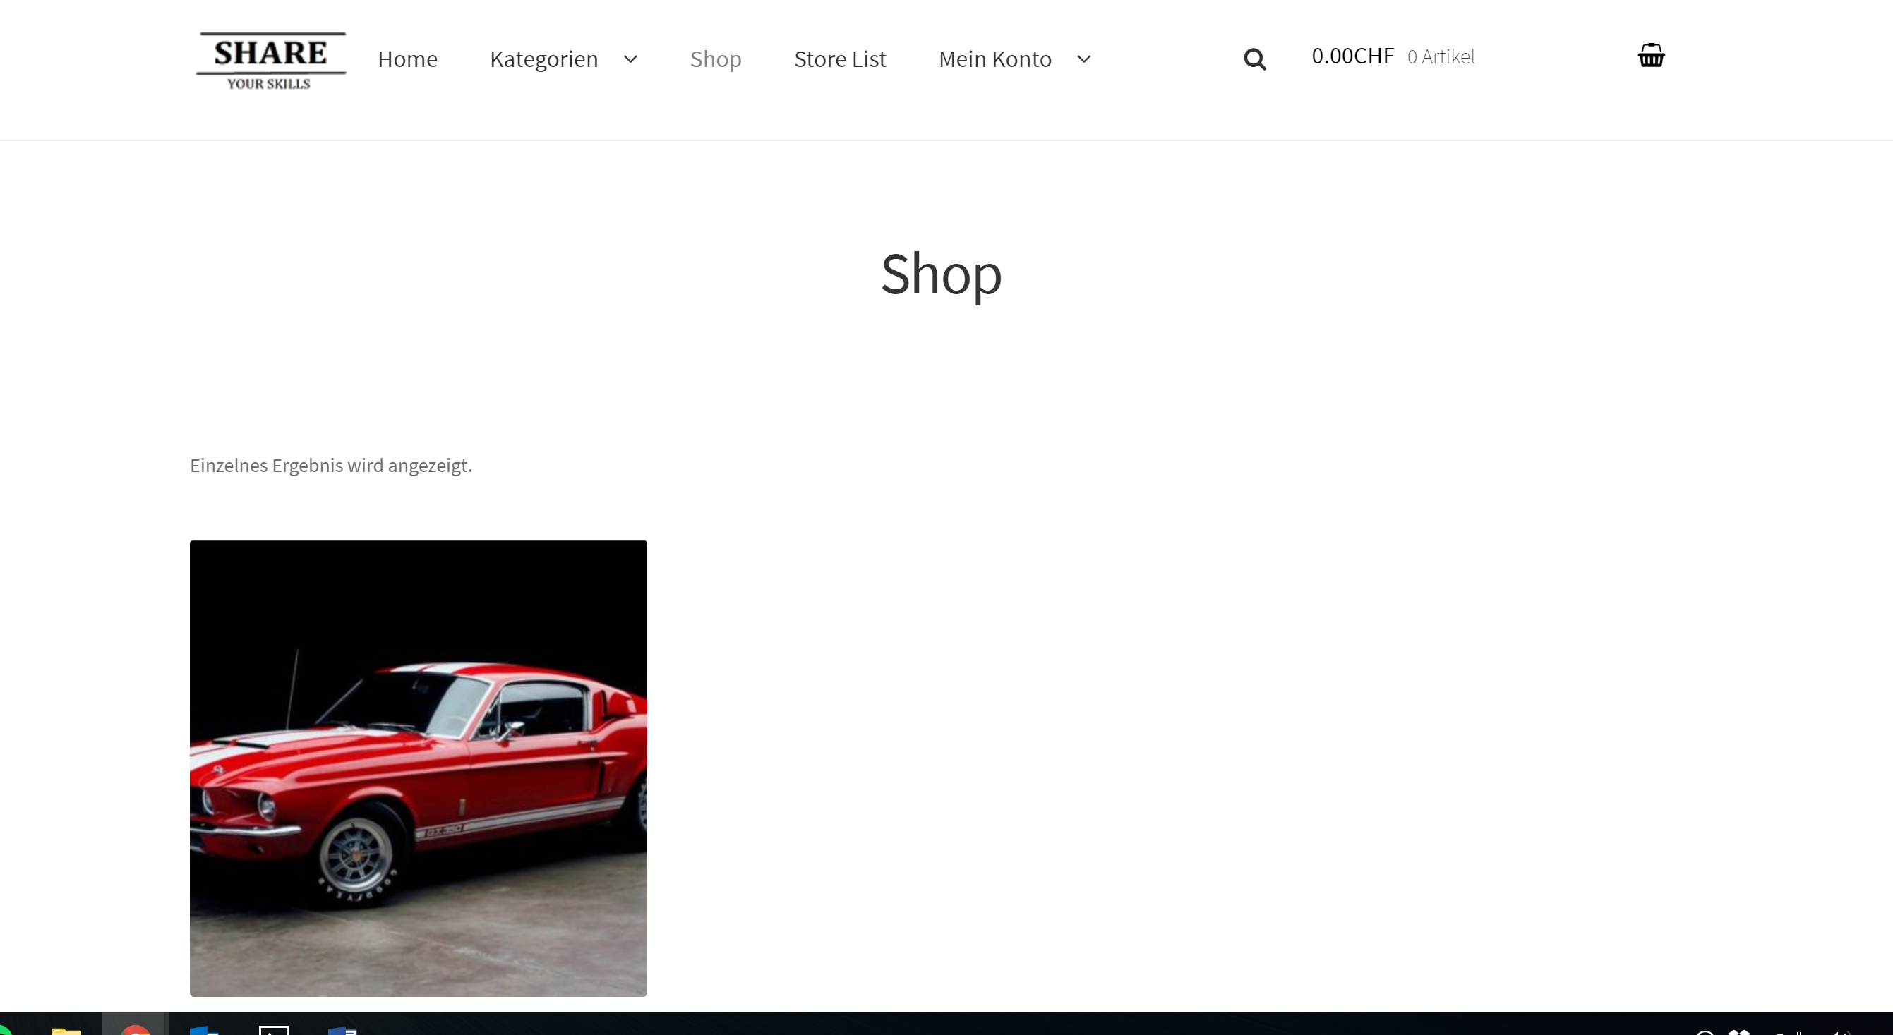
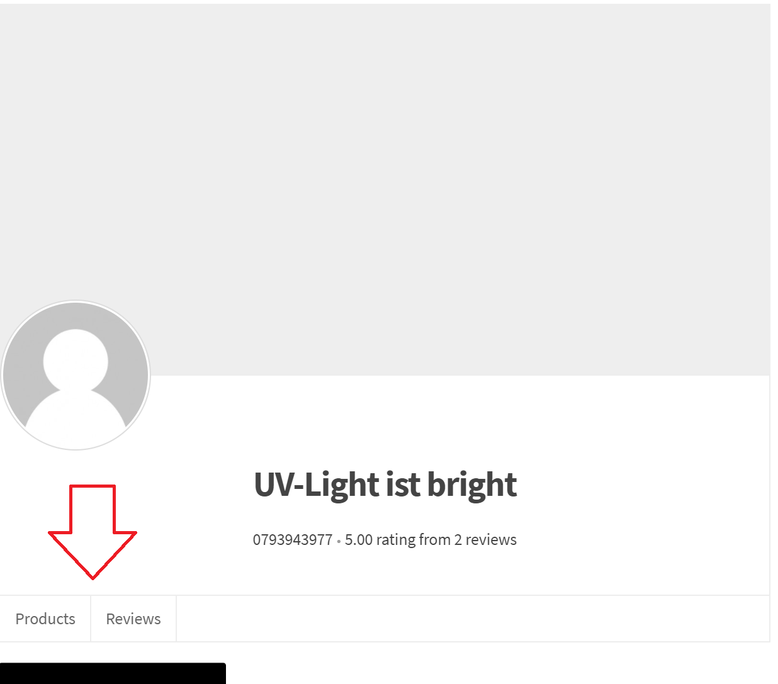
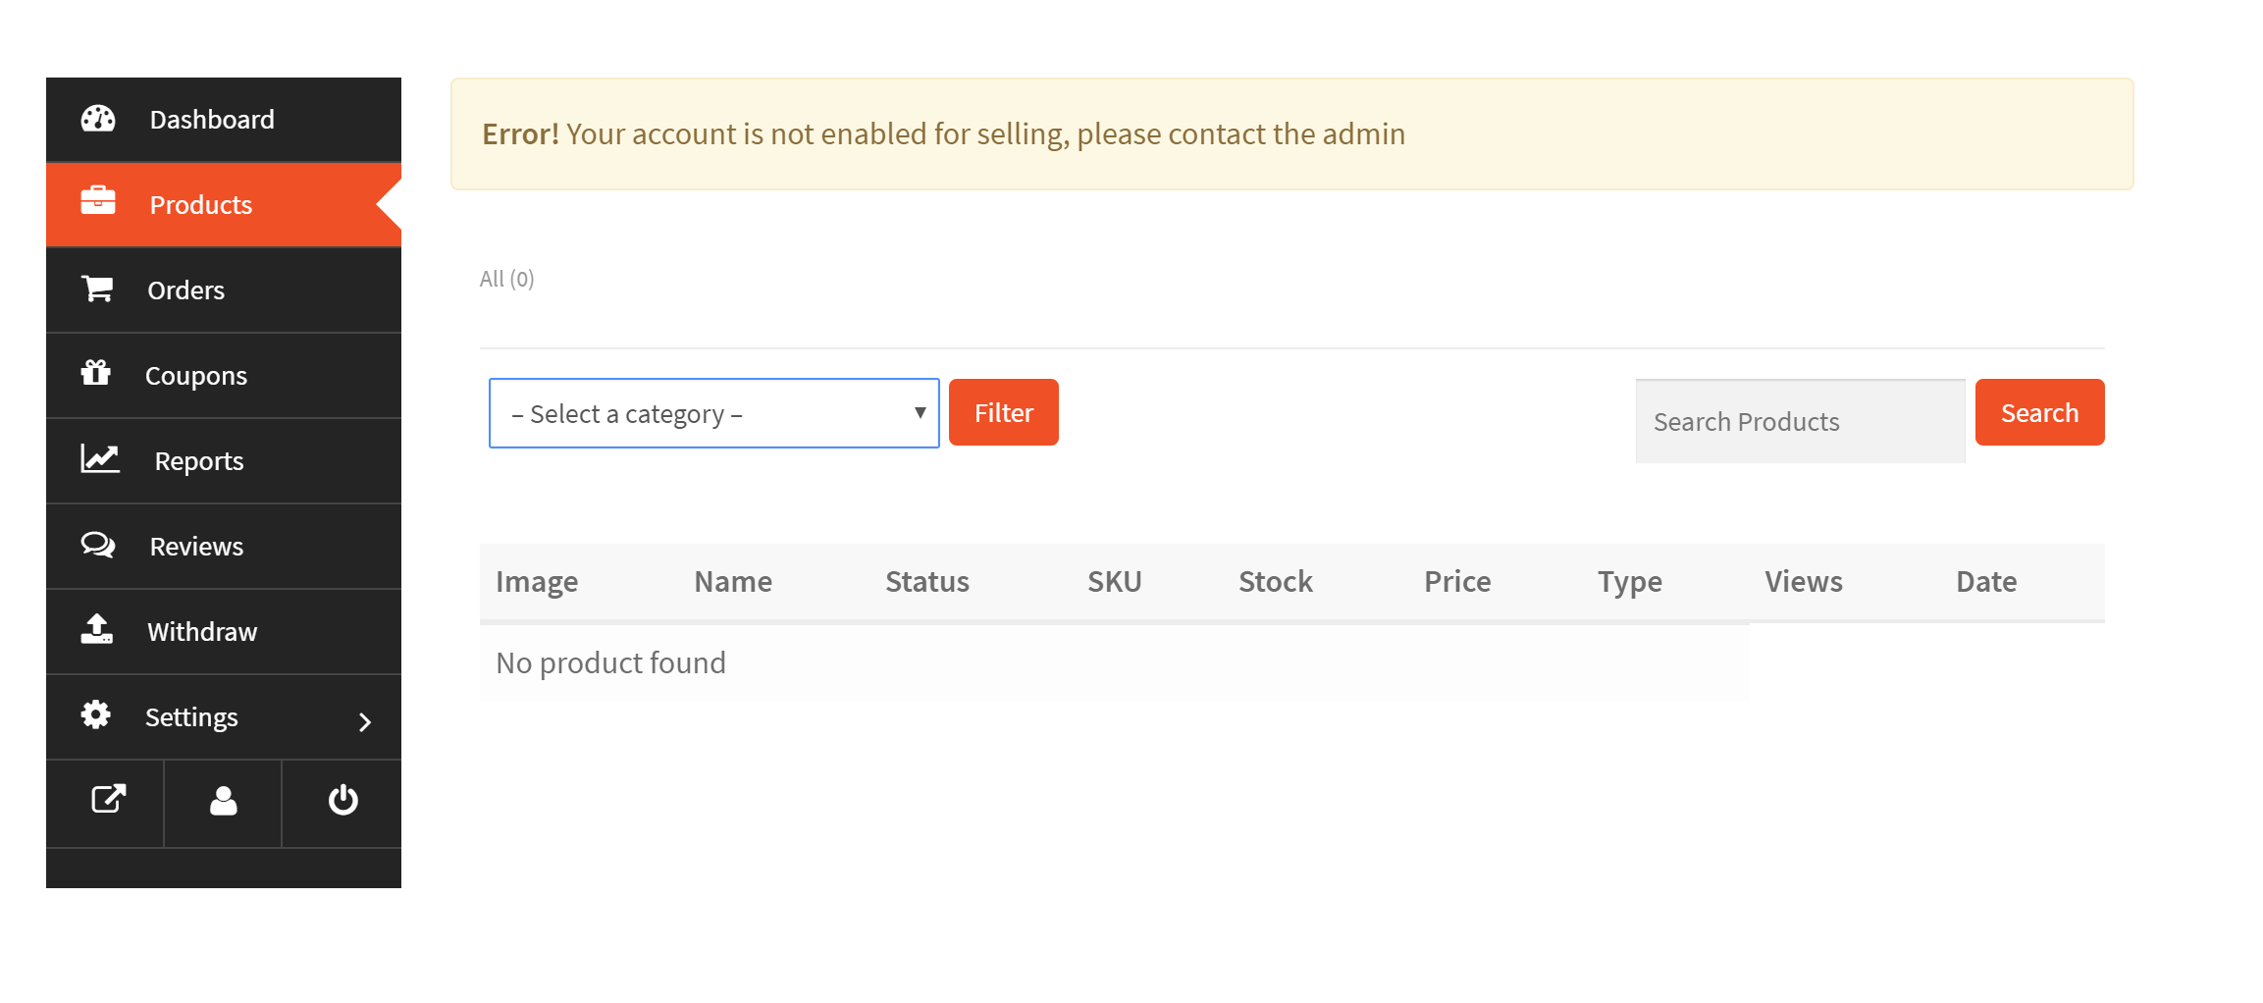

ShareYourSkills

Autor: Joel Gratwohl

Ort, Datum: Olten, 6. November 2017

Inhaltsverzeichnis
Inhaltsverzeichnis 2
1Current Status 3
2Developers/Support 3
3Goal 4

Current Status
At the moment it exists a Webpage with all the basic functionalities I would like to have.

Developers/Support
Here are all necessary information listed:
Web-Page | https://pejbooxu.preview.infomaniak.website
Login-WP | Username: support  Password: Support.2017
FTP | Domain: pejb.ftp.infomaniak.com  User: pejb_Support  PW: Support.2017

Goal
The goal ist o finish the website with all the necessary requirements. Following functions need to be implemented next:
- Store List:

The customers need to have the possibility to filter the stores with the following attributes:

Attribute | Explanation
Search vendor | As it is no, searching for storename/vendor. Just included in the left-filter-sidebar
Zipcode | While registration, user add a zipcode to their store (Which is in general the zipcode where they’re living)
Rangeslider | The rangeslider adds a range to the zipcode added.  Stores within these range around the zipcode will be shown.
Vendor rating | User can filter stores apart the vendors rating.  (Star-Rating)

As I mentioned, the filter will be on the left side (left-sidebar).
- Category- and Shop- Page:

Both of those pages must to have a filter! Both of them can use the following filter and attributes:

Attribute | Explanation
Search Product | Live text search as it is implemented in the header.  Users can search for products apart their names, etc.
Zipcode | While adding a product, Zipcode of the Store is added to the product, that the people can search products within a specific zipcode.
Rangeslider | The rangeslider adds a range to the zipcode added.  Products within these range around the zipcode will be shown.
Price Range slider | Products can be filtered withing a specific “cost-range”  Example: I would like to see all products which are between 0$ and 50$.
Attributes | Attributes such as:  - Downloadable Product  - Bookable Servives  - Physical products  - Video lessons
Categories | All main and sub- productcategories which I added to Wordpress.  These Categories must be shown as a list with checkboxes.
Product-Rating | User can filter products apart the ratings  (Star-Rating)

- Store Register:

On the Storepage of each user there must be 2 additional registers.
Products | Skills | Education | Reviews
Here are all the different products listed. Such as:  - Physical Products  - Bookable Services  - Downloadable Products  - Video Lessons | Here are the Skills of the vendor listed.  He can add his Skills (such as education) in de Dokan dashboard | Here the vendors can list all their past/current education | Here are the reviews of the Store (made by other users/vendors)

Skills and Education can be added in the Dokan Dashboard underneath “Products”.

