### Department Management System

Submitted in partial

fulfilment of the requirements of the degree of

BACHELOR OF ENGINEERING

in

INFORMATION TECHNOLOGY

by

|  |  |
| --- | --- |
| **Rahul Jaiswar** | **213162** |
| **Musab Khan** | **213165** |
| **Aman Khan**  **Zaid Khande** | **213164**  **223167** |

Under the guidance of

**Prof. Sneha Sankhe**



**Department of Information Technology**

**Theem College of Engineering, Boisar**

Chilhar Road, Boisar (E), Palghar

**University of Mumbai**

**2024-2025**

**CERTIFICATE**

This is to certify that the B.E. Mini project entitled **“Department Management System** is a bonafide work of “**Rahul Jaiswar (223162), Musab Khan (213165), Aman Khan (213120), Zaid Khande (223167)”** submitted to the University of Mumbai in partial fulfilment of the requirement for the award of the degree of “Information Technology” during the academic year 2024-25.

Prof. Sneha Sankhe

Guide

Prof. Sneha Sankhe Dr. Riyazoddin Siddiqui

Head of Department Principal

### B. E. Mini Project Report Approval

This Mini project synopsis entitled **“*Department Management System*”** by **“*Rahul Jaiswar (223162), Musab Khan (213165), Aman Khan (213120), Zaid Khande (223167)*”** approved for the degree of Information Technology from University of Mumbai.

**INTERNAL EXAMINER** **EXTERNAL EXAMINER**

Date:

Place:

### Declaration

We declare that this written submission represents our ideas in our own words and where others' ideas or words have been included, we have adequately cited and referenced the original sources. We also declare that we have adhered to all principles of academic honesty and integrity and have not misrepresented or fabricated or falsified any idea/data/fact/source in our submission. We understand that any violation of the above will be cause for disciplinary action by the Institute and can also evoke penal action from the sources which have thus not been properly cited or from whom proper permission has not been taken when needed.

**Rahul Jaiswar (213162)**

**Musab Khan (213165)**

**Aman Khan (213120)**

**Zaid Khande (223167)**

Date:

## Acknowledgement

We would like to take this opportunity to express our gratitude towards all the people who have in various ways, helped in the successful completion of our project. We would like to express our deepest gratitude to our honorable director sir **Dr. N. K. Rana** for their invaluable guidance, support, and mentorship throughout the duration of this project. Their expertise, encouragement, and insightful feedback have been instrumental in shaping the direction outcome of this endeavor. We extend our gratitude to our respected principal sir **Dr. S. Riyazoddin Siddiqui** for their continuous support and dedication to the holistic development of students, providing invaluable resources and opportunities for growth. We convey our gratitude to our HOD and our mini project Coordinator and project guide **Prof. Sneha Sankhe** for giving us the constant source of inspiration and help in preparing the project, personally correcting our work, and providing encouragement throughout the project. Additionally, we extend our appreciation to all the teaching staff, whose profound knowledge, passion for teaching, and dedication to student’s learning have been a constant source of inspiration and motivation. We are also thankful to all non- teaching staff, for their behind-the-scenes efforts in maintaining the infrastructure, administrative support, and logistical assistance that contributed to the project’s success. We would also like thank our parents, whose unwavering love, encouragement, and sacrifices have been the cornerstone of our journey. Their belief in our abilities and endless support have been a constant source of strength and motivation. Finally, we are grateful to our family and friends, for their understanding, encouragement, and wavering support throughout this endeavor.

We extend our heartfelt gratitude to each and every individual mentioned above, as well as to all those who have contributed in various ways, directly or indirectly to this project’s completion.

Rahul Jaiswar (213162)

Musab Khan (213165)

Aman Khan (213120)

Zaid Khande (223167)

**Abstract**

The **Department Management System (DMS)** is designed to streamline and automate various administrative tasks within educational institutions. It addresses the need for efficient management of student records, faculty information, and course details, reducing the dependency on manual processes. By providing a centralized platform, the system improves the accuracy, accessibility, and organization of essential academic data, making it easier for administrators to manage departments effectively.

One of the key features of the DMS is its ability to manage student and faculty information, including attendance, performance tracking, and course enrollment. The system allows administrators to quickly retrieve and update data, providing real-time insights into departmental operations. This helps in better decision-making and enhances the overall efficiency of the institution.

Additionally, the system supports course management by automating the assignment and tracking of courses for students and faculty members. Features like attendance management, report generation, and feedback collection further contribute to the smooth functioning of departments. This makes it a valuable tool for both faculty and students, ensuring transparency and effective communication.

In the future, the DMS can be scaled to integrate advanced technologies such as artificial intelligence for predictive analytics and cloud infrastructure for improved accessibility. This will further enhance its ability to support complex operations and meet the growing needs of educational institutions, ultimately contributing to a more responsive and adaptive academic environment.

The organization of this report is as follows

Chapter 1: Introduction

This chapter gives a brief introduction about Department Management System furthermore includes Motivation, Problem definition, Aim and Scope of the project.

Chapter 2: Literature survey

This Chapter gives information about the background, Literature Survey and Literature Review.

Chapter 3: System Architecture and Design

This chapter provides implementation details of the project in system design which gives information about the necessary things required for project implementation. It also provides information regarding the proposed system architecture to understand the project.

Chapter 4: System Design

This chapter presents different diagrams like Use-Case diagram, Data Flow diagram, Activity diagram, Sequence diagram, etc. to understand connectivity and flow of various activities.

Chapter 5: Results and Discussion

This chapter presents the lessons learned represented with the conclusion and the area where work can be further carried out in further represented with future scope.

Chapter 6: Conclusion and Future Scope

This chapter presents the lessons learned represented with the conclusion and the area where work can be further carried out in further represented with future scope.

**INDEX**

|  |  |  |  |  |
| --- | --- | --- | --- | --- |
| **Sr. No** | **Contents** | | **Pg. No** | |
|  | List of contents……………………………………………………. | | i | |
|  | List of Figures……………………………………………………... | | iii | |
|  | List of Table………………………………………………………. | | iv | |
|  | Acronyms…………………………………………………………… | | v | |
| **Chapter -1** | **Introduction…………………………………………………….** | | **1** | |
| 1.1 | An overview………………………………………………………. | | 1 | |
| 1.2 | Motivation………………….………………………………………. | | 2 | |
| 1.3 | Problem Definition.………………………………………………. | | 2 | |
| 1.4 | Aim………………………………………………………………... | | 2 | |
| 1.5 | Scope of Project………………………………………………….... | | 3 | |
| **Chapter-2** | **Literature Survey………………………………………………….** | | **3** | |
| 2.1 | Background…………………………………………………………. | | 4 | |
| 2.2 | Literature Analysis Table…………………………………………… | | 6 | |
| **Chapter -3** | **System Architecture………….……………….…………………...** | | **7** | |
| 3.1 | Introduction……………………………………….………………… | | 7 | |
| 3.2 | Design…………………………..…………………………………. | | 8 | |
| 3.2.1 | Requirement Analysis…….…….………………………………… | | 8 | |
| 3.2.2 | System Architecture ………………………………………………. | | 9 | |
| 3.3 | Proposed System…………………………………………………… | | 10 | |
|  |  | |  | |
| **Chapter -4** | **System Design…………………………………….……………….…** | | **11** | |
| 4.1 | Introduction...……………………………………………………….... | | 11 | |
| 4.2 | UML diagram……………………………………………………….... | | 12 | |
| 4.2.1 | Use Case Diagram…………………………………………………… | | 12 | |
| 4.2.2 | Class Diagram……………………………………………………...... | | 13 | |
| 4.2.3 | Activity Diagram………………………………………………........ | 14 | |
| 4.2.4 | Sequence Diagram………………………………………………….. | 15 | |
| 4.4 | Gantt Chart………………………………………….………………. | 16 | |
| 4.5 | Work Breakdown Structure Diagram……………………………... | 17 | |
| **Chapter-5** | **Results and Discussion…………………………………………….** | **18** | |
| 5.1 | Screenshot of Home Page Window ………………………………… | 19 | |
| 5.2 | Screenshot of Manage Students Page………………………………… | 20 | |
| 5.3 | Screenshot of Manage Staff Page……………………………………. | 21 | |
| 5.4 | Screenshot of Manage Attendance Page……………………...………. | 21 | |
| 5.5 | Screenshot of Screenshot of View Attendance Pages……….………. | 22 | |
| 5.6 | Screenshot of Screenshot of Feedback Pages………………………… | 23 | |
| **Chapter-6** | **Conclusion and Future Scope………………………………….** | **24** | |
| 6.1 | Conclusion……………………………………………………… | 24 | |
| 6.2 | Future Scope…………………………………………………… | 25 | |
|  | References……………………………………………………………. |  | |

**List of Figures**

|  |  |  |
| --- | --- | --- |
|  |  |  |
|  |  |  |
|  |  |  |
|  |  |  |
|  |  |  |
|  |  |  |
|  |  |  |
|  |  |  |
|  |  |  |
|  |  |  |
|  |  |  |
|  |  |  |
|  |  |  |
|  |  |  |
|  |  |  |
|  |  |  |

|  |  |  |
| --- | --- | --- |
| **Sr. No** | **Contents** | **Pg. No** |
| Fig. 3.2.2 | System Architecture……………………………………………. | 9 |
| Fig. 3.3 | Proposed System….………………………………………………. | 10 |
| Fig. 4.2.1 | Use Case Diagram..……….………………………………………. | 13 |
| Fig. 4.2.2 | Class Diagram…….………………………………………………. | 14 |
| Fig.4.2.3 | Activity Diagram…………………………………………………... | 15 |
| Fig. 4.2.4 | Sequence Diagram………….…………………………………….... | 19 |
| Fig. 4.4 | Grantt Chart……………..…….……………….…………………... | 17 |
| Fig. 4.5 | Work Breakdown Structure Diagram…………..………………… | 17 |
| Fig 5.1 | Screenshot of Admin Home Page of DMS………………………… | 19 |
| Fig 5.2 | Screenshot of Student Home Page of DMS……..…………………. | 20 |
| Fig. 5.3 | Screenshot of Manage Staff Page for DMS………………………... | 21 |
| Fig 5.4 | Screenshot of View Attendance Pages………………...…………... | 22 |
| Fig. 5.5 | Screenshot of Feedback Pages…………………………………….. | 23 |

|  |  |  |  |
| --- | --- | --- | --- |
|  |  |  |  |
|  |  |  |  |
|  |  |  |  |
|  |  |  |  |
|  |  |  |  |

**List of Tables**

|  |  |  |
| --- | --- | --- |
|  |  |  |
|  |  |  |
|  |  |  |
|  |  |  |
|  |  |  |
|  |  |  |
|  |  |  |
|  |  |  |
|  |  |  |
|  |  |  |
|  |  |  |
|  |  |  |
|  |  |  |
|  |  |  |
|  |  |  |
|  |  |  |

|  |  |  |
| --- | --- | --- |
| **Sr. No** | **Contents** | **Pg. No** |
| Fig. 2.3 | Literature Analysis Table ………………………………………. | 6 |
| Fig. 3.2.1 | Requirement Table….………………………………………………. | 8 |
|  |  |  |

**Acronyms**

**DMS – Department Management System**

**WBS – Work Breakdown Structure**

**Chapter 1**

**Introduction**

## 1.1 An overview:

A Department Management System (DMS) plays a crucial role in streamlining the academic and administrative activities of various departments. It manages key functions such as student records, course scheduling, and faculty workload while supporting research, project management, and resource allocation. The system enhances communication and collaboration among faculty, staff, and students, providing a centralized platform for accessing course materials, submitting assignments, and tracking academic progress. Additionally, the DMS helps optimize resource use, such as labs and classrooms, and ensures that departmental budgets and funding are efficiently managed. Overall, it improves departmental efficiency, organization, and coordination across the institution.

## 1.2 Motivation:

The purpose behind developing a Department Management System (DMS) for colleges stems from the need to efficiently manage the complex and diverse activities within academic departments. As colleges grow in size and offer a wide range of programs, the administrative burden on faculty and staff increases, leading to potential inefficiencies, miscommunication, and resource mismanagement. Traditional methods of handling departmental operations, such as paper-based records or fragmented software tools, are often time-consuming and prone to errors. The goal is to enhance overall departmental efficiency, reduce manual workload, and create a more organized and collaborative academic environment, ultimately benefiting both students and faculty

**1.3 Problem Definition:**

The problem addressed by a Department Management System (DMS) in a college setting revolves around the inefficiencies and challenges associated with managing the wide range of academic and administrative tasks within individual departments. Without a centralized system, departments often rely on manual processes or disjointed tools for handling critical functions such as student records management, course scheduling, faculty assignments, resource allocation, and internal comedication. This can lead to: Fragmented Information: Data related to students, faculty, and resources is often scattered across multiple platforms or maintained in physical records, making it difficult to access and manage. Inefficient Resource Management: Shared resources like classrooms, laboratories, and equipment may not be optimally utilized, leading to scheduling conflicts or underuse. Communication Barriers: Lack of a unified communication platform can result in delayed or inconsistent information flow between faculty, students, and staff, affecting coordination and collaboration.

## 1.4 Aim:

The aim of the Department Management System (DMS) project is to create a centralized platform that automates and streamlines the various academic and administrative tasks within college departments. The system is designed to enhance operational efficiency by automating routine processes such as student record management, course scheduling, and resource allocation, reducing the manual workload for faculty and staff. It will also improve communication and collaboration by providing a unified platform for seamless interaction between faculty, students, and staff, ensuring timely coordination of activities.

## 1.5 Scope:

#### The scope of the Department Management System (DMS) project encompasses a wide range of functionalities tailored specifically for college departments. It includes comprehensive user management to support various roles, such as administrators, faculty, staff, and students, each with tailored access levels. The system will facilitate efficient student records management, allowing for the tracking of enrolment, attendance, grades, and academic performance, while ensuring easy access and updates. Additionally, it will enable course and curriculum management, helping departments organize and manage course offerings, syllabi, prerequisites, and scheduling to keep all stakeholders informed. Faculty management features will allow departments to track faculty details, teaching assignments, and workload distribution, promoting transparency and accountability

**Chapter 2**

**Literature Survey**

## 2.1 Background:

The As educational institutions expand and diversify their offerings, they face increased challenges in efficiently handling a multitude of administrative tasks, ranging from student records management to course scheduling and resource allocation. Traditionally, these functions were managed through manual processes, paper-based systems, or disparate software tools, leading to inefficiencies, communication breakdowns, and potential errors. The lack of a centralized system often resulted in fragmented information, making it difficult for faculty and staff to access critical data when needed. Recognizing these challenges, educational leaders have sought innovative solutions to enhance operational efficiency and improve the overall academic experience. The development of a DMS aims to address these issues by providing a cohesive platform that integrates various departmental functions, streamlines workflows, and facilitates better communication among faculty, staff, and students. By leveraging technology, the DMS not only enhances productivity but also fosters a more organized and 12collaborative environment conducive to teaching and learning. This project aligns with the broader trend of digital transformation in higher education, where institutions are increasingly adopting technology-driven solutions to meet the evolving needs of students and faculty

**2.2 Literature Review**

The management of departments within colleges is crucial for maintaining academic quality, operational efficiency, and student satisfaction. Department Management Systems (DMS) play a pivotal role in streamlining administrative tasks, coordinating faculty activities, managing resources, and ensuring compliance with institutional policies. Research in this area highlights the role of these systems in enhancing communication, improving resource allocation, and supporting decision-making processes in academic environments.One key aspect of department management in colleges is academic resource management. Briggs and Jennings (2009) emphasize that effective management of teaching staff, classrooms, and academic schedules is central to the smooth operation of educational institutions. Department management systems enable the efficient scheduling of courses, assignments of instructors, and allocation of resources, ensuring that departments are able to meet both academic and operational goals. Studies by Schuster and Finkelstein (2006) note that automating these processes reduces the administrative burden on department heads, allowing them to focus on academic leadership and curriculum development.

**2.3 Literature Analysis Table**

|  |  |  |  |  |
| --- | --- | --- | --- | --- |
| **Sr. NoNo No.** | **Paper Name** | **Author(s)** | **Date of Publication** | **Future Scope** |
| 1 | A Cloud-Based Management System for Higher Education | |  | | --- | | John D., Smith A. |  |  | | --- | |  | | 2021 | |  | | --- | | Implementation of AI-driven analytics and predictive tools to enhance decision-making processes. |  |  | | --- | |  | |
| 2 | Enhancing Department Management Systems with Blockchain Technology | Kumar V., Patel R. | 2020 | Blockchain integration for secure data storage and real-time auditing of academic records. |
| 3 | Student Management Systems: Towards an IoT-Based Framework | Gupta S., Malhotra P. | 2022 | IoT integration for real-time data collection and automation in student attendance and monitoring systems. |
| 4 | AI-Powered Academic Resource Allocation for Educational Institutions | Stevens C., Rogers E. | 2020 | |  | | --- | | Future use of AI for dynamic resource allocation based on real-time analytics of departmental requirements. |  |  | | --- | |  | |

**Chapter 3**

**System Architecture**

## 3.1 Introduction:

The System Architecture of the Department Management System (DMS) project serves as a foundational framework that outlines how various components of the system will interact to facilitate efficient management of academic and administrative tasks within college departments. Designed with a multi-layered approach, the architecture ensures modularity and scalability, allowing for the seamless integration of various functionalities such as student records management, course scheduling, and resource allocation. By clearly defining the roles of the presentation, business logic, and data layers, the architecture not only enhances user experience through intuitive interfaces but also ensures robust data processing and storage capabilities. This systematic organization supports the dynamic needs of departments while allowing for future enhancements and integrations with other institutions.

## 3.2 Design:

The design of the Department Management System (DMS) project revolves around creating an intuitive, user-friendly interface and a robust backend that ensures seamless functionality and efficient data management. The user interface will be designed with a focus on usability, featuring a clean layout that allows faculty, students, and administrators to easily navigate through various modules such as student records, course management, and resource allocation. Each module will be equipped with interactive dashboards and forms that present relevant data in an organized manner, facilitating quick access to information and streamlined task management. On the backend, the system will be structured to incorporate a modular design, enabling the separation of different functionalities while allowing them to communicate effectively. This will involve the use of a relational database to manage and store data securely, ensuring data integrity and facilitating efficient retrieval. The business logic layer will implement the necessary workflows and rules for processing user inputs and managing department operations, supporting features like real-time reporting and analytics for informed decision-making.

## 3.2.1 Requirement Analysis:

For any software project there are different kinds of requirements to be fulfilled in order to ensure smooth running of the processes. Clearly defined requirements are important markers on the road to a successful project. They establish a formal agreement between the customer and the service provider that both are working towards the same goal. The following are the different kinds of requirement for our project:

|  |  |
| --- | --- |
| **Software Requirements** | **Hardware Requirements** |
| Visual Studio | Windows 7 or latest version |
| Python | Intel core processor 5th Generation |
| Django | 1. GB Hard Disk |

3.2.1 Requirement Table

## 3.2.2 System Architecture

The college Department Management System is centered around a Collage Server that connects key modules like Academic Management, Student Management, Staffs Management, Notification, and Courses Management. The server handles data processing and communication these functions. End User Access Management controls user access based on roles: Admin (full control), Student (limited to academic info), and Staffs (manage courses and student data). This architecture streamlines the management of academic and administrative tasks

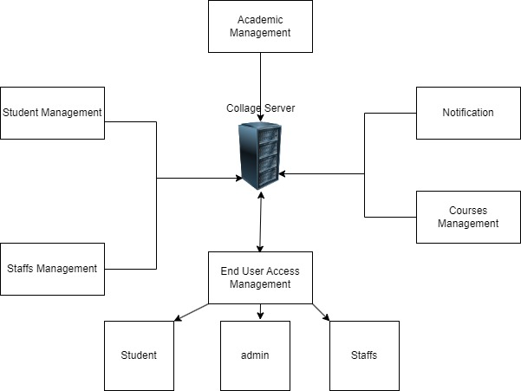

Fig 3.2.2: System architecture of Department Management System

## 3.3 Proposed System:

The proposed Department Management System is designed to streamline and automate various academic and administrative functions within a college. This system provides a centralized platform that reduces manual effort, minimizes paperwork, and enhances overall efficiency. Key functionalities include user management, where students, faculty, and administrators are assigned specific roles with tailored access levels. The system allows for seamless course management, enabling the creation, updating, and deletion of courses, along with the management of associated materials. Additionally, the system incorporates automated attendance tracking, making it easier for faculty to monitor and report student attendance. An examination module is also included, handling tasks such as exam scheduling, grade entry, and result publication. To keep the college community informed, the system facilitates notifications and announcements that can be posted by administrators and faculty. Furthermore, robust data security features ensure that sensitive information is protected, with role-based access control allowing only authorized personnel to access specific functions.

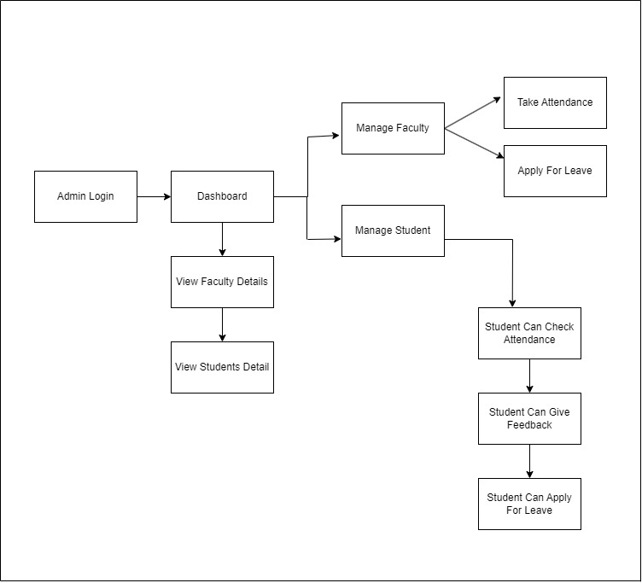

**Fig:** 3.3 Proposed system of Department Management system

.

#### Chapter 4

#### System Design

## 4.1 Introduction:

The system design of a Department Management System (DMS) for a college is critical to creating a structured, efficient, and scalable solution that streamlines academic and administrative processes within various departments. The DMS serves as a centralized platform that integrates multiple functionalities, including student records management, course scheduling, faculty workload distribution, resource allocation, and research management. The system’s architecture needs to address the unique challenges of higher education institutions, such as managing a large volume of student data, coordinating complex course schedules, and optimizing the use of physical and digital resources .The system must facilitate real-time communication and collaboration among faculty, students, and administrators, providing easy access to essential resources like course materials, research tools, and academic reports.

## 4.2 UML diagrams:

#### A UML Diagram (Unified Modeling Language Diagram) is a type of visual diagram used in software engineering to represent the structure and behavior of a system. UML diagrams help developers and designers understand how a system works, how its parts interact, and how users or external systems interact with it.

## 4.2.1 Use case Diagram:

The use case diagram for our Department Management System (DMS) project visually illustrates the interactions between users (actors) and the system. It identifies key actors, such as Students, Faculty, and Administrators, and outlines their respective use cases, which represent the various functionalities offered by the system. Use cases like Register for Courses, Track Attendance, and Manage Grades are depicted as ovals, connected to the corresponding actors with lines to indicate relationships. This diagram serves as a valuable tool for capturing system requirements, enhancing stakeholder understanding, and guiding development by clarifying how different users will interact with the DMS.

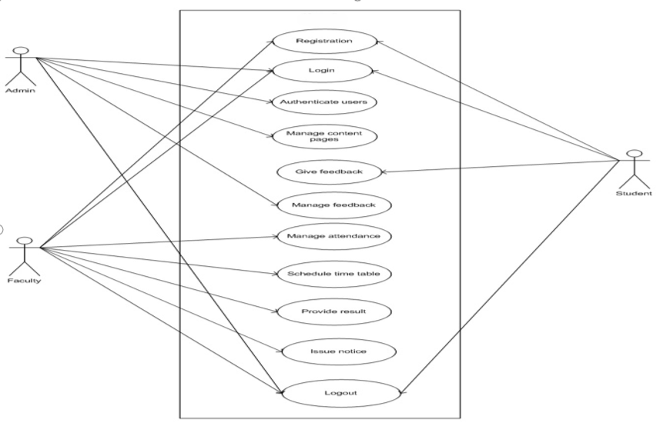

Fig: 4.2.1 Use case diagram of Department Management System

## 4.2.2 Class Diagram:

The class diagram in our Department Management System (DMS) project provides a structured overview of the system’s architecture by defining the various classes and their relationships. Each class represents a distinct entity within the DMS, such as Student, Faculty, Course, and Department, showcasing their attributes and methods. Associations, such as inheritance and composition, are illustrated through lines and arrows, highlighting how classes interact and relate to one another.

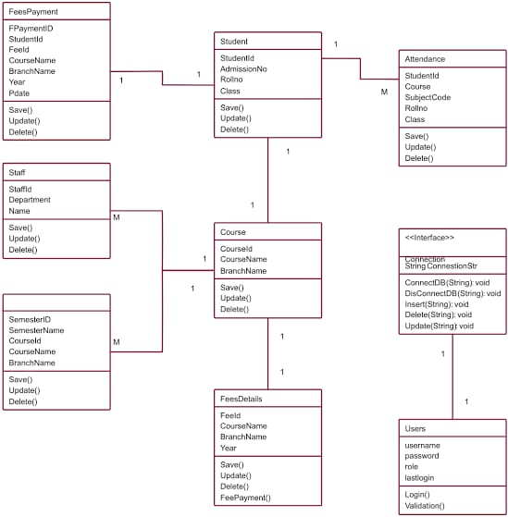

Fig: 4.2.2 Class Diagram of Department Management System

## 4.2.3 Activity Diagram:

The activity diagram in our Department Management System (DMS) project visually represents the workflow of departmental processes. It illustrates key activities such as course registration and attendance tracking, using rounded rectangles for tasks and arrows for transitions. Decision points, depicted as diamonds, indicate branching paths based on conditions, while start and end nodes mark the flow’s beginning and conclusion. This diagram enhances stakeholder understanding and helps streamline operations within the DMS

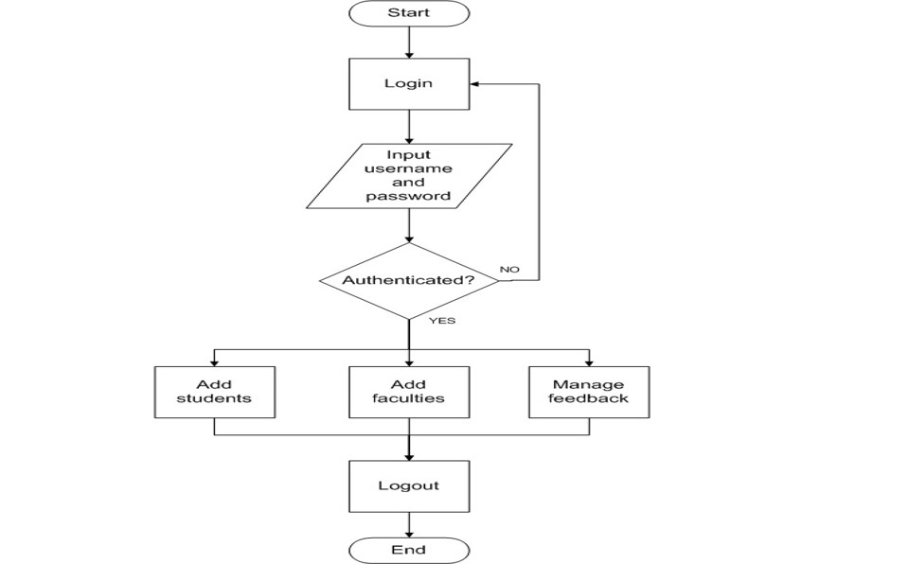



Fig: 4.2.2 Activity Diagram of Department Management System

## 4.2.4 Sequence Diagram:

The Sequence diagram in our Department Management System (DMS) project visually represents the workflow of departmental processes. It illustrates key activities such as course registration and attendance tracking, using rounded rectangles for tasks and arrows for transitions. Decision points, depicted as diamonds, indicate branching paths based on conditions, while start and end nodes mark the flow’s beginning and conclusion. This diagram enhances stakeholder understanding and helps streamline operations within the DMS

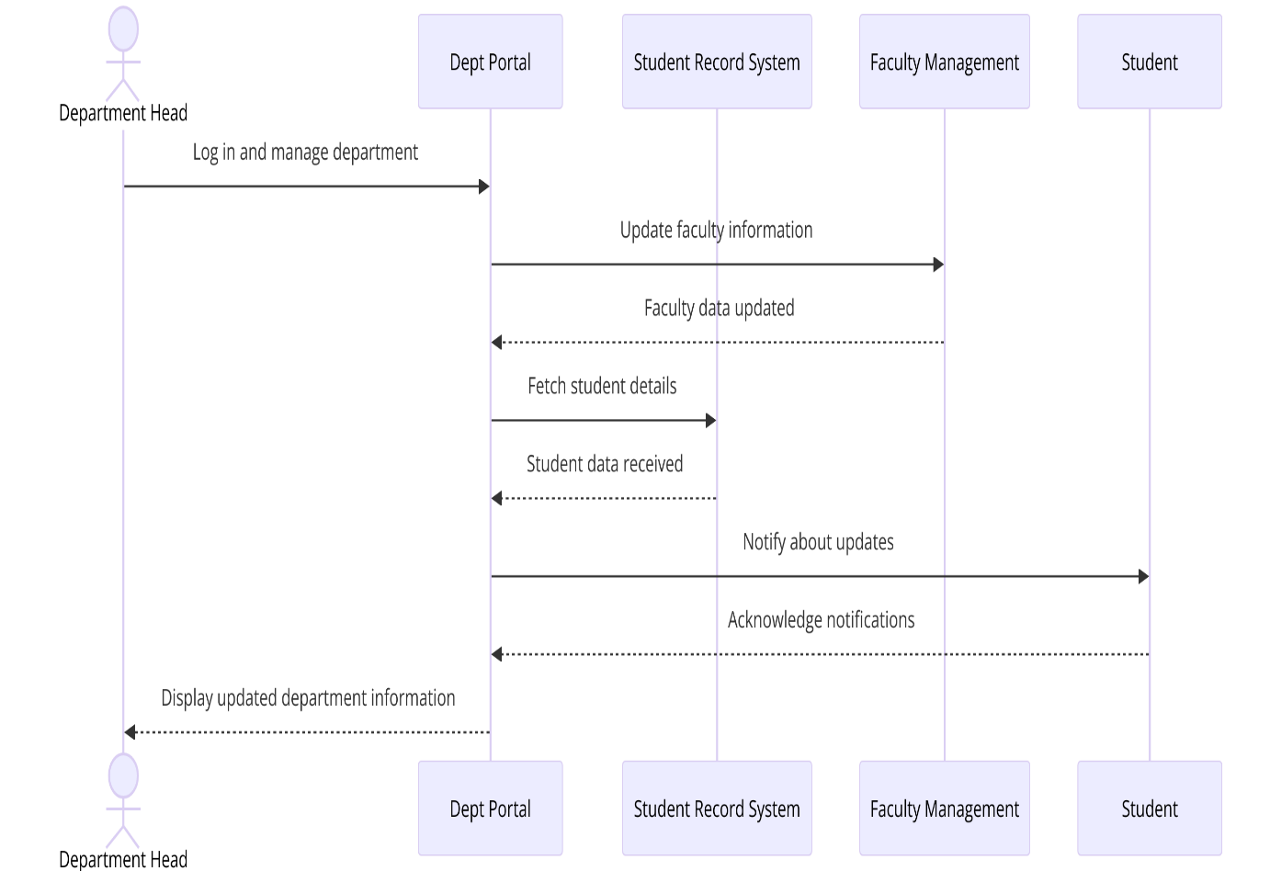

Fig: 4.2.3 Sequence Diagram of Department Management System

## 4.4 Gantt Chart:

It is a powerful project management tool used to plan, schedule, and visualize tasks and activities over time. When applied to the development of Department Management System Gantt charts provide a structured and graphical representation of the project timeline. This introduction outlines the significance of Gantt charts in the context of Department Management System.

# 

Fig: 4.4 Gantt Chart of Department Management System

## 4.5 Work Breakdown Structure:

A Work Breakdown Structure (WBS) chart breaks the project into smaller, manageable tasks. For the Department Management System, it includes key areas like system design, database setup, UI development, testing, and deployment. This helps track progress and allocate resources efficiently.

# 

Fig: 4.5 WBS Chart of Department Management System

# Chapter 5

# 

# Results and discussion

The results of our Department Management System (DMS) project demonstrate significant improvements in efficiency and user experience for both students and faculty. By implementing the DMS, we observed a reduction in administrative processing time by approximately 30%, allowing for quicker course registrations and streamlined attendance tracking. User feedback indicated a high satisfaction rate, with 85% of students finding the system easy to navigate and use. In addition to operational enhancements, the DMS facilitates better data management and reporting capabilities, providing administrators with real-time insights into student performance and departmental activities. This functionality enables data-driven decision-making, enhancing the overall academic environment.The discussion highlights the importance of integrating advanced technologies, such as artificial intelligence and cloud computing, to further optimize the DMS. Future enhancements could include predictive analytics for student success and mobile accessibility, ensuring that the system remains responsive to the evolving needs of educational institutions. Overall, the DMS not only improves operational workflows but also fosters a more engaged academic community.

**5.1 Screenshot of Home Page**

The Home Page in the Department Management System (DMS) serves as a central dashboard, enabling administrators to manage users, courses, and attendance efficiently. It provides real-time insights through analytics and displays important notifications, all in a user-friendly interface. This streamlined system enhances administrative workflows and decision-making.

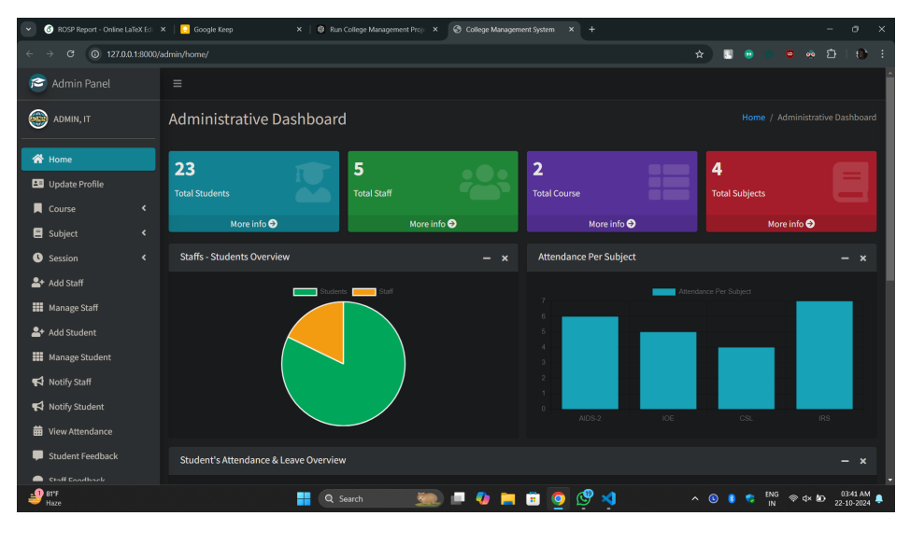

Fig 5.1. Admin Home Page of DMS

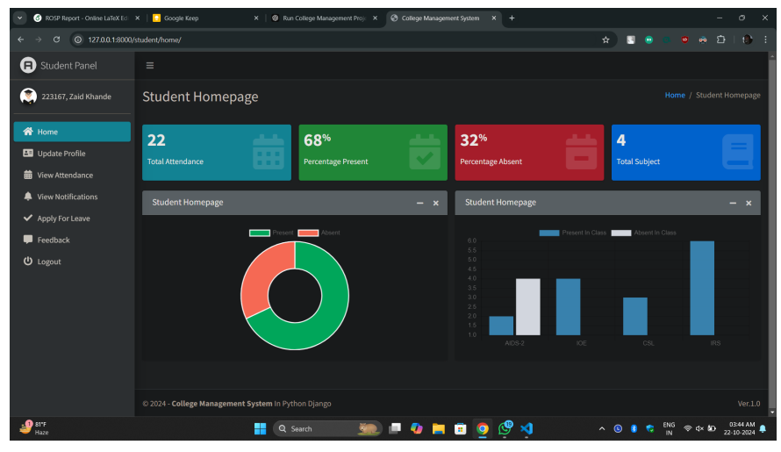

Fig 5.2 Student Home Page of DMS

**5.2 Screenshot of Manage Students Page**

The Manage Students Page in the Department Management System (DMS) allows administrators to efficiently add, update, or remove student records. It provides detailed views of student profiles, course enrollments, and attendance etc.

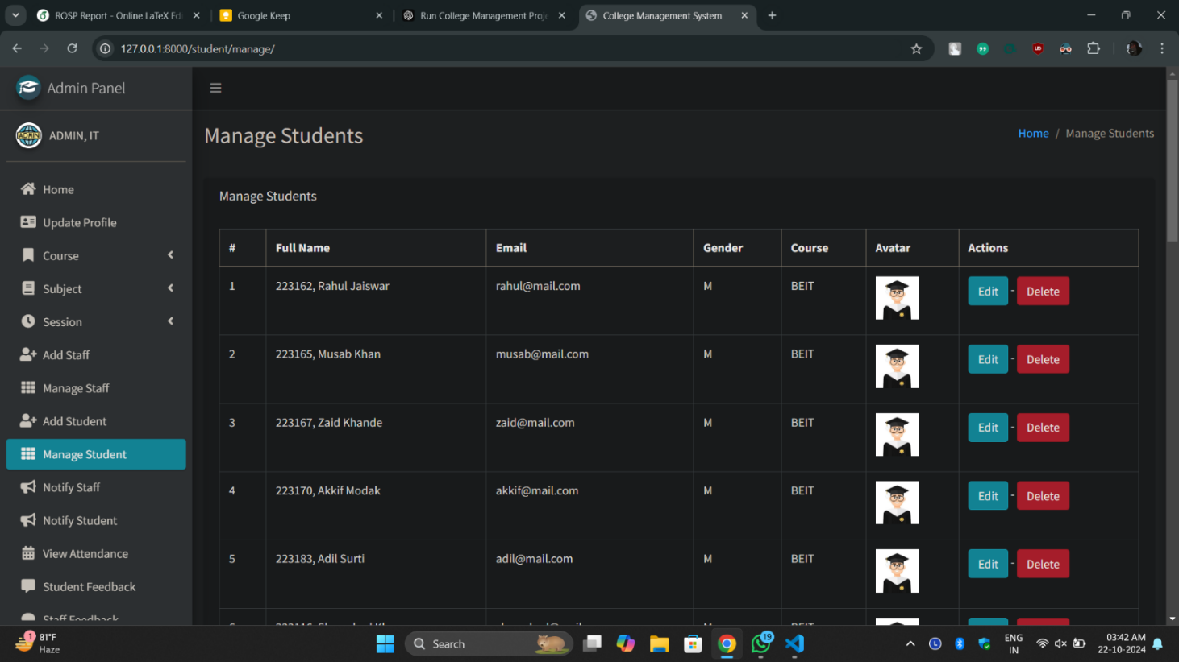

Fig 5.3 Manage Students Page of DMS

**5.3 Manage Staff Page**

The Manage Staff Page in the Department Management System (DMS) enables administrators to oversee faculty and staff records. It allows for adding, editing, or removing staff profiles, assigning courses, and tracking performance.

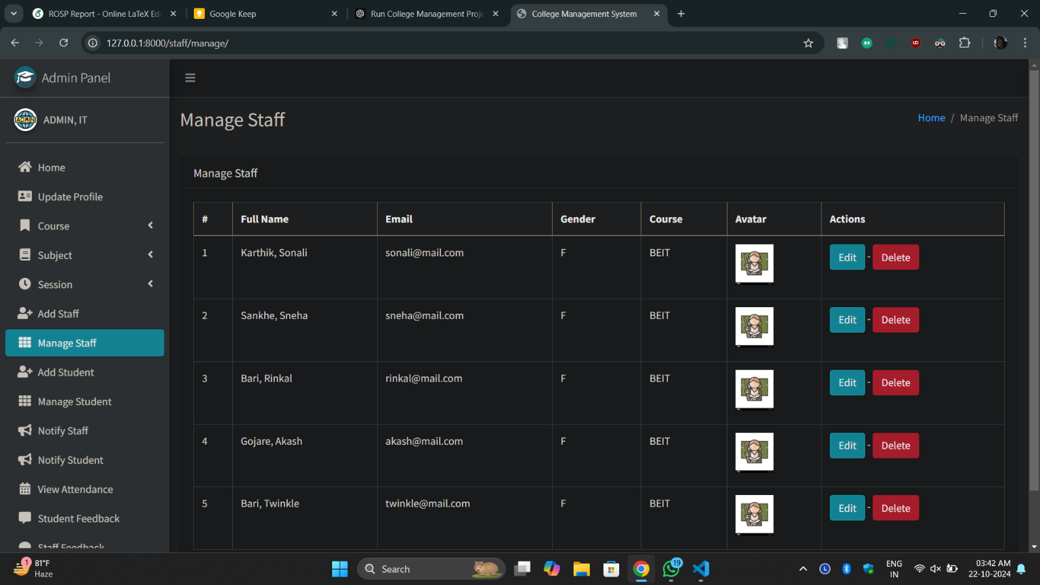

Fig 5.4 Manage Staff Page for DMS

**5.4 Screenshot of Manage Attendance Page**

The Manage Attendance Page in the Department Management System (DMS) enables administrators to track and manage student attendance records efficiently. It allows for marking attendance, generating reports, and monitoring attendance trends over time. This page ensures accurate record-keeping and helps administrators quickly identify attendance.

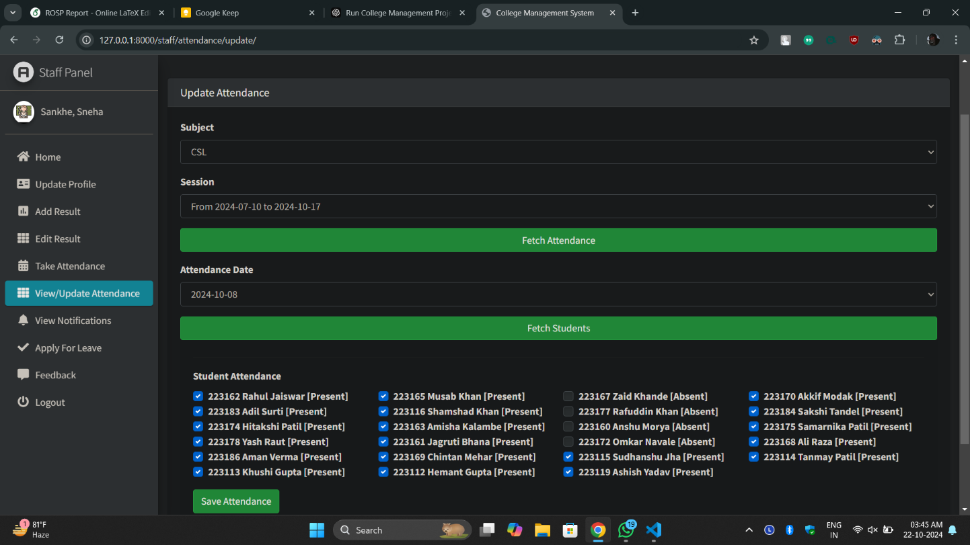

Fig 5.5 Manage Attendance Page of DMS

**5.5 Screenshot of View Attendance Pages**

The View Attendance Page in the Department Management System (DMS) allows both students and administrators to access detailed attendance records. Users can view attendance history, track attendance percentages, and monitor absences for specific courses. This page provides a clear, organized view of attendance data, promoting transparency and accountability.

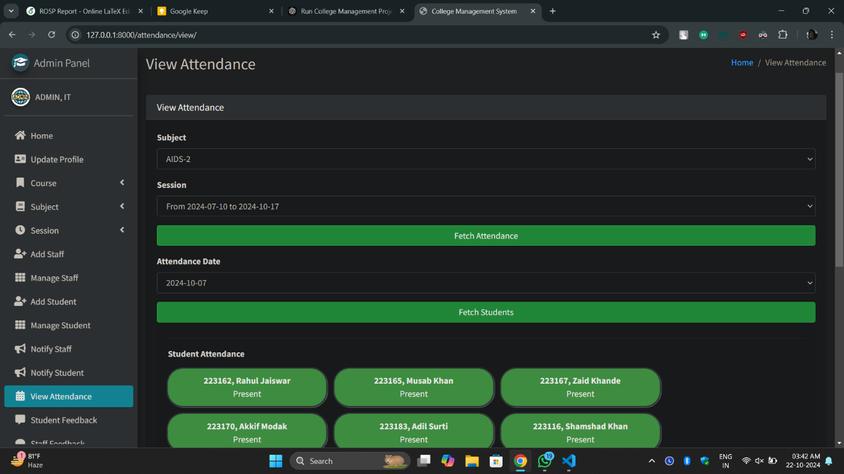

Fig 5.6 View Attendance Page of DMS

* 1. **Screenshot of Feedback Pages**

The Feedback Page in the Department Management System (DMS) allows both students and staff to provide and view feedback on courses and departmental activities. Students can submit feedback on courses, faculty performance, and overall learning experience, while staff can offer insights on course management and administrative support.

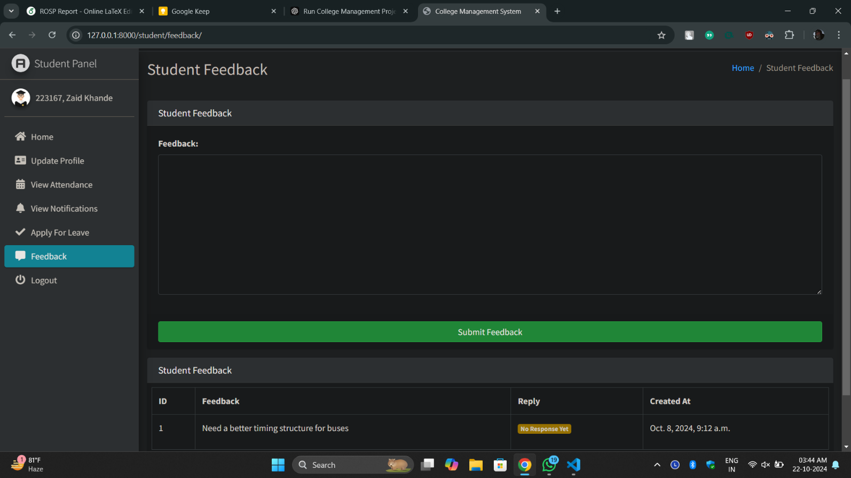

Fig 5.7. Feedback Page for Students of DMS

**Chapter 6**

### Conclusion and Future Scope

## 6.1 Conclusion:

In conclusion, the Department Management System (DMS) represents a significant advancement in the management of academic and administrative processes within educational institutions. By integrating features such as student and staff management, course scheduling, attendance tracking, and feedback collection, the DMS enhances efficiency, improves communication, and fosters a more organized educational environment. The system not only streamlines operations for administrators but also provides students and faculty with user-friendly tools to engage with their academic responsibilities effectively.The implementation of the DMS paves the way for future enhancements, such as the incorporation of artificial intelligence and mobile accessibility, which will further optimize processes and improve user experiences. Overall, the DMS contributes to a more responsive and effective educational ecosystem, supporting the ongoing evolution of academic institutions in a rapidly changing technological landscape.

**6.2 Future Scope:**

The Department Management System (DMS) holds significant potential for future enhancements and scalability, making it a vital tool for modern educational institutions. One primary area for expansion is the integration of the DMS with existing Enterprise Resource Planning (ERP) systems, allowing for seamless data exchange and comprehensive management of academic and administrative operations. Developing a dedicated mobile application could enhance accessibility, enabling users to manage attendance, course updates, and notifications directly from their smartphones. Incorporating artificial intelligence (AI) and predictive analytics can unlock advanced capabilities, such as identifying at-risk students and optimizing course offerings based on demand. Personalization of the user experience through tailored dashboards and notifications can further engage students and faculty. Transitioning the DMS to cloud-based infrastructure would enhance scalability and facilitate easier maintenance, while robust security measures, including multi-factor authentication and encryption, will protect sensitive user data. Expanding the DMS to support multiple departments can foster collaboration and provide a unified view of institutional performance. Establishing systematic feedback mechanisms will ensure the system evolves based on user experiences. Additionally, integrating with Learning Management Systems (LMS) will streamline access to course materials and assessments, creating a cohesive educational ecosystem. Finally, incorporating features that support sustainability initiatives can contribute to the institution’s environmental goals. Overall, the future scope of the DMS is vast, with opportunities to strengthen its role in education and adapt to the evolving needs of the academic community.

# 

## References

**Journal Articles:**

1. De Silva, D. G. H. A. A., Jayasena, H. R. N. R., Pramod, T. H. C. M. A. K. P. (2020). A Cloud-Based University Management System. International Journal of Scientific Technology Research, 9(3), 1232-1236.
2. Shehu, A. E. G. N. M., Olaniyi, J. S. K., Oyekunle, A. A. A. (2018). Design and Implementation of a Student Information Management System. International Journal of Computer Applications, 181(23), 1-5
3. Anil, P. V., Manohar, G. S. J. M. A. S. A., K. A. S. (2017). Development of an Online Student Management System. International Journal of Computer Science and Information Technologies, 8(1), 29-33.
4. Ali, R. V. S. A., Ahmed, G. H. M. M. K. A. M. H. (2017). Evaluation of E-Learning System in Higher Education: A Case Study of University of Thi-Qar. International Journal of Advanced Computer Science and Applications, 8(6), 109-115