

**Green University of Bangladesh**

**Department of Computer Science and Engineering (CSE)**

**Faculty of Sciences and Engineering**

**Semester: (Fall, Year:2022), B.Sc. in CSE (Day)**

**Course Title: Algorithm Lab**

**Course Code: CSE 204**

**Section: DA**

**Lab Project Name:** Sudoku Solver and Checker.

**Student Details**

|  |  |  |
| --- | --- | --- |
| **Name** | | **ID** |
| **1.** | **Md. Rahul Islam Joy** | **212902070** |

**Submission Date :**

**Course Teacher’s Name : Dr. Faiz Al Faisal**

**[For Teachers use only: Don’t Write Anything inside this box]**

|  |
| --- |
| **Lab Project Status**  **Marks: …………………………………                              Signature: .....................**  **Comments: ..............................................                             Date: ..............................** |

Table of Contents

**Chapter 1 Introduction** [**3**](https://docs.google.com/document/d/1Nr3aOess1ttdV-mjh5Svjq2rDGMsjTfO/edit#heading=h.gjdgxs)

1.1 Introduction---------------------------------------------------------------------------[3](https://docs.google.com/document/d/1Nr3aOess1ttdV-mjh5Svjq2rDGMsjTfO/edit#heading=h.30j0zll)

1.2 Design Goals--------------------------------------------------------------------------[3](https://docs.google.com/document/d/1Nr3aOess1ttdV-mjh5Svjq2rDGMsjTfO/edit#heading=h.1fob9te)

**Chapter 2 Implementation of the Project** [**4**](https://docs.google.com/document/d/1Nr3aOess1ttdV-mjh5Svjq2rDGMsjTfO/edit#heading=h.2et92p0)

2.1 Chess Board --------------------------------------------------------------------------[4](https://docs.google.com/document/d/1Nr3aOess1ttdV-mjh5Svjq2rDGMsjTfO/edit#heading=h.tyjcwt)

2.1.1 Board picture--------------------------------------------------------------------------4

**Chapter 3 Performance Evaluation** [**5**](https://docs.google.com/document/d/1Nr3aOess1ttdV-mjh5Svjq2rDGMsjTfO/edit#heading=h.4d34og8)

3.1 Simulation Environment----------------------------------------------------------[5](https://docs.google.com/document/d/1Nr3aOess1ttdV-mjh5Svjq2rDGMsjTfO/edit#heading=h.2s8eyo1)

3.2 Results and Discussions----------------------------------------------------------[5](https://docs.google.com/document/d/1Nr3aOess1ttdV-mjh5Svjq2rDGMsjTfO/edit#heading=h.17dp8vu)-6

**Chapter 4 Conclusion 7**

4.1 Practical Implications---------------------------------------------------------------7

4.2 Scope of Future Work ---------------------------------------------------------------7

**References 8**

**Chapter 1**

**Introduction**

1. **Introduction**

Sudoku game is the Japanese popular game. Now a days, Sudoku puzzles are becoming popular among all over the world. The game has become popular now in a large number of countries and many developers have tried to generate even more complicated and more interesting puzzles. Now a days, we can see this game appears in almost every newspaper, in books and in many websites. This means that the algorithm is implemented based on human perceptions. I implement this game that’s mean sudoku game solver and checker in C language using Backtreaking.

1. **Design Goals**

The goal of sudoku is simple: **fill in the numbers 1-9 exactly once in every row, column, and 3x3 region**. For example, look at the above puzzle and compare it to the solved version below. Notice that every row, column and 3x3 region contain every number from 1-9 exactly once.

**Chapter 2**

**Implementation of the project**

**2.1** **Problem Implementation:**

Given a 9 x 9 the rows and column of the Problem.

**2.1.1.**

{4,3,8,1,9,2,7,6,5},

{9,7,1,8,5,6,3,4,2},

{0,6,0,0,0,0,0,0,1},

{8,2,0,0,1,0,0,0,0},

{1,4,0,5,0,7,0,2,6},

{0,0,0,0,8,0,0,3,9},

{5,0,0,0,0,0,0,1,0},

{0,8,4,9,2,0,0,5,0},

{0,0,0,3,7,0,4,0,0}

};

**Chapter 3**

**Performance Evaluation**

**3.1** **Simulation Environment:**

IDE: CodeBlocks

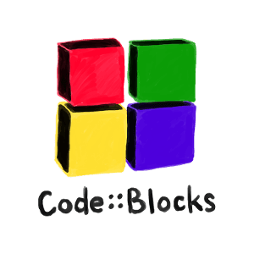

Programming Language: C



[This Photo](http://www.flickr.com/photos/lwr/158885251/) by Unknown Author is licensed under [CC BY-SA-NC](https://creativecommons.org/licenses/by-nc-sa/3.0/)

**3.2** **Results and Discussions:**

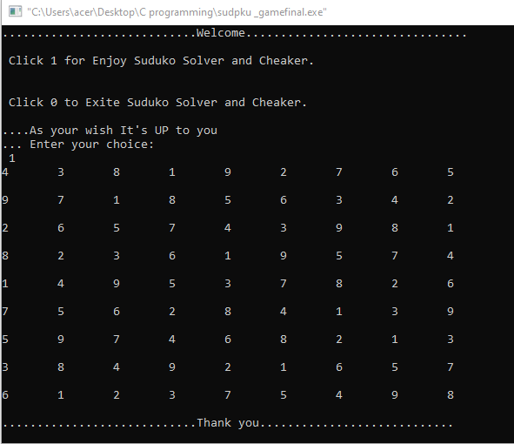

**Sudoku – The Rules**

* Only use the numbers 1 to 9 in a game of Sudoku. ...
* Avoid trying to guess the solution to the Sudoku puzzle. ...
* Only use each number once – do not repeat any numbers. ...
* Use the process of elimination as a tactic. ...
* Use cross-hatching and penciling-in techniques to solve the puzzle.

**Chapter 4**

**Conclusion**

## Introduction

In this project I have used c programing language. I have successfully completed the code implementation using backtracking. The code run according to the loops and functions implemented inside the code.

## Practical Implications

## For Brain exercise. Backtracking is used in computer science and industrial applications, load balancing in a multiprocessor computer.

## Scope of Future Work

In future by adding more features it can be more attractive game.

**References:**

[1] <https://www.gamesver.com/sudoku-rules-for-beginners-all-you-need-to-know/>

[2] YouTube

[3] Geek For Geeks