TSP With Only Left Turns
Project Specification and Design

Team Members (Group 3):
Rahul Kothari (Student ID: 201316606)
Tyler Jay (Student ID: 201263334)
Matthew Neersoo (Student ID: 201245264)

Primary Supervisor: Alkmini Sgouritsa

Secondary Supervisor: Aris Filos Ratsikas

Index
- Project Introduction 3

- Aims and Objectives 3

- Background Research and Key Literature 3

- Development Process and Method 7

- Data Sources and Ethical Considerations 8

- Project Plan 8

- Risks and Contingency Plans 9

- System Design 10
  - Extracting and Storing Data 10
  - Data Structures 10
  - Key Algorithm Design and Implementation 11
    - Dijkstra Algorithm 11
    - Plot Graphs and Routes 12
    - Manipulating Edge Lengths 12

- Experimentation, Evaluation and Testing 13
  - Hypothesis Assumptions 13
  - Testing and Test Data 13
  - Experiment Design 13
  - Analysis 13
  - Anticipated Conclusions 13

- References 14

Project Introduction
The Travelling Salesman Problem [1] is a well-known optimisation problem that has consistently proved relevant in both theoretical and practical Computer Science. The nature of the Travelling Salesman Problem permits it to be understood as a part of graph theory and subsequently modelled as a graph. This is noteworthy in this project, for reasons that will be explained shortly.

Focusing on the practical relevance of the Travelling Salesman Problem, we know it is of particular interest among delivery services, whose goal is (generally speaking) to deliver all given products in a set time frame using the most efficient possible route. This metric of efficiency tends to take various factors into account; distance, fuel costs, time taken, and so forth. A delivery service’s ability to identify the optimal route in their area of operations allows them to minimise travel and labour costs.

This brings us to a specific case of this in action; UPS’ route optimisation, known as ORION. The UPS (United Parcel Service) has a policy mandating that drivers completely avoid all left turns in their delivery routes. The reasoning behind this, of course, goes back to, as stated earlier, the increased costs associated with left turns, with evidence showing that right turns may be more efficient in terms of time and fuel consumption [2].

The project undertaken here is an investigation, the purpose of which is to discover whether a route avoiding all right turns could be a better solution than the actual minimum route, by assuming some cost on the right turns [3]. (Note: because this project is carried out in the UK which practises left-hand traffic, we will avoid right turns instead of left)

Aims and Objectives
- Extract real-world map data for experimental calculations
- Implement the ability to identify node-to-node directions representing left turn, forward, and right turn options on a given route
- Identify the optimal route on given extracted map data in accordance with Dijkstra’s algorithm
- Restrict available routes within given extracted map data to forbid right turns and/or assume some cost that makes them unattractive to choose
- Compare and contrast the outcomes for right-turns-only route and the optimal route for TSP

Background Research and Key Literature
United Parcel Service (UPS) is an American multinational package delivery company that developed ORION (On-Road Integrated Optimization and Navigation) – a 1,000-page proprietary algorithm that the company developed to come closer to finding an optimal solution to the Travelling Salesman Search Problem (TSP).

The Travelling Salesman Search Problem (TSP) is an NP-Complete problem since it is both NP and NP-Hard (An NP-Hard problem is one where all NP problems can be reduced to it in polynomial time). TSP addresses the following question: “Given a list of cities and the distances between each pair of cities, what is the shortest possible route that visits each city exactly once and returns to the origin city?”

With just 10 cities, there are 3.6 million possible routes. Each UPS driver typically visits 100s of cities a day. ORION optimises delivery routes with regard to distance, fuel and time. ORION was developed after UPS gathered data from its GPS sensors, and it undergoes constant improvement by learning from the experience of UPS drivers. ORION doesn’t give the perfect route but provides a fast alternative. By 2016, ORION was deployed in 55,000 routes in North America. One of ORION’s famous principles is avoiding left turns, as to take left turns, one has to wait at traffic signals and spend time idling thus increasing the time a route takes. It also means going against the flow of traffic, which increases exposure to oncoming cars and results in a higher incidence of accidents. Avoiding left turns is therefore faster, fuel-saving, and safer [4], [5], [6].

The aim of this project is to analyse whether avoiding the left turn is actually useful with routing on simple street maps. Due to the fact this project is conducted in the UK, which practices left-hand traffic, the analysis is to be conducted with right turn avoidance.

As implied in the Aims and Objectives section,

Step 1 for the analysis would be to extract map data into a directed graph.

Using real street maps rather than randomly generated data would make the research more effective (especially given that ORION also runs on real-world data). There are many options for extracting map-related data – Google Maps API, Bing API, Open Street Maps (OSM) etc. OSM is an open-source project, where people all across the world add data about streets, buildings and other locations. Aside from being one of the only free to use options, it also has the largest amount of compatible python libraries. One such library is OSMnx [7] which is built on top of network, matplotlib and NumPy. OSMnx docs, OSM’s wiki and a dedicated stack overflow topic for OSM questions meant that OSM would be the easiest to use in terms of importing maps. OSMnx lets you download spatial geometries and model, project, visualise and analyse real-world street networks from OpenStreetMap’s APIs [8]. An XML file of an area of a map can also be downloaded from the website which is imported in the form of a MultiDiGraph. A multidigraph is a directed graph where multiple edges can exist between the same two nodes [9]. Each node represents a building or a location, and each edge represents the streets connecting two locations. Each edge also has a weight which represents the distance (in metres) i.e. how long the street is. So when the graph is plotted, the streets are elongated based on the distance. The edge also has other associated attributes. Shown below, are the attributes stored for an edge that represents Ashton Street in the University of Liverpool, UK

(
24987605,
348150958,
{
‘osmid’: 4961018,
‘name’: ‘Ashton Street’,
‘highway’: ‘service’,
‘access’: ‘private’,
‘oneway’: False,
‘length’: 147.614,
‘geometry’: <shapely.geometry.linestring.LineString object at 0x000001CB1DB4F1D0>, ‘bearing’: 176.2
}
)

The first two numbers are Node IDs for the nodes that are connected by this edge. Next is the OSM id for the edge, the name of the street, and so on. The geometry attribute helps OSMnx to plot the street on the right angle. According to the OSMnx documentation, bearings represent the angle in degrees (clockwise) between north and the direction from the origin node to the destination node.

Finally, when using OSMnx to plot all nodes and edges in Liverpool, United Kingdom, the graph looks like the one shown in Figure 3.1.
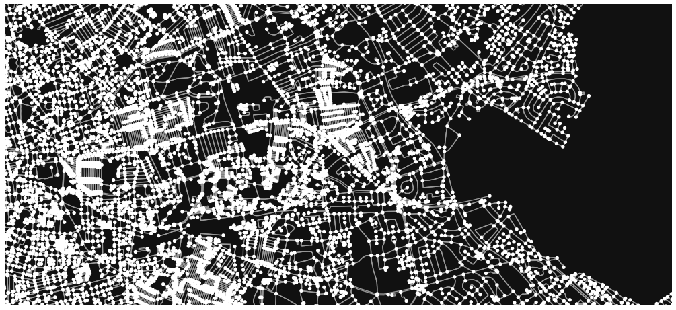
Figure 3.1 – Liverpool extracted map data
Given such a map, the idea is to hard-code certain node IDs and perform TSP on them.

Step 2 – Apply the Dijkstra Algorithm on each pair of nodes

A typical, basic TSP problem can be represented as it appears in Figure 3.2.

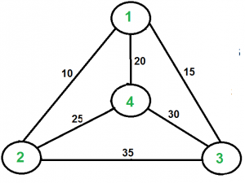
Figure 3.2 – TSP Problem [10]

There seems to be just one undirected edge between two nodes. In our case, there could be multiple ways to reach any pair of nodes.

Thus, the Dijkstra algorithm is initially employed between every pair of nodes to calculate the shortest distance between two nodes. This is a computationally expensive step (O(n²) where n = number of nodes), however, it is necessary to eventually run TSP on the graph.

Dijkstra’s algorithm was invented by EW Dijkstra in 1959 [11] as a way to find the shortest path between two nodes connected in a weighted directed graph with positive weights. The idea behind Dijkstra's algorithm is as follows: maintain a set of unvisited nodes. Initialize the starting node as 0, and set distance for all other nodes as infinity. For the current node, mark the tentative distance for its unvisited neighbours. Mark the current node as visited. Choose the node with the minimum distance as the current node and repeat the algorithm until the destination node is visited.

Once the shortest paths between the selected nodes are found, we have a graph similar to the typical TSP graph to carry out the TSP algorithm.

Step 3 -TSP on all locations.

Now we implement an algorithm for TSP to find the best route between all nodes. We can look at all possible shortest routes between nodes, and then calculate the optimal solution (the shortest path between all nodes). TSP is an NP-Complete problem so there is no known polynomial-time solution. However, there are a few exact algorithms like brute-force approach that solve in exponential time complexity. Various branch-and-bound algorithms and linear programming concepts have been applied to completely solve large instances of the TSP. For example, an exact solution for TSP on 15,112 German towns was found in 2001 using an idea proposed in the Solution of a Large-Scale Traveling-Salesman Problem [12]. There are several heuristic and approximation algorithms that run in pseudo-polynomial time. For example, the Christofides–Serdyukov algorithm is a 3/2-approximation algorithm. [13], [14]

Step 4: Dijkstra avoiding right turn

The project aims to analyse how the result of TSP changes when avoiding right turns as opposed to when implementing TSP with no such restriction. Steps 2 and 3 already use Dijkstra and TSP without any restrictions.

To carry out TSP with no right turns, we simply calculate the shortest path between each pair of nodes (using Dijkstra), but this time the paths must not contain any right turns.

In Dijkstra, for each selected node, the algorithm iterates through all of its outgoing edges. At this step, we filter out all edges that have a bearing that signifies a right turn. Note that a bearing is an angle in degrees (clockwise) between north and the direction from the origin node to the destination node.
E.g.:
>>> osmnx.bearing.get_bearing((0,0), (10,0))
0.0
>>> osmnx.bearing.get_bearing((0,0), (0,10))
90.0
>>> osmnx.bearing.get_bearing((0,0), (-10,0))
180.0
>>> osmnx.bearing.get_bearing((0,0), (0,-10))
270.0
>>> osmnx.bearing.get_bearing((0,0), (-10,-10))
224.56145141325769

So a ‘neat’ right turn would have a bearing of 270 degrees. However, in the real world, not all roads are straight and cars typically don’t take any sharp right turns. Therefore we must include all bearings between 225 degrees to 315 degrees (45 degrees to either side of 270) to be a right turn.

And so Dijkstra would only give us paths that avoid right turns

Step 5: Apply TSP on the new paths

Same as Step 3, except this time the paths avoid right turns so by default whatever route TSP does take will also exclude right turns.

UPS’ ORION algorithm factors in factors such as fuel cost and time wasted on idling. To mimic this, the route distances when avoiding right turns could be artificially reduced by a factor. The intention is that once experiments with the authentic length have been conducted and comparisons with the known optimal route have been made, we artificially alter the ‘weight’ i.e. length of the edges present. The degree of these alterations will vary, ranging from the authentic weight to a hypothetical upper bound, wherein only left turns becomes the new optimal solution - that is assuming that there will exist cases that only left turns will not be optimal on a given map whilst the weights remain unchanged. It is considered that there may not be an optimal solution provided by only left turns, in which case these weights will be varied to discover how close we can go to the optimal solution without sacrificing computational time.

Although no research papers could be found to be exactly similar to the project conducted here, there have been many studies that have applied TSP to real-world maps like the one here: [15].

Development Process and Method
Since the development of this project began before writing this document, an evolutionary development model is used. Given, this is a research-based project, the idea is to create a prototype, do some experimentation and keep iterating on it until the final system is satisfactory to conduct analysis on. Although there is a lack of process visibility, this model works well when the requirements aren’t perfectly clear. This suits the team well, given the team can gather sufficient prior knowledge to design the system. As shown in Figure 4.1, the concurrent activities of developing and analysing allow us to better understand various aspects of the system, which we otherwise would have had little knowledge in, (such as extracting maps from OSM, figuring out the left and right turns, etc.).
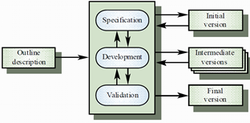
Figure 4.1 - Evolutionary Development Diagram [17]
We are using python as the programming language for this project, because of the rich tools and libraries written in it (e.g. Numpy, OSMnx, matplotlib etc.). Python’s dynamic type casting mean that we can spend more time thinking about the actual development rather than worrying about the syntax issues. We also use a python virtual environment to isolate the system and easily manage the dependencies. The entire team uses Windows OS however using a python virtual environment allows for easier portability between operating systems. Finally, we are using git for version control. All the code is stored on a GitHub private repository, as a backup.

Data Sources and Ethical Consideration
The vast majority of data in consideration for this project is that of the map data. Since the intention is, as stated earlier, to use real map data for experimental calculations, this data will need to be properly accredited and undergo ethical considerations by the project team before it is processed for the experimental work in the project. This data will be extracted via a program developed by the project team using the OSMnx library.

The source of the map(s) being used has been identified earlier in the specification as OpenStreetMap (OSM). OSM is a collaborative, open-source project and thus the data it makes available, including the data that will be used in this project, is open to free and fair use provided proper credit is given. The specifics of what credit should be given to OSM and it’s contributors and how it should be done is outlined in full on the OSM copyright page [16] and will be included in all deliverables relating to this project.

Regarding any further data and the ethics surrounding its use, there is little. No personal data will be used throughout the project and newly generated data that will come from adaptations of OSM extracted map data falls under the free and fair use policy that OSM outlines. The testing & evaluation will also not require any external evaluation from those not involved in the project, i.e. the public, and therefore no considerations to proper handling and anonymising of personal data will be necessary.

Project Plan
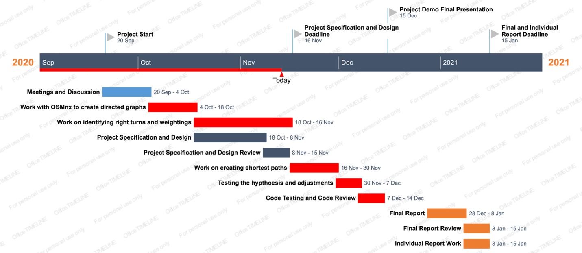

Risks and Contingency Plans

Risk | Contingencies | Likelihood | Impact
Hardware Failure | To stop hardware failure, we are using GitHub to manage our project versions. This means the most up to date version of the project is always stored in the cloud. So if any of our hardware fails, only work local to that machine that hasn’t been committed is lost. | Low | Due to the contingencies we put in place, the overall impact of hardware failure will be minimal, as only local work can be lost and this won’t affect the main branch of work.
Software Failure | To stop software failure, we are taking a few levels of precaution. The first is managing versions with GitHub, meaning if any of our text editors or any other software needed for the code crashes, only work local to that user is lost and the most up to date version of the project is still saved. | Medium | Due to the contingencies, we have put in place, the overall impact of software failure will be minimal to our project.
Running out of Time | To make sure we don’t run out of time, we have produced a Gantt chart for the project so we know how much time to allocate to each phase of the project. We also have weekly meetings to discuss progress and adjust the allocated time if we feel it necessary | Low | Overall, if we ran out of time and missed any deadline, this would have a large impact on the project, however, due to the contingencies put in place, we should be able to spot this before it happens and make new plans to avoid this.
Programming Problems | To make sure programming problems are dealt with, we have weekly meetings where any issues are discussed and the group can provide potential solutions. We also have a group chat where anything that needs to be discussed urgently can be and the group can help solve the issue. If the group as a whole can’t solve a programming problem, then we have access to online documentation or our project supervisor that can help us. | High | While programming problems are inevitable, the overall impact will be minimal to the project. This is because we have many ways of overcoming these problems and making sure they never cause a major disruption to the timeline of the project.
Low Motivation | We are working in a group to inspire each other. | Low | Catastrophic Impact

System Design

Extracting and Storing Data
As mentioned in previous sections, data is extracted from Open Street Maps. The OSMnx library in Python provides a convenient graph_from_place() method that takes in a string as a parameter.

E.g.:
G = osmnx.graph_from_place('Liverpool, North West England, England, United Kingdom')

Would return a MultiDiGraph representing all roads and buildings in Liverpool, UK. In this case, it includes about 30150 nodes and 75131 edges.

This graph can then be stored as a .osm file (OSM formatted xml file) using the save_graph_xml() method.

Another way of extracting data is through the OSM Website [18]. A user can zoom into the right location and export the data into a .osm file which can be loaded using osmnx.graph.graph_from_xml() method. For example, Figure 8.1 shows the graph obtained when zoomed into the University of Liverpool area on OSM.
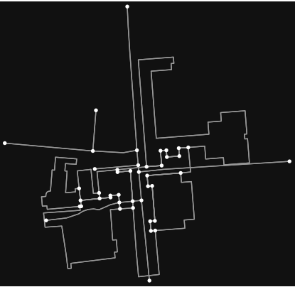
Figure 8.1 - University of Liverpool Campus Extracted Map Data

Data Structures
The key data structure present in the project is the directed multigraph. All the practical experiments that have been outlined throughout the specification and design, and subsequently the success of the project as a whole, relies on the directed multigraph data structure. This is because all real-world map data extracted and processed in the project is expressed as a directed multigraph.
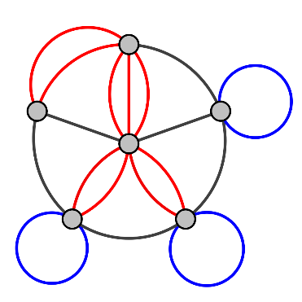
Figure 8.2 - (Undirected) Multigraph [19]
Figure 8.2 shows us an undirected multigraph. The structure consists of multiple nodes, along with a series of edges between the existing nodes. Our data structure is slightly different to Figure 6.2 in that these edges have directions attached, reflecting the directional restrictions in the real-world streets our data is based upon.

Reiterating what was explained in the background research section of the specification, there will be two primary directed multigraphs (MultiDiGraph) to be used in this project and both are closely connected. With the first processing step, in terms of extracting, map data we will have a directed multigraph wherein the nodes represent key locations (or ‘stops’, thinking in a more practical sense) and the edges represent the streets connecting any two given key locations. It is also worth noting the weight of each edge, representing distance. Further along in the processing, we rework the aforementioned directed multigraph, ignoring right turns and producing a new directed multigraph in which key experiments can take place and we can produce outcomes to be compared with the optimal route.

Key Algorithm Design and Implementation
This section handles all the key algorithms that manipulate data structures used, other algorithms that are key to the project and their pseudocode.

Dijkstra Algorithm
The implementation of Dijkstra occurs in Python, in line with the guideline outlined by Ben Keen [20]. Ignoring the right turns during processing, as stated earlier, occurs based on conditions related to the bearing between any two given nodes. The program iterates through the edges between an initial node and a concluding target node, as well the nodes in between, ignoring the edges with node-to-node bearings between 225 and 315 degrees, i.e. right turns. If the edge in consideration does not qualify as a right turn the Dijkstra algorithm continues without disregarding the edge. The aforementioned edge avoidance produces a graph that allows us to understand it as a TSP.

Psuedocode
function dijkstra(graph, source node, target node, avoid right turns)
while current node isn’t target node
if avoid right turns is true
filter out edges where edge.bearing > 225 or edge.bearing < 315

traverse nodes to find the shortest path based on edge weights

while a current node exists
add current node to path
reassign current node to be next node with lowest weight
return path

Plot Graphs and Routes
Whilst the project outcome is not directly dependent on an interface for the various graphs to be dealt with, various graphs will be plotted throughout the implementation to aid in our understanding of the project and, subsequently, improve how the project is conducted. The OSMnx package includes a ‘plot’ module [21], which has the plot_graph_route() function that can plot a route on a graph, which is of particular use since it allows us to see exactly what nodes and edges we visit in a given route calculation like shown in Figure 8.3.

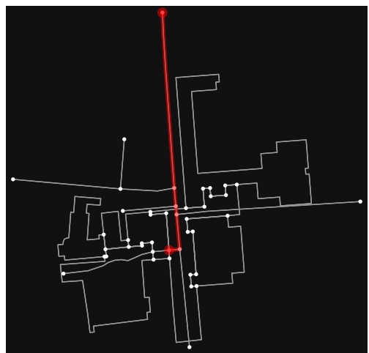
Figure 8.3 - Displaying a Route in a Graph

Manipulating Edge Lengths
As described earlier, in the background research, the intention is to include variations of the weights of edges to discover exactly how close an only-left-turns solution can come to the known optimal route. Varying from the authentic length to a hypothetical ‘upper bound’ simply involves iterating artificial weights across the specified range to produce outcomes to be understood and evaluated in terms of the goals of the experimentation in this project.

Psuedocode
factor <- SOME_PRE_DETERMINED_RATIO
G <- import osm map
newG <- G
for edge in G.edges():
edge = edge * factor

//now do Dijkstra on the edges with avoid_right_turns flag = True

Experimentation, Evaluation and Testing

Hypothesis Assumptions
The purpose of this project is to investigate if a route avoiding all right turns could be a better solution to the travelling salesman problem than the actual minimal route if we assume some cost on right turns to simulate real life.

To test this hypothesis we have to make two assumptions:
- That a right turn has a bearing of between 225 and 315 degrees. This is because we have to have a way of classifying right turns to try and avoid them. This is an approximation (some right turns may still be missed out, or non-right turns may be included).
- The second assumption is the factor by which we increase path lengths, to add weight, is reasonable and can appropriately simulate the real-world cost of a right turn compared to a left turn.

Testing and Test Data
Initial early tests will be conducted on a graph of the University of Liverpool guild. This is because it is a small graph and easy to see any problems and logical errors we might encounter. For the final hypothesis testing, we intend on using a multigraph of the entire Liverpool region. This is the best graph for testing as it is a street map that is similar to what UPS use for their deliveries, meaning we can accurately test our hypothesis.

Experiment Design
We will first create the street graph of Liverpool, then perform the Dijkstra algorithm on each pair of nodes. Using the information we gathered from Dijkstra we can then perform a TSP solution on a given set of nodes. This gives us our control solution. We will then perform Dijkstra for each pair of nodes again, only this time we use bearings to identify the right turns. We will iterate through the right turn edges and increase the length to add weight. The TSP solution will be continuously tested until we have a solution that avoids right turns.

Analysis
To analyse our results, we will compare the first TSP solution (shortest path on the unweighted graph) to the second (TSP solution taking into account the weighting on right turns) and see which solution is better in terms of distance. We also analyse the weight needed for the solution avoiding right turns and look to see if this weight is a reasonable simulation for the real-life cost of a right turn (traffic light time, increased risk etc.)

Anticipated Conclusions
Overall, we anticipate that the original shortest path will be more optimal, even when taking weighted right turns into account. This is because we suspect the weights needed for a solution that avoids right turns will be unreasonable (as they are hard to estimate).

References
[1] ‘Travelling salesman problem’ (2020) Wikipedia. Available at: https://en.wikipedia.org/wiki/Travelling_salesman_problem (Accessed 2 November 2020).

[2] DeliveryBizPro (2018) What is the travelling salesman problem and how can you solve it?. Available at: https://www.deliverybizpro.com/blog/delivery-routing-software/what-is-the-traveling-salesman-problem-and-how-can-you-solve-it/ (Accessed: 2 November 2020).

[3] Sgouritsa, A. (2020) TSP with only right turns. Available at: https://sam.csc.liv.ac.uk/COMP591/index.php (Accessed: 2 November 2020).

[4] UPS (2016) ORION: The algorithm proving that left isn’t right. Available at: https://www.ups.com/us/en/services/knowledge-center/article.page?kid=aa3710c2#:~:text=ORION%20is%20the%20heart%20of,locations%20and%20dates%20as%20needed (Accessed: 3 November 2020).

[5] Holland, C., Levis, J., Nuggehalli, R., Santilli, B. and Winters, J. (2017) ‘UPS Optimizes Delivery Routes’, Interfaces, 47(1):8-23. doi:10.1287/inte.2016.0875.

[6] UPS (no date) Orion Backgrounder. Available at: https://www.pressroom.ups.com/pressroom/ContentDetailsViewer.page?ConceptType=Factsheets&id=1426321616277-282 (Accessed: 4 November 2020).

[7] Boeing, G. (2020) osmnx package. Available at: https://osmnx.readthedocs.io/en/stable/osmnx.html (Accessed: 5 November 2020).

[8] Boeing, G. (2020) OSMnx. Available at: https://github.com/gboeing/osmnx/README.md (Accessed: 5 November 2020).

[9] NetworkX (2015) MultiDiGraph - Directed graphs with self loops and parallel edges. Available at: https://networkx.org/documentation/networkx-1.10/reference/classes.multidigraph.html (Accessed: 5 November 2020).

[10] Singh, N. (2020) Travelling Salesman Problem (TSP) Implementation. Available at: https://www.geeksforgeeks.org/traveling-salesman-problem-tsp-implementation/ (Accessed: 3 November 2020).
[11] Dijkstra, E W. (1959) ‘A Note on Two Problems in Connexion with Graphs’, Numerische Mathematik, 1, pp. 269-271. doi:10.1007/BF01386390.

[12] Dantzig, G., Fulkerson, R. and Johnson, S. (1954) ‘Solution of a Large-Scale Travelling Salesman Problem’, Journal of the Operations Research Society of America, 2(4), pp. 393-410. doi:10.1287/opre.2.4.393.

[13] Christofides, N. (1976), ‘Worst-Case Analysis of a New Heuristic for the Travelling Salesman Problem’, Technical Report 388. Available at: https://apps.dtic.mil/dtic/tr/fulltext/u2/a025602.pdf (Accessed: 6 November 2020).

[14] Serdyukov, A. (1978) ‘О некоторых экстремальных обходах в графах’ [On some extremal walks in graphs], Upravlyaemye Sistemy, 17:76–79. Available at:
http://nas1.math.nsc.ru/aim/journals/us/us17/us17_007.pdf (Accessed: 6 November 2020).

[15] Erol, M H. and Bulut, F. (2017) ‘Real-time application of travelling salesman problem using Google Maps API’, 2017 Electric Electronics, Computer Science, Biomedical Engineerings' Meeting (EBBT), Istanbul, 20-21 April, pp. 1-5. doi:10.1109/EBBT.2017.7956764.

[16] OpenStreetMap (no date) Copyright and Licence. Available at: https://www.openstreetmap.org/copyright (Accessed: 4 November 2020).

[17] Coope, S. (2018) ‘Lecture 2- Software Processes’. COMP201 Software Engineering I. University of Liverpool. Unpublished.

[18] OpenStreetMap (2020) OpenStreetMap. Available at: https://www.openstreetmap.org (Accessed: 7 November 2020).

[19] Multi-pseudograph (2010) Available at: https://en.wikipedia.org/wiki/Multigraph#/media/File:Multi-pseudograph.svg (Accessed: 7 November 2020).

[20] Keen, B. (2017) Implementing Djikstra’s Shortest Path Algorithm with Python. Available at: https://benalexkeen.com/implementing-djikstras-shortest-path-algorithm-with-python/ (Accessed: 9 November 2020).
[21] Boeing, G. (2020) osmnx.plot module. Available at: https://osmnx.readthedocs.io/en/stable/osmnx.html#module-osmnx.plot (Accessed: 5 November 2020).

