Software Requirements Specification



NAAC Accredited “A” Grade Institute

NBA Accredited MCA Program

ONLINE JOB PORTAL

**Submitted by:**

*RAHUL KUMAR BANTI:*

*(1803814952)*

**Department of IT**

**Institute of Technology and Science**

**Mohan Nagar, Ghaziabad**

**Date**

**Table of Contents**

|  |  |  |
| --- | --- | --- |
| **S. No** | **Topic** | **Page No** |
| **1** | **Introduction** | **1** |
| **1.1** | **Purpose** |  |
| **1.2** | **Intended Audience** |  |
| **1.3** | **Project Scope** |  |
| **1.4** | **References** |  |
| **2** | **Definition,Acronyms,abbreviation** |  |
| **3** | **Overall Description** |  |
| **3.1** | **Product Prescriptive** |  |
| **3.2** | **Product Features** |  |
| **3.2.1** | **Functional Requirement** |  |
| **3.2.2** | **Non Functional Requirement** |  |
| **3.3** | **User Class And Character** |  |
| **3.4** | **Operating Environment** |  |
| **4** | **Tools and technology** |  |
| **5** | **Hardware interface** |  |
| **6** | **Design And Implementation** |  |
| **6.1** | **Data Flow Diagram** |  |
| **6.2** | **Use Case Diagram** |  |
| **6.3** | **Class Diagram** |  |
| **6.4** | **Sequence Diagram** |  |
| **6.5** | **Activity Diagram** |  |
| **7** | **Database Schema** |  |
| **7.1** | **Data Dictionary** |  |
| **7.2** | **Er Diagram** |  |
| **8** | **Codes** |  |
| **9** | **System Testing** |  |
| **10** | **Conclusion** |  |

# Introduction

## Purpose

* We have developed the job-portal. This portal can handle data of Recruits (Several Companies) who are looking for suitable candidates for their vacancies.
* This portal will be most useful for Consultants for searching of matching job with jobseekers etc
* The classic Functionality of this Application focuses on data storage. However, the means to retrieve and analyze data, to extract, transform and load data, and to manage the data dictionary.
* An administrator is provided through which can enter Recruiter’s record /type of jobs/jobseeker’s description. A registration form is provided through which user can enter details of company like location of company/type of job/status of job/Qualification of jobseekers. This data once entered can be edited/deleted as required when there will be vast entries of data user can scroll the data.

## Intended Audience and Reading Suggestions

The main stakeholders of this system are:

1. Recruiting manager.

2. Vacancies

3. Job Seekers.

4. Administrator

Recruiter:-they can publish about job openings and also can search appropriate candidate according to their requirement.

Jobseeker:-they can create update and manage their account, upload resume ,apply for jobs ,or search for a job.

Admin:-admin is administrator of portal who can manage all activities.

## Project Scope

It provides the Recruiting people with all the necessary tools to schedule the interview and applicants to register and apply for jobs and interviewers to view the interview details.

It provides the users with all the necessary privileges to access and modify

The data intended for them.

It doesn’t entirely replace the existing system but it mostly atomizes the

Recruitment process and all the data used.

## References

<https://www.w3schools.com/>

# **Definition, Acronyms, and Abbreviations**

* Recruiting manager : The person who creates vacancies (HR Manager).
* Job Seekers. : The person who sell applies for job
* Number : The unique id given to either seeker, Administrator or Recruiter who access the data in the site

# **Overall Description**

## Product Perspective

This software is totally self-contained and works relatively as efficient as other packages related to the subject. It provides simple database rather than complex ones for high requirements and it provides good and easy graphical user interface to both new ,naïve as well as experienced users of the computers.There is no any online Payment gateway provided in this portal. So, any company which would register would not be able to pay online. Payment would be done by check/case.

There are no banners for advertisement on the site.

Supportive language is only English.

## Product Features

*This system has following features –*

* Provides the searching facilities based on various factors. Such as Job vacancies, Job details, Bio data,
* Online Job Portal also manage the Job vacancies, Job details, Bio data, details.
* It tracks all the information of Job vacancies, Job details, Bio data, etc
* Manage the information of Call later
* Shows the information and description of the Interview
* To increase efficiency of managing the Job vacancies, Job details
* It deals with monitoring the information and transactions of payment.
* Manage the information of job seeker
* Editing, adding and updating of Records is improved which results in proper resource management of Online Job Portal data.

### 3.2.1 Functional Requirements

Admin

1. Manage Job Seeker and Employer Pro_les

2. Manage Payments of Both Employer and Job Seekers

3. Add New Services, Related to Employers or Job Seekers

4. Send Message to Employer and Job seeker for Subscription etc

Employer

1. Ability to Search resume by keywords, job category, days since posted.

2. Post jobs with detailed job description (job title, company name, company url, location, salary,

job type, work type, description, required skills...)

3. Ability to create and edit a company pro_le.

4. Ability to add a Company Logo.

5. Retrieve passwords reset by automated email.

6. Employer Registration

7. Reporting information on how much time left on each job posting and how long left on CV access

Job Seekers

1. Apply for a job with the click of a button

2. Resume Posting.

3. Automatically retrieve passwords by email.

4. Job Seeker Registration

5. Login and update pro_le, including forgotten password reminders

6. View Application History from pro_le

7. Powerful online job search tool.

Ability to add and submit Photos to profile.

### 3.2.2 Non Functional Requirements

1. Secure access of con_dential data (user's details). SSL can be used.

2. 24 X 7 availability

3. Better component design to get better performance at peak time

4. Flexible service based architecture will be highly desirable for future extension

## User Classes and Characteristics

**End User**

* Every user should be comfortable working with computers and net browsing.
* He must have a basic knowledge of English too.
* He must be some knowledge of how to use any websites.

**Administrator**

* Administrator is an entity that will manage entire system. He/she will have the highest level of access rights and he will be provided with his own interface to access powerful features. An administrator can cover areas such as database, security and integration.
* He can view, modify or delete records. He can do all kind of alterations in the database.

## Operating Environment

*Project will be accessed in any type of browser. And can be accessed from anywhere. Project needs a web server like apache and MySQL database*

# Tools & **Technologies to be used:**

Code editor: vs. code

Server: xampp

Database: MySQL

# 5.Hardware Interface:

|  |  |  |  |
| --- | --- | --- | --- |
| **Minimum Hardware requirements** | | | |
| **Client Side** | | | |
| **Browser** | **Processor** | **RAM** | **Disk Space** |
| Intel Pentium And Above Version | 2GB | 20GB |
| **Server Side** | | | |
| **Web Server** | XAMPP |  |  |
| **Database** | MySQL |  |  |

# Design and Implementation Constraints

*Implement the database at least using a centralized database management system*

# Architectural Design:

## Data Flow Diagram

Level 0



Level 1









Level 2













## Use case Diagram

## Class Diagram

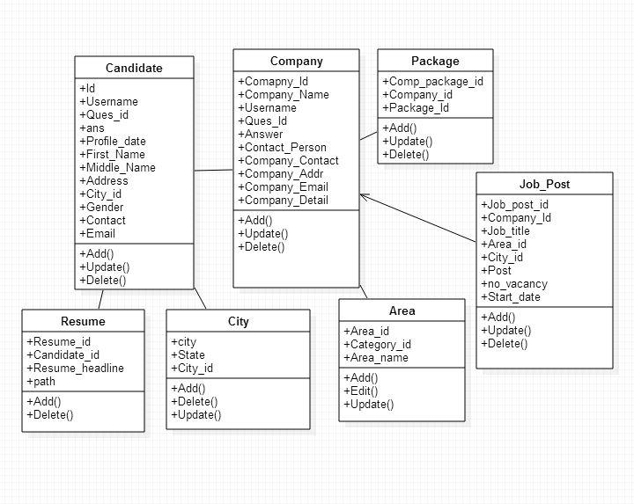

## Sequence Diagram

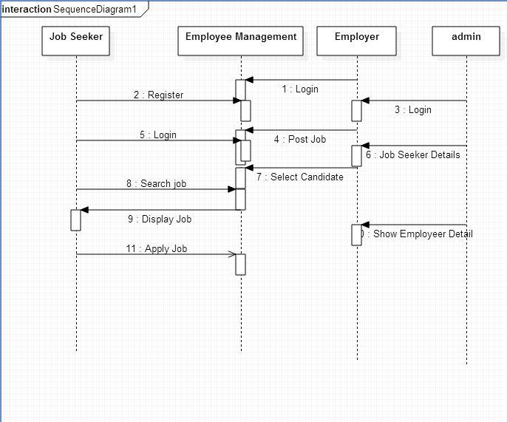

## Activity Diagram

Job-seeker activity

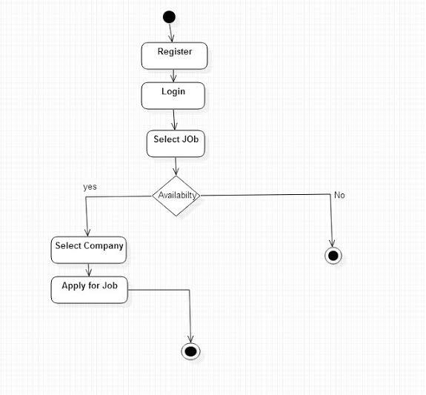

Employer’s activity

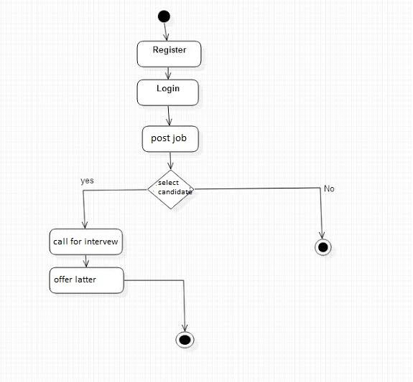

# Database Schema:

## Data Dictionary

ADMIN

|  |  |  |  |
| --- | --- | --- | --- |
| **Field name** | **Data type** | **Constraint** | **Description** |
| adm_id | Int(20) | Primary key | User id |
| Adm_pass | varchar2(12) | - | Password of user |
| Role_name | varcharr(100) | - | Name of user |

Application

|  |  |  |  |
| --- | --- | --- | --- |
| **Field name** | **Data type** | **Constraint** | **Description** |
| Apply_id | Int(20) | Primary key | Application id |
| User_id | Int(20) | Foreign key | User id |
| Emp_id | Int(20) | Foreign key | Employeer id |
| Job_id | Int(10) |  | Job id for which apply |
| Status | Int(20) |  | Status reject or select |
| Date_applied | Varchar(10) |  | Date of apply |

Employer

|  |  |  |  |
| --- | --- | --- | --- |
| **Field name** | **Data type** | **Constraint** | **Description** |
| Eid | Int(20) | Primary key | Employee id |
| Login_id | Int(20) | - | Id for login |
| Ename | Varchar(100) | - | Employeer name |
| Etype | Varchar(100) |  | Type of employeer |
| Industry | Varchar(100) |  |  |
| Address | Varchar(100) |  |  |
| Pincode | Varchar(10) |  |  |
| Executive | Varchar(100) |  |  |
| Phone | Varchar(100) |  |  |
| Location | Varchar(200) |  |  |
| Profile | Varchar(700) |  |  |
| Logo | Varchar(50) |  | Logo of company |

Jobs

|  |  |  |  |
| --- | --- | --- | --- |
| **Field name** | **Data type** | **Constraint** | **Description** |
| Job_id | Int(20) | Primary key | Id for job |
| Eid | Int(20) | Foreign key | Employer id |
| Title | Varchar(100) | - | Title of job |
| Jobdesc | Varchar(700) |  | Job description |
| Vacno | Int(20) |  | No of vcancy |
| Experience | Varchar(100) |  | Experience of candidate |
| Basicpay | Varchar(200) |  |  |
| Fnarea | Varchar(100) |  | Location of work |
| Location | Varchar(700) |  |  |
| Industry | Varchar(200) |  | Area of work |
| Ugqual | Varchar(200) |  | Undergraduate qualification |
| Pgqual | Varchar(200) |  | Post graduate qualification |
| Jprofile | Varchar(700) |  | Job profile |
| Postdate | Varchar(200) |  | Date of job post |

Job seeker

|  |  |  |  |
| --- | --- | --- | --- |
| **Field name** | **Data type** | **Constraint** | **Description** |
| user_id | Int(20) | Primary key | Employee id |
| Login_id | Int(20) | Unique key | Id for login |
| name | Varchar(100) | - | Name of job seeker |
| Phone | Int(20) |  |  |
| skill | Varchar(100) |  |  |
| Basic_edu | Varchar(100) |  | Basic education |
| Master_edu | Varchar(100) |  | Master education |
| exprience | Varchar(100) |  |  |
| Dob | Varchar(50) |  | Date of birth |
| Location | Varchar(200) |  |  |
| Other_qual | Varchar(100) |  | Other qualification |
| Resume | Varchar(50) |  | Resume of job seeker |
| Photo | Varchar(200) |  | Photo of job seeker |

Login

|  |  |  |  |
| --- | --- | --- | --- |
| **Field name** | **Data type** | **Constraint** | **Description** |
| Login_id | Int(20) | Primary key | User id |
| Email | varchar2(100) | - | Emailed |
| Password | varcharr(100) | - | Password |
| Usertype | Varchar(100) |  | User account type |
| Status | Varchar(10) |  | Active/deactive |

Selection

|  |  |  |  |
| --- | --- | --- | --- |
| **Field name** | **Data type** | **Constraint** | **Description** |
| Sel_id | Int(20) | Primary key | Selection id |
| User_id | varchar2(100) | Foreign key |  |
| Emp_id | varcharr(100) | Foreign key |  |
| Job_id | Varchar(200) | Foreign key |  |
| Status | Varchar(10) |  | Accept/reject |
| Date | Varchar(100) |  | Date of selection |

## ER Diagram

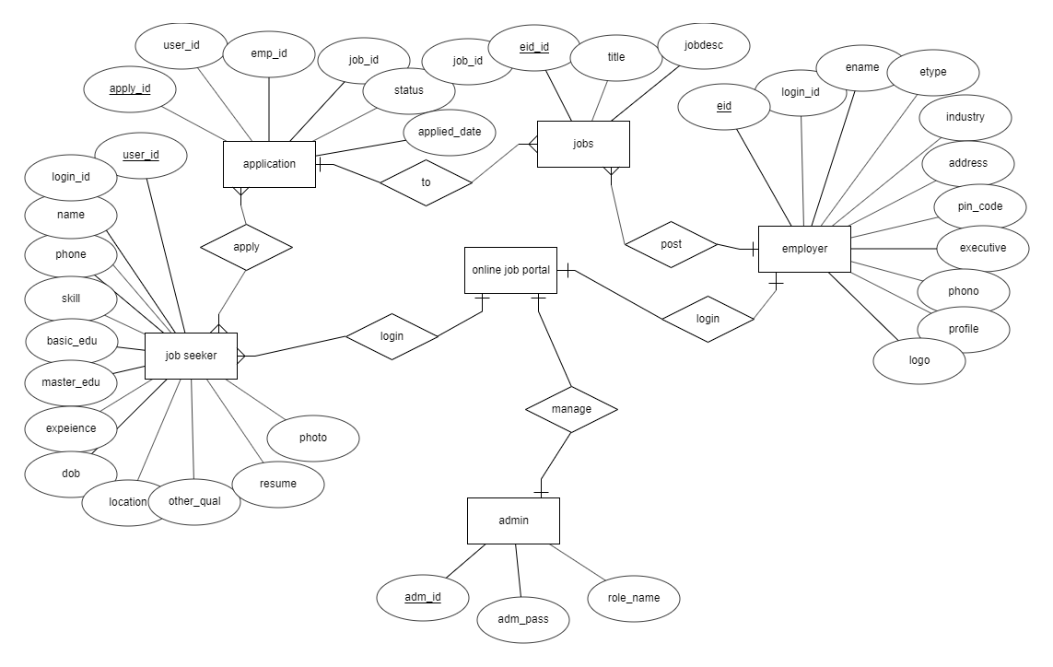

# codes:

index page

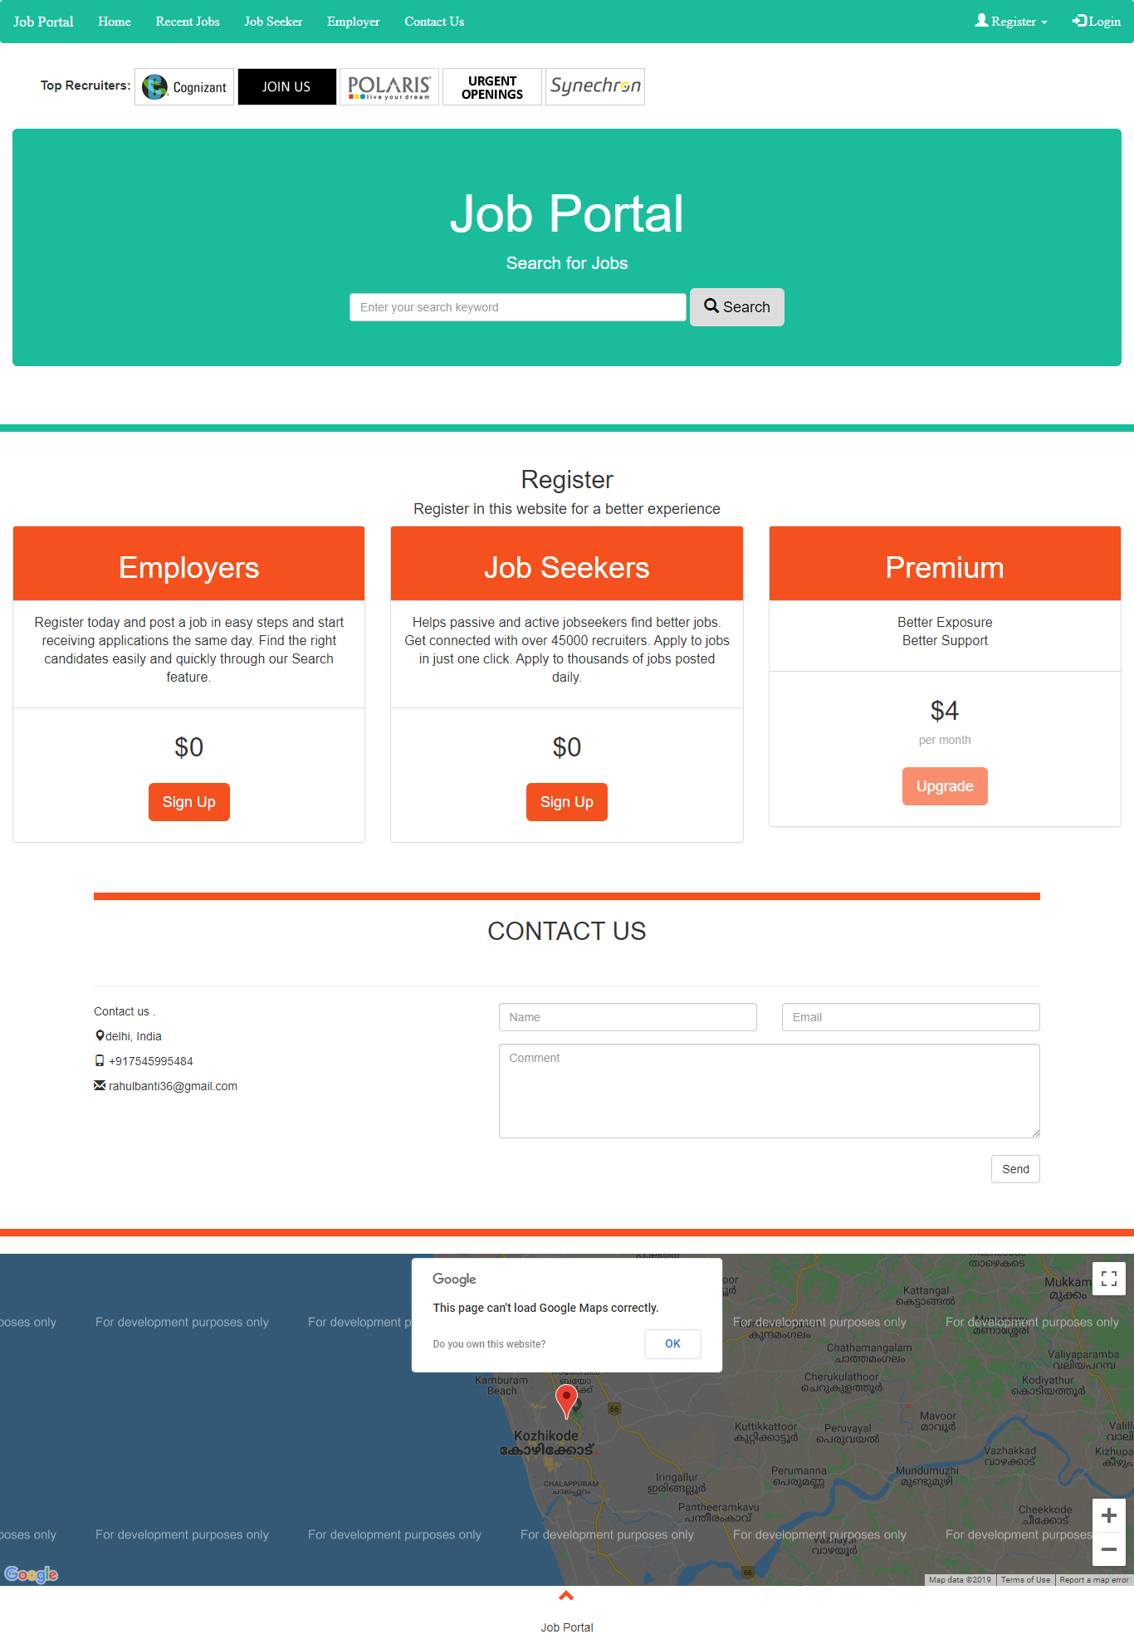

<?php

?>

<!DOCTYPE HTML>

<html>

<head>

<meta charset="utf-8">

<meta http-equiv="X-UA-Compatible" content="IE=edge">

<meta name="viewport" content="width=device-width, initial-scale=1">

<meta charset="utf-8">

<meta http-equiv="X-UA-Compatible" content="IE=edge">

<meta name="viewport" content="width=device-width, initial-scale=1">

<title> Job Portal </title>

<script type="application/javascript">

$(document).ready(function(){

// Add smooth scrolling to all links in navbar + footer link

$(".navbar a, footer a[href='#insidenav']").on('click', function(event) {

// Prevent default anchor click behavior

event.preventDefault();

// Store hash

var hash = this.hash;

// Using jQuery's animate() method to add smooth page scroll

// The optional number (900) specifies the number of milliseconds it takes to scroll to the specified area

$('html, body').animate({

scrollTop: $(hash).offset().top

}, 900, function(){

// Add hash (#) to URL when done scrolling (default click behavior)

window.location.hash = hash;

});

});

$(window).scroll(function() {

$(".slideanim").each(function(){

var pos = $(this).offset().top;

var winTop = $(window).scrollTop();

if (pos < winTop + 600) {

$(this).addClass("slide");

}

});

});

})

</script>

</head>

<nav class="navbar" id="insidenav">

<div class="container-fluid">

<div class="navbar-header">

<a class="navbar-brand" href="#">Job Portal</a>

</div>

<ul class="nav navbar-nav">

<li class="active"><a data-toggle="tab" href="#main1">Home</a></li>

<li><a data-toggle="tab" href="#recent"">Recent Jobs</a></li>

<li><a data-toggle="tab" href="#jobseeker">Job Seeker</a></li>

<li><a data-toggle="tab" href="#">Employer</a></li>

<li><a data-toggle="tab" href="#contact">Contact Us</a></li>

</ul>

<ul class="nav navbar-nav navbar-right">

<li class="dropdown"><a class="dropdown-toggle" data-toggle="dropdown" href="#">

<span class="glyphicon glyphicon-user"></span> Register <span class="caret"></span></a>

<ul class="dropdown-menu">

<li><a href="jobseeker/register_user.php">Jobseeker</a></li>

<li role="separator" class="divider"></li>

<li><a href="employer/register_emp.php">Employer</a></li>

</ul>

</li>

<li><a href="login.php"><span class="glyphicon glyphicon-log-in"></span> Login</a></li>

</ul>

</div>

</nav>

<!--- -------------------------------------------------------------------------------------------------- -->

<body id="indexbody" data-spy="scroll" data-target=".navbar" data-offset="60">

<div class="bmsTop">

<ul>

<li style="font-size: 15px; font-weight: bold">Top Recruiters:</li>

<li><a href="#" target="_blank">

<img src="images/1.gif" border="0">

</a></li>

<li><a href="#" target="_blank">

<img src="images/2.gif" border="0">

</a></li>

<li><a href="#" target="_blank">

<img src="images/3.gif" border="0"></a>

</li>

<li><a href="#" target="_blank">

<img src="images/4.gif" border="0"></a></li>

<li><a href="#" target="_blank">

<img src="images/5.gif" border="0"></a>

</li>

</ul>

</div>

<div class="container-fluid" id="main1"> <!-- jumbotron fluid -->

<div class="jumbotron text-center" id="searchjum">

<h1>Job Portal</h1>

<p>Search for Jobs</p>

<form class="form-inline" id="homesearch">

<input type="text" class="form-control" size="50" placeholder="Enter your search keyword" name="keyword" id="keyword">

<button type="button" onclick="search()" class="btn btn-lg " style="color: black"><span class="glyphicon glyphicon-search"></span> Search</button>

</form>

</div>

</div> <!-- jumbotron -->

<div class="container" id="subcontent" style="background: transparent">

<!-- div for search contents -->

</div>

<div class="page-header" style="background:#1abc9c"></div>

<div class="container-fluid" style="background: transparent">

<div class="text-center">

<h2>Register</h2>

<h4>Register in this website for a better experience</h4>

</div>

<div class="row">

<div class="col-sm-4">

<div class="panel panel-default text-center">

<div class="panel-heading">

<h1>Employers</h1>

</div>

<div class="panel-body">

<p style="font-size: 16px">Register today and post a job in easy steps and start receiving applications the same day.

Find the right candidates easily and quickly through our Search feature.</p>

</div>

<div class="panel-footer">

<h3>$0</h3>

<a href="employer/register_emp.php" style="color: inherit"> <button class="btn btn-lg">Sign Up</button></a>

</div>

</div>

</div>

<div class="col-sm-4">

<div class="panel panel-default text-center">

<div class="panel-heading">

<h1>Job Seekers</h1>

</div>

<div class="panel-body">

<p style="font-size: 16px">Helps passive and active jobseekers find better jobs. Get connected with over 45000 recruiters.

Apply to jobs in just one click. Apply to thousands of jobs posted daily.</p>

</div>

<div class="panel-footer">

<h3>$0</h3>

<a href="jobseeker/register_user.php" style="color: inherit"><button class="btn btn-lg">Sign Up</button></a>

</div>

</div>

</div>

<div class="col-sm-4">

<div class="panel panel-default text-center">

<div class="panel-heading">

<h1>Premium</h1>

</div>

<div class="panel-body">

<p style="font-size: 16px;">Better Exposure <br>

Better Support</p>

</div>

<div class="panel-footer">

<h3>$4</h3>

<h4>per month</h4>

<button class="btn btn-lg disabled">Upgrade</button>

</div>

</div>

</div>

</div>

</div>

<div class="container bg-grey" id="contact">

<div class="page-header" style="background: #f4511e"></div>

<h2 class="text-center">CONTACT US</h2>

<div class="page-header"></div>

<div class="row">

<div class="col-sm-5">

<p>Contact us .</p>

<p><span class="glyphicon glyphicon-map-marker"></span>delhi, India</p>

<p><span class="glyphicon glyphicon-phone"></span> +917545995484</p>

<p><span class="glyphicon glyphicon-envelope"></span> rahulbanti36@gmail.com</p>

</div>

<div class="col-sm-7">

<div class="row">

<div class="col-sm-6 form-group">

<input class="form-control" id="name" name="name" placeholder="Name" type="text" required>

</div>

<div class="col-sm-6 form-group">

<input class="form-control" id="email" name="email" placeholder="Email" type="email" required>

</div>

</div>

<textarea class="form-control" id="comments" name="comments" placeholder="Comment" rows="5"></textarea><br>

<div class="row">

<div class="col-sm-12 form-group">

<button class="btn btn-default pull-right" type="submit">Send</button>

</div>

</div>

</div>

</div>

</div> <!-- Contact -->

</div> <!-- sub content -->

<div class="page-header" style="background: #f4511e"></div>

</div> <!-- Container -->

<!-- Set height and width with CSS -->

<div id="googleMap" style="height:400px;width:100%;"></div>

<!-- Add Google Maps -->

<script src="http://maps.googleapis.com/maps/api/js"></script>

<script>

var myCenter = new google.maps.LatLng(11.2680519,75.7891479);

function initialize() {

var mapProp = {

center:myCenter,

zoom:12,

scrollwheel:false,

draggable:false,

mapTypeId:google.maps.MapTypeId.ROADMAP

};

var map = new google.maps.Map(document.getElementById("googleMap"),mapProp);

var marker = new google.maps.Marker({

position:myCenter,

});

marker.setMap(map);

}

google.maps.event.addDomListener(window, 'load', initialize);

</script>

<footer class="container-fluid text-center">

<a href="#insidenav" title="To Top">

<span class="glyphicon glyphicon-chevron-up"></span>

</a>

<p>Job Portal</p>

</footer>

</body>

<script src="js/jquery-1.12.0.min.js"></script>

<script src="js/search.js"></script>

<script src="js/bootstrap.min.js"></script>

<link href="css/home.css" rel="stylesheet">

<link rel="stylesheet" href="bootstrap/dist/css/bootstrap.min.css">

</html>

employer registration

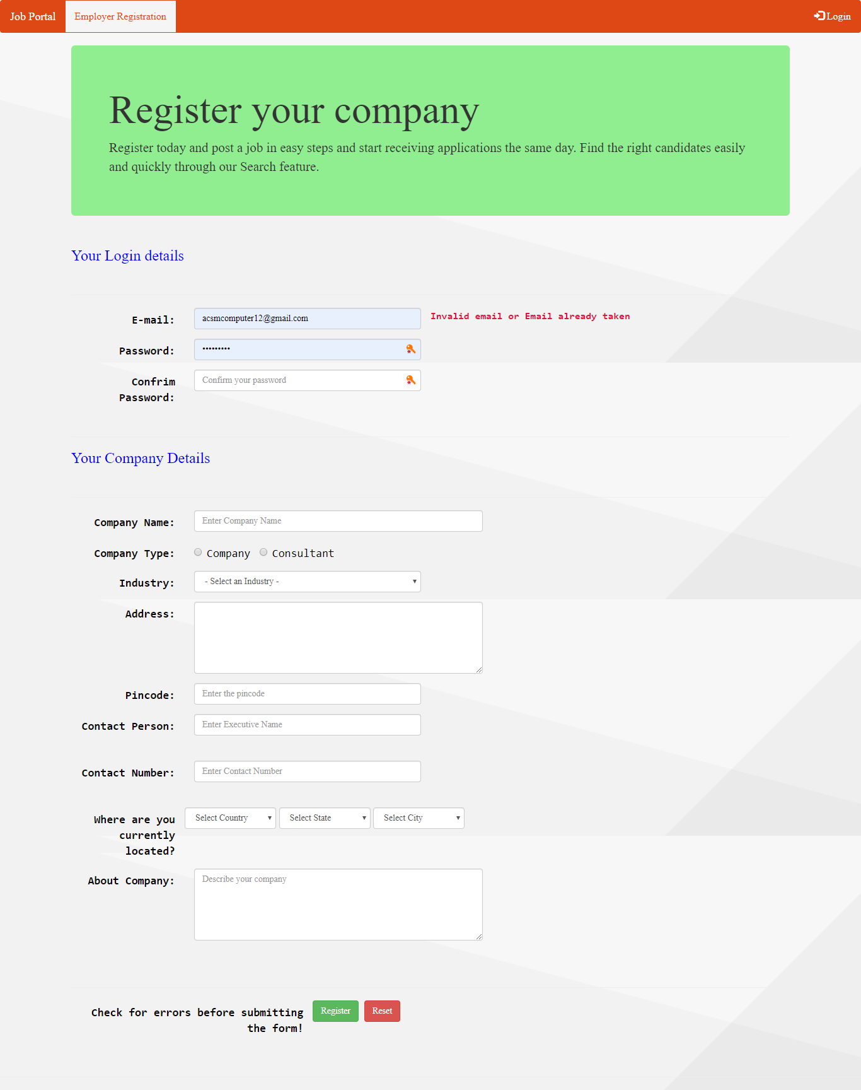

employe_reg.php

<!DOCTYPE html>

<html>

<head>

<meta charset="utf-8">

<meta http-equiv="X-UA-Compatible" content="IE=edge">

<meta name="viewport" content="width=device-width, initial-scale=1">

<title> NEW CLIENT REGISTRATION </title>

<script type="text/javascript" src="/job_portal/js/validate.js"></script>

<script>

function checkForm() {

// Fetching values from all input fields and storing them in variables.

var email = document.getElementById("emailerror").innerHTML;

var pass1 = document.getElementById("pass1error").innerHTML;

var pass2 = document.getElementById("pass2error").innerHTML;

var compname = document.getElementById("comperror").innerHTML;

var addr = document.getElementById("addrerror").innerHTML;

var pincode = document.getElementById("pinerror").innerHTML;

var person = document.getElementById("personerror").innerHTML;

var phone = document.getElementById("pherror").innerHTML;

var about=document.getElementById("abouterror").innerHTML;

//alert(email + pass1 + pass2 + compname + addr + pincode + person + phone);

//Check input Fields Should not be blanks.

//validateRadio("comtype","typeerror");

var p1=document.getElementById("pass1").value;

var p2=document.getElementById("pass2").value;

if (p1 != p2) {

document.getElementById("pass2error").innerHTML="Password Donot Match" ;

}

else

{

document.getElementById("pass2error").innerHTML="" ;

}

if(email == "" && pass1 == "" && pass2 == "" && compname == "" && addr == "" && pincode == "" && person == "" && phone == "" && about == "") {

//document.getElementById("regcomp").submit();

return true;

}

else {

alert("Fill in with correct information");

return false;

}

}

</script>

</head>

<body>

<!-- navigation bar starts here -->

<nav class="navbar" id="insidenav">

<div class="container-fluid">

<div class="navbar-header">

<a class="navbar-brand" href="../index.php">Job Portal</a>

</div>

<ul class="nav navbar-nav">

<li class="active"><a href="#">Employer Registration</a></li>

</ul>

<ul class="nav navbar-nav navbar-right">

<li><a href="../login.php"><span class="glyphicon glyphicon-log-in"></span> Login</a></li>

</ul>

</div>

</nav>

<!-- navigation bar ends here -->

<!-- container div for page contents -->

<div class="container">

<div class="jumbotron">

<h1>Register your company</h1>

<div id="insidejumb">

<p>

Register today and post a job in easy steps and start receiving applications the same day.

Find the right candidates easily and quickly through our Search feature.

</p>

</div>

</div>

<form role="form" id="regcomp" onsubmit="return checkForm()" class="form-horizontal" method="post" action="process_regemp.php">

<h3 class="h3style"> Your Login details </h3>

<div class="page-header"> </div>

<div class="form-group">

<label for="email" class="control-label col-sm-2">E-mail:</label>

<div class="col-sm-4">

<input type="email" required placeholder="Enter your email" class="form-control" name="email" id="email"

onblur="validate('email','emailerror',this.value)">

</div>

<label class="error" id="emailerror"></label>

</div>

<div class="form-group">

<label class="control-label col-sm-2" for="pass1">Password:</label>

<div class="col-sm-4">

<input type ="password" placeholder="Enter your password" name="pass1" id="pass1" class="form-control"

required onblur="validate('password','pass1error',this.value)">

</div>

<label class="error" id="pass1error"></label>

</div>

<div class="form-group">

<label for="pass2" class="control-label col-sm-2"> Confrim Password: </label>

<div class="col-sm-4">

<input type ="password" placeholder="Confirm your password" name="pass2" id="pass2" class="form-control" required>

</div>

<label class="error" id="pass2error"></label>

</div>

<div class="page-header"></div>

<h3 class="h3style"> Your Company Details</h3>

<div class="page-header"></div>

<div class="form-group">

<label class="control-label col-sm-2"> Company Name:</label>

<div class="col-sm-5">

<input type ="text" class="form-control" name="compname" id="compname" placeholder="Enter Company Name"

required onblur="validate('company','comperror',this.value)">

</div>

<label class="error" id="comperror"></label>

</div>

<div class="form-group">

<label class="control-label col-sm-2" for="comtype"> Company Type: </label>

<div class="col-sm-4 form-inline" id="comtype">

<label class="radio-inline"><input type="radio" name="comtype" id="type1" value="Company">Company</label>

<label class="radio-inline"><input type="radio" name="comtype" id="type2" value="Consultant">Consultant</label>

</div>

<label class="error" id="typeerror"></label>

</div>

<div class="form-group">

<label for="indtype" class="control-label col-sm-2">Industry:</label>

<div class="col-sm-4">

<select name="indtype" id="indtype" class="form-control" required>

<option selected="selected" value="">- Select an Industry -</option>

<option value="Accessories/Apparel/Fashion Design">Accessories/Apparel/Fashion Design</option>

<option value="Accounting/Consulting/Taxation">Accounting/Consulting/Taxation</option>

<option value="Advertising/Event Management/PR">Advertising/Event Management/PR</option>

<option value="Agriculture/Dairy Technology">Agriculture/Dairy Technology</option>

<option value="Airlines/Hotel/Hospitality/Travel/Tourism/Restaurants">Airlines/Hotel/Hospitality/Travel/Tourism/Restaurants</option>

<option value="Animation / Gaming">Animation / Gaming</option>

<option value="Architectural Services/ Interior Designing">Architectural Services/ Interior Designing</option>

<option value="Auto Ancillary/Automobiles/Components">Auto Ancillary/Automobiles/Components</option>

<option value="Banking/Financial Services/Stockbroking/Securities">Banking/Financial Services/Stockbroking/Securities</option>

<option value="Banking/FinancialServices/Broking">Banking/FinancialServices/Broking</option>

<option value="Biotechnology/Pharmaceutical/Clinical Research">Biotechnology/Pharmaceutical/Clinical Research</option>

<option value="Brewery/Distillery">Brewery/Distillery</option>

<option value="Cement/Construction/Engineering/Metals/Steel/Iron">Cement/Construction/Engineering/Metals/Steel/Iron</option>

<option value="Ceramics/Sanitaryware">Ceramics/Sanitaryware</option>

<option value="Chemicals/Petro Chemicals/Plastics">Chemicals/Petro Chemicals/Plastics</option>

<option value="Computer Hardware/Networking">Computer Hardware/Networking</option>

<option value="Consumer FMCG/Foods/Beverages">Consumer FMCG/Foods/Beverages</option>

<option value="Consumer Goods - Durables">Consumer Goods - Durables</option>

<option value="Courier/Freight/Transportation/Warehousing">Courier/Freight/Transportation/Warehousing</option>

<option value="CRM/ IT Enabled Services/BPO">CRM/ IT Enabled Services/BPO</option>

<option value="Education/Training/Teaching">Education/Training/Teaching</option>

<option value="Electricals/Switchgears">Electricals/Switchgears</option>

<option value="Employment Firms/Recruitment Services Firms">Employment Firms/Recruitment Services Firms</option>

<option value="Entertainment/Media/Publishing/Dotcom">Entertainment/Media/Publishing/Dotcom</option>

<option value="Export Houses/Textiles/Merchandise">Export Houses/Textiles/Merchandise</option>

<option value="FacilityManagement">FacilityManagement</option>

<option value="Fertilizers/Pesticides">Fertilizers/Pesticides</option>

<option value="FoodProcessing">FoodProcessing</option>

<option value="Gems and Jewellery">Gems and Jewellery</option>

<option value="Glass">Glass</option>

<option value="Government/Defence">Government/Defence</option>

<option value="Healthcare/Medicine">Healthcare/Medicine</option>

<option value="HeatVentilation/AirConditioning">HeatVentilation/AirConditioning</option>

<option value="Insurance">Insurance</option>

<option value="KPO/Research/Analytics">KPO/Research/Analytics</option>

<option value="Law/Legal Firms">Law/Legal Firms</option>

<option value="Machinery/Equipment Manufacturing/Industrial Products">Machinery/Equipment Manufacturing/Industrial Products</option>

<option value=">Mining">Mining</option>

<option value="NGO/Social Services">NGO/Social Services</option>

<option value="Office Automation">Office Automation</option>

<option value="Others/Engg. Services/Service Providers">Others/Engg. Services/Service Providers</option>

<option value="Petroleum/Oil and Gas/Projects/Infrastructure/Power/Non-conventional Energy">Petroleum/Oil and Gas/Projects/Infrastructure/Power/Non-conventional Energy</option>

<option value="Printing/Packaging">Printing/Packaging</option>

<option value="Publishing">Publishing</option>

<option value="Real Estate">Real Estate</option>

<option value="Retailing">Retailing</option>

<option value="Security/Law Enforcement">Security/Law Enforcement</option>

<option value="Shipping/Marine">Shipping/Marine</option>

<option value="Software Services">Software Services</option>

<option value="Steel">Steel</option>

<option value="Strategy/ManagementConsultingFirms">Strategy/ManagementConsultingFirms</option>

<option value="Telecom Equipment/Electronics/Electronic Devices/RF/Mobile Network/Semi-conductor">Telecom Equipment/Electronics/Electronic Devices/RF/Mobile Network/Semi-conductor</option>

<option value="Telecom/ISP">Telecom/ISP</option>

<option value="Tyres">Tyres</option>

<option value="WaterTreatment/WasteManagement">WaterTreatment/WasteManagement</option>

<option value="Wellness/Fitness/Sports">Wellness/Fitness/Sports</option>

</select>

</div>

<label class="error" id="inderror"></label>

</div>

<div class="form-group">

<label for="addr" class="control-label col-sm-2">Address:</label>

<div class="col-sm-5"><textarea id="addr" rows="5" name="addr" class="form-control" required

onblur="validate('address','addrerror',this.value)"></textarea>

</div>

<label class="error" id="addrerror"></label>

</div>

<div class="form-group">

<label for="pincode" class="control-label col-sm-2">Pincode:</label>

<div class="col-sm-4">

<input type ="text" class="form-control" placeholder="Enter the pincode" name="pin_code" id="pincode"

required onblur="validate('pincode','pinerror',this.value)">

</div>

<label class="error" id="pinerror"></label>

</div>

<div class="form-group">

<label class="control-label col-sm-2" for="person">Contact Person:</label>

<div class="col-sm-4">

<input type="text"class="form-control" placeholder="Enter Executive Name" id="person" name="person"

required onblur="validate('username','personerror',this.value)">

<label class="error" id="personerror"></label>

</div>

</div>

<div class="form-group">

<label class="control-label col-sm-2" for="phone">Contact Number:</label>

<div class="col-sm-4">

<input type="text"class="form-control" placeholder="Enter Contact Number" id="phone" name="phone"

required onblur="validate('mobilenum','pherror',this.value)">

<label class="error" id="pherror"></label>

</div>

</div>

<div class="form-group">

<label class="control-label col-sm-2"> Where are you currently located? </label>

<div class="form-inline">

<select name="country" class=" form-control countries" id="countryId" style="width:145px;" required>

<option value="">Select Country</option>

</select>

<select name="state" class="form-control states" id="stateId" style="width:145px;" required>

<option value="">Select State</option>

</select>

<select name="city" class="form-control cities" id="cityId" style="width:145px;">

<option value="">Select City</option>

</select>

</div>

</div>

<div class="form-group">

<label class="control-label col-sm-2">About Company:</label>

<div class="col-sm-5">

<textarea placeholder="Describe your company" class="form-control" rows="5" required onblur="validate('longtext','abouterror',this.value)"></textarea>

<label class="error" id="abouterror"></label>

</div>

</div>

<div class="page-header"> </div>

<div class="form-group form-inline col-sm-10">

<label for="reg" class="control-label col-sm-5">Check for errors before submitting the form!</label>

<button class="btn btn-success" type="submit" id="reg">Register</button>

<label for"reset" class="control-label"> </label>

<button class="btn btn-danger" type="reset" id="reset"> Reset </button>

</div>

</form>

</div>

<div class="page-header"> </div>

<link rel="stylesheet" href="../bootstrap/dist/css/bootstrap.min.css">

<link href="../css/main.css" rel="stylesheet">

<link href="../css/employer.css" rel="stylesheet">

<script src="../js/jquery-1.12.0.min.js"></script>

<script src="../js/bootstrap.min.js"></script>

<script src="../location/location.js"></script>

</body>

</html>

job seeker registration

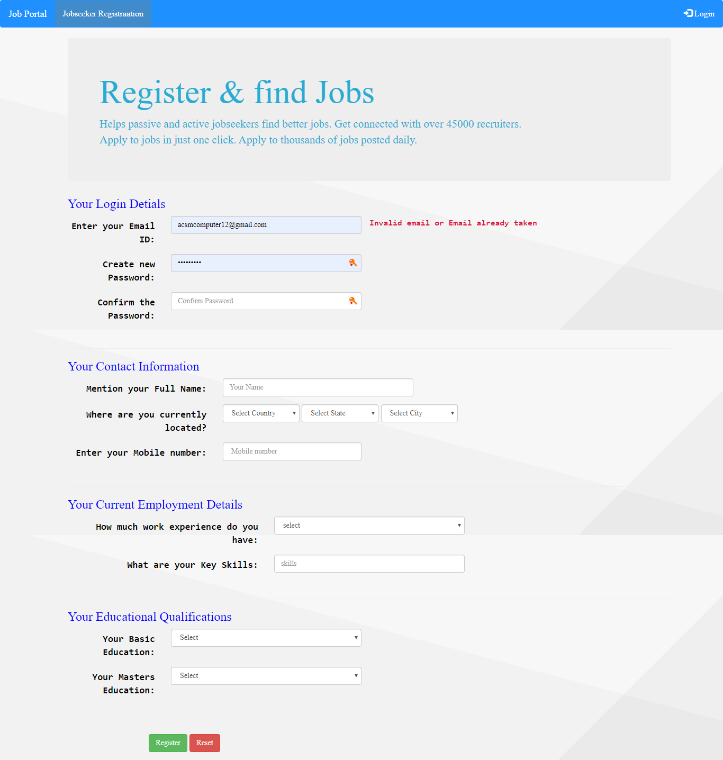

user_rej.php

<!DOCTYPE HTML>

<html>

<head>

<meta charset="utf-8">

<meta http-equiv="X-UA-Compatible" content="IE=edge">

<meta name="viewport" content="width=device-width, initial-scale=1">

<title>Job Seeker Registration</title>

<script type="text/javascript">

function checkForm() {

// Fetching values from all input fields and storing them in variables.

var email = document.getElementById("emailerror").innerHTML;

var pass1 = document.getElementById("passerror").innerHTML;

var pass2 = document.getElementById("passerror2").innerHTML;

var name = document.getElementById("nameerror").innerHTML;

var mobno = document.getElementById("mobnoerror").innerHTML;

var skills = document.getElementById("skillerror").innerHTML;

//Check input Fields Should not be blanks.

var p1=document.getElementById("passnew").value;

var p2=document.getElementById("passconf").value;

if (p1 != p2) {

document.getElementById("passerror2").innerHTML="Password Donot Match" ;

}

else

{

document.getElementById("passerror2").innerHTML="" ;

}

if(email == '' && pass1 == '' && pass2 == '' && name == "" && mobno == '' && skills =='') {

//document.getElementById("reguser").submit();

return true;

}

else {

alert("Fill in with correct information");

return false;

}

}

</script>

</head>

<body>

<nav class="navbar" id="insidenav">

<div class="container-fluid">

<div class="navbar-header">

<a class="navbar-brand" href="../index.php">Job Portal</a>

</div>

<ul class="nav navbar-nav">

<li class="active"><a href="#">Jobseeker Registraation</a></li>

</ul>

<ul class="nav navbar-nav navbar-right">

<li><a href="../login.php"><span class="glyphicon glyphicon-log-in"></span> Login</a></li>

</ul>

</div>

</nav>

<div class="container">

<div class="container">

<div class="jumbotron">

<h1>Register & find Jobs</h1>

<p>

Helps passive and active jobseekers find better jobs. Get connected with over 45000 recruiters.<br/>

Apply to jobs in just one click. Apply to thousands of jobs posted daily.

</p>

</div>

<FORM id="reguser" onsubmit="return checkForm()" METHOD="post" ACTION="process_user.php" enctype="multipart/form-data" class="form-horizontal">

<h3 class="h3style"> Your Login Detials </h3>

<div class="form-group">

<label class="control-label col-sm-2" for="email" >Enter your Email ID:</label>

<div class="col-sm-4">

<input type="email" name="useremail" placeholder="Your E-mail" class="form-control" id="email"

required onblur="validate('email','emailerror',this.value)">

</div>

<label id="emailerror" class="error" ></label>

</div>

<div class="form-group">

<label class="control-label col-sm-2 " for="passnew" > Create new Password:</label>

<div class="col-sm-4"> <input type="password" id="passnew" placeholder="New Password" name="pass1" class="form-control"

required onblur="validate('password','passerror',this.value)">

</div>

<label id="passerror" class="error"></label>

</div>

<div class="form-group">

<label class="control-label col-sm-2 for="passconf">Confirm the Password:</label>

<div class="col-sm-4">

<input type="password" id="passconf" placeholder="Confirm Password" name="pass2" class="form-control" required>

</div>

<label class="error" id="passerror2"></label>

</div>

<div class="page-header"></div>

<h3 class="h3style">Your Contact Information</h3>

<div class="form-group">

<label class="control-label col-sm-3" for="name">Mention your Full Name:</label>

<div class="col-sm-4">

<input type="text" id="name" placeholder="Your Name" name="uname" class="form-control"

required onblur="validate('username','nameerror',this.value)">

</div>

<label id="nameerror" class="error"></label>

</div>

<div class="form-group">

<label class="control-label col-sm-3" for="location"> Where are you currently located? </label>

<div class="form-inline col-sm-7" id="location">

<select name="country" class=" form-control countries" id="countryId" style="width:145px;" required>

<option value="">Select Country</option>

<option value="india">india</option>

</select>

<select name="state" class="form-control states" id="stateId" style="width:145px;" required>

<option value="">Select State</option>

<option value="delhi">delhi</option>

</select>

<select name="city" class="form-control cities" id="cityId" style="width:145px;">

<option value="">Select City</option>

<option value="gzb">gaziabad</option>

</select>

</div>

</div>

<div class="form-group">

<label class="control-label col-sm-3" for="mobno">Enter your Mobile number:</label>

<div class="col-sm-3"><input type="text" name="mobno" placeholder=" Mobile number" class="form-control" id="mobno"

required onblur="validate('mobilenum','mobnoerror',this.value)">

</div>

<label id="mobnoerror" class="error"></label>

</div>

<div class="page-header"></div>

<h3 class="h3style"> Your Current Employment Details </h3>

<div class="form-group">

<label for="experience" class="control-label col-sm-4"> How much work experience do you have:</label>

<div class="col-sm-4">

<select name="experience" class="form-control" id="experience" required>

<option value="">select </option>

<option value="1">1 year </option>

<option value="2">2 year </option>

<option value="3">3 year </option>

<option value="4">4 year </option>

<option value="5">5 year </option>

<option value="6">6 year </option>

<option value="7">7 year </option>

<option value="8">8 year </option>

<option value="9+">9+ year </option>

</select>

</div>

</div>

<div class="form-group">

<label class="control-label col-sm-4" for="skills"> What are your Key Skills:</label>

<div class="col-sm-4"><input type="text" name="skills" placeholder="skills" class="form-control" name="skills" id="skills"

required onblur="validate('text','skillerror',this.value)">

</div>

<label id="skillerror" class="error"></label>

</div>

<div class="page-header"></div>

<h3 class="h3style"> Your Educational Qualifications </h3>

<div class="form-group">

<label class="control-label col-sm-2" for="ugcourse"> Your Basic Education: </label>

<div class="col-sm-4"> <select name="ugcourse" id="ugcourse" class=" form-control" required>

<option value="" label="Select">Select</option>

<option value="Not Pursuing Graduation"> Not Pursuing Graduation</option>

<option value="B.A">B.A</option>

<option value="B.Arch">B.Arch</option>

<option value="BCA">BCA</option>

<option value="B.B.A">B.B.A</option>

<option value="B.Com">B.Com</option>

<option value="B.Ed">B.Ed</option>

<option value="BDS">BDS</option>

<option value="BHM">BHM</option>

<option value="B.Pharma">B.Pharma</option>

<option value="B.Sc">B.Sc</option>

<option value="B.Tech/B.E.">B.Tech/B.E.</option>

<option value="LLB">LLB</option>

<option value="MBBS">MBBS</option>

<option value="Diploma">Diploma</option>

<option value="BVSC">BVSC</option>

<option value="Other">Other</option>

</select>

</div>

</div>

<div class="form-group">

<label class="control-label col-sm-2" for="pgcourse"> Your Masters Education:</label>

<div class="col-sm-4"> <select name="pgcourse" id="pgcourse" class="form-control" required>

<option value="">Select</option>

<option value="Not Pursuing Post Graduation"> Not Post Pursuing Graduation</option>

<option value="CA">CA</option>

<option value="CS">CS</option>

<option value="ICWA (CMA)">ICWA (CMA)</option>

<option value="Integrated PG">Integrated PG</option>

<option value="LLM">LLM</option>

<option value="M.A">M.A</option>

<option value="M.Arch">M.Arch</option>

<option value="M.Com">M.Com</option>

<option value="M.Ed">M.Ed</option>

<option value="M.Pharma">M.Pharma</option>

<option value="M.Sc">M.Sc</option>

<option value="M.Tech">M.Tech</option>

<option value="MBA/PGDM">MBA/PGDM</option>

<option value="MCA">MCA</option>

<option value="MS">MS</option>

<option value="PG Diploma">PG Diploma</option>

<option value="MVSC">MVSC</option>

<option value="MCM">MCM</option>

<option value="Other">Other</option>

</select>

</div>

</div>

<div class="page-header"> </div>

<div class="form-group form-inline col-sm-10">

<button class="btn btn-success" type="submit" id="reg" value="submit">Register</button>

<label class="col-sm-2"></label>

<button class="btn btn-danger" type="reset" id="reset"> Reset </button>

</div>

</form>

<link rel="stylesheet" href="../bootstrap/dist/css/bootstrap.min.css">

<link href="../css/main.css" rel="stylesheet">

<link href="../css/jobseeker.css" rel="stylesheet">

<script type="text/javascript" src="../js/validate.js"></script>

<script src="../js/jquery-1.12.0.min.js"></script>

<script src="../js/bootstrap.min.js"></script>

<script src="../location/location.js"></script>

</body>

</html>

login



<?php

?>

<!DOCTYPE html>

<html lang="en">

<head>

<meta charset="utf-8">

<meta http-equiv="X-UA-Compatible" content="IE=edge">

<meta name="viewport" content="width=device-width, initial-scale=1">

<meta charset="utf-8">

<meta http-equiv="X-UA-Compatible" content="IE=edge">

<meta name="viewport" content="width=device-width, initial-scale=1">

<title>Signin</title>

<?php

if(isset($_GET['msg']) && ($_GET['msg']=="failed")){

?>

<script type='text/javascript'>alert("Login Failed: Invalid Username or Password!");</script>

<?php

}

else if(isset($_GET['msg']) && ($_GET['msg']=="registered"))

{

?>

<script type='text/javascript'>alert("Successfully registered, Please login now!");</script>

<?php

}

else if(isset($_GET['msg']) && ($_GET['msg']=='please_login'))

{

?>

<script type="text/javascript">alert("Please Login First to access your profile!");</script>

<?php

}

?>

</head>

<nav class="navbar" id="insidenav">

<div class="container-fluid">

<div class="navbar-header">

<a class="navbar-brand" href="index.php">Job Portal</a>

</div>

<ul class="nav navbar-nav">

<li class="active"><a href="#">Login</a></li>

</ul>

<ul class="nav navbar-nav navbar-right">

<li class="dropdown"><a class="dropdown-toggle" data-toggle="dropdown" href="#">

<span class="glyphicon glyphicon-user"></span> Sign Up <span class="caret"></span></a>

<ul class="dropdown-menu">

<li><a href="jobseeker/register_user.php">Jobseeker</a></li>

<li role="separator" class="divider"></li>

<li><a href="employer/register_emp.php">Company</a></li>

</ul>

</li>

</ul>

</div>

</nav>

<body>

<div class="container col-sm-5 pull-right">

<form class="form-signin" action="process_login.php" method="post">

<h2 class="form-signin-heading">Please sign in</h2>

<label for="inputEmail" class="sr-only">Email address</label>

<input type="email" id="inputEmail" class="form-control" placeholder="Email address" required autofocus name="email">

<label for="inputPassword" class="sr-only">Password</label>

<input type="password" id="inputPassword" class="form-control" placeholder="Password" required name="password">

<div class="checkbox">

<label><input type="checkbox" value="remember-me"> Remember me </label>

<a href="forget.php">/Forgot Password</a>

</div>

<button class="btn btn-lg btn-primary btn-block" type="submit">Sign in</button>

</form>

</div>

<div class="col-sm-10">

<br> <br>

<br>

<br>

<br>

<br>

<br>

</div>

<div class="container col-sm-10 pull-right" >

<div class="row">

<div class="askreg">

<div class="col-lg-3">

<br>

</div>

<div class="col-lg-4 ">

<h2>Find Jobs</h2>

<p> Helps passive and active jobseekers find better jobs.

Get connected with over 45000 recruiters.

Apply to jobs in just one click.

Apply to thousands of jobs posted daily.

</p>

<p><a class="btn btn-default" href="jobseeker/register_user.php">Register Today<span class="glyphicon glyphicon-arrow-right"></span> </a></p>

</div>

</div>

<div class="askreg">

<div class="col-lg-4 ">

<h2>Looking for the right candidate?</h2>

<p> Post a job in easy steps and start receiving applications the same day.

Find the right candidates easily and quickly through our Search feature.

</p>

<p><a class="btn btn-default" href="employer/register_emp.php">Register Your Company <span class="glyphicon glyphicon-arrow-right"></span> </a></p>

</div>

</div>

</div>

</div>

</body>

<link rel="stylesheet" href="bootstrap/dist/css/bootstrap.min.css">

<link href="css/signin.css" rel="stylesheet">

<script src="js/jquery-1.12.0.min.js"></script>

<script src="js/bootstrap.min.js"></script>

</html>

//////login-process.php//////

<?php

include_once('config.php');

$email=$_POST['email'];

$passd=$_POST['password'];

$query=mysqli_query($db1,"select * from login where email='$email'");

$result=mysqli_fetch_array($query,MYSQLI_ASSOC);

if(($result>0) && ( password_verify( $passd, $result['password'] ) ) ){

if($result['usertype']=="jobseeker")

{

session_start();

$_SESSION["id"] = $result['log_id'];

$_SESSION["type"] = $result['usertype'];

header('location:jobseeker/profile.php?msg=success');

}

elseif($result['usertype']=="employer")

{

session_start();

$_SESSION["elogid"] = $result['log_id'];

$_SESSION["type"] = $result['usertype'];

$_SESSION["status"]=$result['status'];

header('location:employer/profile.php?msg=success');

}

}

else

{

header('location:login.php?msg=failed');

}

?>

job seeker profile 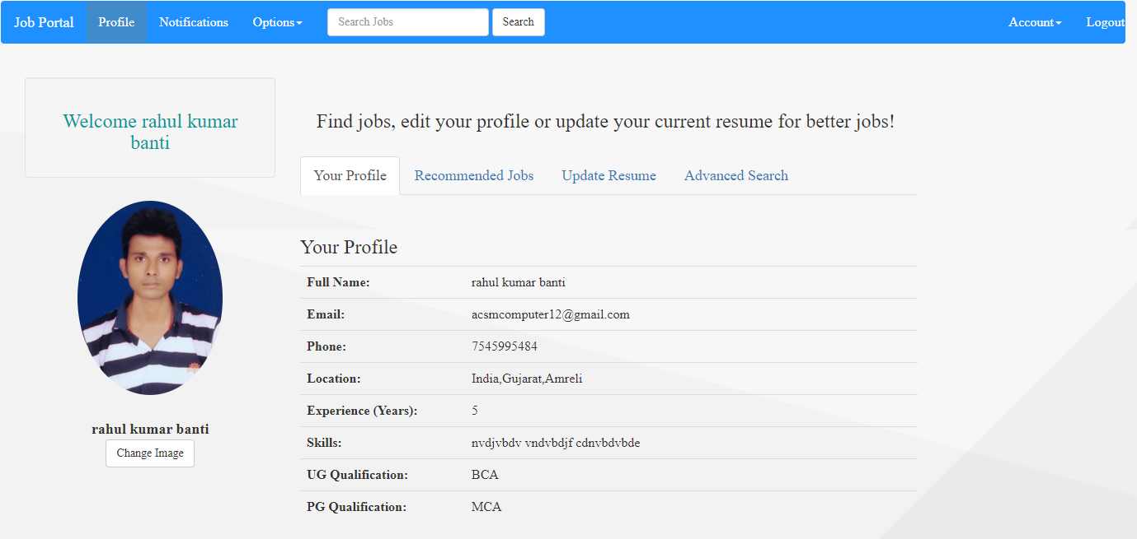

job search

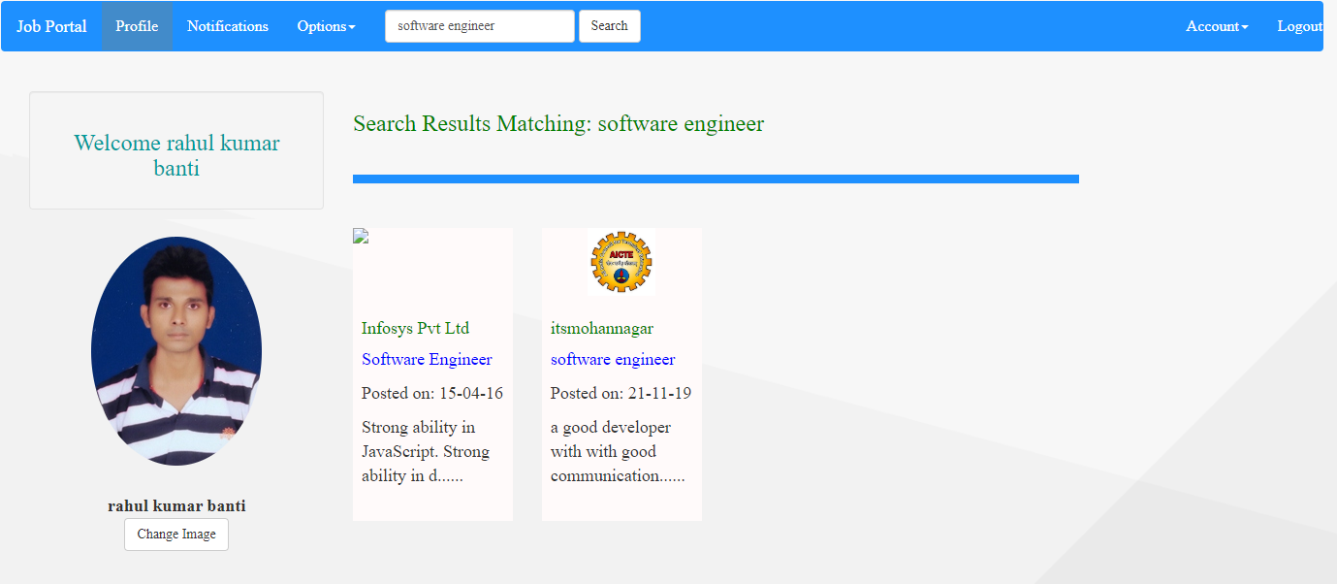

apply for job

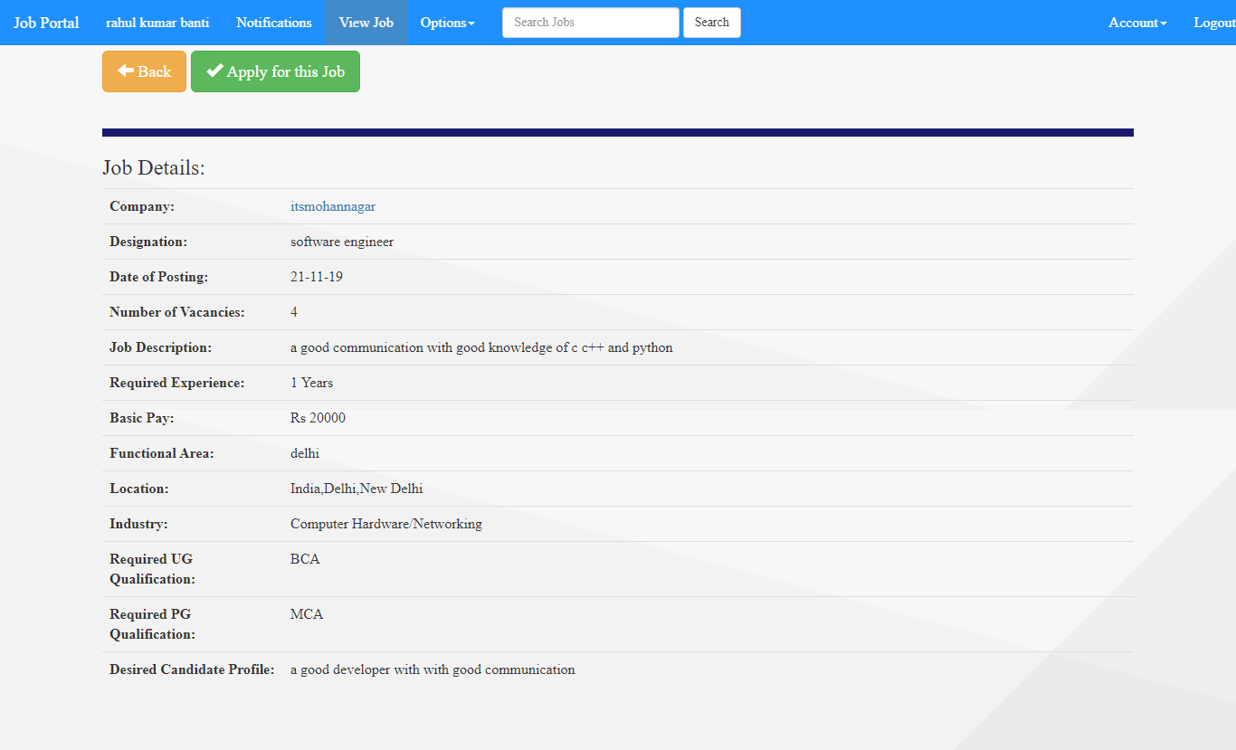

applied job list

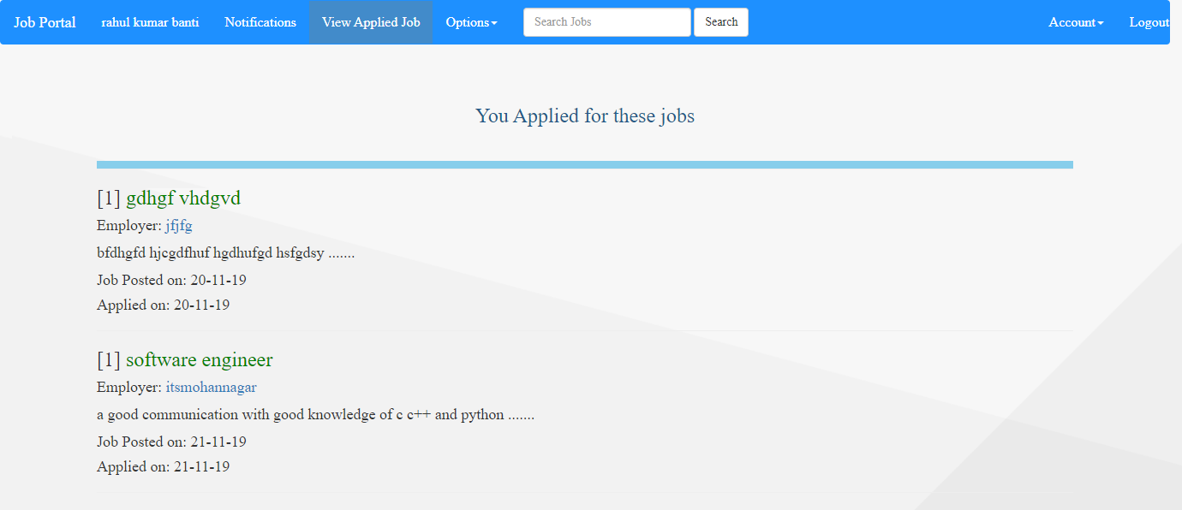

selected job seeker job

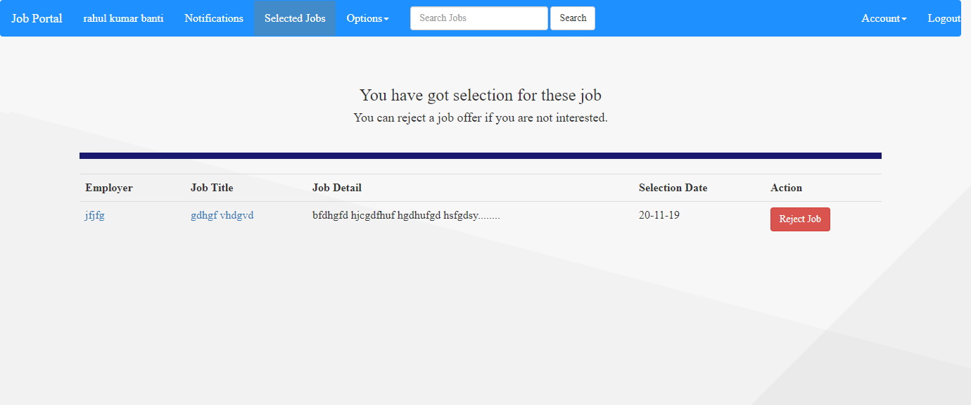

employer’s profile

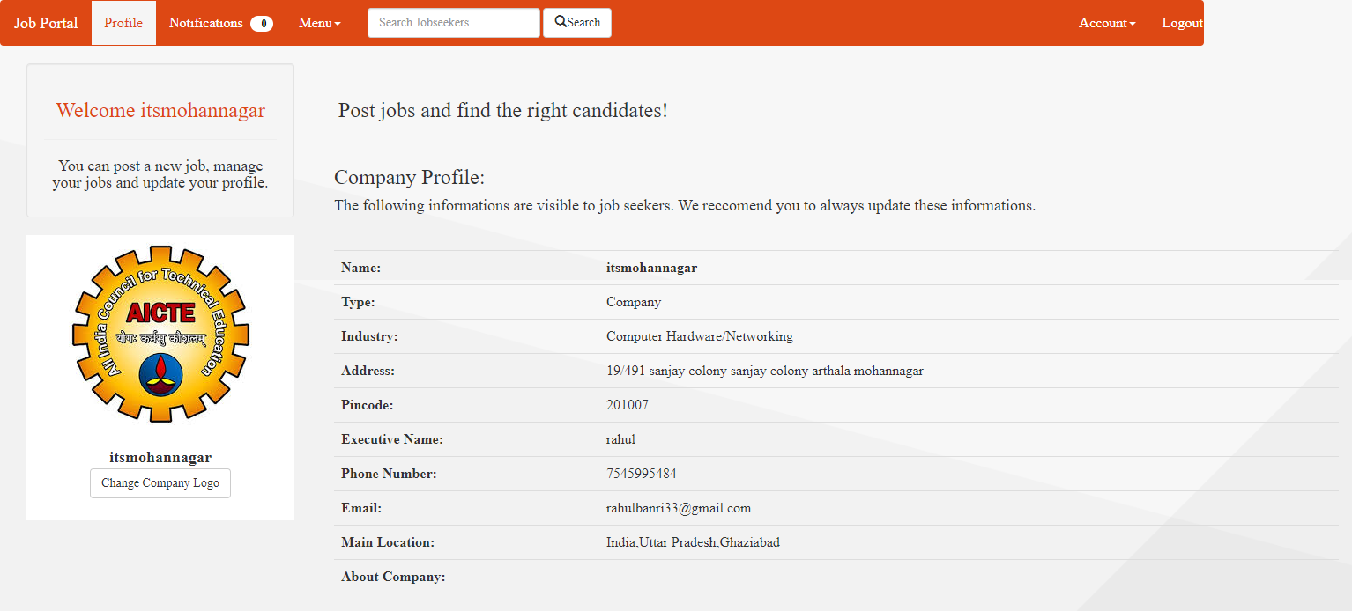

post job by employer

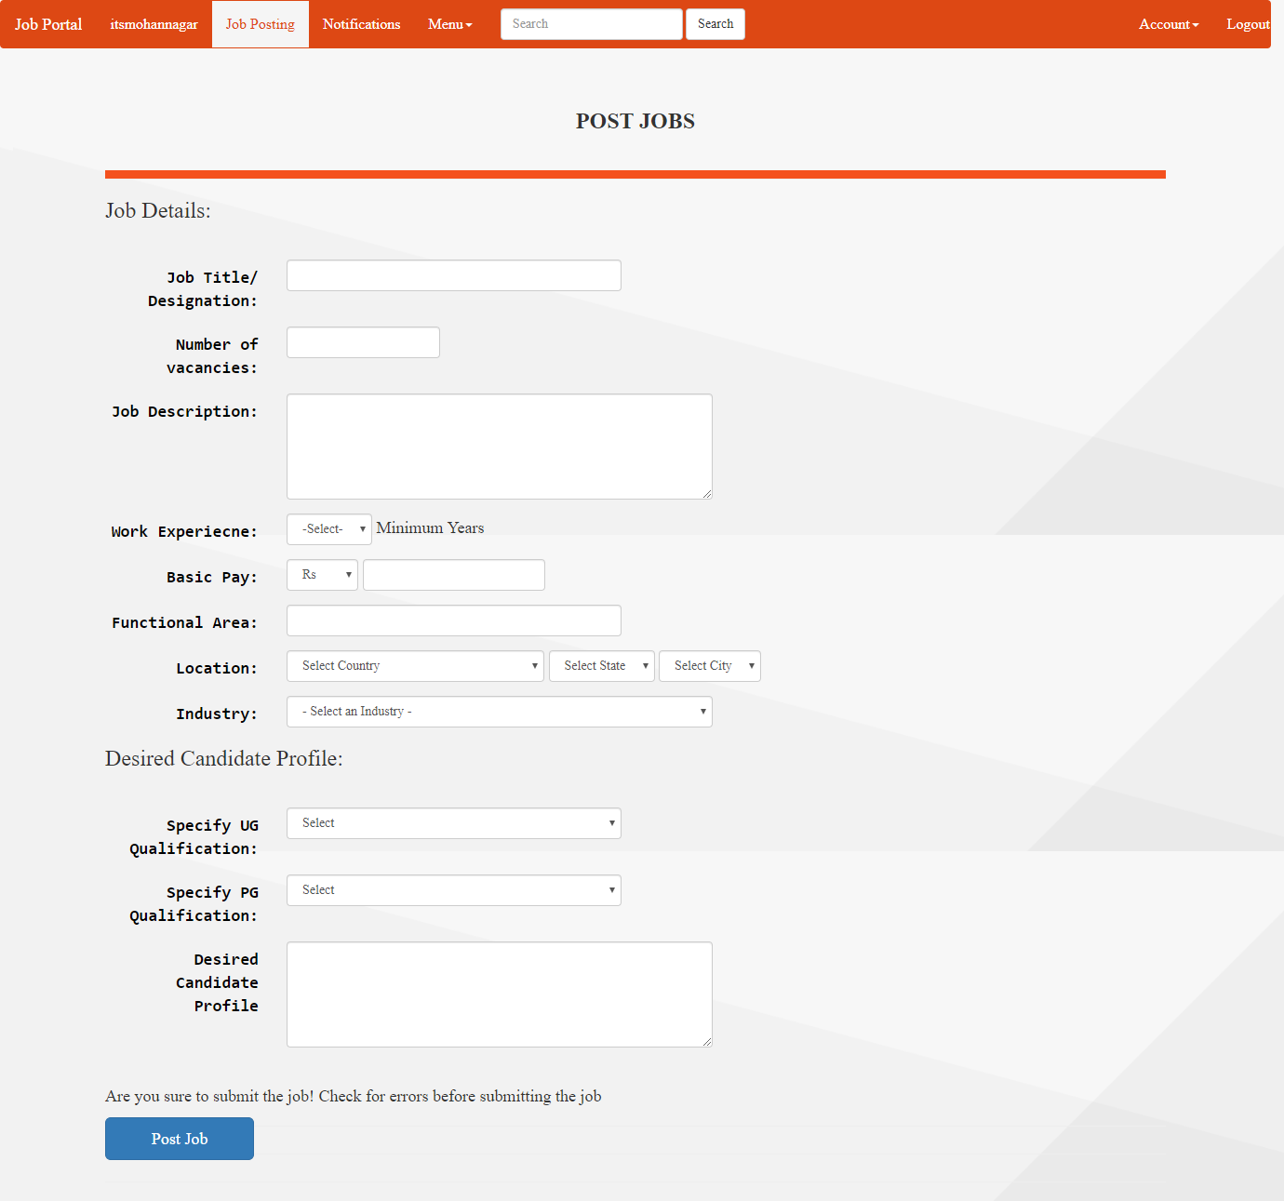

list of posted job employer

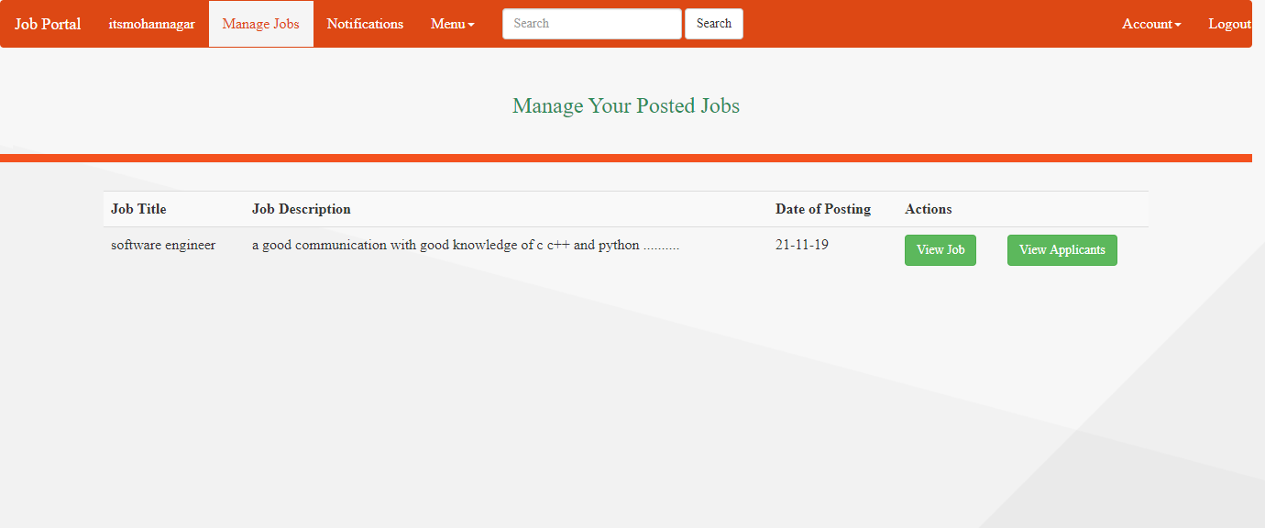

list of candidate for select or reject by employer

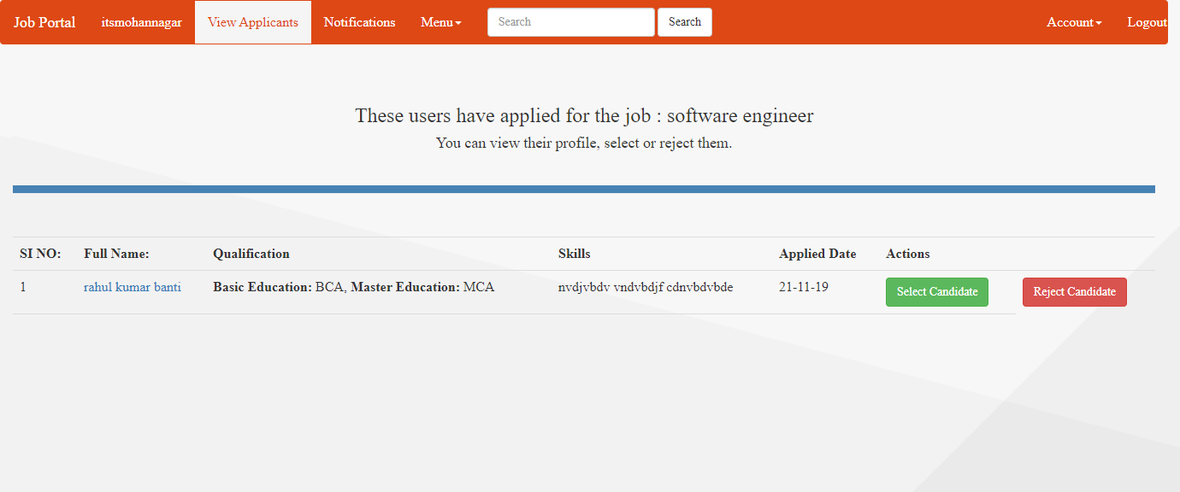

# System Testing

**Test Cases**

testing Login Module.

|  |  |  |  |  |  |  |  |  |  |
| --- | --- | --- | --- | --- | --- | --- | --- | --- | --- |
| **Test Cases and Test Result of Module (e.g. Login Module)** | | | | | | | | | |
| **Prerequisites** | | **This screen lets user to login** | | | |  |  |  |  |
| Test | Test Case Name | Test Case Description | Test Procedure | Input Data | Expected Result | Test Results | Severity (H/M/L)(if Failed) | Test Results | Comments |
|  |  |  |  |  |  |  |  |  |  |
|  |  |  |  |  |  |  |  |  |  |

# Conclusion