Q 1 : Create a main directory named linux_practice_lab.

Ans: 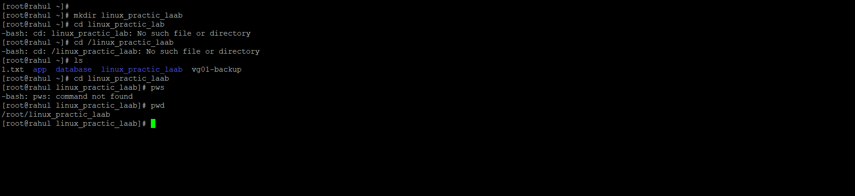

Q 2 : Inside it, create three directories named documents, notes, and backup.

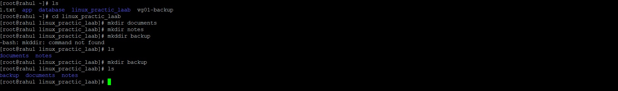

Q 3 : Move into the documents directory and create three empty files: intro.txt, commands.txt, and practice.txt.
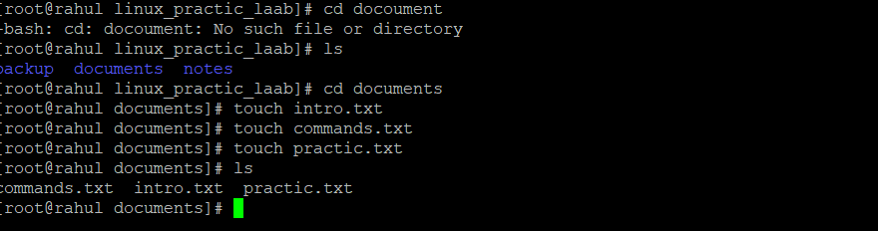
Q 4 : Add at least five Linux commands you learned into commands.txt.
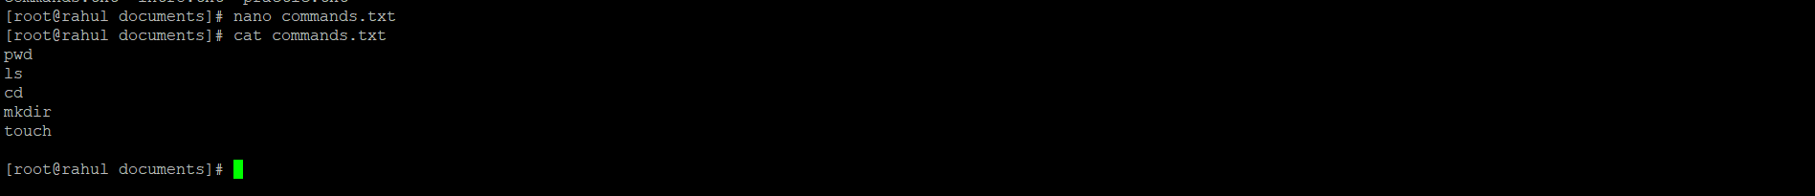
Q 5 : Display the content of commands.txt using cat, head, and tail.
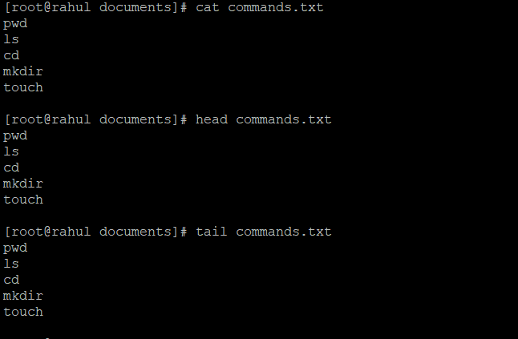
Q 6 : Copy commands.txt into the backup directory.
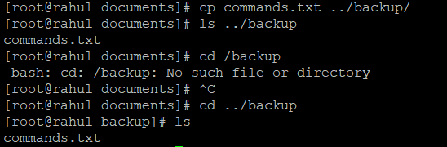
Q 7 : Rename practice.txt to daily_practice.txt.

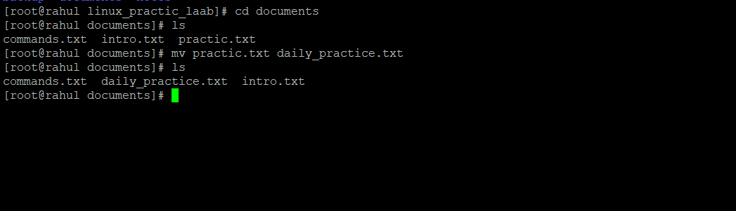
Q 8 : Move intro.txt from documents to notes.

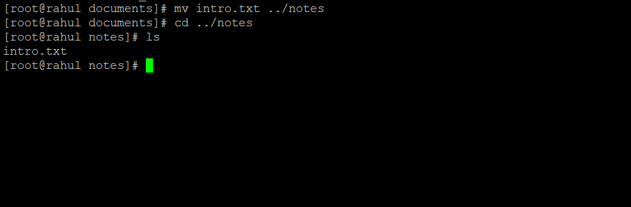

Q 9 : Create a hidden file named .secret_notes inside the main directory and then list it using an option that shows hidden files.
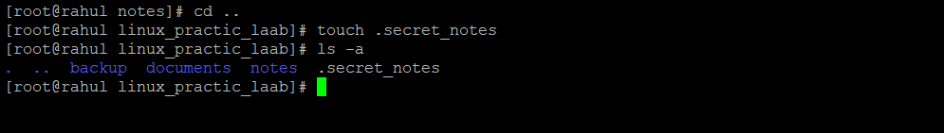
Q 10: Create a nested directory structure named projects/week1/day1 using a single command.
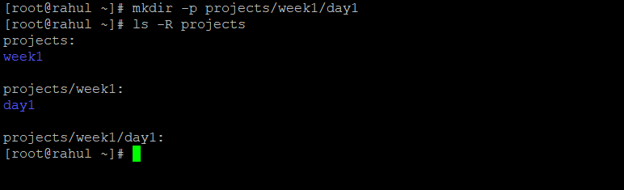
Q 11 : Use both relative and absolute paths to list files from two different locations.
Q 12 : Remove one unnecessary test file that you create yourself, but do not remove any required assignment file.
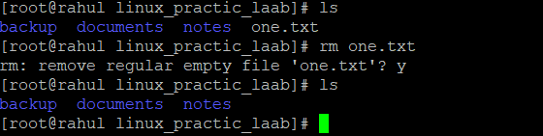
Q 13 : Create a file named lab_observation.txt explaining what each of these commands does: pwd, ls, cd, mkdir, touch, cp, mv, rm, and rmdir.
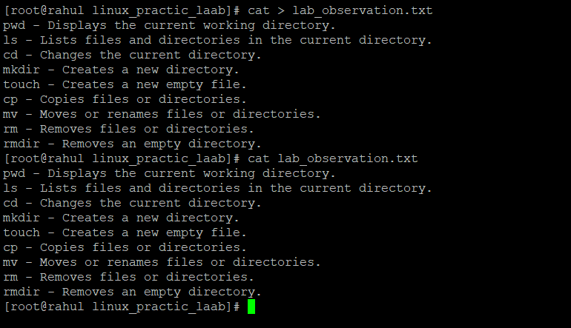

- Expert Level

- : Create the full directory structure again using fewer commands.
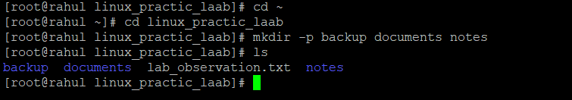
- Use command options to show file sizes in human-readable format.
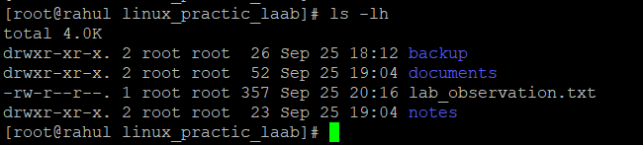
- Find all .txt files inside linux_practice_lab.

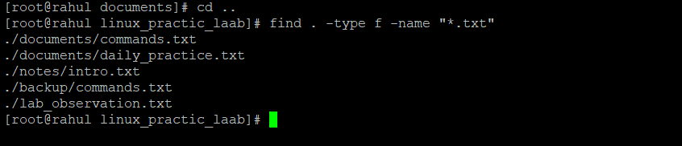

- Compare the original commands.txt and the backup copy to confirm both contain the same content.
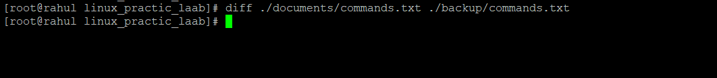

- Write a short note on when rm can be dangerous and how a learner should use it carefully.

Ans : The rm command in Linux is used to delete files and directories. It can be dangerous because deleted files may not be easily recoverable, especially when using options like -r or -f.

