CancelTest
03/11/2020 16:04:30
User Is Navigated To Site : http://172.19.9.53/ICRARevamp/#/login
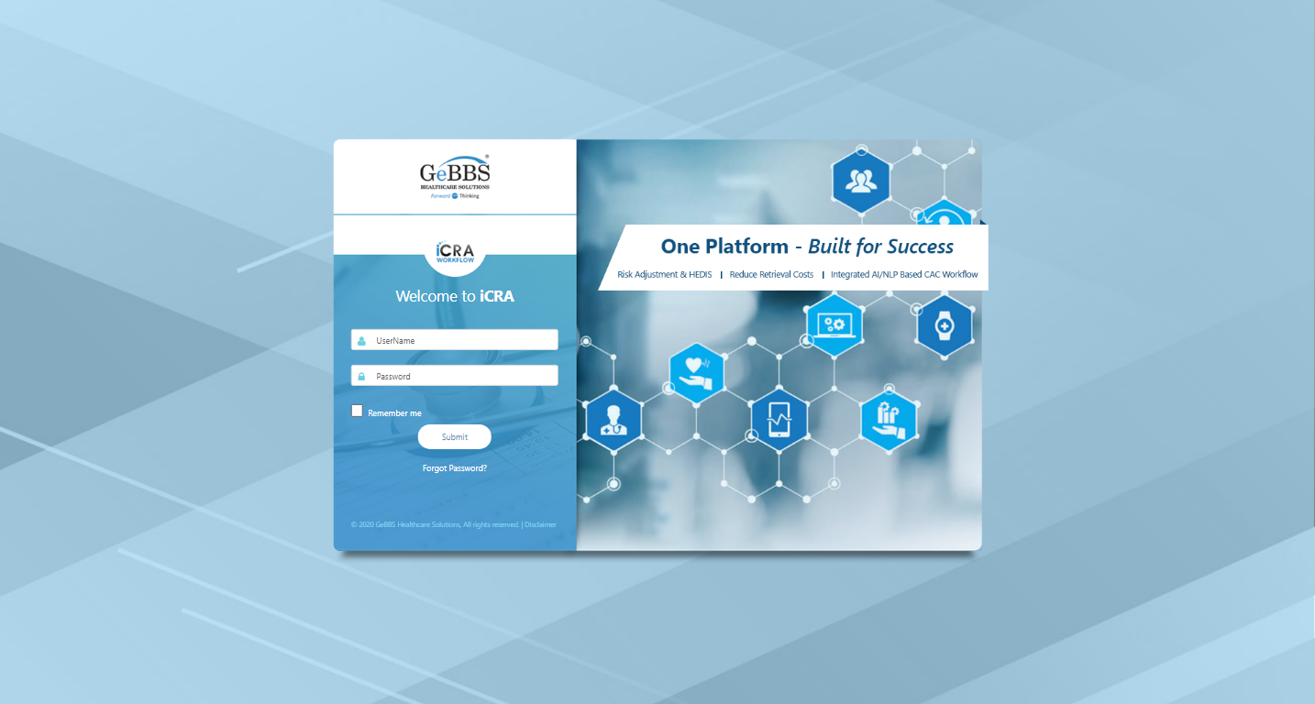
*****CancelTest is Started *****
Username is entered
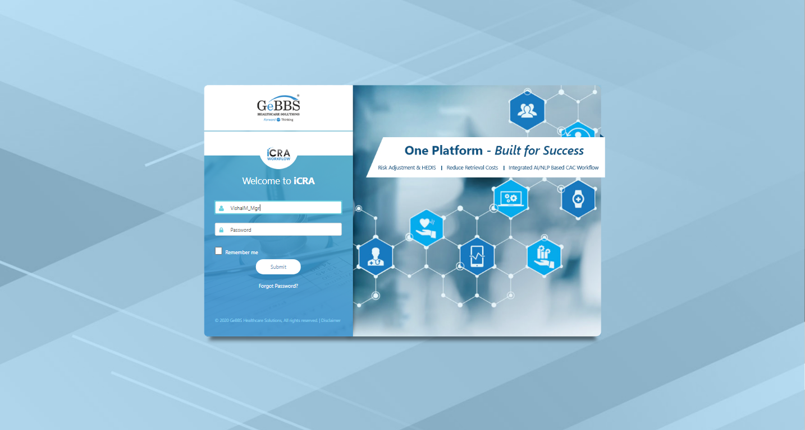
Password is entered
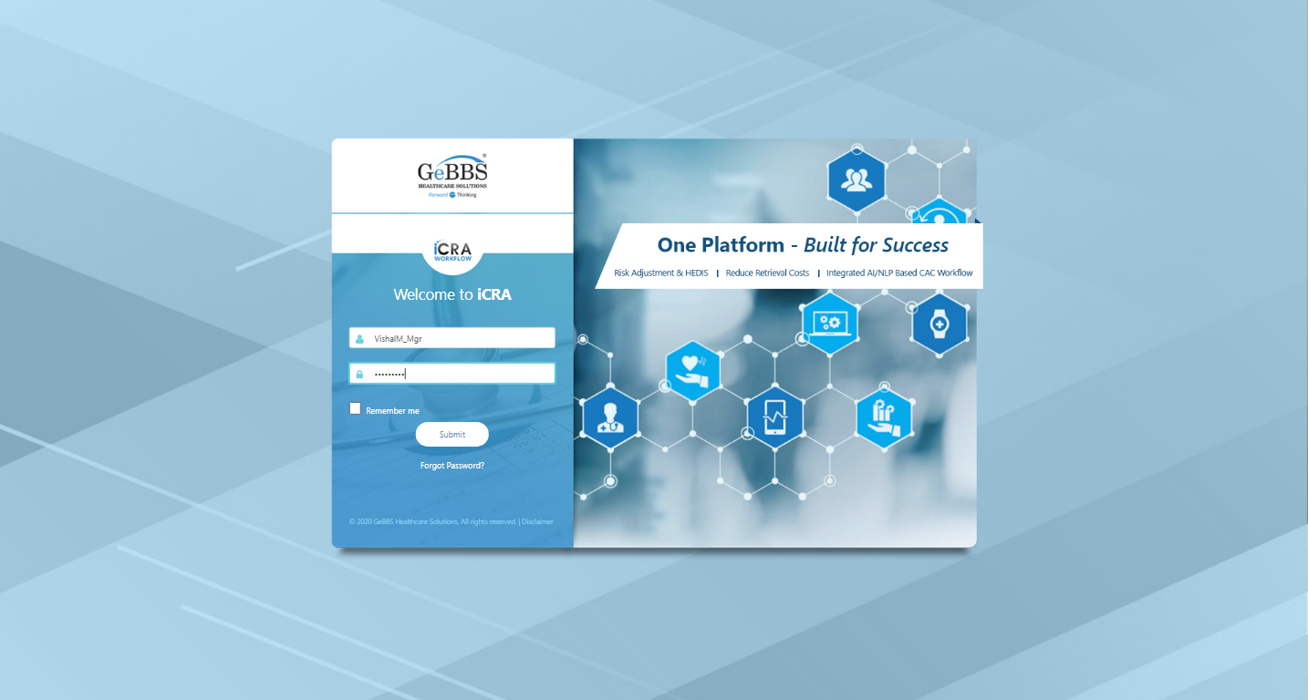
Submit button is clicked
Text of the element : Successfully logged in
Successfully logged in
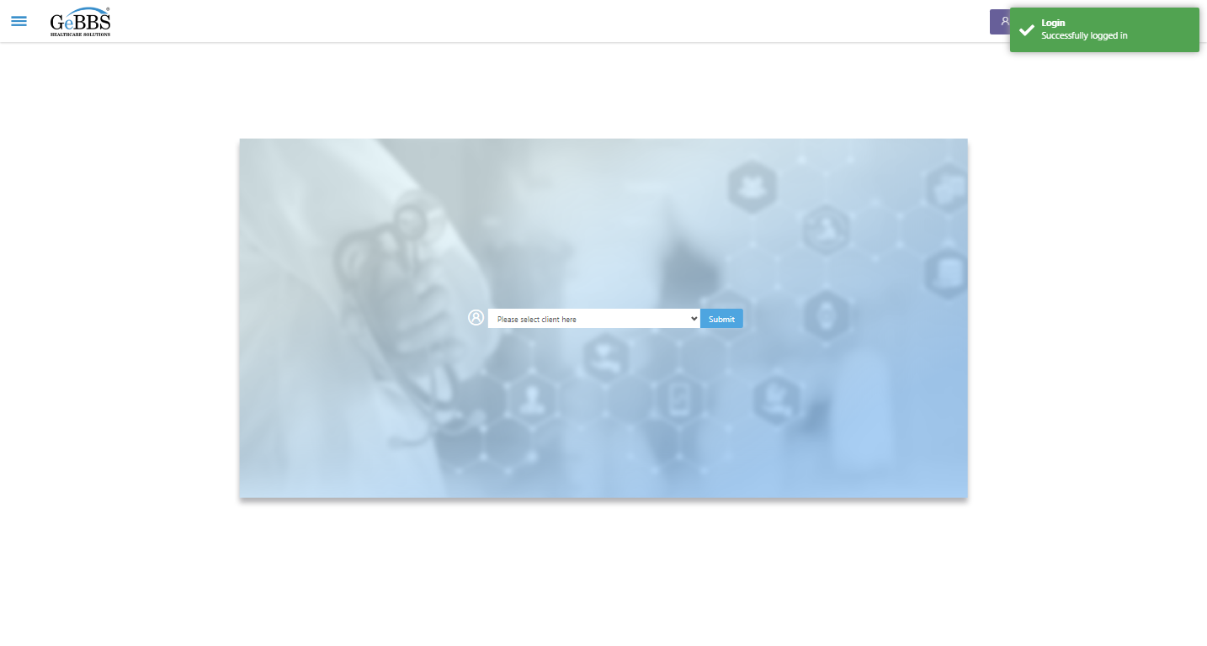
Client dropdown button is clicked
Client dropdown button is clicked
Submit button is clicked
Main Page loaded

Scrolled successfully
Chart Retrieval is clicked
All submenus

Submenu in 1 is :Field Tech
Submenu in 2 is :FieldTech Area Assignment
Submenu in 3 is :Intake
Submenu in 4 is :RecordQA
Submenu in 5 is :RecordQA Approval
Scrolled successfully
RecordQA is clicked
RecordQA selected
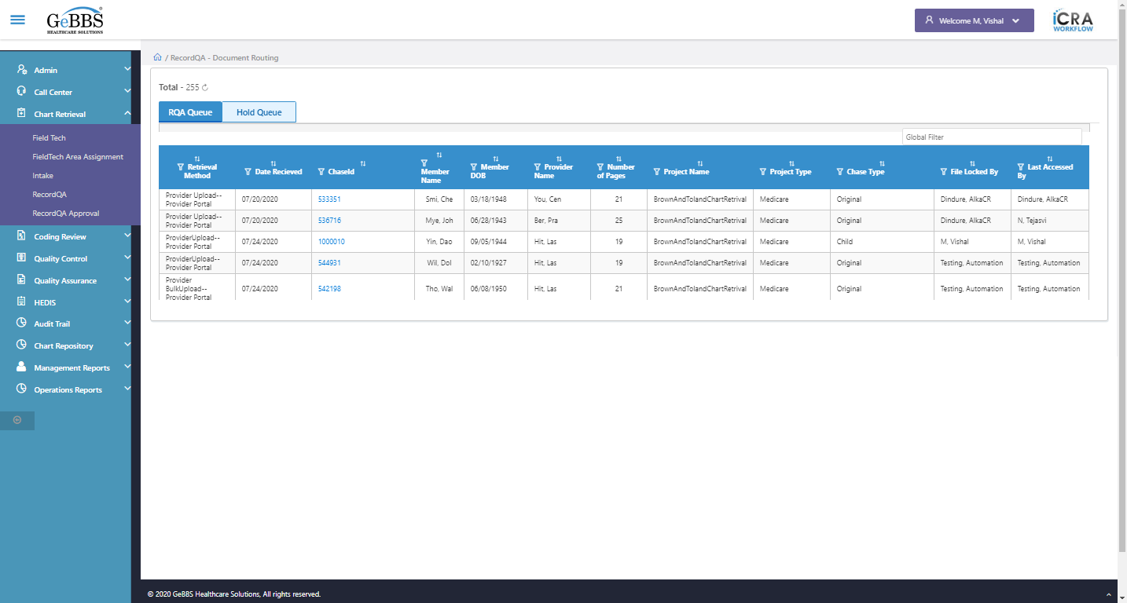
Scrolled successfully
Scrolled successfully
Scrolled successfully
Scrolled successfully
Scrolled successfully
Scrolled successfully
Scrolled successfully
Scrolled successfully
Scrolled successfully
Scrolled successfully
Text of the element : 1000021
GolbalFilter is entered
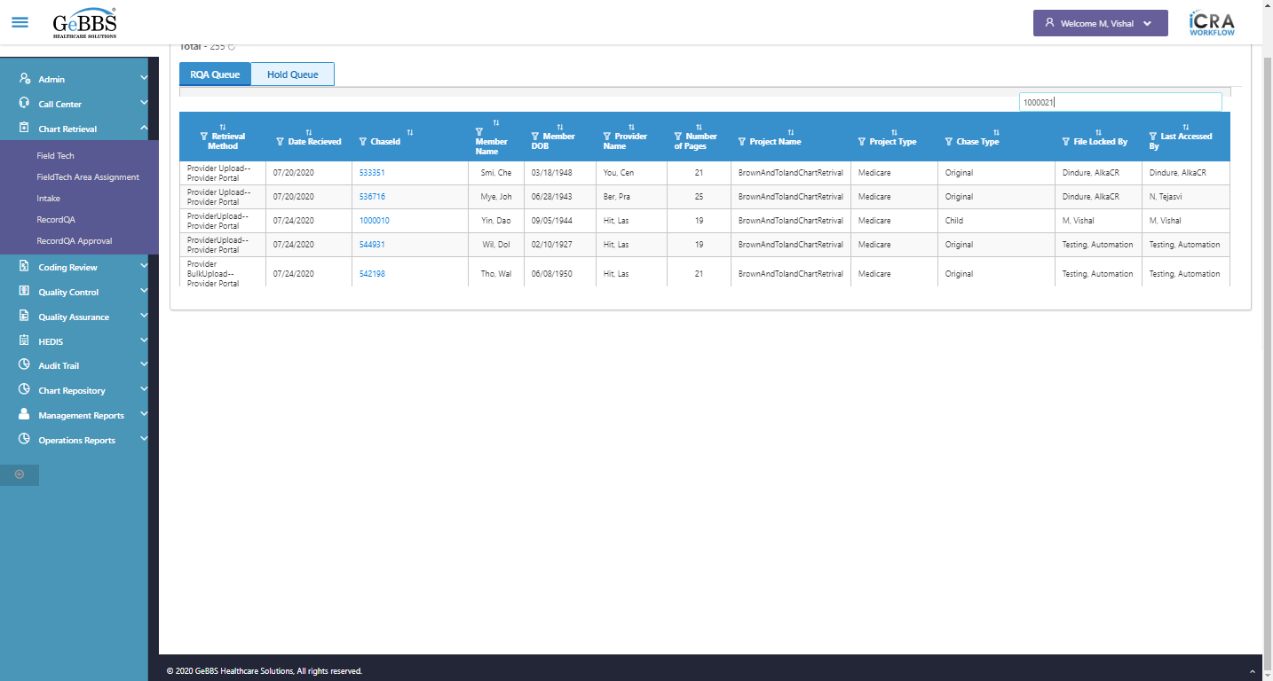
Text of the element : 36
chaseid is clicked
Chkbox_1 is displayed
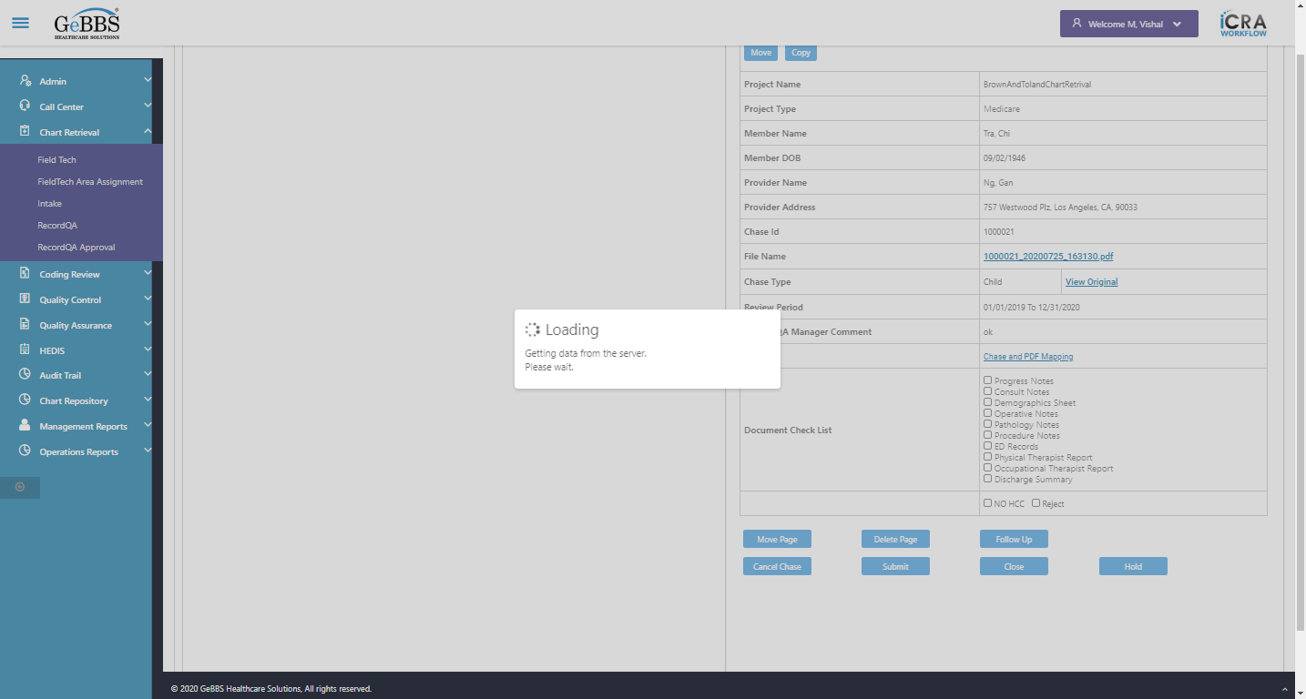
Progress Notes is displayed
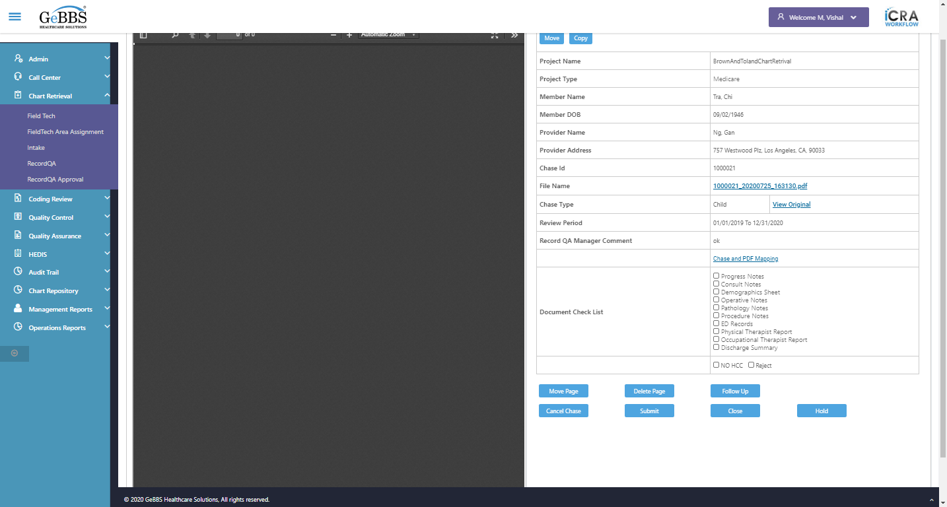
Text of the element : Progress Notes
text is correct
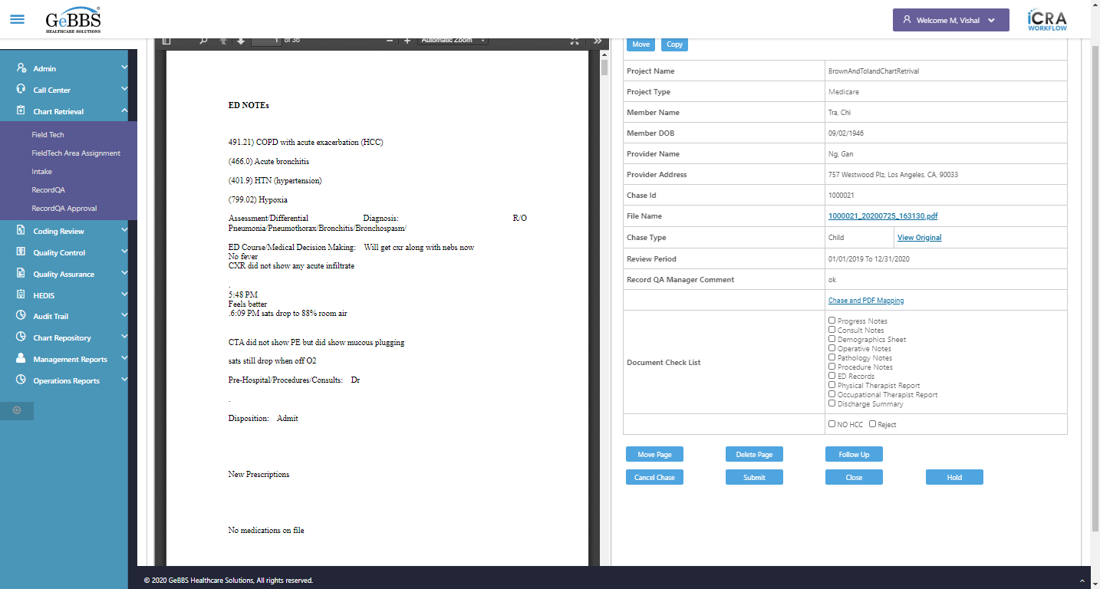
Chkbox_2 is displayed
Consult Notes is displayed
Text of the element : Consult Notes
text is correct
Chkbox_3 is displayed
Demographics Sheet is displayed
Text of the element : Demographics Sheet
text is correct
Chkbox_4 is displayed
Operative Notes is displayed
Text of the element : Operative Notes
text is correct
Chkbox_5 is displayed
Pathology Notes is displayed
Text of the element : Pathology Notes
text is correct
Chkbox_6 is displayed
Procedure Notes is displayed
Text of the element : Procedure Notes
text is correct
Chkbox_7 is displayed
ED Records is displayed
Text of the element : ED Records
text is correct
Chkbox_8 is displayed
Physical Therapist Report is displayed
Text of the element : Physical Therapist Report
text is correct
Chkbox_9 is displayed
Occupational Therapist Report is displayed
Text of the element : Occupational Therapist Report
text is correct
Chkbox_10 is displayed
Discharge Summary is displayed
Text of the element : Discharge Summary
text is correct
ChkBoxNoHCC is displayed
Text of the element : NO HCC
NOHCC text is correct
ChkBoxReject is displayed
Text of the element : Reject
Reject text of is correct
Move is displayed
Copy is displayed
Scrolled successfully
MovePage is displayed
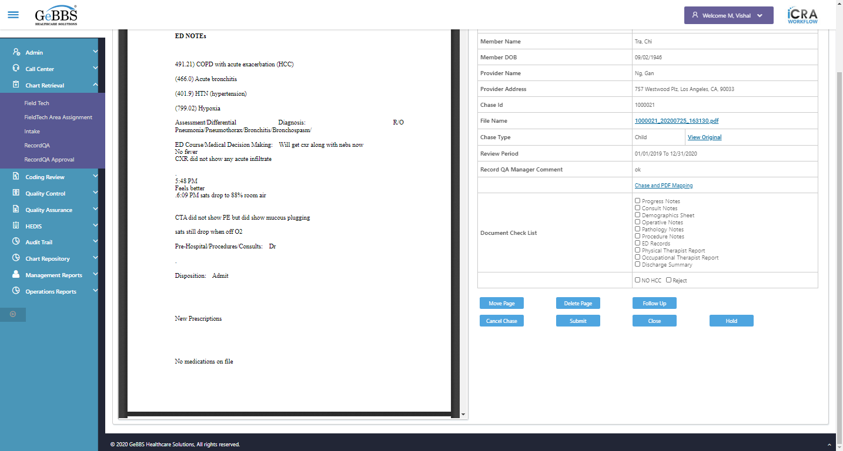
DeletePage is displayed
FollowUp is displayed
CancelChase is displayed
Submit is displayed
Close_RecordQA is displayed
Hold is displayed
Scrolled successfully
CancelChase is clicked
Close_CxlChaseWindow is clicked
Close button oF Cancel Chase/Follow Up Window working
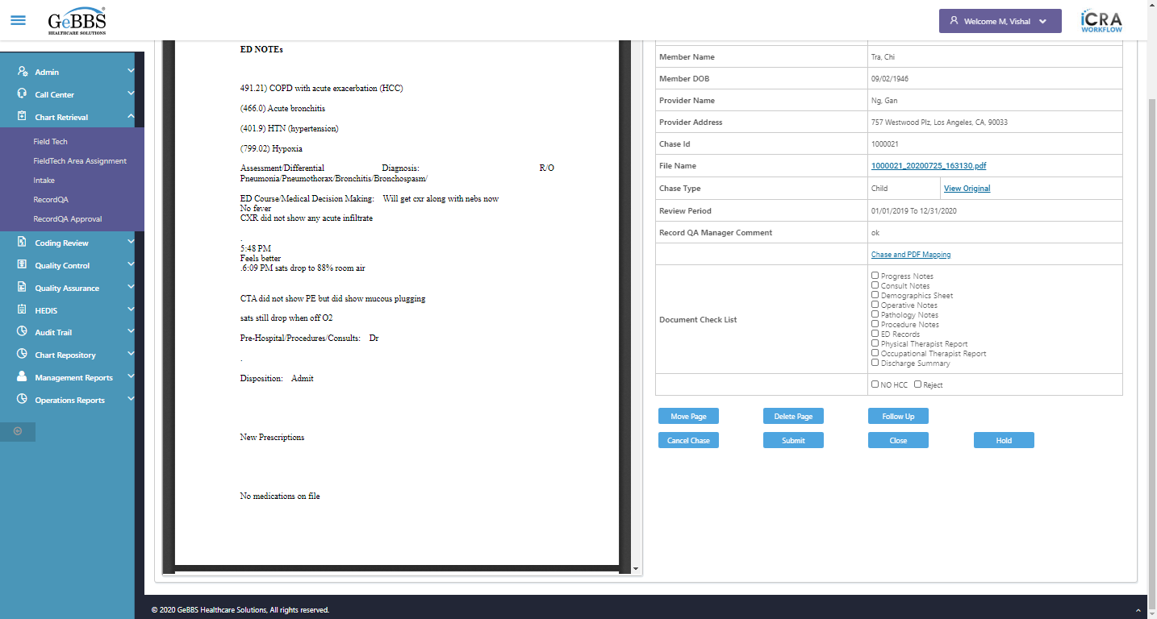
Scrolled successfully
CancelChase is clicked
BrownAndTolandChartRetrival is correct
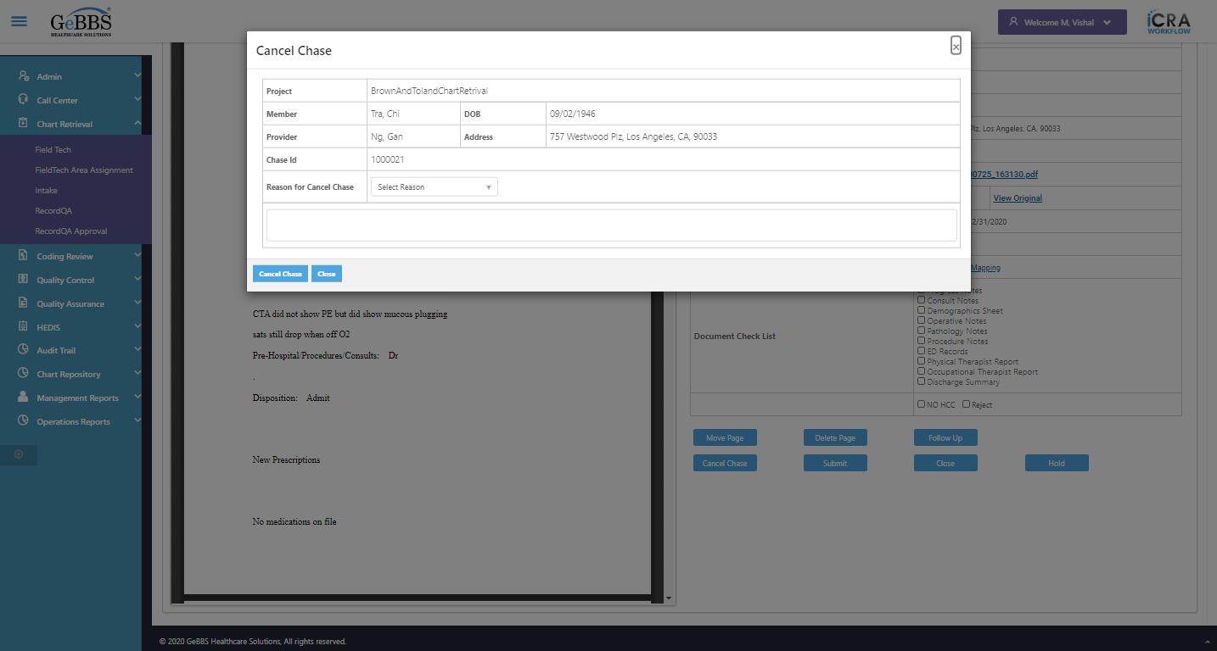
Tra, Chi is correct
09/02/1946 is correct
Ng, Gan is correct
757 Westwood Plz, Los Angeles, CA, 90033 is correct
1000021 is correct
Reason is displayed
Com is displayed
CancelChase is displayed
Close_CancelChaseWin is displayed
CancelChase is clicked
Reasonmsg_CancelChaseWindow is displayed
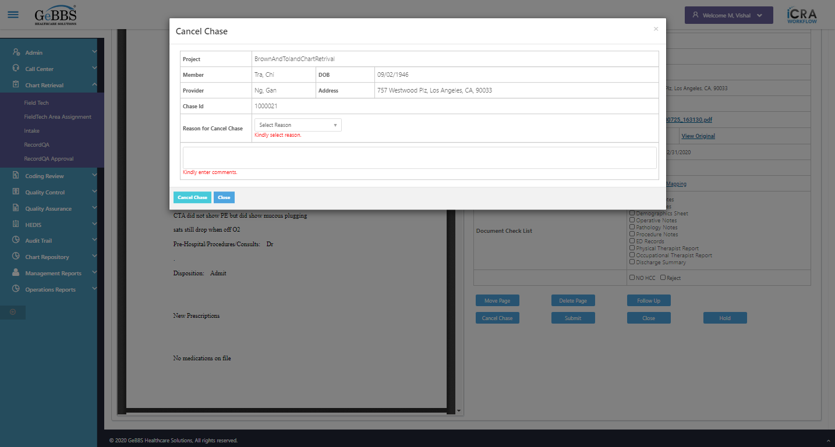
Reasonmsg_CancelChaseWindow is correct
Commmsg_CancelChaseWindow is displayed
Commmsg_CancelChaseWindow is correct
Drop down option with visible text TEST is selected
Comm_CancelChaseWin is entered
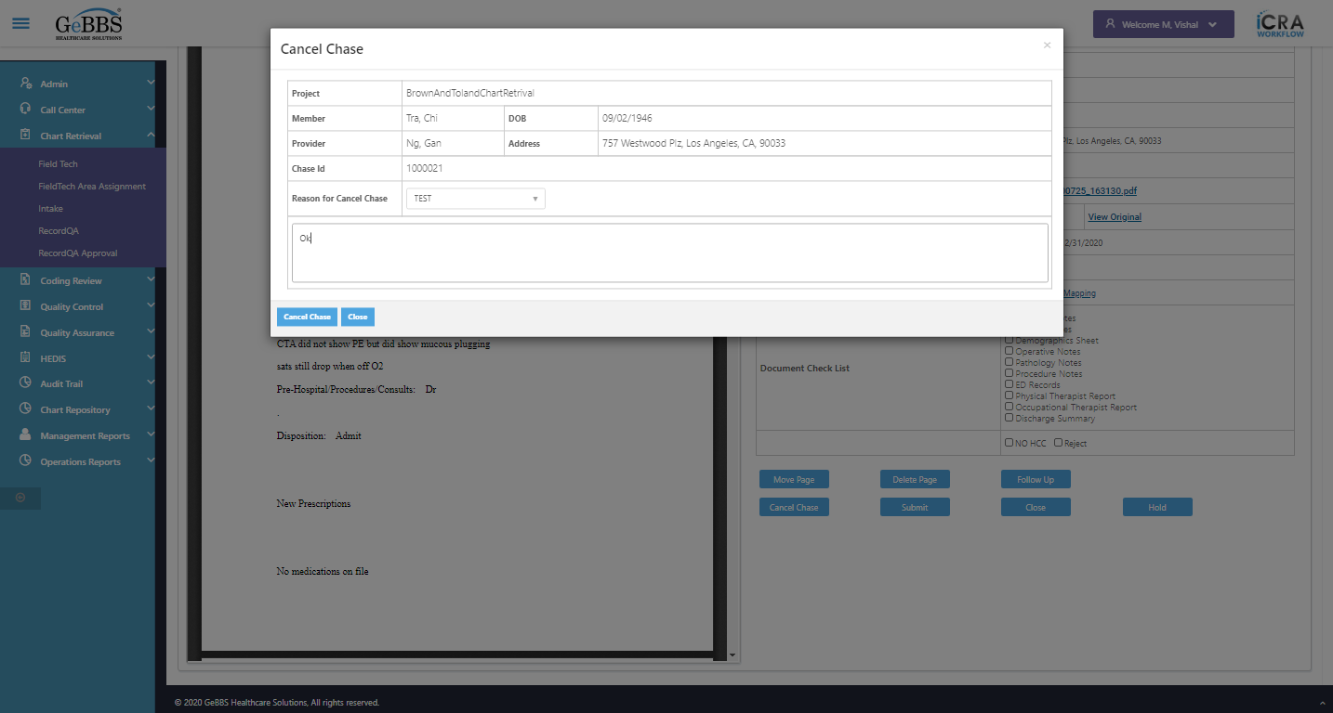
CancelChase is clicked
CancelChaseAlert is displayed
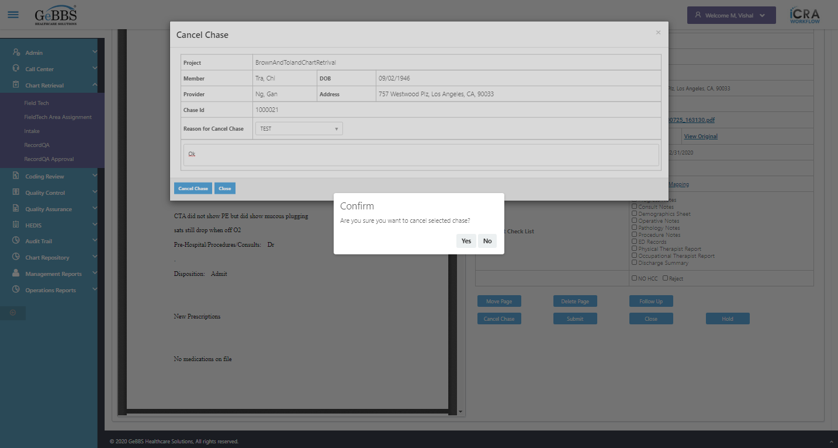
CancelChaseAlert text of popup is correct
Yes is clicked
CheckElementDisplay() failed - stale element reference: element is not attached to the page document
(Session info: chrome=86.0.4240.111)
For documentation on this error, please visit: https://www.seleniumhq.org/exceptions/stale_element_reference.html
Build info: version: '3.141.59', revision: 'e82be7d358', time: '2018-11-14T08:17:03'
System info: host: 'GEBBSET17063', ip: '172.30.54.166', os.name: 'Windows 10', os.arch: 'amd64', os.version: '10.0', java.version: '13.0.1'
Driver info: org.openqa.selenium.chrome.ChromeDriver
Capabilities {acceptInsecureCerts: false, browserName: chrome, browserVersion: 86.0.4240.111, chrome: {chromedriverVersion: 85.0.4183.87 (cd6713ebf92fa..., userDataDir: C:\Users\nishinde\AppData\L...}, goog:chromeOptions: {debuggerAddress: localhost:58209}, javascriptEnabled: true, networkConnectionEnabled: false, pageLoadStrategy: normal, platform: WINDOWS, platformName: WINDOWS, proxy: Proxy(), setWindowRect: true, strictFileInteractability: false, timeouts: {implicit: 0, pageLoad: 300000, script: 30000}, unhandledPromptBehavior: dismiss and notify, webauthn:virtualAuthenticators: true}
Session ID: 3a8213f63bceec5daec3d03d0ebdecf5
ClkCxlChase_ChkMsg() failed - stale element reference: element is not attached to the page document
(Session info: chrome=86.0.4240.111)
For documentation on this error, please visit: https://www.seleniumhq.org/exceptions/stale_element_reference.html
Build info: version: '3.141.59', revision: 'e82be7d358', time: '2018-11-14T08:17:03'
System info: host: 'GEBBSET17063', ip: '172.30.54.166', os.name: 'Windows 10', os.arch: 'amd64', os.version: '10.0', java.version: '13.0.1'
Driver info: org.openqa.selenium.chrome.ChromeDriver
Capabilities {acceptInsecureCerts: false, browserName: chrome, browserVersion: 86.0.4240.111, chrome: {chromedriverVersion: 85.0.4183.87 (cd6713ebf92fa..., userDataDir: C:\Users\nishinde\AppData\L...}, goog:chromeOptions: {debuggerAddress: localhost:58209}, javascriptEnabled: true, networkConnectionEnabled: false, pageLoadStrategy: normal, platform: WINDOWS, platformName: WINDOWS, proxy: Proxy(), setWindowRect: true, strictFileInteractability: false, timeouts: {implicit: 0, pageLoad: 300000, script: 30000}, unhandledPromptBehavior: dismiss and notify, webauthn:virtualAuthenticators: true}
Session ID: 3a8213f63bceec5daec3d03d0ebdecf5
03/11/2020 16:06:41

