CodingReviewDashboardTest
10/11/2020 11:39:21
User Is Navigated To Site : http://172.19.9.53/ICRARevamp/#/login
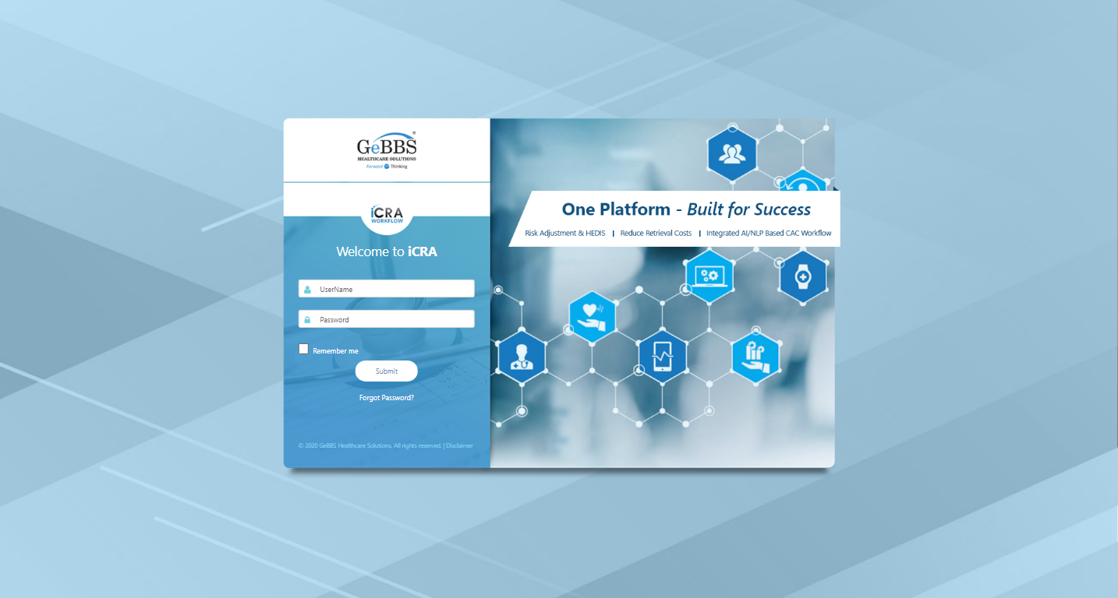
Username is entered
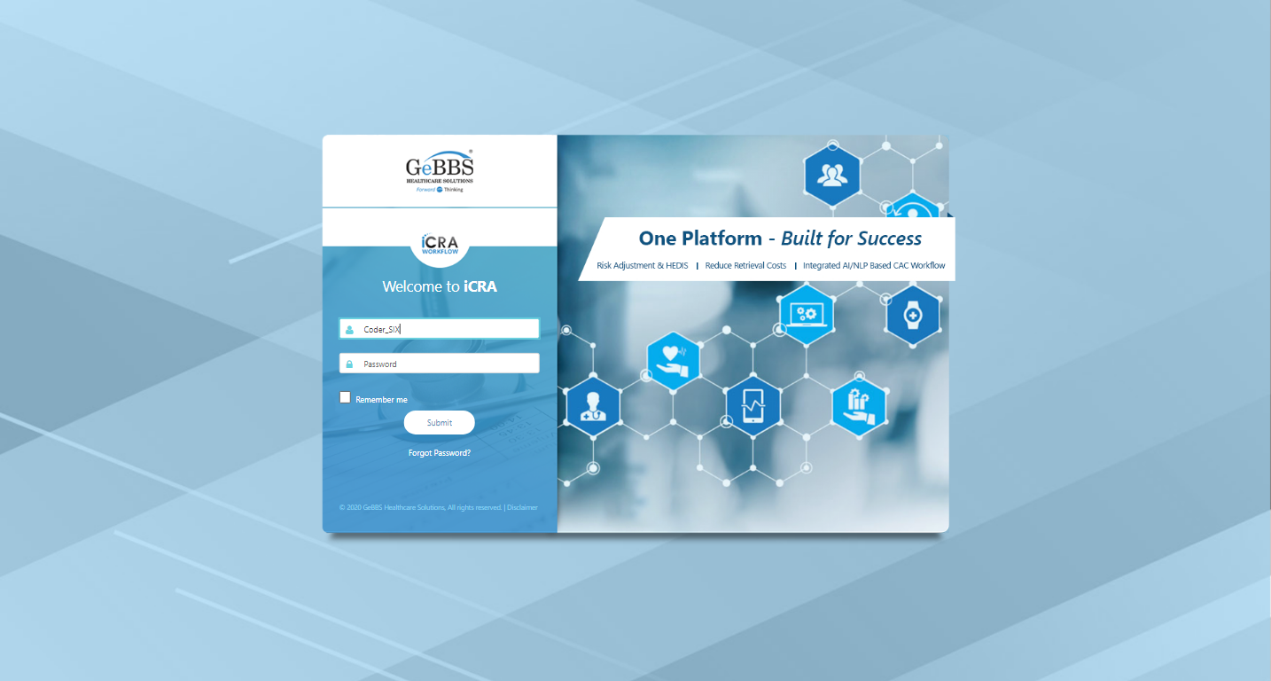
Password is entered
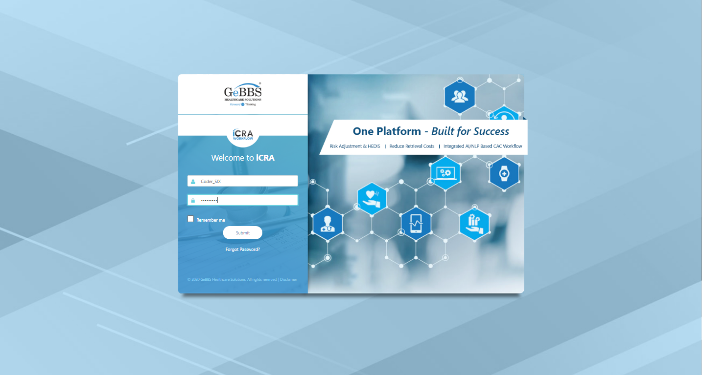
Submit button is clicked
Text of the element : Successfully logged in
Successfully logged in
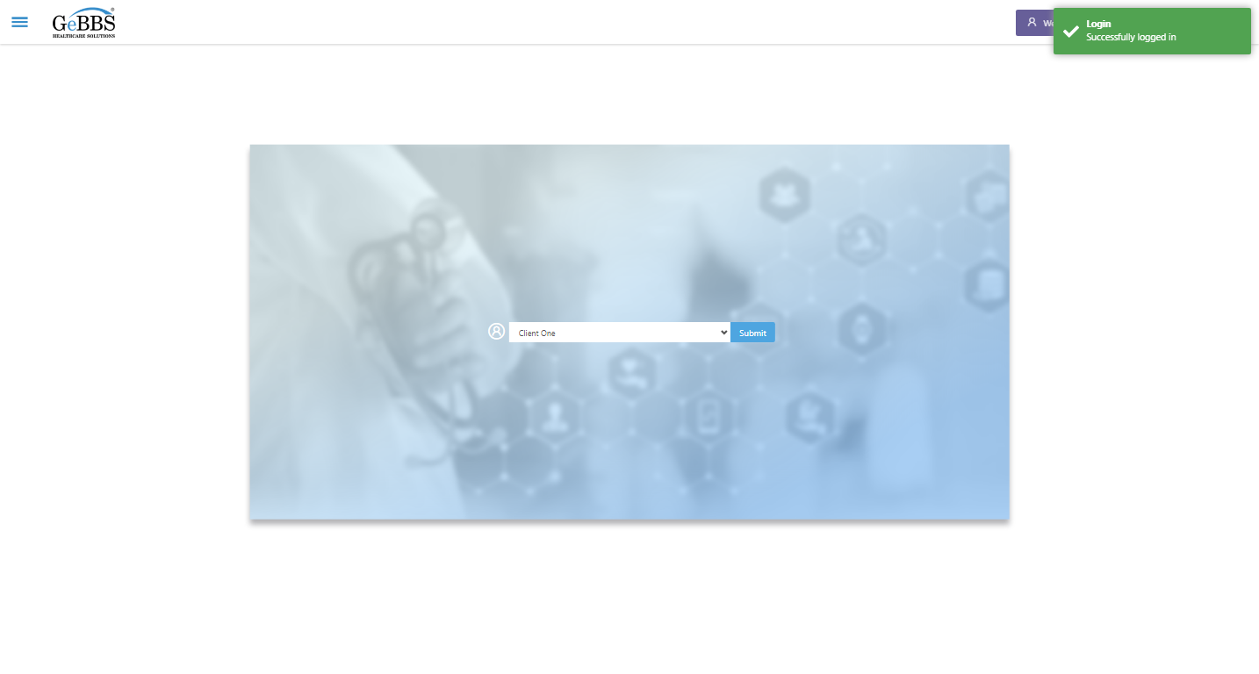
SelectClient is clicked
Drop down option at the position 1 is selected
Submit selected client is clicked
Desired client found.
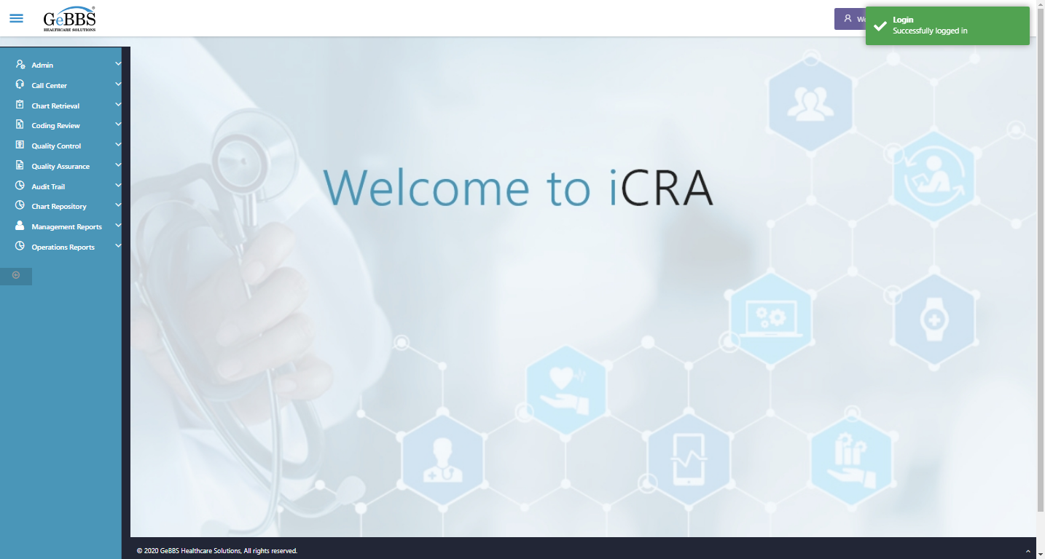
Main Page loaded

Scrolled successfully
Management Reports is clicked
All submenus

Submenu in 1 is :Charts in Queue Report
Submenu in 2 is :Coding Review Dashboard
Submenu in 3 is :HCC Change Report
Submenu in 4 is :Invoice Report
Submenu in 5 is :Retrieval Progress Dashboard
Submenu in 6 is :Review Quality Report
Scrolled successfully
Coding Review Dashboard is clicked
Coding Review Dashboard selected
Frame found and switched to
Frame found and switched to
CodingCompletionStatus is displayed
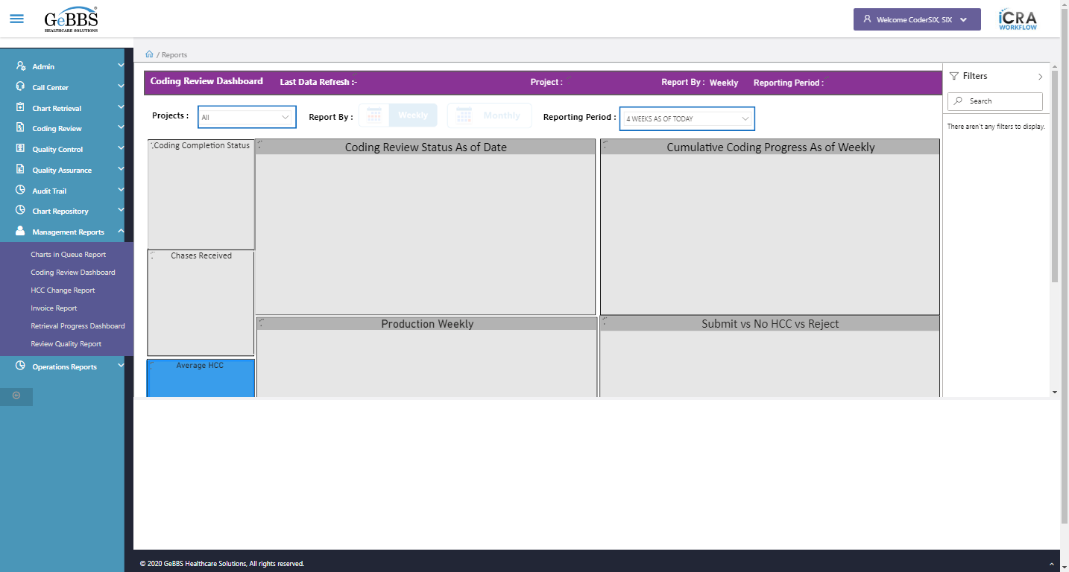
Chases_Received icon is displayed
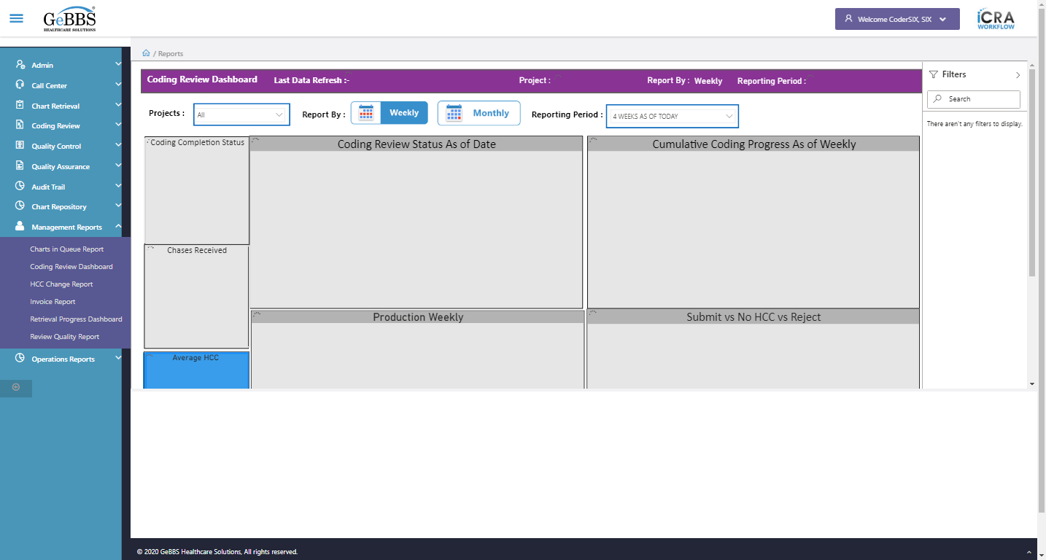
AverageHCC image is displayed
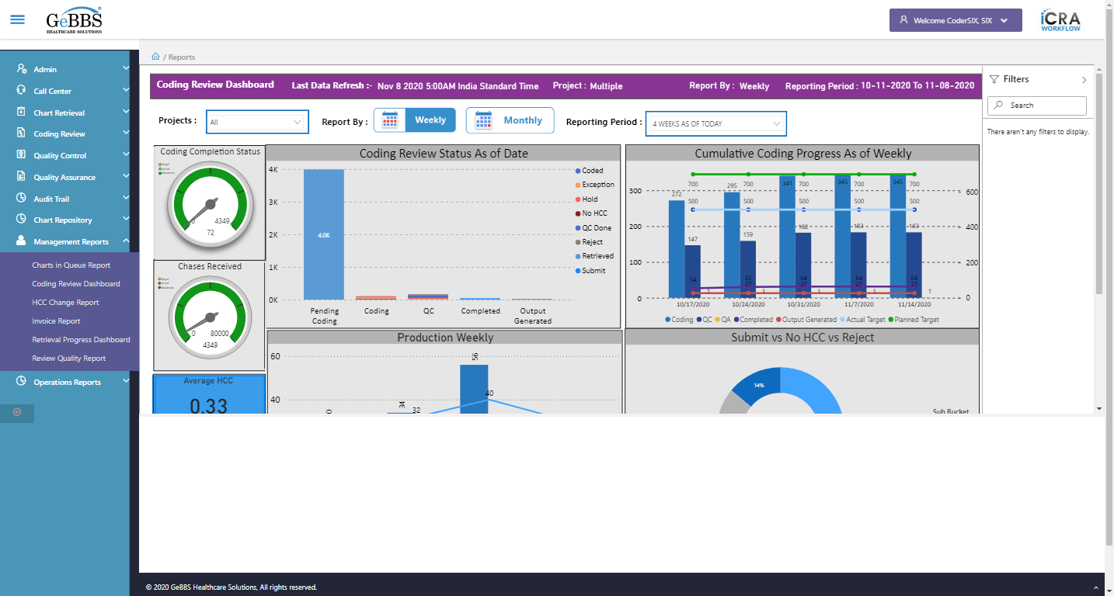
AveragePageCount image is displayed
AverageDOS image is displayed
CoderReviewStatus graph is displayed
CumulativeCoding graph is displayed
ProductionWeekly graph is displayed
Submit_NoHCC_Reject graph is displayed
ProjectDropdown is displayed
ReportingPeriod is displayed
ShowFilterPane is displayed
Filters text is displayed
Filters icon is displayed
AverageDOSMonthly is displayed
MonthlyDashboard is displayed
Search_Filter is displayed
ShowFilterPane is clicked
Attribute for title is : Multiple
Project name is displayed at header is correct
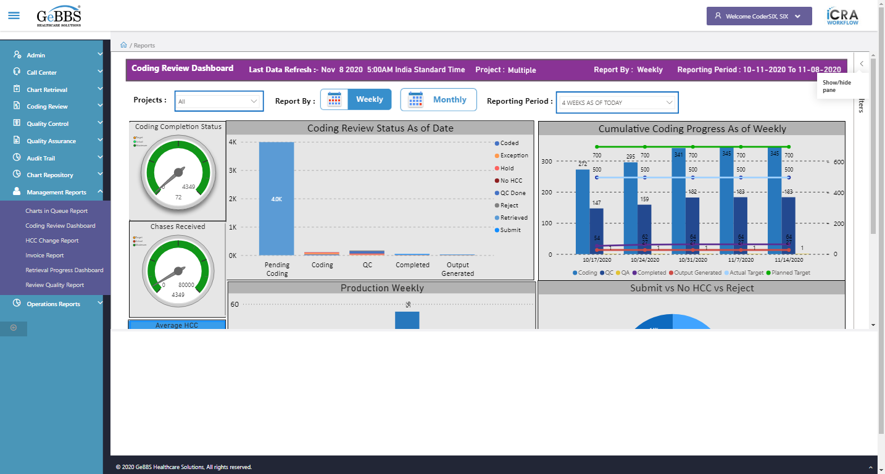
Project name field is correct
Reporting period value i.e 4 WEEKS AS OF TODAY is selected by default
ReportingBy_Weekly is displayed
ReportingBy_Monthly is displayed
ReportbyTitle2 i.e weekly is displayed
MonthlyDashboard is clicked
CodingCompletionStatus is displayed
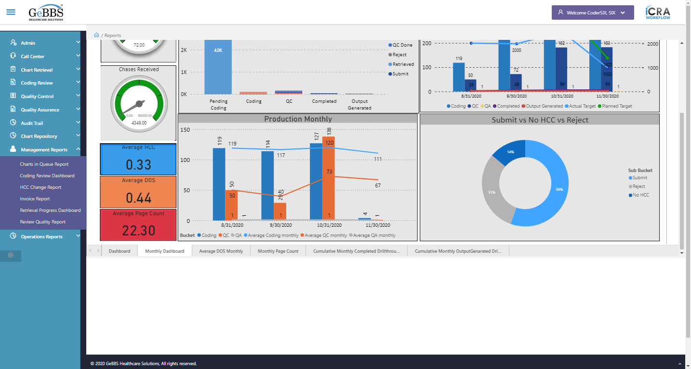
Chases_Received icon is displayed
AverageHCC image is displayed
AveragePageCount image is displayed
AverageDOS image is displayed
CoderReviewStatus graph is displayed
CumulativeCoding graph is displayed
ProductionMonthly graph is displayed
Submit_NoHCC_Reject graph is displayed
ProjectDropdown is displayed
ReportingPeriod is displayed
ShowFilterPane is displayed
Filters text is displayed
Filters icon is displayed
AverageDOSMonthly is displayed
MonthlyDashboard is displayed
Search_Filter is not displayed
ShowFilterPane is clicked
ReportbyTitle1 i.e Monthly is displayed
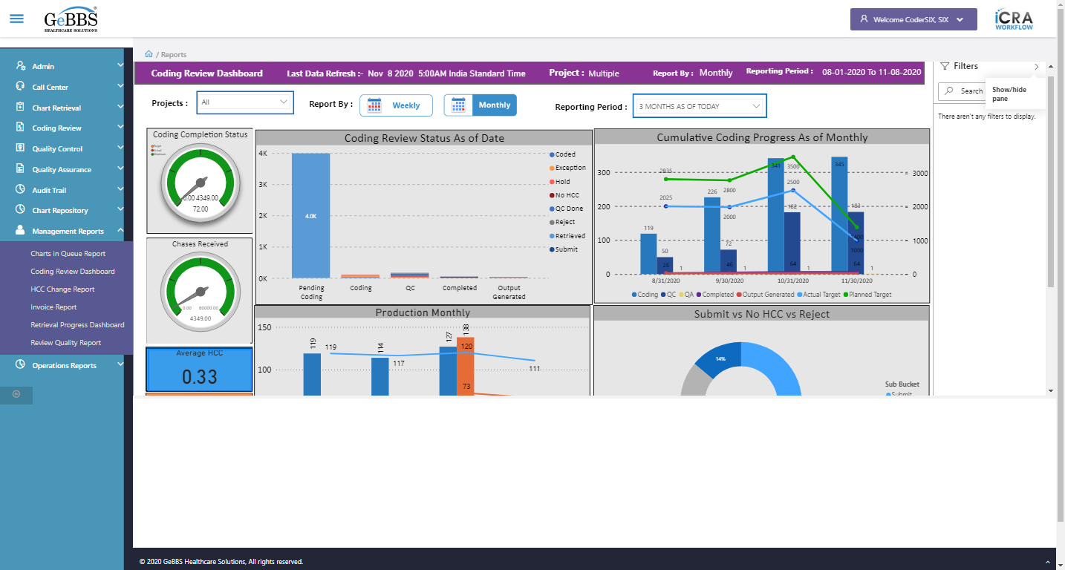
ReportingPeriod is displayed
Reporting period value i.e 3 MONTHS AS OF TODAY is selected by default
Average DOS Monthly is clicked
Backarrow is displayed
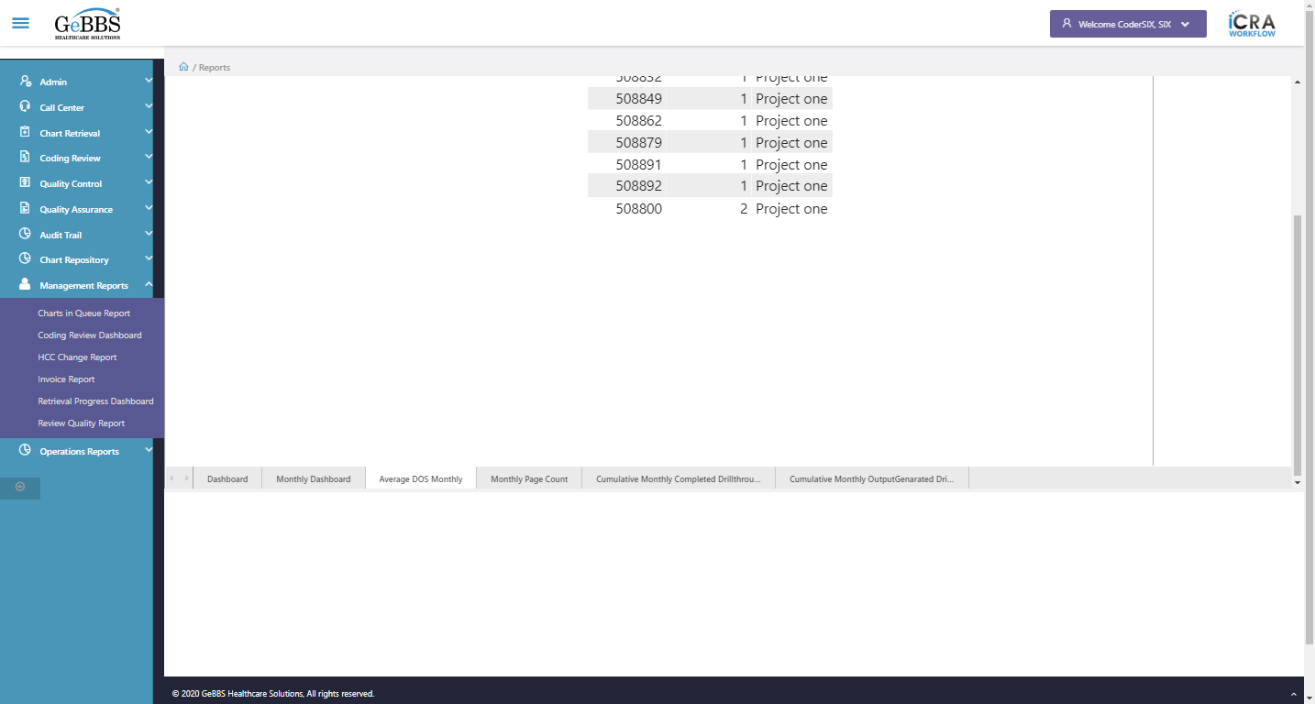
ShowFilterPane is displayed
FilterPane is clicked
ChkFilterSection() failed
ChkTblCol_OtherElements() failed
Dashboard_AvgDOSWeek_Month() failed
ChkAllDashBoard() failed
10/11/2020 11:41:54

