FollowUpTest
03/11/2020 16:15:03
User Is Navigated To Site : http://172.19.9.53/ICRARevamp/#/login

*****FollowUpTest is Started *****
Username is entered

Password is entered

Submit button is clicked
Text of the element : Successfully logged in
Successfully logged in
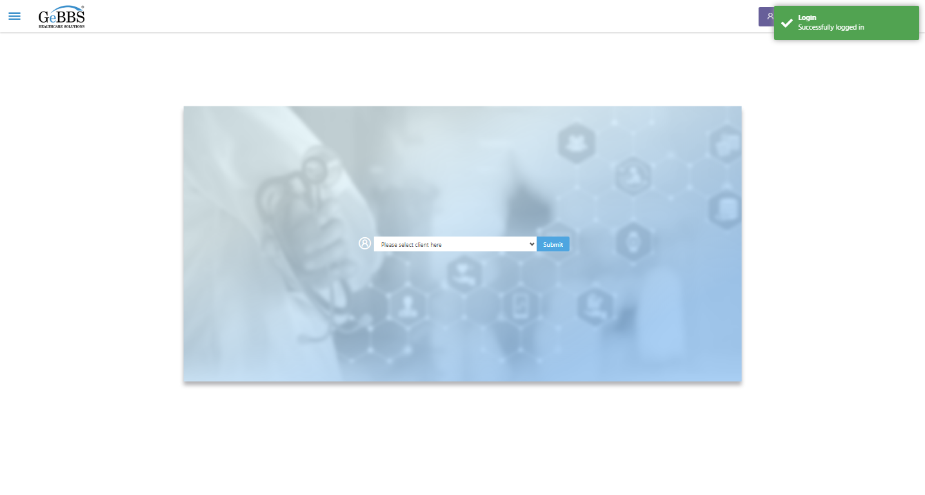
Client dropdown button is clicked
Client dropdown button is clicked
Submit button is clicked
Main Page loaded

Scrolled successfully
Chart Retrieval is clicked
All submenus

Submenu in 1 is :Field Tech
Submenu in 2 is :FieldTech Area Assignment
Submenu in 3 is :Intake
Submenu in 4 is :RecordQA
Submenu in 5 is :RecordQA Approval
Scrolled successfully
RecordQA is clicked
RecordQA selected
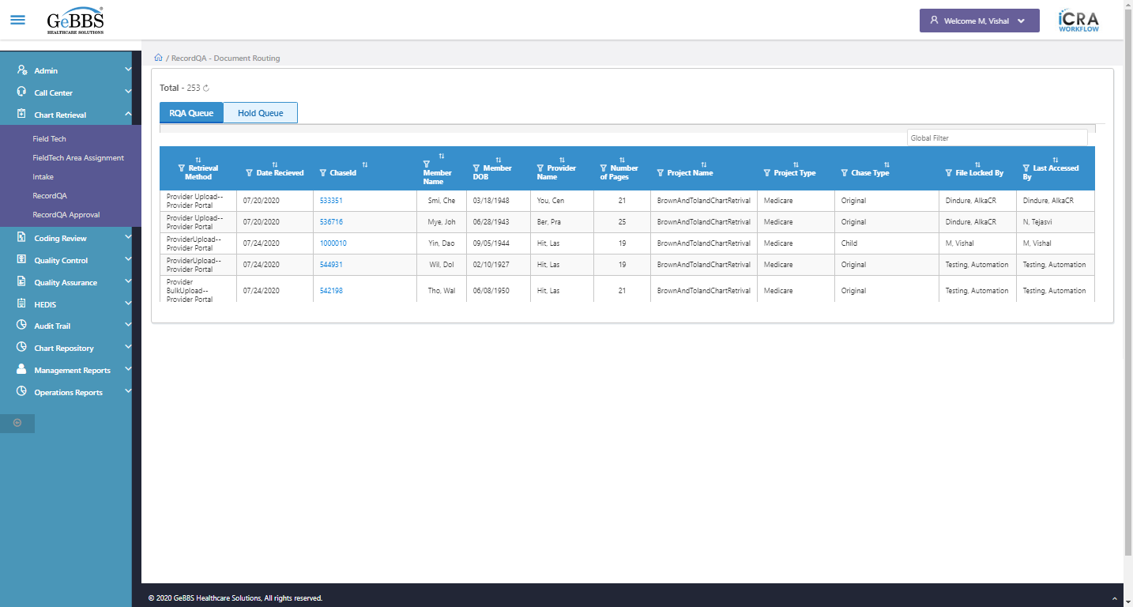
Scrolled successfully
Scrolled successfully
Scrolled successfully
Scrolled successfully
Scrolled successfully
Scrolled successfully
Scrolled successfully
Scrolled successfully
Scrolled successfully
Scrolled successfully
Scrolled successfully
Text of the element : 1000029
GolbalFilter is entered
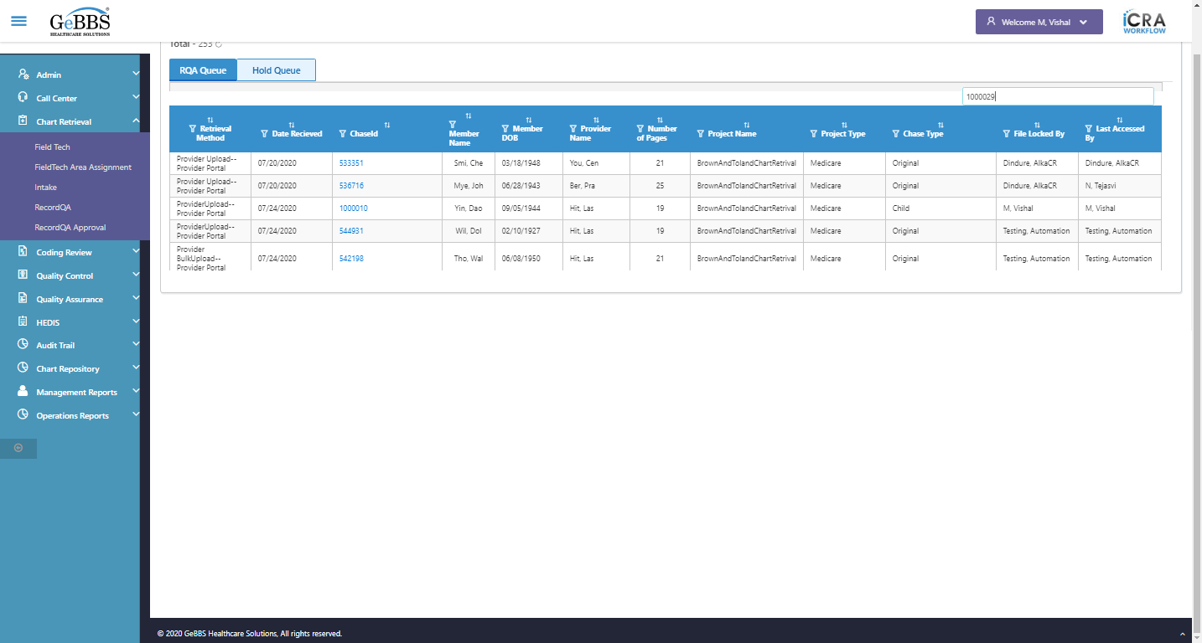
Text of the element : 3
chaseid is clicked
Chkbox_1 is displayed
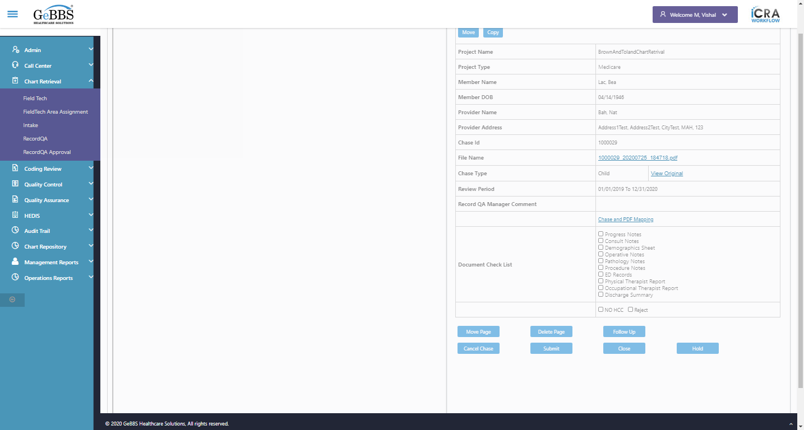
Progress Notes is displayed
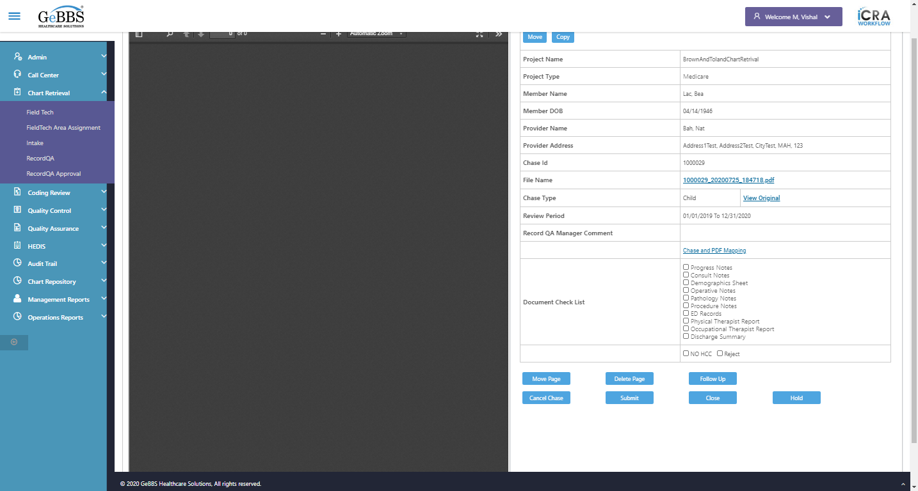
Text of the element : Progress Notes
text is correct
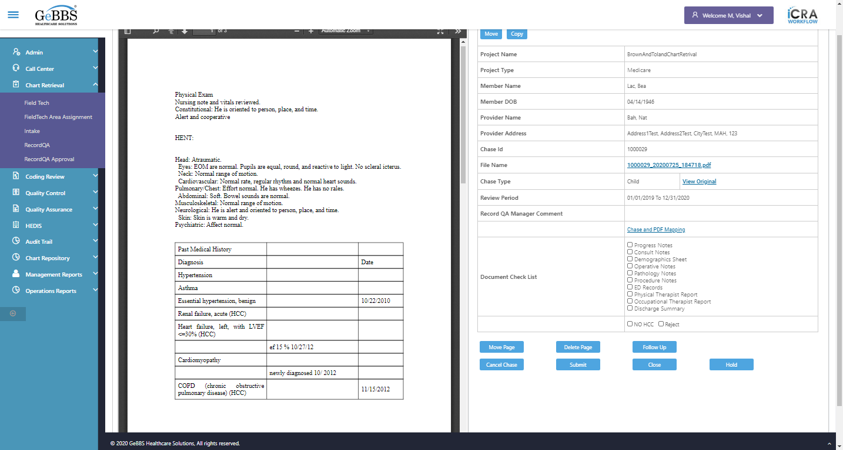
Chkbox_2 is displayed
Consult Notes is displayed
Text of the element : Consult Notes
text is correct
Chkbox_3 is displayed
Demographics Sheet is displayed
Text of the element : Demographics Sheet
text is correct
Chkbox_4 is displayed
Operative Notes is displayed
Text of the element : Operative Notes
text is correct
Chkbox_5 is displayed
Pathology Notes is displayed
Text of the element : Pathology Notes
text is correct
Chkbox_6 is displayed
Procedure Notes is displayed
Text of the element : Procedure Notes
text is correct
Chkbox_7 is displayed
ED Records is displayed
Text of the element : ED Records
text is correct
Chkbox_8 is displayed
Physical Therapist Report is displayed
Text of the element : Physical Therapist Report
text is correct
Chkbox_9 is displayed
Occupational Therapist Report is displayed
Text of the element : Occupational Therapist Report
text is correct
Chkbox_10 is displayed
Discharge Summary is displayed
Text of the element : Discharge Summary
text is correct
ChkBoxNoHCC is displayed
Text of the element : NO HCC
NOHCC text is correct
ChkBoxReject is displayed
Text of the element : Reject
Reject text of is correct
Move is displayed
Copy is displayed
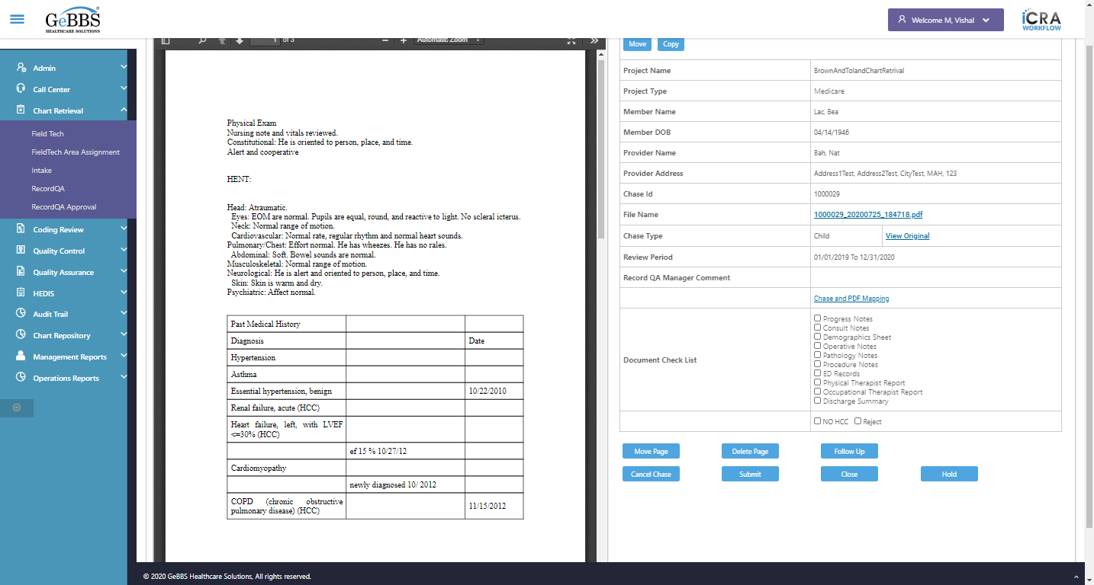
Scrolled successfully
MovePage is displayed
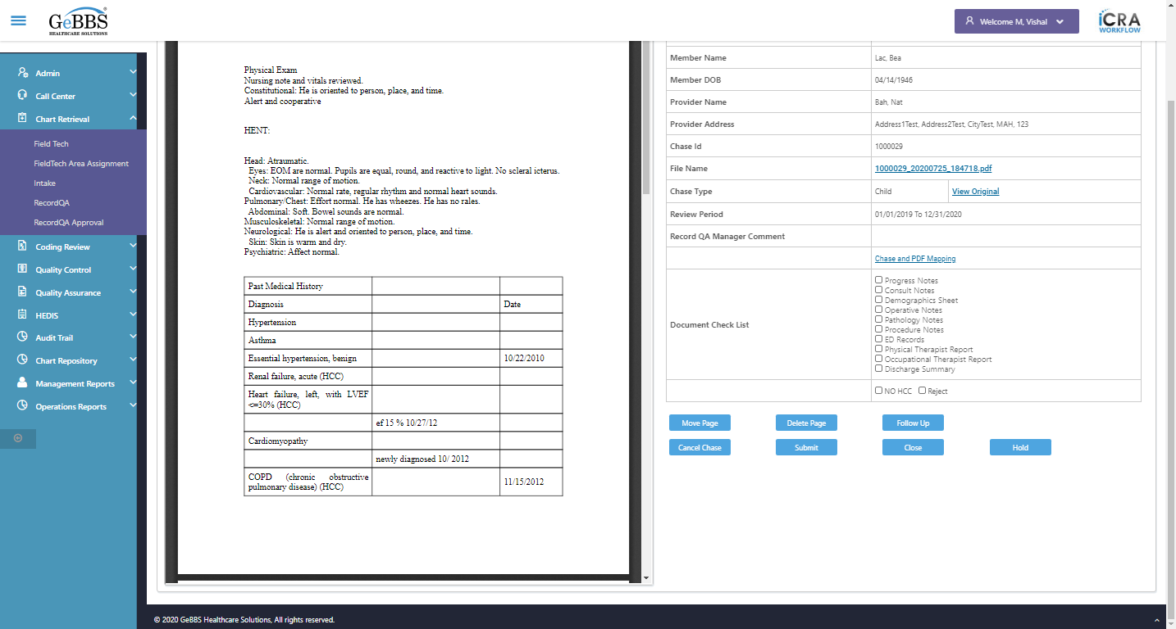
DeletePage is displayed
FollowUp is displayed
CancelChase is displayed
Submit is displayed
Close_RecordQA is displayed
Hold is displayed
FollowUp is clicked
Close_CxlChaseWindow is clicked
Close button oF Cancel Chase/Follow Up Window working
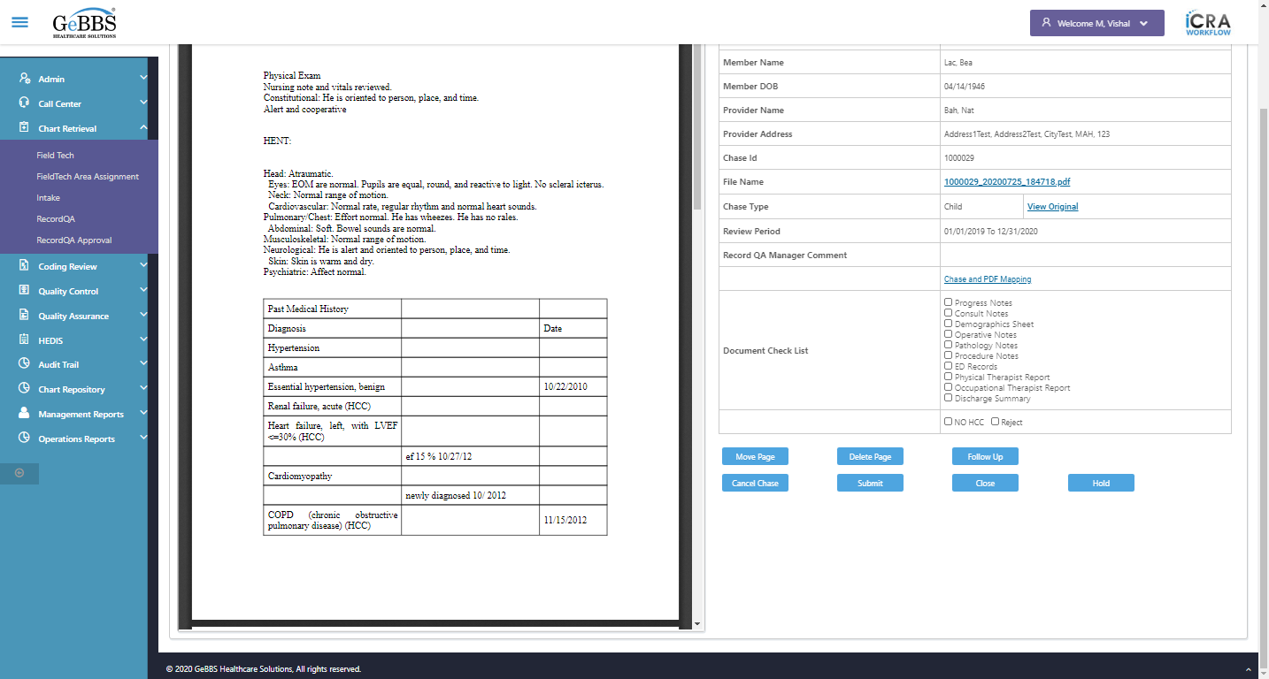
FollowUp is clicked
BrownAndTolandChartRetrival is correct
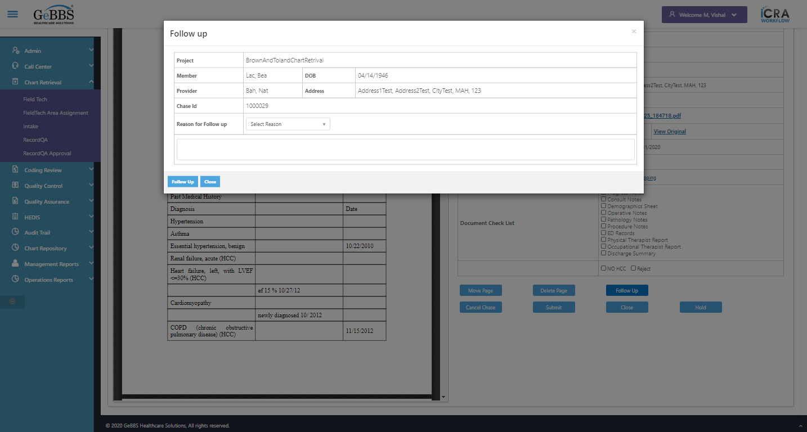
Lac, Bea is correct
04/14/1946 is correct
Bah, Nat is correct
Address1Test, Address2Test, CityTest, MAH, 123 is correct
1000029 is correct
Reason is displayed
Com is displayed
FollowUpChase is displayed
Close_FollowUpChaseWin is displayed
CancelChase is clicked
Reasonmsg_CancelChaseWindow is displayed
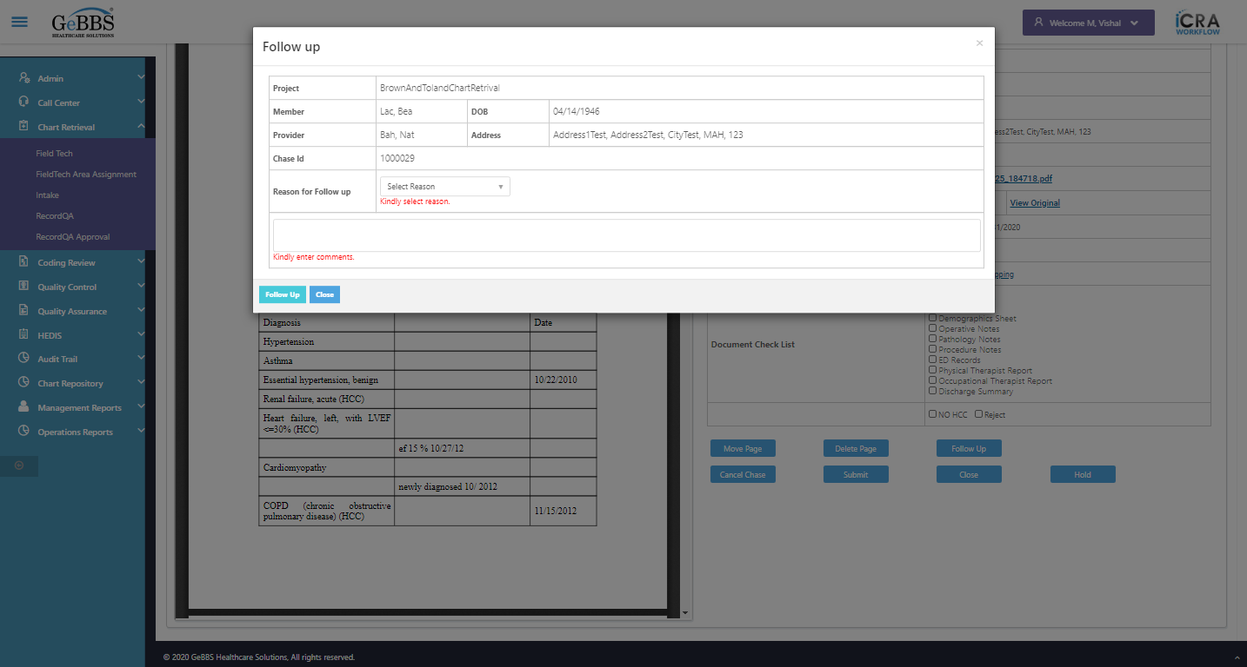
Reasonmsg_CancelChaseWindow is correct
Commmsg_CancelChaseWindow is displayed
Commmsg_CancelChaseWindow is correct
Drop down option with visible text Member Demographics Mismatch is selected
Comm_CancelChaseWin is entered
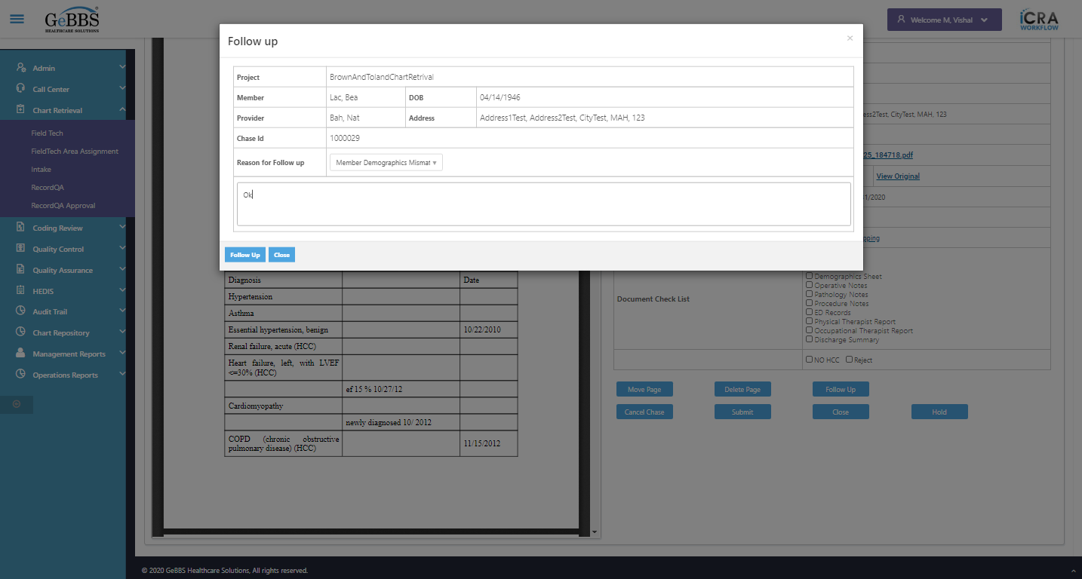
FollowUpChase is clicked
Follow Up Chase Success Message is displayed
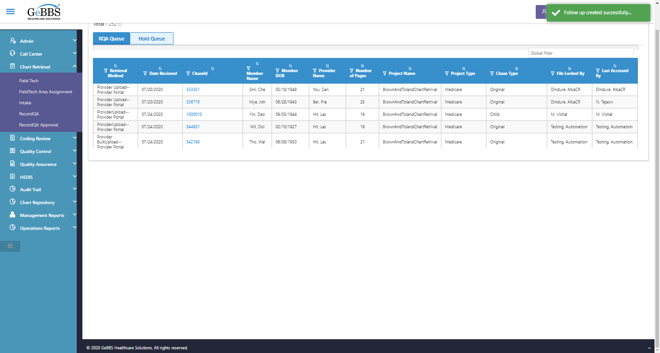
Record count correct
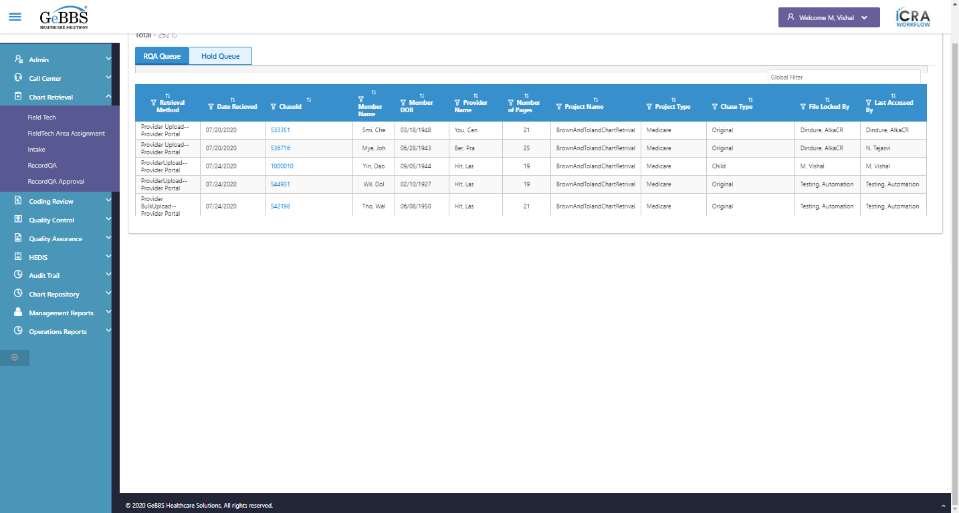
RecordQA scrren is displayed
Address Rollup is clicked
Chase and Request For is correct in record qa grid
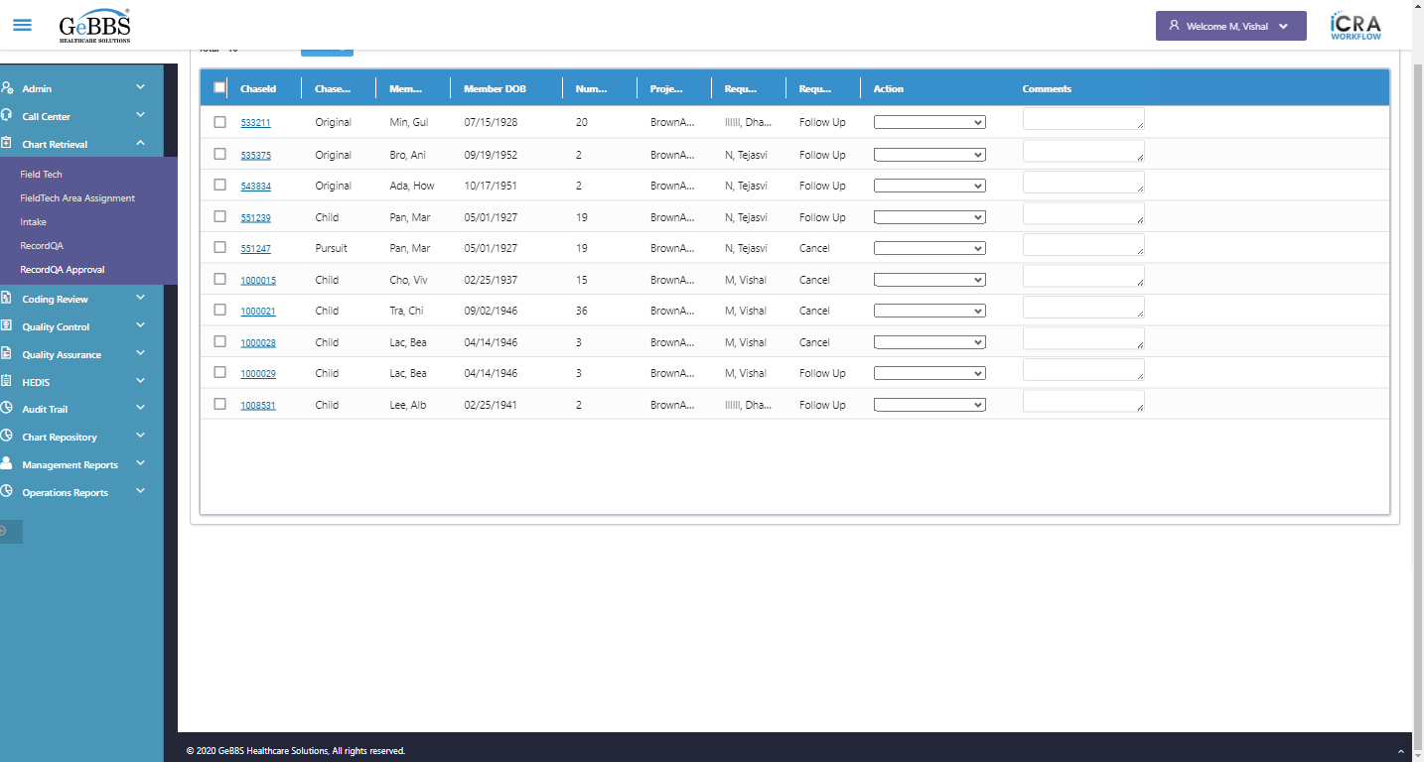
*****FollowUpTest is Ended *****
03/11/2020 16:17:26

