**AddressAllocationScreenTest  
09/11/2020 13:35:37**  
User Is Navigated To Site : http://172.19.9.53/ICRARevamp/#/login  
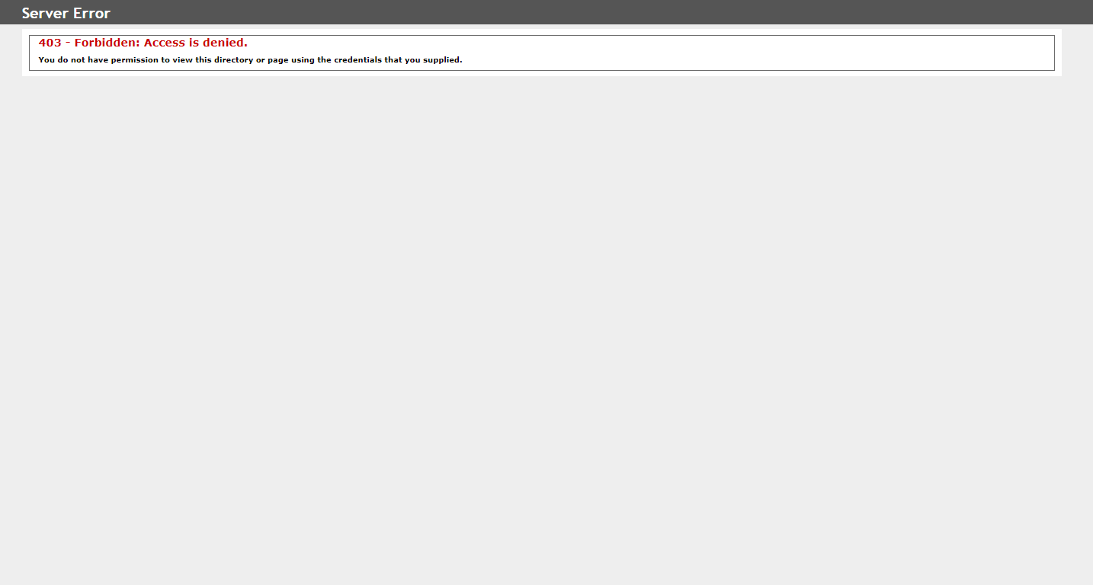  
Expected condition failed: waiting for visibility of Proxy element for: DefaultElementLocator 'By.xpath: //input[@formcontrolname='UserName']' (tried for 5 second(s) with 500 milliseconds interval)  
  
Expected condition failed: waiting for visibility of Proxy element for: DefaultElementLocator 'By.xpath: //input[@formcontrolname='UserName']' (tried for 5 second(s) with 500 milliseconds interval)  
  
Expected condition failed: waiting for visibility of Proxy element for: DefaultElementLocator 'By.xpath: //input[@formcontrolname='UserName']' (tried for 5 second(s) with 500 milliseconds interval)  
  
Expected condition failed: waiting for visibility of Proxy element for: DefaultElementLocator 'By.xpath: //input[@formcontrolname='UserName']' (tried for 5 second(s) with 500 milliseconds interval)  
  
Expected condition failed: waiting for visibility of Proxy element for: DefaultElementLocator 'By.xpath: //input[@formcontrolname='UserName']' (tried for 5 second(s) with 500 milliseconds interval)  
  
no such element: Unable to locate element: {"method":"xpath","selector":"//input[@formcontrolname='UserName']"}
(Session info: chrome=86.0.4240.183)
For documentation on this error, please visit: https://www.seleniumhq.org/exceptions/no_such_element.html
Build info: version: '3.141.59', revision: 'e82be7d358', time: '2018-11-14T08:17:03'
System info: host: 'GEBBSET17063', ip: '172.30.54.166', os.name: 'Windows 10', os.arch: 'amd64', os.version: '10.0', java.version: '13.0.1'
Driver info: org.openqa.selenium.chrome.ChromeDriver
Capabilities {acceptInsecureCerts: false, browserName: chrome, browserVersion: 86.0.4240.183, chrome: {chromedriverVersion: 85.0.4183.87 (cd6713ebf92fa..., userDataDir: C:\Users\nishinde\AppData\L...}, goog:chromeOptions: {debuggerAddress: localhost:49162}, javascriptEnabled: true, networkConnectionEnabled: false, pageLoadStrategy: normal, platform: WINDOWS, platformName: WINDOWS, proxy: Proxy(), setWindowRect: true, strictFileInteractability: false, timeouts: {implicit: 0, pageLoad: 300000, script: 30000}, unhandledPromptBehavior: dismiss and notify, webauthn:virtualAuthenticators: true}
Session ID: 3496e6f58d2b5688d025823ead17ad50
*** Element info: {Using=xpath, value=//input[@formcontrolname='UserName']}  
