**AddressAllocationScreenTest  
09/11/2020 20:27:18**  
User Is Navigated To Site : http://172.19.9.53/ICRARevamp/#/login  
  
Username is entered  
  
Password is entered  
  
Submit button is clicked  
Text of the element : Successfully logged in  
Successfully logged in  
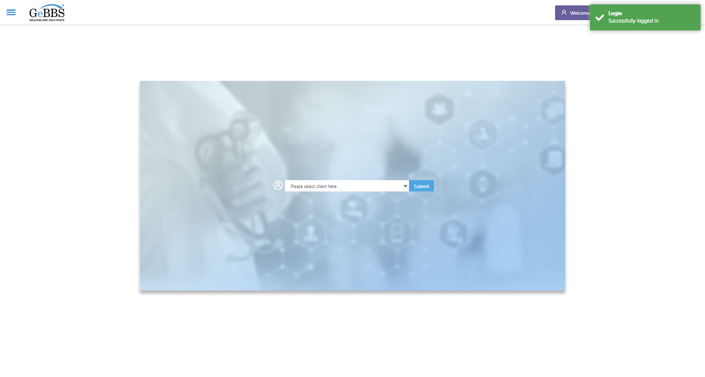  
Client dropdown button is clicked  
Client dropdown button is clicked  
Submit button is clicked  
Main Page loaded  
  
Scrolled successfully  
Call Center is clicked  
All submenus  
  
Submenu in 1 is :Address Allocation  
Submenu in 2 is :Address Approval  
Submenu in 3 is :Address Rollup  
Submenu in 4 is :Data Upload  
Submenu in 5 is :Inbound Call  
Submenu in 6 is :Manager Address Rollup  
Submenu in 7 is :PNP Exception  
Scrolled successfully  
Address Allocation is clicked  
Address Allocation selected  
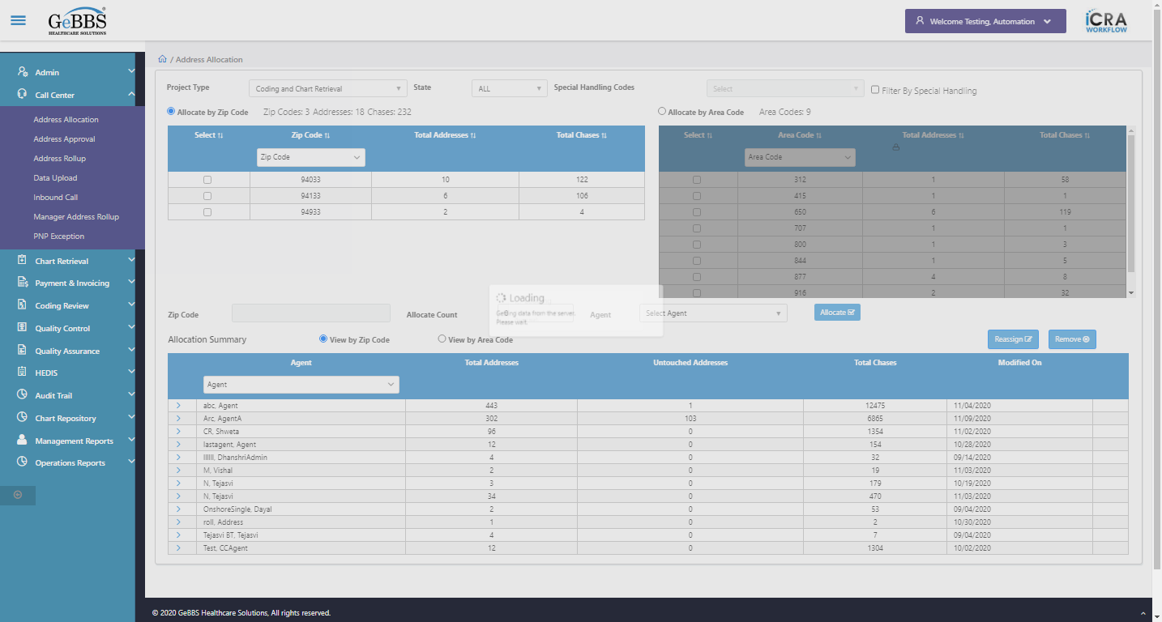  
ProjectTypDropdwn is displayed  
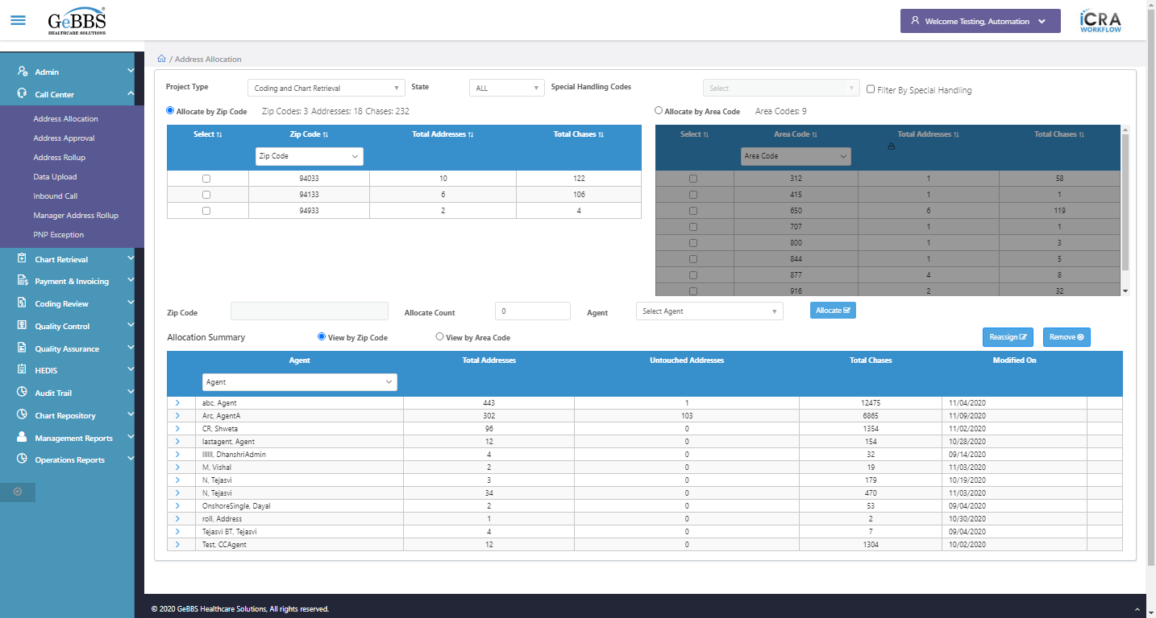  
State dropdown is displayed  
  
SpecHandDropDown is displayed  
  
FilterSpecHand Checkbox is displayed  
  
AllocateAreaCodeRadio is displayed  
  
AllocateZipCodeRadio is selected  
  
ViewByZipRadioButton is selected  
  
SpecHandDropDown is disable  
  
Header Elements are Checked.......  
Area Code table is disable  
  
Checked Area Code table visbility  
1th column is displayed  
  
1th Sorting icon is displayed  
  
2th column is displayed  
  
2th Sorting icon is displayed  
  
3th column is displayed  
  
3th Sorting icon is displayed  
  
4th column is displayed  
  
4th Sorting icon is displayed  
  
ZipCodeTextBox is displayed  
  
Zip Code tables colums are checked  
Area Code Radio Button is clicked  
Zip Code table is disable  
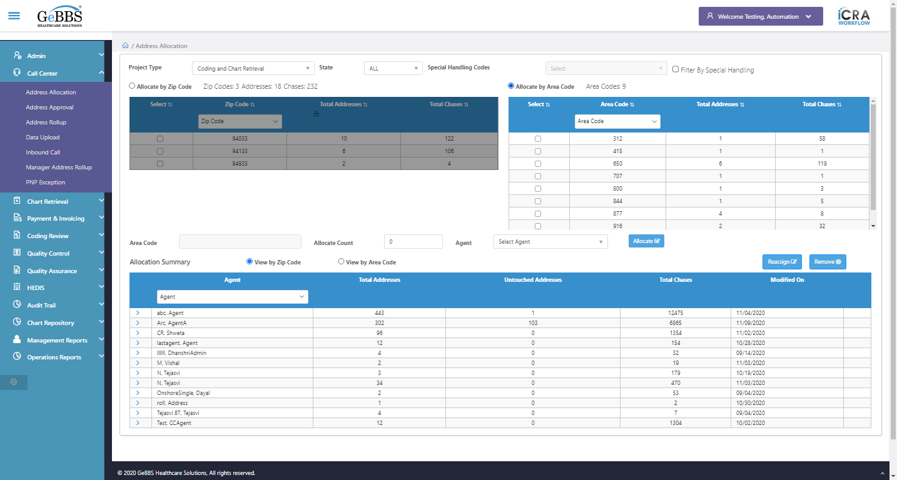  
Checked Zip Code table visbility  
1th column is displayed  
  
1th Sorting icon is displayed  
  
2th column is displayed  
  
2th Sorting icon is displayed  
  
3th column is displayed  
  
3th Sorting icon is displayed  
  
4th column is displayed  
  
4th Sorting icon is displayed  
  
AreaCodeTextBox is displayed  
  
Area Code tables colums are checked  
FilterSpecHandChk is clicked  
SpecHandDropDown is enable  
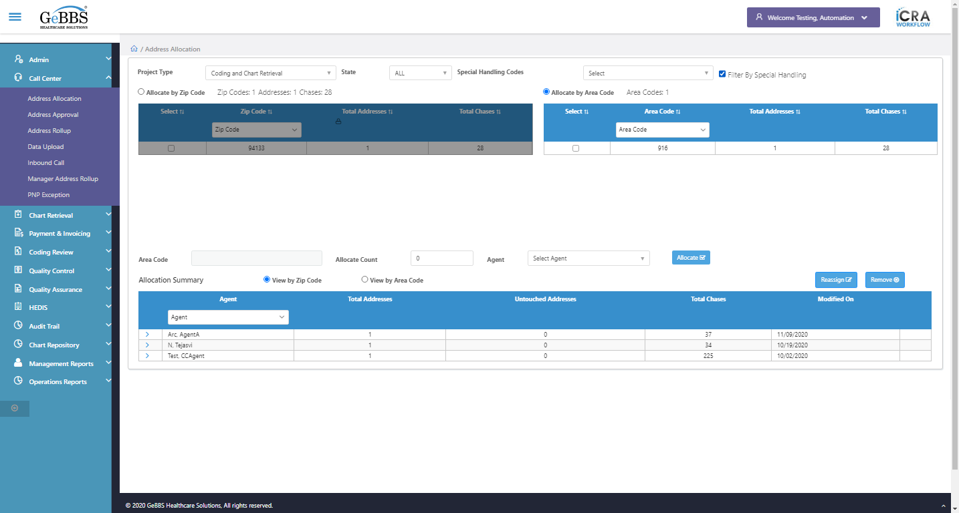  
Chked Special Handling drpdown after clicking filter code chkbox  
Scrolled successfully  
Reassign is clicked  
Text Is Correct  
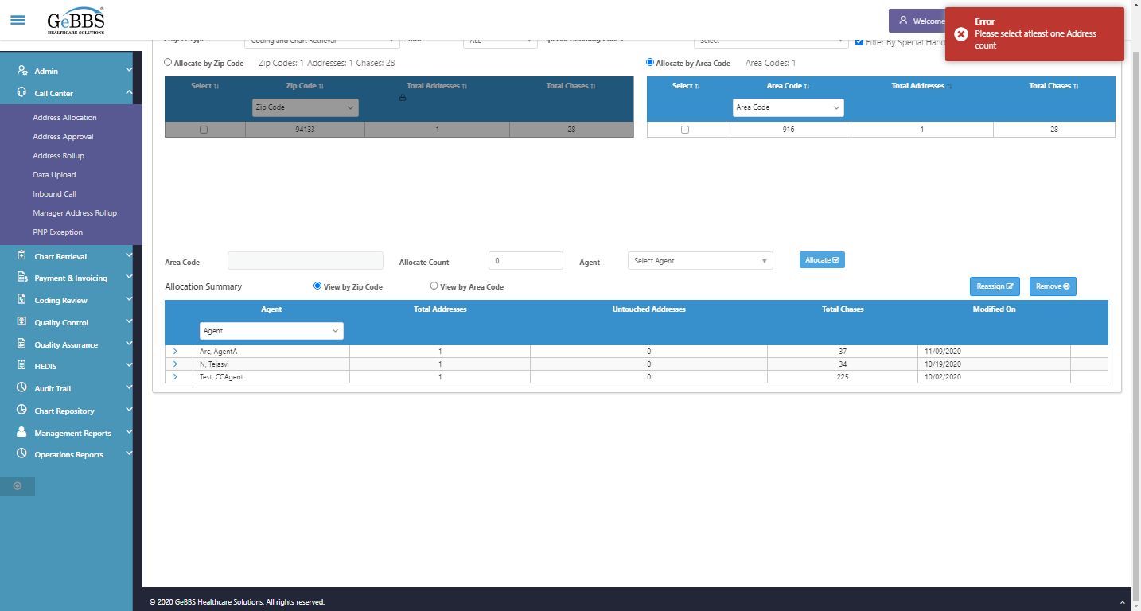  
Agent Dropdown is displayed  
  
Allocate Count Box is displayed  
  
Code text box is displayed  
  
Allocate Button is displayed  
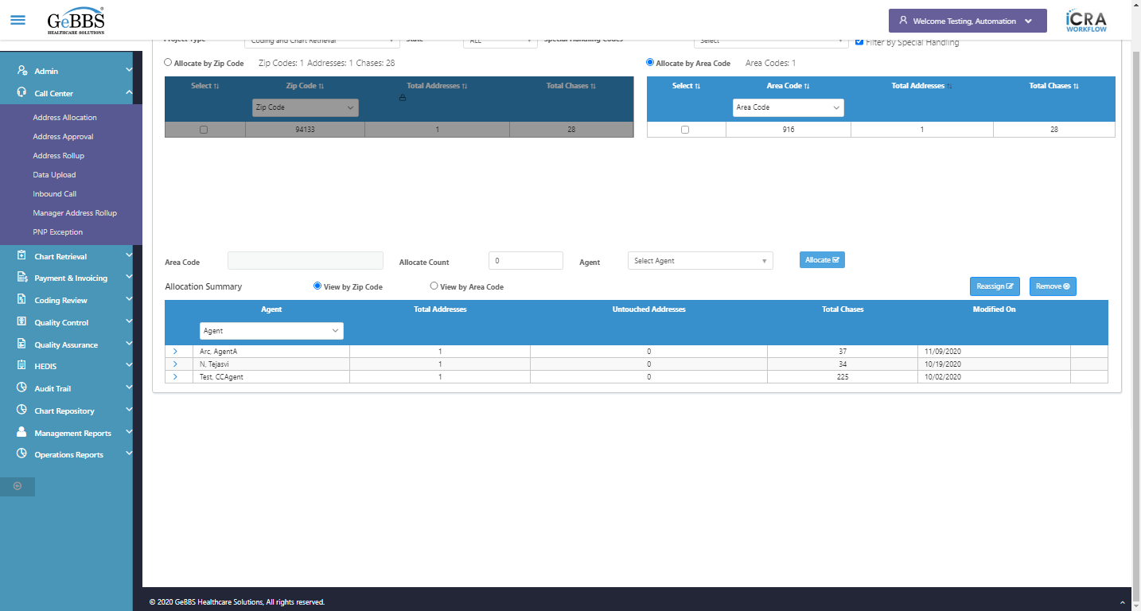  
Reassign button is displayed  
  
Remove button is displayed  
  
ViewByAreaRadio Button is displayed  
  
ViewByZipRadioButton is displayed  
  
Chked Other Fields or button display or not.....  
*****AddressAllocationScreenTest is Ended ***** **09/11/2020 20:28:35**