**CallCenterProductionReportsTest  
09/11/2020 13:42:45**  
User Is Navigated To Site : http://172.19.9.53/ICRARevamp/#/login  
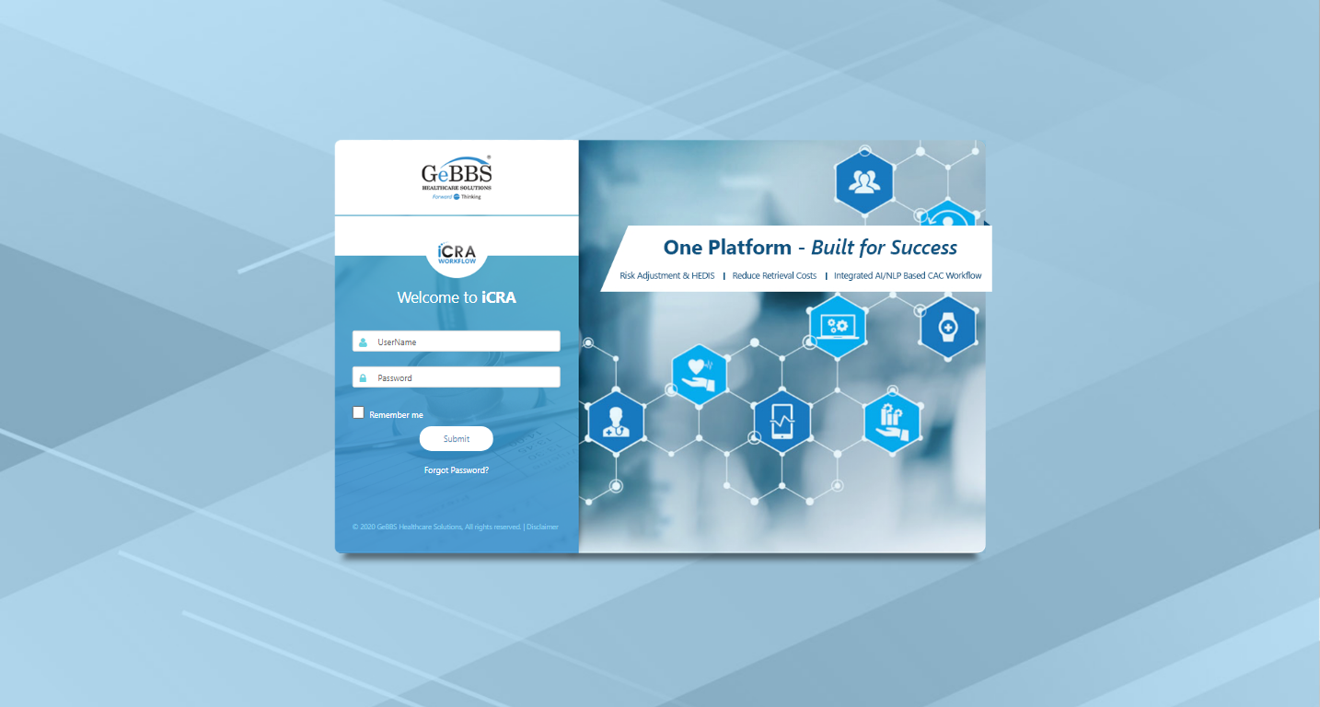  
Username is entered  
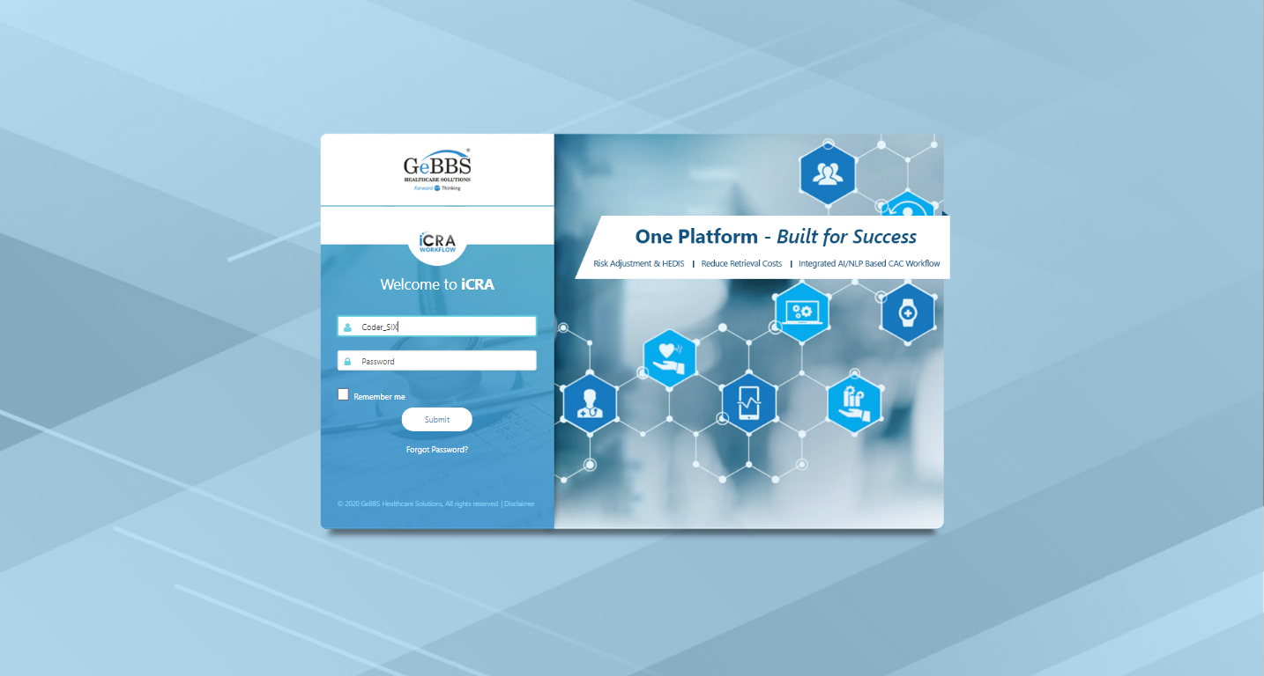  
Password is entered  
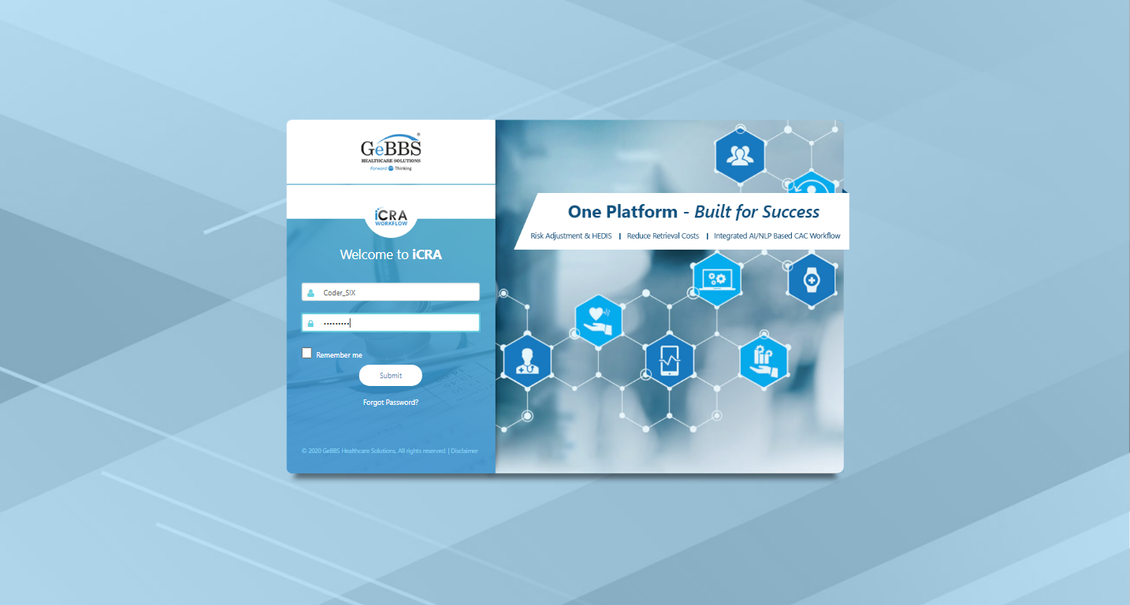  
Submit button is clicked  
Text of the element : Successfully logged in  
Successfully logged in  
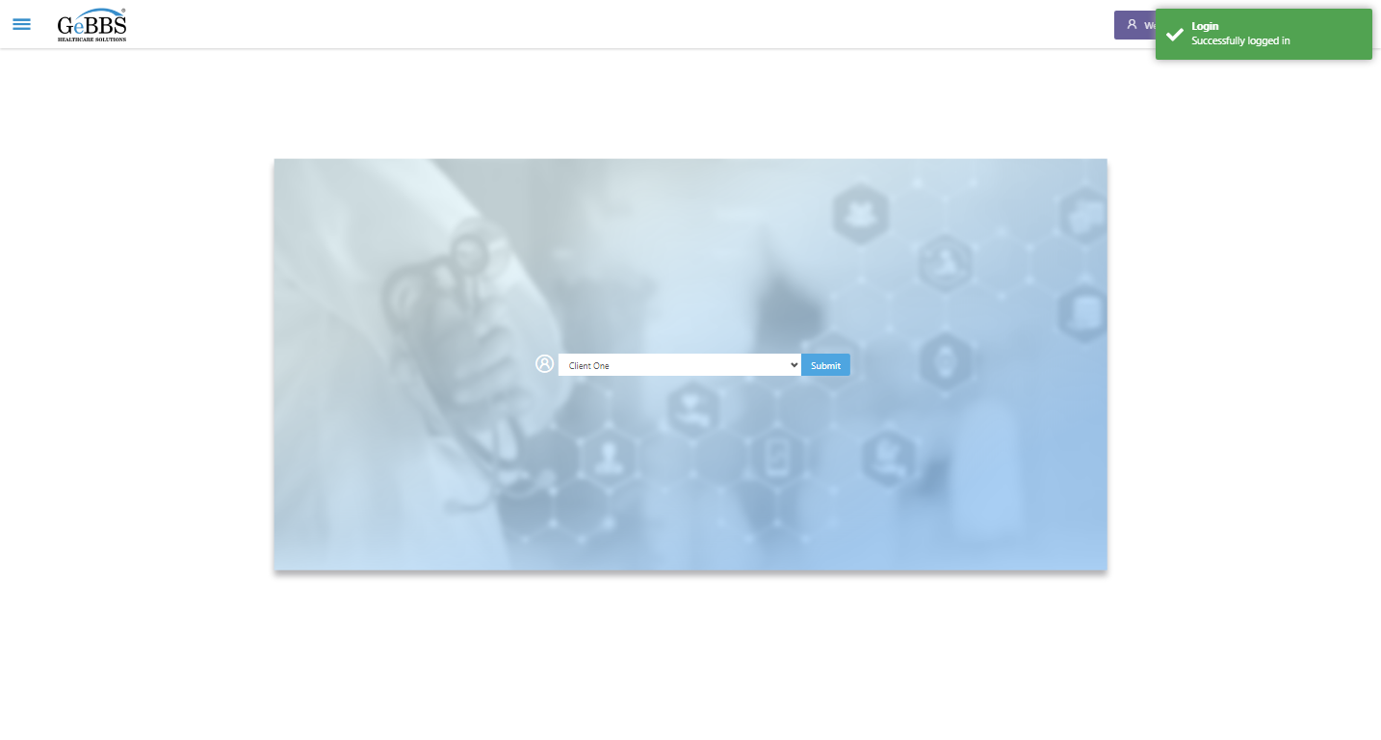  
SelectClient is clicked  
Drop down option at the position 1 is selected  
Submit selected client is clicked  
Desired client found.  
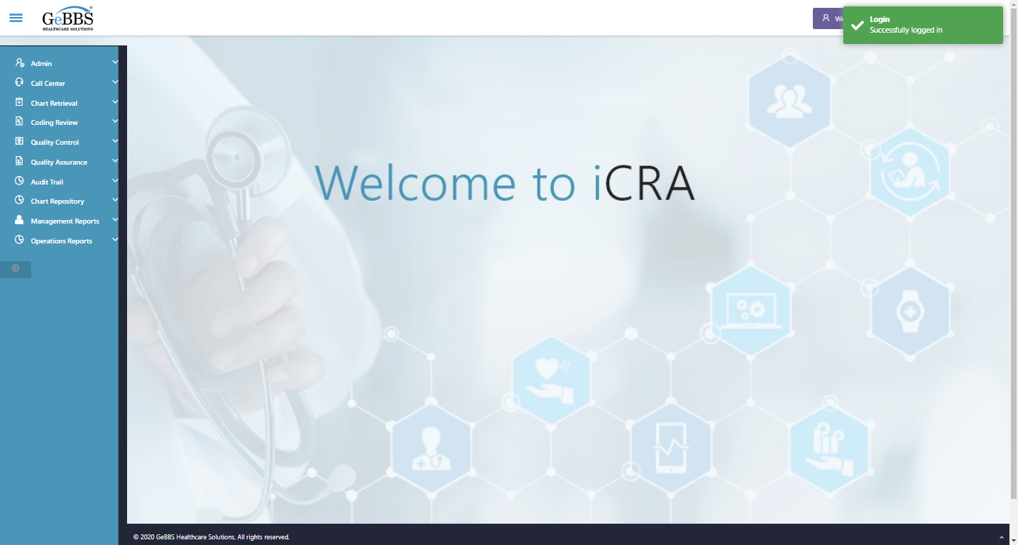  
Frame found and switched to   
Submit is clicked  
Drop down option with visible text 2:00 is selected  
Submit is clicked  
Production Report Grid is displayed....  
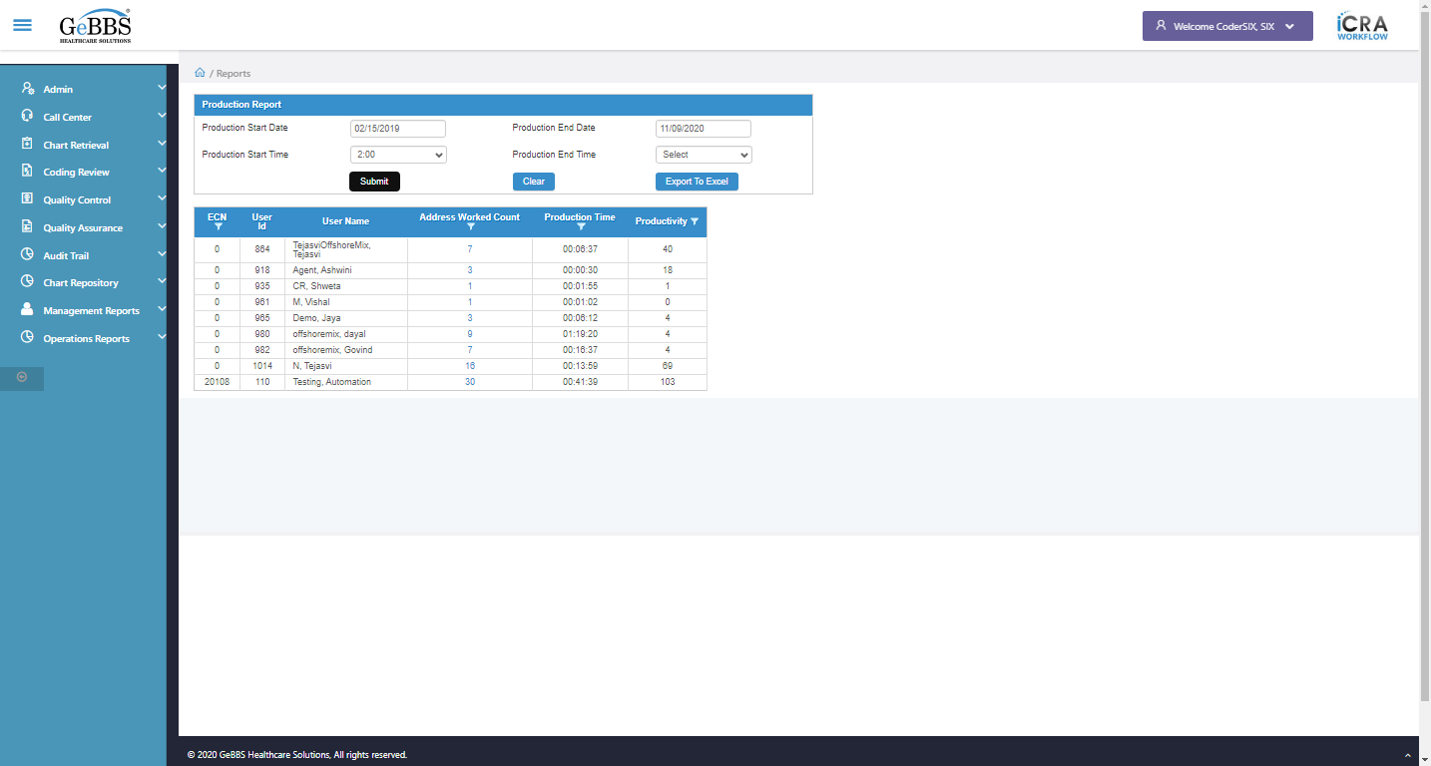 **09/11/2020 13:43:30**