**CancelTest  
03/11/2020 16:07:27**  
User Is Navigated To Site : http://172.19.9.53/ICRARevamp/#/login  
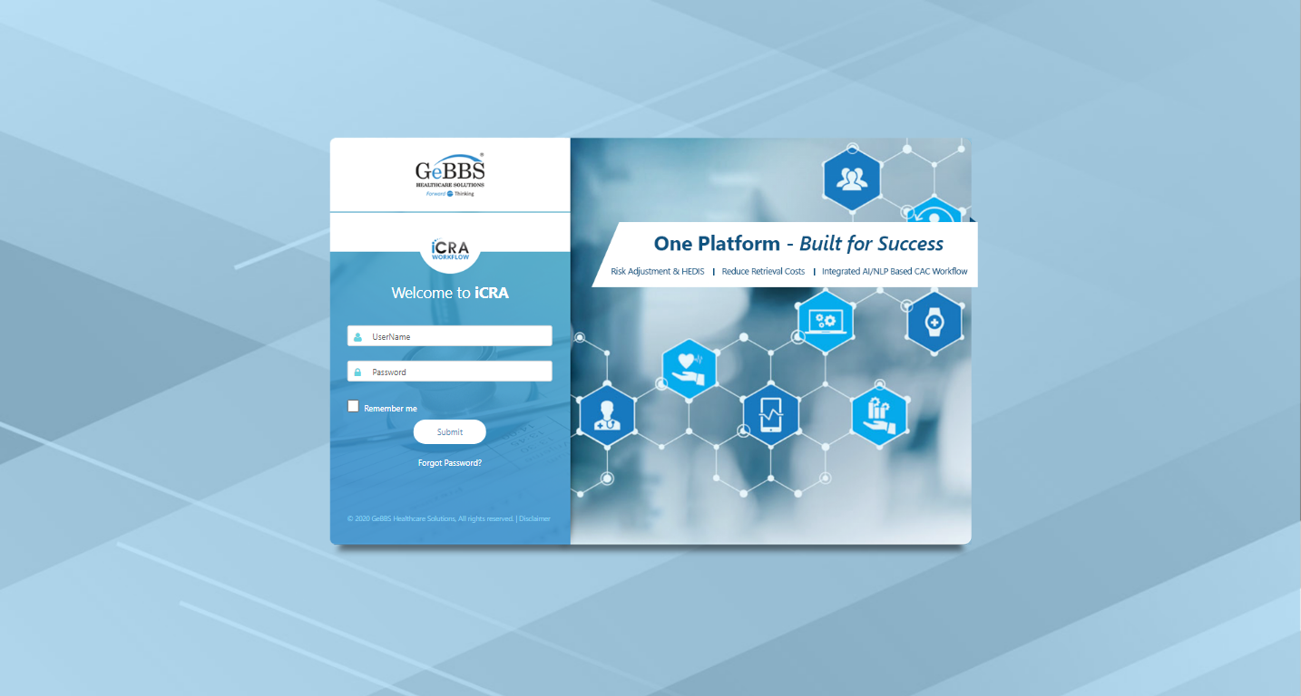  
*****CancelTest is Started *****  
Username is entered  
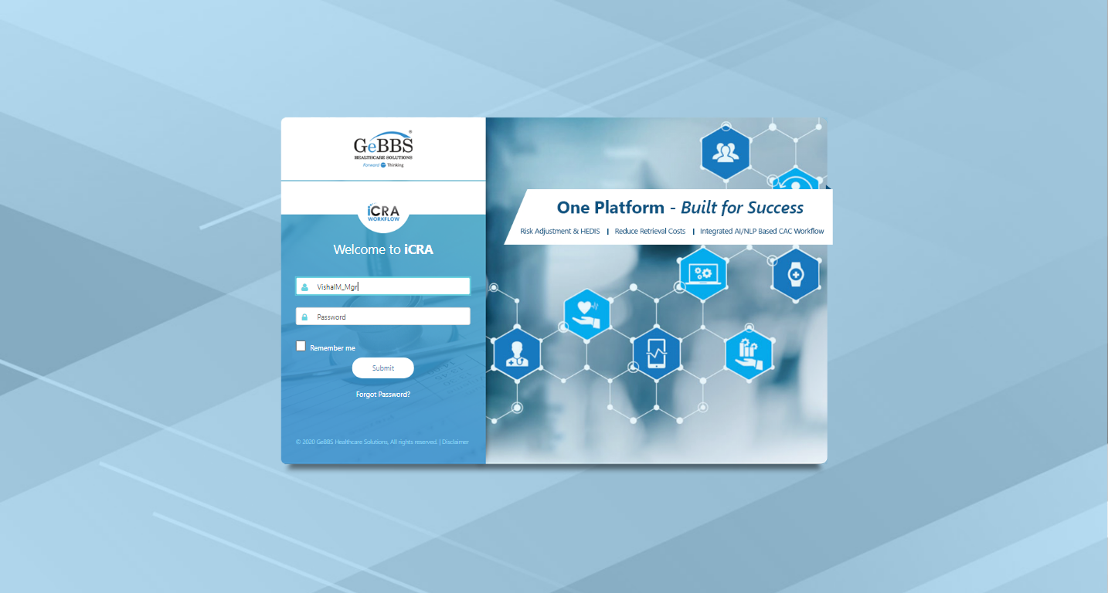  
Password is entered  
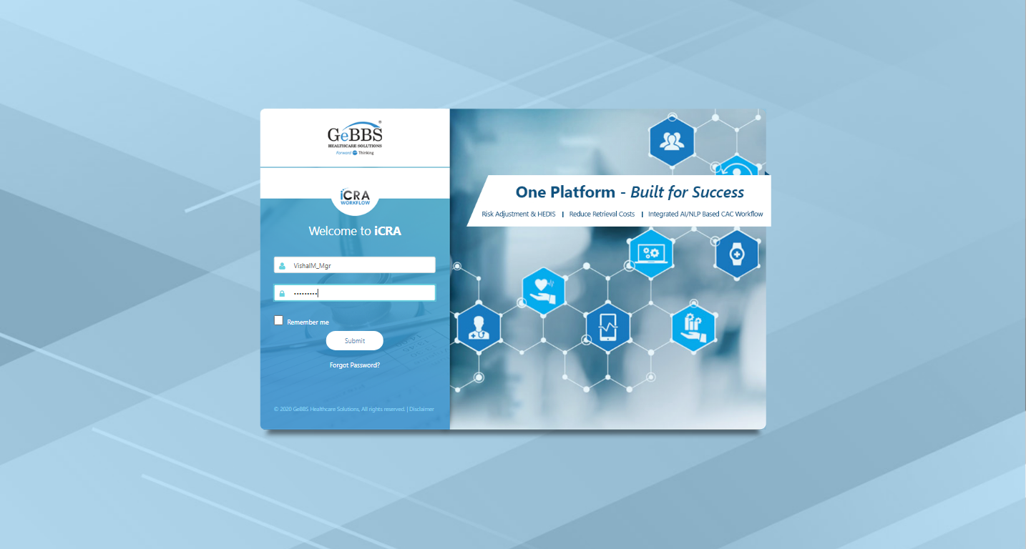  
Submit button is clicked  
Text of the element : Successfully logged in  
Successfully logged in  
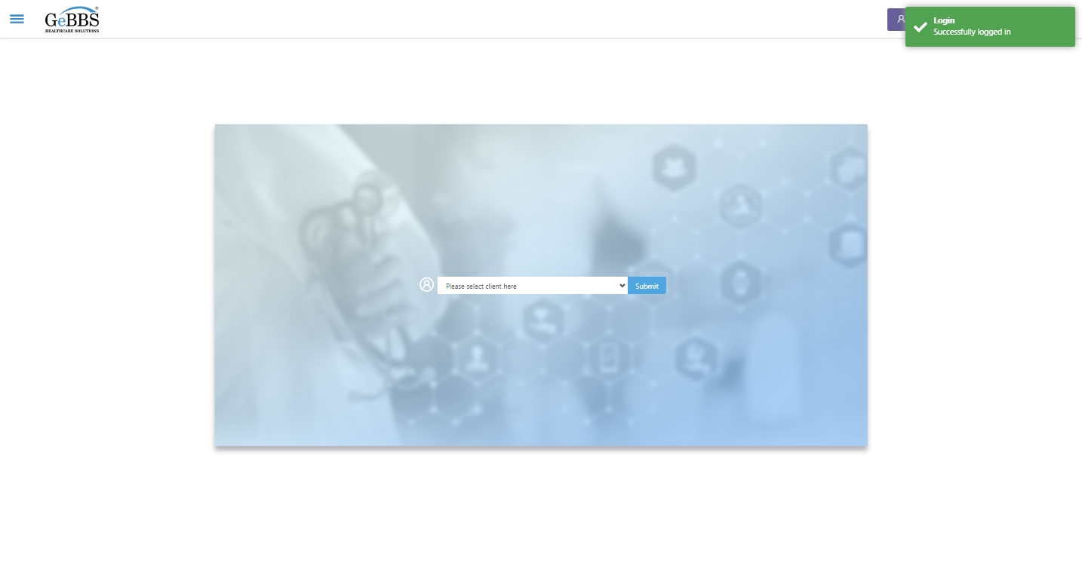  
Client dropdown button is clicked  
Client dropdown button is clicked  
Submit button is clicked  
Main Page loaded  
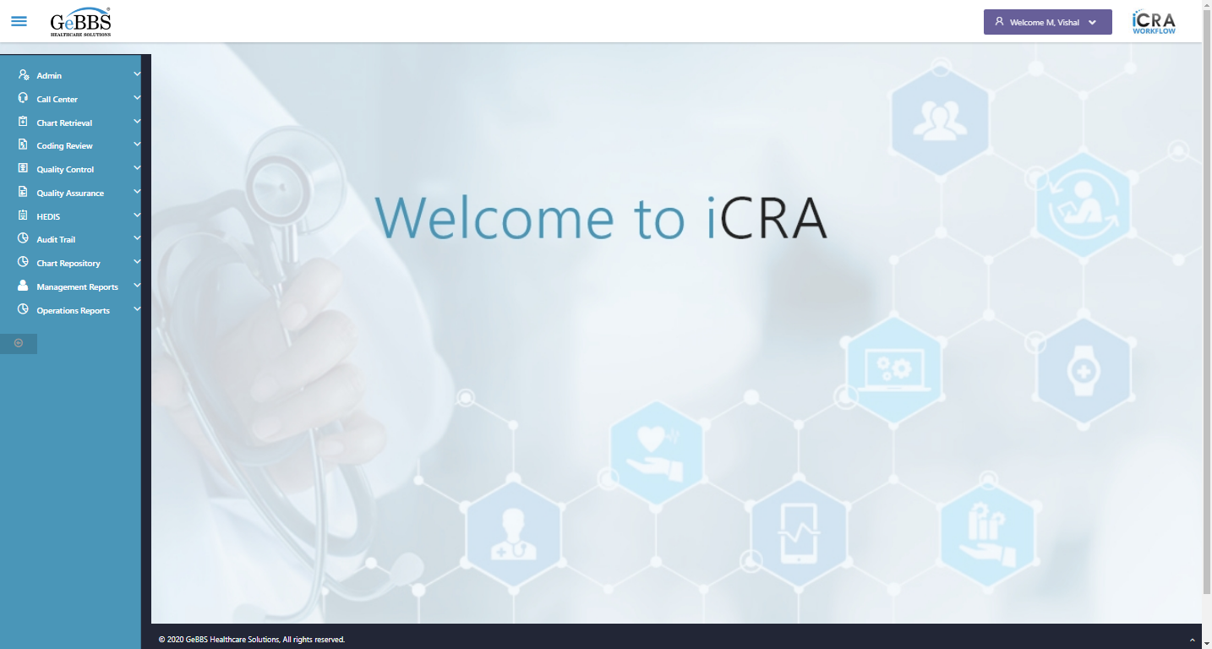  
Scrolled successfully  
Chart Retrieval is clicked  
All submenus  
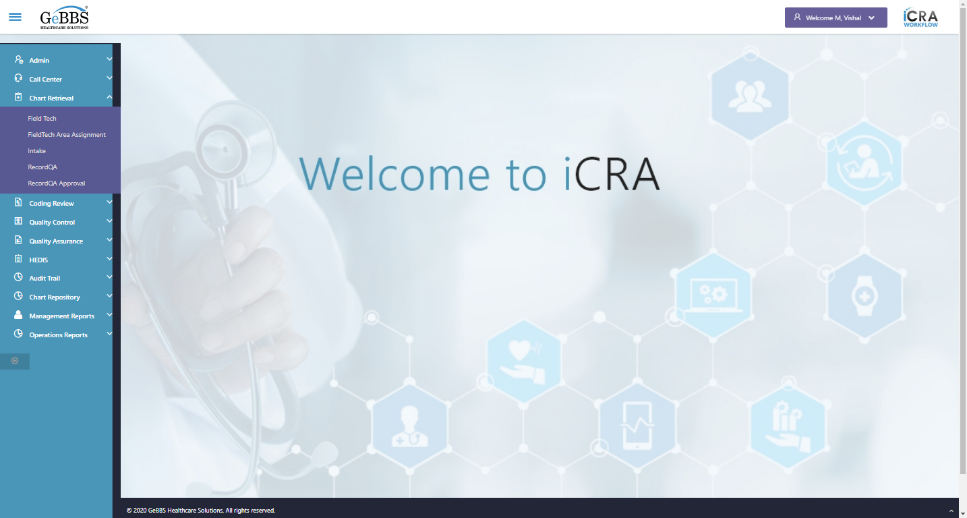  
Submenu in 1 is :Field Tech  
Submenu in 2 is :FieldTech Area Assignment  
Submenu in 3 is :Intake  
Submenu in 4 is :RecordQA  
Submenu in 5 is :RecordQA Approval  
Scrolled successfully  
RecordQA is clicked  
RecordQA selected  
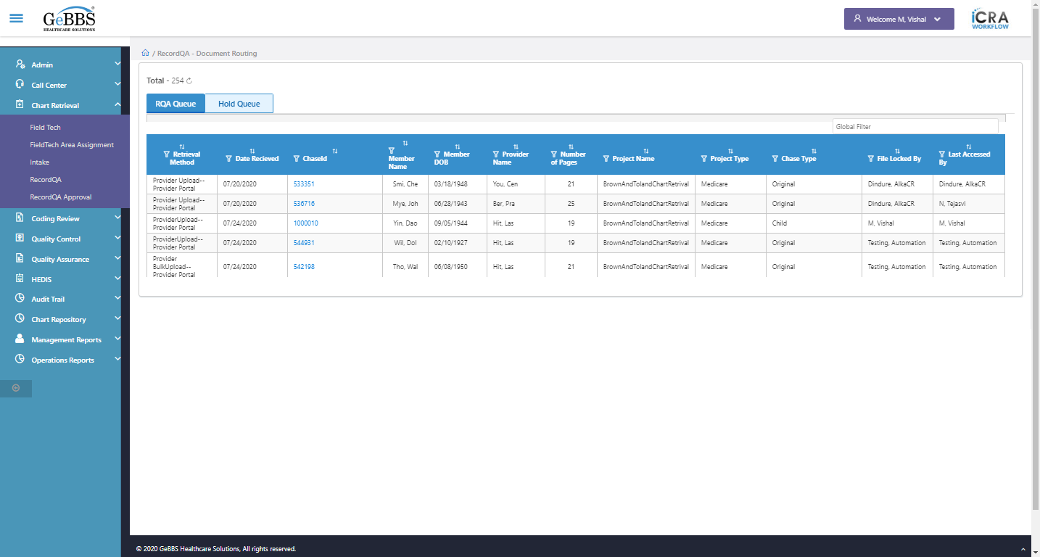  
Scrolled successfully  
Scrolled successfully  
Scrolled successfully  
Scrolled successfully  
Scrolled successfully  
Scrolled successfully  
Scrolled successfully  
Scrolled successfully  
Scrolled successfully  
Scrolled successfully  
Scrolled successfully  
Text of the element : 1000028  
GolbalFilter is entered  
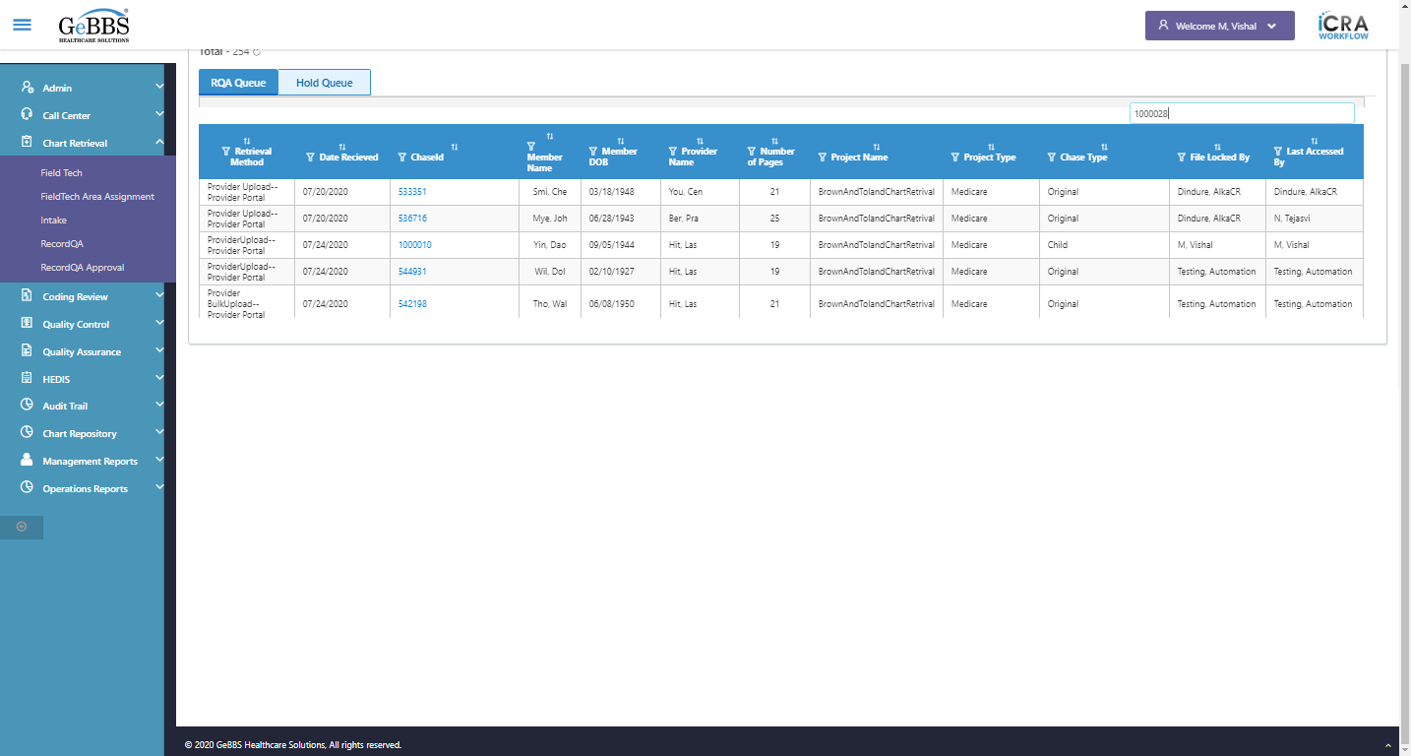  
Text of the element : 3  
chaseid is clicked  
ChkOthDetChaseScrren() failed - no such element: Unable to locate element: {"method":"xpath","selector":"//table[contains(@class,'table allcp-form theme')]//tr[14]//tr[1]//input"}
(Session info: chrome=86.0.4240.111)
For documentation on this error, please visit: https://www.seleniumhq.org/exceptions/no_such_element.html
Build info: version: '3.141.59', revision: 'e82be7d358', time: '2018-11-14T08:17:03'
System info: host: 'GEBBSET17063', ip: '172.30.54.166', os.name: 'Windows 10', os.arch: 'amd64', os.version: '10.0', java.version: '13.0.1'
Driver info: org.openqa.selenium.chrome.ChromeDriver
Capabilities {acceptInsecureCerts: false, browserName: chrome, browserVersion: 86.0.4240.111, chrome: {chromedriverVersion: 85.0.4183.87 (cd6713ebf92fa..., userDataDir: C:\Users\nishinde\AppData\L...}, goog:chromeOptions: {debuggerAddress: localhost:58301}, javascriptEnabled: true, networkConnectionEnabled: false, pageLoadStrategy: normal, platform: WINDOWS, platformName: WINDOWS, proxy: Proxy(), setWindowRect: true, strictFileInteractability: false, timeouts: {implicit: 0, pageLoad: 300000, script: 30000}, unhandledPromptBehavior: dismiss and notify, webauthn:virtualAuthenticators: true}
Session ID: b8c63d86f82ef77b6e81c33b2572f14a
*** Element info: {Using=xpath, value=//table[contains(@class,'table allcp-form theme')]//tr[14]//tr[1]//input} **03/11/2020 16:08:35**