**CoderProductionReportsTest24  
09/11/2020 18:22:58**  
User Is Navigated To Site : http://172.19.9.53/ICRARevamp/#/login  
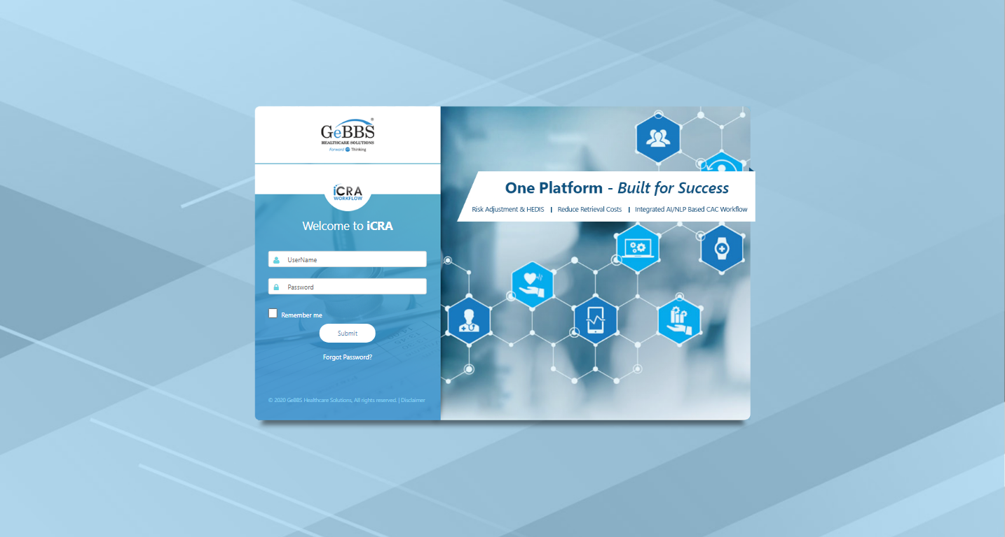  
Username is entered  
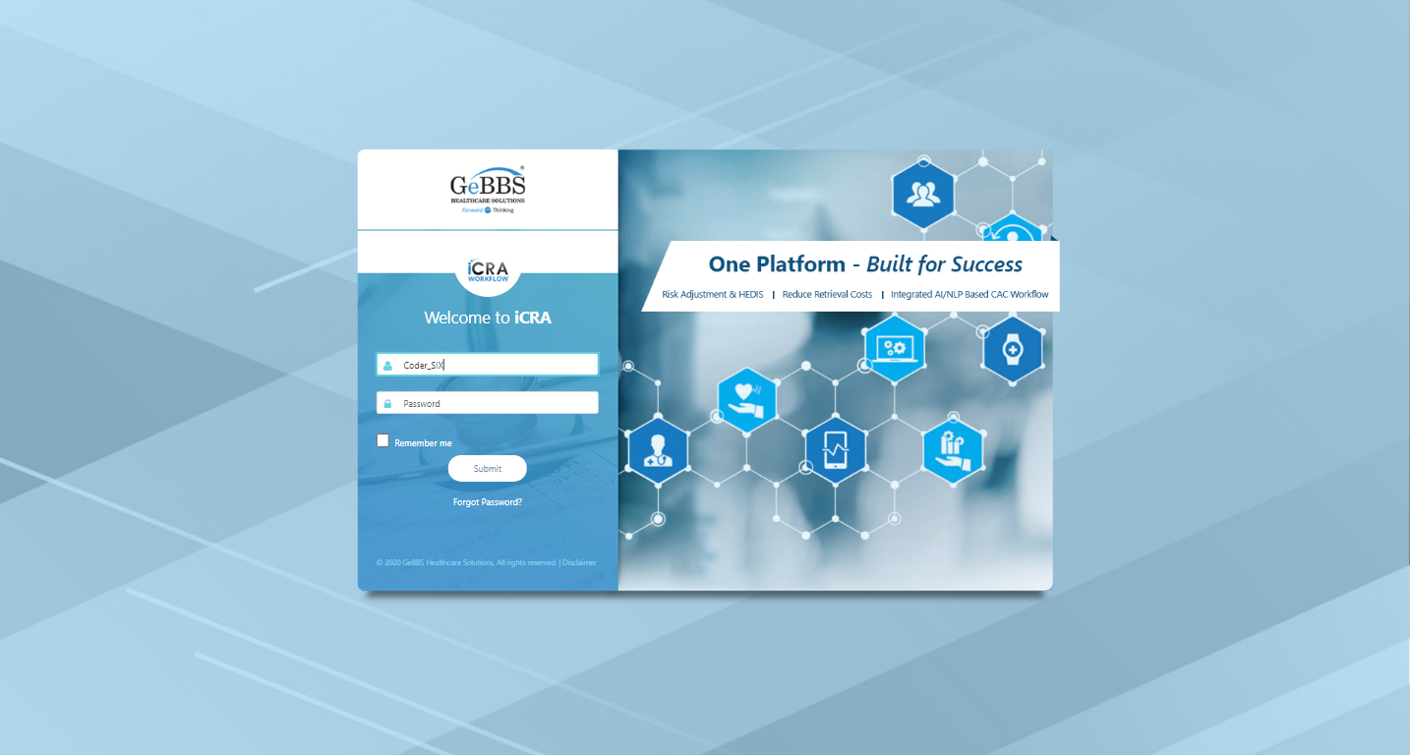  
Password is entered  
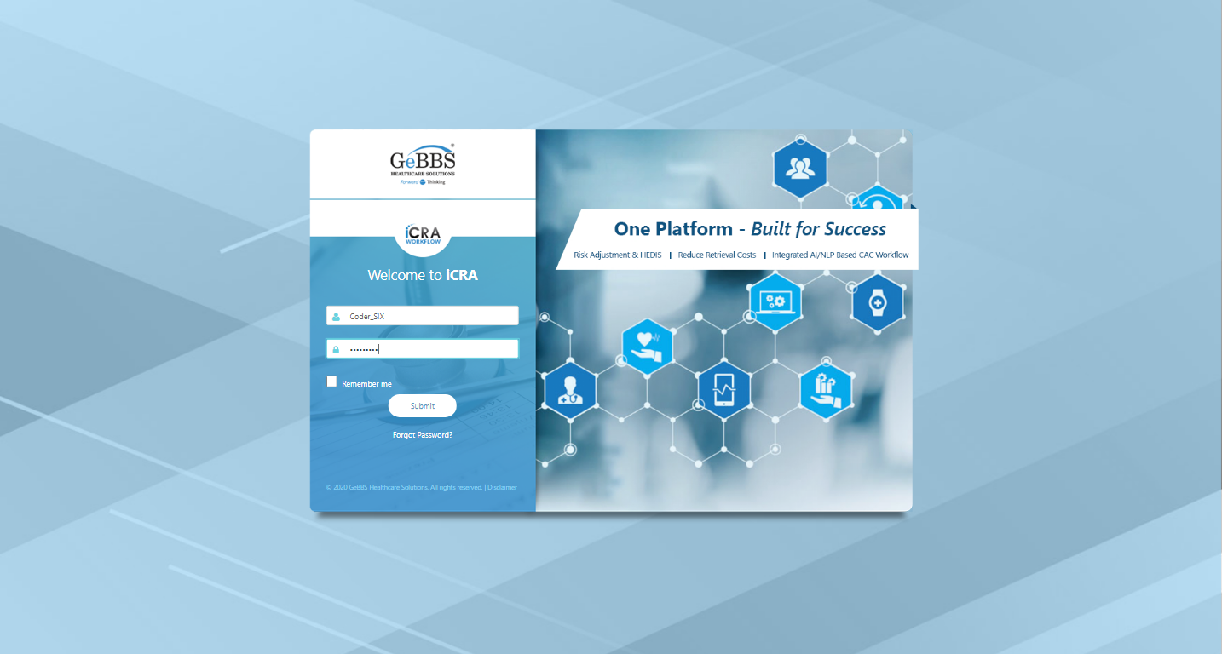  
Submit button is clicked  
Text of the element : Successfully logged in  
Successfully logged in  
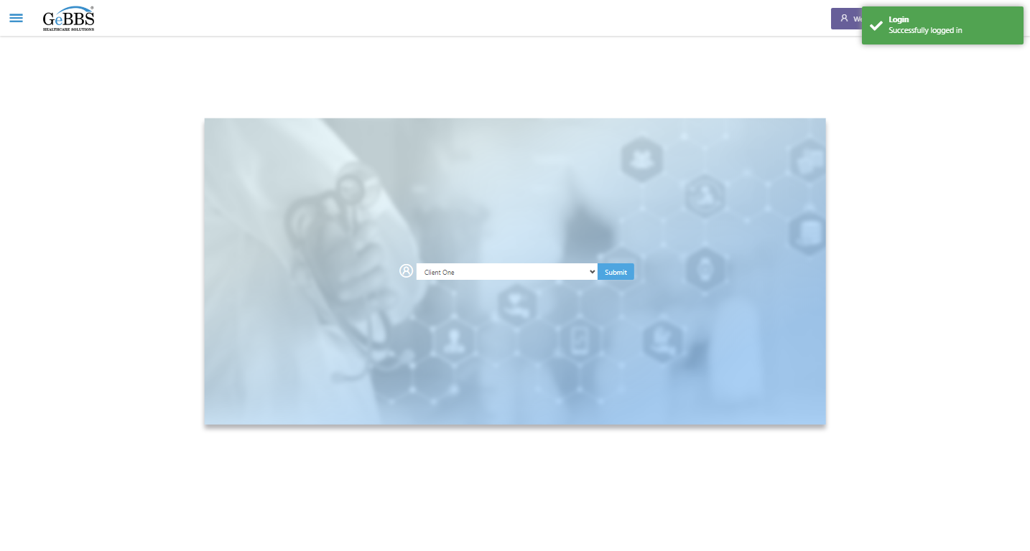  
SelectClient is clicked  
Drop down option at the position 1 is selected  
Submit selected client is clicked  
Desired client found.  
  
timeout: Timed out receiving message from renderer: 5.000
(Session info: chrome=86.0.4240.183)
Build info: version: '3.141.59', revision: 'e82be7d358', time: '2018-11-14T08:17:03'
System info: host: 'GEBBSET17063', ip: '172.30.54.166', os.name: 'Windows 10', os.arch: 'amd64', os.version: '10.0', java.version: '13.0.1'
Driver info: org.openqa.selenium.chrome.ChromeDriver
Capabilities {acceptInsecureCerts: false, browserName: chrome, browserVersion: 86.0.4240.183, chrome: {chromedriverVersion: 85.0.4183.87 (cd6713ebf92fa..., userDataDir: C:\Users\nishinde\AppData\L...}, goog:chromeOptions: {debuggerAddress: localhost:62709}, javascriptEnabled: true, networkConnectionEnabled: false, pageLoadStrategy: normal, platform: WINDOWS, platformName: WINDOWS, proxy: Proxy(), setWindowRect: true, strictFileInteractability: false, timeouts: {implicit: 0, pageLoad: 300000, script: 30000}, unhandledPromptBehavior: dismiss and notify, webauthn:virtualAuthenticators: true}
Session ID: 94cdc878d98e07a667ebc5b86fa89c14  
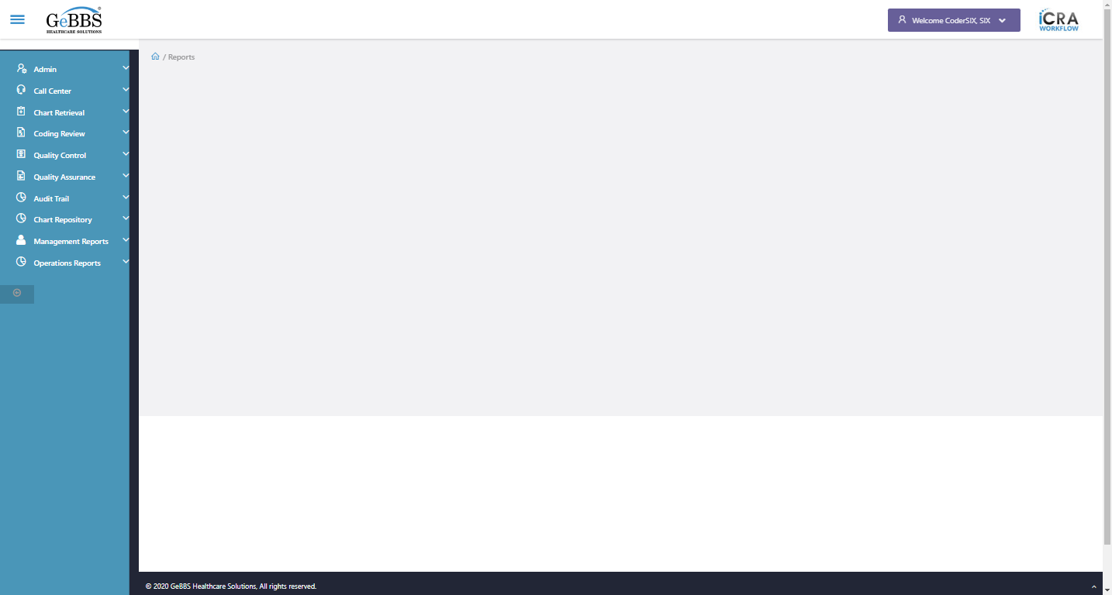  
no such element: Unable to locate element: {"method":"xpath","selector":"//input[@id='btnSubmit']"}
(Session info: chrome=86.0.4240.183)
For documentation on this error, please visit: https://www.seleniumhq.org/exceptions/no_such_element.html
Build info: version: '3.141.59', revision: 'e82be7d358', time: '2018-11-14T08:17:03'
System info: host: 'GEBBSET17063', ip: '172.30.54.166', os.name: 'Windows 10', os.arch: 'amd64', os.version: '10.0', java.version: '13.0.1'
Driver info: org.openqa.selenium.chrome.ChromeDriver
Capabilities {acceptInsecureCerts: false, browserName: chrome, browserVersion: 86.0.4240.183, chrome: {chromedriverVersion: 85.0.4183.87 (cd6713ebf92fa..., userDataDir: C:\Users\nishinde\AppData\L...}, goog:chromeOptions: {debuggerAddress: localhost:62709}, javascriptEnabled: true, networkConnectionEnabled: false, pageLoadStrategy: normal, platform: WINDOWS, platformName: WINDOWS, proxy: Proxy(), setWindowRect: true, strictFileInteractability: false, timeouts: {implicit: 0, pageLoad: 300000, script: 30000}, unhandledPromptBehavior: dismiss and notify, webauthn:virtualAuthenticators: true}
Session ID: 94cdc878d98e07a667ebc5b86fa89c14
*** Element info: {Using=xpath, value=//input[@id='btnSubmit']}  
  
FillData_HoldHCCRejectCoderProdution() failed **09/11/2020 18:24:06**