**CoderProductionReportsTest24  
09/11/2020 18:39:53**  
User Is Navigated To Site : http://172.19.9.53/ICRARevamp/#/login  
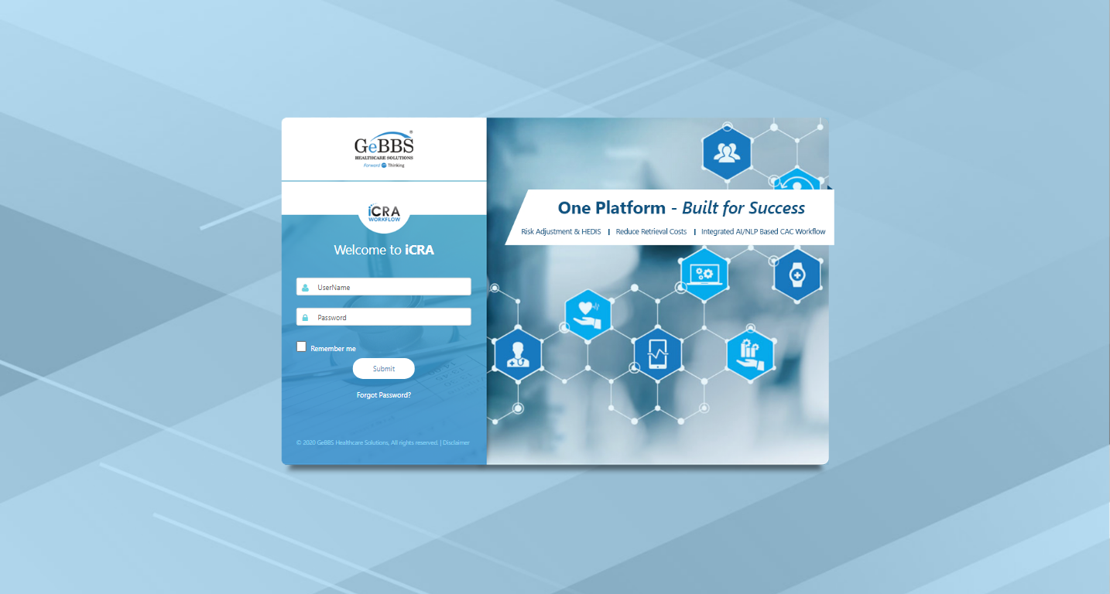  
Username is entered  
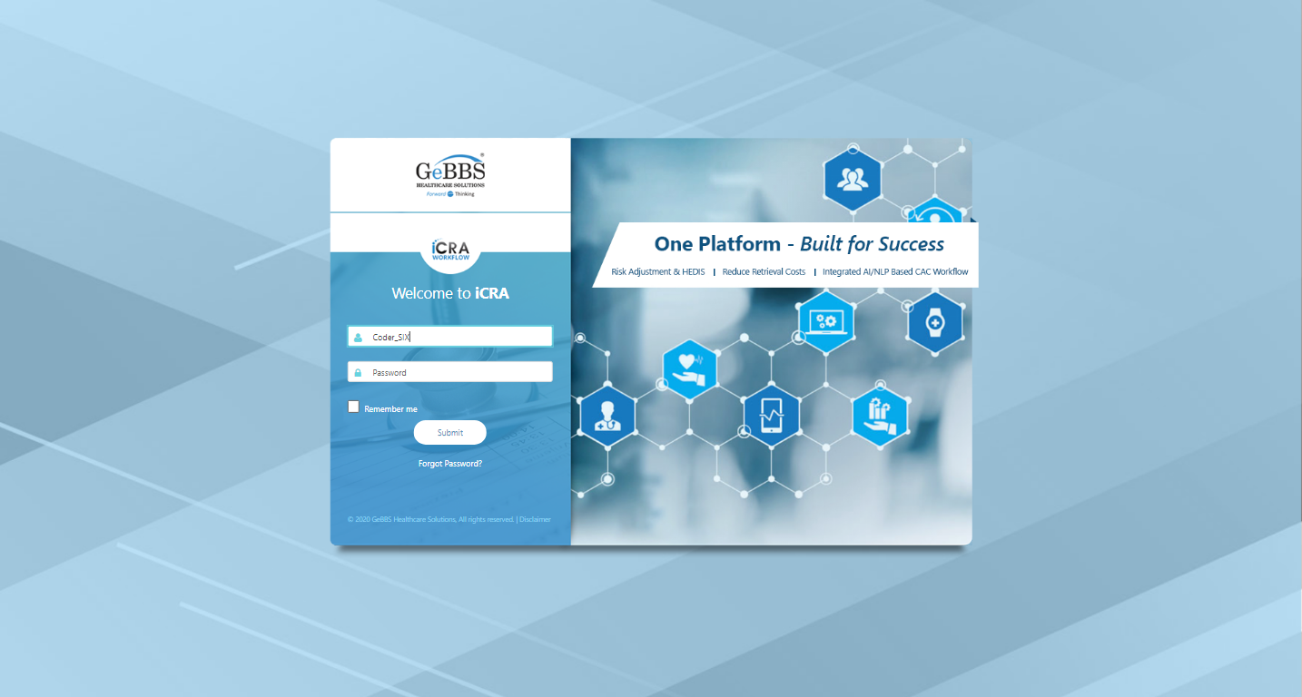  
Password is entered  
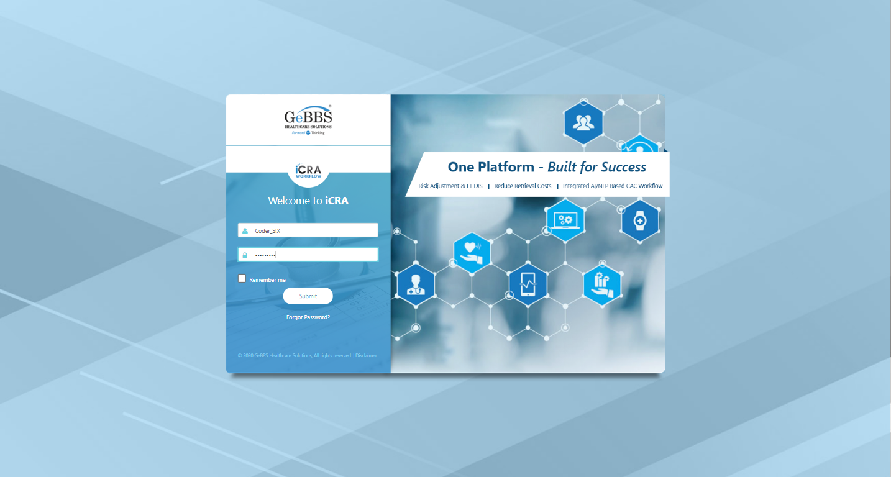  
Submit button is clicked  
Text of the element : Successfully logged in  
Successfully logged in  
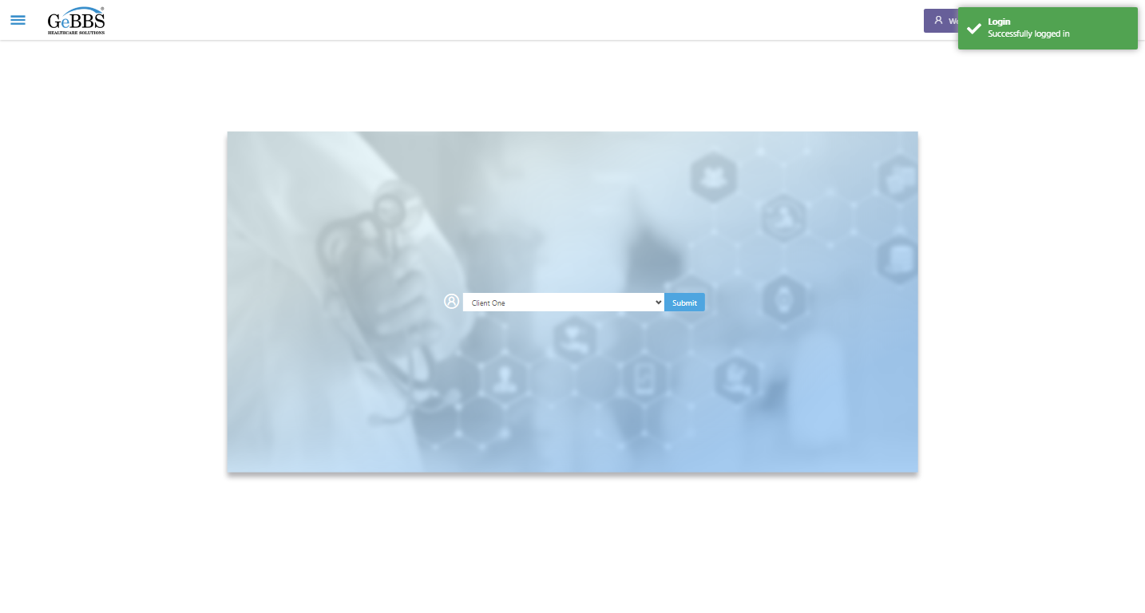  
SelectClient is clicked  
Drop down option at the position 1 is selected  
Submit selected client is clicked  
Desired client found.  
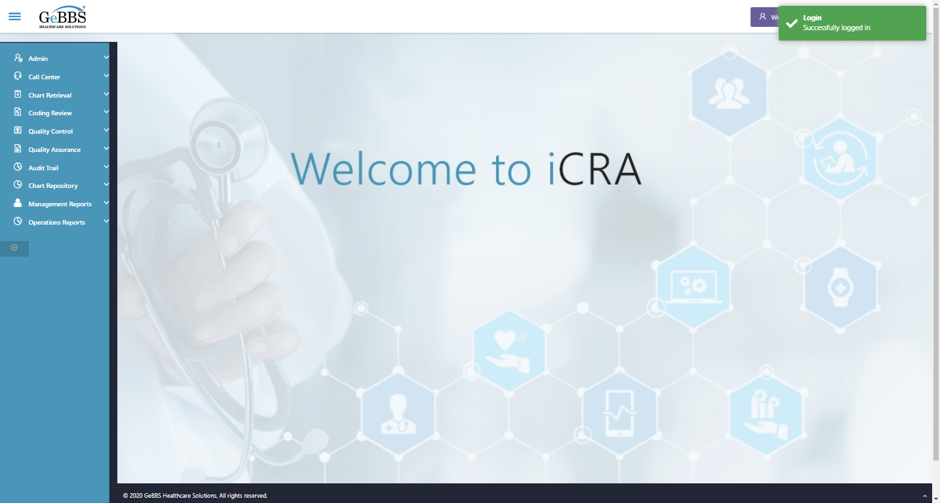  
Main Page loaded  
  
Scrolled successfully  
Operations Reports is clicked  
All submenus  
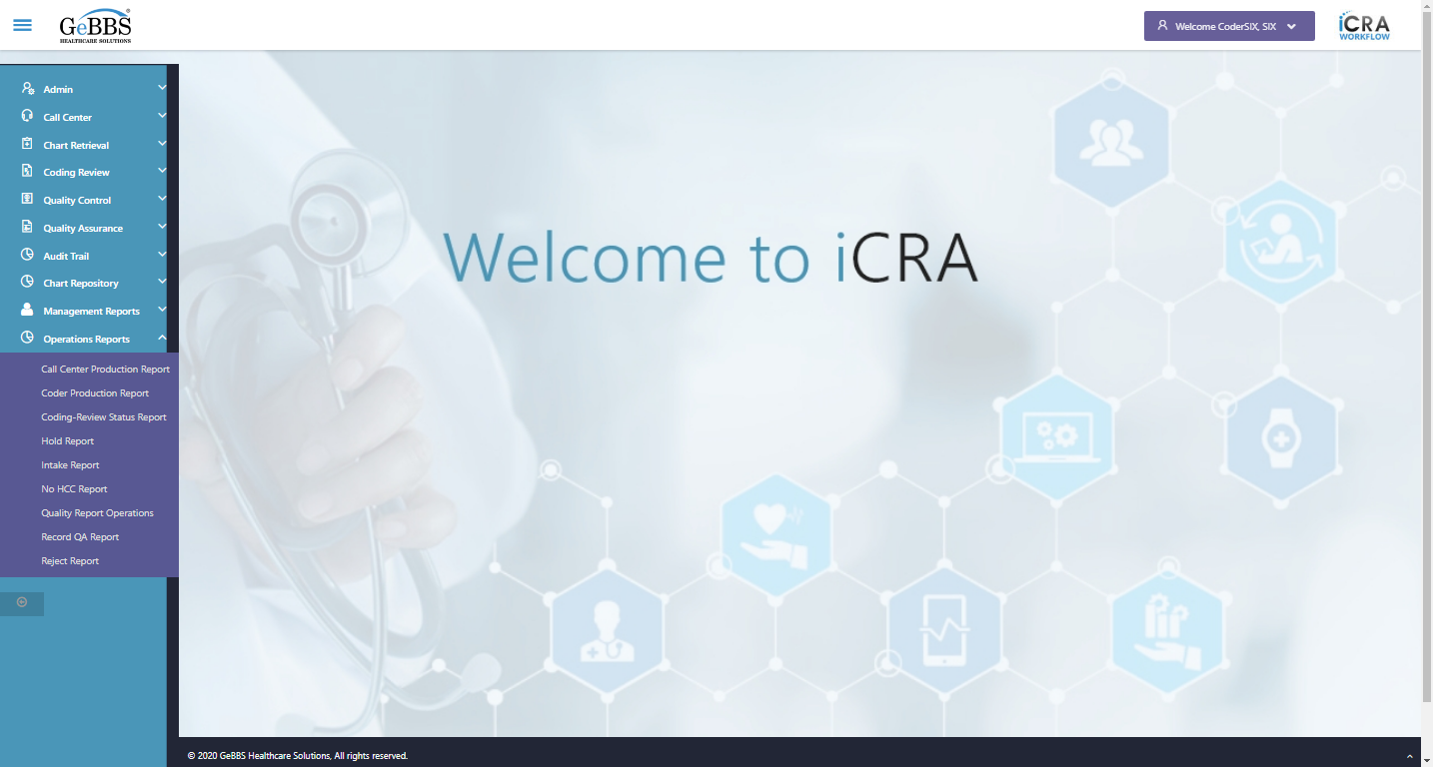  
Submenu in 1 is :Call Center Production Report  
Submenu in 2 is :Coder Production Report  
Submenu in 3 is :Coding-Review Status Report  
Submenu in 4 is :Hold Report  
Submenu in 5 is :Intake Report  
Submenu in 6 is :No HCC Report  
Submenu in 7 is :Quality Report Operations  
Submenu in 8 is :Record QA Report  
Submenu in 9 is :Reject Report  
Scrolled successfully  
Coder Production Report is clicked  
Coder Production Report selected  
  
FillData_HoldHCCRejectCoderProdution() failed **09/11/2020 18:40:38**