**CoderProductionReportsTest24  
09/11/2020 19:00:38**  
User Is Navigated To Site : http://172.19.9.53/ICRARevamp/#/login  
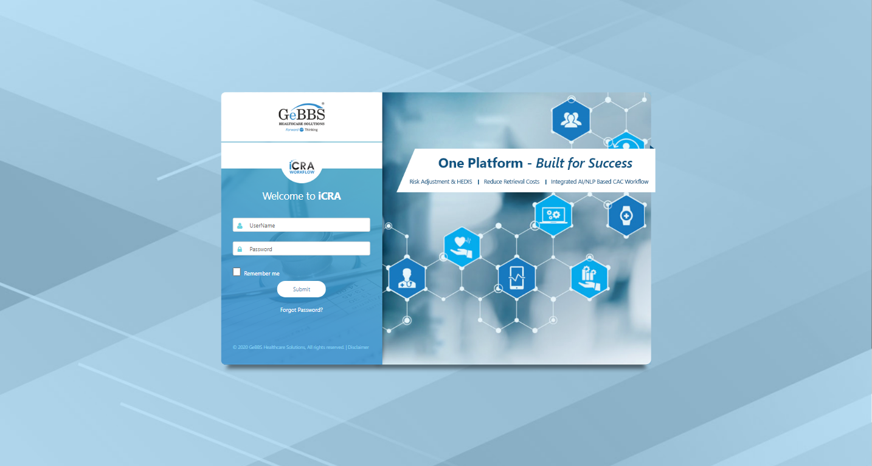  
Username is entered  
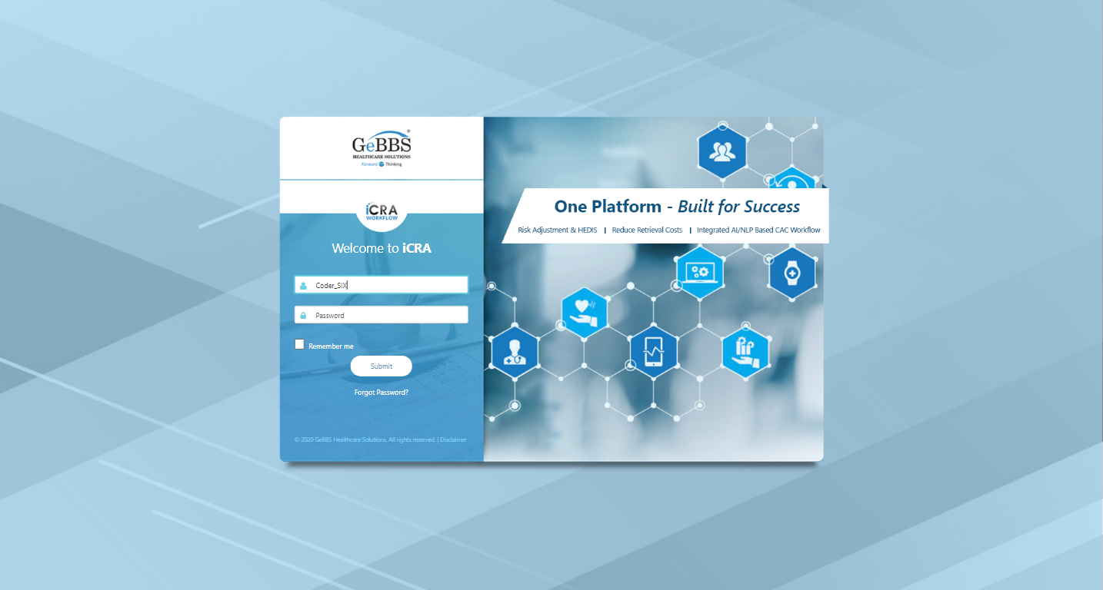  
Password is entered  
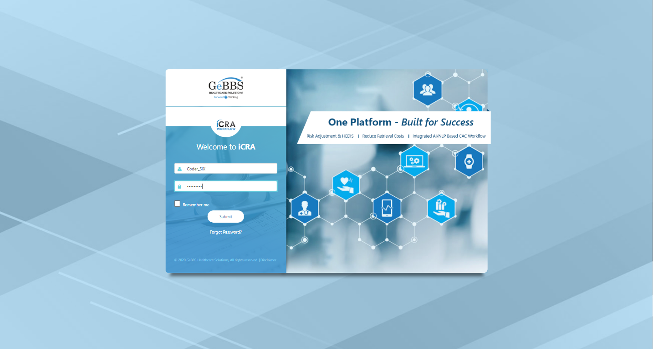  
Submit button is clicked  
Text of the element : Successfully logged in  
Successfully logged in  
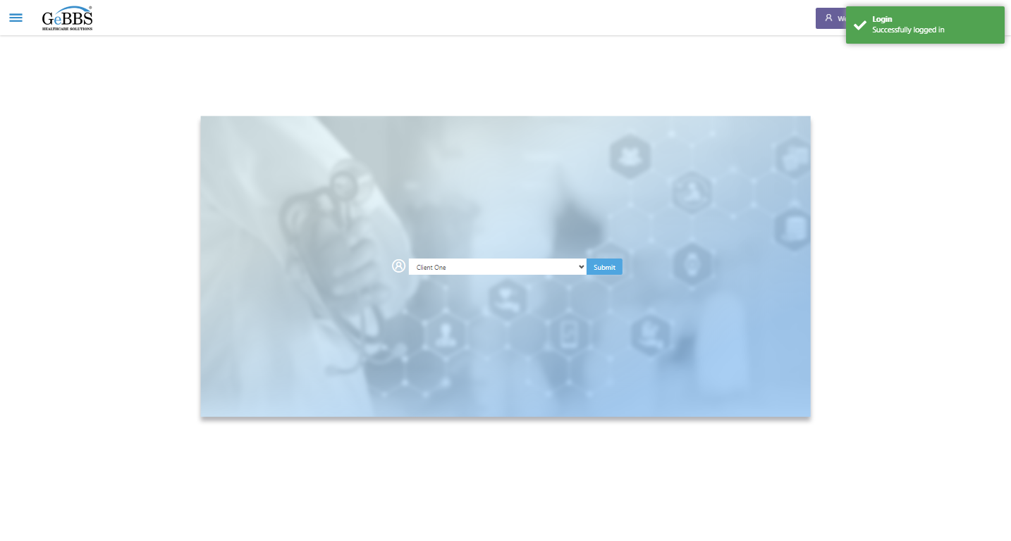  
SelectClient is clicked  
Drop down option at the position 1 is selected  
Submit selected client is clicked  
Desired client found.  
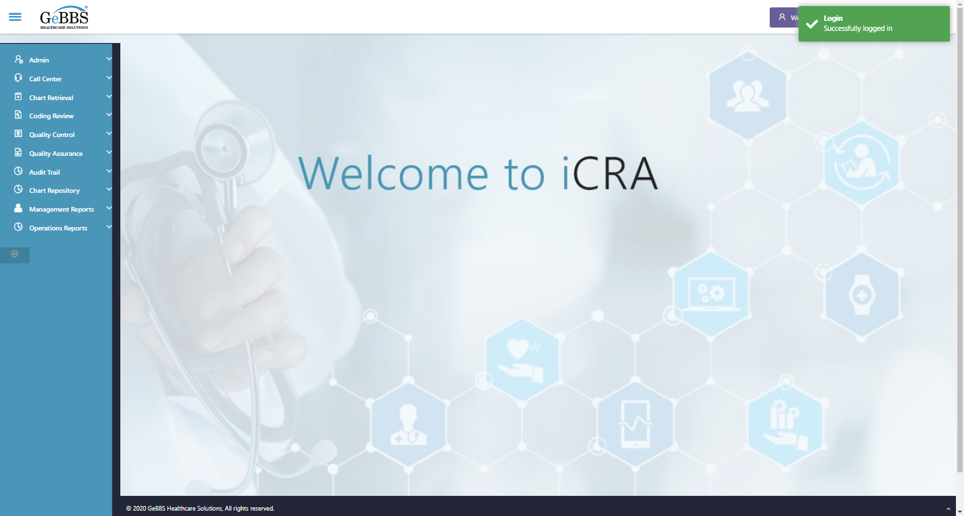  
Main Page loaded  
  
Scrolled successfully  
Operations Reports is clicked  
All submenus  
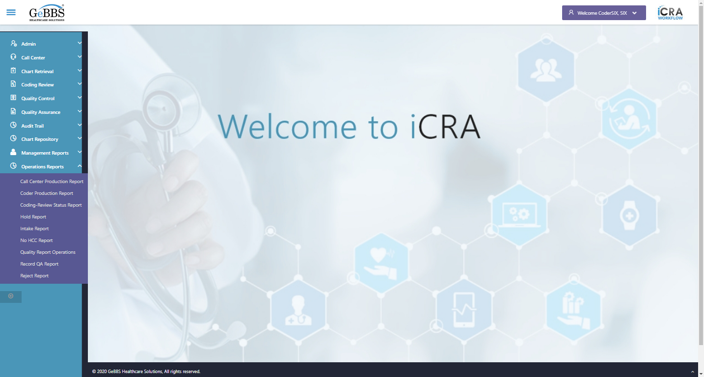  
Submenu in 1 is :Call Center Production Report  
Submenu in 2 is :Coder Production Report  
Submenu in 3 is :Coding-Review Status Report  
Submenu in 4 is :Hold Report  
Submenu in 5 is :Intake Report  
Submenu in 6 is :No HCC Report  
Submenu in 7 is :Quality Report Operations  
Submenu in 8 is :Record QA Report  
Submenu in 9 is :Reject Report  
Scrolled successfully  
Coder Production Report is clicked  
Coder Production Report selected  
  
Frame found and switched to   
Submit is clicked  
WarningMsg is displayed  
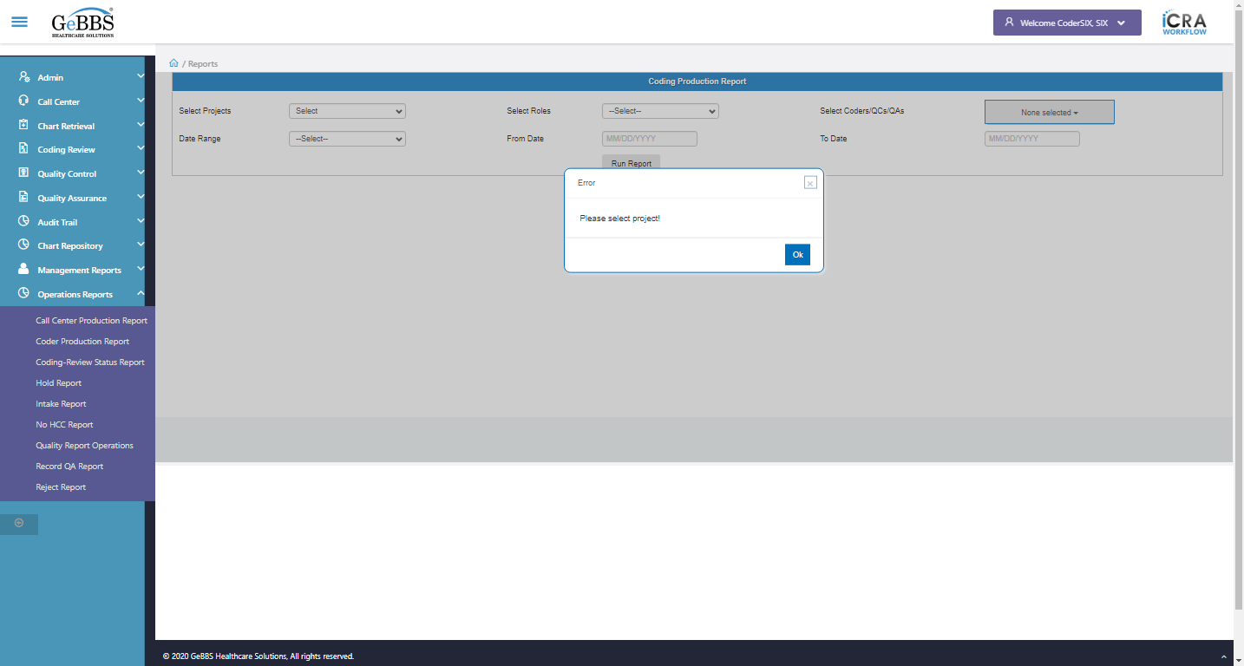  
ok is clicked  
Drop down option with visible text P three CallCenter Blind is selected  
Drop down option with visible text QC is selected  
NoneSelected is clicked  
SelectAllChkbok is clicked  
Drop down option with visible text Year To Date is selected  
Submit is clicked  
Coder Production Grid Tbl is displayed  
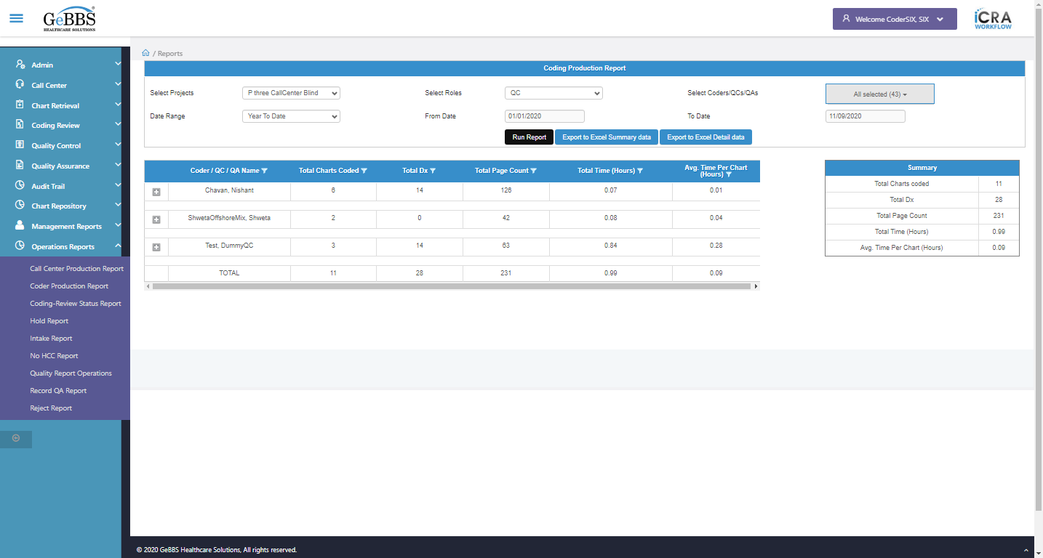  
Coder Production Summary Report is displayed....  
 **09/11/2020 19:01:38**