**CoderReviewStatusReportsTest3  
09/11/2020 14:57:03**  
User Is Navigated To Site : http://172.19.9.53/ICRARevamp/#/login  
  
Username is entered  
  
Password is entered  
  
Submit button is clicked  
Text of the element : Successfully logged in  
Successfully logged in  
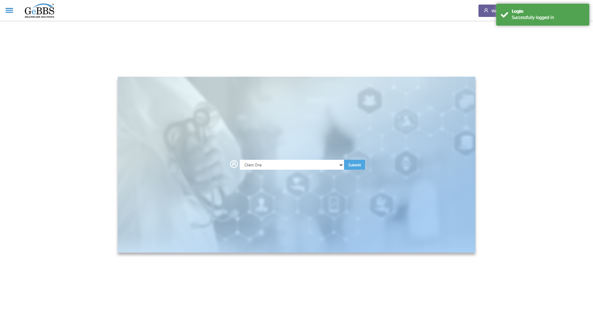  
SelectClient is clicked  
Drop down option at the position 1 is selected  
Submit selected client is clicked  
Desired client found.  
  
Frame found and switched to   
Drop down option with visible text Select is selected  
Search_CoderReviewStatus is clicked  
WarningMsg is displayed  
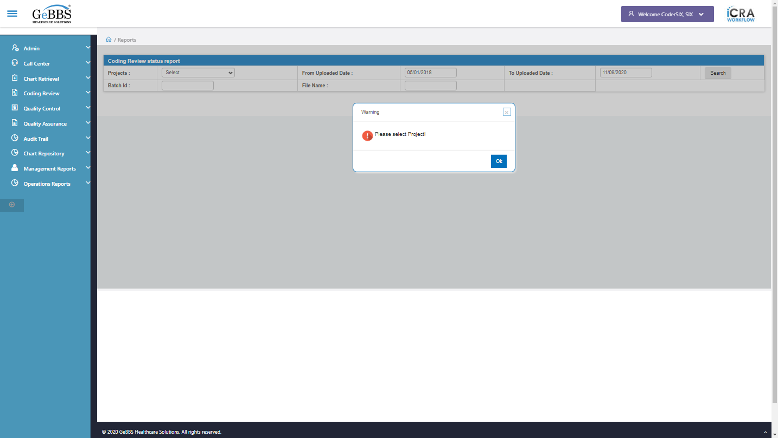  
ok is clicked  
Drop down option with visible text P three CallCenter Blind is selected **09/11/2020 14:57:57**