**CodingReviewDashboardTest  
09/11/2020 19:54:16**  
User Is Navigated To Site : http://172.19.9.53/ICRARevamp/#/login  
  
Username is entered  
  
Password is entered  
  
Submit button is clicked  
Text of the element : Successfully logged in  
Successfully logged in  
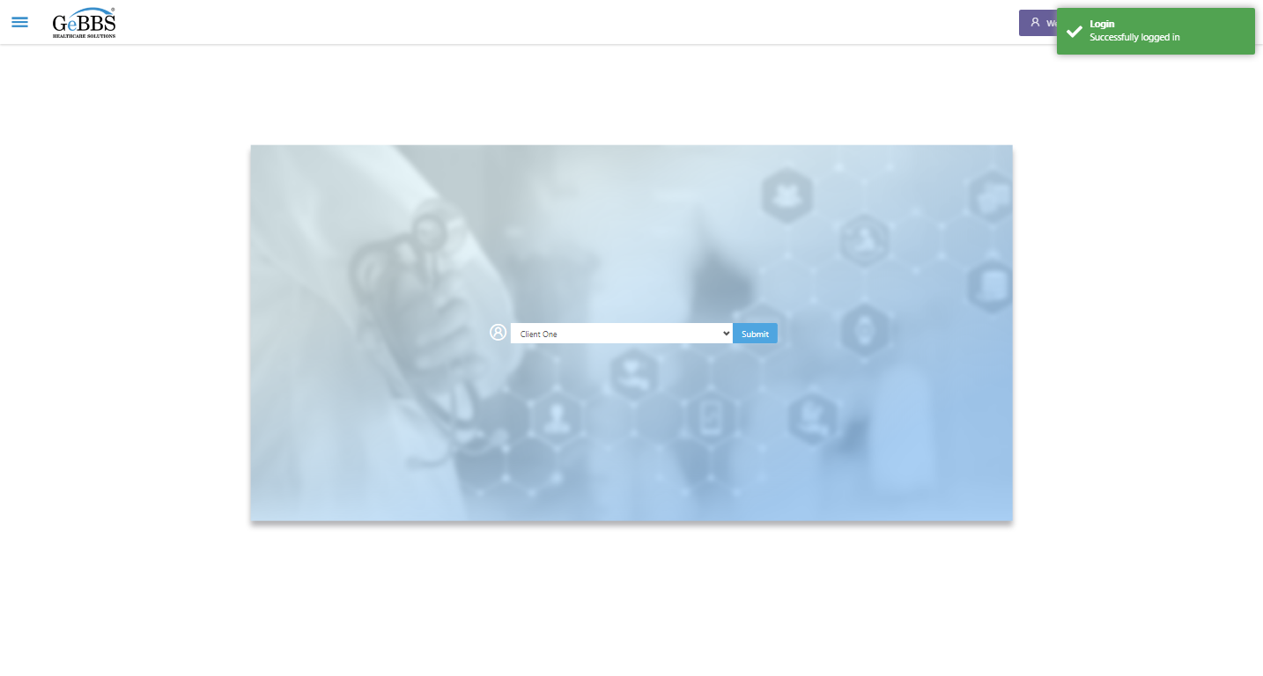  
SelectClient is clicked  
Drop down option at the position 1 is selected  
Submit selected client is clicked  
Desired client found.  
  
Main Page loaded  
  
Scrolled successfully  
Management Reports is clicked  
All submenus  
  
Submenu in 1 is :Charts in Queue Report  
Submenu in 2 is :Coding Review Dashboard  
Submenu in 3 is :HCC Change Report  
Submenu in 4 is :Invoice Report  
Submenu in 5 is :Retrieval Progress Dashboard  
Submenu in 6 is :Review Quality Report  
Scrolled successfully  
Coding Review Dashboard is clicked  
Coding Review Dashboard selected  
  
Frame found and switched to   
Frame found and switched to   
CodingCompletionStatus is displayed  
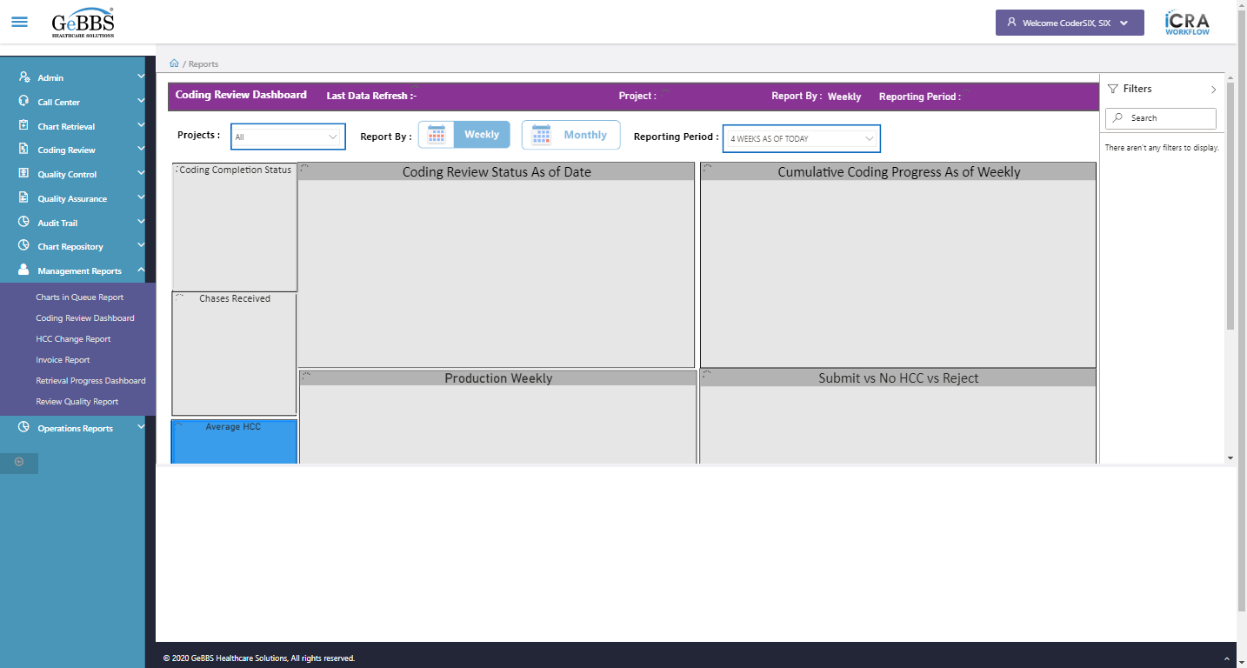  
Chases_Received icon is displayed  
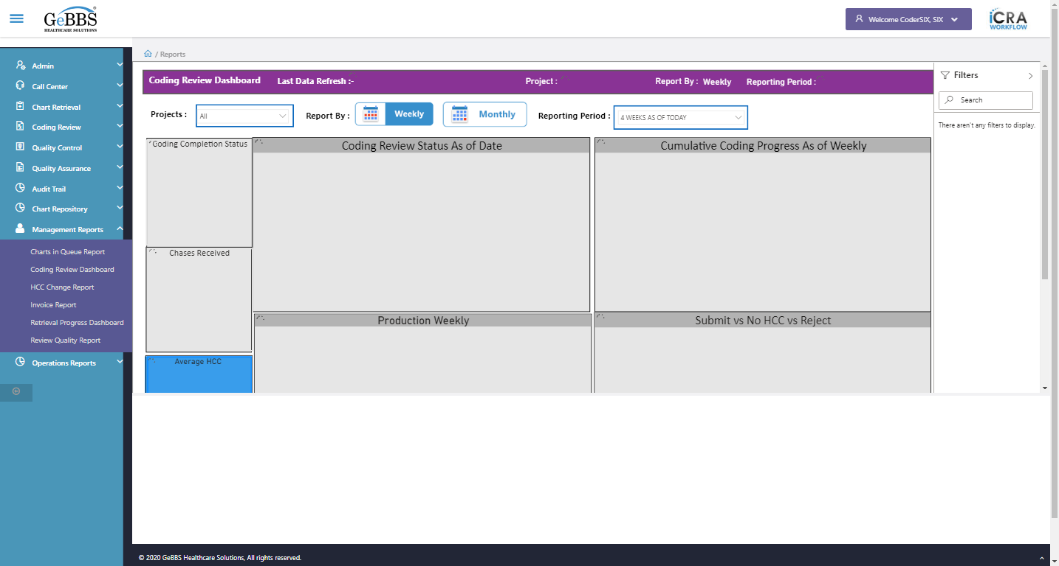  
AverageHCC image is displayed  
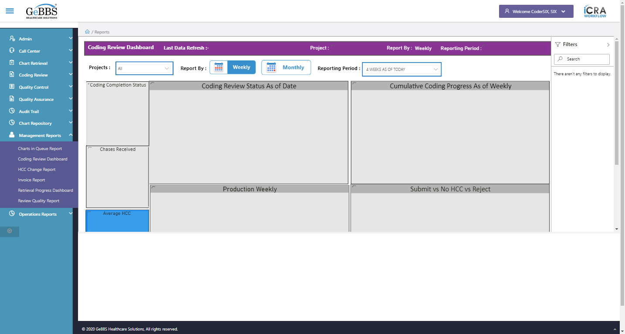  
AveragePageCount image is displayed  
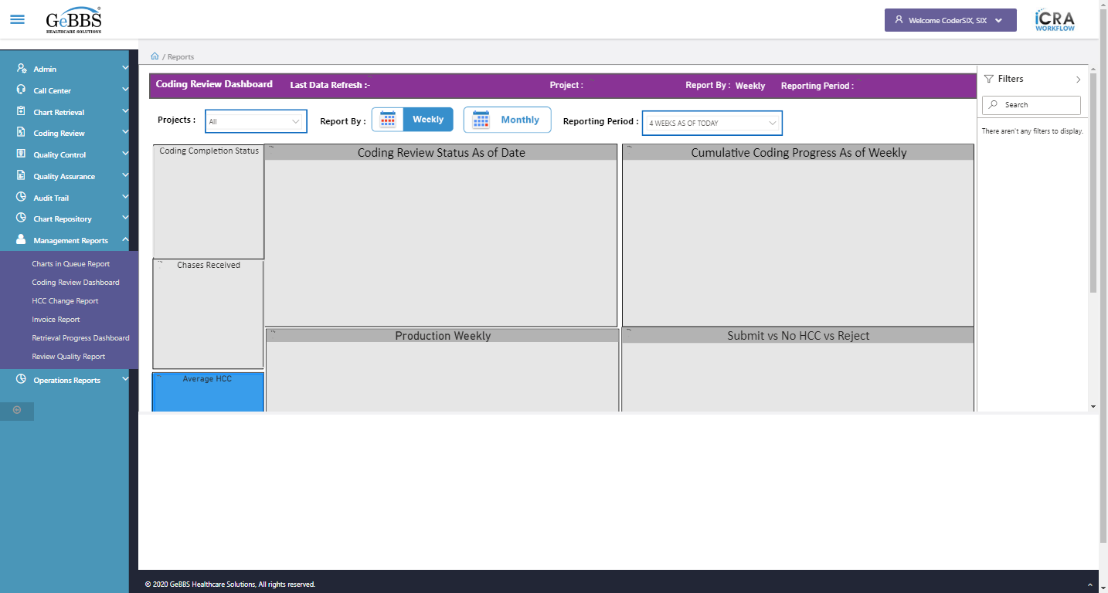  
AverageDOS image is displayed  
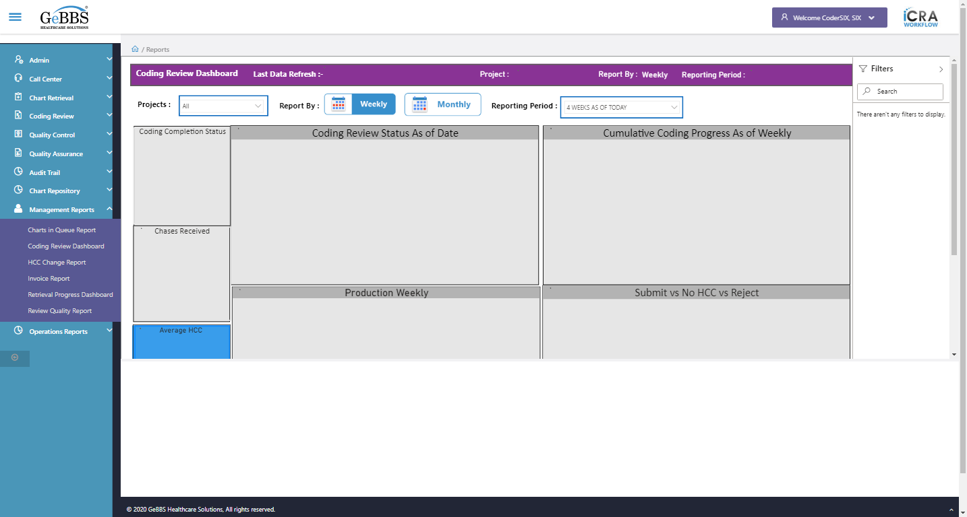  
CoderReviewStatus graph is displayed  
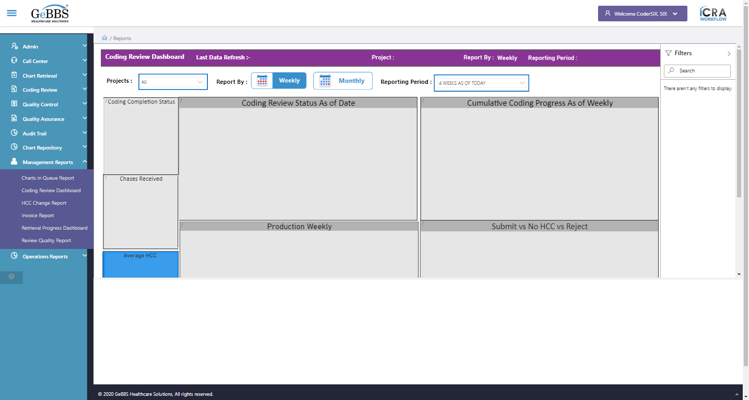  
CumulativeCoding graph is displayed  
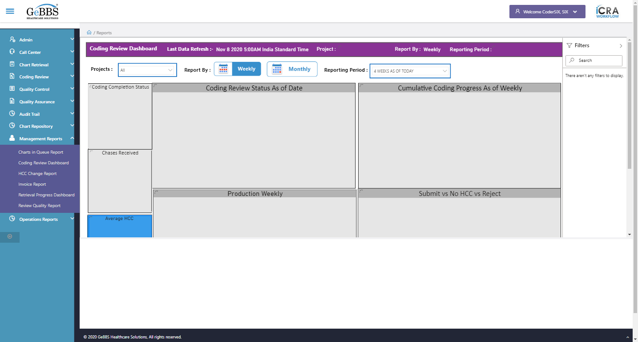  
ProductionWeekly graph is displayed  
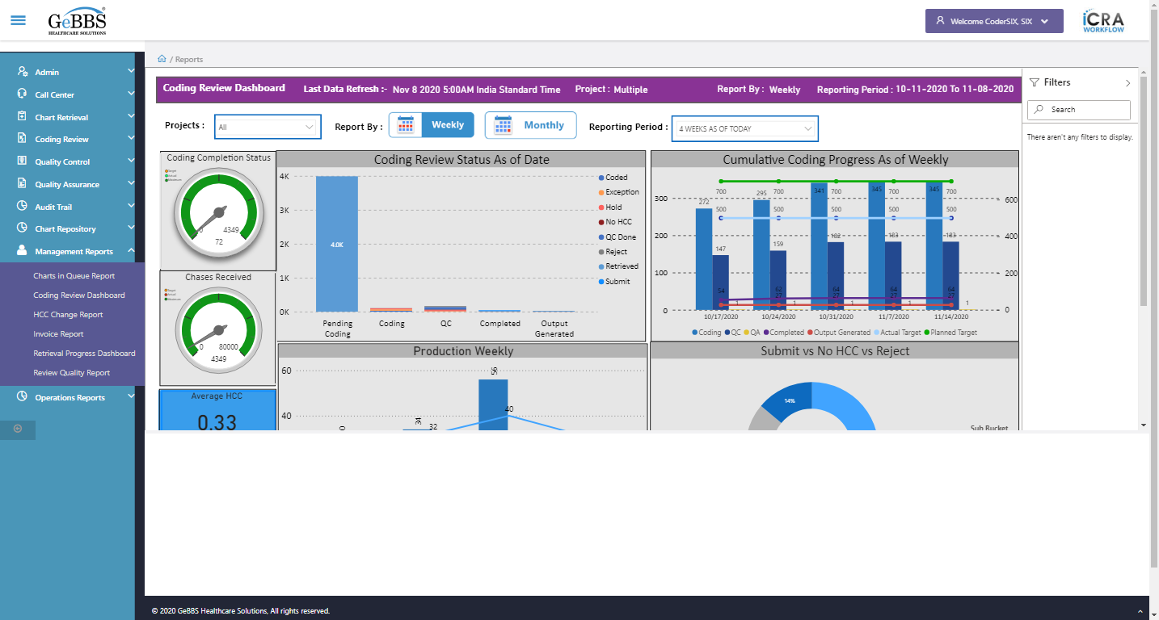  
Submit_NoHCC_Reject graph is displayed  
  
ProjectDropdown is displayed  
  
ReportingPeriod is displayed  
  
ShowFilterPane is displayed  
  
ShowFilterPane is clicked  
Filters text is displayed  
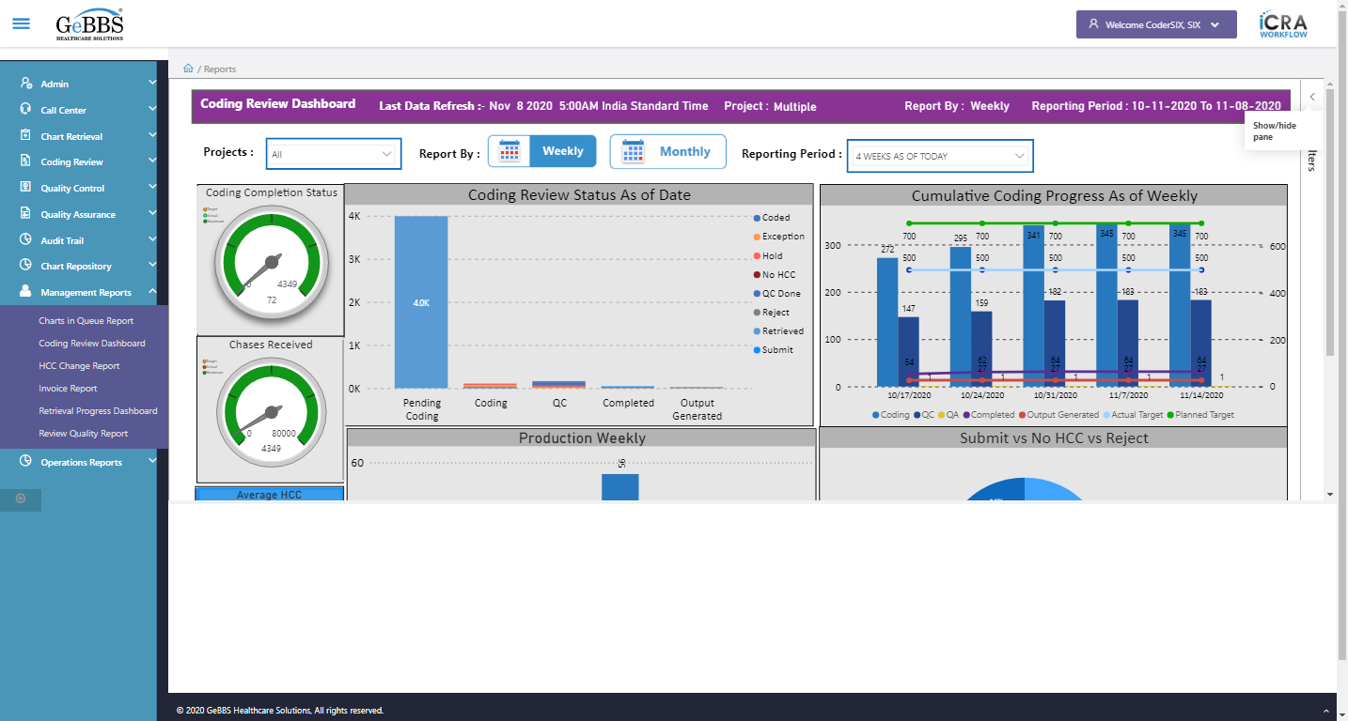  
Filtersicon is displayed  
  
AverageDOSMonthly is displayed  
  
MonthlyDashboard is displayed  
  
Search_Filter is not displayed  
  
ShowFilterPane is clicked  
Attribute for title is : Multiple  
Project name is displayed at header is correct  
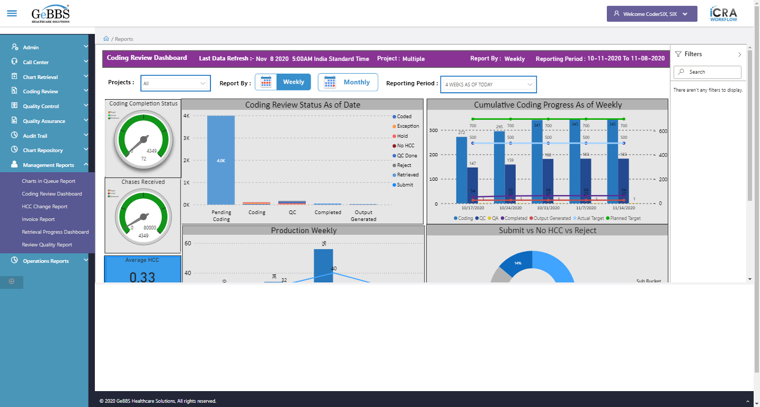  
Project name field is correct  
  
Reporting period value i.e 4 WEEKS AS OF TODAY is selected by default  
  
ReportingBy_Weekly is displayed  
  
ReportingBy_Monthly is displayed  
  
ReportbyTitle2 i.e weekly is displayed  
  
MonthlyDashboard is clicked  
CodingCompletionStatus is displayed  
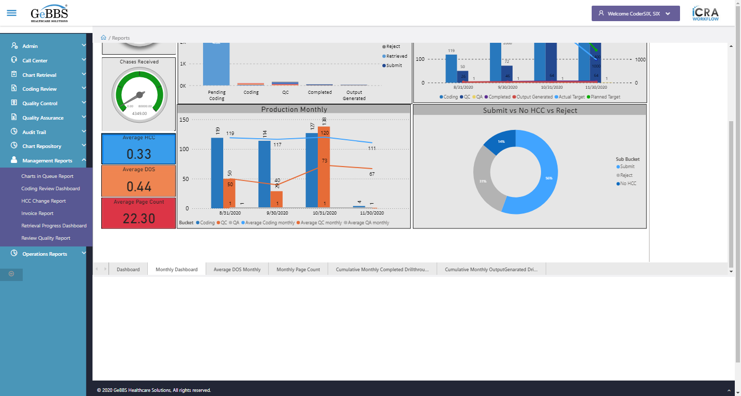  
Chases_Received icon is displayed  
  
AverageHCC image is displayed  
  
AveragePageCount image is displayed  
  
AverageDOS image is displayed  
  
CoderReviewStatus graph is displayed  
  
CumulativeCoding graph is displayed  
