**NOHCCReportsTest1  
09/11/2020 14:24:33**  
User Is Navigated To Site : http://172.19.9.53/ICRARevamp/#/login  
  
Username is entered  
  
Password is entered  
  
Submit button is clicked  
Text of the element : Successfully logged in  
Successfully logged in  
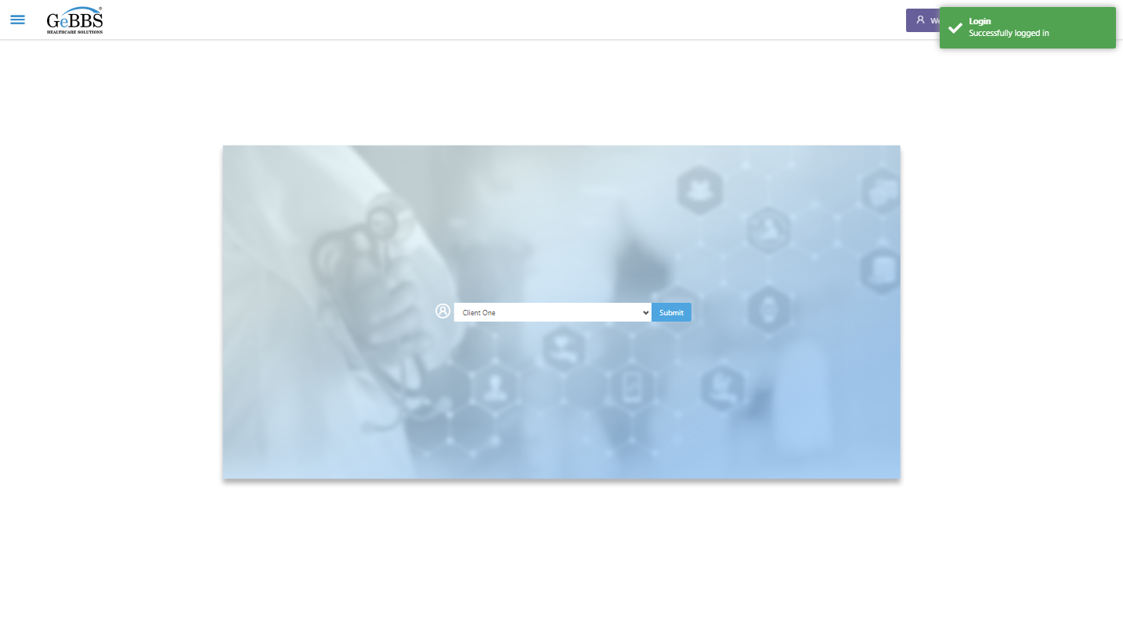  
SelectClient is clicked  
Drop down option at the position 1 is selected  
Submit selected client is clicked  
Desired client found.  
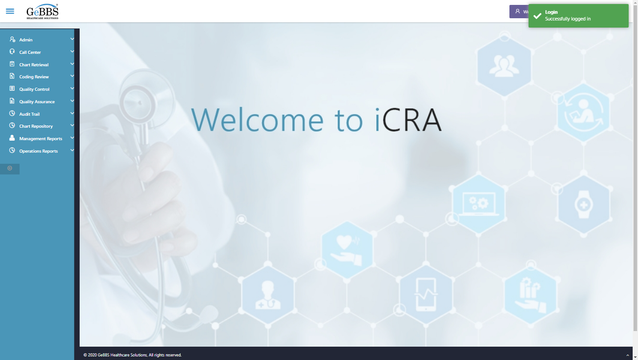  
Frame found and switched to   
Submit is clicked  
WarningMsg is displayed  
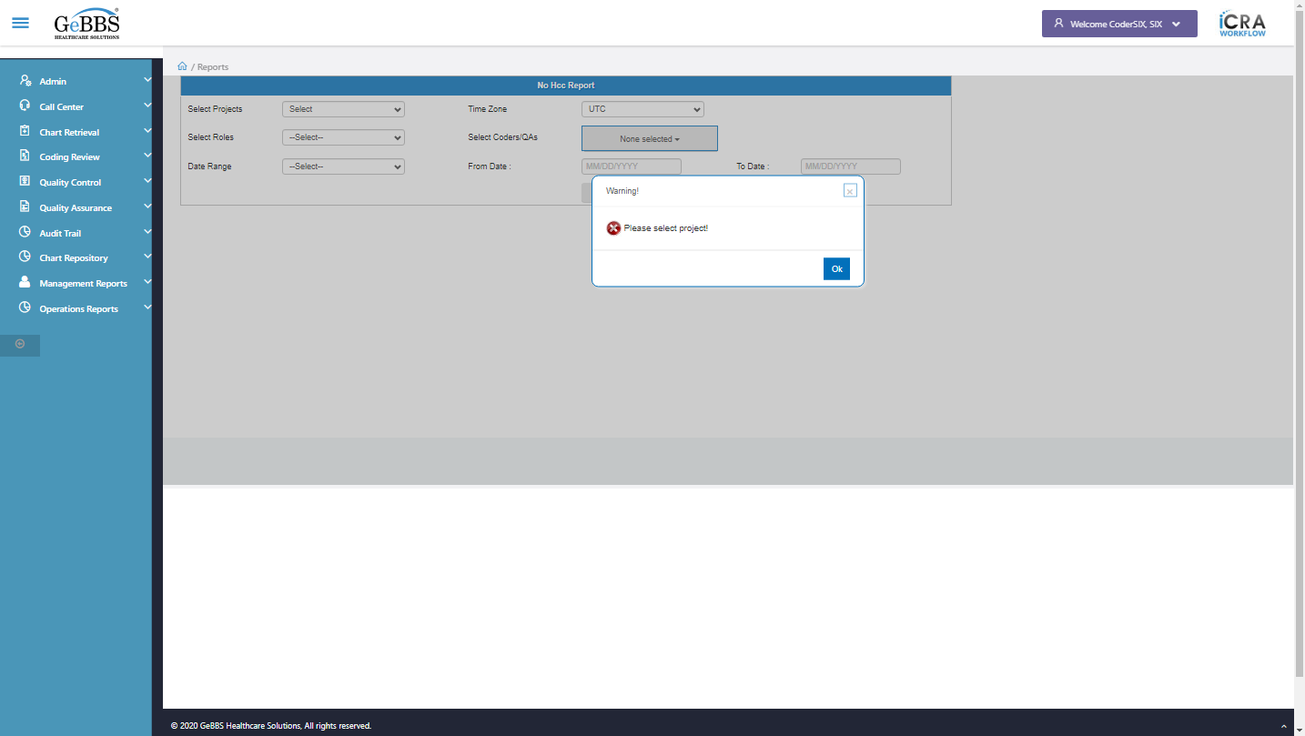  
ok is clicked  
Drop down option with visible text Project one is selected  
Drop down option with visible text IST is selected  
Drop down option with visible text Coder is selected  
NoneSelected is clicked  
SelectAllChkbok is clicked  
Drop down option with visible text Current Quarter is selected  
Submit is clicked  
NOHCC Grid Tbl is displayed  
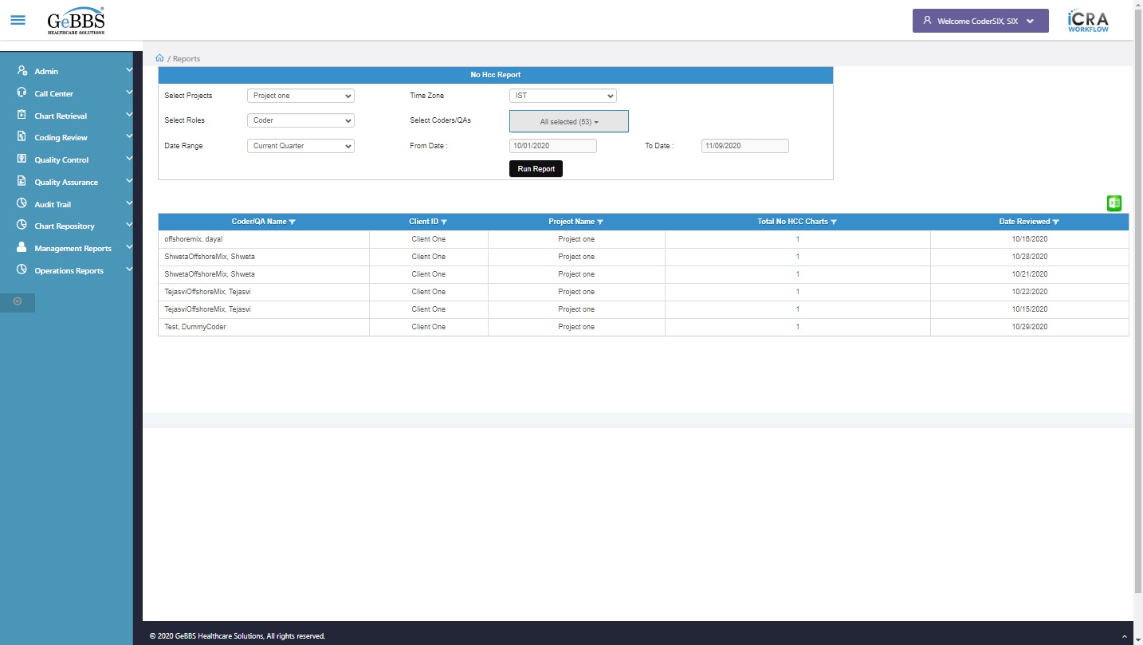 **09/11/2020 14:25:27**