**PageTest  
09/11/2020 15:26:57**  
User Is Navigated To Site : http://172.19.9.53/ICRARevamp/#/login  
  
*****PageTest is Started *****  
Username is entered  
  
Password is entered  
  
Submit button is clicked  
Text of the element : Successfully logged in  
Successfully logged in  
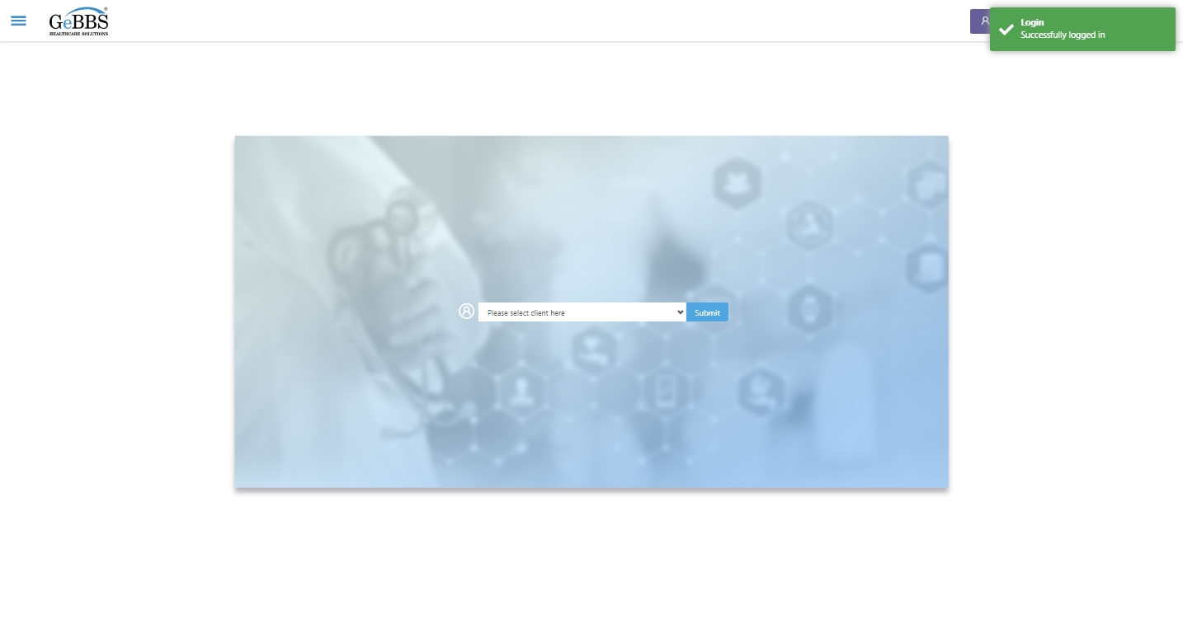  
Client dropdown button is clicked  
Client dropdown button is clicked  
Submit button is clicked  
Main Page loaded  
  
Scrolled successfully  
Chart Retrieval is clicked  
All submenus  
  
Submenu in 1 is :Field Tech  
Submenu in 2 is :FieldTech Area Assignment  
Submenu in 3 is :Intake  
Submenu in 4 is :RecordQA  
Submenu in 5 is :RecordQA Approval  
Scrolled successfully  
RecordQA is clicked  
RecordQA selected  
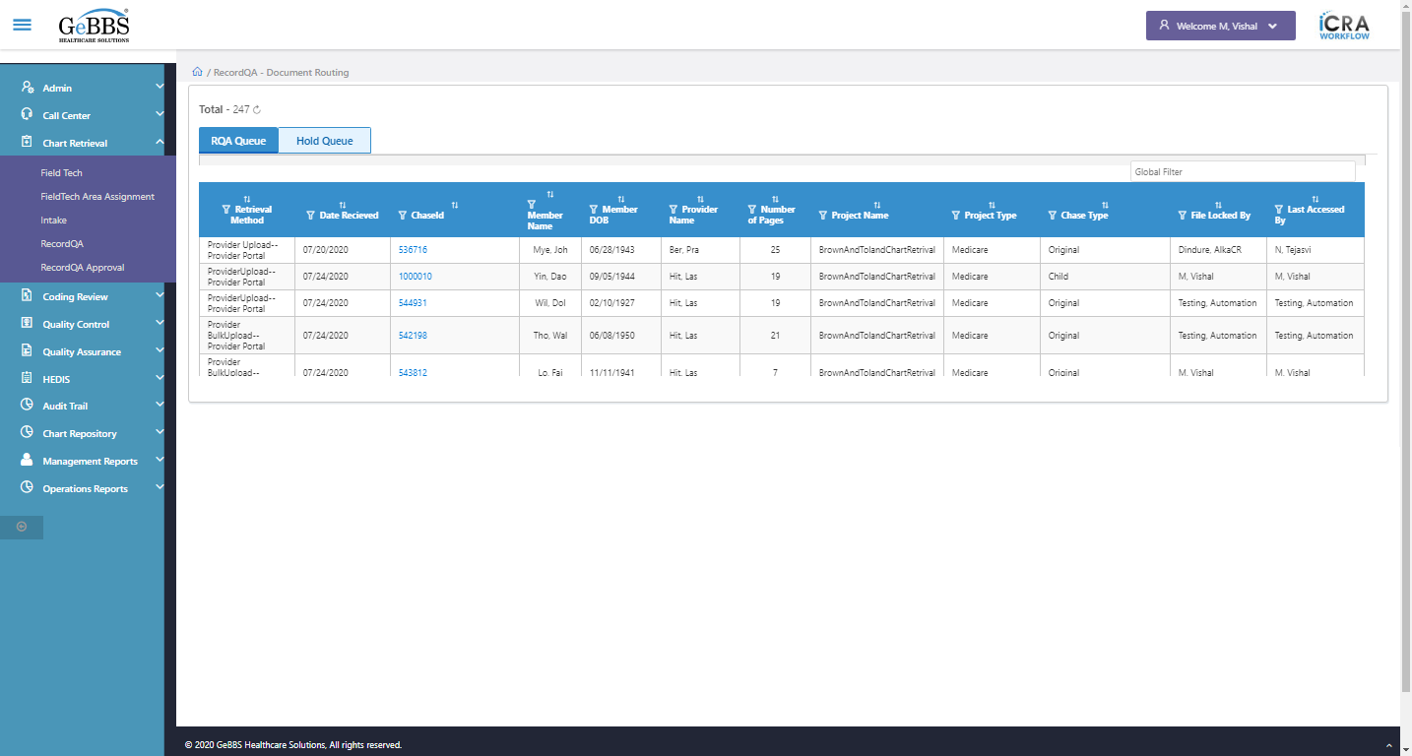  
Scrolled successfully  
Scrolled successfully  
Scrolled successfully  
Scrolled successfully  
Scrolled successfully  
Scrolled successfully  
Scrolled successfully  
Scrolled successfully  
Scrolled successfully  
Scrolled successfully  
Scrolled successfully  
Scrolled successfully  
Scrolled successfully  
Scrolled successfully  
Scrolled successfully  
Scrolled successfully  
Text of the element : 1000044  
GolbalFilter is entered  
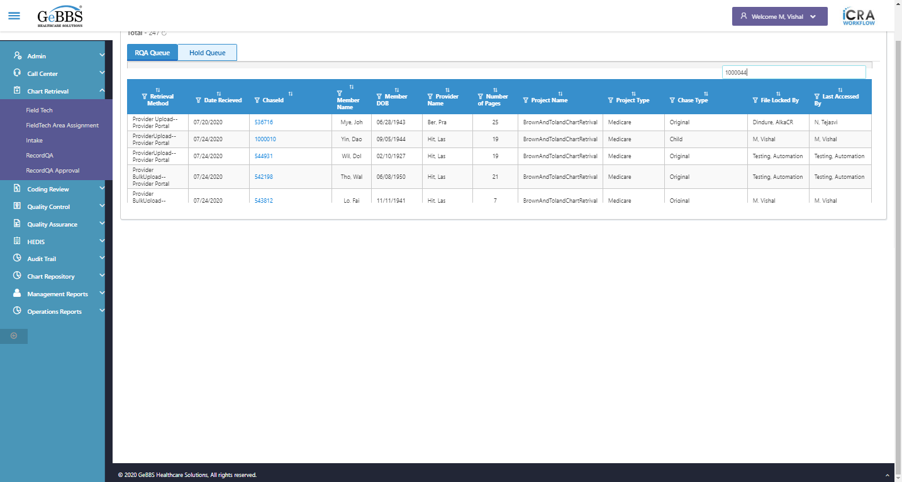  
Text of the element : 2  
chaseid is clicked  
Expected condition failed: waiting for visibility of [[ChromeDriver: chrome on WINDOWS (1f135c6099654af96cc6b438ef475818)] -> xpath: //iframe[@title='ng2-pdfjs-viewer']] (tried for 5 second(s) with 500 milliseconds interval)
Build info: version: '3.141.59', revision: 'e82be7d358', time: '2018-11-14T08:17:03'
System info: host: 'GEBBSET17063', ip: '172.30.54.166', os.name: 'Windows 10', os.arch: 'amd64', os.version: '10.0', java.version: '13.0.1'
Driver info: org.openqa.selenium.chrome.ChromeDriver
Capabilities {acceptInsecureCerts: false, browserName: chrome, browserVersion: 86.0.4240.183, chrome: {chromedriverVersion: 85.0.4183.87 (cd6713ebf92fa..., userDataDir: C:\Users\nishinde\AppData\L...}, goog:chromeOptions: {debuggerAddress: localhost:56114}, javascriptEnabled: true, networkConnectionEnabled: false, pageLoadStrategy: normal, platform: WINDOWS, platformName: WINDOWS, proxy: Proxy(), setWindowRect: true, strictFileInteractability: false, timeouts: {implicit: 0, pageLoad: 300000, script: 30000}, unhandledPromptBehavior: dismiss and notify, webauthn:virtualAuthenticators: true}
Session ID: 1f135c6099654af96cc6b438ef475818  
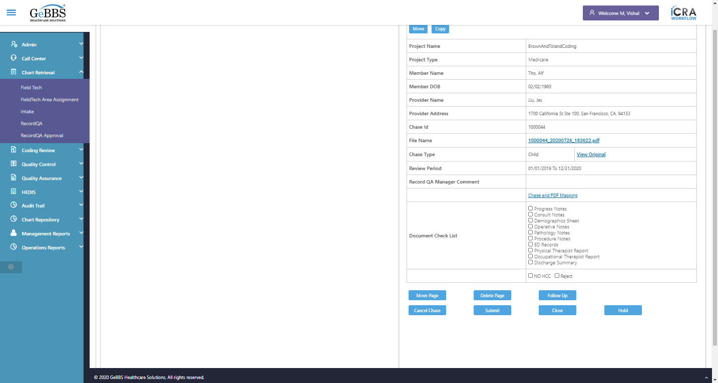  
Expected condition failed: waiting for visibility of [[ChromeDriver: chrome on WINDOWS (1f135c6099654af96cc6b438ef475818)] -> xpath: //iframe[@title='ng2-pdfjs-viewer']] (tried for 5 second(s) with 500 milliseconds interval)
Build info: version: '3.141.59', revision: 'e82be7d358', time: '2018-11-14T08:17:03'
System info: host: 'GEBBSET17063', ip: '172.30.54.166', os.name: 'Windows 10', os.arch: 'amd64', os.version: '10.0', java.version: '13.0.1'
Driver info: org.openqa.selenium.chrome.ChromeDriver
Capabilities {acceptInsecureCerts: false, browserName: chrome, browserVersion: 86.0.4240.183, chrome: {chromedriverVersion: 85.0.4183.87 (cd6713ebf92fa..., userDataDir: C:\Users\nishinde\AppData\L...}, goog:chromeOptions: {debuggerAddress: localhost:56114}, javascriptEnabled: true, networkConnectionEnabled: false, pageLoadStrategy: normal, platform: WINDOWS, platformName: WINDOWS, proxy: Proxy(), setWindowRect: true, strictFileInteractability: false, timeouts: {implicit: 0, pageLoad: 300000, script: 30000}, unhandledPromptBehavior: dismiss and notify, webauthn:virtualAuthenticators: true}
Session ID: 1f135c6099654af96cc6b438ef475818  
  
Expected condition failed: waiting for visibility of [[ChromeDriver: chrome on WINDOWS (1f135c6099654af96cc6b438ef475818)] -> xpath: //iframe[@title='ng2-pdfjs-viewer']] (tried for 5 second(s) with 500 milliseconds interval)
Build info: version: '3.141.59', revision: 'e82be7d358', time: '2018-11-14T08:17:03'
System info: host: 'GEBBSET17063', ip: '172.30.54.166', os.name: 'Windows 10', os.arch: 'amd64', os.version: '10.0', java.version: '13.0.1'
Driver info: org.openqa.selenium.chrome.ChromeDriver
Capabilities {acceptInsecureCerts: false, browserName: chrome, browserVersion: 86.0.4240.183, chrome: {chromedriverVersion: 85.0.4183.87 (cd6713ebf92fa..., userDataDir: C:\Users\nishinde\AppData\L...}, goog:chromeOptions: {debuggerAddress: localhost:56114}, javascriptEnabled: true, networkConnectionEnabled: false, pageLoadStrategy: normal, platform: WINDOWS, platformName: WINDOWS, proxy: Proxy(), setWindowRect: true, strictFileInteractability: false, timeouts: {implicit: 0, pageLoad: 300000, script: 30000}, unhandledPromptBehavior: dismiss and notify, webauthn:virtualAuthenticators: true}
Session ID: 1f135c6099654af96cc6b438ef475818  
  
Expected condition failed: waiting for visibility of [[ChromeDriver: chrome on WINDOWS (1f135c6099654af96cc6b438ef475818)] -> xpath: //iframe[@title='ng2-pdfjs-viewer']] (tried for 5 second(s) with 500 milliseconds interval)
Build info: version: '3.141.59', revision: 'e82be7d358', time: '2018-11-14T08:17:03'
System info: host: 'GEBBSET17063', ip: '172.30.54.166', os.name: 'Windows 10', os.arch: 'amd64', os.version: '10.0', java.version: '13.0.1'
Driver info: org.openqa.selenium.chrome.ChromeDriver
Capabilities {acceptInsecureCerts: false, browserName: chrome, browserVersion: 86.0.4240.183, chrome: {chromedriverVersion: 85.0.4183.87 (cd6713ebf92fa..., userDataDir: C:\Users\nishinde\AppData\L...}, goog:chromeOptions: {debuggerAddress: localhost:56114}, javascriptEnabled: true, networkConnectionEnabled: false, pageLoadStrategy: normal, platform: WINDOWS, platformName: WINDOWS, proxy: Proxy(), setWindowRect: true, strictFileInteractability: false, timeouts: {implicit: 0, pageLoad: 300000, script: 30000}, unhandledPromptBehavior: dismiss and notify, webauthn:virtualAuthenticators: true}
Session ID: 1f135c6099654af96cc6b438ef475818  
  
Expected condition failed: waiting for visibility of [[ChromeDriver: chrome on WINDOWS (1f135c6099654af96cc6b438ef475818)] -> xpath: //iframe[@title='ng2-pdfjs-viewer']] (tried for 5 second(s) with 500 milliseconds interval)
Build info: version: '3.141.59', revision: 'e82be7d358', time: '2018-11-14T08:17:03'
System info: host: 'GEBBSET17063', ip: '172.30.54.166', os.name: 'Windows 10', os.arch: 'amd64', os.version: '10.0', java.version: '13.0.1'
Driver info: org.openqa.selenium.chrome.ChromeDriver
Capabilities {acceptInsecureCerts: false, browserName: chrome, browserVersion: 86.0.4240.183, chrome: {chromedriverVersion: 85.0.4183.87 (cd6713ebf92fa..., userDataDir: C:\Users\nishinde\AppData\L...}, goog:chromeOptions: {debuggerAddress: localhost:56114}, javascriptEnabled: true, networkConnectionEnabled: false, pageLoadStrategy: normal, platform: WINDOWS, platformName: WINDOWS, proxy: Proxy(), setWindowRect: true, strictFileInteractability: false, timeouts: {implicit: 0, pageLoad: 300000, script: 30000}, unhandledPromptBehavior: dismiss and notify, webauthn:virtualAuthenticators: true}
Session ID: 1f135c6099654af96cc6b438ef475818  
  
Total Count of PDF Page found and switched to   
Expected condition failed: waiting for visibility of Proxy element for: DefaultElementLocator 'By.xpath: //div[@class='toolbar']//input[@id='pageNumber']' (tried for 5 second(s) with 500 milliseconds interval)  
  
Expected condition failed: waiting for visibility of Proxy element for: DefaultElementLocator 'By.xpath: //div[@class='toolbar']//input[@id='pageNumber']' (tried for 5 second(s) with 500 milliseconds interval)  
  
Expected condition failed: waiting for visibility of Proxy element for: DefaultElementLocator 'By.xpath: //div[@class='toolbar']//input[@id='pageNumber']' (tried for 5 second(s) with 500 milliseconds interval)  
  
Expected condition failed: waiting for visibility of Proxy element for: DefaultElementLocator 'By.xpath: //div[@class='toolbar']//input[@id='pageNumber']' (tried for 5 second(s) with 500 milliseconds interval)  
  
Expected condition failed: waiting for visibility of Proxy element for: DefaultElementLocator 'By.xpath: //div[@class='toolbar']//input[@id='pageNumber']' (tried for 5 second(s) with 500 milliseconds interval)  
  
no such element: Unable to locate element: {"method":"xpath","selector":"//div[@class='toolbar']//input[@id='pageNumber']"}
(Session info: chrome=86.0.4240.183)
For documentation on this error, please visit: https://www.seleniumhq.org/exceptions/no_such_element.html
Build info: version: '3.141.59', revision: 'e82be7d358', time: '2018-11-14T08:17:03'
System info: host: 'GEBBSET17063', ip: '172.30.54.166', os.name: 'Windows 10', os.arch: 'amd64', os.version: '10.0', java.version: '13.0.1'
Driver info: org.openqa.selenium.chrome.ChromeDriver
Capabilities {acceptInsecureCerts: false, browserName: chrome, browserVersion: 86.0.4240.183, chrome: {chromedriverVersion: 85.0.4183.87 (cd6713ebf92fa..., userDataDir: C:\Users\nishinde\AppData\L...}, goog:chromeOptions: {debuggerAddress: localhost:56114}, javascriptEnabled: true, networkConnectionEnabled: false, pageLoadStrategy: normal, platform: WINDOWS, platformName: WINDOWS, proxy: Proxy(), setWindowRect: true, strictFileInteractability: false, timeouts: {implicit: 0, pageLoad: 300000, script: 30000}, unhandledPromptBehavior: dismiss and notify, webauthn:virtualAuthenticators: true}
Session ID: 1f135c6099654af96cc6b438ef475818
*** Element info: {Using=xpath, value=//div[@class='toolbar']//input[@id='pageNumber']}  
  
Scrolled successfully  
MovePage is clicked  
Close_MoveWindow is clicked  
Move is displayed  
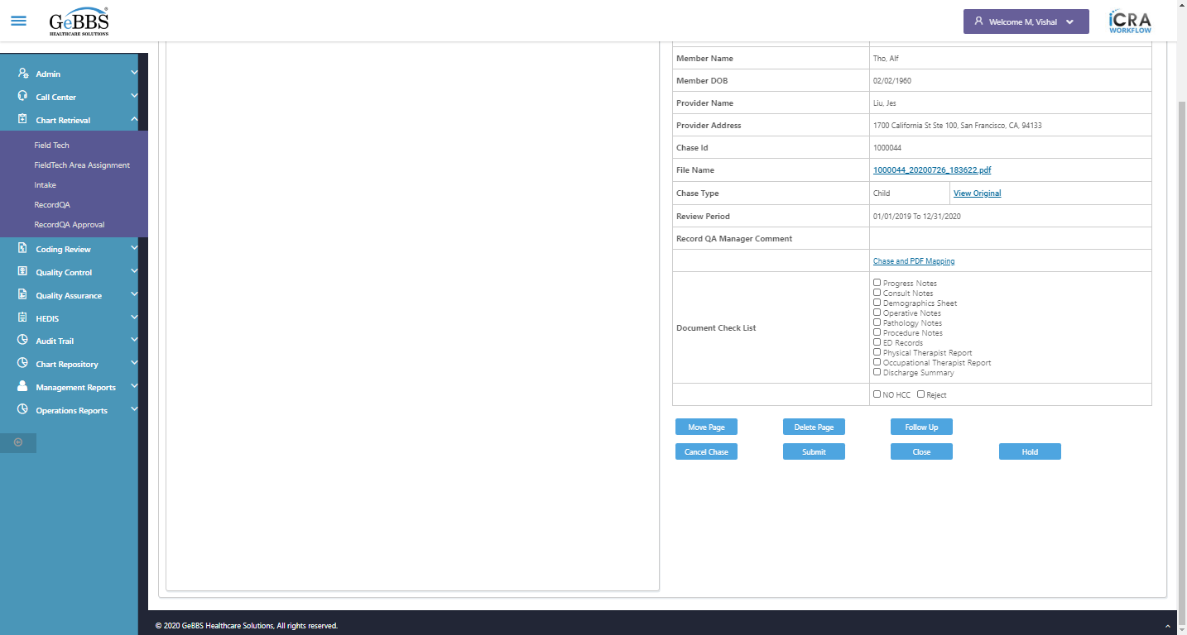  
Chked After Cliking Close button user is navigated to PDF detail screen or not  
Scrolled successfully  
MovePage is clicked  
FromPage_MovePageWin is displayed  
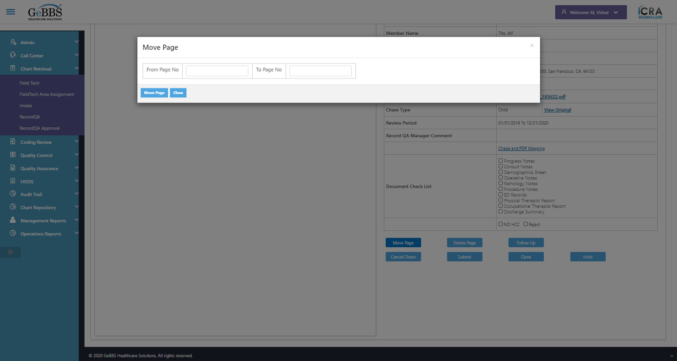  
ToPage_MovePageWin is displayed  
  
Move_MovePgeWindow is displayed  
  
Close_MovePgeWindow is displayed  
  
Move_MovePgeWindow is clicked  
Message is displayed  
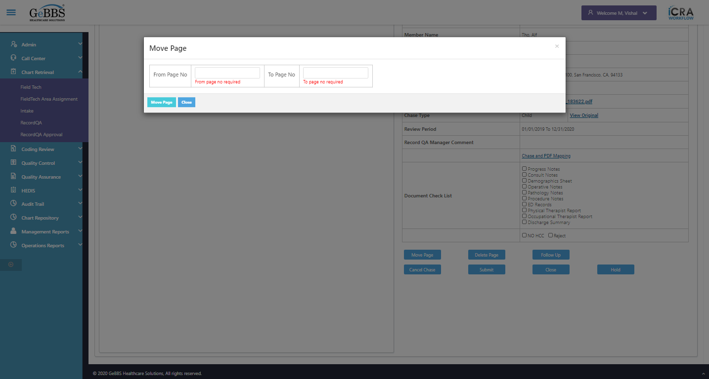  
From page error message of move page is correct  
  
Message is displayed  
  
To page error message of move page is correct  
  
DeletePage is clicked  
Close_MoveWindow is clicked  
Move is displayed  
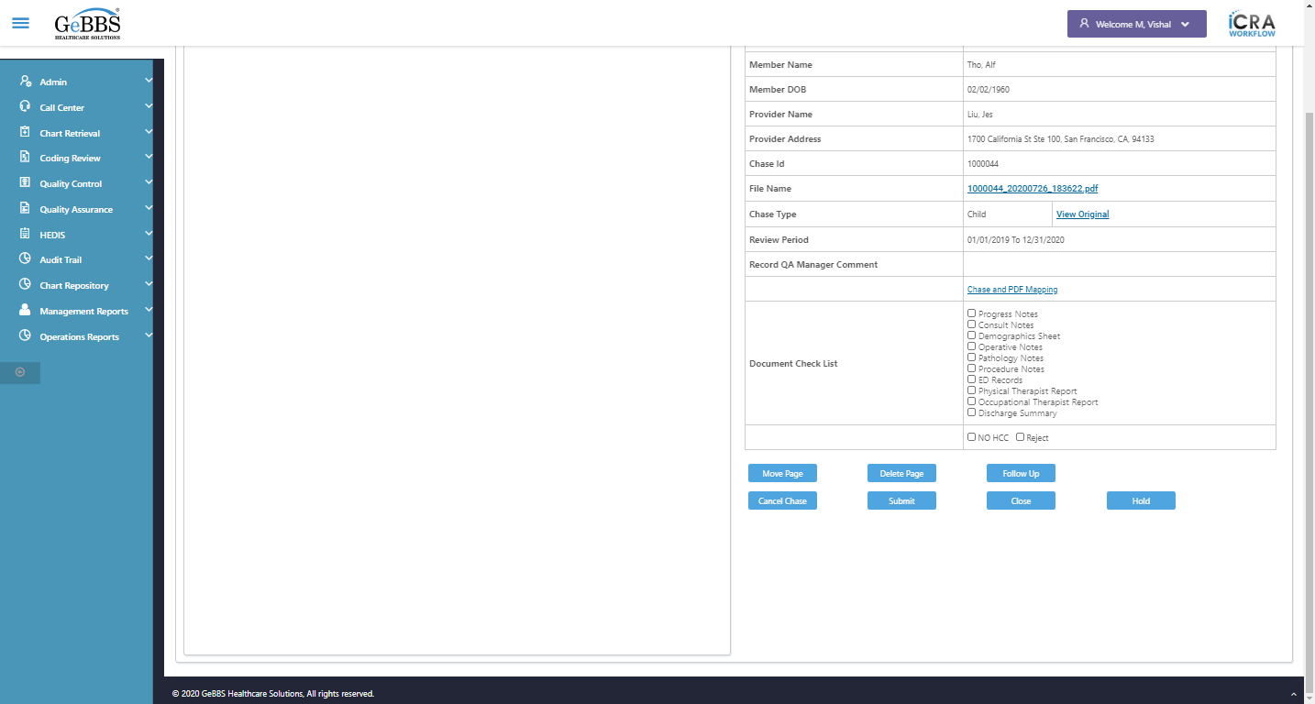  
Chked After Cliking Close button user is navigated to PDF detail screen or not  
DeletePage is clicked  
DeletePages_DeletepgeWin is displayed  
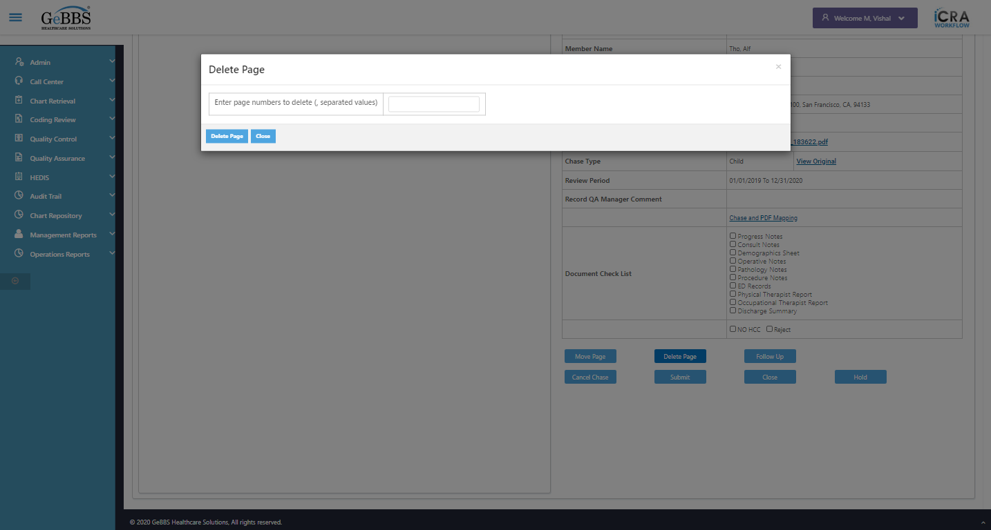  
Delete_DeletePgeWin is displayed  
  
Close_DeletePgeWin is displayed  
  
Move_MovePgeWindow is clicked  
Message is displayed  
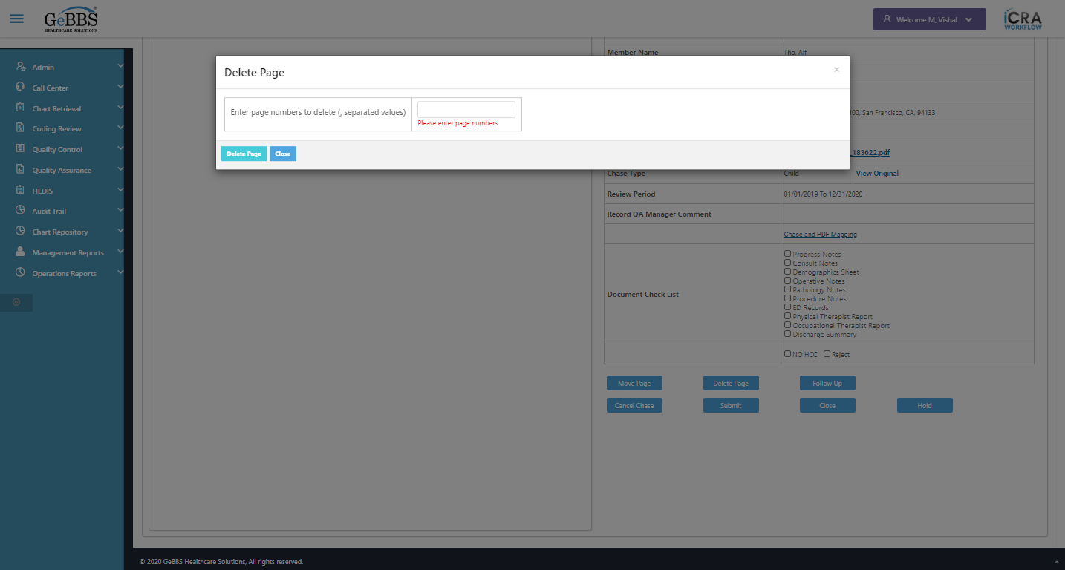  
Delete page error message of Delete page is correct  
  
Delete Page no is entered  
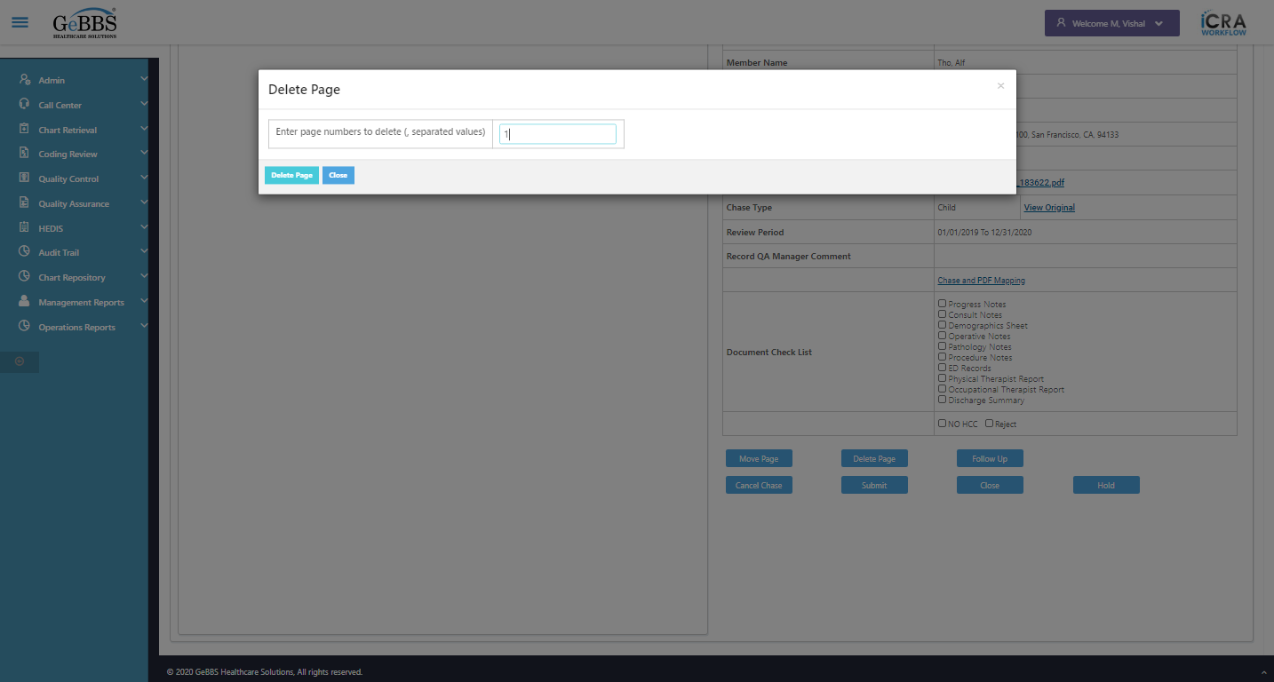  
Delete page is clicked  
Delete page Success msg is not correct  
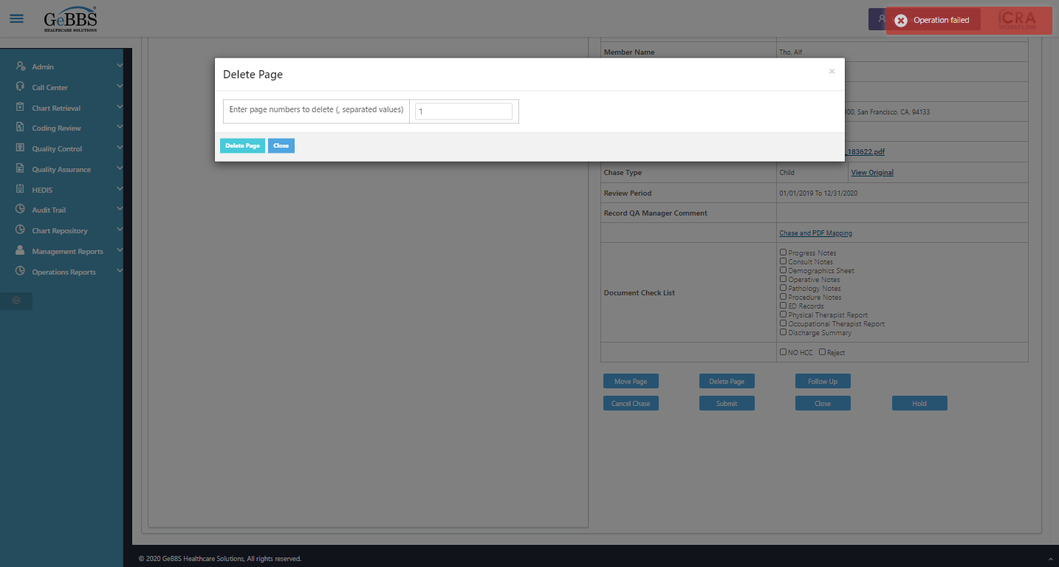  
Expected condition failed: waiting for visibility of [[ChromeDriver: chrome on WINDOWS (1f135c6099654af96cc6b438ef475818)] -> xpath: //iframe[@title='ng2-pdfjs-viewer']] (tried for 5 second(s) with 500 milliseconds interval)
Build info: version: '3.141.59', revision: 'e82be7d358', time: '2018-11-14T08:17:03'
System info: host: 'GEBBSET17063', ip: '172.30.54.166', os.name: 'Windows 10', os.arch: 'amd64', os.version: '10.0', java.version: '13.0.1'
Driver info: org.openqa.selenium.chrome.ChromeDriver
Capabilities {acceptInsecureCerts: false, browserName: chrome, browserVersion: 86.0.4240.183, chrome: {chromedriverVersion: 85.0.4183.87 (cd6713ebf92fa..., userDataDir: C:\Users\nishinde\AppData\L...}, goog:chromeOptions: {debuggerAddress: localhost:56114}, javascriptEnabled: true, networkConnectionEnabled: false, pageLoadStrategy: normal, platform: WINDOWS, platformName: WINDOWS, proxy: Proxy(), setWindowRect: true, strictFileInteractability: false, timeouts: {implicit: 0, pageLoad: 300000, script: 30000}, unhandledPromptBehavior: dismiss and notify, webauthn:virtualAuthenticators: true}
Session ID: 1f135c6099654af96cc6b438ef475818  
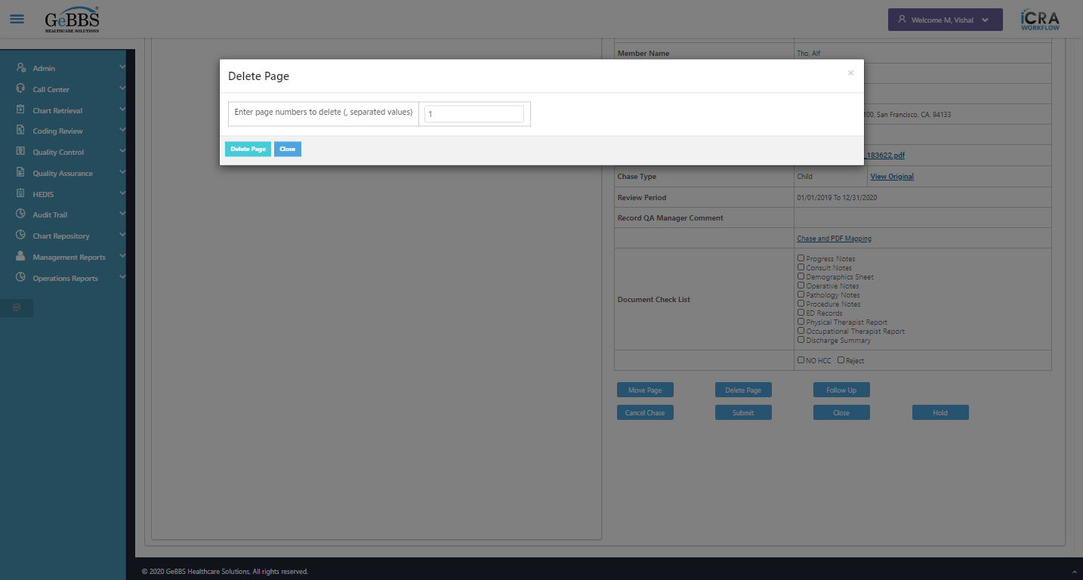  
Expected condition failed: waiting for visibility of [[ChromeDriver: chrome on WINDOWS (1f135c6099654af96cc6b438ef475818)] -> xpath: //iframe[@title='ng2-pdfjs-viewer']] (tried for 5 second(s) with 500 milliseconds interval)
Build info: version: '3.141.59', revision: 'e82be7d358', time: '2018-11-14T08:17:03'
System info: host: 'GEBBSET17063', ip: '172.30.54.166', os.name: 'Windows 10', os.arch: 'amd64', os.version: '10.0', java.version: '13.0.1'
Driver info: org.openqa.selenium.chrome.ChromeDriver
Capabilities {acceptInsecureCerts: false, browserName: chrome, browserVersion: 86.0.4240.183, chrome: {chromedriverVersion: 85.0.4183.87 (cd6713ebf92fa..., userDataDir: C:\Users\nishinde\AppData\L...}, goog:chromeOptions: {debuggerAddress: localhost:56114}, javascriptEnabled: true, networkConnectionEnabled: false, pageLoadStrategy: normal, platform: WINDOWS, platformName: WINDOWS, proxy: Proxy(), setWindowRect: true, strictFileInteractability: false, timeouts: {implicit: 0, pageLoad: 300000, script: 30000}, unhandledPromptBehavior: dismiss and notify, webauthn:virtualAuthenticators: true}
Session ID: 1f135c6099654af96cc6b438ef475818  
  
Expected condition failed: waiting for visibility of [[ChromeDriver: chrome on WINDOWS (1f135c6099654af96cc6b438ef475818)] -> xpath: //iframe[@title='ng2-pdfjs-viewer']] (tried for 5 second(s) with 500 milliseconds interval)
Build info: version: '3.141.59', revision: 'e82be7d358', time: '2018-11-14T08:17:03'
System info: host: 'GEBBSET17063', ip: '172.30.54.166', os.name: 'Windows 10', os.arch: 'amd64', os.version: '10.0', java.version: '13.0.1'
Driver info: org.openqa.selenium.chrome.ChromeDriver
Capabilities {acceptInsecureCerts: false, browserName: chrome, browserVersion: 86.0.4240.183, chrome: {chromedriverVersion: 85.0.4183.87 (cd6713ebf92fa..., userDataDir: C:\Users\nishinde\AppData\L...}, goog:chromeOptions: {debuggerAddress: localhost:56114}, javascriptEnabled: true, networkConnectionEnabled: false, pageLoadStrategy: normal, platform: WINDOWS, platformName: WINDOWS, proxy: Proxy(), setWindowRect: true, strictFileInteractability: false, timeouts: {implicit: 0, pageLoad: 300000, script: 30000}, unhandledPromptBehavior: dismiss and notify, webauthn:virtualAuthenticators: true}
Session ID: 1f135c6099654af96cc6b438ef475818  
  
Expected condition failed: waiting for visibility of [[ChromeDriver: chrome on WINDOWS (1f135c6099654af96cc6b438ef475818)] -> xpath: //iframe[@title='ng2-pdfjs-viewer']] (tried for 5 second(s) with 500 milliseconds interval)
Build info: version: '3.141.59', revision: 'e82be7d358', time: '2018-11-14T08:17:03'
System info: host: 'GEBBSET17063', ip: '172.30.54.166', os.name: 'Windows 10', os.arch: 'amd64', os.version: '10.0', java.version: '13.0.1'
Driver info: org.openqa.selenium.chrome.ChromeDriver
Capabilities {acceptInsecureCerts: false, browserName: chrome, browserVersion: 86.0.4240.183, chrome: {chromedriverVersion: 85.0.4183.87 (cd6713ebf92fa..., userDataDir: C:\Users\nishinde\AppData\L...}, goog:chromeOptions: {debuggerAddress: localhost:56114}, javascriptEnabled: true, networkConnectionEnabled: false, pageLoadStrategy: normal, platform: WINDOWS, platformName: WINDOWS, proxy: Proxy(), setWindowRect: true, strictFileInteractability: false, timeouts: {implicit: 0, pageLoad: 300000, script: 30000}, unhandledPromptBehavior: dismiss and notify, webauthn:virtualAuthenticators: true}
Session ID: 1f135c6099654af96cc6b438ef475818  
  
Expected condition failed: waiting for visibility of [[ChromeDriver: chrome on WINDOWS (1f135c6099654af96cc6b438ef475818)] -> xpath: //iframe[@title='ng2-pdfjs-viewer']] (tried for 5 second(s) with 500 milliseconds interval)
Build info: version: '3.141.59', revision: 'e82be7d358', time: '2018-11-14T08:17:03'
System info: host: 'GEBBSET17063', ip: '172.30.54.166', os.name: 'Windows 10', os.arch: 'amd64', os.version: '10.0', java.version: '13.0.1'
Driver info: org.openqa.selenium.chrome.ChromeDriver
Capabilities {acceptInsecureCerts: false, browserName: chrome, browserVersion: 86.0.4240.183, chrome: {chromedriverVersion: 85.0.4183.87 (cd6713ebf92fa..., userDataDir: C:\Users\nishinde\AppData\L...}, goog:chromeOptions: {debuggerAddress: localhost:56114}, javascriptEnabled: true, networkConnectionEnabled: false, pageLoadStrategy: normal, platform: WINDOWS, platformName: WINDOWS, proxy: Proxy(), setWindowRect: true, strictFileInteractability: false, timeouts: {implicit: 0, pageLoad: 300000, script: 30000}, unhandledPromptBehavior: dismiss and notify, webauthn:virtualAuthenticators: true}
Session ID: 1f135c6099654af96cc6b438ef475818  
  
Total Count of PDF Page found and switched to   
Expected condition failed: waiting for visibility of Proxy element for: DefaultElementLocator 'By.xpath: //div[@class='toolbar']//input[@id='pageNumber']' (tried for 5 second(s) with 500 milliseconds interval)  
  
Expected condition failed: waiting for visibility of Proxy element for: DefaultElementLocator 'By.xpath: //div[@class='toolbar']//input[@id='pageNumber']' (tried for 5 second(s) with 500 milliseconds interval)  
  
Expected condition failed: waiting for visibility of Proxy element for: DefaultElementLocator 'By.xpath: //div[@class='toolbar']//input[@id='pageNumber']' (tried for 5 second(s) with 500 milliseconds interval)  
  
Expected condition failed: waiting for visibility of Proxy element for: DefaultElementLocator 'By.xpath: //div[@class='toolbar']//input[@id='pageNumber']' (tried for 5 second(s) with 500 milliseconds interval)  
  
Expected condition failed: waiting for visibility of Proxy element for: DefaultElementLocator 'By.xpath: //div[@class='toolbar']//input[@id='pageNumber']' (tried for 5 second(s) with 500 milliseconds interval)  
  
no such element: Unable to locate element: {"method":"xpath","selector":"//div[@class='toolbar']//input[@id='pageNumber']"}
(Session info: chrome=86.0.4240.183)
For documentation on this error, please visit: https://www.seleniumhq.org/exceptions/no_such_element.html
Build info: version: '3.141.59', revision: 'e82be7d358', time: '2018-11-14T08:17:03'
System info: host: 'GEBBSET17063', ip: '172.30.54.166', os.name: 'Windows 10', os.arch: 'amd64', os.version: '10.0', java.version: '13.0.1'
Driver info: org.openqa.selenium.chrome.ChromeDriver
Capabilities {acceptInsecureCerts: false, browserName: chrome, browserVersion: 86.0.4240.183, chrome: {chromedriverVersion: 85.0.4183.87 (cd6713ebf92fa..., userDataDir: C:\Users\nishinde\AppData\L...}, goog:chromeOptions: {debuggerAddress: localhost:56114}, javascriptEnabled: true, networkConnectionEnabled: false, pageLoadStrategy: normal, platform: WINDOWS, platformName: WINDOWS, proxy: Proxy(), setWindowRect: true, strictFileInteractability: false, timeouts: {implicit: 0, pageLoad: 300000, script: 30000}, unhandledPromptBehavior: dismiss and notify, webauthn:virtualAuthenticators: true}
Session ID: 1f135c6099654af96cc6b438ef475818
*** Element info: {Using=xpath, value=//div[@class='toolbar']//input[@id='pageNumber']}  
 **09/11/2020 15:32:02**