**PageTest  
10/11/2020 13:24:14**  
User Is Navigated To Site : http://172.19.9.53/ICRARevamp/#/login  
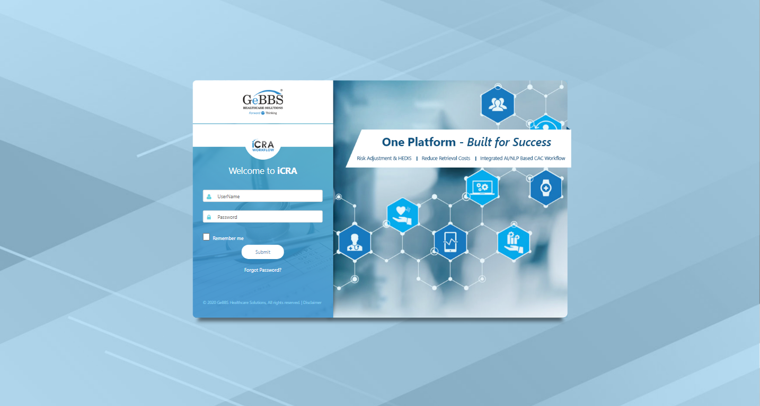  
*****PageTest is Started *****  
Username is entered  
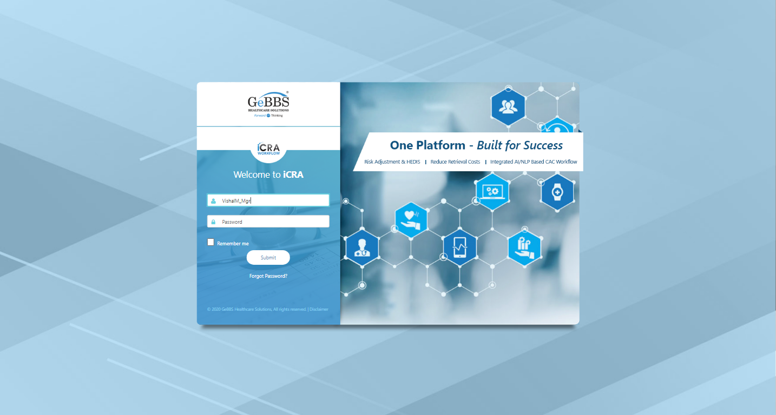  
Password is entered  
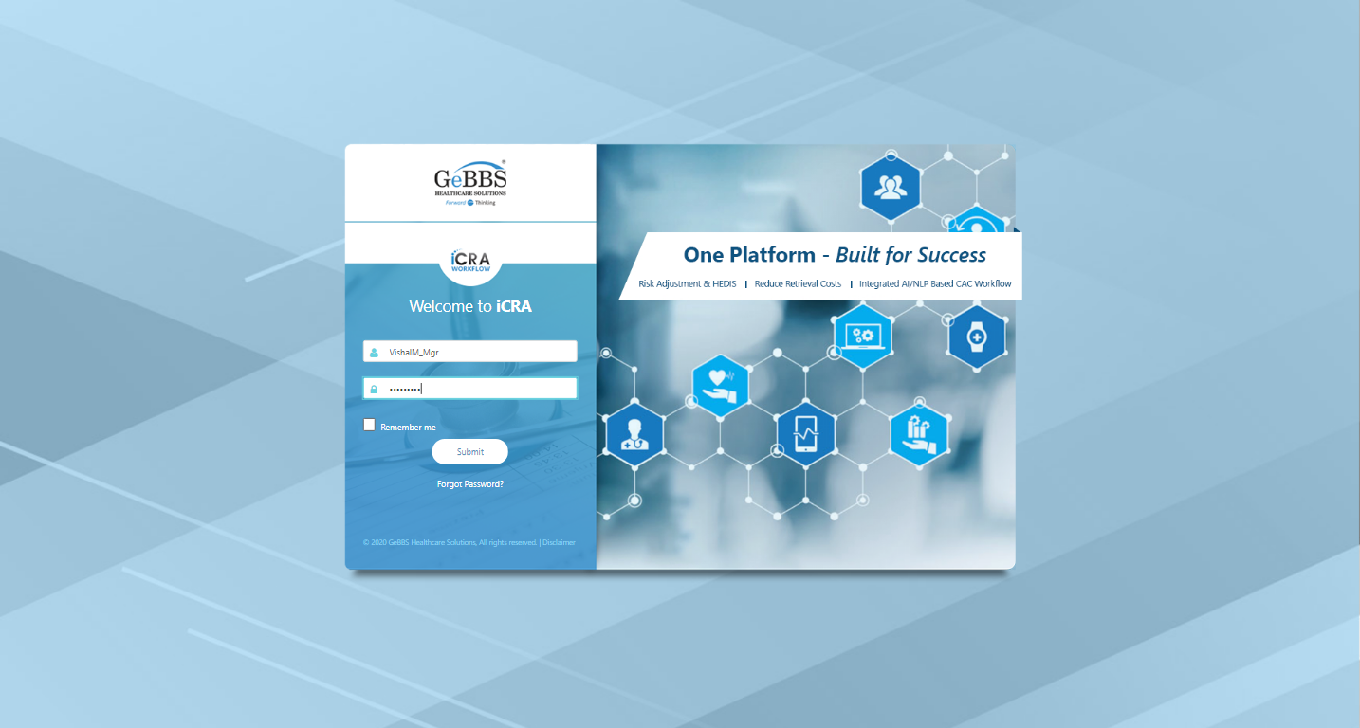  
Submit button is clicked  
Text of the element : Successfully logged in  
Successfully logged in  
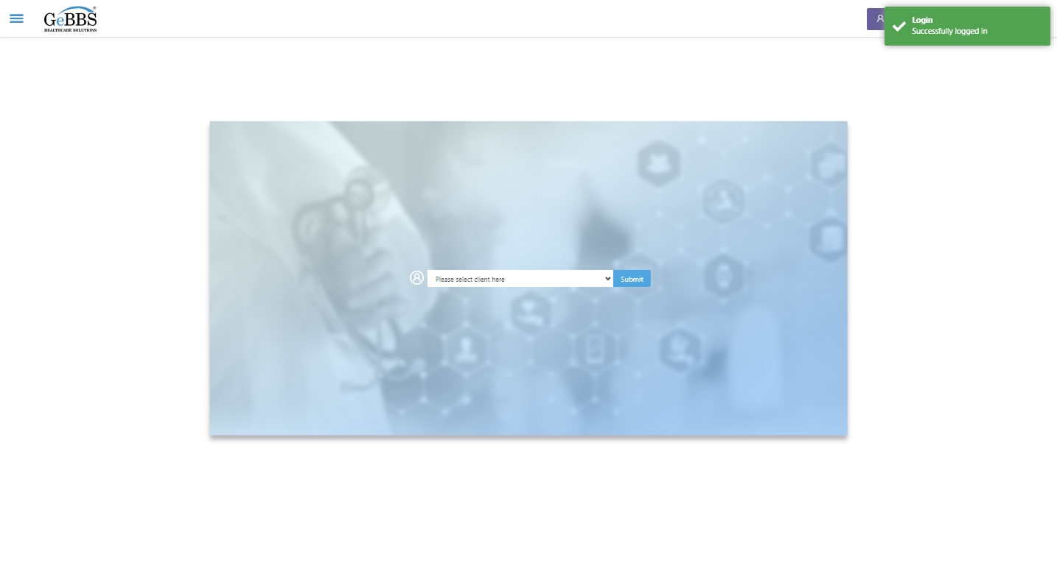  
Client dropdown button is clicked  
Client dropdown button is clicked  
Submit button is clicked  
Main Page loaded  
  
Scrolled successfully  
Chart Retrieval is clicked  
All submenus  
  
Submenu in 1 is :Field Tech  
Submenu in 2 is :FieldTech Area Assignment  
Submenu in 3 is :Intake  
Submenu in 4 is :RecordQA  
Submenu in 5 is :RecordQA Approval  
Scrolled successfully  
RecordQA is clicked  
RecordQA selected  
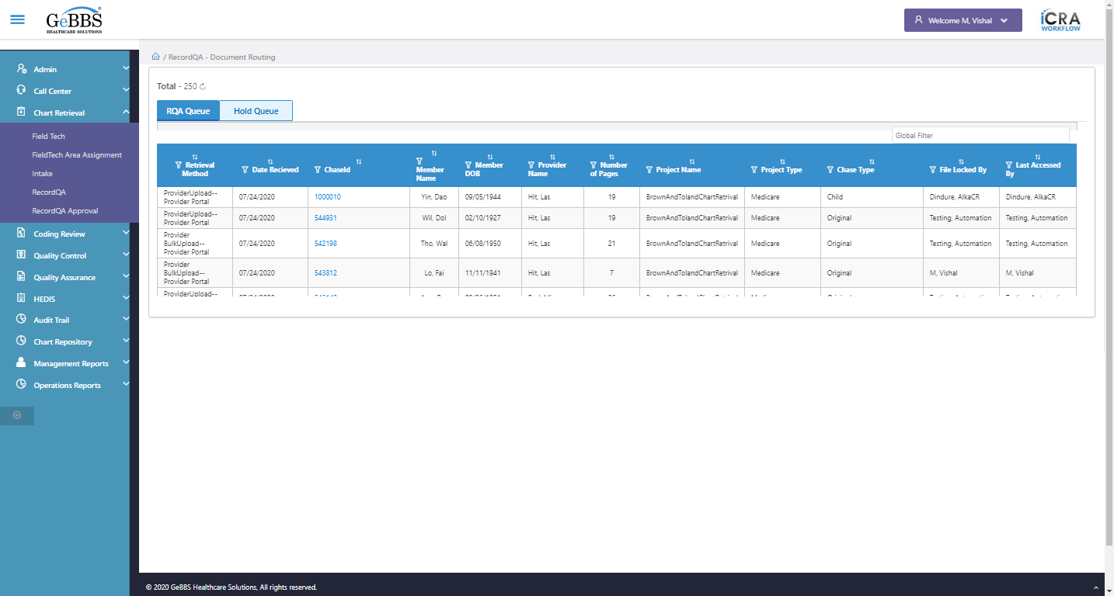  
Scrolled successfully  
Scrolled successfully  
Scrolled successfully  
Scrolled successfully  
Scrolled successfully  
Scrolled successfully  
Scrolled successfully  
Scrolled successfully  
Scrolled successfully  
Scrolled successfully  
Scrolled successfully  
Scrolled successfully  
Scrolled successfully  
Scrolled successfully  
Scrolled successfully  
Scrolled successfully  
Scrolled successfully  
Text of the element : 1000046  
GolbalFilter is entered  
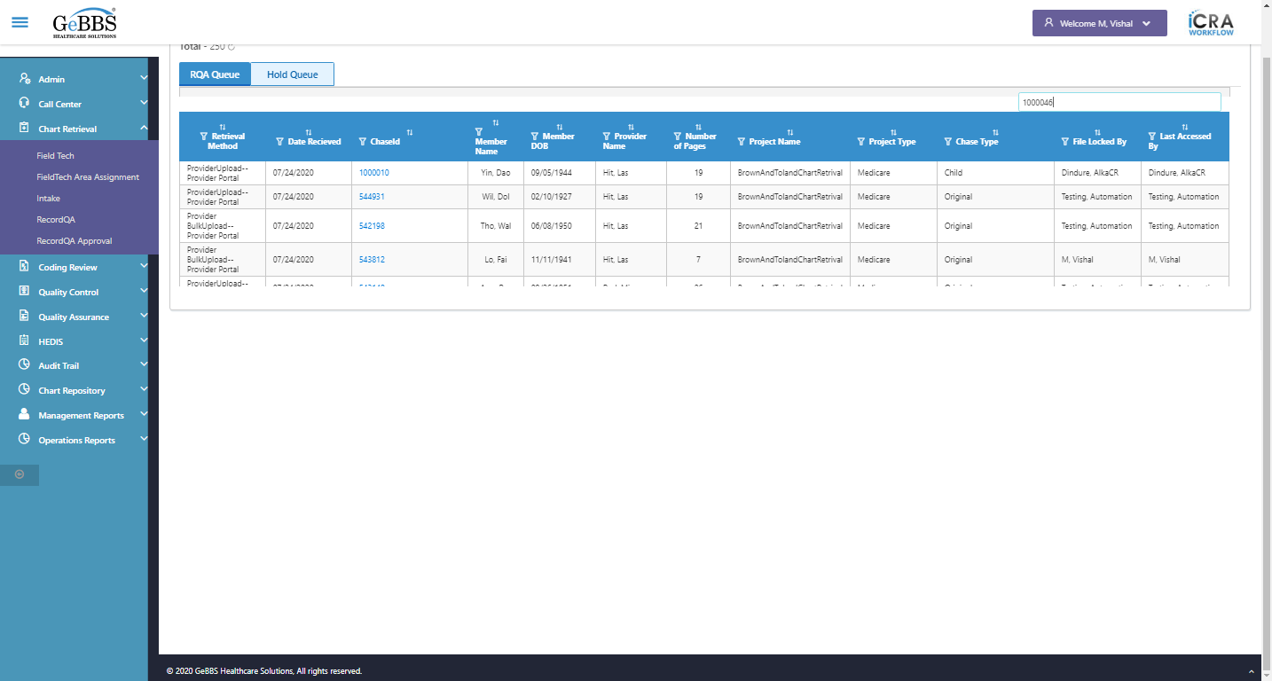  
Text of the element : 2  
chaseid is clicked  
Expected condition failed: waiting for visibility of [[ChromeDriver: chrome on WINDOWS (a9813e0a2ee4fd685a7773e8caaa9570)] -> xpath: //iframe[@title='ng2-pdfjs-viewer']] (tried for 5 second(s) with 500 milliseconds interval)
Build info: version: '3.141.59', revision: 'e82be7d358', time: '2018-11-14T08:17:03'
System info: host: 'GEBBSET17063', ip: '172.30.54.166', os.name: 'Windows 10', os.arch: 'amd64', os.version: '10.0', java.version: '13.0.1'
Driver info: org.openqa.selenium.chrome.ChromeDriver
Capabilities {acceptInsecureCerts: false, browserName: chrome, browserVersion: 86.0.4240.183, chrome: {chromedriverVersion: 85.0.4183.87 (cd6713ebf92fa..., userDataDir: C:\Users\nishinde\AppData\L...}, goog:chromeOptions: {debuggerAddress: localhost:63213}, javascriptEnabled: true, networkConnectionEnabled: false, pageLoadStrategy: normal, platform: WINDOWS, platformName: WINDOWS, proxy: Proxy(), setWindowRect: true, strictFileInteractability: false, timeouts: {implicit: 0, pageLoad: 300000, script: 30000}, unhandledPromptBehavior: dismiss and notify, webauthn:virtualAuthenticators: true}
Session ID: a9813e0a2ee4fd685a7773e8caaa9570  
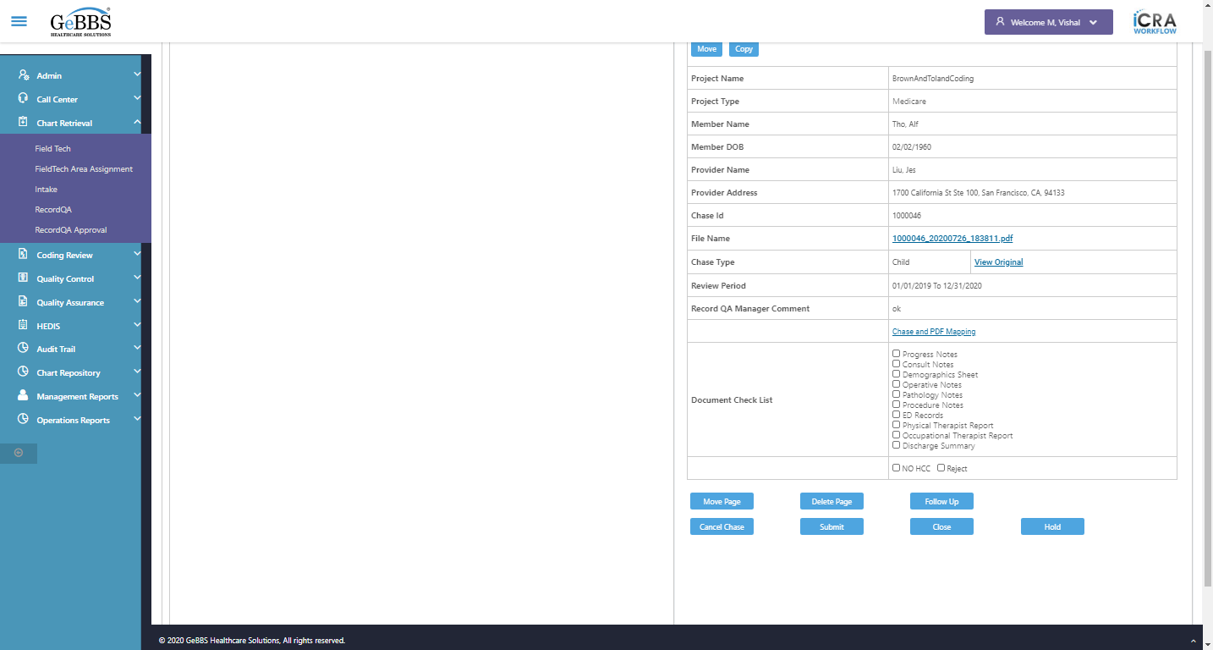  
Expected condition failed: waiting for visibility of [[ChromeDriver: chrome on WINDOWS (a9813e0a2ee4fd685a7773e8caaa9570)] -> xpath: //iframe[@title='ng2-pdfjs-viewer']] (tried for 5 second(s) with 500 milliseconds interval)
Build info: version: '3.141.59', revision: 'e82be7d358', time: '2018-11-14T08:17:03'
System info: host: 'GEBBSET17063', ip: '172.30.54.166', os.name: 'Windows 10', os.arch: 'amd64', os.version: '10.0', java.version: '13.0.1'
Driver info: org.openqa.selenium.chrome.ChromeDriver
Capabilities {acceptInsecureCerts: false, browserName: chrome, browserVersion: 86.0.4240.183, chrome: {chromedriverVersion: 85.0.4183.87 (cd6713ebf92fa..., userDataDir: C:\Users\nishinde\AppData\L...}, goog:chromeOptions: {debuggerAddress: localhost:63213}, javascriptEnabled: true, networkConnectionEnabled: false, pageLoadStrategy: normal, platform: WINDOWS, platformName: WINDOWS, proxy: Proxy(), setWindowRect: true, strictFileInteractability: false, timeouts: {implicit: 0, pageLoad: 300000, script: 30000}, unhandledPromptBehavior: dismiss and notify, webauthn:virtualAuthenticators: true}
Session ID: a9813e0a2ee4fd685a7773e8caaa9570  
  
Expected condition failed: waiting for visibility of [[ChromeDriver: chrome on WINDOWS (a9813e0a2ee4fd685a7773e8caaa9570)] -> xpath: //iframe[@title='ng2-pdfjs-viewer']] (tried for 5 second(s) with 500 milliseconds interval)
Build info: version: '3.141.59', revision: 'e82be7d358', time: '2018-11-14T08:17:03'
System info: host: 'GEBBSET17063', ip: '172.30.54.166', os.name: 'Windows 10', os.arch: 'amd64', os.version: '10.0', java.version: '13.0.1'
Driver info: org.openqa.selenium.chrome.ChromeDriver
Capabilities {acceptInsecureCerts: false, browserName: chrome, browserVersion: 86.0.4240.183, chrome: {chromedriverVersion: 85.0.4183.87 (cd6713ebf92fa..., userDataDir: C:\Users\nishinde\AppData\L...}, goog:chromeOptions: {debuggerAddress: localhost:63213}, javascriptEnabled: true, networkConnectionEnabled: false, pageLoadStrategy: normal, platform: WINDOWS, platformName: WINDOWS, proxy: Proxy(), setWindowRect: true, strictFileInteractability: false, timeouts: {implicit: 0, pageLoad: 300000, script: 30000}, unhandledPromptBehavior: dismiss and notify, webauthn:virtualAuthenticators: true}
Session ID: a9813e0a2ee4fd685a7773e8caaa9570  
  
Expected condition failed: waiting for visibility of [[ChromeDriver: chrome on WINDOWS (a9813e0a2ee4fd685a7773e8caaa9570)] -> xpath: //iframe[@title='ng2-pdfjs-viewer']] (tried for 5 second(s) with 500 milliseconds interval)
Build info: version: '3.141.59', revision: 'e82be7d358', time: '2018-11-14T08:17:03'
System info: host: 'GEBBSET17063', ip: '172.30.54.166', os.name: 'Windows 10', os.arch: 'amd64', os.version: '10.0', java.version: '13.0.1'
Driver info: org.openqa.selenium.chrome.ChromeDriver
Capabilities {acceptInsecureCerts: false, browserName: chrome, browserVersion: 86.0.4240.183, chrome: {chromedriverVersion: 85.0.4183.87 (cd6713ebf92fa..., userDataDir: C:\Users\nishinde\AppData\L...}, goog:chromeOptions: {debuggerAddress: localhost:63213}, javascriptEnabled: true, networkConnectionEnabled: false, pageLoadStrategy: normal, platform: WINDOWS, platformName: WINDOWS, proxy: Proxy(), setWindowRect: true, strictFileInteractability: false, timeouts: {implicit: 0, pageLoad: 300000, script: 30000}, unhandledPromptBehavior: dismiss and notify, webauthn:virtualAuthenticators: true}
Session ID: a9813e0a2ee4fd685a7773e8caaa9570  
  
Expected condition failed: waiting for visibility of [[ChromeDriver: chrome on WINDOWS (a9813e0a2ee4fd685a7773e8caaa9570)] -> xpath: //iframe[@title='ng2-pdfjs-viewer']] (tried for 5 second(s) with 500 milliseconds interval)
Build info: version: '3.141.59', revision: 'e82be7d358', time: '2018-11-14T08:17:03'
System info: host: 'GEBBSET17063', ip: '172.30.54.166', os.name: 'Windows 10', os.arch: 'amd64', os.version: '10.0', java.version: '13.0.1'
Driver info: org.openqa.selenium.chrome.ChromeDriver
Capabilities {acceptInsecureCerts: false, browserName: chrome, browserVersion: 86.0.4240.183, chrome: {chromedriverVersion: 85.0.4183.87 (cd6713ebf92fa..., userDataDir: C:\Users\nishinde\AppData\L...}, goog:chromeOptions: {debuggerAddress: localhost:63213}, javascriptEnabled: true, networkConnectionEnabled: false, pageLoadStrategy: normal, platform: WINDOWS, platformName: WINDOWS, proxy: Proxy(), setWindowRect: true, strictFileInteractability: false, timeouts: {implicit: 0, pageLoad: 300000, script: 30000}, unhandledPromptBehavior: dismiss and notify, webauthn:virtualAuthenticators: true}
Session ID: a9813e0a2ee4fd685a7773e8caaa9570  
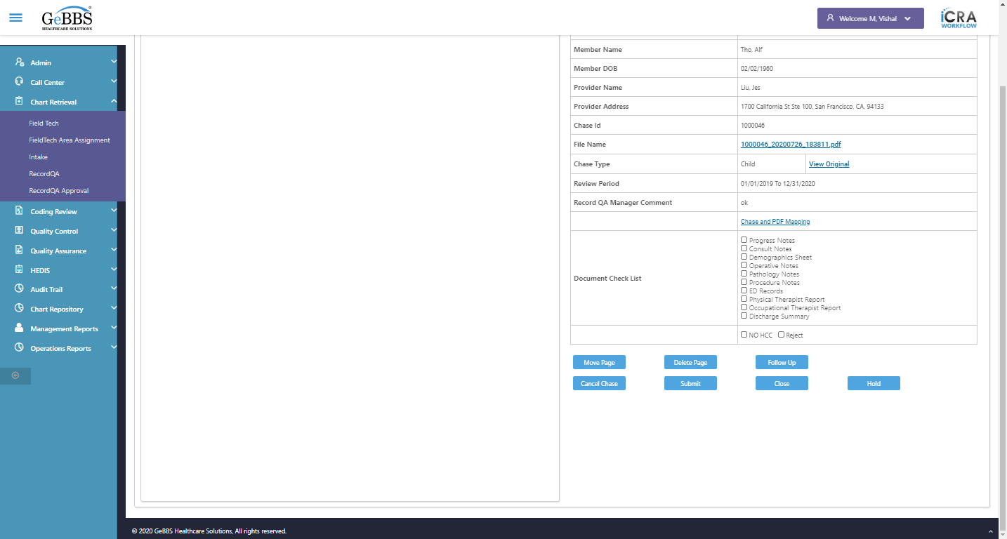  
Frame found and switched to   
ChkPDFOpenOrNot() failed - no such element: Unable to locate element: {"method":"xpath","selector":"//div[@class='toolbar']//input[@id='pageNumber']"}
(Session info: chrome=86.0.4240.183)
For documentation on this error, please visit: https://www.seleniumhq.org/exceptions/no_such_element.html
Build info: version: '3.141.59', revision: 'e82be7d358', time: '2018-11-14T08:17:03'
System info: host: 'GEBBSET17063', ip: '172.30.54.166', os.name: 'Windows 10', os.arch: 'amd64', os.version: '10.0', java.version: '13.0.1'
Driver info: org.openqa.selenium.chrome.ChromeDriver
Capabilities {acceptInsecureCerts: false, browserName: chrome, browserVersion: 86.0.4240.183, chrome: {chromedriverVersion: 85.0.4183.87 (cd6713ebf92fa..., userDataDir: C:\Users\nishinde\AppData\L...}, goog:chromeOptions: {debuggerAddress: localhost:63213}, javascriptEnabled: true, networkConnectionEnabled: false, pageLoadStrategy: normal, platform: WINDOWS, platformName: WINDOWS, proxy: Proxy(), setWindowRect: true, strictFileInteractability: false, timeouts: {implicit: 0, pageLoad: 300000, script: 30000}, unhandledPromptBehavior: dismiss and notify, webauthn:virtualAuthenticators: true}
Session ID: a9813e0a2ee4fd685a7773e8caaa9570
*** Element info: {Using=xpath, value=//div[@class='toolbar']//input[@id='pageNumber']} **10/11/2020 13:26:01**