**ReassignZipIdTest  
09/11/2020 13:41:51**  
User Is Navigated To Site : http://172.19.9.53/ICRARevamp/#/login  
  
*****ReassignZipIdTest is Started *****  
Username is entered  
  
Password is entered  
  
Submit button is clicked  
Text of the element : Successfully logged in  
Successfully logged in  
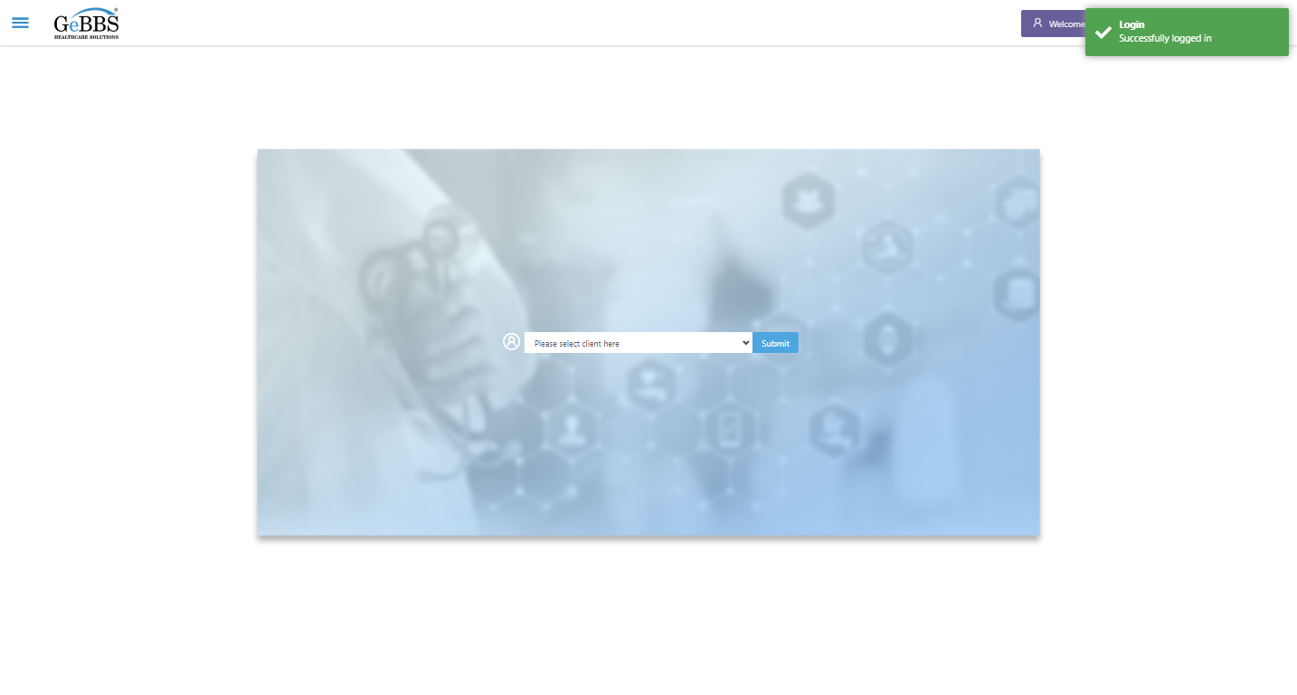  
Client dropdown button is clicked  
Client dropdown button is clicked  
Submit button is clicked  
Main Page loaded  
  
Scrolled successfully  
Call Center is clicked  
All submenus  
  
Submenu in 1 is :Address Allocation  
Submenu in 2 is :Address Approval  
Submenu in 3 is :Address Rollup  
Submenu in 4 is :Data Upload  
Submenu in 5 is :Inbound Call  
Submenu in 6 is :Manager Address Rollup  
Submenu in 7 is :PNP Exception  
Scrolled successfully  
Address Allocation is clicked  
Address Allocation selected  
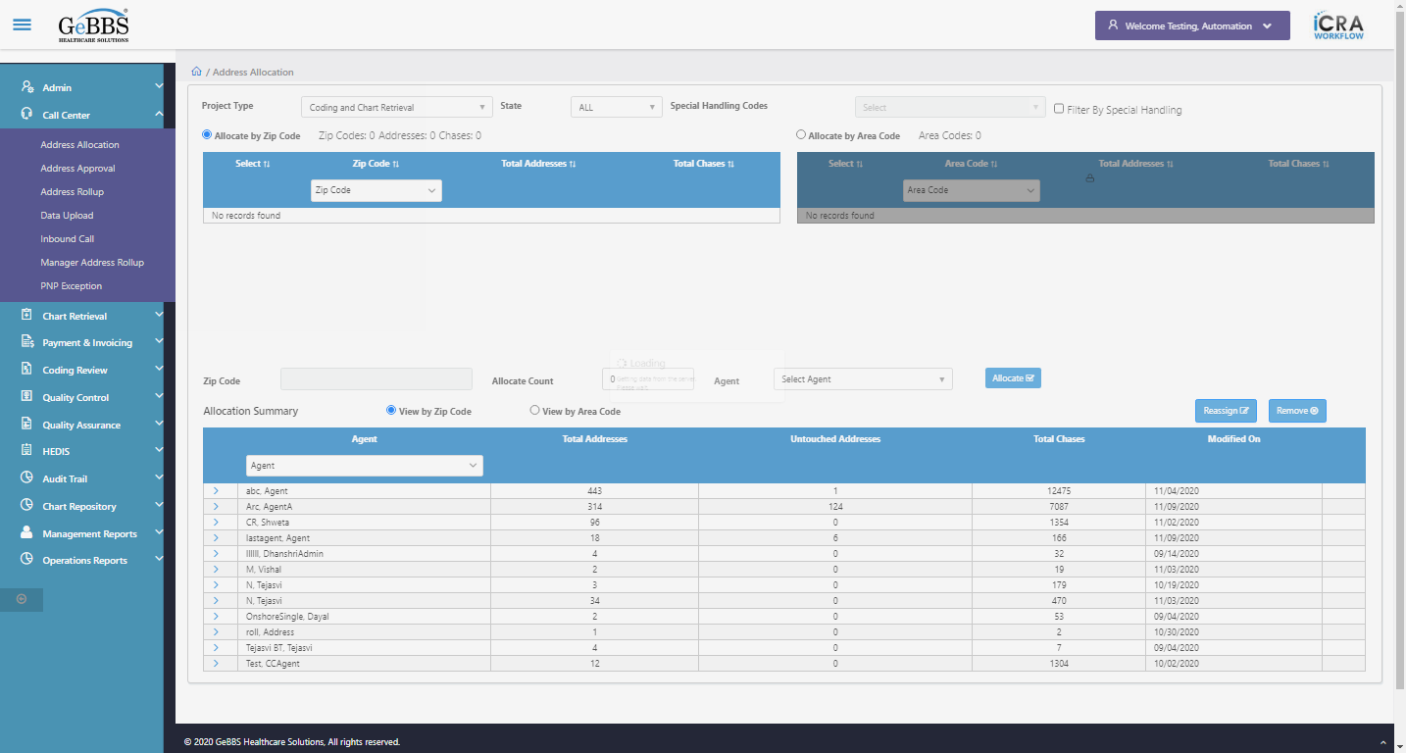  
Agent Found  
Total count of Addresses In Summary Table :6  
Total count of Chases In Summary Table :166  
Zip Code,Address Count,Chase Count In Heading Is Taken Before Allocation  
Allocate is clicked  
Text Is Correct  
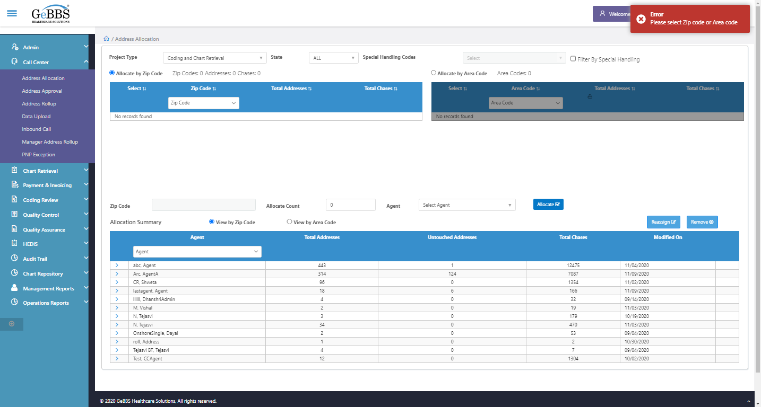  
Get1stRecordAddressCount() failed  
AssignZip_ChkHdrCnt() failed **09/11/2020 13:42:44**