**ReassignZipIdTest  
09/11/2020 12:52:12**  
User Is Navigated To Site : http://172.19.9.53/ICRARevamp/#/login  
  
*****ReassignZipIdTest is Started *****  
Username is entered  
  
Password is entered  
  
Submit button is clicked  
Text of the element : Successfully logged in  
Successfully logged in  
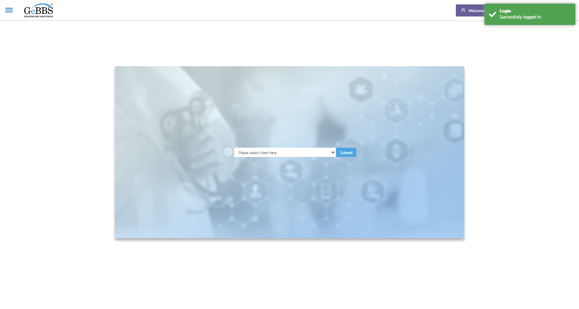  
Client dropdown button is clicked  
Client dropdown button is clicked  
Submit button is clicked  
Main Page loaded  
  
Scrolled successfully  
Call Center is clicked  
All submenus  
  
Submenu in 1 is :Address Allocation  
Submenu in 2 is :Address Approval  
Submenu in 3 is :Address Rollup  
Submenu in 4 is :Data Upload  
Submenu in 5 is :Inbound Call  
Submenu in 6 is :Manager Address Rollup  
Submenu in 7 is :PNP Exception  
Scrolled successfully  
Address Allocation is clicked  
Address Allocation selected  
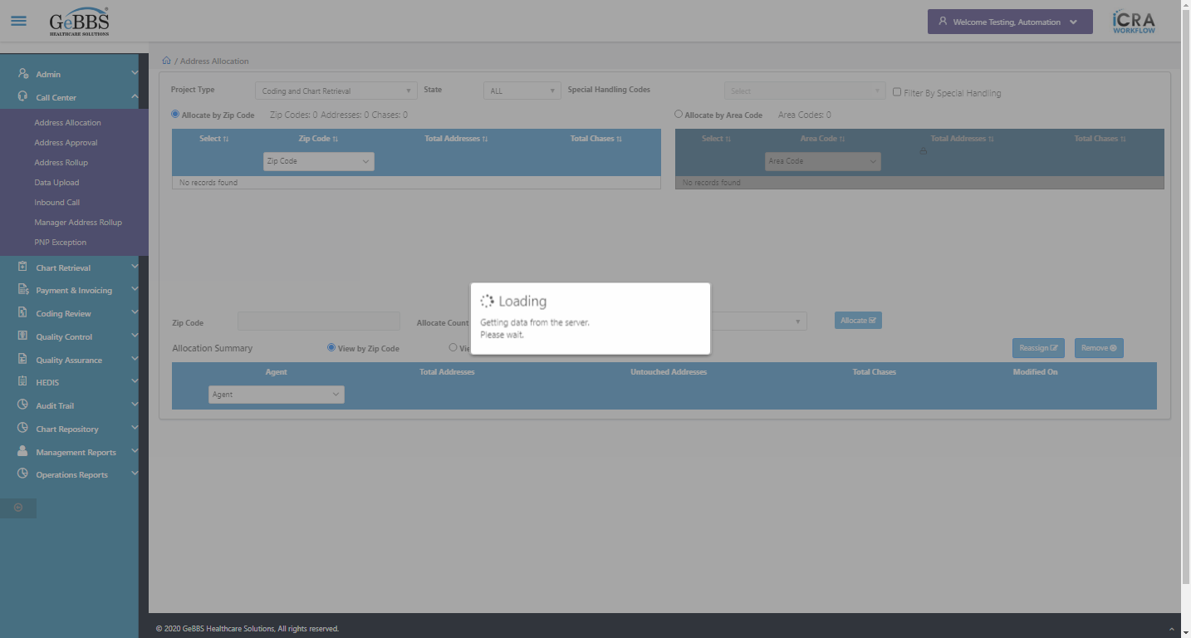  
Agent Found  
Total count of Addresses In Summary Table :4  
Total count of Chases In Summary Table :162  
Zip Code,Address Count,Chase Count In Heading Is Taken Before Allocation  
Allocate is clicked  
Text Is Correct  
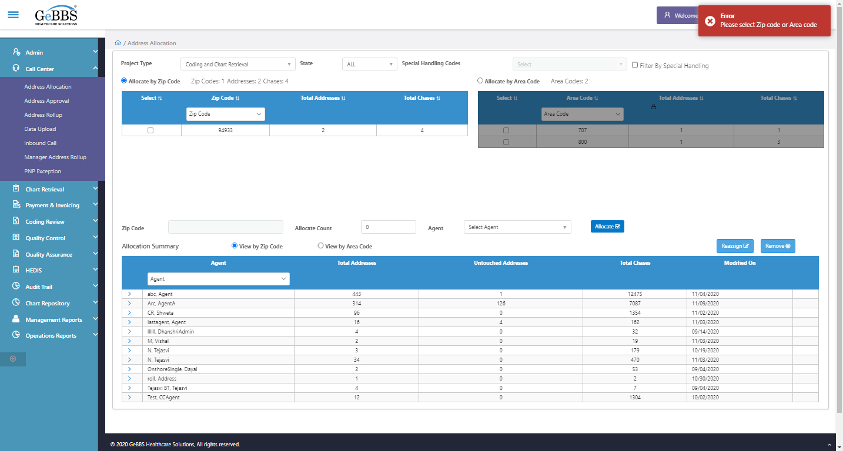  
Zip Code,Address Count,Chase Count In Zip Code Table Is Taken Before Allocation  
Zip code is clicked  
Agent is clicked  
AgentName is clicked  
Allocate is clicked  
Text Is Correct  
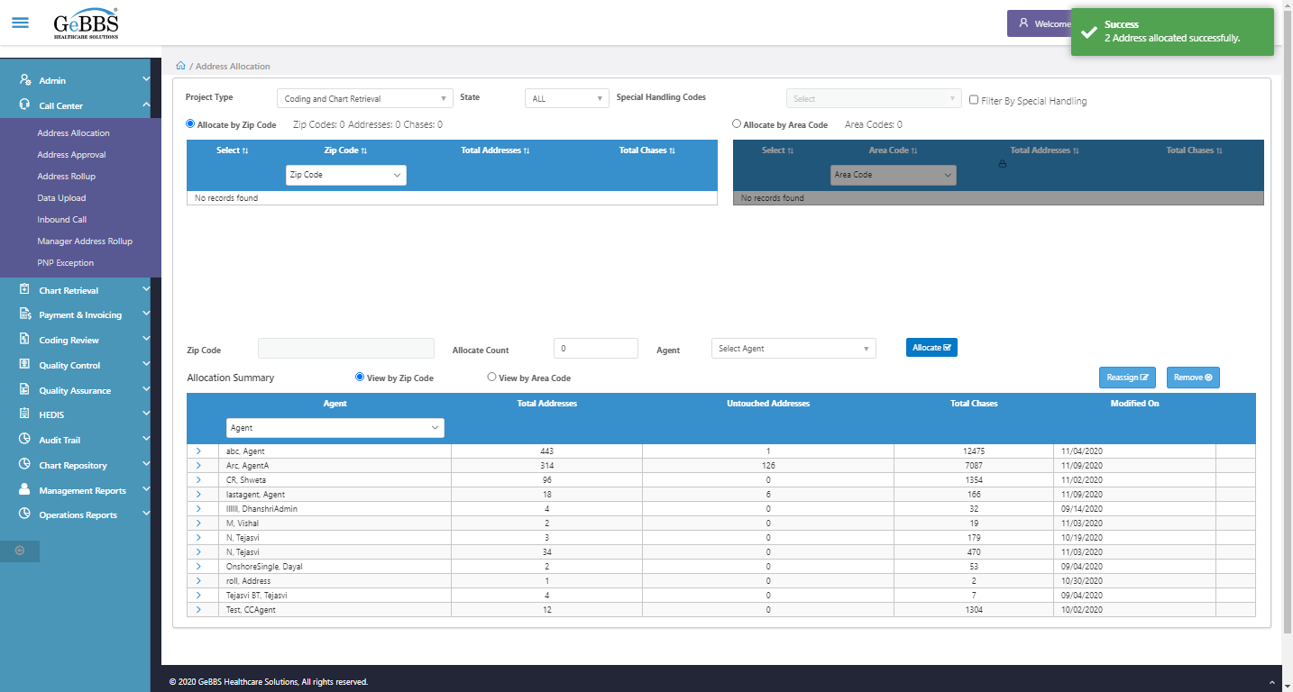  
======== ZipCode is allocated =============  
Zip Code,Address Count,Chase Count In Heading Is Taken After Allocation  
Count of zip in header is correct  
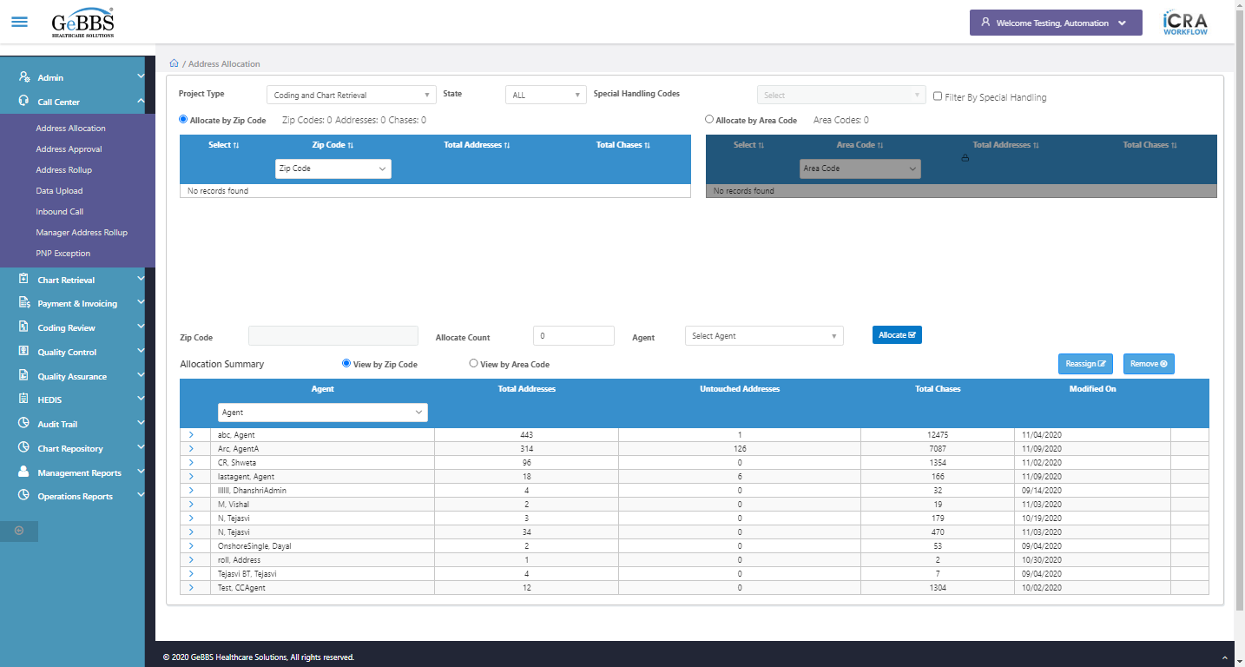  
Count of Address in header is correct  
  
Count of Chases in header is correct  
  
Zip id assigned and checked Header Count  
Zipcode Textbox is clicked  
Zip Id is entered  
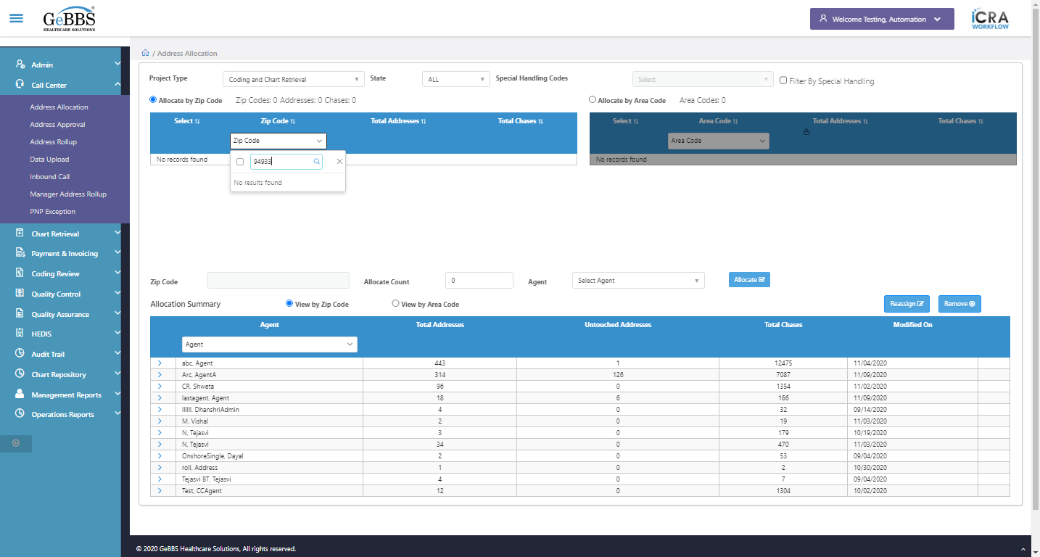  
Address Count is Zero i.e correct  
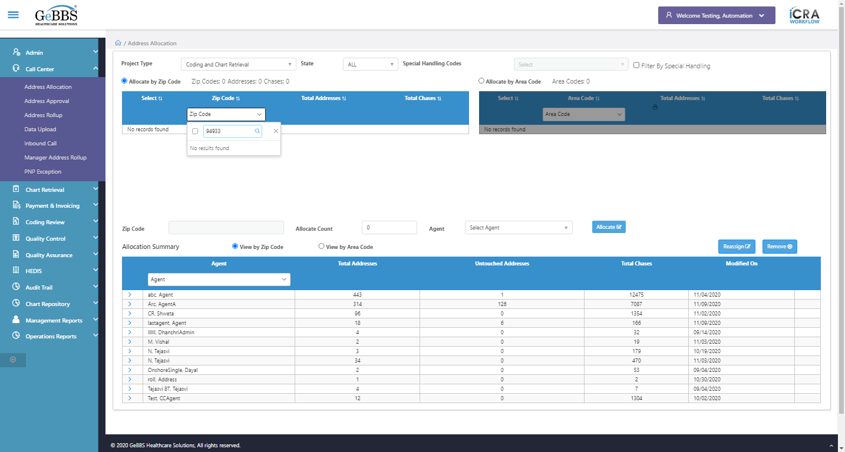  
Checked Zip Id in zip code table  
Total Untouch address count is correct in summary  
  
Chase Count In Summary Table is added  
  
Checked total Untouch and Chase Count in Allocation Summary table  
Scrolled successfully  
> sign is clicked  
Clicked on > sign of that agent  
Code is entered  
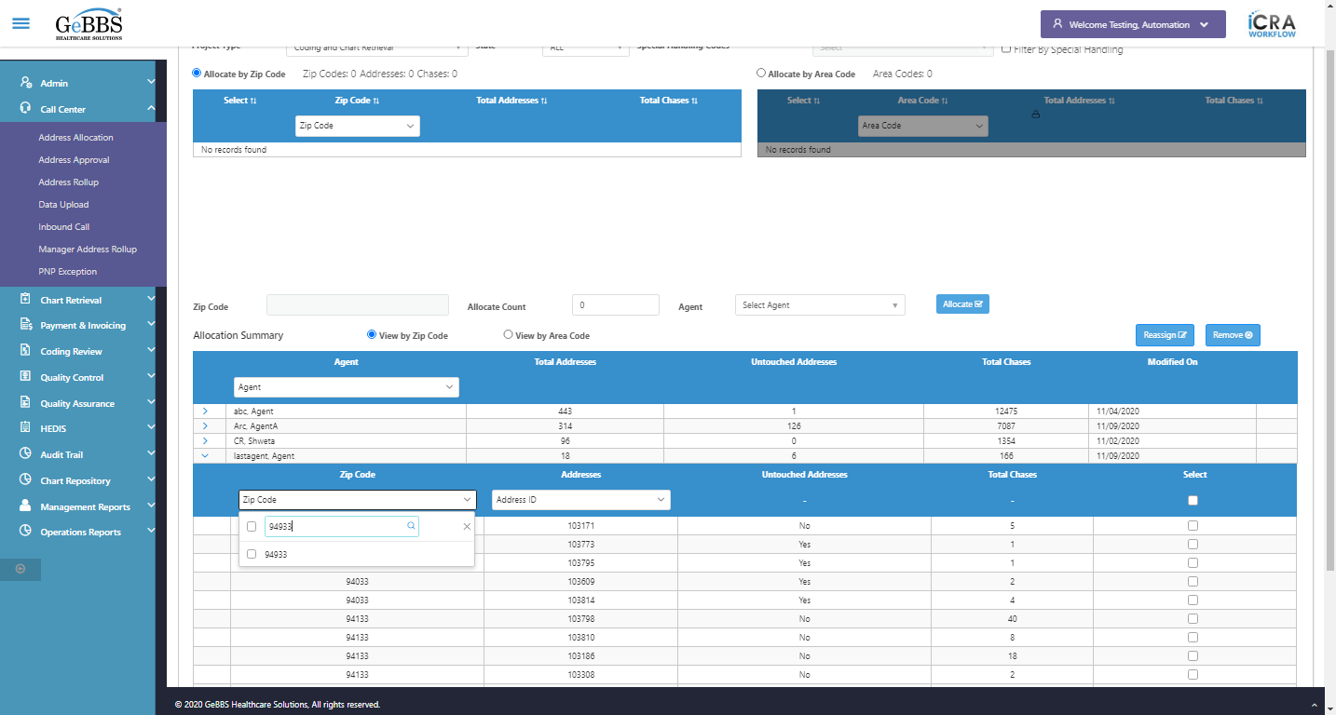  
checkbox is clicked  
Close is clicked  
Id is present in Summary table  
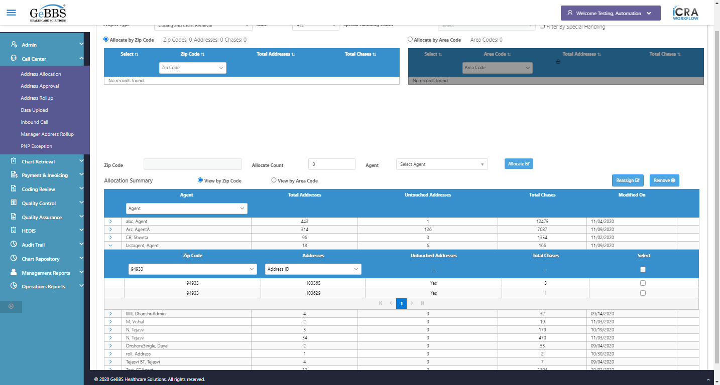  
Username is entered  
  
Password is entered  
  
Scrolled successfully  
Submit button is clicked  
Client dropdown button is clicked  
Client dropdown button is clicked  
Submit button is clicked  
Mainmenu is clicked  
Submenu is clicked  
Address Allocation is selected  
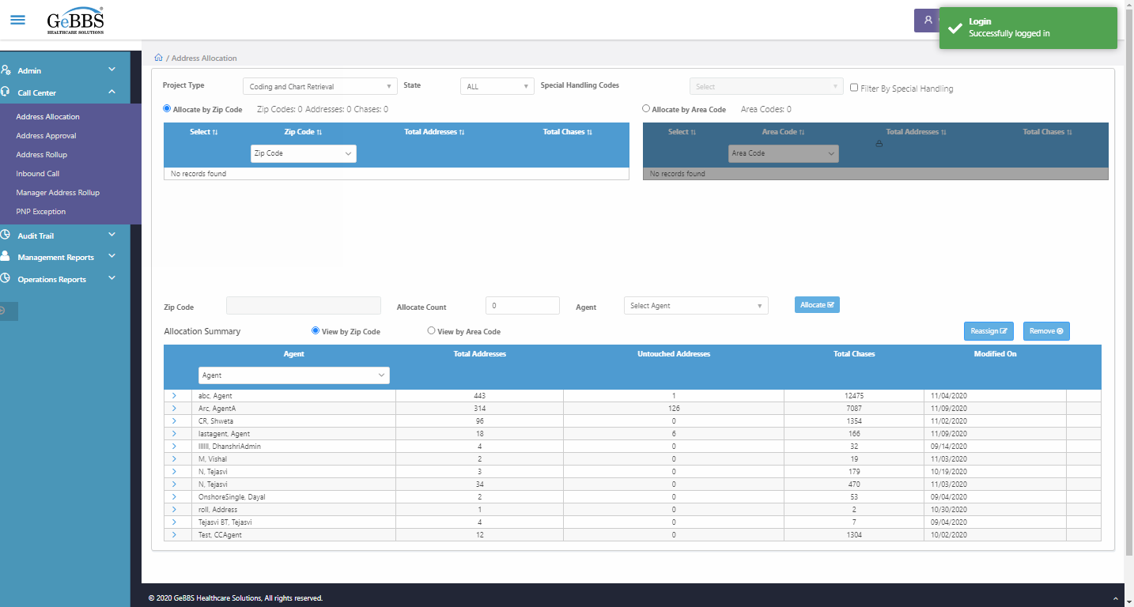  
ClickAdrRollup() failed **09/11/2020 12:53:57**