**SubmitTest_RecordQA  
03/11/2020 18:24:04**  
User Is Navigated To Site : http://172.19.9.53/ICRARevamp/#/login  
  
*****SubmitTest_RecordQA is Started *****  
Username is entered  
  
Password is entered  
  
Submit button is clicked  
Text of the element : Successfully logged in  
Successfully logged in  
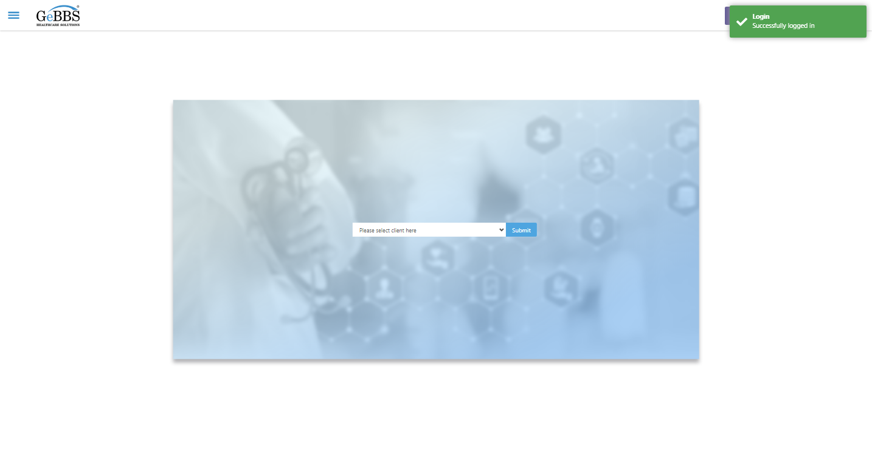  
SelectClient is clicked  
Cannot locate option with index: -1
For documentation on this error, please visit: https://www.seleniumhq.org/exceptions/no_such_element.html
Build info: version: '3.141.59', revision: 'e82be7d358', time: '2018-11-14T08:17:03'
System info: host: 'GEBBSET17063', ip: '172.30.54.166', os.name: 'Windows 10', os.arch: 'amd64', os.version: '10.0', java.version: '13.0.1'
Driver info: driver.version: unknown  
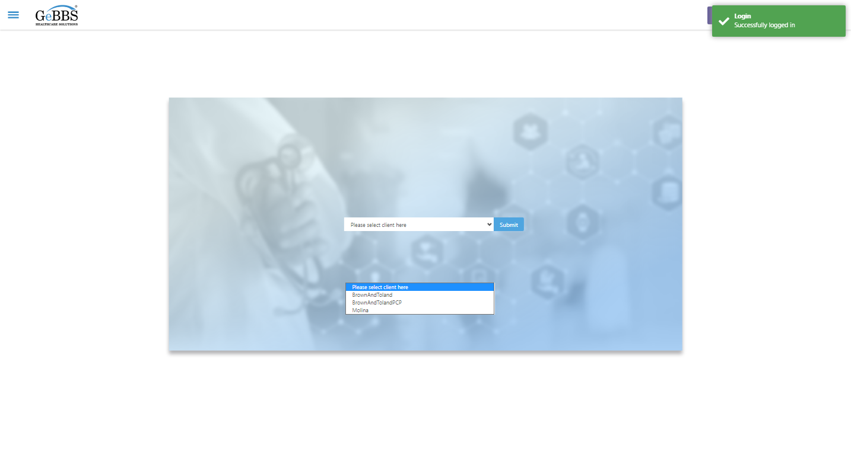  
Submit selected client is clicked  
Expected condition failed: waiting for visibility of Proxy element for: DefaultElementLocator 'By.xpath: //div[contains(@class,'sidebar-left')]' (tried for 5 second(s) with 500 milliseconds interval)  
