**SubmitTest_RecordQA  
03/11/2020 18:25:53**  
User Is Navigated To Site : http://172.19.9.53/ICRARevamp/#/login  
  
*****SubmitTest_RecordQA is Started *****  
Username is entered  
  
Password is entered  
  
Submit button is clicked  
Text of the element : Successfully logged in  
Successfully logged in  
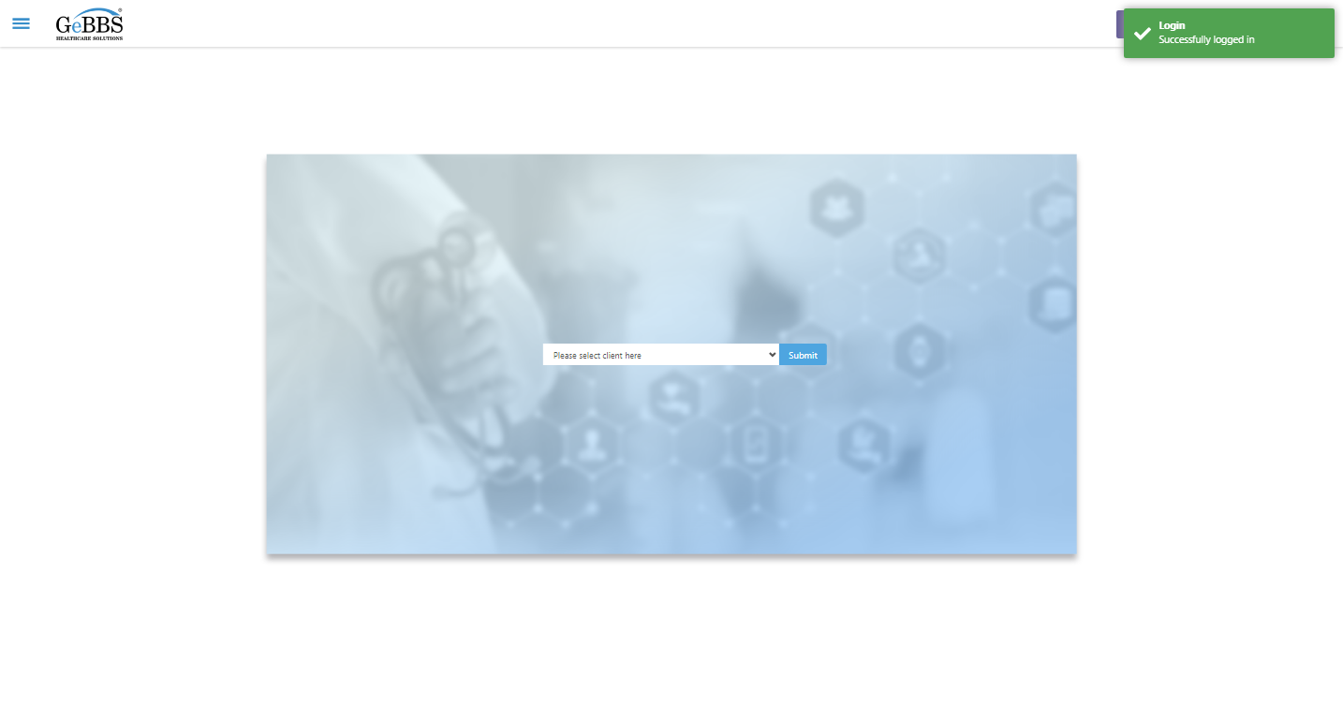  
Client dropdown button is clicked  
Client dropdown button is clicked  
Submit button is clicked  
Main Page loaded  
  
Scrolled successfully  
Chart Retrieval is clicked  
All submenus  
  
Submenu in 1 is :Field Tech  
Submenu in 2 is :FieldTech Area Assignment  
Submenu in 3 is :Intake  
Submenu in 4 is :RecordQA  
Submenu in 5 is :RecordQA Approval  
Scrolled successfully  
RecordQA is clicked  
RecordQA selected  
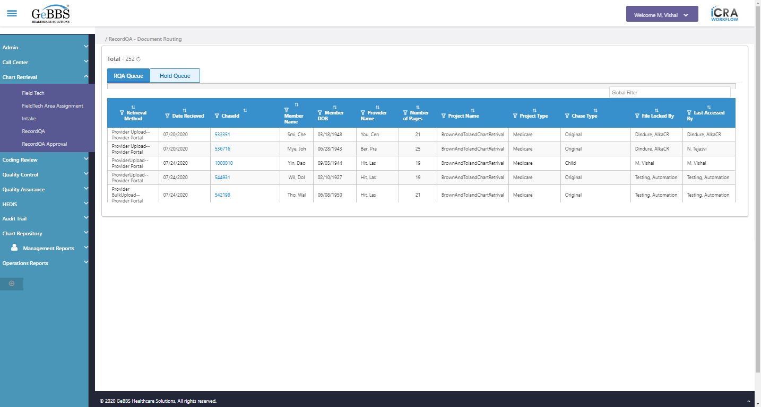  
Scrolled successfully  
Scrolled successfully  
Scrolled successfully  
Scrolled successfully  
Scrolled successfully  
Scrolled successfully  
Scrolled successfully  
Scrolled successfully  
Scrolled successfully  
Scrolled successfully  
Scrolled successfully  
Text of the element : 1000030  
GolbalFilter is entered  
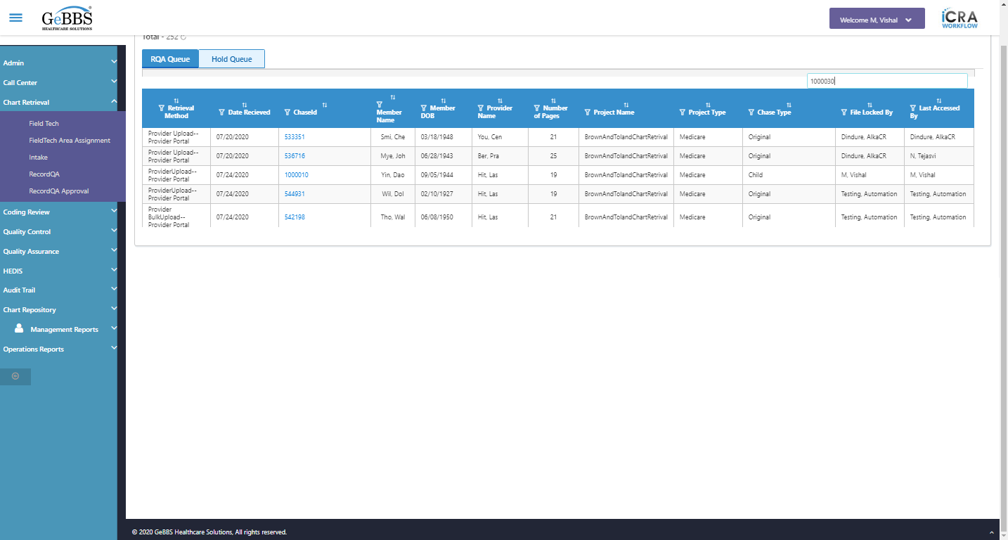  
Text of the element : BrownAndTolandChartRetrival  
Text of the element : Medicare  
Text of the element : Lac, Bea  
Text of the element : 04/14/1946  
Text of the element : Bah, Nat  
Text of the element : 1  
Text of the element : Child  
Chase in grid:1000030  
PojectName in grid:BrownAndTolandChartRetrival  
Project type in grid:Medicare  
Memmber name in grid:Lac, Bea  
Memmber Dob in grid:04/14/1946  
Provider name in grid:Bah, Nat  
Chase type in grid:Child  
Total pages in grid:1  
chaseid is clicked  
Text of the element : BrownAndTolandChartRetrival  
text is correct  
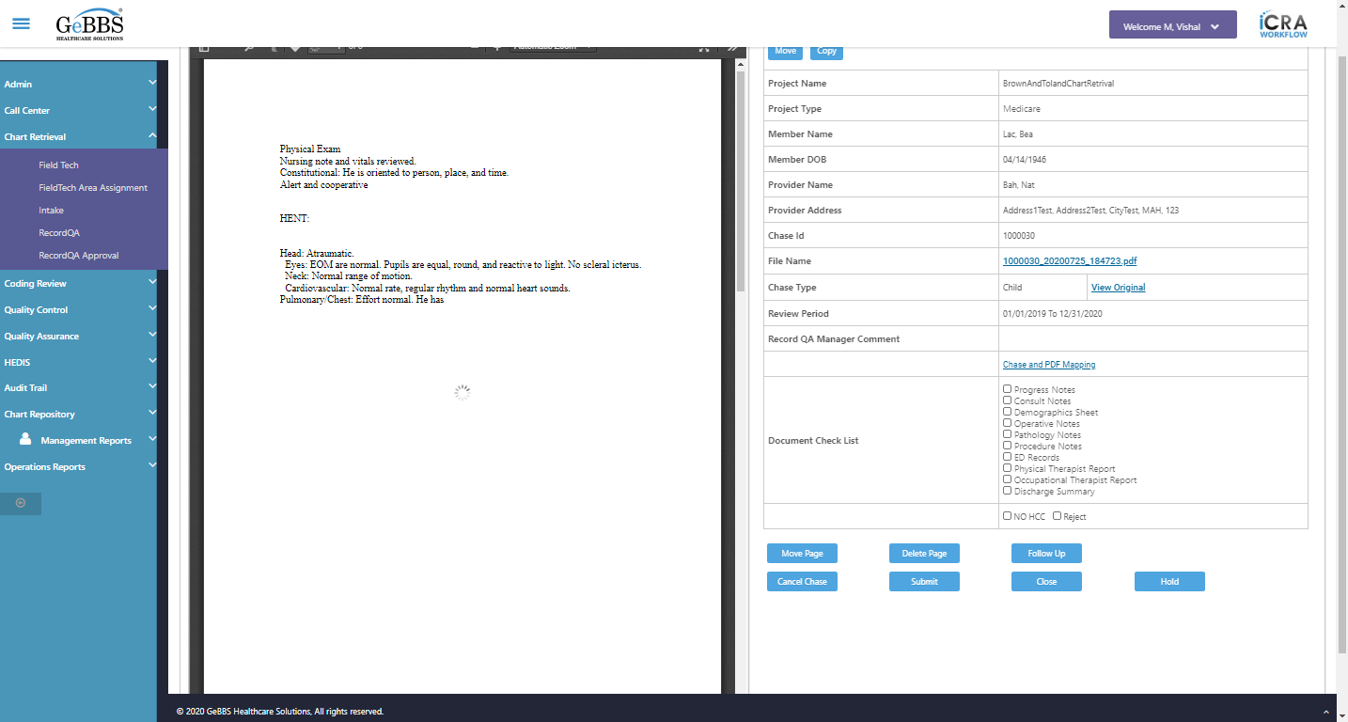  
Text of the element : Medicare  
text is correct  
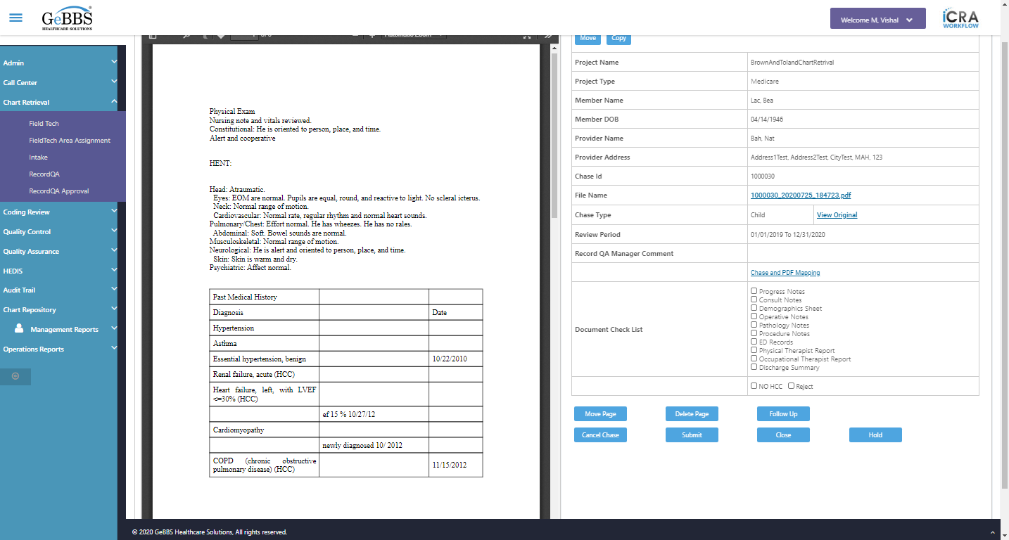  
Text of the element : Lac, Bea  
text is correct  
  
Text of the element : 04/14/1946  
text is correct  
  
Text of the element : Bah, Nat  
text is correct  
  
Address1Test, Address2Test, CityTest, MAH, 123 is displayed  
  
Text of the element : 1000030  
text is correct  
  
1000030_20200725_184723.pdf is displayed  
  
View Original Link is displayed  
  
Text of the element : Child  
text is correct  
  
01/01/2019 To 12/31/2020 is displayed  
  
Chase and PDF Mapping is displayed  
  
Checked scrren of inside chase  
Scrolled successfully  
Close_RecordQA is clicked  
Close Chase alert is displayed  
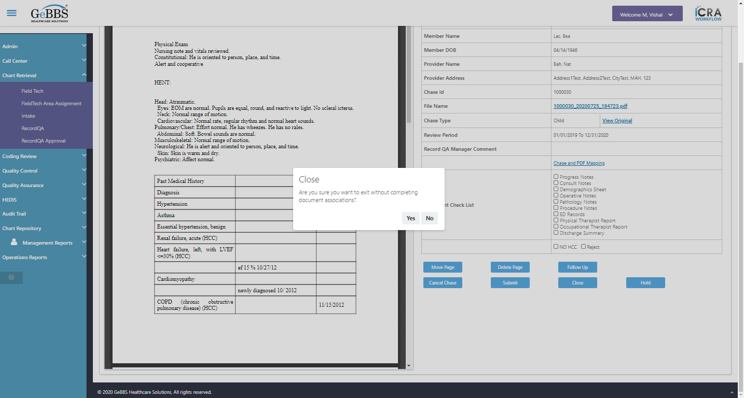  
Close chase alert text of popup is not correct  
  
Yes is clicked  
RecordQA scrren is displayed  
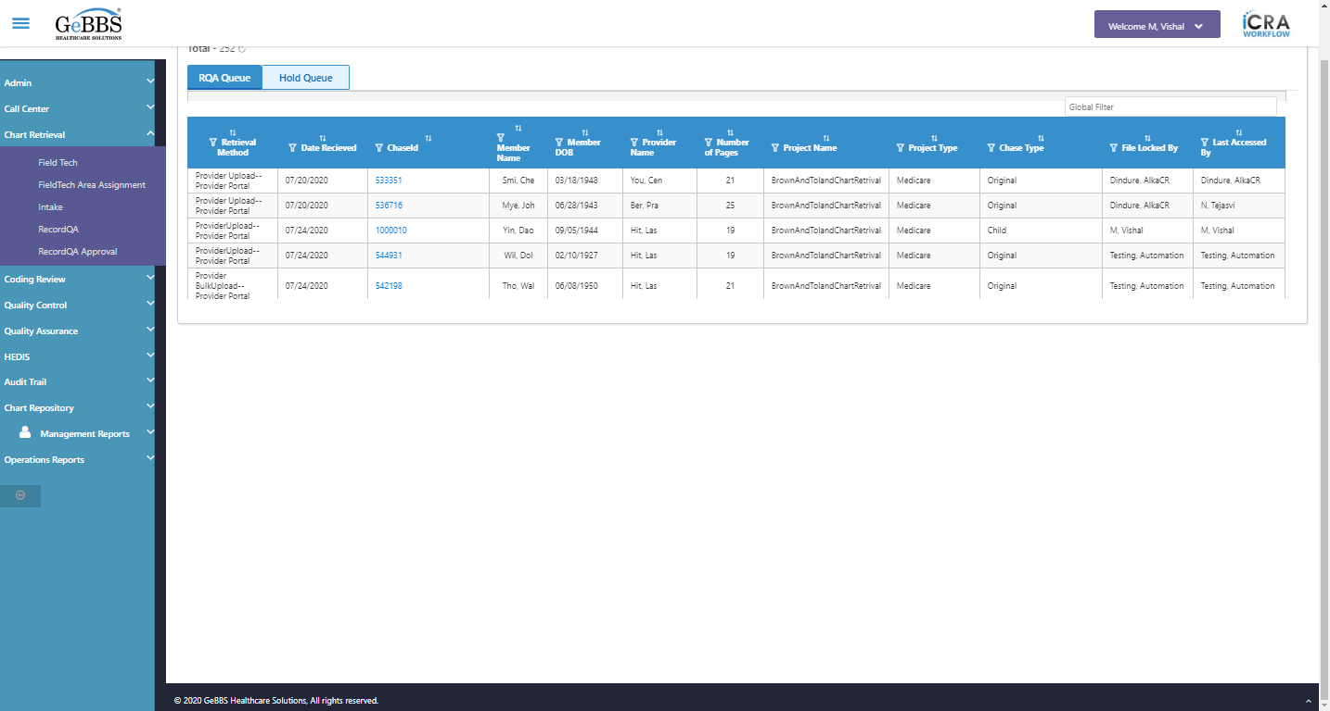  
Checked close function of chase detail screen  
GolbalFilter is entered  
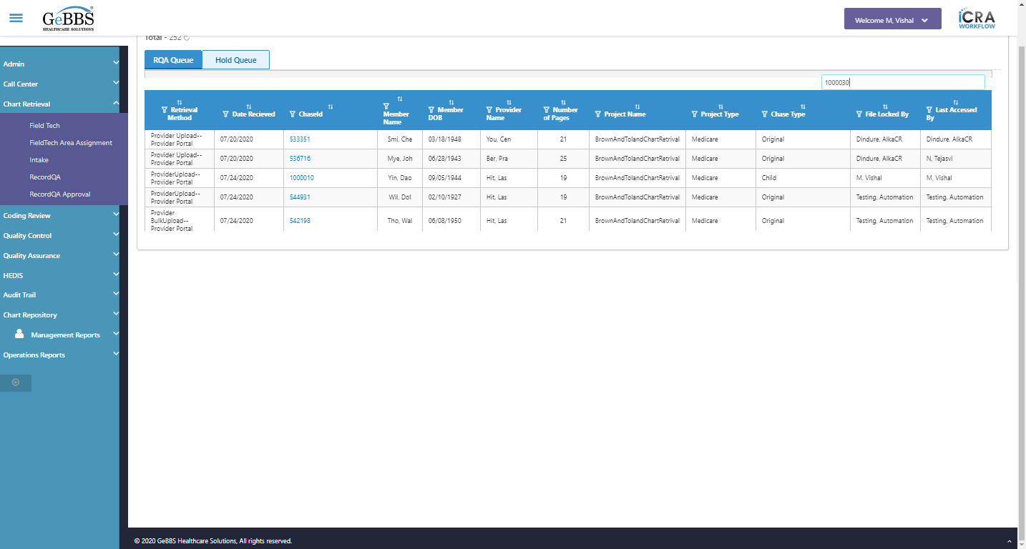  
chaseid is clicked  
Scrolled successfully  
Submit is clicked  
Submit alert is displayed  
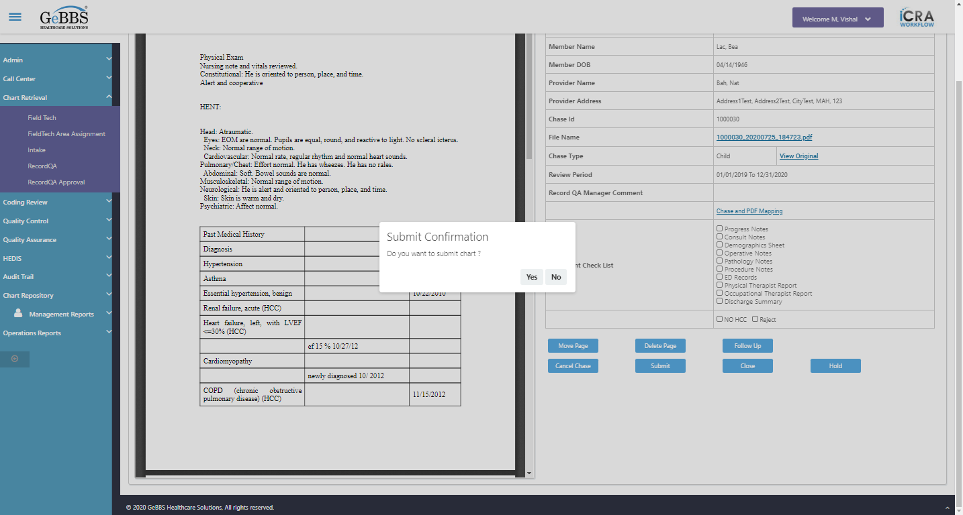  
Submit alert text of popup is correct  
  
Yes is clicked  
SubmitSuccess msg correct  
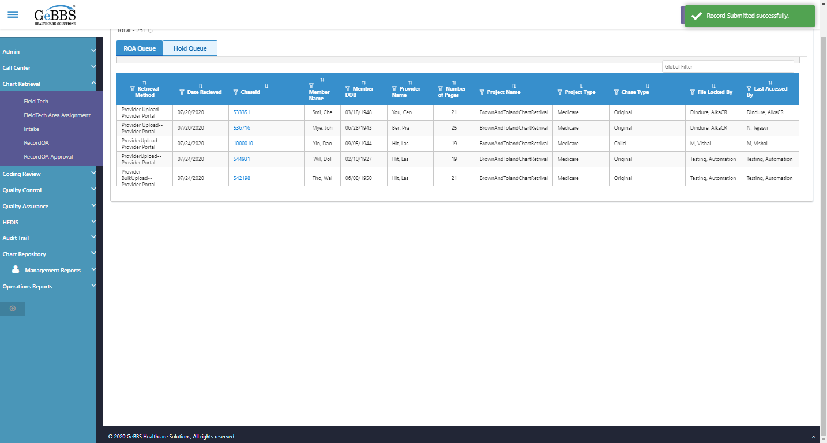  
Record Count is correct  
  
RecordQA scrren is displayed  
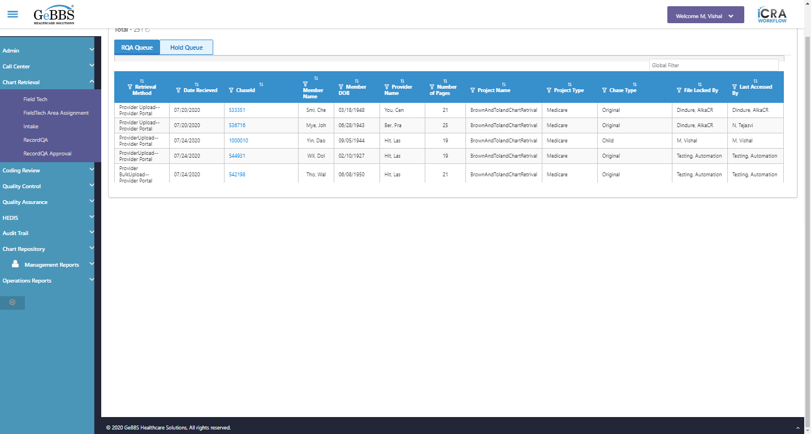  
*****SubmitTest_RecordQA is Ended ***** **03/11/2020 18:27:56**