**SubmitTest_RecordQA  
03/11/2020 18:39:25**  
User Is Navigated To Site : http://172.19.9.53/ICRARevamp/#/login  
  
*****SubmitTest_RecordQA is Started *****  
Username is entered  
  
Password is entered  
  
Submit button is clicked  
Text of the element : Successfully logged in  
Successfully logged in  
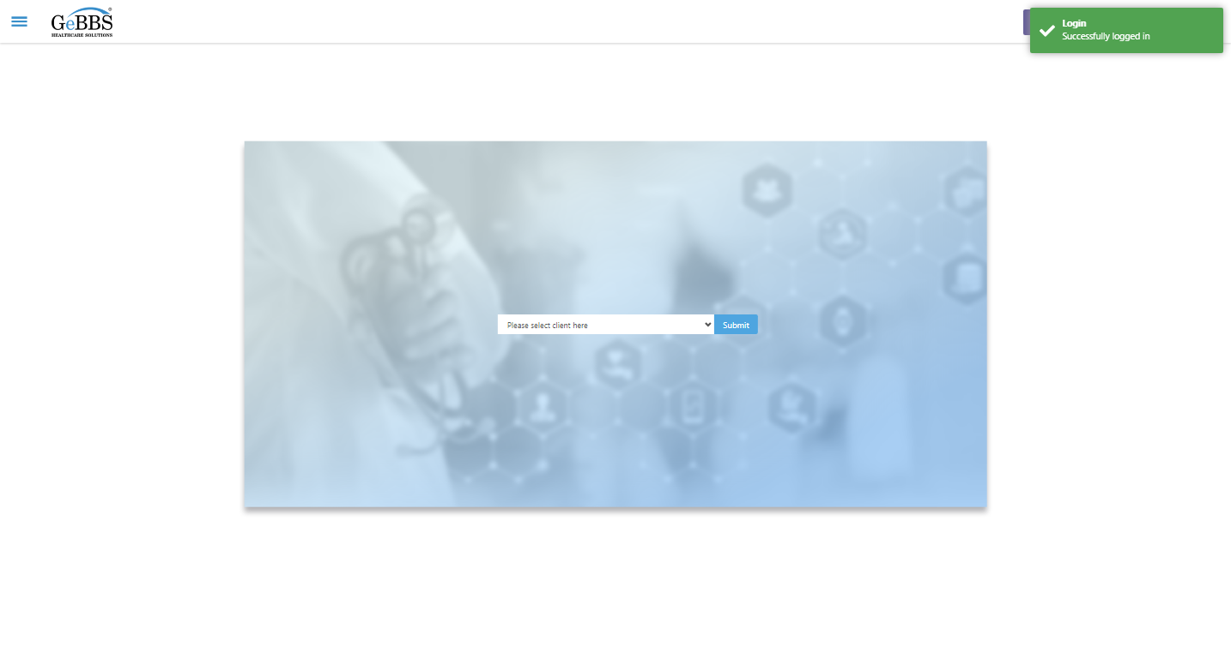  
Client dropdown button is clicked  
Client dropdown button is clicked  
Submit button is clicked  
Main Page loaded  
  
Scrolled successfully  
Chart Retrieval is clicked  
All submenus  
  
Submenu in 1 is :Field Tech  
Submenu in 2 is :FieldTech Area Assignment  
Submenu in 3 is :Intake  
Submenu in 4 is :RecordQA  
Submenu in 5 is :RecordQA Approval  
Scrolled successfully  
RecordQA is clicked  
RecordQA selected  
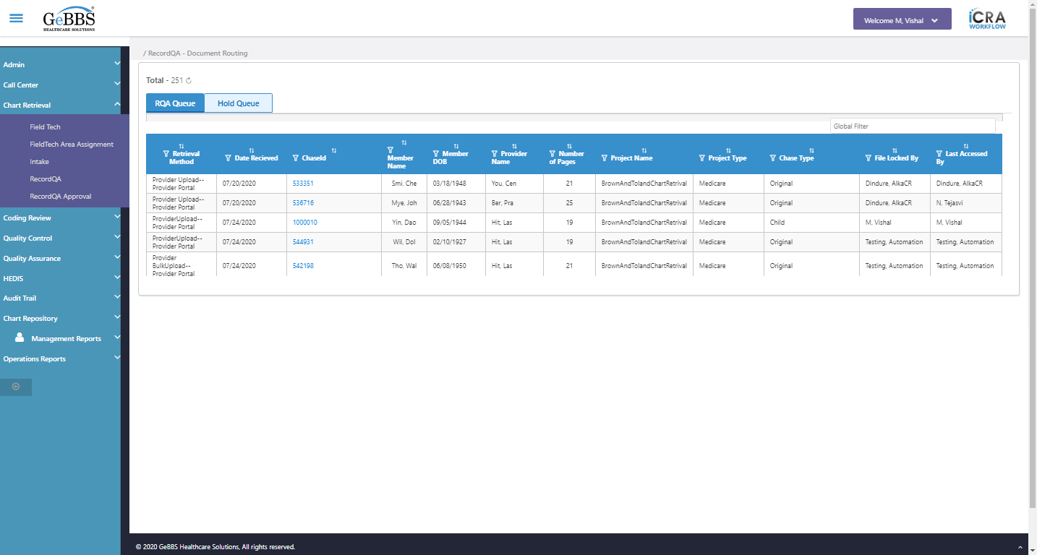  
Scrolled successfully  
Scrolled successfully  
Scrolled successfully  
Scrolled successfully  
Scrolled successfully  
Scrolled successfully  
Scrolled successfully  
Scrolled successfully  
Scrolled successfully  
Scrolled successfully  
Scrolled successfully  
Scrolled successfully  
Scrolled successfully  
Scrolled successfully  
Text of the element : 543932  
GolbalFilter is entered  
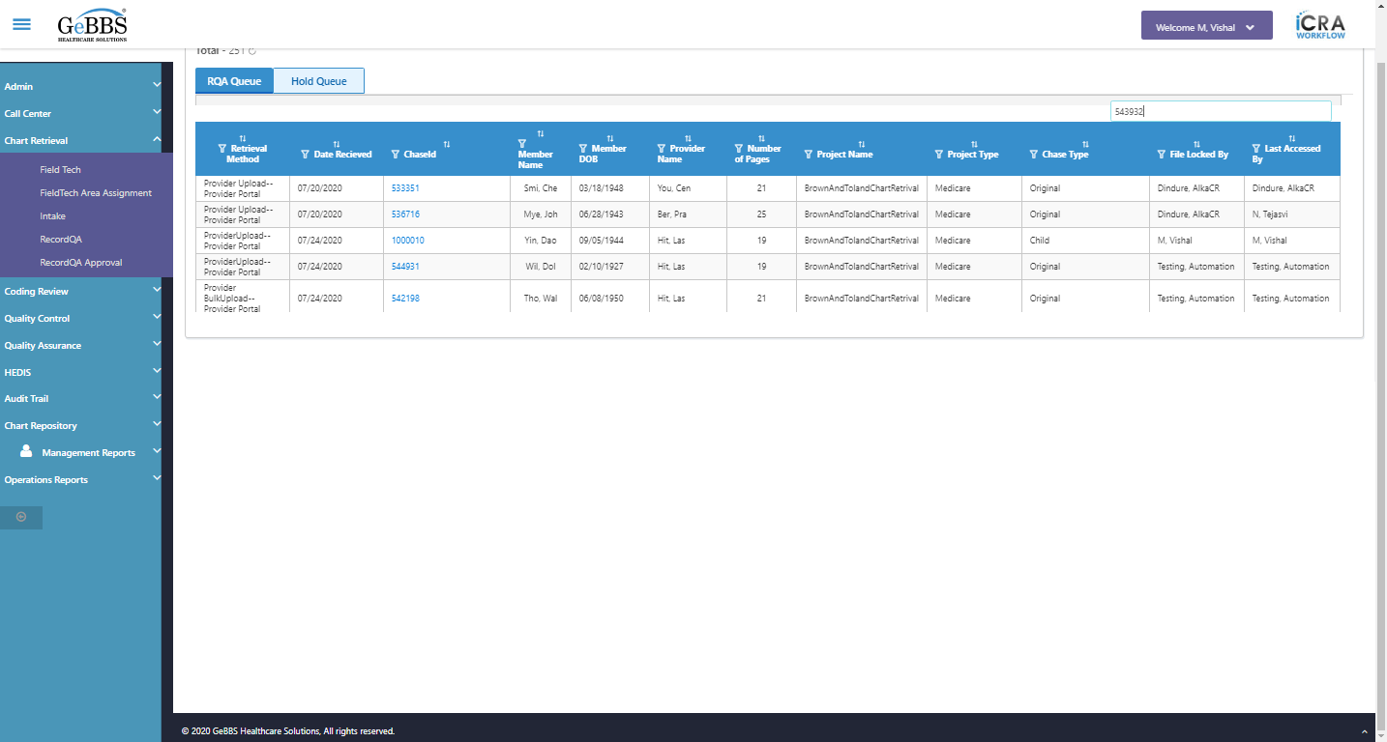  
Text of the element : BrownAndTolandChartRetrival  
Text of the element : Medicare  
Text of the element : Kli, Ric  
Text of the element : 01/20/1989  
Text of the element : Cru, Chr  
Text of the element : 24  
Text of the element : Original  
Chase in grid:543932  
PojectName in grid:BrownAndTolandChartRetrival  
Project type in grid:Medicare  
Memmber name in grid:Kli, Ric  
Memmber Dob in grid:01/20/1989  
Provider name in grid:Cru, Chr  
Chase type in grid:Original  
Total pages in grid:24  
chaseid is clicked  
Text of the element : BrownAndTolandChartRetrival  
text is correct  
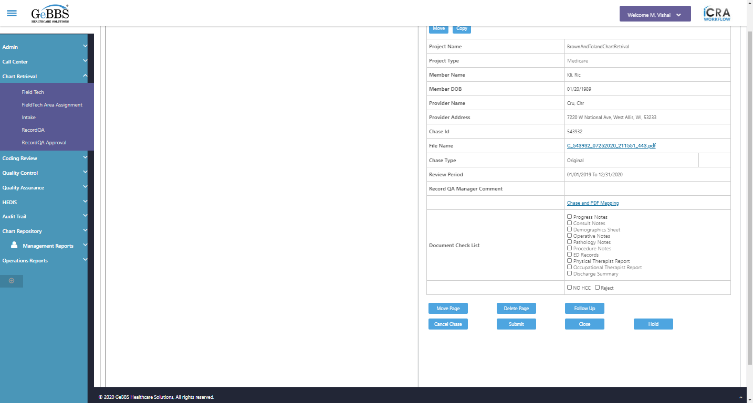  
Text of the element : Medicare  
text is correct  
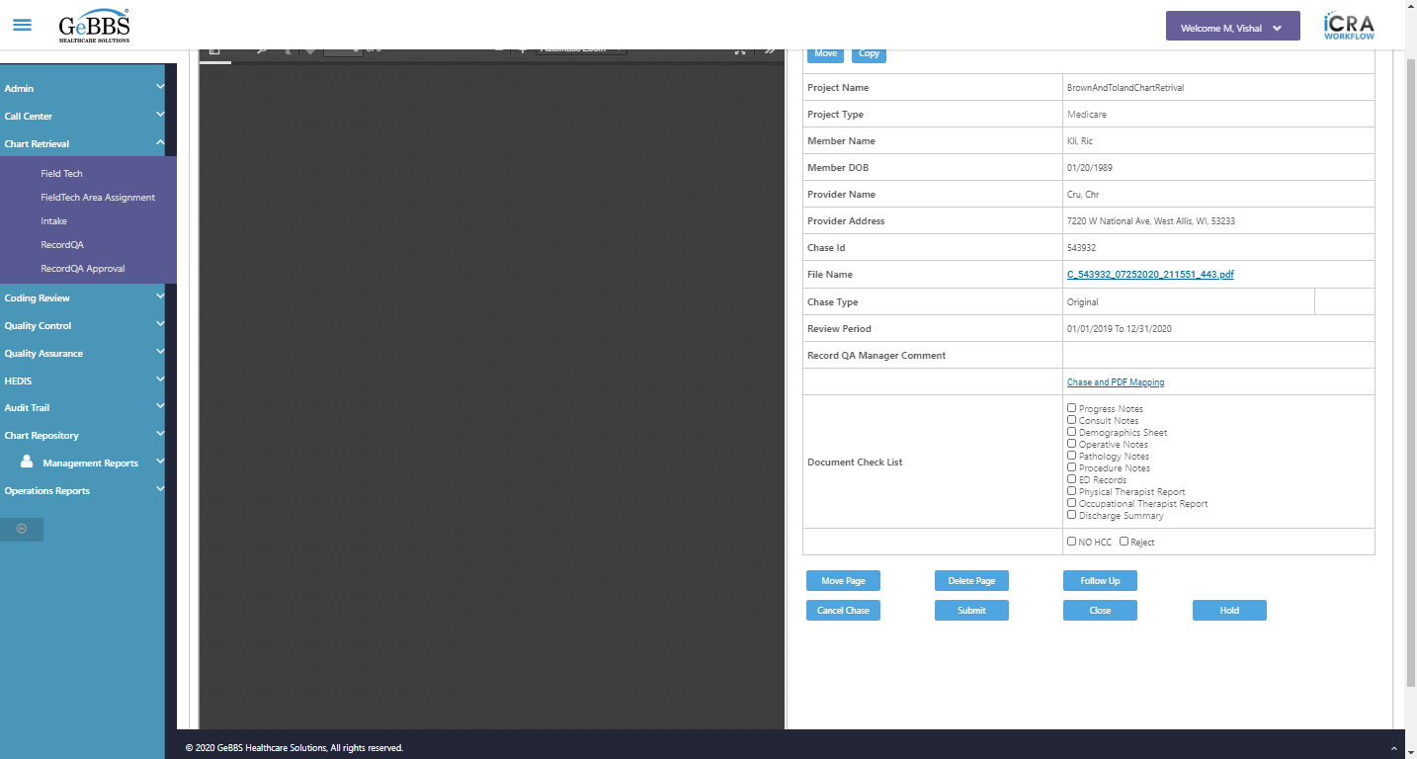  
Text of the element : Kli, Ric  
text is correct  
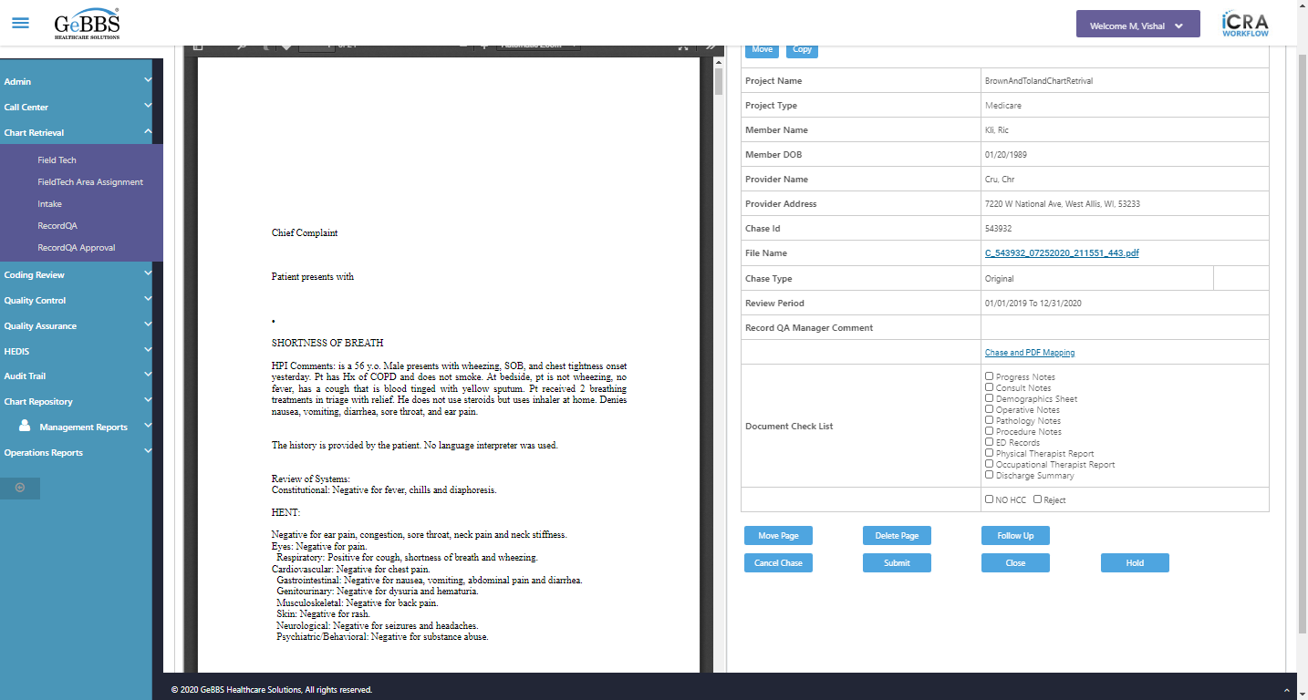  
Text of the element : 01/20/1989  
text is correct  
  
Text of the element : Cru, Chr  
text is correct  
  
7220 W National Ave, West Allis, WI, 53233 is displayed  
  
Text of the element : 543932  
text is correct  
  
C_543932_07252020_211551_443.pdf is displayed  
  
View Original Link is displayed  
  
Text of the element : Original  
text is correct  
  
01/01/2019 To 12/31/2020 is displayed  
  
Chase and PDF Mapping is displayed  
  
Checked scrren of inside chase  
Scrolled successfully  
Close_RecordQA is clicked  
Close Chase alert is displayed  
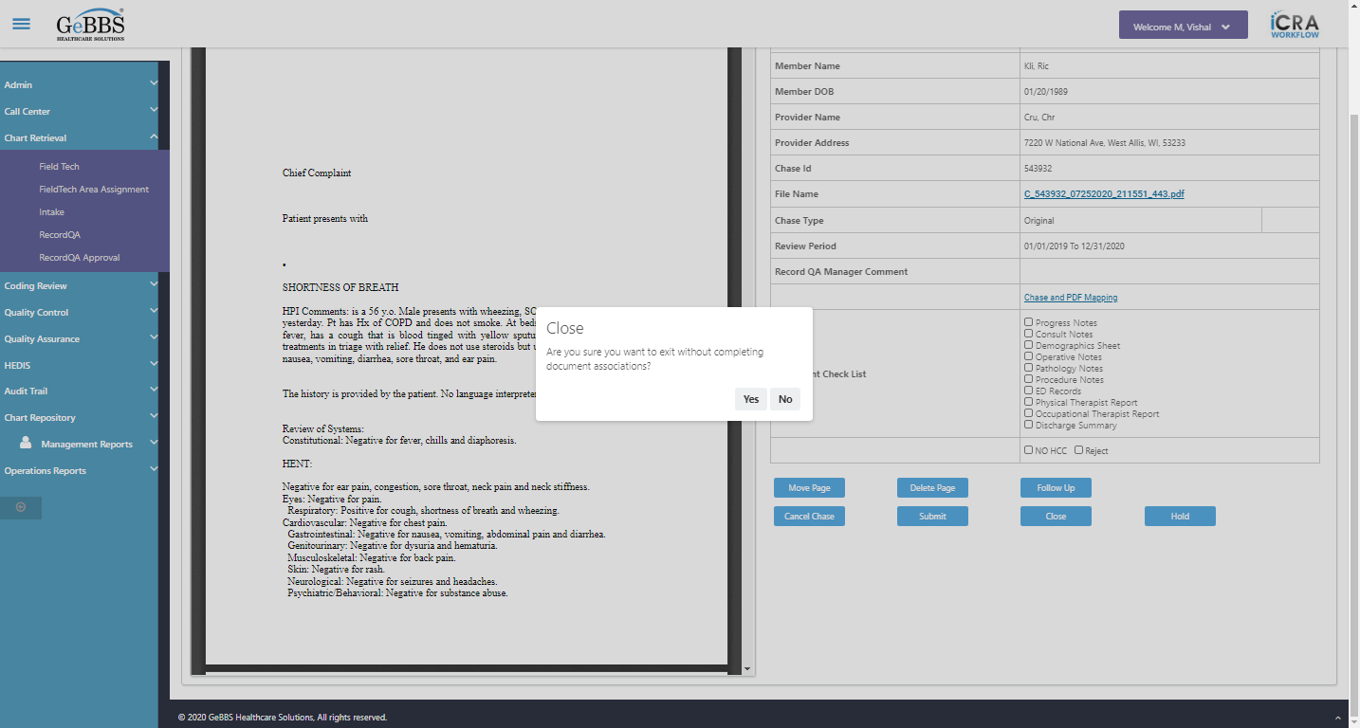  
Close chase alert text of popup is not correct  
  
Yes is clicked  
RecordQA scrren is displayed  
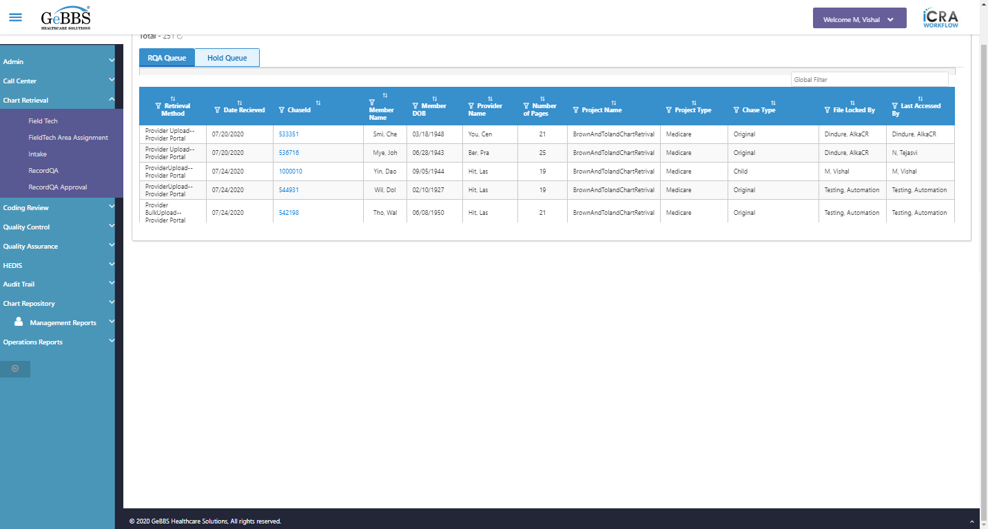  
Checked close function of chase detail screen  
GolbalFilter is entered  
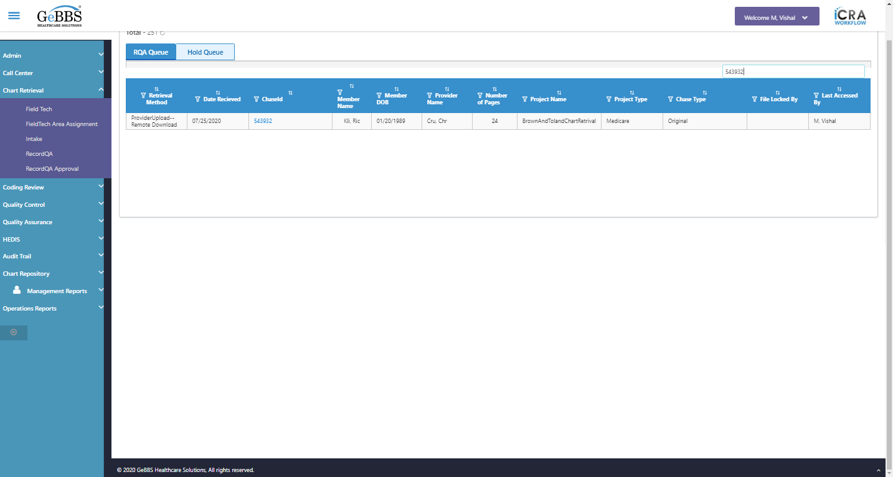  
chaseid is clicked  
*****SubmitTest_RecordQA is Ended ***** **03/11/2020 18:41:45**