**SubmitTest_RecordQA  
09/11/2020 12:53:58**  
User Is Navigated To Site : http://172.19.9.53/ICRARevamp/#/login  
  
*****SubmitTest_RecordQA is Started *****  
Username is entered  
  
Password is entered  
  
Submit button is clicked  
Text of the element : Successfully logged in  
Successfully logged in  
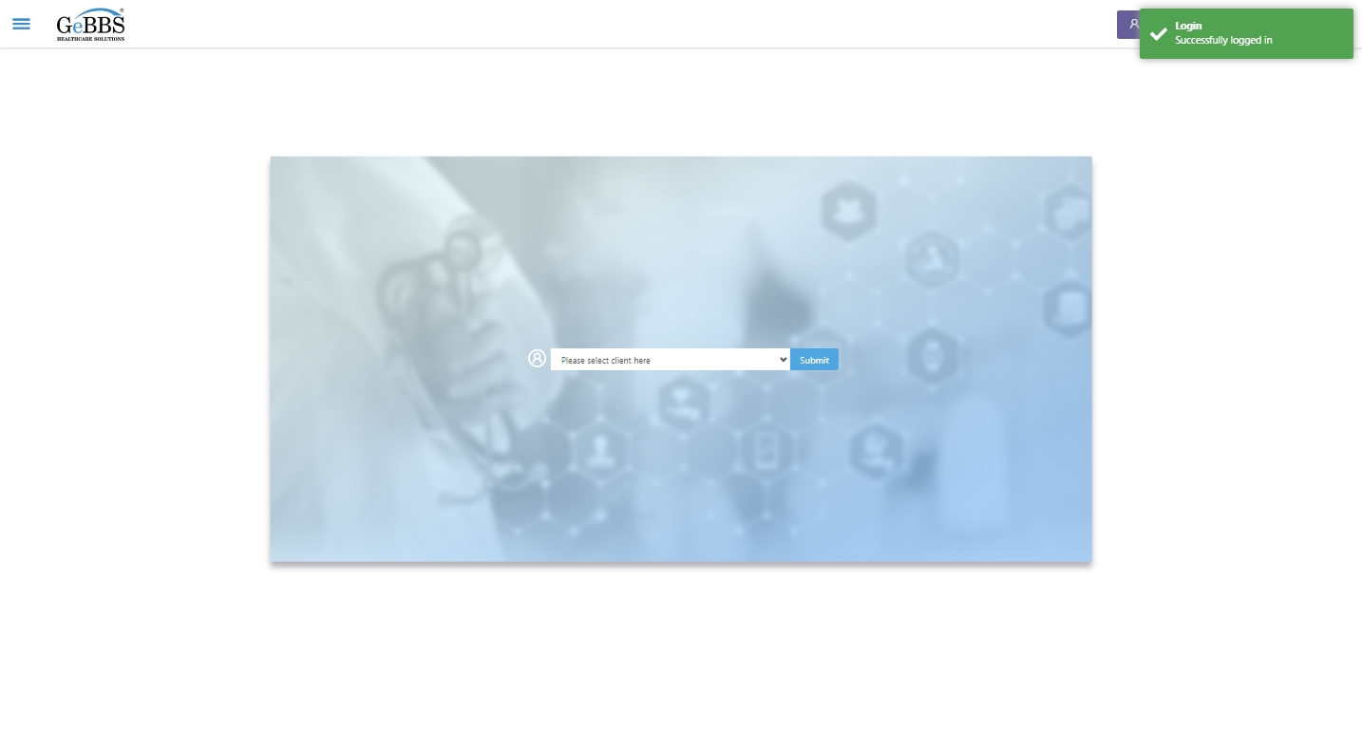  
Client dropdown button is clicked  
Client dropdown button is clicked  
Submit button is clicked  
Main Page loaded  
  
Scrolled successfully  
Chart Retrieval is clicked  
All submenus  
  
Submenu in 1 is :Field Tech  
Submenu in 2 is :FieldTech Area Assignment  
Submenu in 3 is :Intake  
Submenu in 4 is :RecordQA  
Submenu in 5 is :RecordQA Approval  
Scrolled successfully  
RecordQA is clicked  
RecordQA selected  
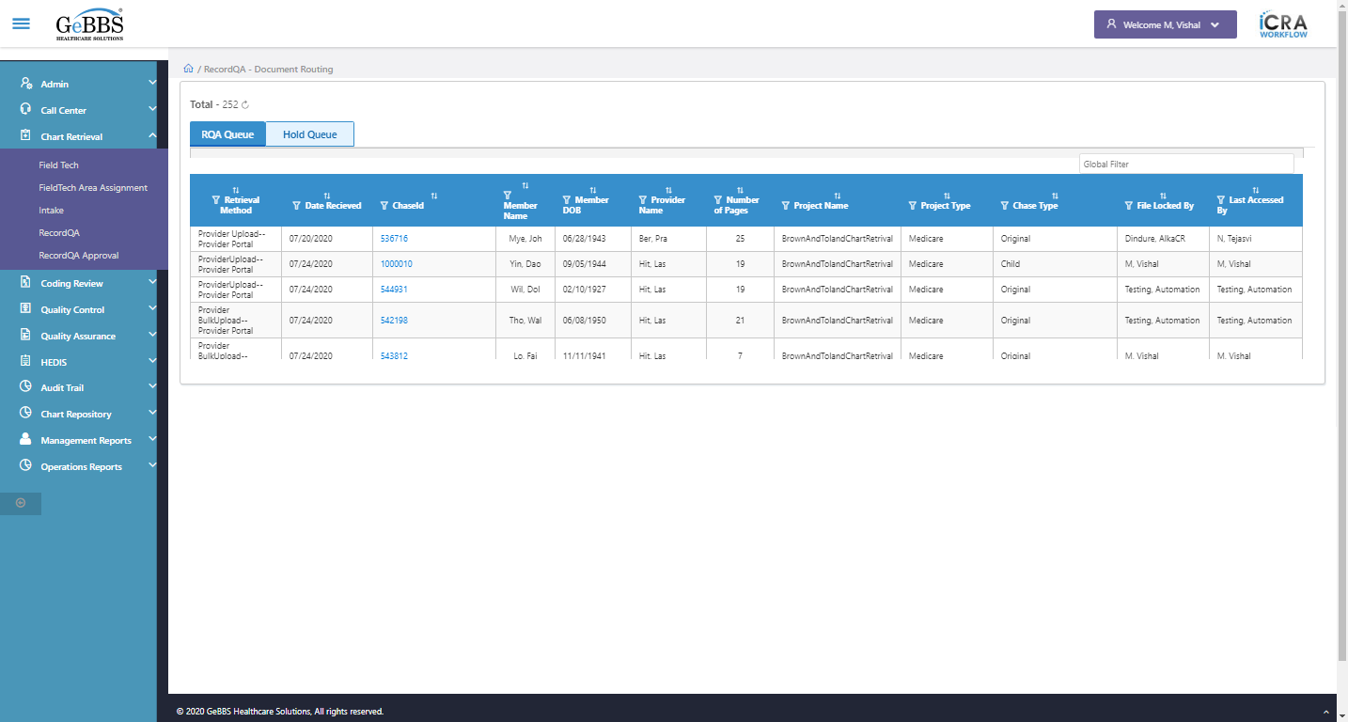  
Scrolled successfully  
Scrolled successfully  
Scrolled successfully  
Scrolled successfully  
Scrolled successfully  
Scrolled successfully  
Scrolled successfully  
Scrolled successfully  
Scrolled successfully  
Scrolled successfully  
Scrolled successfully  
Scrolled successfully  
Scrolled successfully  
Scrolled successfully  
Text of the element : 1000036  
GolbalFilter is entered  
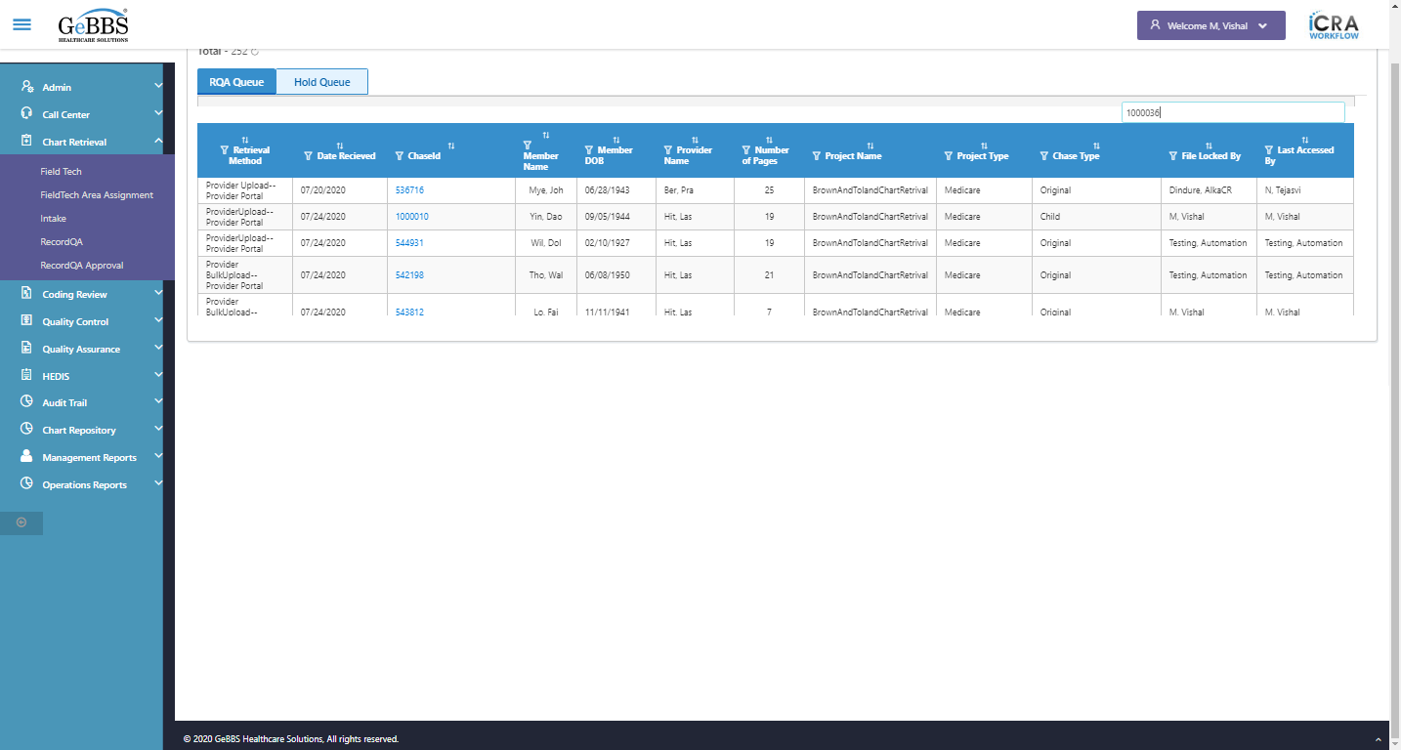  
Text of the element : BrownAndTolandCoding  
Text of the element : Medicare  
Text of the element : Tho, Alf  
Text of the element : 02/02/1960  
Text of the element : Liu, Jes  
Text of the element : 2  
Text of the element : Child  
Chase in grid:1000036  
PojectName in grid:BrownAndTolandCoding  
Project type in grid:Medicare  
Memmber name in grid:Tho, Alf  
Memmber Dob in grid:02/02/1960  
Provider name in grid:Liu, Jes  
Chase type in grid:Child  
Total pages in grid:2  
chaseid is clicked  
Text of the element : BrownAndTolandCoding  
text is correct  
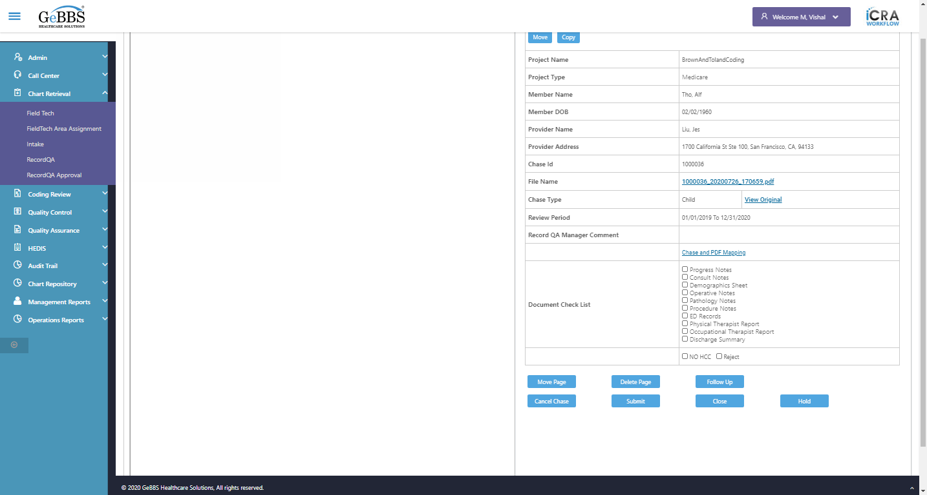  
Text of the element : Medicare  
text is correct  
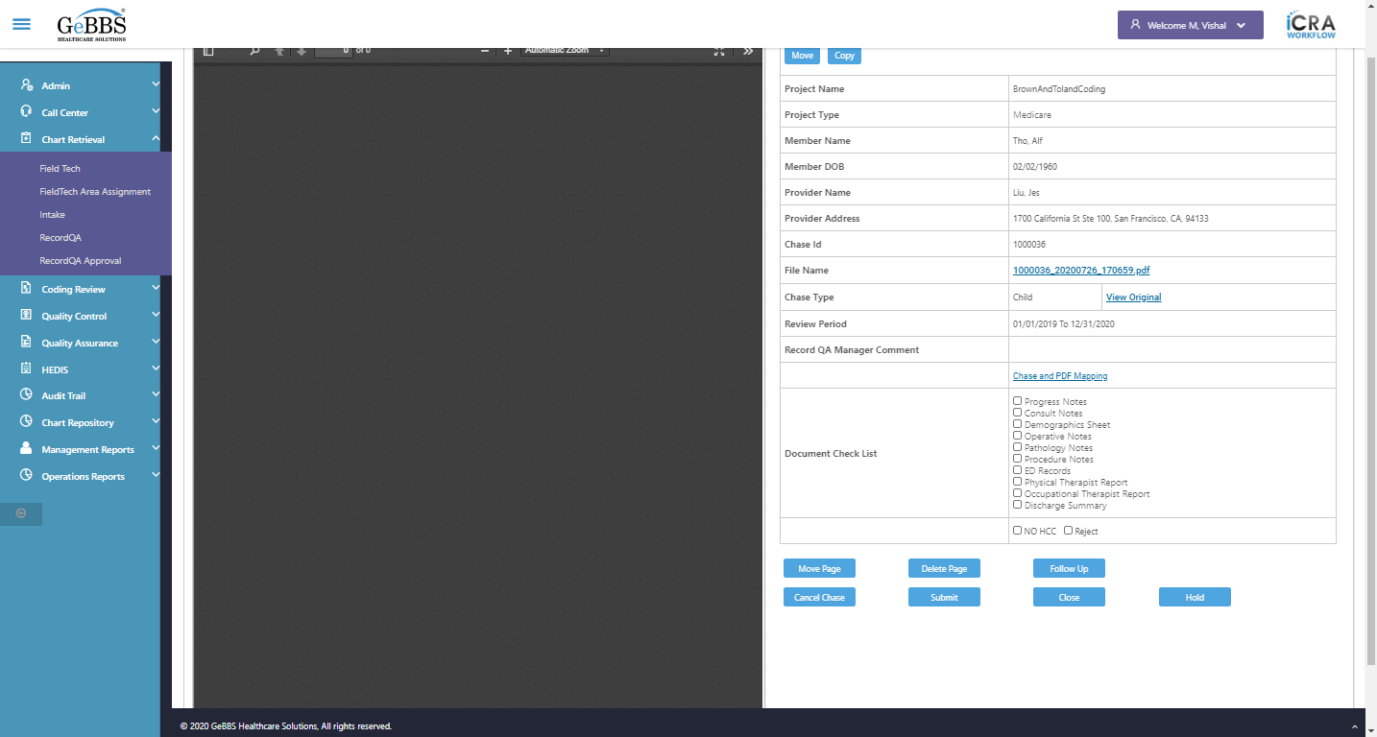  
Text of the element : Tho, Alf  
text is correct  
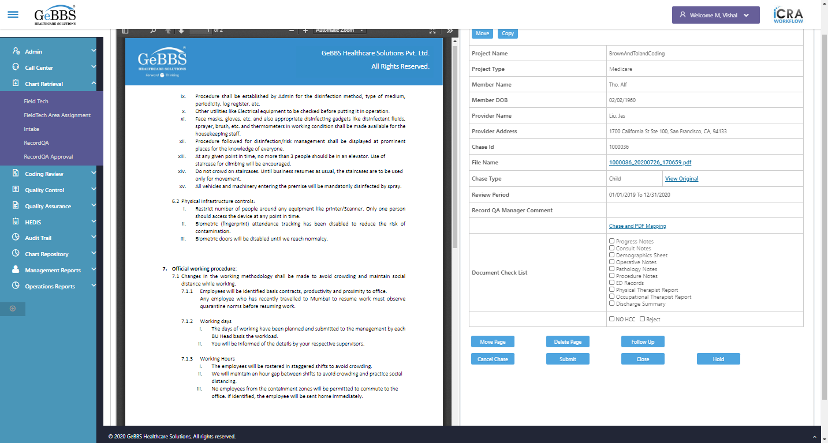  
Text of the element : 02/02/1960  
text is correct  
  
Text of the element : Liu, Jes  
text is correct  
  
1700 California St Ste 100, San Francisco, CA, 94133 is displayed  
  
Text of the element : 1000036  
text is correct  
  
1000036_20200726_170659.pdf is displayed  
  
View Original Link is displayed  
  
Text of the element : Child  
text is correct  
  
01/01/2019 To 12/31/2020 is displayed  
  
Chase and PDF Mapping is displayed  
  
Checked scrren of inside chase  
Scrolled successfully  
Close_RecordQA is clicked  
Close Chase alert is displayed  
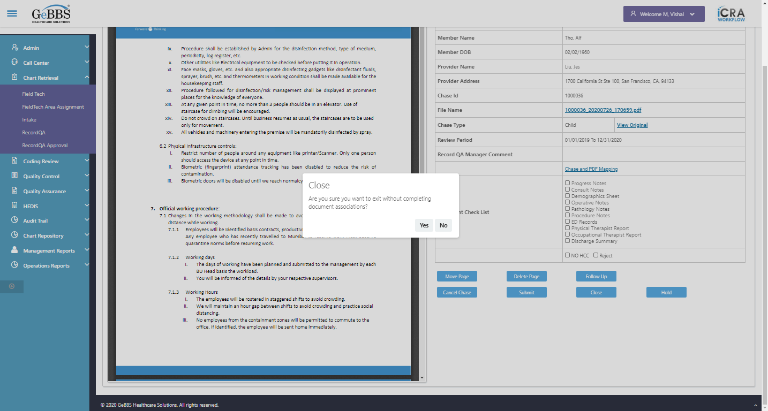  
Close chase alert text of popup is correct  
  
Yes is clicked  
RecordQA scrren is displayed  
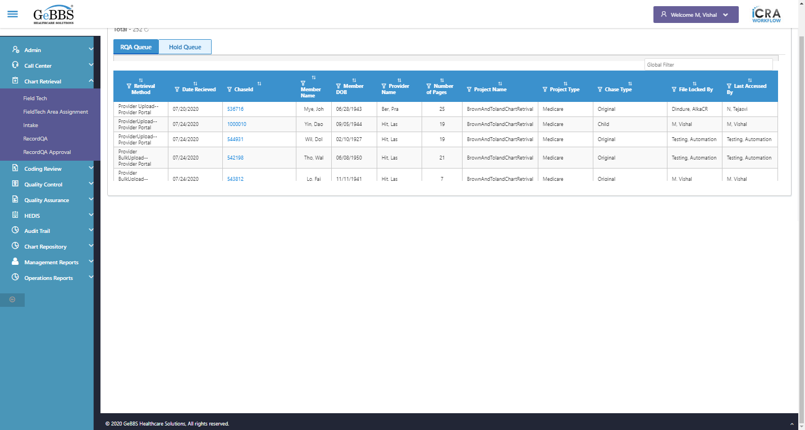  
Checked close function of chase detail screen  
GolbalFilter is entered  
  
chaseid is clicked  
Scrolled successfully  
Submit is clicked  
Submit alert is displayed  
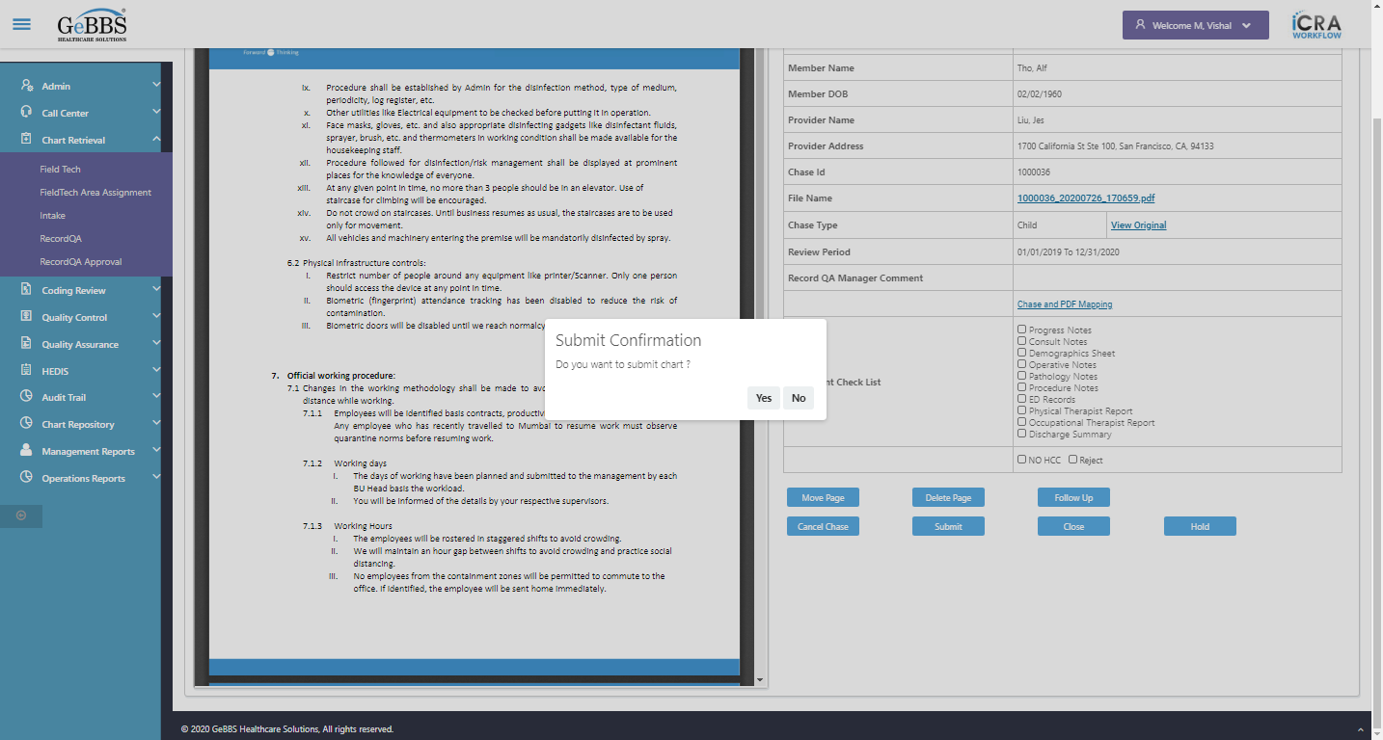  
Submit alert text of popup is correct  
  
Yes is clicked  
SubmitSuccess msg correct  
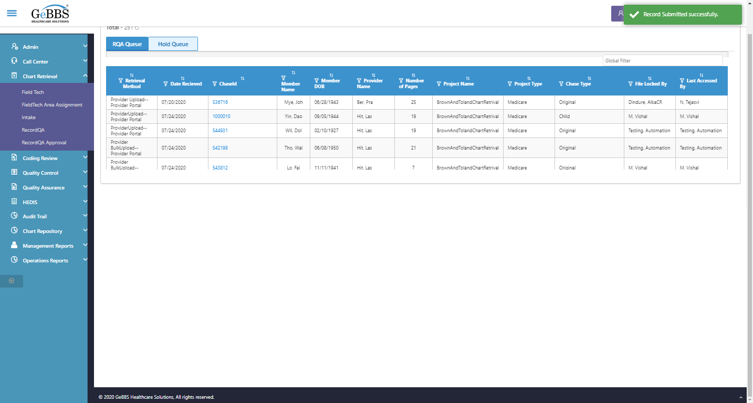  
Record Count is correct  
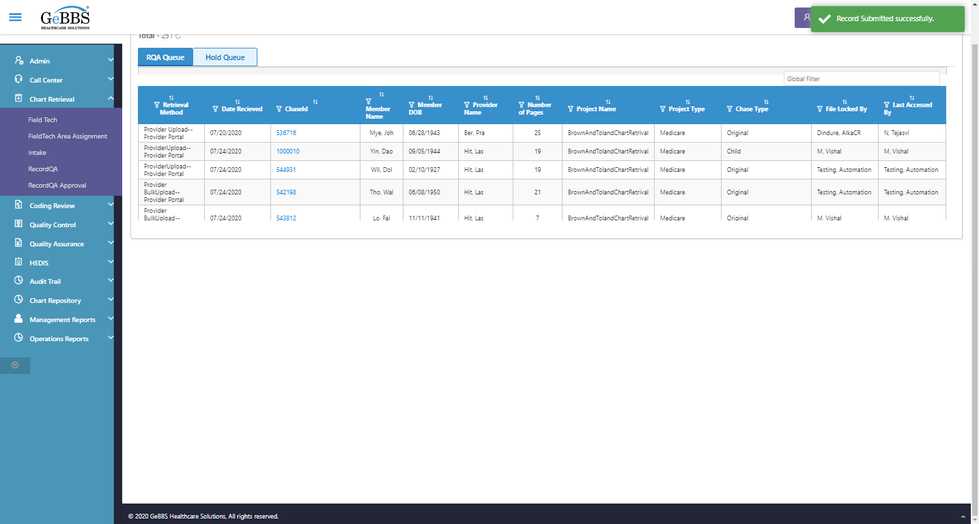  
RecordQA scrren is displayed  
  
*****SubmitTest_RecordQA is Ended ***** **09/11/2020 12:55:28**