Mini Project

on

Split-File Data Encryption

Name of the Students

Roll No | Name
2173150 | Rahul Nanwani
2173085 | Harsh Patel
2173133 | Omkar Patil

Project Guide

Prof. Nagesh Jadhav


DEPARTMENT OF COMPUTER SCIENCE AND ENGINEERING MIT-ADT UNIVERSITY, SCHOOL OF ENGINEERING, RAJBAUG, LONI, INDIA
MIT School of Engineering

Department of Computer Science & Engineering

RAJBAUG, LONI, INDIA


CERTIFICATE

This is to certify that the Mini Project entitled ‘Split-File Data Encryption’, submitted by Rahul Nanwani, Harsh Patel and Omkar Patil is a record of bonafide work carried out by him in the partial fulfillment of the requirement for the award of Degree of B Tech (CSE) at MIT School of Engineering, Rajbaug, Loni, Pune under the MIT ADT University. This work is done during the year 2018-19, Semester III.

Date: 29th October, 2018.

-----------------------------------------

Prof. Nagesh Jadhav

Project Guide

MIT School of Engineering

Loni Kalbhor, Pune

---------------------------------------------

Dr. Rajneeshkaur Sachdeo-Bedi

Dean Engineering,

Head , Department of CSE

MIT School of Engineering

Loni-Kalbhor, Pune

Acknowledgement

We would like to express our special thanks and gratitude to Prof. Nagesh Jadhav, who gave us the golden opportunity to do this wonderful project in the subject Mini-Project -I which also helped us in doing a lot of research, in which we came to know about a lot of new things (learnt concepts that we never knew existed). In turn, helping us building us more confidence in the programming language-Python.

Secondly, we would also like to thank all of our parents and friends who helped us a lot in various aspects of this project and helping us fit infinite number of knowledge in a finite frame.

Name of the Students

Rahul Nanwani

Harsh Patel

Omkar Patil
ABSTRACT

The issue of security is the most paramount issue in the history of computer science, with breachers coming out more frequent then ever and also the rise in the number of attackers this issue has started to affect even more people then if previously used to. These days anything and Everything in either on everyone's mobile phones or on a source which is not distant from internet. In these cases from an account password to any data of national importance is at risk Which leads to the ere of data protection where data in itself is sometimes lesser know for its data and know for its security protocols. Out of many way the only way that have been experiencing a lead in the number of different people using it is “DATA ENCRYPTION” where the motive is to hide the data from everyone buy using any necessary protocol but there are some which are are specially known for its difficulty to crack namely SHA256 and SHA512 these are also called as some or the well know “HASHING” algorithms. There are other different types of methods of hiding the data i.e. using ciphers, etc. However for this specific project we have used some part of hashing and some part of ciphering the data also we have used password to further ensure the security of the data that is been kept also as the topic say split file data encryption we have divided the encoded the file into two parts which means that for decoding this file both of these file and a password will be required ensuring the security to a further deeper / upper level.
Table of Contents

Sr. No. |  | Contents | Page No.
1 | Abstract
2 | List of Figures: Flowchart
3 | 1. | INTRODUCTION
 | 2. | PROBLEM DEFINITION
 | 3. | FEATURES OF PROJECT
 | 4. | PLATFORM / TECHNOLOGY
 | 5. | FLOWCHART
 | 6. | OUTPUT
 | 7. | CODE
 | 8. | GLOSSARY
 | 9. | REFERENCES
 | 10. | CONCLUSION AND FUTURE ENHANCEMENTS


3 | Glossary
4 | Reference & Bibliography
5 | Annexure A

INTRODUCTION

For most, possibly all of the time data management networks and systems are at a high risk of attacks or breach which in-turn makes it really important for everyone to take major steps in order the protect their data, which can maybe be for the most part harmless for the nation as the whole but personal security says else wise. There are different ways this problem is being treated all around the globe people are coming up different types of way to save the data from this type of risks which is basically just the reflection of how big the problem really is. Data attacks can happen at anytime in the data network (Creation / transmission) to prevent this from ever happening there are almost more then just infinite ways to make sure that data security is maintained.

The most popular method for prevention from this type of event is “DATA ENCRYPTION” which is basically nothing but hiding the actual data from everyone. This can be achieved in many different way forming the further sub-categories to the existing directory of thousand upper level sub-categories. Data Encryption reflects to the process of data hiding which is being explained in detail in the further modules.

The specific type of data encryption method used here is a hybrid of more then two types of data replacement algorithms as one would say. Namely “Hashing” & “Ciphering”, that is further protected by splitting the data file into two files and then setting a password followed by the process of encryption which is done using Hashing algorithm named SHA512 and a specific custom data ciphering module. The Decoding process is basically just the same in reverse with a bunch of compare statements.
Table of Contents

Sr. No. |  | Contents | Page No.
1 | Abstract
2 | List of Figures: Flowchart
3 | 1. | INTRODUCTION
 | 2. | PROBLEM DEFINITION
 | 3. | FEATURES OF PROJECT
 | 4. | PLATFORM / TECHNOLOGY
 | 5. | FLOWCHART
 | 6. | OUTPUT
 | 7. | CODE
 | 8. | GLOSSARY
 | 9. | REFERENCES
 | 10. | CONCLUSION AND FUTURE ENHANCEMENTS

3 | Glossary
4 | Reference & Bibliography
5 | Annexure A

INTRODUCTION

For most, possibly all of the time data management networks and systems are at a high risk of attacks or breach which in-turn makes it really important for everyone to take major steps in order the protect their data, which can maybe be for the most part harmless for the nation as the whole but personal security says else wise. There are different ways this problem is being treated all around the globe people are coming up different types of way to save the data from this type of risks which is basically just the reflection of how big the problem really is. Data attacks can happen at anytime in the data network (Creation / transmission) to prevent this from ever happening there are almost more then just infinite ways to make sure that data security is maintained.

The most popular method for prevention from this type of event is “DATA ENCRYPTION” which is basically nothing but hiding the actual data from everyone. This can be achieved in many different way forming the further sub-categories to the existing directory of thousand upper level sub-categories. Data Encryption reflects to the process of data hiding which is being explained in detail in the further modules.

The specific type of data encryption method used here is a hybrid of more then two types of data replacement algorithms as one would say. Namely “Hashing” & “Ciphering”, that is further protected by splitting the data file into two files and then setting a password followed by the process of encryption which is done using Hashing algorithm named SHA512 and a specific custom data ciphering module. The Decoding process is basically just the same in reverse with a bunch of compare statements.
PROBLEM DEFINITION

Writing a Python script using file handling, SHA512 and ciphering data to protect data by splitting the ciphered data into two and saving it at different locations to prevent complete data theft. Then decrypting the same to get the original data back.
FEATURES OF PROJECT

- Runs on any machine which has Python 3.7 installed.
- Works with Microsoft Windows.

- The passcode set on the encrypted data is hashed using SHA512.

- The encrypted data file is split into two to prevent complete data theft.
- Encrypted files can be saved at different locations.

- One cannot access data without both files and the passcode.

- Data is easy to retrieve if you know the passcode and have both files.
PLATFORM / TECHNOLOGY

This project uses Python 3.7 and is compatible on any machine that runs Microsoft Windows which has Python 3.7 installed in it. The passcode is hashed using SHA512 hashing algorithm. The encrypted file uses split-data technology to keep your data safe.



If
char.isupper()


cipher = cipher +
chr((ord(char) + 18 – 65)
% 26 + 65)

Flow Chart
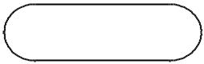

START
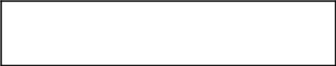

Import shutil, os, hashlib
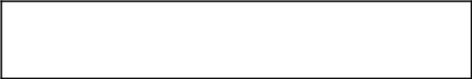

Create a function encrypt(string)
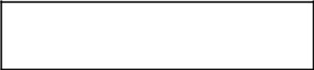

Set cipher = ‘ ‘


for char
in string


elif
char.islower()


cipher = cipher +
chr((ord(char) + 18 – 97)
% 26 + 97)
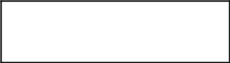

else



cipher = cipher + char

return cipher



If
char.isupper()

cipher = cipher +
chr((ord(char) - 18 – 65)
% 26 + 65)

Create a function decrypt(string)

Set cipher = ‘ ‘

for char
in string


elif
char.islower()

cipher = cipher +
chr((ord(char) - 18 – 97)
- 26 + 97)

return cipher


Print menu


Input int ch
‘Operation Choice
from user’

else

cipher = cipher + char


while ch !=
3


If ch == 1


Input the file
location in
browse


Input password
in code_01

Input password
in code_02
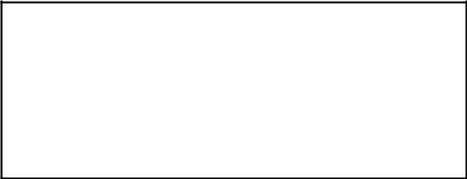

Hash code_01 using SHA512
and store it in password_hash


If
code_01 == else code_02


print
‘Passwords
do not match!’
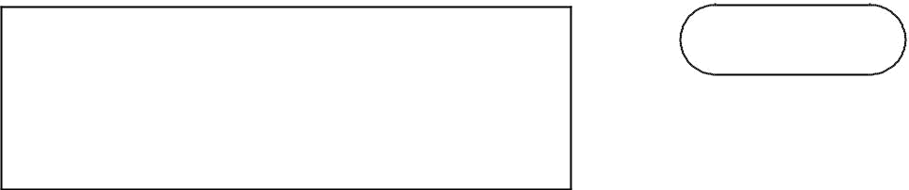

BREAK

Using shutil move file from
browse to ‘C:\\EncryptData\\data.txt’


Create an object ‘file’ and open data.txt
in read only mode
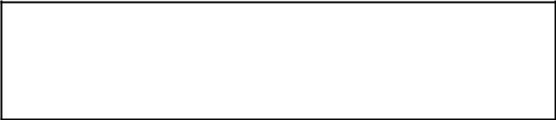

Read lines from data.txt
and store it in variable data
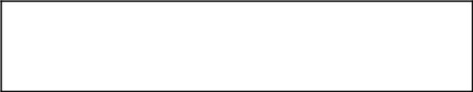

Calculate length and store it in data_len


Calculate mid_len = data_len


Create an object ‘en’ and open
encoded.txt in write mode
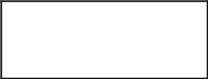

Set i = 0


while i !=
data_len


encrypt data[i] and write
it in encoded.txt
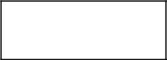

i += 1
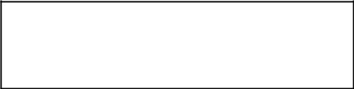

Close objects ‘file’ and ‘en’
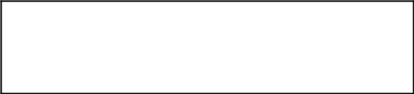

Create object en_01 and open
‘encoded.txt’ in read mode

Create object split_01 and open

‘encoded(01).txt’ in write mode

readlines from encoded.txt
and store it in en_data_01

del lines mid_len to data_len
from en_data_01

Insert ‘\n’ at 0
in en_data_01

Insert password_hash at 0
in en_data_01


write en_data_01 in encoded(01).txt



Close objects en_01 and split_01

Create object en_02 and open
‘encoded.txt’ in read mode

Create object split_02 and open
‘encoded(02).txt’ in write mode

readlines from encoded.txt
and store it in en_data_02

del lines 0 to mid_len
from en_data_02

Insert ‘\n’ at 0
in en_data_02

Insert password_hash at 0
in en_data_02

write en_data_02 in encoded(02).txt

Close objects en_02 and split_02


Input browse_01 and
browse_02
to save encoded files


using shutil move files encoded(01).txt
and encoded(02).txt to browse_01
and browse_02 respectively


using os remove files
data.txt and encoded.txt
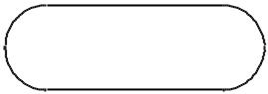

break


elif ch
== 2

Input browse_01 and
browse_02
to loacte encoded files


using shutil move files from
browse_01 and browse_02
to ‘C:\\EncryptData\\encoded(01).txt’
and ‘C:\\EncryptData\\encoded(02).txt’

respectively


Create objects en_01 and en_02
to open files encoded(01).txt
and encoded(02).txt respectively
in read mode


read lines from encoded(01).txt
and encoded(02).txt and
store it in data_01 and
data_02 respectively

read line 0 from data_01 and
data_02 then store it in
code_01 and code_02 respectively


Close objects en_01 and en_02


If
code_01 ==
code_02


Input password in
code


Hash code using SHA512
and store it in password_hash

else


Print ‘Files do
not match!’


Using shutil move files
encoded(01).txt and encoded(02).txt to browse_01 and browse_02 respectively
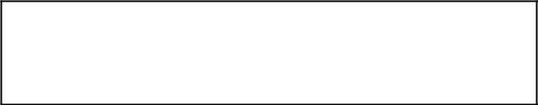

Set password = password_hash + ‘\n’


If code_01
==

password
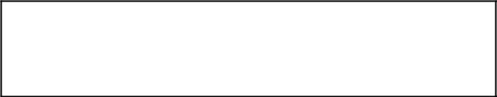

del line 0 from data_01 and data_02

Create an object merge to open
temp.txt in write mode
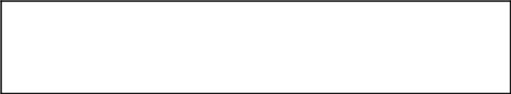

Write lines data_01 and data_02 in temp.txt
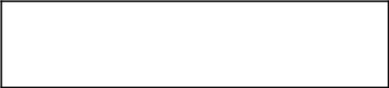

Close object merge
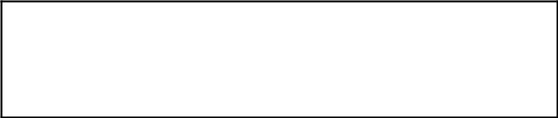

Create an object temp to open
temp.txt in read mode

Create an object decoded to open
decoded.txt in write mode

Read lines from temp.txt
and store it in data

BREAK

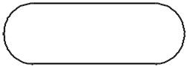

else

print
‘Incorrect
Password!’


Using shutil move files
encoded(01).txt and encoded(02).txt to browse_01 and browse_02 respectively

BREAK
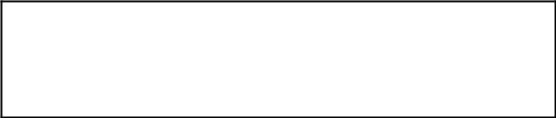

Store length of data in length
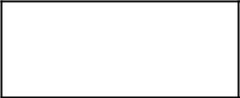

Set i = 0


While i !=
length

Store decrypt and write line
data[i] in decoded.txt

i += 1


Close objects decoded and temp

Input save location
in browse

Using shutil move
decoded.txt to browse


elif ch
== 3

else

Print ‘Operation
Invaild!’ and menu

Take input choice

in ch

Using os remove files
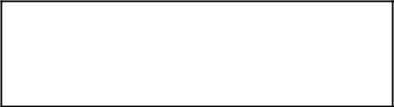
temp.txt


Using os remove files
encoded(01).txt and encoded(02).txt
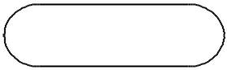

BREAK

STOP

OUTPUT
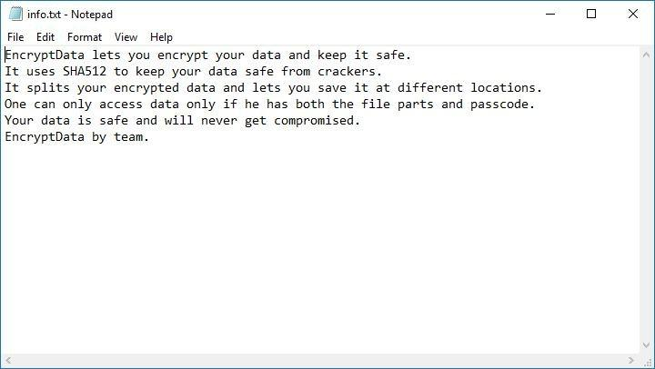

This is some data I want to protect.
It is saved at location ‘C:\’ as ‘info.txt’.
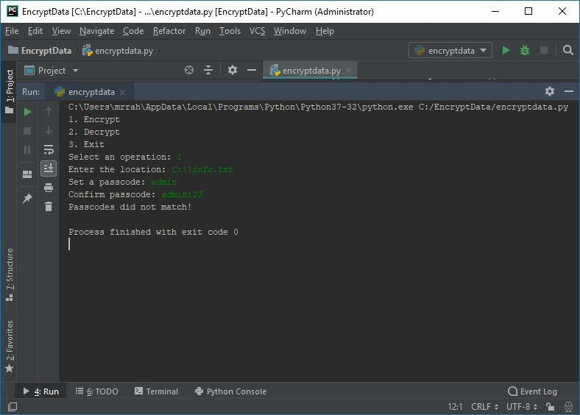

If I fail to re-type the passcode correctly my files will not be affected.
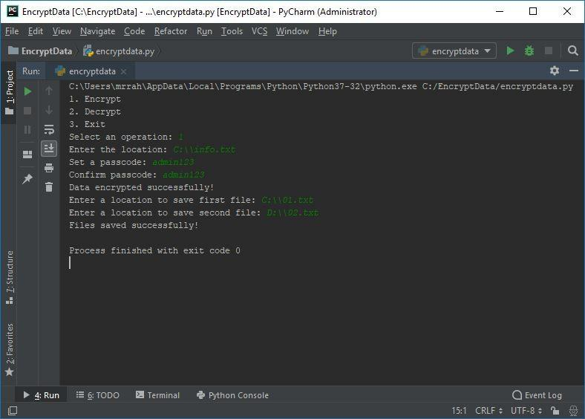

Now, I have saved my encrypted files with passcode ‘admin123’ at locations ‘C:\’ and ‘D:\’ as 01.txt and 02.txt respectively.
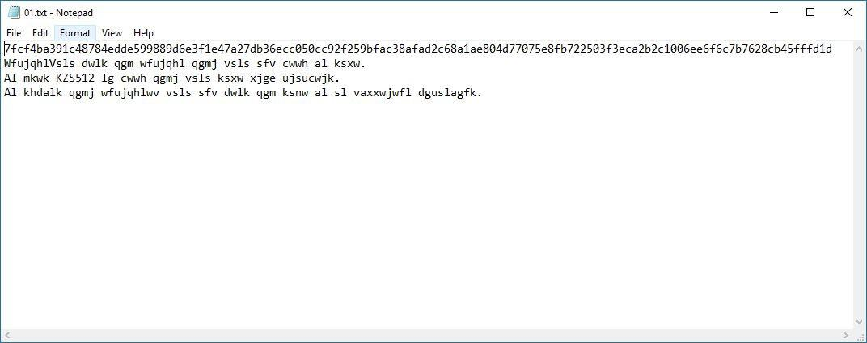

This is my encrypted file ‘01.txt’ at location ‘C:\’.

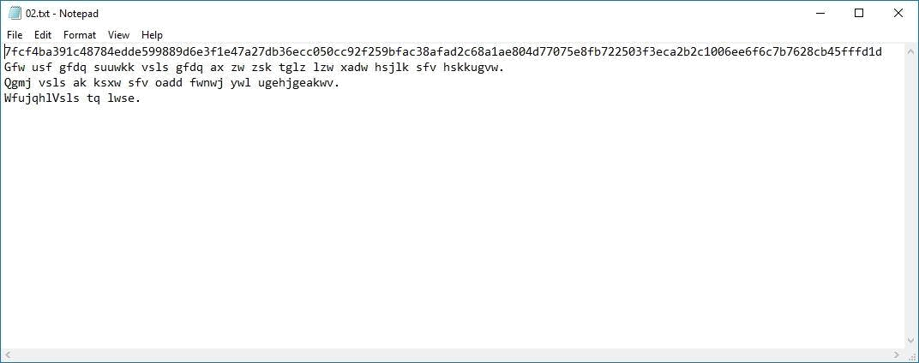

This is my encrypted file ‘02.txt’ at location ‘D:\’.
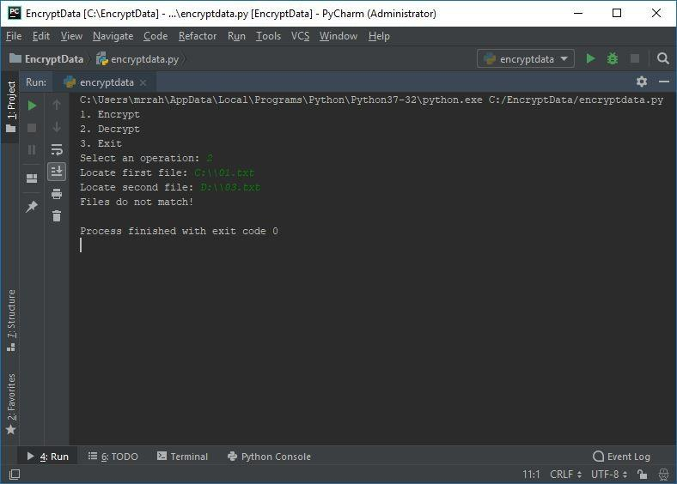

You will always need valid files to decrypt.

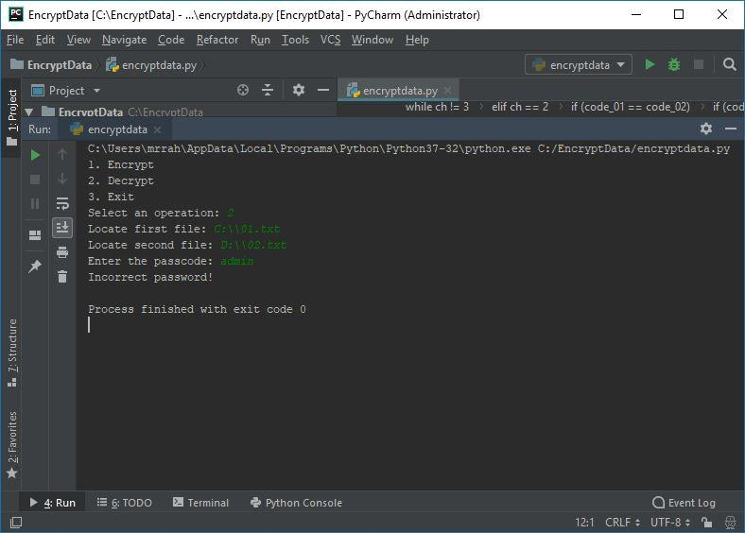

You cannot access your data unless you know the right passcode and have both the parts.
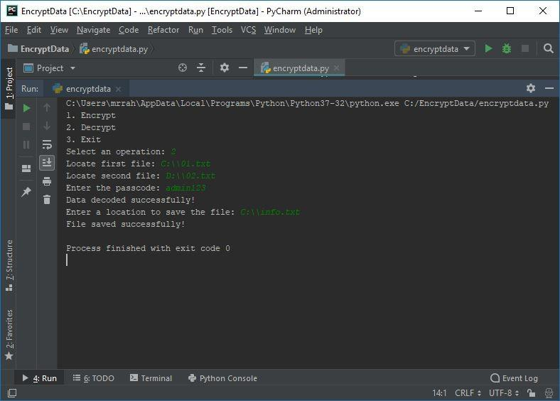

Now, I have finally decrypted my data and saved it back to ‘C:\’ as ‘info.txt’

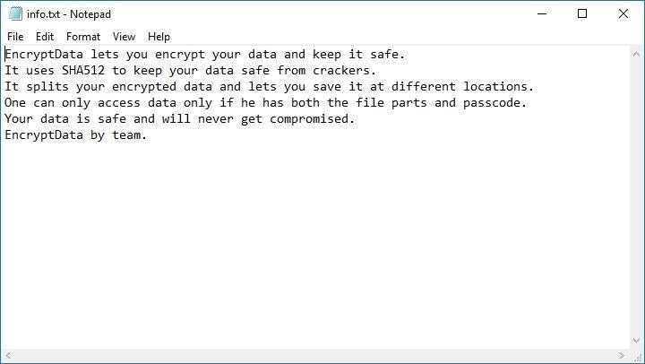

This is my data after decrypting.
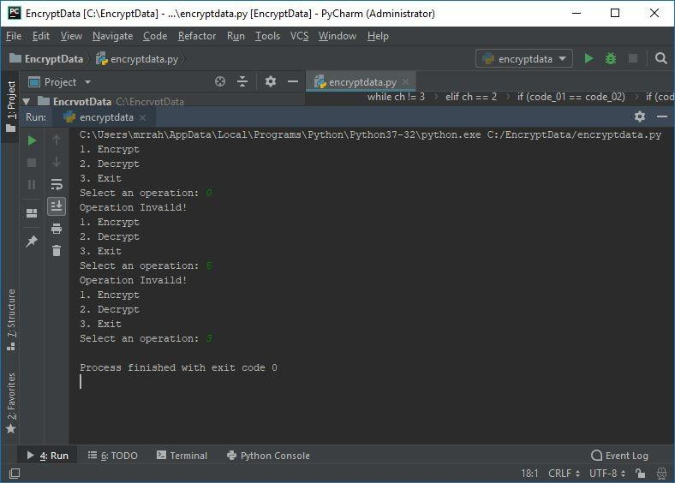

To exit the program you will need to enter only 3.
CODE

import shutil, os, hashlib #importih os and hashlib

def menu(): #defining the function menu
print('1. Encrypt') #defifn the different choices of the menu
print('2. Decrypt')
print('3. Exit')

def encrypt(string): #creating the function encrypt
cipher = ''
for char in string:
if char.isupper():
cipher = cipher + chr((ord(char) + 18 - 65) % 26 + 65) #this operates on uppercase letters
elif char.islower():
cipher = cipher + chr((ord(char) + 18 - 97) % 26 + 97) #this operates in lower case letters
else:
cipher = cipher + char #in cipher = 3 then A will be operated as C

return cipher #returns the value

def decrypt(string): #creating the function Decrypt
cipher = ''
for char in string:
if char.isupper():
cipher = cipher + chr((ord(char) - 18 - 65) % 26 + 65) #operates on upper case letters
elif char.islower():
cipher = cipher + chr((ord(char) - 18 - 97) % 26 + 97) #operates on lowercase letters
else:
cipher = cipher + char #does not make changes to the integer part of the string

return cipher

menu() #a menu function created
ch = int(input('Select an operation: ')) #storing the input in ch variable

while ch != 3:
if ch == 1: #acts when ch = 1
browse = input('Enter the location: ') #print commands for the encryption process
code_01 = input('Set a passcode: ') #print command to ask and store the password
code_02 = input('Confirm passcode: ') #to verify the input in password field

hash = hashlib.sha512() #calling SHA512
hash.update(('%s' % (code_01)).encode('utf-8')) #to pass variable
password_hash = hash.hexdigest()

if (code_01 == code_02): #after the field verifiction in the password tab this statement operates
shutil.move(browse, 'C:\\EncryptData\\data.txt') #moves the file to the given location

file = open("data.txt", "r") #opens the file in read only mode
data = file.readlines() #reads the data
data_len = len(data) #counts the length of data
mid_len = data_len // 2 #mid defined at 1/2 lento split

en = open("encoded.txt", "w") #the ciphered ad hashed data shifts to this location

i = 0
while i != data_len: #increments the value of i till it reaches the end to encode the data
en.writelines(encrypt(data[i]))
i += 1

en.close() #closes the data file
file.close() #closes the encoded file

en_01 = open("encoded.txt", "r") #opens the encoded file as read only
split_01 = open("encoded(01).txt", "w") #first half of the encoded data is refered in this file
en_data_01 = en_01.readlines() #reads the content of encoded file
del en_data_01[mid_len: data_len] #delets the code away from the mid position
en_data_01.insert(0, '\n')
en_data_01.insert(0, password_hash) #the first line pf the encoded data is the hashed password
split_01.writelines(en_data_01) #adds data of en data 01 to split 01
split_01.close() #closes the split 01 file
en_01.close() #closes the en 01 file

en_02 = open("encoded.txt", "r") #encoded data file in opened
split_02 = open("encoded(02).txt", "w")#encoded 02 file is defined
en_data_02 = en_02.readlines() #reads the data of the encoded data file
del en_data_02[0: mid_len] #deleats the data previous to mid
en_data_02.insert(0, '\n') #shifts the 2nd half of the encoded data
en_data_02.insert(0, password_hash) #inserts the hashed password in the first lie 0f the en data 02
split_02.writelines(en_data_02) #wites the data from en data 02 to split data 02
split_02.close() #closes the split02 file
en_02.close() #closes the en 02 file

print('Data encrypted successfully!')
browse_01 = input('Enter a location to save first file: ') #asks the location of the 1st half file tbs
browse_02 = input('Enter a location to save second file: ') #asks the locatin of the 2nd half file tbs
shutil.move('C:\\EncryptData\\encoded(01).txt', browse_01) #moves the given file in the specified location
shutil.move('C:\\EncryptData\\encoded(02).txt', browse_02) #moves the given file in the specified loacation
print('Files saved successfully!')
os.remove('data.txt') #removes the data file
os.remove('encoded.txt') #removes the encoded file

else:
print('Passcodes did not match!') #when passwords do not match

break

elif ch == 2: #action when the input is 02
browse_01 = input('Locate 1st file: ') #aks for the location for the first file
browse_02 = input('Locate 2nd file: ') #asks for the location for the second file

shutil.move(browse_01, 'C:\\EncryptData\\encoded(01).txt')#moves the file to the given location
shutil.move(browse_02, 'C:\\EncryptData\\encoded(02).txt')

en_01 = open("encoded(01).txt", "r") #opens the specific file in read only format
en_02 = open("encoded(02).txt", "r") #opens the specific filein read only format
data_01 = en_01.readlines() #reads the data in the specific file
data_02 = en_02.readlines()
code_01 = data_01[0] #reads the first line of the file
code_02 = data_02[0] #reads the first line of the file
en_02.close()
en_01.close() #closes the specific file

if (code_01 == code_02): #comparesthe first line of both the files
code = input('Enter the passcode: ')#reads the password
hash = hashlib.sha512() #compares the password by hashing
hash.update(('%s' % (code)).encode('utf-8'))
password_hash = hash.hexdigest()
password = password_hash + '\n'
if (code_01 == password): #decodes the file
del data_01[0] #removes the dat 01 and data 02 file
del data_02[0]
merge = open("temp.txt", "w") #creates and opens the file temp .txt
merge.writelines(data_01) #writes the data 01 file in merge file
merge.writelines(data_02) #wirtes the data 02 file in the merge file
merge.close() #closes the merge file

temp = open("temp.txt", "r") #opens the temp file
decoded = open("decoded.txt", "w")#creates and opens the file
data = temp.readlines() #reads the data of temp to data file
length = len(data) #defining length
i = 0
while i != length:
decoded.writelines(decrypt(data[i]))#decrypts the data one by one line
i += 1
decoded.close() #closes the decoded file
temp.close() #coses the temp file

print('Data decoded successfully!')
browse = input('Enter a location to save the file: ')#asks for the location to save the data file
shutil.move('C:\\EncryptData\\decoded.txt', browse)#moves the required file
print('File saved successfully!') #executes the program
else:
print('Incorrect password!') #when the password is not correct
else:
print('Files do not match!') #when wrong files are inserted
shutil.move('C:\\EncryptData\\encoded(01).txt', browse_01)
shutil.move('C:\\EncryptData\\encoded(02).txt', browse_02)
break

os.remove("encoded(01).txt") #removes the specified file
os.remove("encoded(02).txt") #removes the specific file
os.remove("temp.txt") #removes the specific file
break

elif ch == 3:
print('Always keep your data protected.')#when exit fucntion is selected
break

else:
print('Operation Invaild!') #when value which is not in the menu is entered
menu() #runs loop again
ch = int(input('Select an operation: '))#inputs value of ch

CONCLUSION AND FUTURE ENHANCEMENTS

The project gave us brief understanding of advance as well as basic concepts of python such as file handling, Hashing algorithms like SHA256 / SHA512 we also learnt ciphering text as well as deciphering the same. The project Overall helped us develop a mature relationship with python making us more comfortable in specific virtual as well as IRL environment.

The future enhancements in this project could be creating a GUI (Graphical User Interface) and then making it completely a stand-alone setup file. Creating a GUI will be really user-friendly and making it a stand-alone executable could mean that you need not have Python 3.7 installed in your machine. Another improvement that could be done is making another separate version compatible with ubuntu and other UNIX-based systems. Hence, making it something which almost every machine could run it.
Glossary

Cipher: Converting a data into some other character codes.
(Ex. A= 1, B= 2, C= 3; then ABC= 123)

Hashing: Converting a string or passcode into a complex encrypted text.

SHA128/ SHA256/ SHA512: Hard to crack hashing algorithms.
Reference and Bibliography

Cipher code reference:
http://stackoverflow.com/question/2490334/simple-way-to--encode-a-string-accodring-to-a-

password

Move and delete operations reference:
http://automateboringstuff.com/chapter9/

