**Messenger App**

1. Frontend - React JS
2. Backend - express dotenv scoket.io bcrpyt jsonwebtoken cookie-parser cloudinary mongoose

Steps for Projects

1. Setting up the folder structure and file

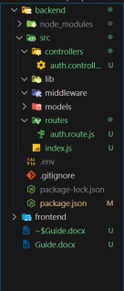

1. Making small routes for chekcing , started with auth routes login …… etc .
2. Setting up the database
3. Making the account in MongoDB and create the project
4. Set MongoDB uri to .env file and importing in the index.js
5. Making the Connection file

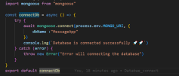

1. After making the connection calling the funciton to the main file index.js
2. Making User Schema

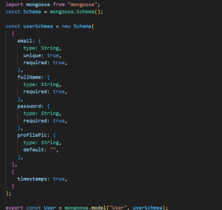

the timestamps :

In Mongoose, the timestamps: true option in a schema automatically adds **two special fields** to your documents:

* **createdAt** – the date and time when the document was first created in the database.
* **updatedAt** – the date and time when the document was last updated.

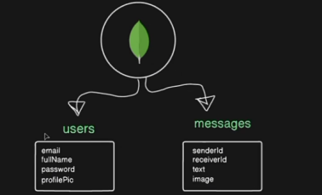

Step 3 : Making the Login Route

1. Asking data like firtName etc from the user.
2. Cheking if the data is provided by the user
3. Validating the input data zod
4. Hashing the password with bcrypt and then store the data with hash password in the database

