BWSSB WQMS Mobile Application
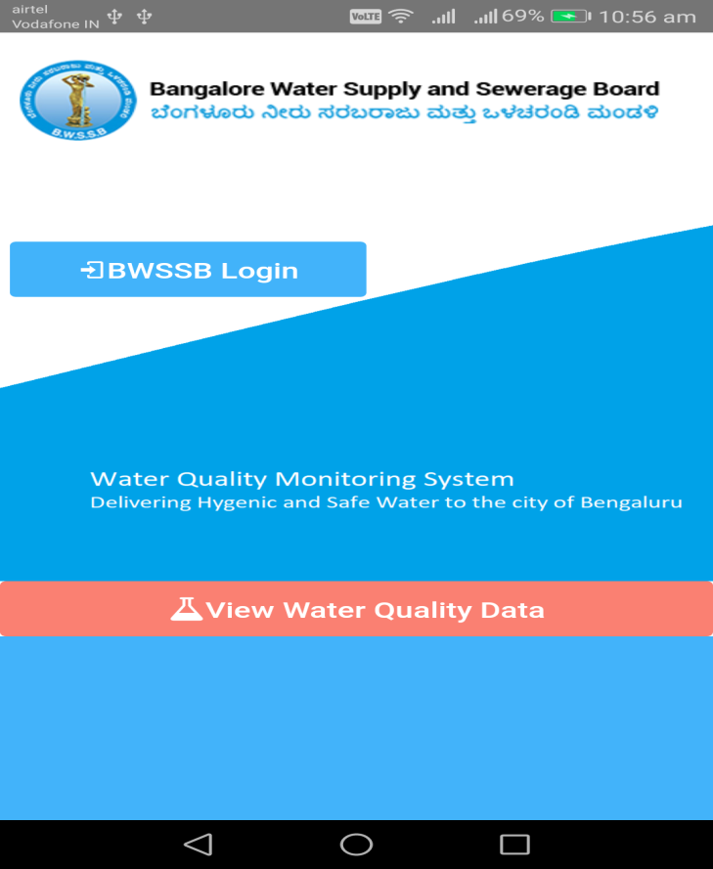

Table Contents
- Introduction
- Home Page
- Login
- Menu
- Add Sample Data
5.1 Add Sample Data for Service Station
5.2 Add Sample Data for Water Treatment Plant
5.3 Add Sample Data for Sewage Treatment Plant
6. Reports
6.1 Service Station
6.2 Water Treatment Plant
6.3 Sewage Treatment Plant
7. Dashboard
7.1 View MapView
7.2 Service Station
7.3 WTP
7.4 STP
8. Logout

Introduction
This User Manual provides details of the usage and the functionalities of the Water Quality Monitoring System (WQMS) Mobile Application. This manual will assist the BWSSB QA Team to enter, manage and report water quality samples for Service Stations, Water Treatment Plants and Sewage Treatment Plants and the Administrator to manage the entire application.

Home Page
On the Home Page of the Application there is an option for the Public Users to view the Laboratory Sample Reports for Service Stations, Water Treatment Plants and Sewage Treatment Plants without the need to login to the application.

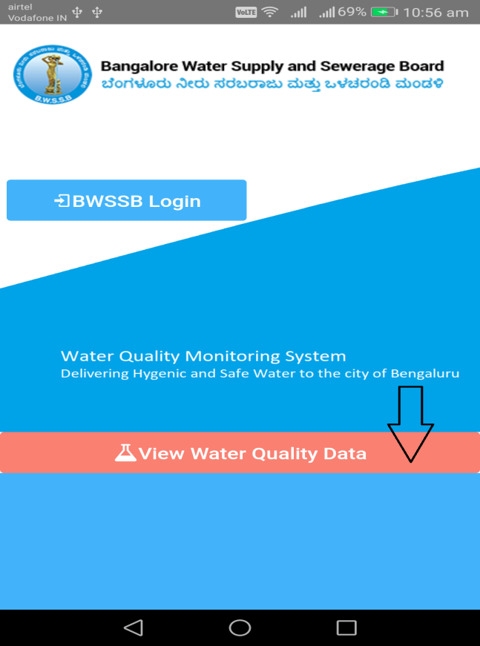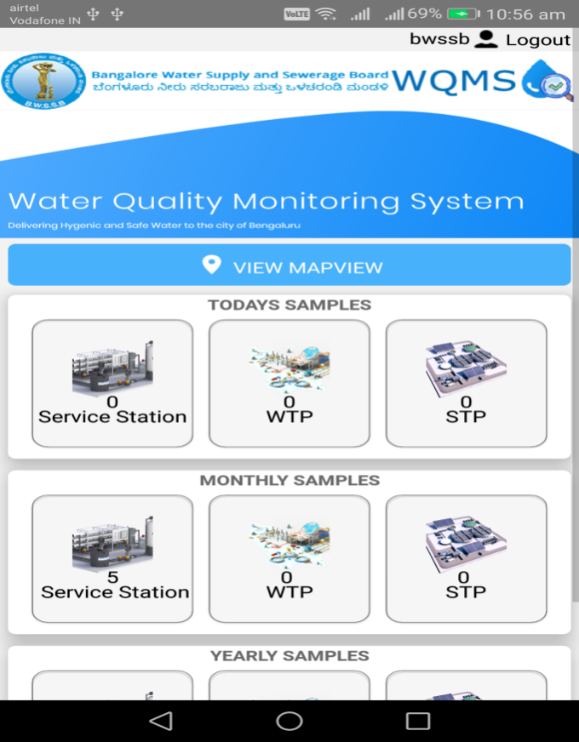

Login
On the Home Page of the Application there is an option for the BWSSB Users to login to the Application. The BWSSB Users can click on the BWSSB Login button to login to the application for entering the sample data and managing the application .
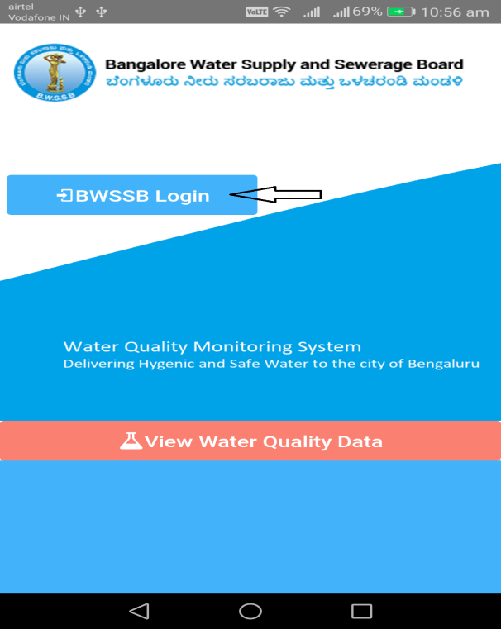

On clicking of the BWSSB Login button, the User is redirected to the login screen where they can login using their User Id or Mobile Number or the password that is assigned or generated for them.
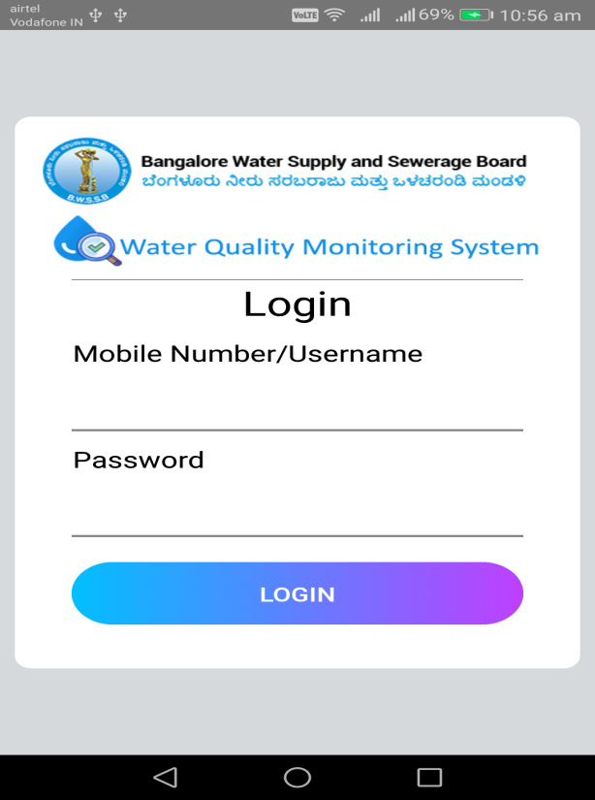

Once the User logs in they can view the Map. It will display the current dates sample collected locations in the GIS Map.
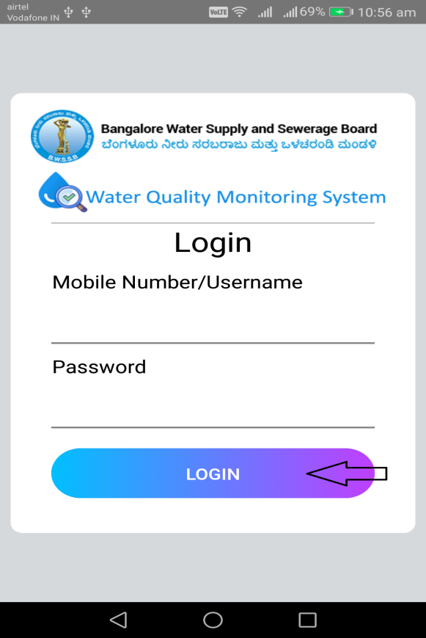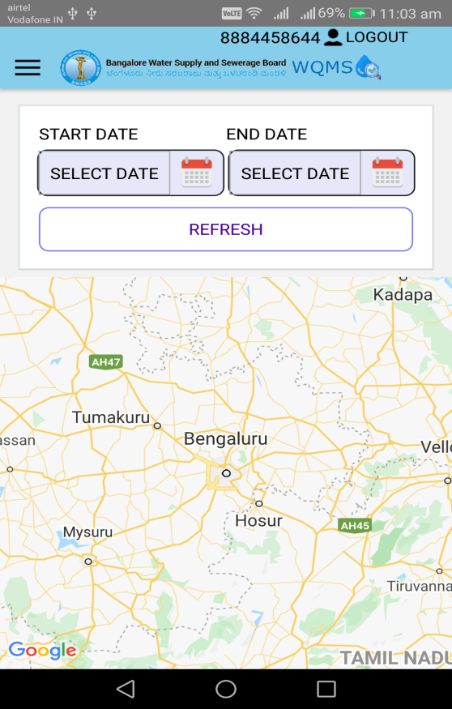

Menu
Clicking on Menu icon it will display the all listed item in menu screen.
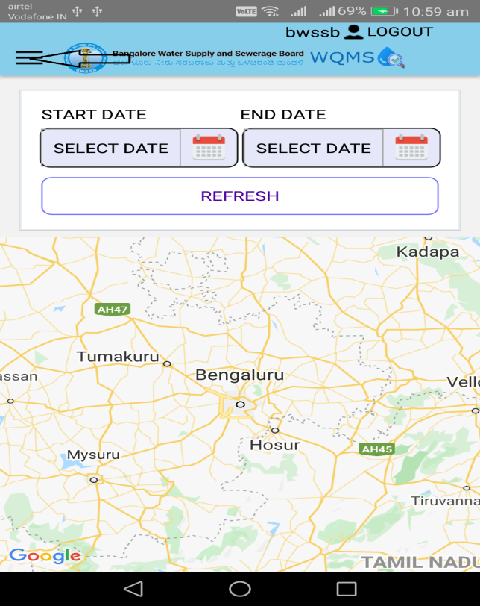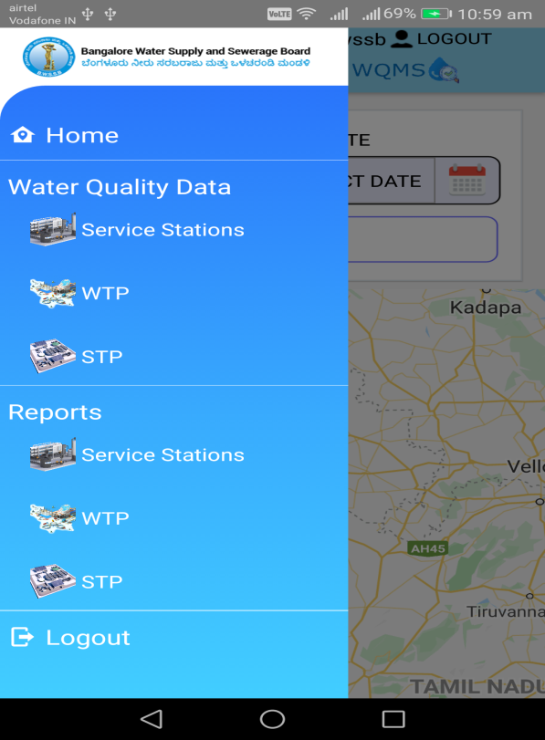

Add Sample Data
This section allows the QA Users to add Water Quality Sample data for Service Stations, Water Treatment Plant and Sewage Treatment Plant.

Add Sample Data for Service Stations
Clicking on Service Station Menu below it will redirect to the service station screen.

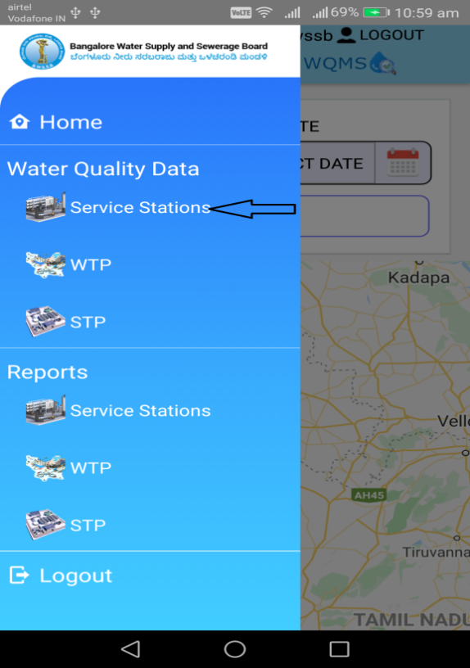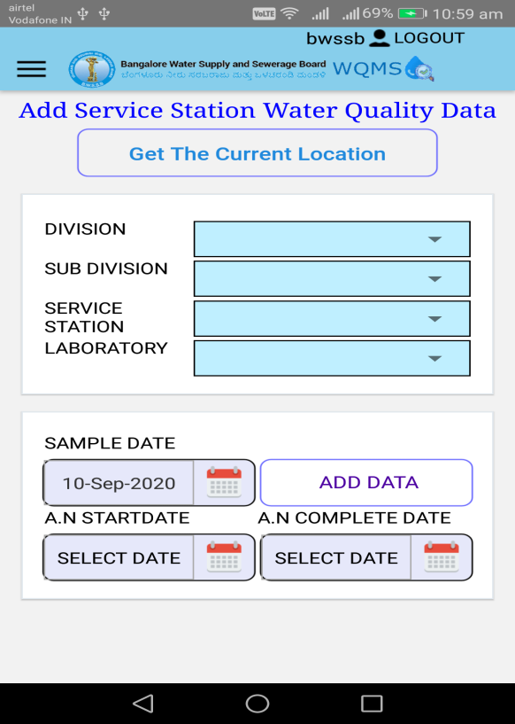

On clicking of the Get the Current Location button, it will display the current location.
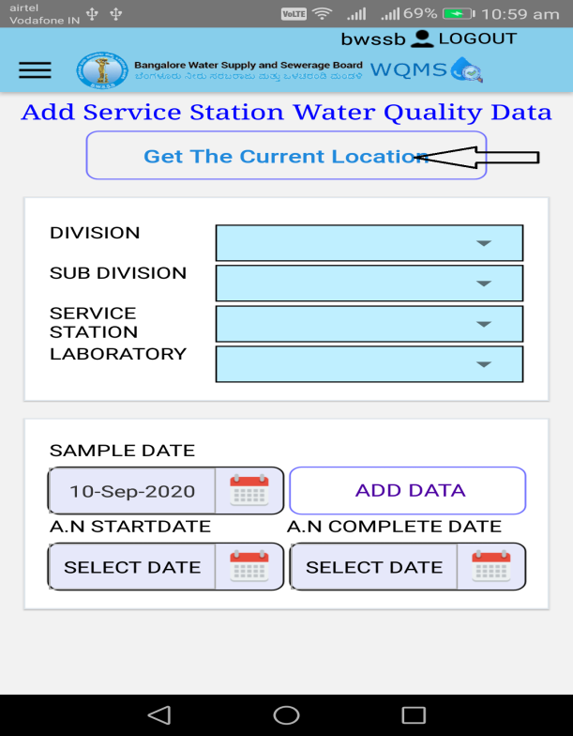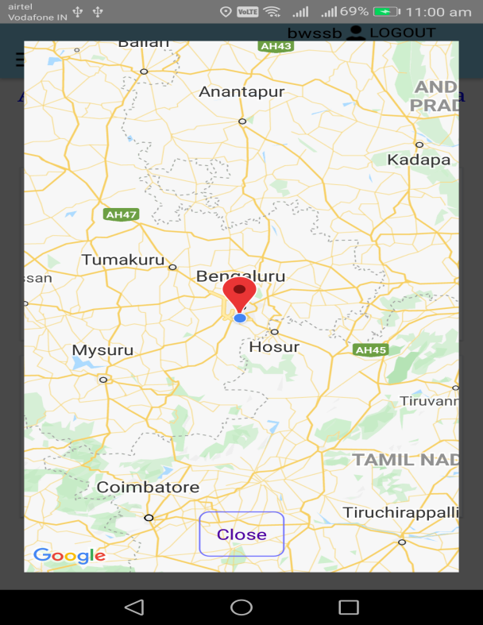

After selecting the division, sub-division, service station and laboratory from drop down, Clicking on the Add Data button will open the Laboratory Data entry screen for the selected Service Station.
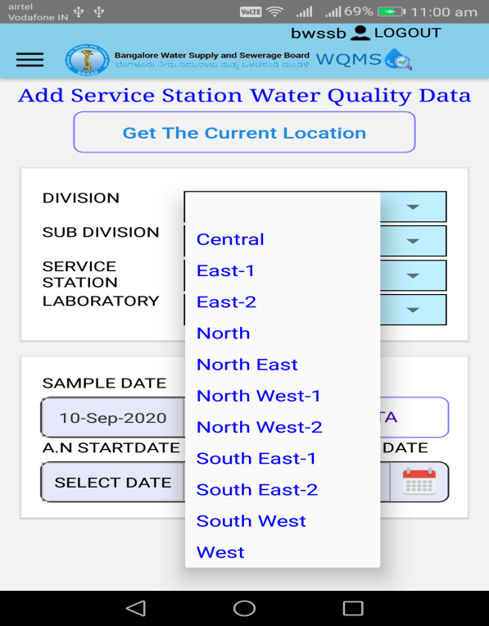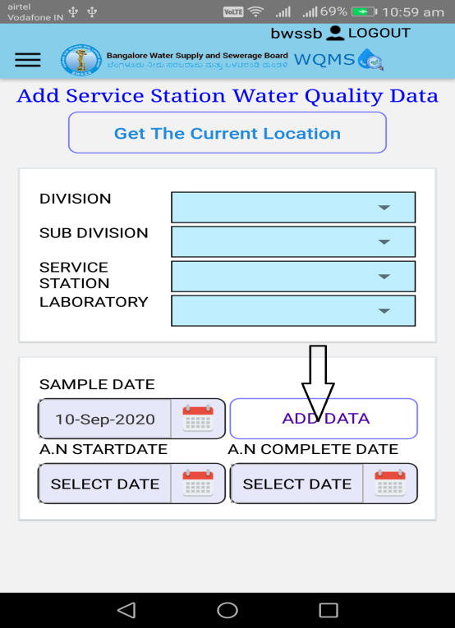

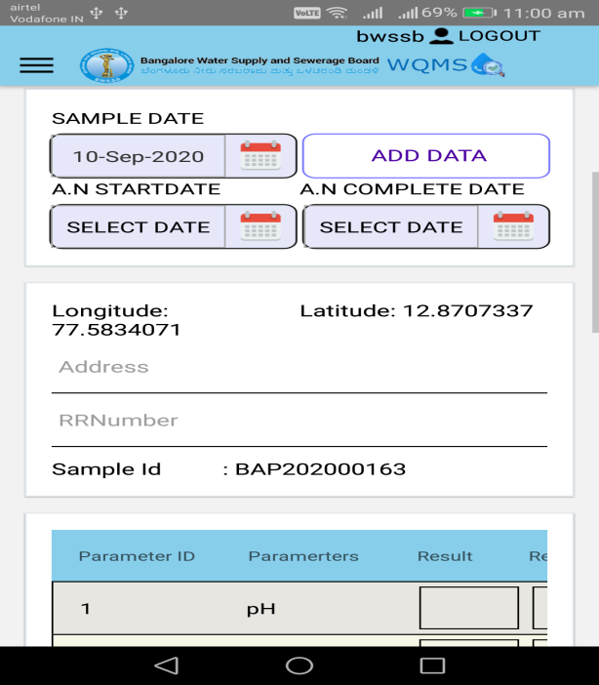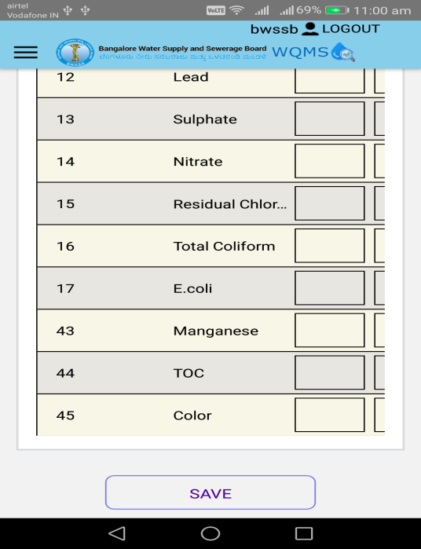

Add Sample Data for Water Treatment Plant
Clicking on WTP Menu below it will redirect to the WTP screen.
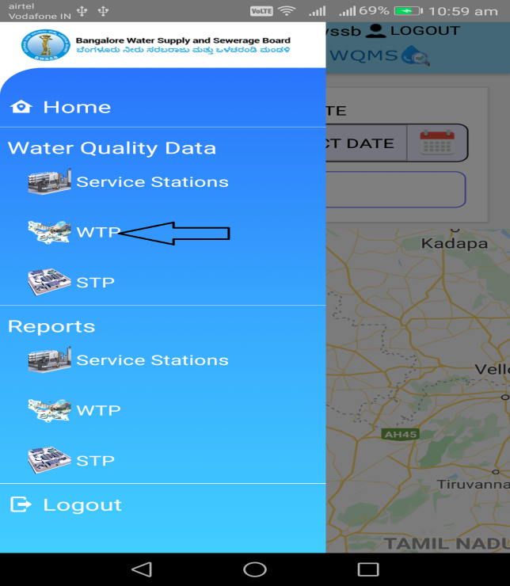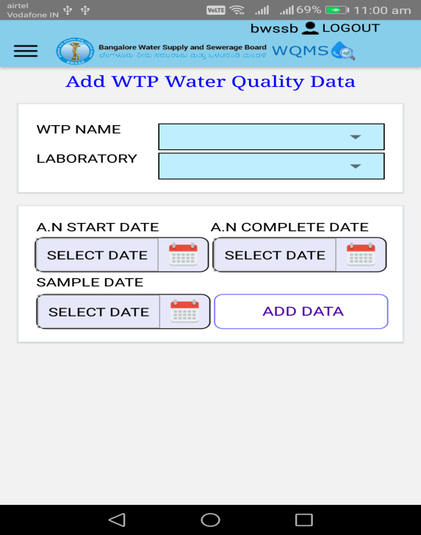
After selecting WTP name and laboratory from drop down, Clicking on the Add Data button will open the Laboratory Data entry screen for the selected WTP name.
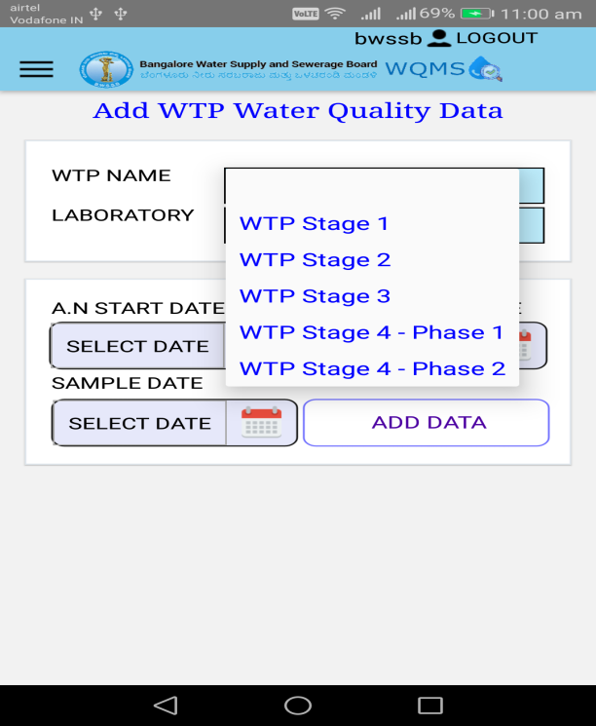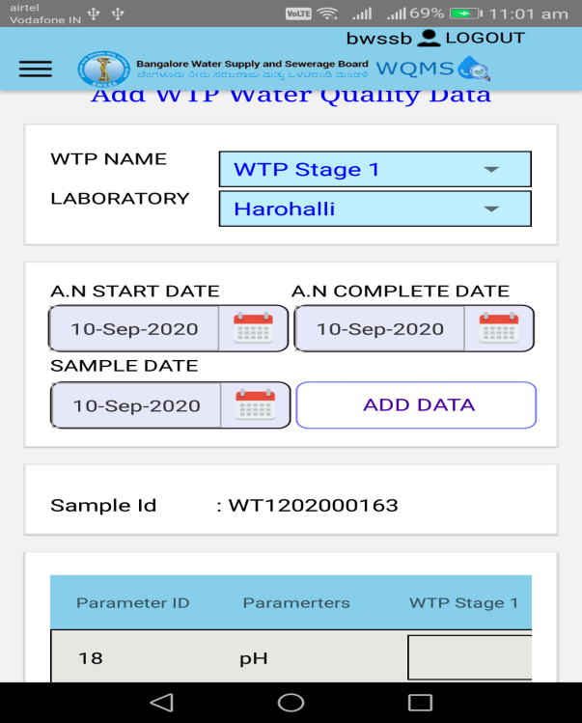

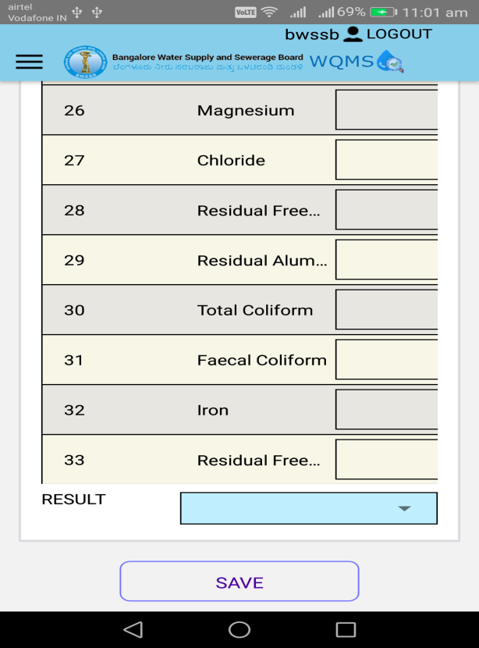

Add Sample Data for Sewage Treatment Plant
Clicking on STP Menu below it will redirect to the STP screen.
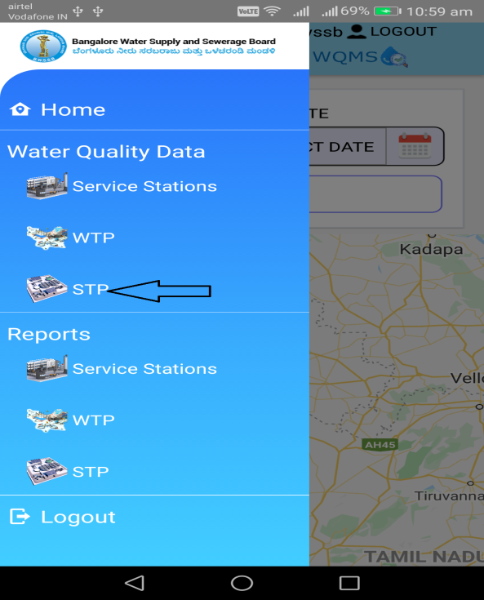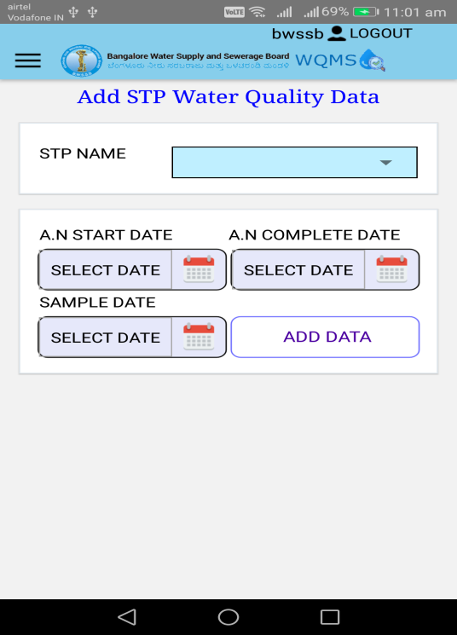
After selecting STP name and laboratory from drop down, Clicking on the Add Data button will open the Laboratory Data entry screen for the selected STP name.
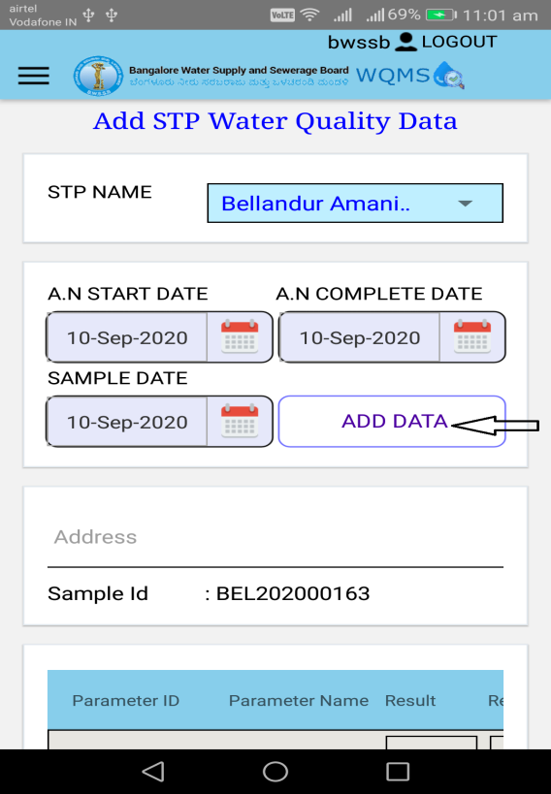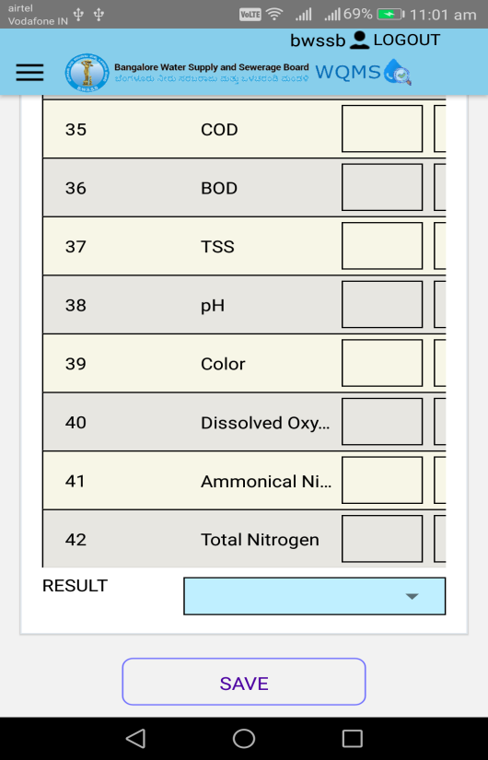

Reports
This section will allow the Users to view the various reports.

Service Station
To access the service station report, use the following
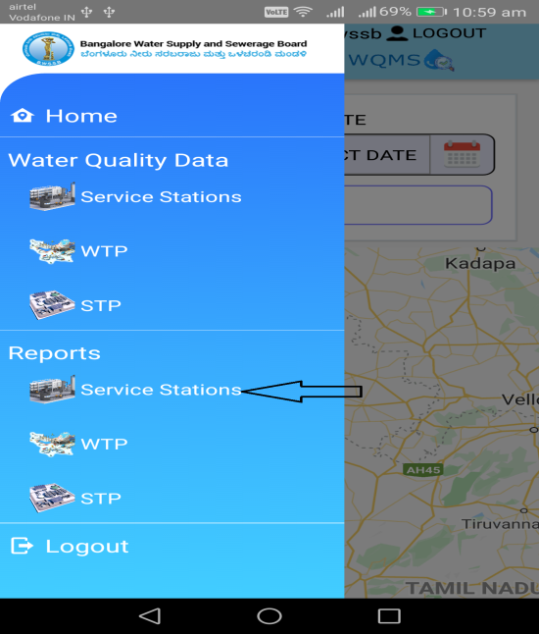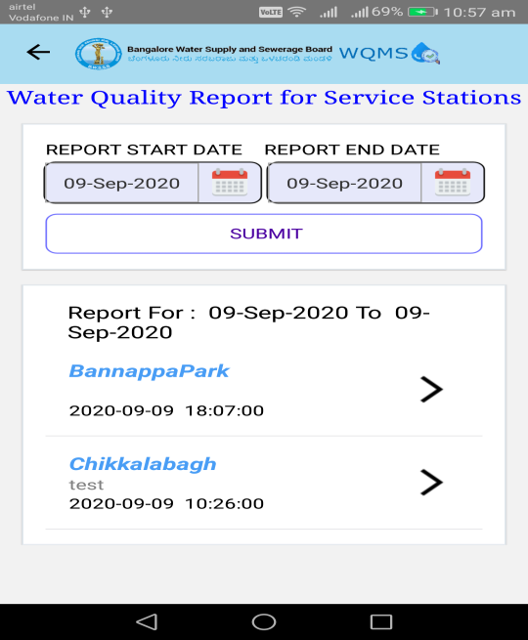
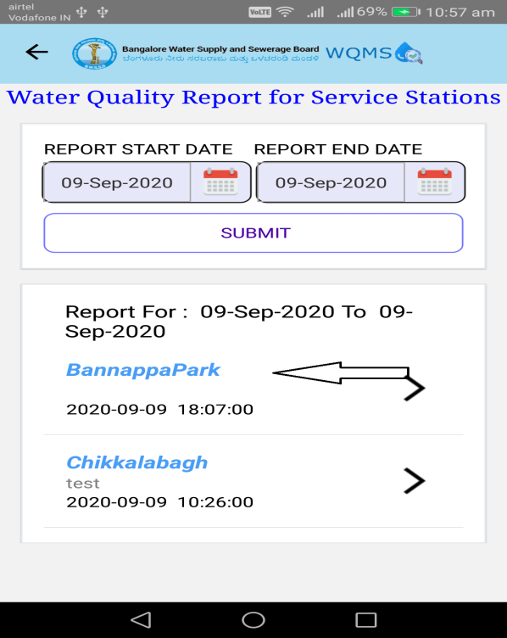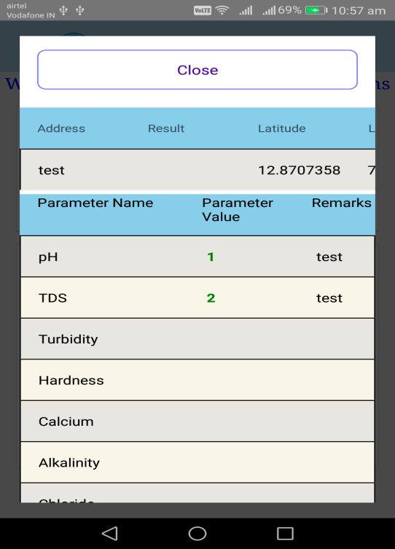

Water Treatment Plant
To access the WTP report, use the following
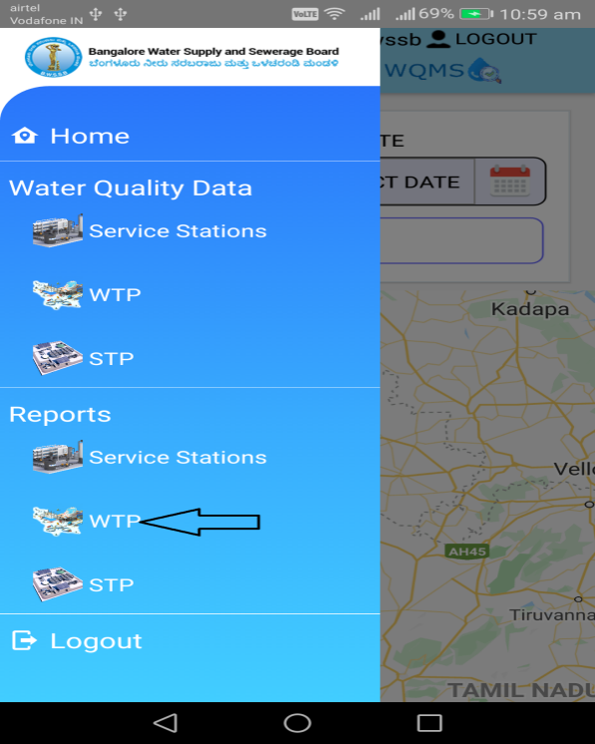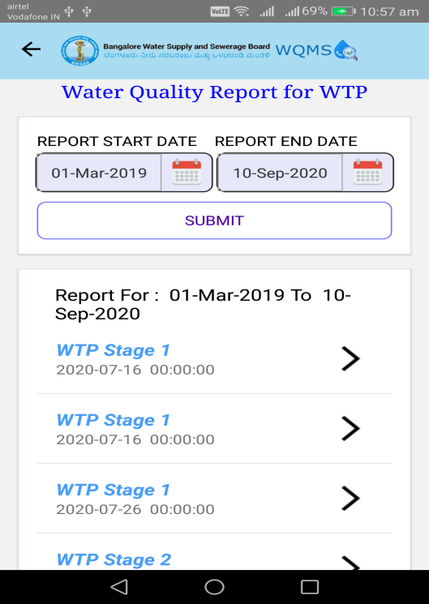

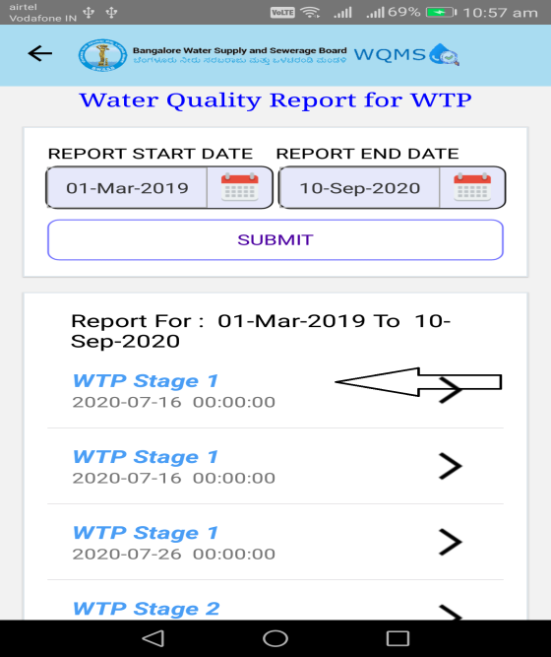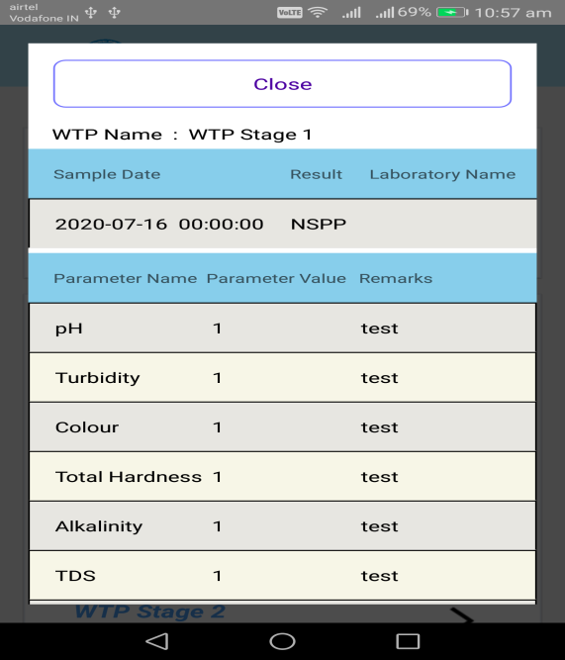

Sewage Treatment Plant
To access the STP report, use the following
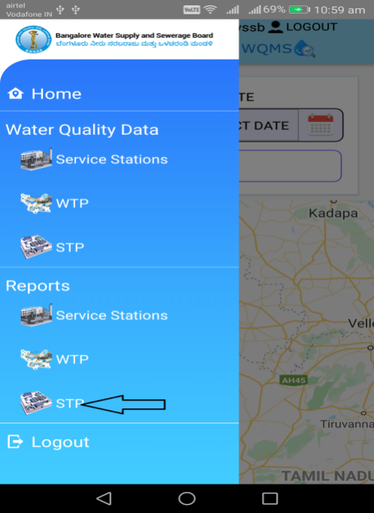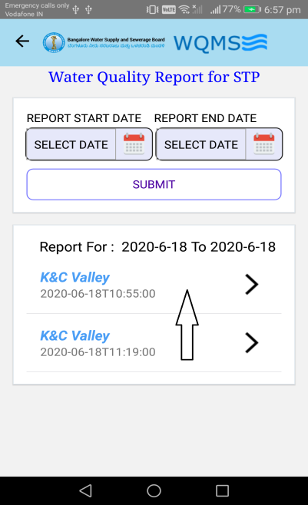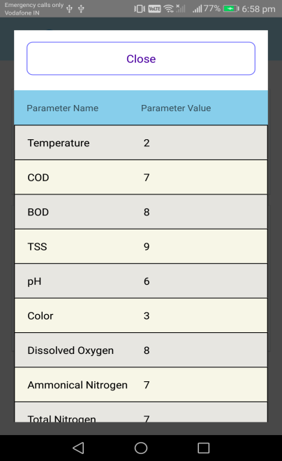

For the QA (6)
Clicking on Menu icon it will display the service station item in menu screen.
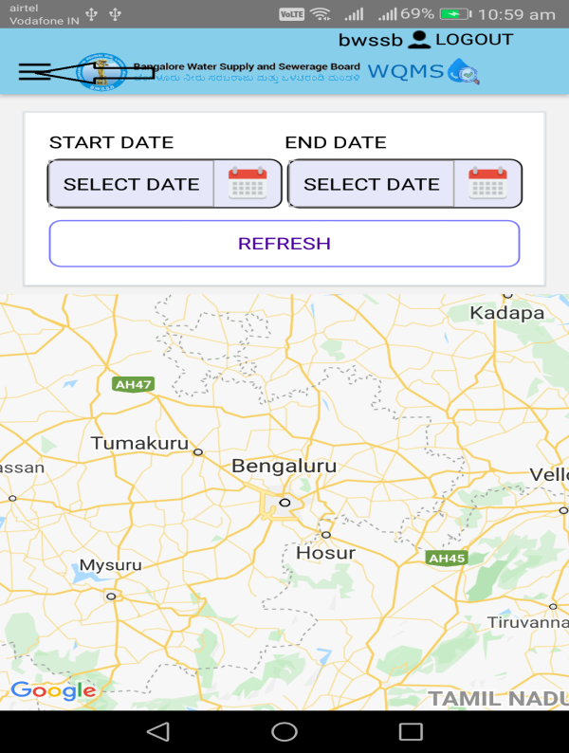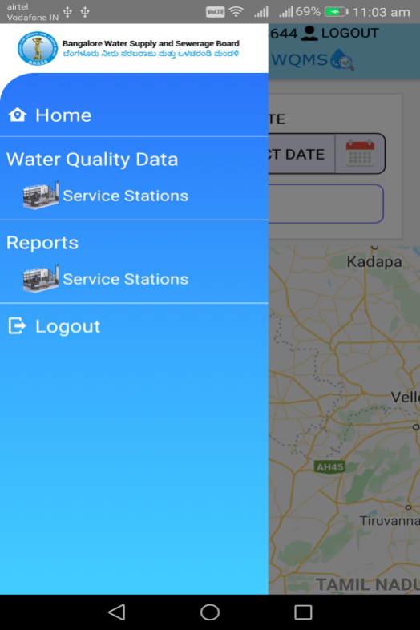

Clicking on Service Station Menu below it will redirect to the Service station screen. 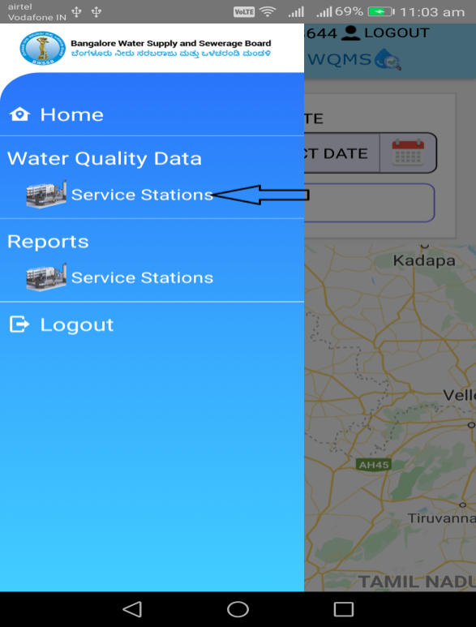 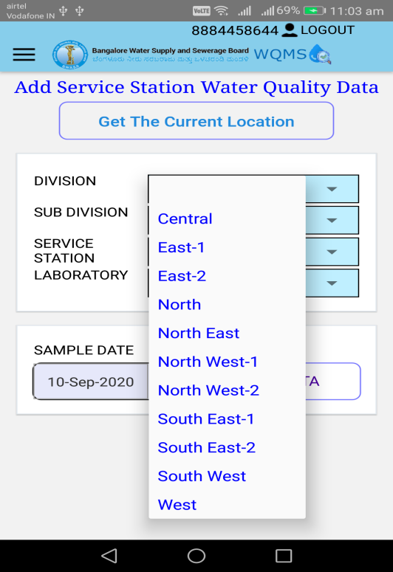

After selecting the division, sub-division, service station and laboratory from drop down, Clicking on the Add Data button will open the Laboratory Data entry screen for Residual Chlorine parameter.
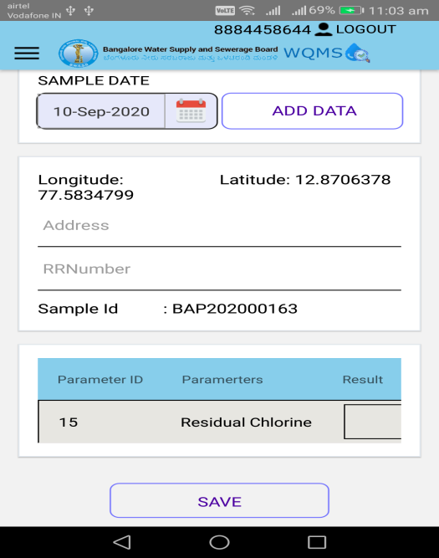

Dashboard
On the Home Page of the Application there is an option for the Public Users to view the Laboratory Sample Reports for Service Stations, Water Treatment Plants and Sewage Treatment Plants without the need to login to the application. On clicking of the View Water Quality Data button it will redirect the Dashboard screen.
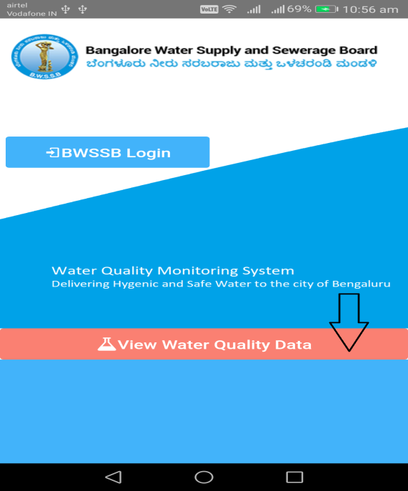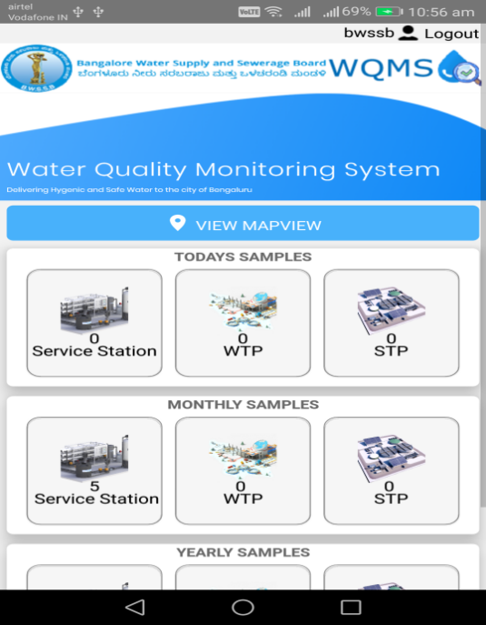

View MapView
On clicking of the View MapView button it will display the current dates sample collected locations in the GIS Map.
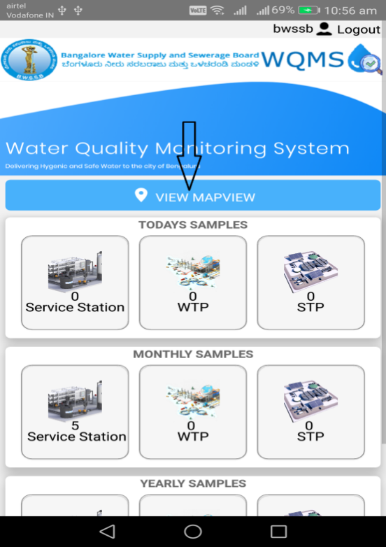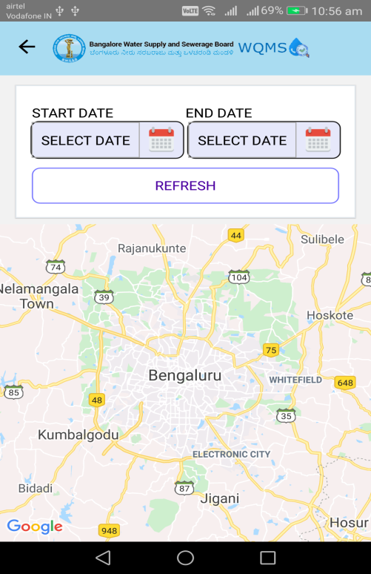

Service Station
To access the service station report from Dashboard, use the following link
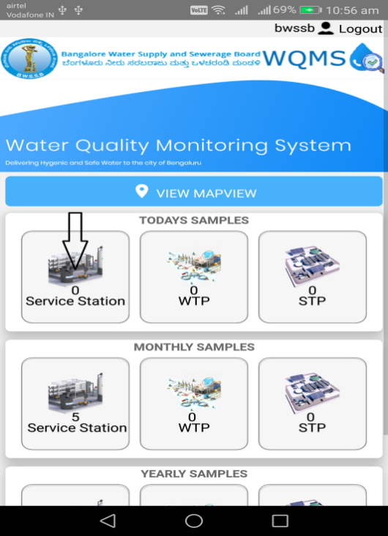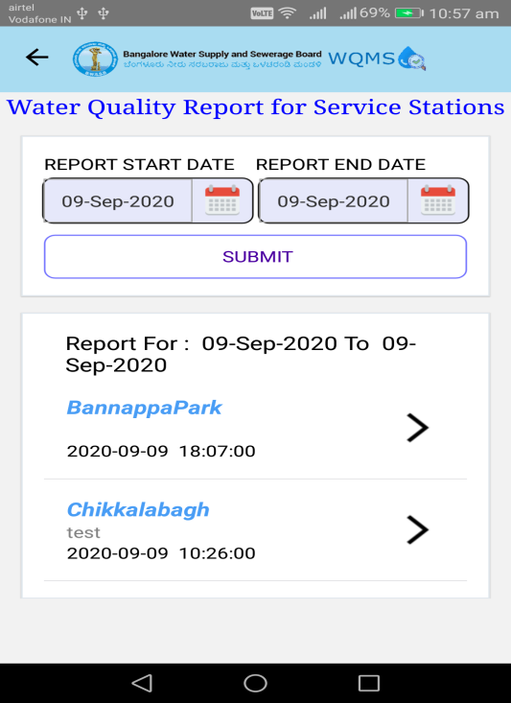


WTP
To access the WTP report from Dashboard, use the following link

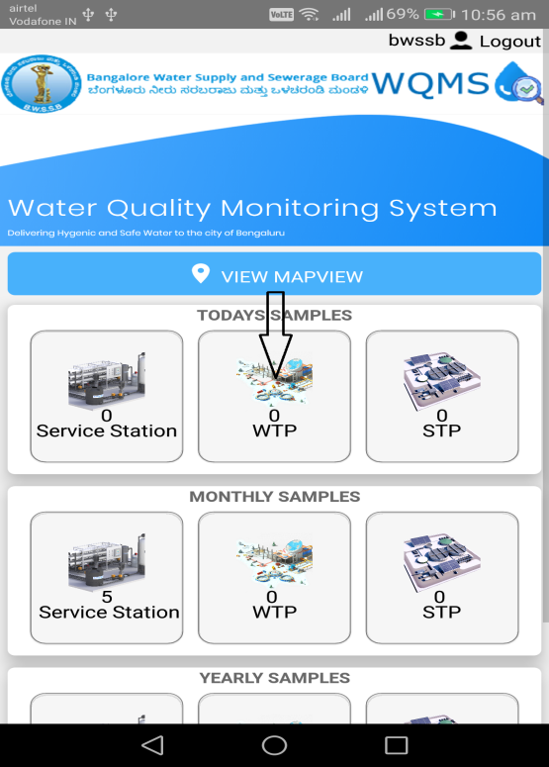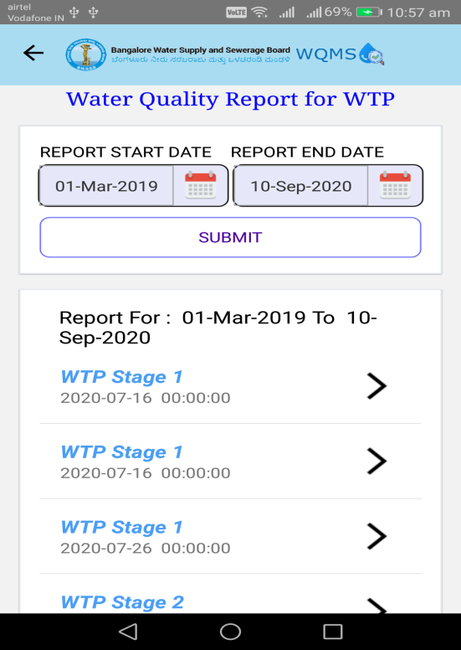



STP
To access the STP report from Dashboard, use the following link
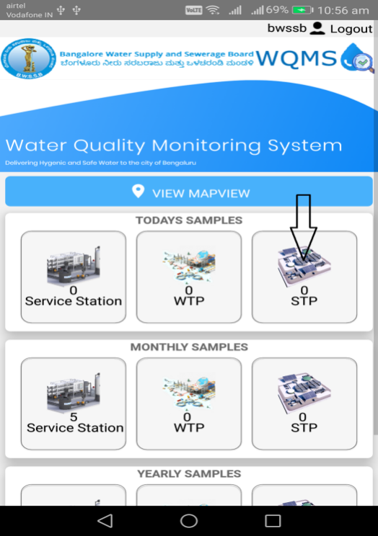



Logout

To exit the application, Click on Logout button
