Fabrico 360: A Data-Driven Approach to Laundry Excellence
A Midterm report for the BDM capstone Project

Submitted by

Name: R Rahul Varma
Roll number: 22f1000756
Date: 08/02/2025



IITM Online BS Degree Program,
Indian Institute of Technology, Madras, Chennai Tamil Nadu, India, 600036
Contents
- Executive Summary and Title 3
- Proof of Originality of Data 3
- Meta Data & Descriptive Statistics 4
- Detailed Explanation of Analysis Process/Method 6
- Results and Findings 7

EXECUTIVE SUMMARY

The primary reason I chose a laundry service business is to explore the impact of such services in a semi-urban area like Ayyanthole, Thrissur, compared to a metropolitan city. This project focuses on Fabrico The Laundry Expert, a well-known laundry franchise with multiple locations across India, offering laundry, dry cleaning, steam ironing, washing and folding, and live laundry services. The business faces challenges such as seasonal demand fluctuations, customer retention issues, and bottlenecks in high-volume processes.
The data for this study has been collected from Fabrico Ayyanthole over two years (2023-2024), including order records, customer segmentation details, and financial performance reports. The data collection period spans 24 months, sourced from internal business records, manager interviews, and structured data extraction from point-of-sale systems.
Our findings show a positive revenue trajectory, though with noticeable seasonal dips—particularly in June—indicating the need for better demand management strategies. Customer segmentation reveals that repeat customers drive a significant portion of revenue, while new customer retention remains a challenge. A Pareto analysis highlights that a small group of loyal customers contributes disproportionately to total revenue, making targeted engagement and loyalty programs a high-impact strategy. Bottleneck analysis points to inefficiencies in handling high-volume orders, especially in Steam Press (SP) and Wash & Iron (WI) services, leading to delayed deliveries. Addressing these through improved scheduling and resource allocation could enhance service efficiency.
From a financial standpoint, the business remains profitable, but optimizing cost structures—especially during low-revenue months could further strengthen margins. By merging these analytical insights, the study aims to enhance service efficiency, improve customer retention, and identify strategic cost-saving opportunities for Fabrico The Laundry Expert. The findings will not only strengthen decision-making at this outlet but also serve as a scalable framework for similar businesses looking to expand in semi-urban regions. With a data-driven approach, the goal is to ensure better resource utilization, maximize profitability, and sustain long-term growth.

PROOF OF ORIGINALITY OF THE DATA

Letter from Organization:

Image:

Video Proof (Conversation with Manager) :

Audio Transcript of the video:

Datasets, PDF of Google Colab notebook :.

METADATA & DESCRIPTIVE STATISTICS

As stated in the proposal, Orders data was collected from January 2022 to December 2023 which provided a comprehensive view of orders & customer activity. Additionally, a separate dataset named "Orders CB" was used, which included revenue, expense, and profit data for the period from January 2024 to December 2024. The Orders dataset was originally in Excel (.xlsx) format, but it was uncleaned and unstructured. Before performing any statistical analysis, both datasets were cleaned and formatted to ensure accuracy and consistency. The initial formatting was done in Google Sheets, where all columns were structured correctly. After that, Google Colab was used to filter relevant fields and prepare the dataset for analysis.

Key Features in Orders TSR

The Orders TSR - Orders Sheet contains critical data about customer transactions, including details such as order dates, pricing, and delivery schedules. Below are the key attributes:

SL#: Serial number of the order.

Order Dt: Date of order placement.

Customer Name: Name of the customer.

Status: Indicates whether the customer is new or existing.

Masked Phone: Contact details (masked for privacy).

Order#: Unique order identifier.

Process: Type of laundry process requested.

Asnd Dlry Dt: Assigned delivery date (Estimated delivery date).

Count: Total number of items in the order.

Price: Total price of the order.

Ready: Status indicating if the order is ready for pickup or delivery.

Dlry. Date: Actual delivery date.

Pay Dt.: Payment date.

Payment Modes: Cash, UPI, FAB (Wallet), Amount Received, Balance Amount.

WO & Remarks: Work order and any additional comments.

These features allow for monthly analysis, customer segmentation, and delivery tracking to identify operational patterns and areas of improvement.

Key Features in Orders TSR
The Orders TSR - CBE Sheet contains financial records, including operational costs and revenue. The key features include:
- Month: The respective month of the data entry.
- Salary: Total salary expenses for employees.
- Rent: Monthly rental costs for the facility.
- Raw Materials: Cost of detergents, chemicals, and other cleaning materials.
- EB (Electricity Bill): Monthly electricity charges.
- Other Expenses: Additional operational costs such as maintenance, marketing, and miscellaneous expenses.
- Total Expenses: The sum of all costs incurred in a given month.
- Orders: Total number of orders placed in the respective month.
- Revenue from Orders: Total revenue generated from customer transactions.
- Profit: The net profit calculated after deducting expenses from revenue.
- Profit Margin (%): The percentage of revenue retained as profit.

Descriptive Analysis of the collected orders data:

The Table 3.1 shows the descriptive measures of Orders & Revenue of 2023 and 2024:

  - Average revenue per month: ₹169,604
  - Average expenses per month: ₹89,347
  - Average profit per month: ₹80,257

Standard deviation of profit: ₹12,800

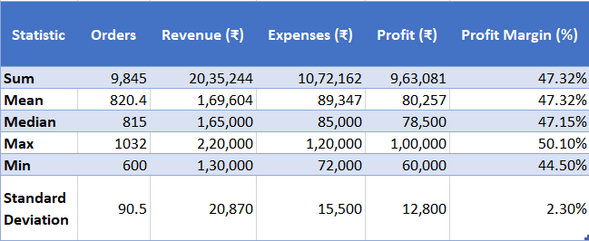

Table 3.1 shows the descriptive statistics of Orders & Revenue of 2023 & 2024

Takeaway from the descriptive statistics: Business is profitable but needs seasonal revenue management.

From the trend of total revenue show a clear upward trend from January 2023 to December 2024, indicating business growth. It has its footfalls in some months and high revenue months.

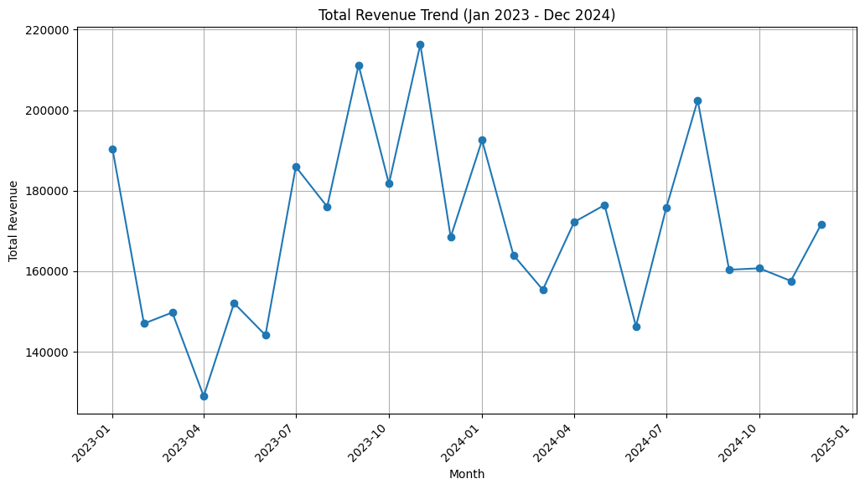

Figure 3.1 shows the trend of revenue of 2023 & 2024 in each month.

The Table 3.2 shows the descriptive measures of Salary, Rent, Raw Materials, and Profit Margins for 2024:

a. Average Salary per month: ₹17,665.42

b. Average Rent per month: ₹34,373.33

c. Average Raw Materials cost per month: ₹12,509.01

d. Average Total Expenses per month: ₹75,435.34

e. Average Revenue from Orders per month: ₹169,603.67

f. Average Profit per month: ₹94,168.33

g. Standard deviation of Profit Margins: 9.56%

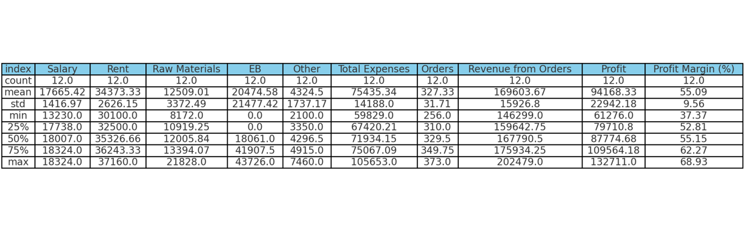

Table 3.2 shows the descriptive statistics of salary, rent, EB, Others, expenses, revenue and profit of 2024.

The data I have collected aligns closely with the problem statement and provides valuable insights for analysis. It includes detailed records of orders and financial performance, both of which are critical for addressing the challenges identified.
The Orders Records contain comprehensive details about total orders, customer information (including whether customers are existing or new), the type of processes involved, the item counts in each order, and delivery timelines. This dataset, maintained on a daily basis, can be organized to identify missing delivery orders and is well-suited for conducting monthly, quarterly, and yearly analyses.
In addition, the Revenue and Profit Records provide essential financial data for cost-benefit analysis. This data, spanning from January 2024 to December 2024, includes monthly details on salary, electricity bills, rent, total orders, revenue, profit, and profit margins. Together, these records form a robust foundation for evaluating the business’s operational efficiency and financial performance over time.

DETAILED EXPLANATION OF ANALYSIS PROCESS / METHOD

Data Cleaning process involved are:
The first step was cleaning and preparing the data to ensure accuracy and reliability. CSV files were uploaded, and unnecessary columns like unnamed and NaN values were removed. Columns were renamed and formatted consistently in lowercase for ease of use. The customer name column, which included names, mobile numbers, and statuses (new or existing), was split into three separate columns for better analysis. Mobile numbers were masked for privacy. Missing values were addressed by replacing empty cells with a placeholder “X” and filtering them out to maintain data integrity. Date columns were converted to datetime format, and year and month were extracted for trend analysis. These steps ensured the data was ready for meaningful insights.
Data Processing and Analysis are:
Once the data was cleaned and prepared, several analyses were conducted to uncover key insights and provide actionable recommendations. Each method was chosen for its relevance and effectiveness in addressing specific business challenges.
Trend Analysis: Revenue and order data were grouped by month and year to uncover seasonal patterns. This method allowed us to identify a recurring dip in revenue during June for both 2023 and 2024. By visualizing trends with bar charts and line graphs, we could easily pinpoint the months that impacted overall performance. Trend analysis was particularly useful because it highlights recurring issues and helps businesses prepare for seasonal fluctuations, making it more effective than random sampling or one-time observations.
Cost-Benefit Analysis: Using financial data from ledgers, we calculated revenue, expenses, and profit margins to assess financial efficiency. This approach revealed that June experienced both lower revenue and higher expenses, leading to reduced profitability. By breaking down costs and profits, the analysis helped identify areas where expenses could be optimized. This method was more appropriate because it provided a detailed view of expense patterns and their impact on profit margins.
Bottleneck Analysis: To identify operational inefficiencies, we examined orders with 25 or more items, as they were most likely to cause delays. The analysis involved comparing assigned delivery dates with actual delivery dates and flagging missing delivery dates as inefficiencies. This targeted approach confirmed that high-order items frequently caused delivery delays, emphasizing the need for better scheduling. Bottleneck analysis was chosen because it focuses on specific pain points that directly affect service quality.
Customer Segmentation: Customers were categorized as loyal or new based on their order frequency, and their behaviour was analysed. Patterns of missed deliveries and delayed pickups among loyal customers revealed an opportunity to introduce a loyalty program to retain high-value clients. Ranking the top 10 customers provided insight into their contribution to revenue. This segmentation was more effective than treating all customers equally because it enabled targeted strategies that address specific customer needs and preferences.
Python libraries such as Pandas and Matplotlib were extensively used for statistical analysis and data visualization. Additional functions were applied to derive insights into different business aspects. All analytic process was done in Google Colab, a pdf to the same is attached. Spreadsheet tools were also used for conducting the cost-benefit analysis, as financial data was obtained from ledger entries and required structured calculations.
Conversations with the manager provided valuable qualitative insights into employee demographics, attendance patterns, and business preferences. The manager confirmed that the business primarily targets individual customers rather than large corporations due to its limited manpower and machine capacity. Employee attendance was found to be consistent and had no major impact on business performance, so it was not included in the analysis. The manager also highlighted the business’s strategic preference to remain focused on household customers, which aligns with the findings from customer segmentation.
By integrating these methods & analytical approaches, we gained insights that can be used to develop targeted strategies for revenue improvement, operational efficiency, and customer retention.

RESULTS & FINDINGS
Using Python-based data analysis alongside cost-benefit evaluations in spreadsheets, we have identified patterns that highlight areas of strength as well as opportunities for improvement.
1. Orders and Revenue Growth
The overall revenue and order volume show a steady upward trend over the last 24 months, indicating positive business growth. However, in closer examination reveals seasonal fluctuations with peaks in January, May and July. There are dips in April, June and October suggesting a cyclical decline in customer activity. Interestingly, we can see a dip in both June 2023 & 2024. This pattern suggests external factors such as seasonal spending habits, weather conditions, or changes in customer demand which needs to be addressed.
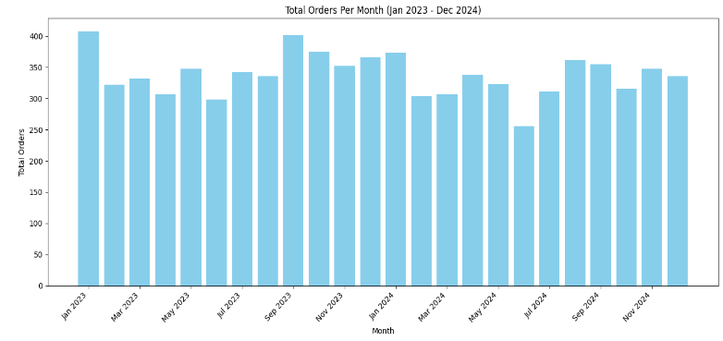
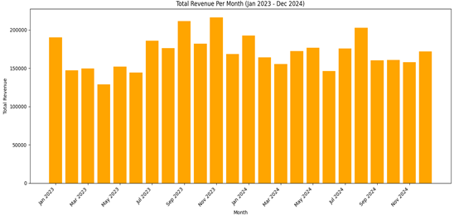

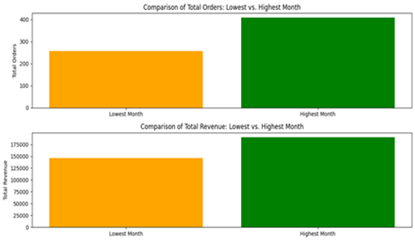

2. Customer Segment Analysis

The Customer behaviour shows a clear reliance on repeat customers for in high-revenue months.New customers exhibit a high drop-off rate after just a few orders, indicating a potential gap in engagement and retention strategies. This suggests that while the business successfully attracts new customers, it struggles to convert them into long-term clients.

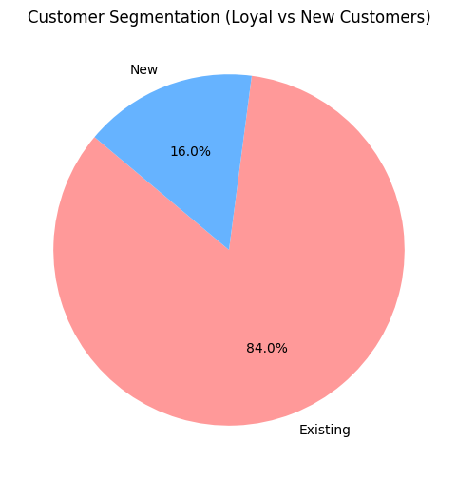

Furthermore, the Pareto analysis of customer order distribution reveals that 20% of customers account for nearly 78% of total revenue, aligning with the Pareto Principle (80/20 Rule). This means that a small, dedicated customer base is driving the majority of business revenue.

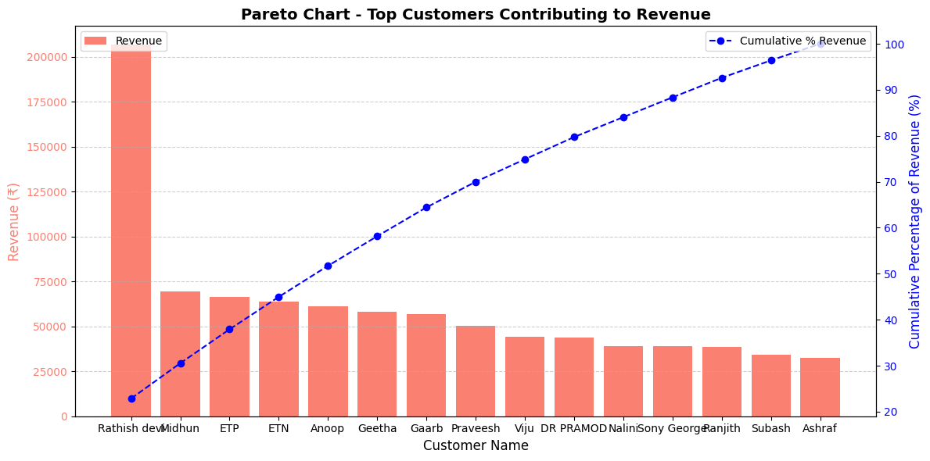

We can introduce a loyalty program such as discounts, membership perks, or exclusive benefit that could benefit the customer retention over time.

3. Bottleneck Analysis

A detailed analysis of orders with 25+ items uncovered frequent missing delivery dates, indicating inefficiencies in processing and delivery systems. The services Steam Press (SP) and Wash & Iron (WI) emerged as the most requested, but they also represent the primary bottlenecks due to their high demand. The analysis further revealed that during peak months, the processing capacity struggles to meet demand, leading to delivery backlogs and delays. These inefficiencies impact customer satisfaction and hinder operational performance.

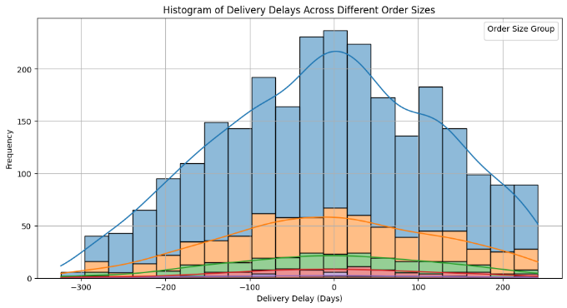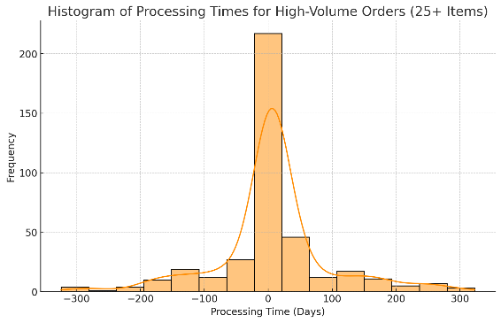

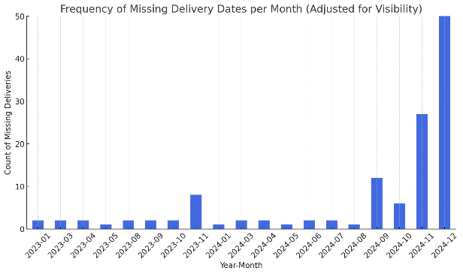
Analysis reveals that larger orders (25+ items) frequently face longer and inconsistent delays, highlighting inefficiencies in the workflow. This indicates a need for more structured and efficient processes to handle bulk orders effectively. Additionally, missing delivery dates show a noticeable spike during November and December 2024, suggesting that the system struggles to manage high demand during peak months. This emphasize the importance of identifying bottlenecks and optimizing operational capacity to prevent delays.

To address these challenges, should optimize scheduling to manage high-volume orders more efficiently, along with prioritizing peak-month demand, can significantly reduce bottlenecks and improve overall service delivery.
.

4. Cost-Benefit Analysis

A comprehensive cost-benefit analysis was conducted, comparing revenue, expenses, and profit margins for 2024. The analysis highlights that while the business is profitable overall, expense management during low-revenue months can further enhance profit margins. For instance, June, being a low-revenue month, disproportionately affects profitability due to steady fixed costs. Expense Drivers which as rent and salaries are consistent contributors to expenses, but raw materials and electricity bills create variability in high-demand months. By controlling raw material costs and implementing energy efficiency measures can help reduce expenses during high-revenue periods.
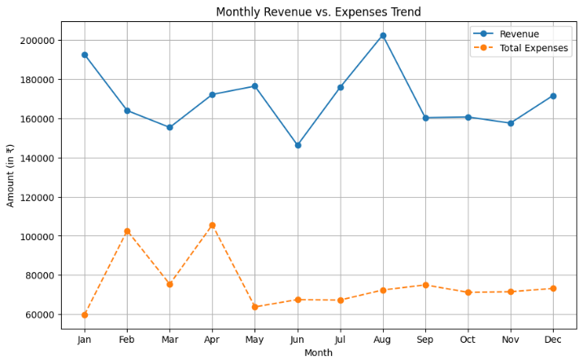
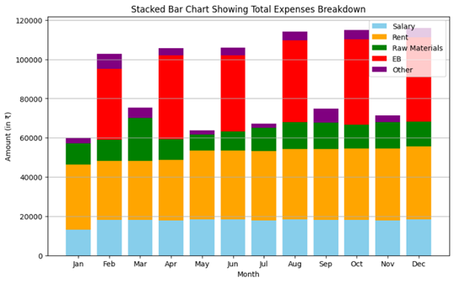

.

PS: Google Colab file used for analysis is attached in google drive link in the proof of originality section.

